Supplementary Table S1: Summary of tissue sample pathology and patient demographics.
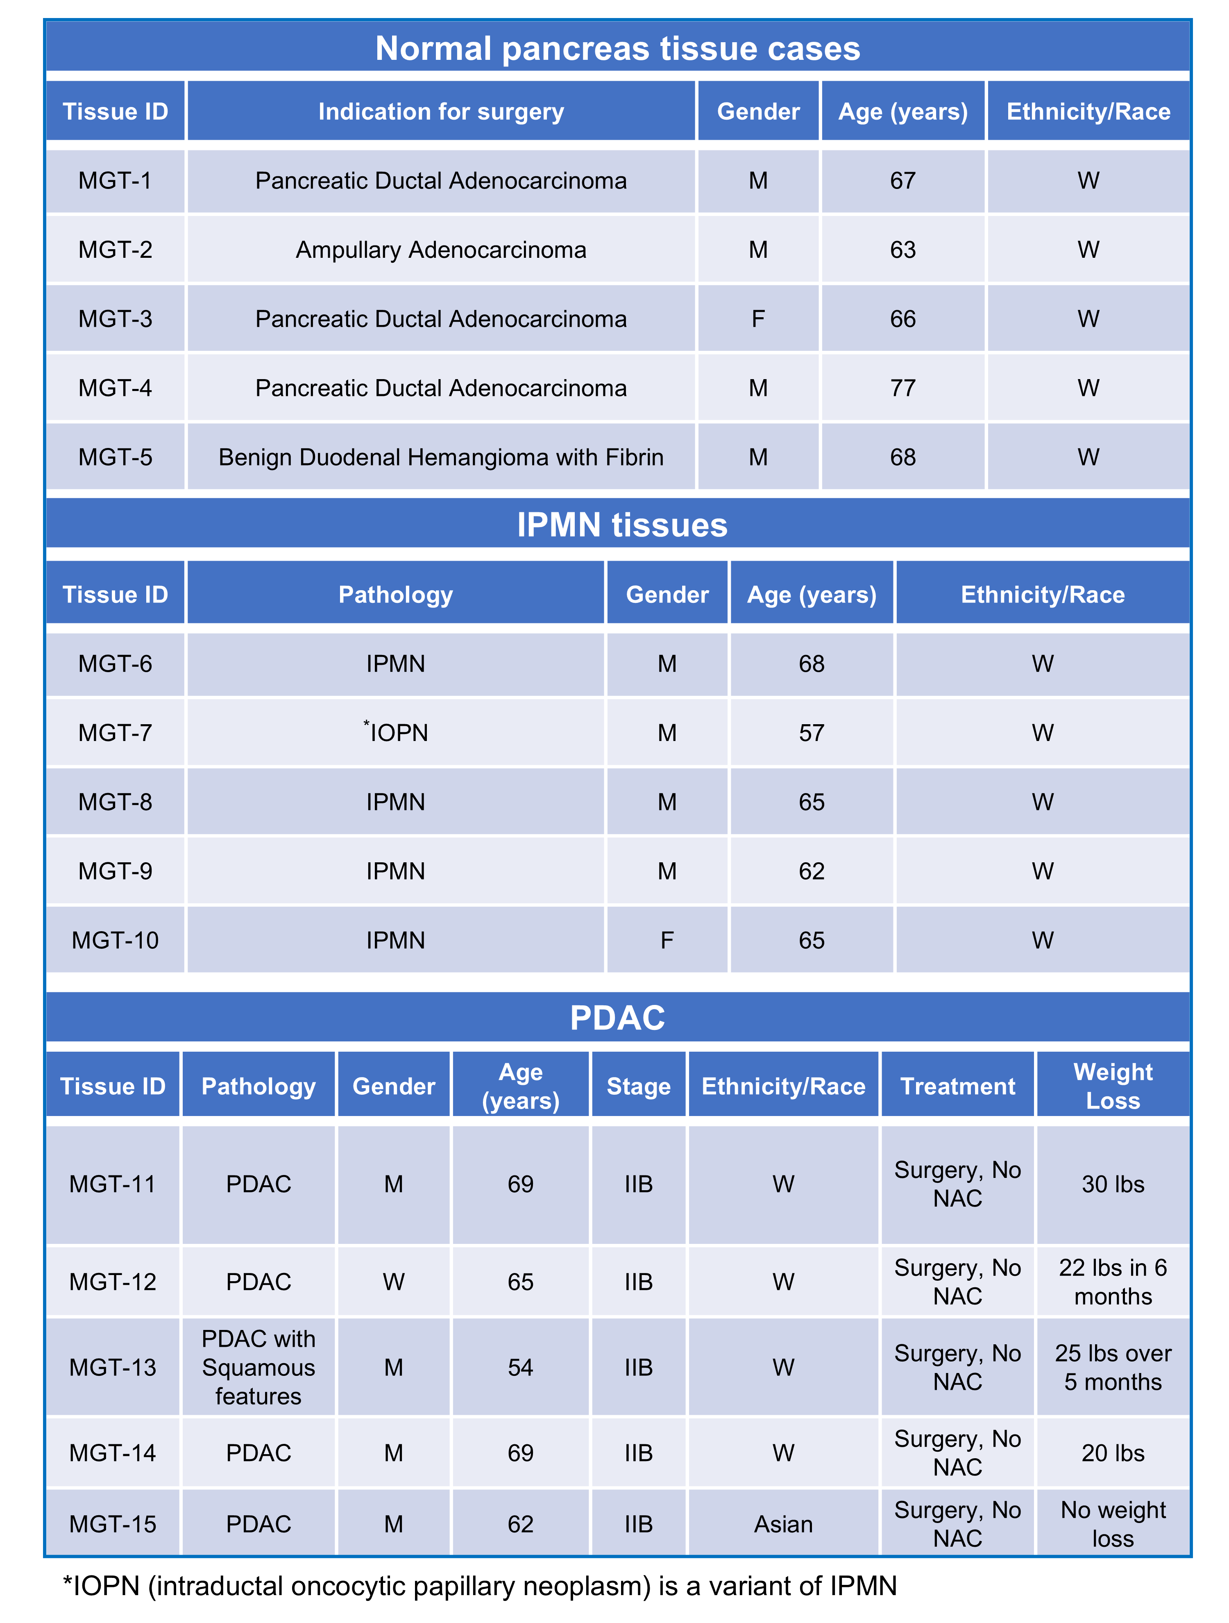

Supplementary Table S2: Area Under the Curve (AUC) values from ROC curve analysis of metabolites and lipids across normal, IPMN, and PDAC tissue comparisons.
 |  | AUC
m/z | Mode | Normal vs PDAC | Normal vs IPMN | IPMN vs PDAC
124.01 | Negative | 0.96 | 0.68 | 0.76
132.08 | Positive | 0.88 | 0.72 | 0.80
133.01 | Negative | 1.00 | 0.60 | 0.80
137.07 | Positive | 0.88 | 0.52 | 0.88
151.02 | Negative | 0.76 | 0.92 | 0.84
154.06 | Negative | 0.92 | 0.52 | 0.80
174.03 | Negative | 0.84 | 0.52 | 0.84
175.02 | Negative | 0.88 | 0.56 | 0.84
188.06 | Negative | 0.92 | 0.76 | 0.68
191.02 | Negative | 0.76 | 0.92 | 0.52
204.12 | Positive | 0.84 | 0.56 | 0.88
213.06 | Positive | 0.84 | 0.92 | 0.60
227.06 | Positive | 0.80 | 0.64 | 0.64
232.15 | Positive | 0.84 | 0.92 | 0.88
296.11 | Positive | 0.92 | 0.80 | 0.60
496.32 | Positive | 0.96 | 0.72 | 0.96
694.44 | Positive | 0.96 | 0.60 | 0.80
720.44 | Positive | 0.92 | 0.72 | 0.64
722.46 | Positive | 0.92 | 0.61 | 0.64
723.52 | Positive | 0.84 | 0.64 | 0.72
725.53 | Positive | 1.00 | 0.64 | 0.76
731.60 | Positive | 0.84 | 0.52 | 0.64
732.53 | Positive | 1.00 | 0.52 | 0.80
734.57 | Positive | 1.00 | 0.80 | 0.76
736.41 | Positive | 0.96 | 0.52 | 0.80
756.55 | Positive | 1.00 | 0.72 | 0.92
780.53 | Positive | 1.00 | 0.52 | 0.80
782.54 | Positive | 0.92 | 0.80 | 0.68
784.55 | Positive | 0.88 | 0.80 | 0.52
788.59 | Positive | 1.00 | 0.56 | 0.64
810.57 | Positive | 0.96 | 0.68 | 0.76
812.61 | Positive | 0.92 | 0.64 | 0.68
832.55 | Positive | 0.96 | 0.64 | 0.80
834.57 | Positive | 0.96 | 0.56 | 0.84
835.64 | Positive | 0.92 | 0.52 | 0.84
836.64 | Positive | 0.88 | 0.52 | 0.80
837.65 | Positive | 1.00 | 0.56 | 0.80
838.66 | Positive | 0.88 | 0.52 | 0.80

Supplementary Table S3: Dot product scores for MS/MS spectral matching of identified metabolites with and without the precursor ion.
Metabolite | Dot product (With Precursor Ion) | Dot product (Without Precursor Ion)
Taurine | 0.99 | 0.99
Creatine | 0.87 | 0.88
Ascorbic acid | 0.97 | 0.98
Xanthine | 0.99 | 0.99
Malate | 0.86 | 0.82
Citrate | 0.89 | 0.68
N-Methylnicotinamide | 0.83 | 0.46
Histidine | 0.80 | 0.37
N-Acetylaspartate | 0.63 | 0.70
N-Acetylglutamate | 0.61 | 0.30

Supplementary Table S4a: Diagnostic MS/MS fragments and structural assignments of confirmed compounds
Experimental m/z | Theoretical m/z | Δ  (Da) | Mass error (ppm) | MSMS Diagnostic Fragments | Assignment
Negative Ion Mode
124.006 | 124.007 | -0.001 | -8.06 | 79.96, 106.98 | Taurine [M-H]-
133.007 | 133.013 | -0.006 | -45.10 | 59.01, 71.01, 73.00, 87.01, 89.02, 115.00 | Malic acid  [M-H]-
151.024 | 151.025 | -0.001 | -6.62 | 42.00, 108.02 | Xanthine [M-H]-
175.024 | 175.025 | -0.001 | -5.71 | 43.01, 59.01, 71.01, 87.00, 115.00, 127.00 | Ascorbic acid [M-H]-
740.523 | 740.524 | 0.001 | -1.21 | 279.23, 281.25 | PE 36:3 [M-H]-
Positive Ion Mode
132.080 | 132.077 | 0.003 | 22.71 | 104.04, 115.05, 117.05 | Creatine [M+H]+
204.116 | 204.123 | -0.007 | -34.29 | 144.10, 145.05, 162.10 | Acetylcarnitine [M+H]+
213.079 | 213.075 | 0.004 | 18.77 | 153.05, 169.07, 178.06, 195.05, 196.05 | Arginine [M+K]+
227.072 | 227.079 | -0.007 | -30.82 | 118.06, 130.06, 142.06, 144.07, 183.08, 209.06, 210.07 | Tryptophan [M+Na]+
232.147 | 232.154 | -0.008 | -33.59 | 144.10, 162.10, 173.07 | Car 4:0 [M+H]+
496.327 | 496.339 | -0.012 | -24.17 | 184.07, 258.10, 313.26, 419.24 | LPC 16:0 [M+H]+
720.440 | 720.444 | -0.004 | -5.55 | 184.07, 496.32, 537.37 | PC 28:3;O3 [M+H]+
722.455 | 722.460 | 0.005 | -6.92 | 184.07, 239.23, 539.39, 663.38 | PC 28:2;O3 [M+H]+
731.608 | 731.606 | 0.002 | 2.73 | 125.00, 184.07, 713.60 | SM 36:1;O2 [M+H]+
734.571 | 734.569 | 0.002 | 2.17 | 125.00, 184.07, 496.34 | PC 32:0 [M+H]+
756.553 | 756.554 | 0.001 | -1.05 | 125.00, 184.07, 239.24, 478.33, 500.31, 573.49, 697.48 | PC 34:3 [M+H]+
756.553 | 756.551 | 0.002 | 2.64 | 146.98, 184.07, 239.24, 500.31, 551.51, 573.49, 697.48 | PC 32:0 [M+Na]+
812.612 | 812.616 | 0.004 | -5.41 | 184.07, 441.24, 500.31, 629.54, 753.54 | PC 38:3 [M+H]+

Supplementary Table S4b: Tentative assignments of metabolites and lipids.
Experimental m/z | Theoretical m/z | Δ (Da) | Mass error (ppm) | MSMS Diagnostic Fragments | Tentative Assignment
Negative Ion Mode
154.063 | 154.061 | 0.002 | 12.98 | 108.06, 109.04, 110.07, 114.04, 118.04, 127.04, 136.05, 137.04 | Histidine [M-H]-
174.030 | 174.040 | -0.01 | -57.45 | 130.05, 132.02, 156.04 | N-Acetylaspartic acid [M-H]-
188.058 | 188.056 | 0.002 | 10.63 | 116.04, 144.06, 146.05, 170.05 | N-Acetylglutamic acid [M-H]-
191.019 | 191.019 | -0.001 | -2.61 | 85.02, 87.00, 111.00, 129.01, 130.99, 173.00 | Citric Acid [M-H]-
Positive Ion Mode
137.069 | 137.071 | -0.002 | -14.59 | 108.04, 109.05, 110.05, 117.04, 119.05, 120.04 | N-Methylnicotinamide [M+H]+
723.517 | 723.541 | -0.024 | -33.17 | 146.98, 184.07, 265.24, 518.48, 540.46, 664.45 | SM 34:2;O2 [M+Na]+
725.533 | 725.556 | -0.023 | -31.7 | 146.98, 239.23, 502.48, 520.49, 542.47, 666.46 | SM 34:1;O2 [M+Na]+
732.529 | 732.553 | 0.025 | -32.76 | 125.0, 184.07, 494.31, 496.32, 549.47 | PC 32:1 [M+H]+
736.411 | 736.431 | 0.020 | -27.15 | 162.95, 184.07, 553.37, 677.35 | PC 30:4 [M+K]+
780.526 | 780.551 | 0.025 | -31.77 | 146.98, 184.07, 500.30, 524.29, 575.49, 597.47, 721.45 | PC 34:2 [M+Na]+
782.541 | 782.567 | 0.026 | -33.22 | 146.98, 184.07, 500.29, 526.31, 544.32, 577.50, 599.48, 723.47 | PC 34:1 [M+Na]+
784.554 | 784.582 | 0.028 | -35.68 | 184.07, 496.32, 528.32, 546.33, 601.49, 725.48 | PC 36:3 [M+H]+
784.554 | 784.582 | 0.028 | -35.68 | 146.98, 184.07, 500.30, 528.32, 546.33, 579.51, 601.49,725.48 | PC 34:0 [M+Na]+
788.589 | 788.616 | 0.026 | -34.23 | 184.07, 504.33, 524.36 | PC 36:1 [M+H]+
810.572 | 810.600 | 0.029 | -34.54 | 184.07, 506.34, 524.35, 526.31, 544.32, 627.51, 751.50 | PC 38:4 [M+H]+
832.554 | 832.57 | 0.015 | -19.21 | 125.00, 184.07, 517.25, 649.50, 773.48 | PC 36:3;O3 [M+H]+
832.554 | 832.57 | 0.015 | -19.21 | 146.98, 184.07, 489.22, 528.33, 548.29, 627.51, 649.50, 773.48 | PC 38:4 [M+Na]+
834.569 | 834.6 | 0.031 | -37.14 | 184.07, 463.21, 491.23, 506.34, 524.35, 550.31, 651.51, 775.50 | PC 40:6 [M+H]+
834.569 | 834.600 | 0.031 | -37.14 | 146.98, 184.07, 463.21, 522.33, 629.53, 651.51, 775.50 | PC 38:3 [M+Na]+
835.639 | 835.666 | 0.027 | -32.31 | 146.98, 184.07, 612.59, 630.60, 652.58, 776.57 | SM 42:2;O2 [M+Na]+
836.641 | 836.616 | 0.024 | 29.64 | 125.00, 184.07, 506.35, 524.35, 653.58, 777.57 | PC 40:5 [M+H]+
836.641 | 836.616 | 0.024 | 29.64 | 146.98, 184.07, 631.54, 653.58, 777.57 | PC 38:2 [M+Na]+
837.654 | 837.682 | 0.028 | -33.42 | 146.98, 184.07, 614.60, 632.62, 654.59, 778.58 | SM 42:1;O2 [M+Na]+
838.656 | 838.632 | 0.024 | 28.61 | 184.07, 524.35, 655.59, 779.58 | PC 40:4 [M+H]+

