Appendix Table A. Components of EPA National Walkability Index.
Index Component | Data Source
Intersection Density
Street intersection density excluding automobile-oriented intersections | 2018 HERE Maps NAVSTREETS
Proximity to Transit Stops
Distance from population-weighted centroid to nearest transit stop | 2020 GTFS and 2020 CTOD
Employment Mix
Total employment | 2017 Census LEHD WAC
Within 8-tier employment classification scheme:
Retail jobs | 2017 Census LEHD WAC
Office jobs | 2017 Census LEHD WAC
Industrial jobs | 2017 Census LEHD WAC
Service jobs | 2017 Census LEHD WAC
Entertainment jobs | 2017 Census LEHD WAC
Education jobs | 2017 Census LEHD WAC
Health care jobs | 2017 Census LEHD WAC
Public administration jobs | 2017 Census LEHD WAC
Employment and Household Mix
Occupied housing units | ACS 2014-2018 5-year estimates
Total employment | 2017 Census LEHD WAC
Within 5-tier employment classification scheme:
Retail jobs | 2017 Census LEHD WAC
Office jobs | 2017 Census LEHD WAC
Industrial jobs | 2017 Census LEHD WAC
Service jobs | 2017 Census LEHD WAC
Entertainment jobs | 2017 Census LEHD WAC
Note. The overall walkability index is computed as the weighted average of the ranked scores for intersection density (one-third weight), proximity to transit stops (one-third weight), employment mix (one-sixth weight), and employment and household mix (one-sixth weight). Details on index computation, including the computation of the employment mix and employment and household mix measures based on the components shown, are available in Chapman et al., 2021. Employment mix and employment and household mix were included as proxies for land use mix. ACS = American Community Survey; CTOD = Center for Transit Oriented Development; GTFS = General Transit Feed Specification; LEHD = Longitudinal Employer-Household Dynamics; WAC = Work Area Characteristics.

Appendix Table B. Comparison of Counties Comprising Analytical Sample to All Other U.S. Counties.
 | Analytical Sample Counties (n=259) | All Other U.S. Counties (n=2884) | Analytical vs. All Other U.S. Counties
 | Mean (SD) or % | Mean (SD) or % | p-value
% non-Hispanic White | 63.30 (20.39) | 76.25 (19.91) | <.001
% non-Hispanic Black | 11.45 (11.61) | 8.56 (14.51) | <.001
% Hispanic | 16.23 (16.30) | 9.22 (13.65) | <.001
Median household income | 75,073 (19,811) | 56,723 (14,160)ª | <.001
Census region
West | 18.53% | 13.90% | <.001
Midwest | 19.69% | 34.81% | <.001
Northeast | 25.48% | 5.24% | <.001
South | 36.29% | 46.05% | <.001
Population size | 569,543 (828,849) | 63,779 (200,742) | <.001
P-values are from bivariable linear regressions with robust standard errors for continuous variables and Pearson’s chi-squared test for categorical variables.
ª n=2883 due to missing data for this item.

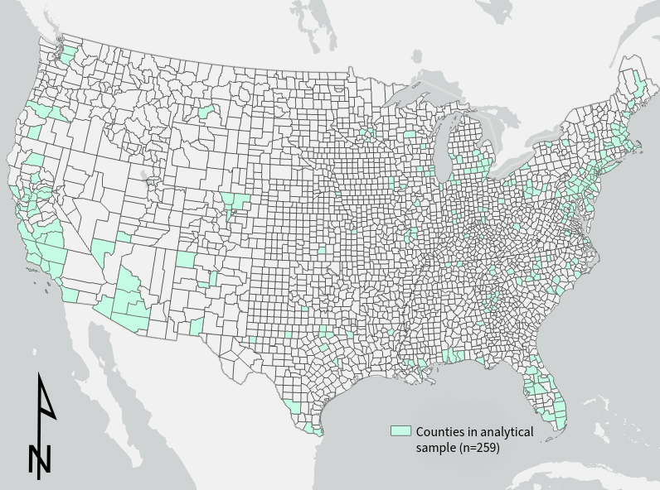
Appendix Figure A. Counties included in the analytical sample for the current study. The 259 counties in which the sample of 21,616 Current Population Survey respondents were located are shown in green.

