Figure S1. Genotyping and sequence analysis of NSRRC:0086 and R614 lines. (A) PCR diagnostic assay results for B4GALNT2/B4GALNT2-like (primers 1095-1730; 632 bp) demonstrating a truncated band in NSRRC:0086 cloned pigs compared to the wild-type (WT) pig band. (B) PCR genotyping assay results for B4GALNT2/B4GALNT2-like (primers 353-3018; 2,264 bp) used to identify large deletions in NSRRC:0086 and R614 lines; large deletions were detected in the NSRRC:0086 male and R614 lines. (C) Sanger sequencing results aligned to WT B4GALNT2 or B4GALNT2-like sequences for the R614 line. No WT alleles were detected in any GE pigs; specifically, the NSRRC:0086 female carried a 65 bp deletion in B4GALNT2 and biallelic 66 bp and 72 bp deletions in B4GALNT2-like (A), while the NSRRC:0086 male exhibited a 68 bp deletion in both B4GALNT2 and B4GALNT2-like (A) along with large structural deletions of 1095 bp and 1140 bp (B). R614 line showed a 5 bp deletion in both B4GALNT2/B4GALNT2-like in addition to large 1095 bp and 1140 bp deletions (B and C). Note that these large deletions could not be differentiated between B4GALNT2 and B4GALNT2-like because the specific sequence regions required for gene differentiation were absent in these edited alleles. L: ladder; CT+: positive control, edited colony used to clone NSRRC:0086 male pigs; Water: negative control, no DNA; Black line in (C) indicate gRNA 2 sequence.

Figure S2. Validation of B4GALNT2 expression via immunofluorescence staining in NSRRC:0086 and R614 lines. Kidney and liver tissues, as well as isolated porcine kidney cells (PKC), were analyzed from GE founder lines (cloned male/female NSRRC:0086 and R614). Column 1: Wild-type (WT) samples stained with DBA-Rhodamine (red) or DBA-FITC (green) lectin as positive controls. Column 2: WT samples treated with PBS only (negative control). Column 3: Corresponding samples from the GE lines showing a total loss of DBA binding.

Figure S3. DBA lectin staining in the endometrium of non-pregnant WT and B4GALNT2/B4GALNT2-like null pigs. (A) Fluorescence of DBA-FITC staining in the endometrial luminal epithelium (LE) of WT pig and its absence in the B4GALNT2/B4GALNT2-like null (KO) tissue. (B) High-magnification images showing that DBA lectin is localized to the apical surface of both the LE and glandular epithelium (GE) in WT pigs, while no staining is detected in the null tissue. The localization pattern observed in the WT tissue is consistent with the DBA staining profile previously demonstrated by Bailey et al. (2010). BF: brightfield.

Gene, Specie (Gene ID) | B4GALNT2 Sus scrofa | B4GALNT2-like Sus scrofa
B4GALNT,, Sus scrofa (100621328) | 100 | 96.79
B4GALNT2-like Sus scrofa (110255214) | 96.79 | 100
B4GALNT2 Mus musculus (14422) | 48.97 | 50.44
B4GALNT2 Homo sapiens (124872) | 53.02 | 55.46
B4GALNT2 Bos taurus (508108) | 60.70 | 63.99

Table S1: Pairwise comparison of nucleotide sequence identity matrix of porcine B4GALNT2 and B4GALNT2-like compared to other mammalian orthologs. Percentage identities were calculated from a Clustal Omega Multiple Sequence Alignment (MSA) using sequences retrieved from the NCBI database.

Protein, Specie (NCBI Reference Sequence) | B4GALNT2 | B4GALNT2-like isoform X3 | B4GALNT2-like isoform X5
B4GALNT2, Sus scrofa (NP_001231259.1) | 100 | 95.22 | 94.93
B4GALNT2-like isoform X3, Sus scrofa (XP_005668911.2) | 95.22 | 100 | 100
B4GALNT2-like isoform X5, Sus scrofa (XP_005668913.2) | 94.93 | 100 | 100
B4GALNT2, Mus musculus (NP_032107.1) | 69.52 | 70.75 | 70.65
B4GALNT2 isoform a, Homo sapiens, (NP_703147.2) | 75.5 | 76.28 | 75.47
B4GALNT2 isoform b, Homo sapiens (NP_001152860.1) | 77.52 | 78.54 | 77.83
B4GALNT2 isoform c, Homo sapiens (NP_001152859.1) | 76.1 | 76.88 | 76.1
B4GALNT2 isoform X1, Bos taurus (XP_059734498.1) | 78.49 | 80.04 | 79.25
B4GALNT2 isoform X2, Bos taurus (XP_010814492.1) | 78.69 | 80.24 | 79.45
B4GALNT2 isoform X3, Bos taurus (XP_010814493.1) | 79.14 | 80.73 | 79.96

Table S2: Pairwise protein sequence identity matrix comparing porcine B4GALNT2 and B4GALNT2-like (isoforms X3 and X5) with mammalian orthologs. Percentage identities were calculated from a Clustal Omega Multiple Sequence Alignment (MSA) using sequences retrieved from the NCBI database.

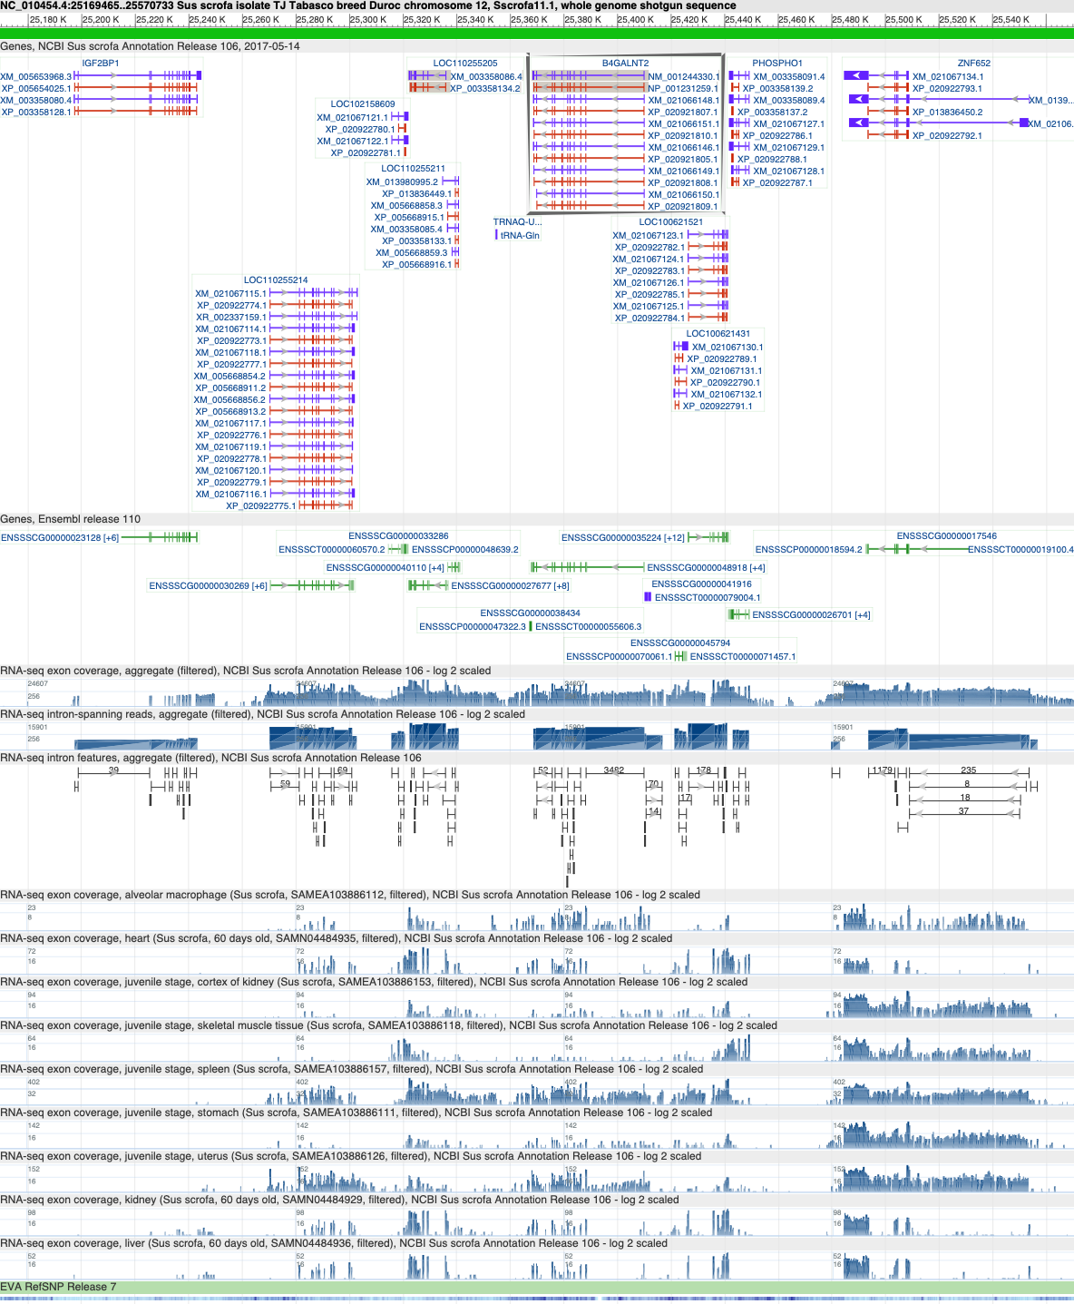
ABI3
GNGT2
ABI3
GNGT2
B4GALNT2-LIKE
PHOSPHO1
Figure S4. NCBI genomic view of the Sus Scrofa IGF2BP1- ZNF652 interval. Genes that have not been annotated were identified and labeled based on their predicted mRNA transcripts and sequence homology to other species.

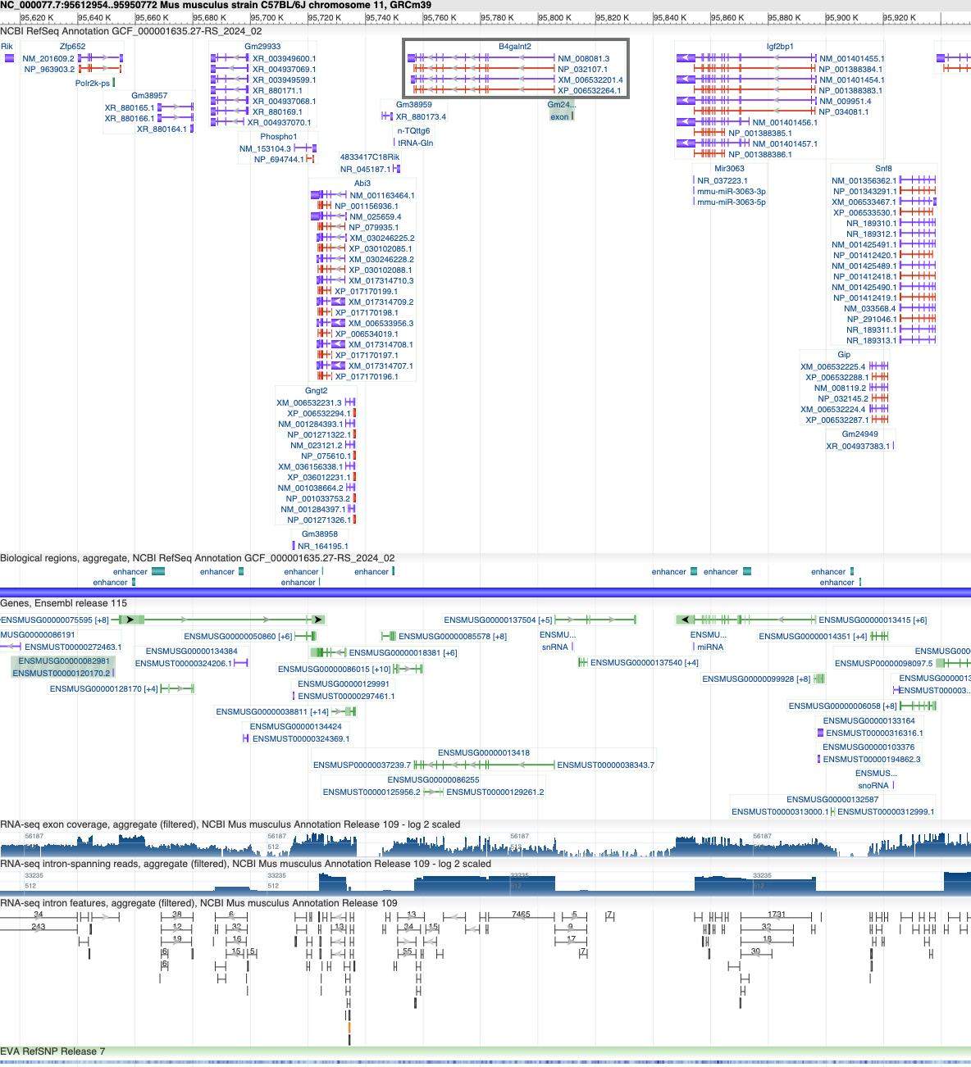
Figure S5. NCBI genomic view of the Mus musculus IGF2BP1- ZNF652 interval.

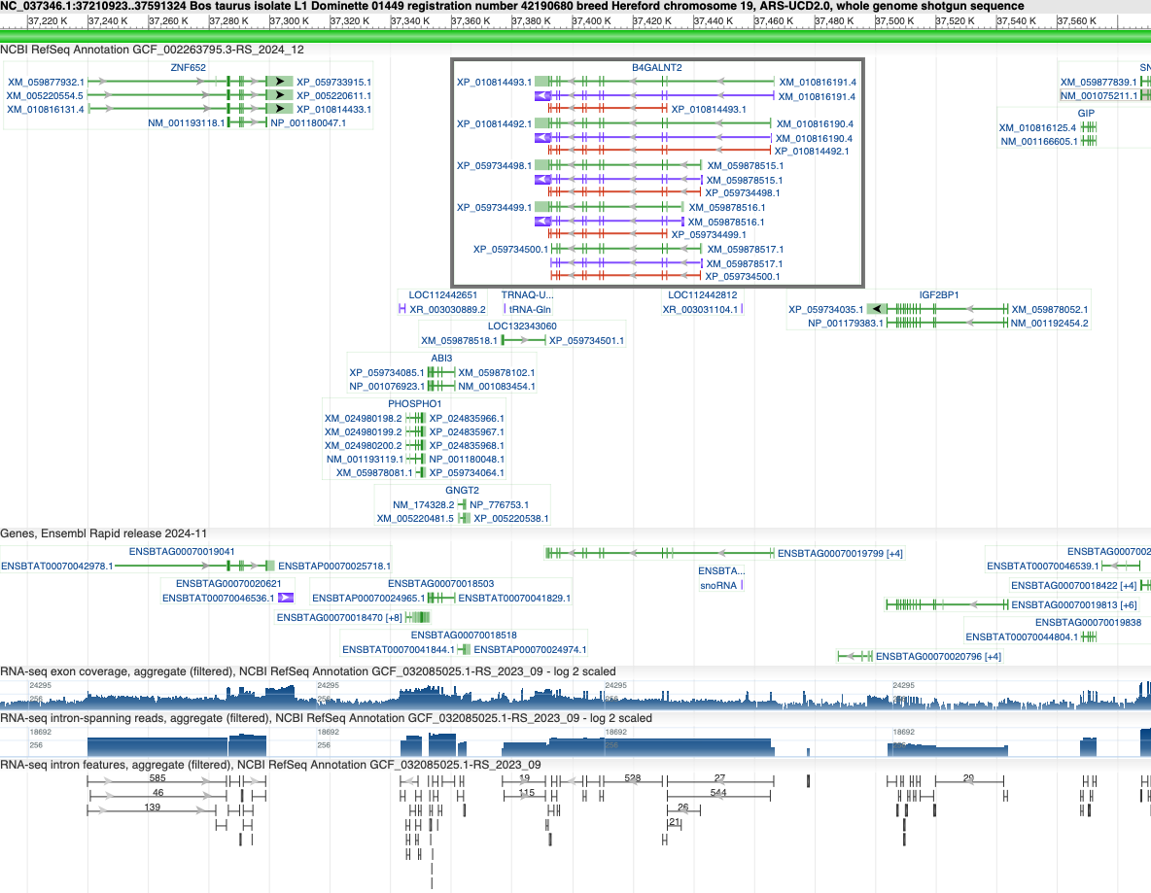
Figure S6. NCBI genomic view of the Bos taurus IGF2BP1- ZNF652 interval.

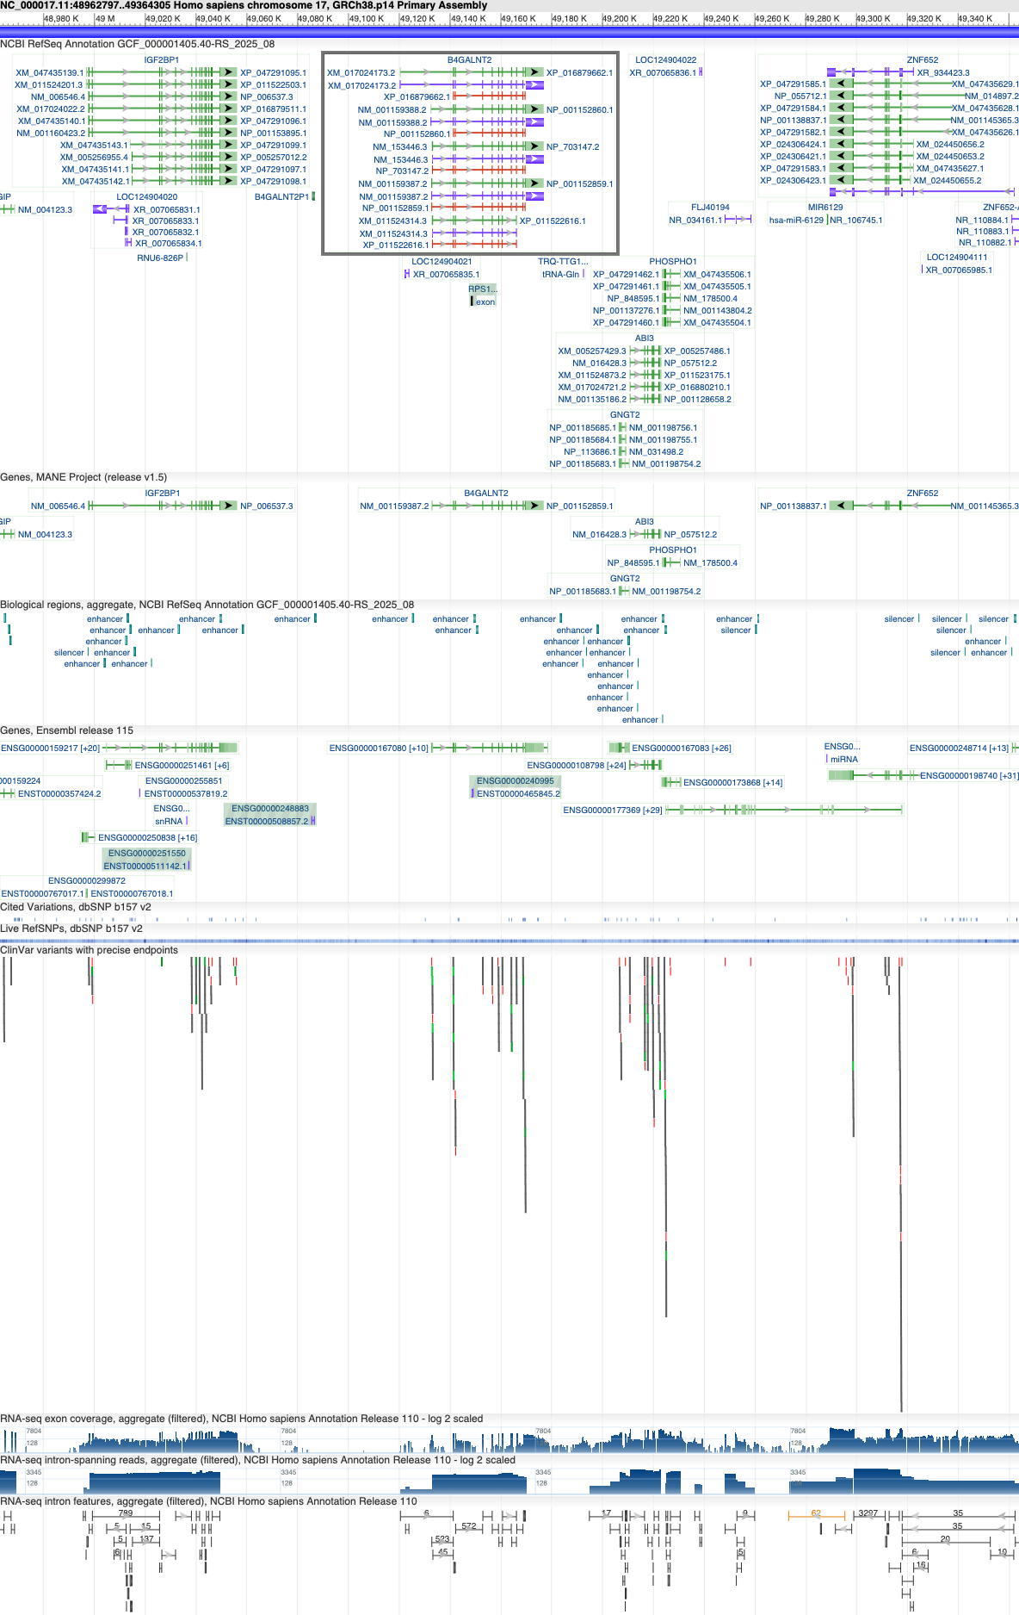
Figure S7. NCBI genomic view of the Homo sapiens IGF2BP1- ZNF652 interval.

