Title: Autism spectrum disorder in central North Carolina: A spatial analysis using generalized additive models

Figure 1……………………………………………………………………………………..Page 2
Mother’s educational attainment at the time of birth n=11,034. Map reflects the optimal span size of the ASD analyses (span=0.95; global P<0.001); the optimal span size of the education analysis was 0.05 (global P<0.001). Larger prevalence ratios indicate a higher prevalence of mothers with college or more education at the child’s birth. Areas of significantly increased and decreased risk are indicated by black contour bands.

Figure 2……………………………………………………………………………………..Page 3
Adjusted maps for (A) ASD prevalence (birth cohort n=11,034 and ASD n=532), (B) ASD-ID (birth cohort n=11,034 and ASD-ID n=318), and (C) ASD+ID (birth cohort n=11,034 and ASD+ID n=214). Maps are not significantly different than flat (global P=0.052, global P=0.294 and global P=0.196, respectively). Adjustment factors were year of birth; plurality; maternal age, race, and level of education; and report of tobacco use during pregnancy.

Figure 1:
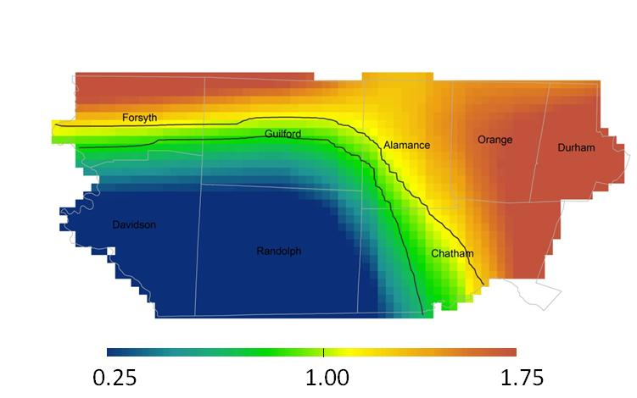

Figure 2:
