Graphic illustrations of the six emerging PrEP products utilized in the study: a weekly oral pill, event-driven oral pills, anal douche/enema, anal suppository, long-acting injection, and a skin implant
1) Weekly oral pill and 2) event-driven oral pills
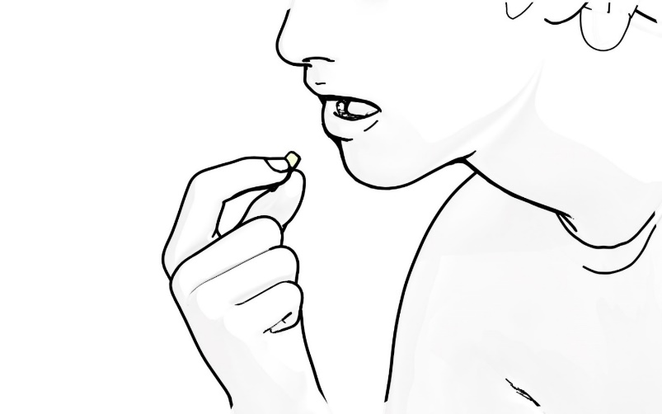
3) anal douche/enema

4) Anal suppository


5) Long-acting injection
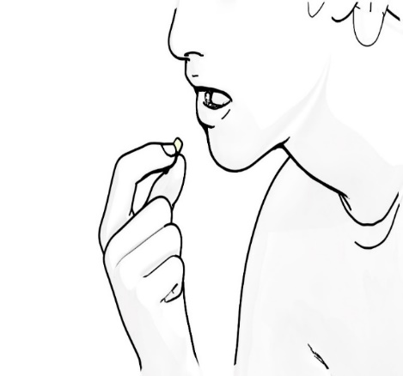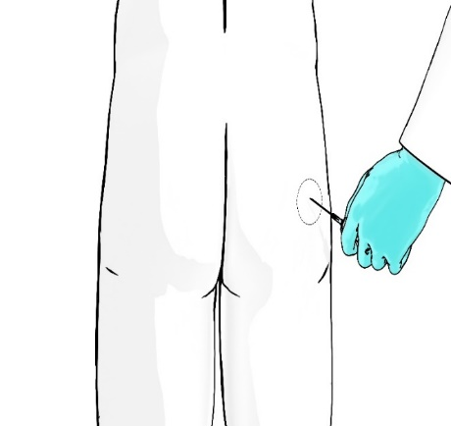
6) Skin implant
