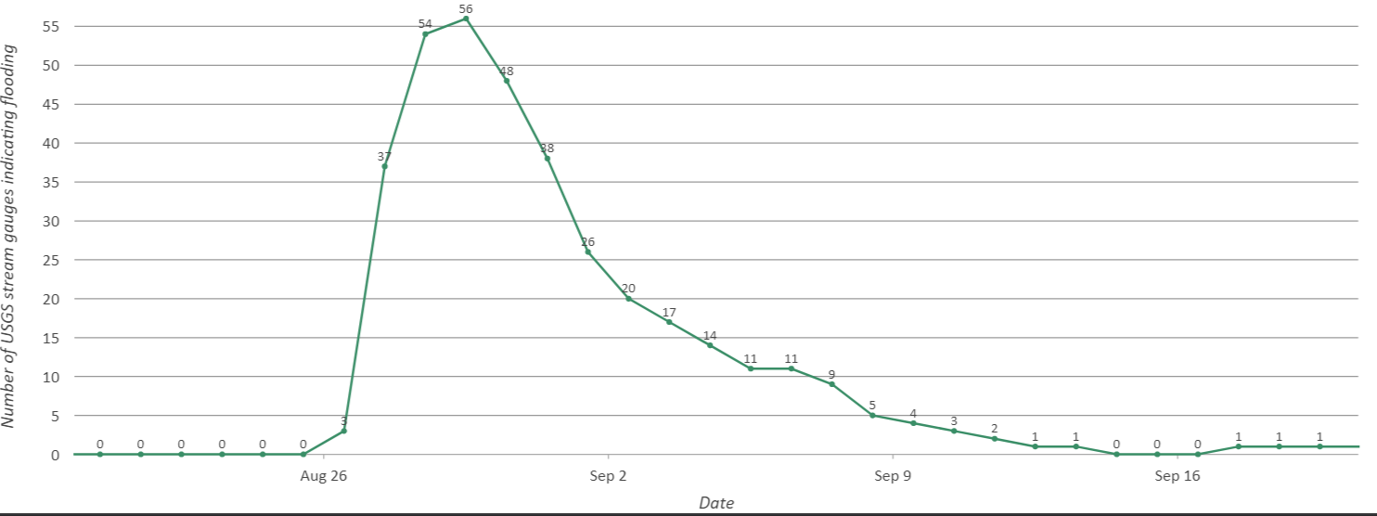
Supplementary Figure 1: Number of USGS stream gauges indicating stage height greater than the NWS flood stages. There was a total of 597 USGS stream gauges with NWS flood stage values in the study region.

