Supplemental Document for Manuscript: The need for better metrics for floor-tile topography: Conventional metrics correlate only modestly with shoe-floor friction

- Data availability for all measurements
All data have been made publicly accessible via DOI for download and supplementary analyses. The measured data for COF and roughness parameters are available in a public repository [1]. The raw data from all surface measurements is also accessible using the contact.engineering web application, with DOIs for each digital surface twin listed in Table S1.
Table S1: List of flooring tiles used, along with DOI for accessing all surface-topography measurements for each tile.
Manufacturer | Tile Product | Finish | Tile Code | DOI
Crossville | Graphite | Polished | BPOL | https://doi.org/10.57703/ce-bpczg
Crossville | Graphite | Unpolished Sheen | BUPS | https://doi.org/10.57703/ce-cxyn8
Fired Earth | Piemonte | Matte | PPM | https://doi.org/10.57703/ce-wkq6z
Fired Earth | Piemonte | Polished | PPP | https://doi.org/10.57703/ce-j5qtr
Fired Earth | Piemonte | Satin-Bone | PBS | https://doi.org/10.57703/ce-yhzx9
Fired Earth | Piemonte | Satin-Pearl | PPS | https://doi.org/10.57703/ce-v6t8p
Crossville | Roasted Chestnut | Polished | APOL | https://doi.org/10.57703/ce-zcpbh
Crossville | Roasted Chestnut | Unpolished Sheen | AUPS | https://doi.org/10.57703/ce-mdqfs
Crossville | Venho Verde | Unpolished Sheen | CUPS | https://doi.org/10.57703/ce-8tzq3
Fired Earth | Umbria | Polished | UMBP | https://doi.org/10.57703/ce-g4cym
Fired Earth | Umbria | Matte | UMBM | https://doi.org/10.57703/ce-crtwt
Fired Earth | Umbria | Satin | UMBS | https://doi.org/10.57703/ce-wbp5n
Fired Earth | Lombardia | Polished | LMBP | https://doi.org/10.57703/ce-6qy4a
Fired Earth | Lombardia | Matte | LMBM | https://doi.org/10.57703/ce-ynqrq
Fired Earth | Lombardia | Satin | LMBS | https://doi.org/10.57703/ce-r5cau
Crossville | State of Grace | Unpolished Sheen | FUPS | https://doi.org/10.57703/ce-57etj
Crossville | State of Grace | Satin | FSAT | https://doi.org/10.57703/ce-nu46d
Crossville | Juno | Unpolished Sheen | EUPS | https://doi.org/10.57703/ce-b3tjf
Crossville | Juno | Honed | EHON | https://doi.org/10.57703/ce-4pq7x
American Wonder | Asher Haze | Finish 1 | AH1 | https://doi.org/10.57703/ce-9wzs6
American Wonder | Asher Haze | Finish 2 | AH2 | https://doi.org/10.57703/ce-2j7be
American Wonder | Venato | Polished | VPOL | https://doi.org/10.57703/ce-mg4cy
American Wonder | Polar Style | White | PSW | https://doi.org/10.57703/ce-zaf32

- Power spectral density analysis
  - Approach to acquiring power spectral density plots from stylus profilometry data
The power spectral density (PSD, C(q)) is a mathematical tool that transforms roughness profiles from the spatial domain (h(x) where h is the height and x is the spatial position) to the wavevector (large wavevectors are associated with shorter wavelengths), q. Plots of PSD enable visualization of the contributions of different wavevectors to the topography of a surface. Mathematically, the PSD is the Fourier transform $\tilde{h}$ of the autocorrelation function, or the square of the Fourier transform of the height function itself. The power spectral density was computed according to the approach of Ref. [2]:
$C\left(q\right)= L^{-1}{|\tilde{h}\left(q\right)|}^{2}= L^{-1}{\left|\int_{0}^{L}{h(x)e^{-iqx}dx}\right|}^{2}$ Eq. (S1)
where L is the scan length. Sanner et al. [3] investigated how to determine the crossover to q⁻⁴ (λ⁴) in a power spectral density which translates into large wavevector (small-wavelength) cutoff which is different for each surface in Fig. 1. The authors suggested a tip-radius reliability cutoff, where they compared scale-dependent root-mean-square curvature to tip curvature (h”(l)), Eq. (S2). Building on that idea, the authors proposed an additional metric to accurately detect the onset of the tip-radius artifact. The metric was the minimum curvature value at a specific scale ‘l’, where D_{(l)} is a differential operator:
$h_{min}^{''}\left(l\right)= -\min_{k}{[\frac{D_{\left(l\right)}^{2}}{D_{\left(l\right)}x^{2}}h\left(x_{k}\right)]}$ Eq. (S2)
For each tip radius and surface topography, there is a critical length scale below which the stylus profilometry data is unreliable. This critical length scale depends both on the tip radius and the curvature of the measured surface, which implies that rougher surfaces have more tip artifacts than smoother surfaces. This is because a tip that can conform to the valleys of a smoother surface may not be able to conform to the valleys of the rougher surfaces. This is why unpolished tiles may have a larger small-wavelength cutoff than the polished tiles.
  - Power spectral density results
Power spectral density analysis plots are provided for each type of flooring tile. Detailed information for each tile (Section 2.1, Table 1) and detailed information about stylus profilometry measurement methods (Section 2.3) are available in the main text.

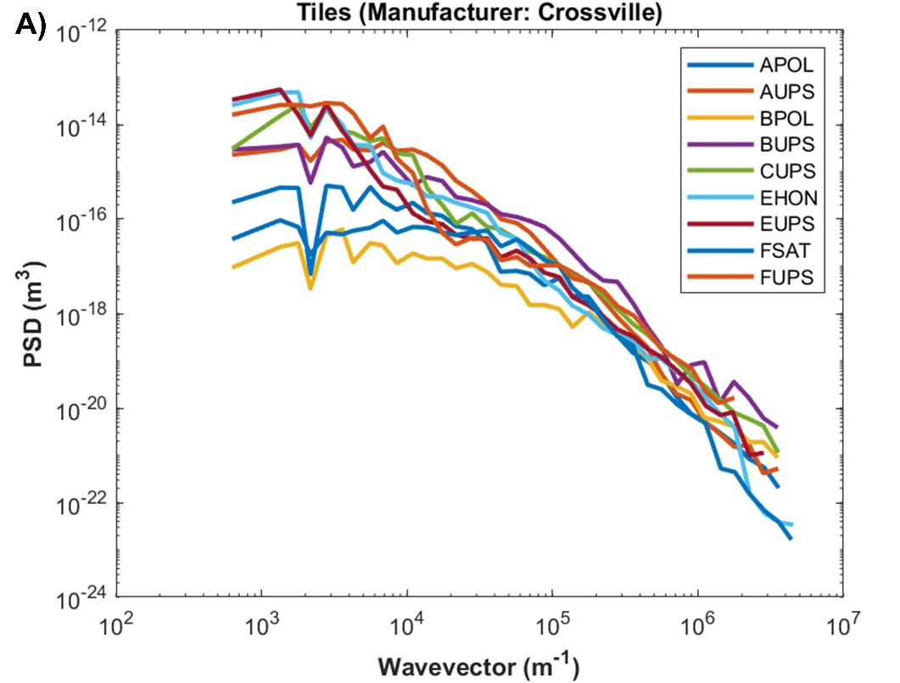
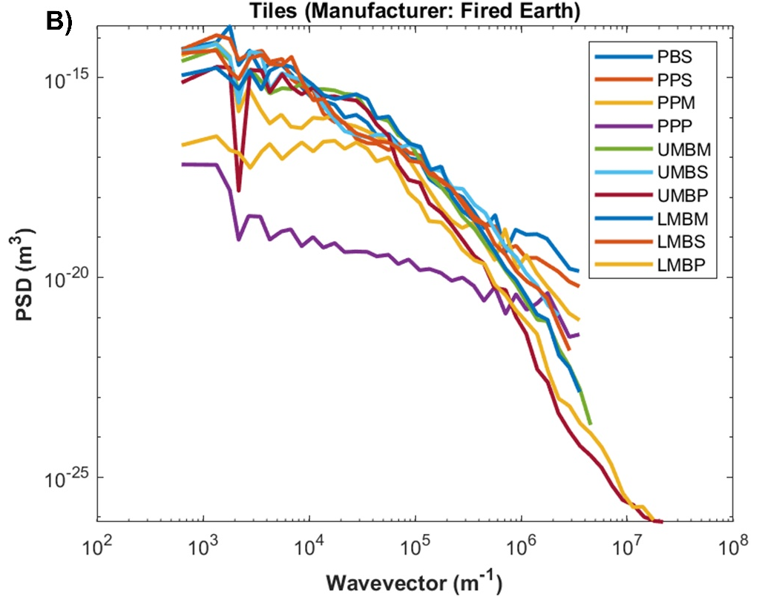
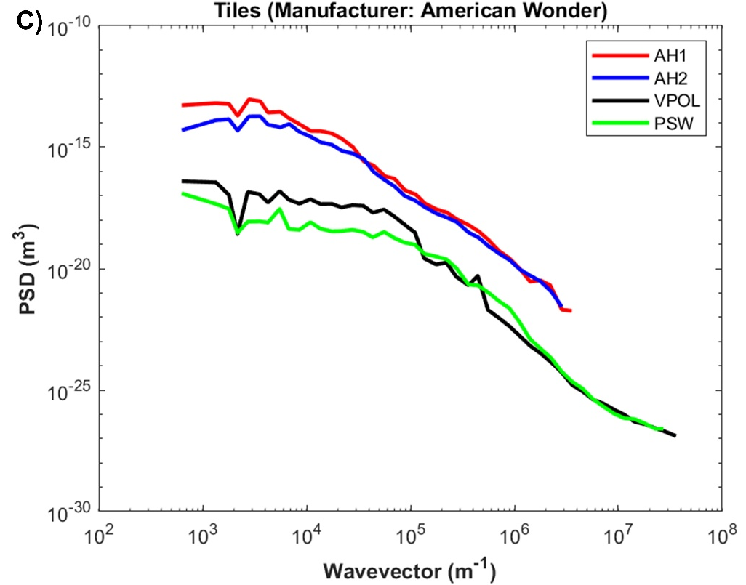
Supplemental Figure 1: Power spectral density plots across wavevectors. Note that smaller wave lengths correspond with larger wavevectors.

- Nonparametric statistical analyses
In the nonparametric analyses, positive but weak correlations were observed between each roughness parameter and the COF. Spearman correlation coefficients, r_{s}, were between 0.160 and .719. The r_{s} value (p-value) between COF and each roughness parameter were as follows: R_{a} was 0.675 (p<0.001), R_{q} was 0.584 (p=0.003), R_{p} was 0.719 (p<0.001), and W_{a} was 0.492 (p=0.017).

- References:
[1] Randolph, A.B., Reifler, K., Chadha, V., Jacobs, T.D.B., Beschorner, K.E.: Data Set for Manuscript: The need for better metrics for floor-tile topography: Conventional metrics correlate only modestly with shoe-floor friction. Place (2023)
[2] Jacobs, T.D., Junge, T., Pastewka, L. Quantitative characterization of surface topography using spectral analysis. Surface Topography: Metrology and Properties 5:013001 (2017).
[3] Sanner, A., Nöhring, W.G., Thimons, L.A., Jacobs, T.D., Pastewka, L. Scale-dependent roughness parameters for topography analysis. Applied Surface Science Advances 7:100190 (2022).

