Methodological Appendix

Mixed-Methods Data Analysis and Process

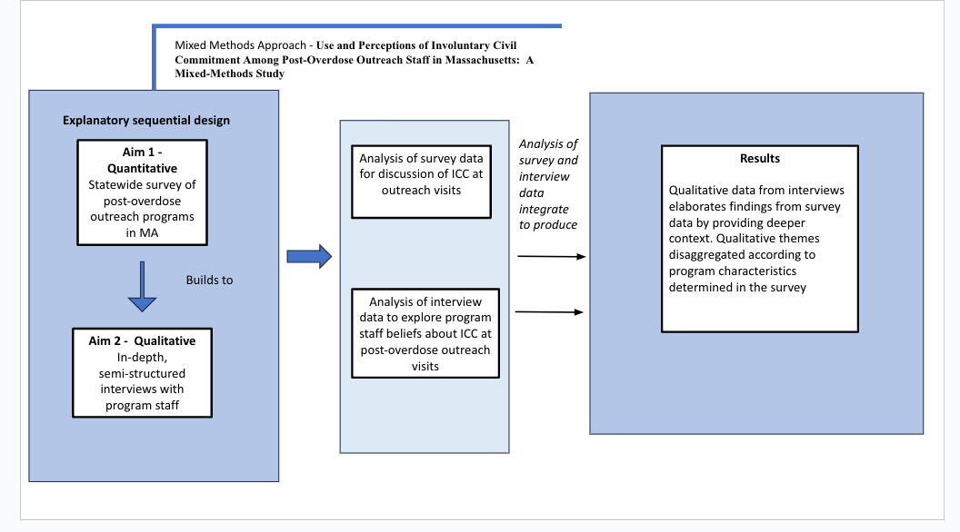

The present study is part of a multi-aim study that used both qualitative and quantitative data. In the first Aim of the study, a state-wide survey was sent to all known post-overdose outreach programs in the state of Massachusetts (see Formica et. al 2021 for a detailed description of Aim 1 methodology). The survey included questions about use of ICC at outreach visits. Following this explanatory-sequential approach, we used the quantitative data to inform our sampling strategies for recruiting in-depth interviews with program staff. We conducted interviews with 38 staff members. The interview guide for semi-structured interviews was developed according to domains asked in the survey (see Formica et al. for survey; interview guides available upon request). The interview guide included questions about program use of ICC, which were developed in part from reviewing survey questions. Survey data was analyzed first and informed qualitative data collection. In the present analysis, coding of our qualitative data was informed by categories in the survey but we also allowed exploratory themes to emerge. This allowed us to use our qualitative data to provide richer detail and context to the survey.

Detailed Quantitative Methodology
To assess the extent to which ICC is part of post-overdose outreach, the primary outcome of interest in this analysis was how frequently ICC was brought up by a team member while on outreach, based on the following survey item: “Please indicate on the scale how frequently Section 35 is brought up by a member of the team during post-overdose outreach (both initial and follow-up)” (sliding scale from “Never – 0” to “Every Time – 100”). To describe how program characteristics differ, we defined “More ICC-focused programs” as those that reported discussing ICC at 50% or more of their outreach encounters and “Less ICC-focused programs” as those that reported discussing ICC less than 50% of the time.
Other ICC-related descriptive variables captured in the survey included: with whom the team will discuss ICC (overdose survivor, family of the survivor, friends of the survivor, and other/blank); how ICC is presented during outreach (as a first step to treatment, as a last resort, and depends on the situation); whether outreach staff will assist families in filing a petition for ICC (yes/no); and whether outreach staff will serve as a primary petitioner for ICC (yes/no). Programs were also asked whether they collaborate with drug courts and/or SUD treatment providers; refer participants to syringe services programs; distribute naloxone; or promote abstinence-based recovery (all yes/no).

Detailed Qualitative Methodology

Participants were recruited for qualitative interviews [by EC] using purposive sampling strategies, which sought to capture the greatest range of professional roles.²³ Survey data guided sampling to ensure representation of different program characteristics, including geographic location of the program, staff role (i.e., public safety professional v. public health representative), and operational structure (law enforcement led v. public health led). Eligible interview participants met the following criteria: at least 18 years of age, currently working in a post-overdose outreach program that responded to the statewide survey, and conducted post-overdose outreach home visits or made phone calls to survivors and/or to survivors’ friends and family in the past 12 months. Participants were contacted directly [by EC] and invited to participate in an interview. All interviews followed a semi-structured interview guide which included the following a priori domains: program history and mission; approach to contacting survivors; approach to conducting a home visit, including follow-ups; storage and protection of identifying information about overdose survivors; and approaches to ICC. Interview Guides are available upon request. Interviews lasted approximately 45 to 60 minutes and were conducted [by EC] in-person prior to March 2020 or via telephone or video call thereafter in accordance with COVID-19 protocols. All interviews were recorded and transcribed for analysis. All participants received a $100 reloadable debit card.
Transcripts were read and free coded [by EC] to identify an initial set of themes and narratives. Several members of the research team [EC, JC, SS] independently reviewed interview transcripts and met to further refine initial themes. A second step of more focused coding was used to elaborate how program staff in different roles approach ICC, how program staff respond to families seeking to petition loved ones, and how the overarching philosophy of a post-overdose outreach program impacts the way that staff view ICC. The themes presented below were generated in this final stage of analysis. To ensure consensus and consistency with the qualitative data, members of the research team meet regularly to engage in a coding consensus process. This allowed us to refine initial ideas and reach agreement on saturation for the themes we present in this analysis.

