Supplemental Online Content
Method used to calculate pregnancy-related mortality ratio denominator (live births)
To generate approximate counts of county-level births, including counties where Centers for Disease Control and Prevention, Wide-ranging Online Data for Epidemiologic Research (CDC WONDER) suppresses data (all sub-national data with fewer than 10 births) from the National Vital Statistics System (NVSS),¹ we used the following method to estimate births per county for each year from 2011 through 2016 and for each included race and ethnicity (Hispanic births and non-Hispanic White, Black or African American, American Indian or Alaska Native, and Asian or Pacific Islander births):
- State fertility rates: we acquired fertility rates (number of births / number women aged 15 to 44 years in specified population) from the NVSS and stratified by year, state, and race/ethnicity. This included all women identified as Hispanic, and all non-Hispanic women in bridged-race categories of White, Black or African American, American Indian or Alaska Native, and Asian or Pacific Islander.
- County population size: we acquired estimates of the number of women aged 15 to 44 years from U.S. Census Bureau population data stratified by year, county, and race and ethnicity. Race and ethnicity groups were the same as those used in acquiring state fertility rates.
- County-level births: for each year and race and ethnicity subgroup, we multiplied state fertility rates by estimated county population counts of women aged 15 to 44 years to calculate county-specific counts of births.
Validating estimated counts
Births by race and ethnicity and year were calculated for each county. We assumed that this method would yield estimated births that were comparable to actual births by county, year (2011-2016), and race and ethnicity (identified as Hispanic births and all non-Hispanic births for bridged-race categories of White, Black or African American, American Indian or Alaska Native, and Asian or Pacific Islander). To validate this assumption, we considered the following 3 questions.

Do estimated county births sum to true births when aggregated to National Center for Health Statistics (NCHS) urban-rural classification scheme?
In Supplemental Figure 1, we compared the sum of county-specific estimated birth counts from 2011-2016 to see how closely they match the counts of “true” births obtained from the NVSS via CDC WONDER (race and ethnicity groups included Hispanic births and births by bridged-race categories of White, Black or African American, American Indian or Alaska Native, and Asian or Pacific Islander), aggregated to the 2013 National Center for Health Statistics-Urban-Rural Classification Scheme.² We log-transformed the axes of Supplemental Figure 1 to permit closer attention to small-count regions. The red diagonal line of equality shows close alignment between estimated births (y-axis) and true births (x-axis) in each urban-rural category, year, and race and ethnicity group. This is evident in large and small count urban-rural categories.

Do estimated county births correlate with true state births?
In Supplemental Figure 2 we compared true state births by race/ethnicity (limited to four largest groups for which data were not suppressed in CDC WONDER: non-Hispanic White, non-Hispanic Black, non-Hispanic Asian or Pacific Islander, and Hispanic) and year (2011-2016) to estimated county births by race and ethnicity groups and years. We log-transformed the axes to allow for closer comparison of low birth counts. The red line of equality shows close alignment between the logs of estimated (y-axis) and true births (x-axis) summed to each state. This is evident in large and small count states.

Is there agreement between true births and estimated births?
One approach to quantifying the agreement between two sets of continuously measured values based on the same unit is the Concordance Correlation Coefficient (CCC).³ The CCC evaluates inter-rate agreement. Values of the CCC range from 0 to 1, with 1 indicating perfect agreement. We estimated the CCC of log-transformed estimated vs. true birth counts for each year (2011-2016) and race and ethnic group (limited to four largest groups for which data were not suppressed via CDC WONDER: non-Hispanic White, non-Hispanic Black, non-Hispanic Asian or Pacific Islander, and Hispanic) and found agreement of at least 0.99 for all categories in each year.

Supplemental References
1. Centers for Disease Control and Prevention. Data use restrictions. Available at: https://wonder.
cdc.gov/datause.html. Accessed April 8, 2020.
2. Ingram DD, Franco SJ. 2013 NCHS urban-rural classification scheme for counties. Vital
Health Stat 2 2014:1–73.
3. Lin LI. A concordance correlation coefficient to evaluate reproducibility. Biometrics 1989;45: 255–68.
SUPPLEMENTAL FIGURE 1
True births compared to estimated births summed to National Center for Health Statistics urban-rural classification (United States, 2011–2016)
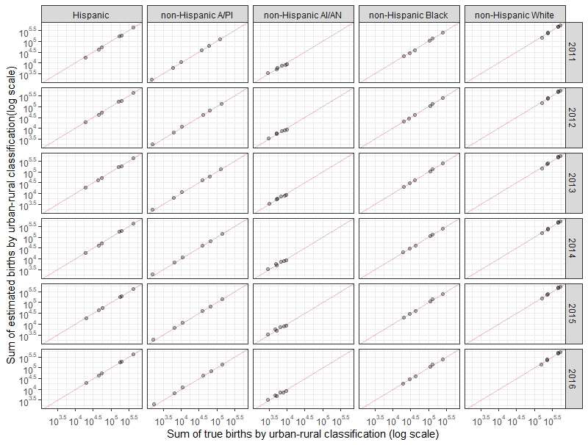
The figure shows a close alignment between estimated births (y-axis) and true births (x-axis) in each urban-rural category, year, and race and ethnicity group.
Merkt et al. Urban-rural differences in pregnancy-related deaths. Am J Obstet Gynecol 2021.
SUPPLEMENTAL FIGURE 2
True births compared to estimated births summed by US state, 2011 to 2016
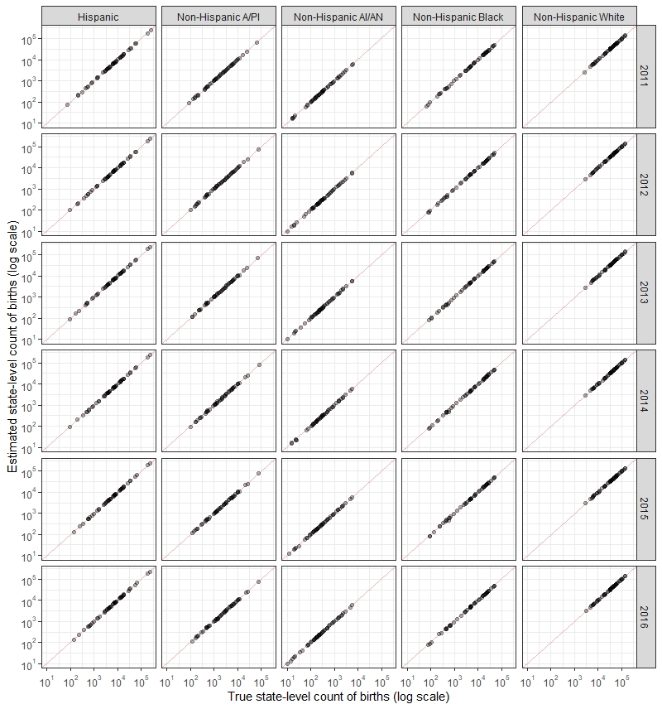
The figure shows a close alignment between the logs of estimated births (y-axis) and true births (x-axis) summed to each state.
Merkt et al. Urban-rural differences in pregnancy-related deaths. Am J Obstet Gynecol 2021.

Supplemental Table 1
Distribution of live births by county urban-rural category and year, United States, 2011–2016
 |  |  |  | n (%)ª
Year | Total |  | Large metro |  | Medium metro | Small metro | Micropolitan | Noncore
2011 | 3,919,509 |  | 2,231,805 (57) |  | 818,038 (21) | 354,626 (9) | 314,104 (8) | 200,936 (5)
2012 | 3,915,553 |  | 2,233,816 (57) |  | 816,336 (21) | 354,394 (9) | 312,245 (8) | 198,762 (5)
2013 | 3,900,280 |  | 2,225,360 (57) |  | 814,339 (21) | 353,155 (9) | 310,120 (8) | 197,306 (5)
2014 | 3,940,369 |  | 2,253,114 (57) |  | 821,926 (21) | 356,534 (9) | 311,171 (8) | 197,624 (5)
2015 | 3,924,710 |  | 2,245,436 (57) |  | 819,577 (21) | 355,066 (9) | 308,983 (8) | 195,648 (5)
2016 | 3,899,799 |  | 2,237,639 (57) |  | 814,786 (21) | 351,427 (9) | 304,001 (8) | 191,946 (5)
Births by year were estimated by multiplying county-level number of women, stratified by race and ethnicity (defined as Hispanic, regardless of race, and non-Hispanic White, Black, American Indian or Alaska Native, or Asian or Pacific Islander) and year, and state fertility rates. The definitions are as follows: large metro, an MSA with a population of at least 1 million; medium metro, an MSA with a population of 250,000 to 999,999; small metro, an MSA with a population of less than 250,000; micropolitan: urban cluster with a population of 10,000 to 49,999; and noncore, nonmetropolitan counties that did not qualify as micropolitan (most rural areas).
MSA, metropolitan statistical area.
ª Percentages may not add to 100 because of rounding.
Merkt et al. Urban-rural differences in pregnancy-related deaths. Am J Obstet Gynecol 2021.

Supplemental Table 2
Distribution of pregnancy-related deaths by county urban-rural category and year, United States, 2011-2016
 |  | n (%)ª
Year | Total | Large metro | Medium metro | Small metro | Micropolitan | Noncore
2011 | 680 | 371 (55) | 125 (18) | 54 (8) | 72 (11) | 58 (9)
2012 | 570 | 280 (49) | 142 (25) | 53 (9) | 56 (10) | 39 (7)
2013 | 643 | 338 (53) | 132 (21) | 58 (9) | 58 (9) | 57 (9)
2014 | 654 | 338 (52) | 142 (22) | 69 (11) | 67 (10) | 38 (6)
2015 | 607 | 317 (52) | 136 (22) | 55 (9) | 63 (10) | 36 (6)
2016 | 593 | 312 (53) | 120 (20) | 55 (9) | 53 (9) | 53 (9)
The definitions are as follows: large metro, an MSA with a population of at least 1 million; medium metro, an MSA with a population of 250,000 to 999,999; small metro, an MSA with a population of less than 250,000; micropolitan, urban cluster with a population of 10,000 to 49,999; and noncore, nonmetropolitan counties that did not qualify as micropolitan (most rural areas).
MSA, metropolitan statistical area.
ª Percentages may not add to 100 because of rounding.
Merkt et al. Urban-rural differences in pregnancy-related deaths. Am J Obstet Gynecol 2021.

Supplemental Table 3
Pregnancy-related mortality ratio by county urban-rural category and year, United States, 2011-2016
 | Pregnancy-related mortality ratioª (95% confidence interval)
Year | Total | Large Metro | Medium Metro | Small Metro | Micropolitan | Noncore
2011 | 17.3 (16.1–18.7) | 16.6 (15.0–18.4) | 15.3 (12.7–18.2) | 15.2 (11.4–19.9) | 22.9 (17.9–28.9) | 28.9 (21.9–37.3)
2012 | 14.6 (13.4–15.8) | 12.5 (11.1–14.1) | 17.4 (14.7–20.5) | 15.0 (11.2–19.6) | 17.9 (13.5–23.3) | 19.6 (14.0–26.8)
2013 | 16.5 (15.2–17.8) | 15.2 (13.6–16.9) | 16.2 (13.6–19.2) | 16.4 (12.5–21.2) | 18.7 (14.2–24.2) | 28.9 (21.9–37.4)
2014 | 16.6 (15.3–17.9) | 15.0 (13.4–16.7) | 17.3 (14.6–20.4) | 19.4 (15.1–24.5) | 21.5 (16.7–27.3) | 19.2 (13.6–26.4)
2015 | 15.5 (14.3–16.7) | 14.1 (12.6–15.8) | 16.6 (13.9–19.6) | 15.5 (11.7–20.2) | 20.4 (15.7–26.1) | 18.4 (12.9–25.5)
2016 | 15.2 (14.0–16.5) | 13.9 (12.4–15.6) | 14.7 (12.2–17.6) | 15.7 (11.8–20.4) | 17.4 (13.1–22.8) | 27.6 (20.7–36.1)
The definitions are as follows: large metro, an MSA with a population of at least 1 million; medium metro, an MSA with a population of 250,000 to 999,999; small metro, an MSA with a population of less than 250,000; micropolitan, urban cluster with a population of 10,000 to 49,999; and noncore, nonmetropolitan counties that did not qualify as micropolitan (most rural areas).
MSA, metropolitan statistical area.
ª Pregnancy-related mortality ratio denominator (births) for year were estimated by multiplying county-level number of women, stratified by race and ethnicity (defined as Hispanic, regardless of race, and non-Hispanic White, Black, American Indian or Alaska Native, or Asian or Pacific Islander) and year, and state fertility rates.
Merkt et al. Urban-rural differences in pregnancy-related deaths. Am J Obstet Gynecol 2021.

Supplemental Table 4
Pregnancy-related mortality ratio by county urban-rural category and sociodemographic characteristics, United States, 2011-2016
 | Pregnancy-related mortality ratioª (95% confidence interval)
Characteristics | Total | Urban | Rural
Overall | 15.9 (15.4–16.5) | 15.1 (14.6–15.7) | 21.4 (19.8–23.1)
Race and ethnicity^{b}
White | 12.0 (11.4–12.6) | 10.8 (10.2–11.4) | 17.5 (15.8–19.3)
Black | 39.5 (37.5–41.7) | 38.1 (36.0–40.1) | 55.4 (47.2–64.6)
American Indian or Alaska Native | 28.8 (22.2–36.7) | 24.1 (16.3–34.1) | 35.0 (24.3–48.9)
Asian or Pacific Islander | 13.1 (11.3–15.0) | 12.5 (10.8–14.4) | 29.9 (16.8–49.4)
Hispanic | 10.4 (9.6–11.3) | 10.3 (9.4–11.2) | 12.7 (9.3–17.0)
Age group (y)
15–19 | 11.0 (9.4–12.8) | 10.4 (8.7–12.4) | 13.5 (9.7–18.3)
20–24 | 11.7 (10.8–12.7) | 11.7 (10.7–12.7) | 12.0 (9.9–14.4)
25–29 | 12.7 (11.9–13.6) | 12.4 (11.6–13.4) | 14.5 (12.2–17.0)
30–34 | 14.4 (13.5–15.4) | 13.9 (12.9–14.9) | 19.2 (16.0–22.8)
35–39 | 27.2 (25.3–29.1) | 24.0 (22.2–25.9) | 61.2 (52.0–71.6)
40–44 | 58.6 (52.9–64.8) | 52.1 (46.5–58.2) | 134.5 (104.8–169.9)
Year
2011 | 17.3 (16.1–18.7) | 16.2 (14.8–17.6) | 25.2 (21.1–30.0)
2012 | 14.6 (13.4–15.8) | 14.0 (12.7–15.3) | 18.6 (15.0–22.7)
2013 | 16.5 (15.2–17.8) | 15.6 (14.3–16.9) | 22.7 (18.7–27.2)
2014 | 16.6 (15.3–17.9) | 16.0 (14.7–17.4) | 20.6 (16.9–25.0)
2015 | 15.5 (14.3–16.7) | 14.9 (13.6–16.2) | 19.6 (15.9–23.9)
2016 | 15.2 (14.0–16.5) | 14.3 (13.1–15.6) | 21.4 (17.5–25.9)
Urban areas include large, medium, and small metropolitan counties. Rural areas include micropolitan and noncore counties. The definitions are as follows: large metro, an MSA with a population of at least 1 million; medium metro, an MSA with a population of 250,000 to 999,999; small metro, an MSA with a population of less than 250,000; micropolitan, urban cluster with a population of 10,000 to 49,999; and noncore, nonmetropolitan counties that did not qualify as micropolitan (most rural areas).
MSA, metropolitan statistical area.
ª Pregnancy-related mortality ratio denominator (births) for year were estimated by multiplying county-level number of women, stratified by race and ethnicity (defined as Hispanic, regardless of race, and non-Hispanic White, Black, American Indian or Alaska Native, or Asian or Pacific Islander) and year, and state fertility rates;
^{b} Women identified as White, Black, American Indian or Alaska Native, or Asian or Pacific Islander were not Hispanic. Hispanic women could be of any race.
Merkt et al. Urban-rural differences in pregnancy-related deaths. Am J Obstet Gynecol 2021.

