Supplementary Table I. Univariate model ORs and 95% CIs for COVID-19 death across all decedents by age, education, occupation, race/ethnicity, sex, and medical conditions associated with higher risk for severe COVID-19
OR
(95%CI)
Age
(in years; Referent: 16–24)
25–34 | 2.388  (2.057–2.773)
35–44 | 5.105  (4.425–5.891)
45–54 | 8.179  (7.104–9.416)
55–65 | 8.642  (7.513–9.942)
Education
(Referent: completed graduate or professional degrees)
Less than high school | 3.474  (3.298–3.659)
Some high school or completed high school | 0.987  (0.943–1.033)
Some college | 1.003  (0.956–1.052)
Completed college | 1.055  (1.002–1.111)
Unknown education | 1.808  (1.634–2.000)
Race and Ethnicity
(Referent: Non–Hispanic White)
Hispanic | 6.289  (6.150–6.432)
Non–Hispanic American Indian Alaskan Native (AIAN) | 3.335  (3.108–3.578)
Non–Hispanic Asian | 3.481  (3.319–3.651)
Non–Hispanic Black | 2.531  (2.471–2.593)
Non–Hispanic Multiple Race | 0.987  (0.860–1.134)
Non–Hispanic Native Hawaiian or Other Pacific Islander (NHOPI) | 3.900  (3.399–4.475)
Unknown Race or Ethnicity | 3.038  (2.400–3.845)
Sex
(Referent: Female)
Male | 1.148  (1.125–1.170)
Medical Conditions
Attention-Deficit/Hyperactivity Disorder (ADHD) | 0.520  (0.164–1.645)
Alcoholic liver disease | 0.156  (0.139–0.174)
Asthma | 2.856  (2.665–3.061)
Bronchiectasis | 1.482  (0.930–2.362)
Cancer | 0.116  (0.110–0.121)
Cardiomyopathies | 0.406  (0.366–0.450)
Cerebral Palsy | 1.379  (0.932–2.042)
Cerebrovascular disease | 0.632  (0.602–0.663)
Chronic kidney disease | 1.221  (1.157–1.287)
Cirrhosis | 0.406  (0.374–0.442)
Chronic obstructive pulmonary disease (COPD) | 0.596  (0.570–0.623)
Coronary artery disease | 0.449  (0.427–0.473)
Cystic fibrosis | 0.088  (0.012–0.618)
Dementia | 1.577  (1.422–1.749)
Depression | 0.375  (0.321–0.438)
Diabetes mellitus, types 1 and 2 | 2.282  (2.230–2.335)
Heart failure | 0.649  (0.619–0.680)
Hepatitis | 0.521  (0.430–0.630)
Human Immunodeficiency Virus (HIV) | 0.906  (0.804–1.020)
Primary immunodeficiencies | 1.581  (1.099–2.275)
Use of immunosuppressive medications | 1.401  (0.909–2.161)
Interstitial lung disease | 1.735  (1.573–1.913)
Obesity | 2.626  (2.548–2.707)
Pulmonary embolism | 1.065  (1.001–1.134)
Pulmonary hypertension | 0.575  (0.500–0.662)
Schizophrenia spectrum disorders | 0.950  (0.781–1.155)
Sickle cell disease | 0.746  (0.524–1.061)
Spinal cord injuries | 0.334  (0.219–0.510)
Substance use disorders | 0.178  (0.171–0.186)
Thalassemia | 1.754  (0.614–5.011)
Tuberculosis | 0.872  (0.566–1.343)

Supplementary Figure 1. Adjusted ORs for COVID-19 death by healthcare occupation with dental assistants as the referent category
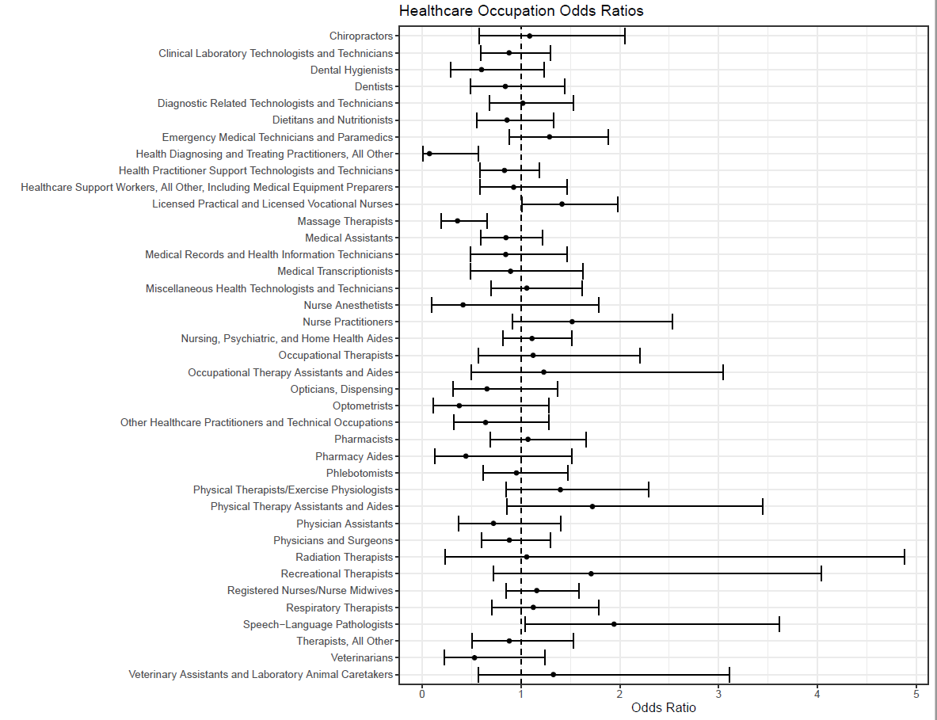
Supplementary Figure 2. Adjusted ORs for COVID-19 death by healthcare occupation with dental hygienists as the referent category

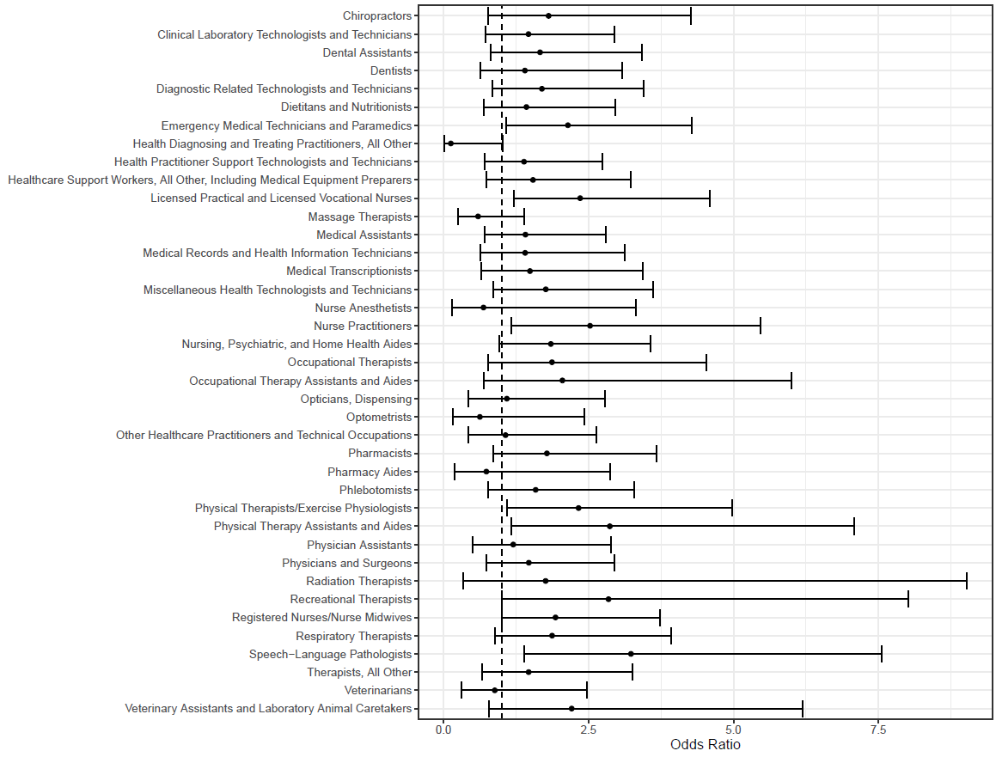
Supplementary Table II. Sensitivity analysis for narrow and broad definitions of COVID-19 death among all healthcare occupations in 2020
Occupation | COVID-19 Underlying Cause of Death, n (%) | COVID-19 Listed Anywhere on Death Certificate, n (%)
Chiropractors (n=207) | 17 (8) | 19 (9)
Clinical laboratory technologists and technicians (n=1,012) | 85 (8) | 92 (9)
Dental assistants (n=754) | 52 (7) | 56 (7)
Dental hygienists (n=307) | 10 (3) | 12 (4)
Dentists (n=317) | 29 (9) | 33 (10)
Diagnostic related technologists and technicians (n=803) | 67 (8) | 73 (9)
Dietitians and nutritionists (n=580) | 49 (8) | 52 (9)
Emergency medical technicians and paramedics (n=1,053) | 102 (10) | 113 (11)
Health diagnosing and treating practitioners, all other (n=110) | 1 (1) | 2 (2)
Health practitioner support technologists and technicians (n=2,033) | 137 (7) | 151 (7)
Healthcare support workers, all other, including medical equipment preparers (n=465) | 43 (9) | 48 (10)
Licensed practical and licensed vocational nurses (n=2,422) | 267 (11) | 290 (12)
Massage therapists (n=504) | 15 (3) | 15 (3)
Medical assistants (n=1,521) | 116 (8) | 130 (9)
Medical records and health information technicians (n=307) | 23 (7) | 24 (8)
Medical transcriptionists (n=306) | 17 (6) | 22 (7)
Miscellaneous health technologists and technicians (n=544) | 60 (11) | 64 (12)
Nurse anesthetists (n=63) | 2 (3) | 2 (3)
Nurse practitioners (n=306) | 34 (11) | 37 (12)
Nursing, psychiatric, and home health aides (n=13,715) | 1,427 (10) | 1,577 (11)
Occupational therapists (n=189) | 13 (7) | 16 (8)
Occupational therapy assistants and aides (n=60) | 7 (12) | 7 (12)
Opticians, dispensing (n=195) | 10 (5) | 11 (6)
Optometrists (n=75) | 3 (4) | 3 (4)
Other healthcare practitioners and technical occupations (n=203) | 12 (6) | 16 (8)
Pharmacists (n=528) | 57 (11) | 61 (12)
Pharmacy aides (n=79) | 3 (4) | 3 (4)
Phlebotomists (n=568) | 49 (9) | 51 (9)
Physical therapists/exercise physiologists (n=303) | 36 (12) | 38 (13)
Physical therapy assistants and aides (n=135) | 13 (10) | 14 (10)
Physician assistants (n=204) | 14 (7) | 14 (7)
Physicians and surgeons (n=1,545) | 154 (10) | 166 (11)
Radiation therapists (n=32) | 2 (6) | 2 (6)
Recreational therapists (n=54) | 9 (17) | 9 (17)
Registered nurses/nurse midwives (n=10,113) | 966 (10) | 1,054 (10)
Respiratory therapists (n=432) | 41 (9) | 43 (10)
Speech-language pathologists (n=200) | 18 (9) | 18 (9)
Therapists, all other (n=346) | 23 (7) | 24 (7)
Veterinarians (n=154) | 7 (5) | 8 (5)
Veterinary assistants and laboratory animal caretakers (n=105) | 8 (8) | 8 (8)
Supplementary Table III. Sensitivity analysis of ORs and 95% CIs for narrow and broad definitions of COVID-19 death between dental occupations and all other occupations in 2020
Occupation  (Referent: all other occupations) | COVID-19 Underlying Cause of Death, OR (95% CI) | COVID-19 Listed Anywhere on Death Certificate, OR (95% CI)
Dental assistants | 0.873 (0.745–1.024) | 0.861 (0.739–1.003)
Dental hygienists | 0.860 (0.683–1.081) | 0.866 (0.697–1.076)
Dentists | 0.997 (0.881–1.128) | 1.048 (0.932–1.177)

Supplementary Table IV. Sensitivity analysis of ORs and 95% CIs for narrow and broad definitions of COVID-19 death between dental occupations and other healthcare occupations
Occupation | COVID-19 Underlying Cause of Death,  OR (95% CI) |  |  | COVID-19 Listed Anywhere on Death Certificate, OR (95% CI)
Occupation | Referent: Dentist | Referent: Dental Assistant | Referent: Dental Hygienist | Referent: Dentist | Referent: Dental Assistant | Referent: Dental Hygienist
Chiropractors | 1.292  (0.660–2.529) | 1.088  (0.577–2.053) | 1.811  (0.768–4.272) | 1.221  (0.647–2.304) | 1.144  (0.626–2.093) | 1.700  (0.766–3.772)
Clinical laboratory technologists and technicians | 1.045  (0.635–1.718) | 0.880  (0.597–1.297) | 1.464  (0.729–2.941) | 0.966  (0.603–1.547) | 0.905  (0.624–1.314) | 1.345  (0.708–2.554)
Dental assistants | 1.187  (0.695–2.029) | – | 1.664  (0.809–3.421) | 1.067  (0.642–1.775) | – | 1.486  (0.764–2.888)
Dental hygienists | 0.713  (0.324–1.570) | 0.601  (0.292–1.235) | – | 0.718  (0.347–1.488) | 0.673  (0.346–1.309) | –
Dentists | – | 0.842  (0.493–1.440) | 1.402  (0.637–3.085) | – | 0.937  (0.563–1.558) | 1.392  (0.672–2.884)
Diagnostic related technologists and technicians | 1.210  (0.724–2.021) | 1.019  (0.678–1.533) | 1.696  (0.835–3.443) | 1.121  (0.690–1.823) | 1.051  (0.710–1.554) | 1.561  (0.813–2.996)
Dietitians and nutritionists | 1.020  (0.595–1.748) | 0.859  (0.555–1.329) | 1.429  (0.692–2.954) | 0.899  (0.539–1.502) | 0.843  (0.553–1.284) | 1.252  (0.640–2.450)
Emergency medical technicians and paramedics | 1.530  (0.936–2.500) | 1.289  (0.882–1.883) | 2.144  (1.073–4.287) | 1.420  (0.893–2.259) | 1.331  (0.926–1.914) | 1.977  (1.047–3.736)
Health diagnosing and treating practitioners, all other | 0.089  (0.012–0.685) | 0.075  (0.010–0.567) | 0.125  (0.015–1.024) | 0.158  (0.036–0.699) | 0.148  (0.034–0.643) | 0.220  (0.046–1.045)
Health practitioner support technologists and technicians | 0.989  (0.615–1.593) | 0.833  (0.584–1.189) | 1.387  (0.703–2.738) | 0.911  (0.581–1.430) | 0.854  (0.608–1.200) | 1.269  (0.680–2.368)
Healthcare support workers, all other, including medical equipment preparers | 1.100  (0.630–1.919) | 0.926  (0.586–1.464) | 1.542  (0.736–3.228) | 1.044  (0.616–1.768) | 0.978  (0.632–1.513) | 1.453  (0.735–2.873)
Licensed practical and licensed vocational nurses | 1.680  (1.058–2.668) | 1.415  (1.013–1.977) | 2.355  (1.207–4.596) | 1.561  (1.008–2.416) | 1.463  (1.061–2.016) | 2.173  (1.177–4.009)
Massage therapists | 0.425  (0.213–0.846) | 0.358  (0.194–0.660) | 0.595  (0.256–1.384) | 0.351  (0.179–0.688) | 0.329  (0.180–0.603) | 0.489  (0.220–1.088)
Medical assistants | 1.007  (0.620–1.637) | 0.848  (0.590–1.221) | 1.412  (0.711–2.801) | 0.957  (0.605–1.515) | 0.897  (0.633–1.270) | 1.332  (0.711–2.498)
Medical records and health information technicians | 1.004  (0.533–1.892) | 0.846  (0.489) | 1.407  (0.633–3.126) | 0.881  (0.480–1.617) | 0.825  (0.485–1.405) | 1.226  (0.582–2.584)
Medical transcriptionists | 1.063  (0.539–2.098) | 0.895  (0.491–1.631) | 1.490  (0.647–3.430) | 1.191  (0.640–2.216) | 1.116  (0.647–1.925) | 1.658  (0.779–3.526)
Miscellaneous health technologists and technicians | 1.257  (0.744–2.126) | 1.059  (0.694–1.616) | 1.763  (0.860–3.612) | 1.125  (0.683–1.854) | 1.055  (0.702–1.584) | 1.567  (0.808–3.039)
Nurse anesthetists | 0.491  (0.111–2.168) | 0.414  (0.096–1.787) | 0.688  (0.143–3.319) | 0.411  (0.094–1.800) | 0.385  (0.090–1.657) | 0.572  (0.122–2.693)
Nurse practitioners | 1.802  (1.019–3.187) | 1.518  (0.910–2.533) | 2.526  (1.167–5.467) | 1.697  (0.988–2.916) | 1.590  (0.973–2.598) | 2.362  (1.155–4.832)
Nursing, psychiatric, and home health aides | 1.320  (0.844–2.065) | 1.112  (0.815–1.517) | 1.850  (0.958–3.575) | 1.232  (0.807–1.879) | 1.154  (0.857–1.555) | 1.715  (0.939–3.132)
Occupational therapists | 1.333  (0.640–2.778) | 1.123  (0.573–2.201) | 1.869  (0.770–4.534) | 1.417  (0.721–2.788) | 1.328  (0.715–2.468) | 1.973  (0.879–4.430)
Occupational therapy assistants and aides | 1.462  (0.560–3.818) | 1.231  (0.498–3.046) | 2.049  (0.699–6.005) | 1.222  (0.475–3.143) | 1.145  (0.467–2.809) | 1.701  (0.602–4.805)
Opticians, dispensing | 0.778  (0.350–1.731) | 0.656  (0.314–1.367) | 1.091  (0.428–2.781) | 0.710  (0.332–1.519) | 0.666  (0.330–1.343) | 0.989  (0.412–2.373)
Optometrists | 0.447  (0.127–1.569) | 0.376  (0.110–1.284) | 0.626  (0.161–2.433) | 0.382  (0.110–1.326) | 0.358  (0.106–1.213) | 0.532  (0.141–2.005)
Other healthcare practitioners and technical occupations | 0.762  (0.360–1.613) | 0.642  (0.320–1.284) | 1.068  (0.432–2.636) | 0.873  (0.444–1.716) | 0.818  (0.439–1.525) | 1.215  (0.539–2.739)
Pharmacists | 1.271  (0.761–2.123) | 1.071  (0.692–1.658) | 1.782  (0.864–3.678) | 1.165  (0.716–1.896) | 1.092  (0.717–1.663) | 1.622  (0.831–3.167)
Pharmacy aides | 0.526  (0.147–1.878) | 0.443  (0.129–1.518) | 0.738  (0.189–2.878) | 0.419  (0.119–1.471) | 0.392  (0.116–1.330) | 0.583  (0.154–2.201)
Phlebotomists | 1.133  (0.659–1.949) | 0.954  (0.616–1.478) | 1.588  (0.768–3.284) | 0.980  (0.584–1.646) | 0.919  (0.601–1.404) | 1.365  (0.696–2.676)
Physical therapists/exercise physiologists | 1.661  (0.936–2.947) | 1.399  (0.853–2.294) | 2.328  (1.088–4.982) | 1.490  (0.862–2.576) | 1.397  (0.866–2.251) | 2.075  (1.024–4.205)
Physical therapy assistants and aides | 2.045  (0.955–4.381) | 1.723  (0.861–3.447) | 2.867  (1.162–7.076) | 1.818  (0.879–3.761) | 1.703  (0.875–3.315) | 2.531  (1.086–5.896)
Physician assistants | 0.857  (0.417–1.759) | 0.722  (0.372–1.399) | 1.201  (0.498–2.893) | 0.727  (0.361–1.467) | 0.682  (0.355–1.308) | 1.013  (0.439–2.333)
Physicians and surgeons | 1.049  (0.668–1.646) | 0.883  (0.602–1.296) | 1.470  (0.734–2.943) | 0.975  (0.637–1.493) | 0.914  (0.633–1.321) | 1.358  (0.717–2.571)
Radiation therapists | 1.256  (0.265–5.947) | 1.058  (0.229–4.880) | 1.760  (0.343–9.022) | 1.019  (0.218–4.762) | 0.955  (0.209–4.362) | 1.418  (0.285–7.066)
Recreational therapists | 2.030  (0.814–5.062) | 1.710  (0.723–4.042) | 2.845  (1.010–8.018) | 1.715  (0.699–4.205) | 1.607  (0.687–3.761) | 2.387  (0.881–6.468)
Registered nurses/nurse midwives | 1.377  (0.884–2.144) | 1.160  (0.846–1.589) | 1.930  (0.999–3.727) | 1.279  (0.842–1.942) | 1.198  (0.885–1.621) | 1.780  (0.975–3.250)
Respiratory therapists | 1.335  (0.767–2.324) | 1.125  (0.709–1.784) | 1.871  (0.893–3.921) | 1.173  (0.691–1.992) | 1.099  (0.703–1.718) | 1.633  (0.822–3.243)
Speech-language pathologists | 2.306  (1.178–4.513) | 1.942  (1.044–3.614) | 3.232  (1.384–7.548) | 1.868  (0.974–3.583) | 1.751  (0.952–3.218) | 2.601  (1.168–5.792)
Therapists, all other | 1.046  (0.565–1.939) | 0.882  (0.507–1.532) | 1.467  (0.659–3.264) | 0.903  (0.500–1.633) | 0.847  (0.495–1.447) | 1.258  (0.595–2.656)
Veterinarians | 0.630  (0.259–1.533) | 0.530  (0.226–1.246) | 0.883  (0.315–2.476) | 0.611  (0.265–1.409) | 0.573  (0.256–1.280) | 0.851  (0.327–2.218)
Veterinary assistants and laboratory animal caretakers | 1.576  (0.635–3.913) | 1.328  (0.566–3.111) | 2.209  (0.788–6.193) | 1.281  (0.526–3.121) | 1.201  (0.519–2.780) | 1.784  (0.663–4.798)

