Supplementary Materials

Associations of serum persistent organic pollutant concentrations with incident diabetes in midlife women: the Study of Women’s Health Across the Nation Multi-Pollutant Study

Amelia Grant-Alfieri¹, William H. Herman^{2,3}, Deborah J. Watkins¹, Stuart Batterman¹, Carrie Karvonen-Gutierrez², Sung Kyun Park^{1,2}

¹ Department of Environmental Health Sciences, University of Michigan School of Public Health, Ann Arbor, Michigan, USA
² Department of Epidemiology, University of Michigan School of Public Health, Ann Arbor, Michigan, USA
³ Department of Internal Medicine, Division of Metabolism, Endocrinology, and Diabetes, University of Michigan Medical School, Ann Arbor, Michigan, USA

Methods

1. Incident diabetes ascertainment
At each SWAN visit, incident diabetes was defined by the participant meeting one or more of the following criteria: (1) use of an anti-diabetic medication at any visit; (2) fasting glucose ≥7 mmol/l at two consecutive visits while not on corticosteroids including glucocorticoids; and (3) any two visits with self-reported diabetes and at least one visit with fasting glucose ≥7 mmol/l. Among women who used anti-diabetic medication, the visit of diabetes incidence was defined as (i) the first visit at which medication use was reported or (ii) the first visit prior to medication commencement at which serum glucose was ≥7 mmol/L or diabetes diagnosis was self-reported. Among women who did not use anti-diabetic medication, the visit of diabetes incidence was defined as the first visit at which serum glucose was ≥7 mmol/L while not on corticosteroids.

2. Inverse probability weighting
Bias may have occurred if exposure to POPs, diabetes risk factors, or potential confounders influenced the selection of participants into SWAN MPS either through (i) loss to follow up from the initial SWAN visit (1996/97) to the third SWAN visit (1999/2000) or (ii) selection into the MPS from the larger SWAN study population. POPs were measured in serum samples collected in 1999/2000 from a subsample of 1,400 SWAN participants designated the MPS. Therefore, we were unable to determine whether women who were censored between 1996/7 and 1999/2000 or who did not participate in MPS were more highly exposed to POPs or at greater risk of developing diabetes later. Participants in SWAN MPS may have been different from the source population. To reduce these two types of bias, we used inverse probability weighting (IPW).
IPW created a pseudo population representing participants at risk of diabetes at the time of POP measurement (1999/2000) in the original SWAN population; data from original SWAN participants was used to weight observations from MPS participants. The probability of continuation in SWAN from 1996/97 to 1999/2000 (P₁) was modeled separately from the probability of selection into MPS (P₂). P₁ was estimated using a logistic regression model adjusted for age, study site, race/ethnicity, education, smoking status, body mass index, waist circumference, diabetes medication use, overall health, and stroke. The reciprocal of this cumulative probability (W₁) was the weight of remaining a participant free of diabetes in 1999/2000. W₁ was then stabilized to minimize the variance, producing SW₁. P₂ was estimated using a logistic regression model adjusted for age, study site, race/ethnicity, education, smoking status, metabolic syndrome, and diastolic blood pressure. The reciprocal of this probability (W₂) was the weight of being selected into MPS in 1999/2000. W₂ was then stabilized to minimize the variance, producing SW₂. Finally, we calculated the joint IPW, SW_{MPS} = SW₁ * SW₂, as the inverse of the probability of participation in the SWAN MPS.

Table A.1: Detection frequencies (DF) of PCBs, PBDEs, and OCPs in SWAN MPS at baseline (1999/2000).

PCB |  | DF (%) |  | OCP | DF (%)
Tetra | 77 | 5.28 |  | p,p’-DDD | 38.94
Tetra | 78 | 0.00 |  | p,p’-DDT | 39.61
Tetra | 79 | 2.01 |  | o,p’-DDT | 16.50
Tetra | 81 | 0.00 |  | p,p’-DDE | 38.78
Tetra | 114 | 9.61 |  | aldrin | 0.25
Penta | 105 | 99.26 |  | dieldrin | 2.09
Penta | 87/110/111 | 0.00 |  | endrin | 2.60
Penta | 118 | 95.35 |  | cis-chlordane | 78.39
Penta | 123 | 91.66 |  | trans-chlordane | 96.06
Penta | 126 | 12.57 |  | heptachlor | 6.37
Hexa | 138 | 100.00 |  | cis-nonachlor | 3.27
Hexa | 149 | 59.66 |  | trans-nonachlor | 72.03
Hexa | 153 | 100.00 |  | mirex | 16.83
Hexa | 156 | 97.25 |  | oxychlordane | 9.72
Hexa | 157 | 85.74 |  | c/t-heptachlorepoxide | 13.32
Hexa | 162 | 0.53 |  | α-HCH | 5.53
Hexa | 167 | 98.84 |  | β-HCH | 22.36
Hexa | 169 | 0.42 |  | γ-HCH | 9.55
Hepta | 170 | 99.68 |  | HCB | 97.15
Hepta | 174 | 98.52
Hepta | 178 | 82.15 |  | PBDE | DF (%)
Hepta | 180 | 94.93 |  | 17 | 5.73
Hepta | 187 | 99.79 |  | 28 | 4.23
Hepta | 188 | 0.00 |  | 47 | 72.84
Hepta | 189 | 0.11 |  | 66 | 0.28
Octa | 194 | 71.81 |  | 71 | 0.00
Octa | 195 | 6.55 |  | 85 | 1.60
Octa | 199 | 61.25 |  | 99 | 20.39
Octa | 202 | 64.84 |  | 100 | 12.69
Octa | 203 | 0.00 |  | 138 | 0.85
Octa | 205 | 0.00 |  | 153 | 15.13
Nona | 206 | 11.93 |  | 154 | 21.15
Nona | 208 | 32.00 |  | 183 | 1.13
Deca | 209 | 20.59 |  | 190 | 2.35
 |  |  |  | 209 | 0.94

Table A.2 Hazard Ratio (95% CI) of incident diabetes associated with serum POP concentrations, 1999-2016. Model is unadjusted. Second and third tertiles of serum POP concentrations were analyzed relative to the first tertile.

Compound | Continuous  (per doubling) | p | Tertile 2 | Tertile 3 | p for trend
OCPs (n = 1040)
cis-chlordane | 1.00 (0.85, 1.18) | 0.9958 | 0.81 (0.50, 1.29) | 0.82 (0.51, 1.31) | 0.3964
HCB | 1.00 (0.78, 1.28) | 0.9948 | 1.44 (0.89, 2.32) | 1.13 (0.69, 1.87) | 0.6405
trans-chlordane | 1.00 (0.87, 1.16) | 0.9460 | 1.29 (0.80, 2.07) | 1.13 (0.69, 1.84) | 0.6372
trans-nonachlor | 1.08 (0.89, 1.31) | 0.4384 | 1.04 (0.64, 1.70) | 1.20 (0.75, 1.93) | 0.4470
PBDEs (n = 943)
PBDE 47 | 1.08 (0.97, 1.21) | 0.1445 | 1.00 (0.60, 1.68) | 1.24 (0.76, 2.04) | 0.3816
PCBs (n = 838)
PCB 105 | 0.98 (0.86, 1.12) | 0.7568 | 0.96 (0.58, 1.59) | 0.75 (0.44, 1.28) | 0.2959
PCB 118 | 0.91 (0.77, 1.07) | 0.2510 | 0.89 (0.53, 1.47) | 0.78 (0.46, 1.32) | 0.3549
PCB 123 | 1.08 (0.94, 1.24) | 0.2578 | 1.87 (1.09, 3.19) | 1.36 (0.77, 2.41) | 0.3120
PCB 138 | 0.94 (0.82, 1.09) | 0.4152 | 0.82 (0.50, 1.36) | 0.68 (0.40, 1.15) | 0.1495
PCB 153 | 0.90 (0.73, 1.10) | 0.3103 | 0.99 (0.60, 1.63) | 0.71 (0.41, 1.21) | 0.2172
PCB 156 | 0.82 (0.69, 0.99) | 0.0380 | 0.71 (0.43, 1.18) | 0.65 (0.39, 1.09) | 0.0961
PCB 157 | 0.88 (0.72, 1.07) | 0.2042 | 0.75 (0.45, 1.24) | 0.69 (0.41, 1.15) | 0.1464
PCB 167 | 0.87 (0.71, 1.06) | 0.1684 | 0.85 (0.51, 1.42) | 0.76 (0.45, 1.28) | 0.3007
PCB 170 | 0.91 (0.75, 1.12) | 0.3805 | 0.98 (0.59, 1.61) | 0.72 (0.42, 1.24) | 0.2476
PCB 174 | 0.90 (0.75, 1.09) | 0.3009 | 1.02 (0.62, 1.67) | 0.72 (0.42, 1.24) | 0.2500
PCB 178 | 0.89 (0.70, 1.12) | 0.3080 | 1.09 (0.66, 1.81) | 0.79 (0.46, 1.35) | 0.3974
PCB 180 | 0.97 (0.84, 1.13) | 0.7174 | 0.73 (0.44, 1.23) | 0.72 (0.43, 1.20) | 0.1947
PCB 187 | 0.94 (0.76, 1.16) | 0.5592 | 1.00 (0.60, 1.67) | 0.81 (0.48, 1.37) | 0.4365
PCB 194 | 0.88 (0.68, 1.14) | 0.3419 | 0.73 (0.43, 1.22) | 0.82 (0.49, 1.35) | 0.4074

Table A.3 Hazard Ratio (95% CI) of incident diabetes associated with serum POP concentrations, 1999-2016. Model adjusted for age at baseline, race/ethnicity, site, education, financial strain, and joint stabilized inverse probability weights. Second and third tertiles of serum POP concentrations were analyzed relative to the first tertile.

Compound | Continuous  (per doubling) | p | Tertile 2 | Tertile 3 | p for trend
OCPs (n = 1040)
cis-chlordane | 1.01 (0.84, 1.21) | 0.9371 | 0.84 (0.51, 1.38) | 0.84 (0.52, 1.36) | 0.4708
HCB | 1.00 (0.79, 1.27) | 0.9935 | 1.55 (0.95, 2.52) | 1.28 (0.76, 2.14) | 0.3331
trans-chlordane | 1.01 (0.88, 1.17) | 0.8510 | 1.30 (0.79, 2.14) | 1.20 (0.71, 2.01) | 0.4970
trans-nonachlor | 1.02 (0.84, 1.24) | 0.8625 | 0.99 (0.60, 1.64) | 1.05 (0.64, 1.72) | 0.8595
PBDEs (n = 943)
PBDE 47 | 1.08 (0.97, 1.21) | 0.1750 | 0.89 (0.52, 1.53) | 1.20 (0.71, 2.04) | 0.4886
PCBs (n = 838)
PCB 105 | 0.96 (0.84, 1.09) | 0.4944 | 1.02 (0.60, 1.75) | 0.74 (0.43, 1.29) | 0.2875
PCB 118 | 0.92 (0.78, 1.08) | 0.3192 | 0.95 (0.56, 1.62) | 0.79 (0.46, 1.36) | 0.4022
PCB 123 | 1.06 (0.93, 1.20) | 0.3771 | 1.80 (1.04, 3.11) | 1.36 (0.77, 2.42) | 0.3066
PCB 138 | 0.95 (0.82, 1.09) | 0.4300 | 0.84 (0.49, 1.44) | 0.67 (0.39, 1.15) | 0.1497
PCB 153 | 0.88 (0.72, 1.08) | 0.2255 | 1.02 (0.60, 1.74) | 0.68 (0.39, 1.18) | 0.1655
PCB 156 | 0.84 (0.68, 1.02) | 0.0783 | 0.83 (0.48, 1.43) | 0.65 (0.38, 1.12) | 0.1177
PCB 157 | 0.89 (0.72, 1.09) | 0.2653 | 0.72 (0.42, 1.24) | 0.72 (0.41, 1.24) | 0.2317
PCB 167 | 0.87 (0.69, 1.09) | 0.2132 | 0.80 (0.47, 1.35) | 0.79 (0.46, 1.35) | 0.3831
PCB 170 | 0.90 (0.75, 1.07) | 0.2355 | 0.84 (0.49, 1.44) | 0.69 (0.41, 1.19) | 0.1801
PCB 174 | 0.90 (0.74, 1.08) | 0.2565 | 0.99 (0.59, 1.67) | 0.72 (0.41, 1.26) | 0.2426
PCB 178 | 0.86 (0.68, 1.08) | 0.1929 | 0.95 (0.55, 1.64) | 0.73 (0.42, 1.26) | 0.2525
PCB 180 | 0.98 (0.85, 1.13) | 0.7416 | 0.63 (0.36, 1.10) | 0.71 (0.42, 1.18) | 0.1832
PCB 187 | 0.92 (0.75, 1.13) | 0.4268 | 0.96 (0.56, 1.66) | 0.77 (0.45, 1.32) | 0.3462
PCB 194 | 0.86 (0.64, 1.14) | 0.2868 | 0.69 (0.39, 1.21) | 0.81 (0.49, 1.34) | 0.4019

Table A.4 Hazard Ratio (95% CI) of incident diabetes associated with serum POP concentrations, 1999-2016. Model adjusted for age at baseline, race/ethnicity, site, education, financial strain, serum lipids, and joint stabilized inverse probability weights. Second and third tertiles of serum POP concentrations were analyzed relative to the first tertile.

Compound | Continuous  (per doubling) | p | Tertile 2 | Tertile 3 | p for trend
OCPs (n = 1040)
cis-chlordane | 1.04 (0.87, 1.24) | 0.7039 | 0.87 (0.53, 1.45) | 0.90 (0.55, 1.48) | 0.6715
HCB | 1.05 (0.82, 1.35) | 0.6880 | 1.66 (1.00, 2.75) | 1.40 (0.82, 2.40) | 0.1987
trans-chlordane | 1.03 (0.89, 1.20) | 0.6936 | 1.37 (0.82, 2.31) | 1.28 (0.75, 2.20) | 0.3658
trans-nonachlor | 1.03 (0.84, 1.25) | 0.8055 | 0.95 (0.58, 1.58) | 1.04 (0.63, 1.72) | 0.8674
PBDEs (n = 943)
PBDE 47 | 1.10 (0.98, 1.23) | 0.1086 | 0.93 (0.53, 1.63) | 1.28 (0.74, 2.23) | 0.3687
PCBs (n = 838)
PCB 105 | 0.97 (0.85, 1.10) | 0.5939 | 1.05 (0.61, 1.80) | 0.79 (0.45, 1.38) | 0.4070
PCB 118 | 0.94 (0.79, 1.11) | 0.4372 | 0.98 (0.57, 1.67) | 0.86 (0.49, 1.49) | 0.5850
PCB 123 | 1.07 (0.94, 1.22) | 0.2863 | 1.76 (1.01, 3.06) | 1.40 (0.79, 2.49) | 0.2529
PCB 138 | 0.95 (0.83, 1.10) | 0.5060 | 0.86 (0.50, 1.47) | 0.71 (0.41, 1.23) | 0.2246
PCB 153 | 0.90 (0.73, 1.11) | 0.3275 | 1.04 (0.61, 1.77) | 0.72 (0.41, 1.27) | 0.2660
PCB 156 | 0.86 (0.70, 1.05) | 0.1382 | 0.86 (0.50, 1.49) | 0.68 (0.39, 1.19) | 0.1732
PCB 157 | 0.91 (0.73, 1.12) | 0.3634 | 0.74 (0.43, 1.27) | 0.76 (0.43, 1.33) | 0.3236
PCB 167 | 0.88 (0.70, 1.12) | 0.3001 | 0.81 (0.48, 1.37) | 0.85 (0.49, 1.47) | 0.5382
PCB 170 | 0.91 (0.76, 1.10) | 0.3205 | 0.86 (0.50, 1.47) | 0.73 (0.42, 1.26) | 0.2588
PCB 174 | 0.92 (0.76, 1.11) | 0.3682 | 1.01 (0.60, 1.72) | 0.77 (0.43, 1.37) | 0.3766
PCB 178 | 0.88 (0.69, 1.12) | 0.2966 | 0.98 (0.57, 1.69) | 0.78 (0.44, 1.36) | 0.3787
PCB 180 | 0.98 (0.85, 1.14) | 0.8182 | 0.64 (0.37, 1.13) | 0.75 (0.45, 1.26) | 0.2716
PCB 187 | 0.94 (0.76, 1.16) | 0.5850 | 0.98 (0.57, 1.69) | 0.83 (0.48, 1.44) | 0.5087
PCB 194 | 0.88 (0.66, 1.17) | 0.3820 | 0.71 (0.40, 1.25) | 0.84 (0.50, 1.40) | 0.4918

Table A.5. Hazard Ratio (95% CI) of incident diabetes associated with the detection of DDT metabolites, 1999-2016. Model adjusted for age at baseline, race/ethnicity, site, education, financial strain, alcohol, smoking, parity, physical activity, high fat dairy intake, meat intake, and fish/shellfish intake, serum lipids at baseline, and joint stabilized inverse probability weights. (n = 1040)

Metabolite | HR (95% CI) | p
p,p’-DDD | 0.95 (0.62, 1.44) | 0.7964
p,p’-DDE | 1.05 (0.69, 1.60) | 0.8146
p,p’-DDT | 1.14 (0.75, 1.73) | 0.5403

Figure A.1 Design of the Study of Women’s Health Across the Nation Multi-Pollutant Study (SWAN MPS) and study sample.

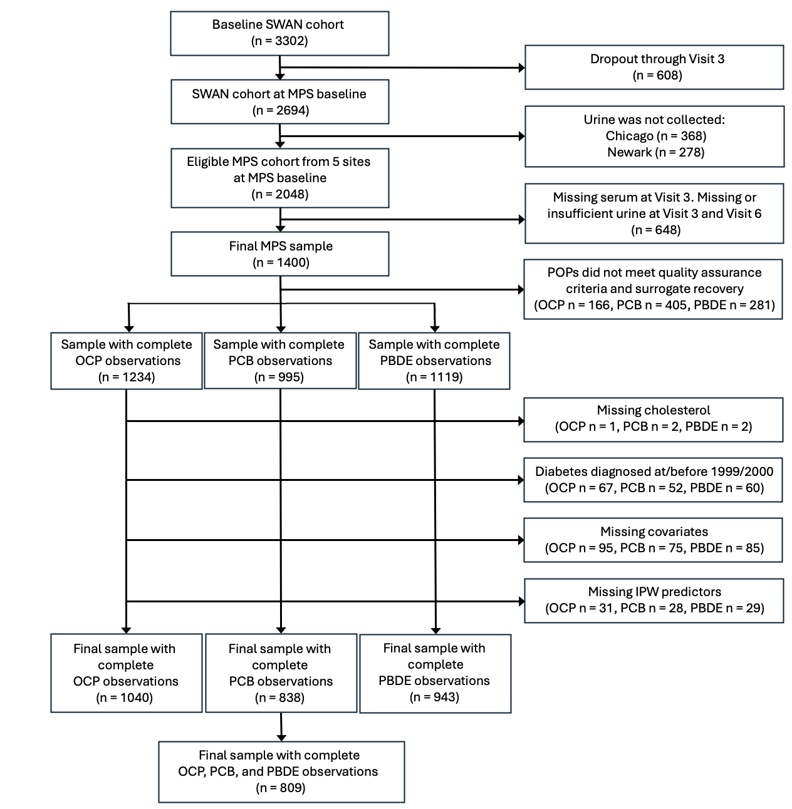

Figure A.2. Correlation heatmap of serum POP concentrations in SWAN MPS at baseline, 1999/2000 (n = 809).

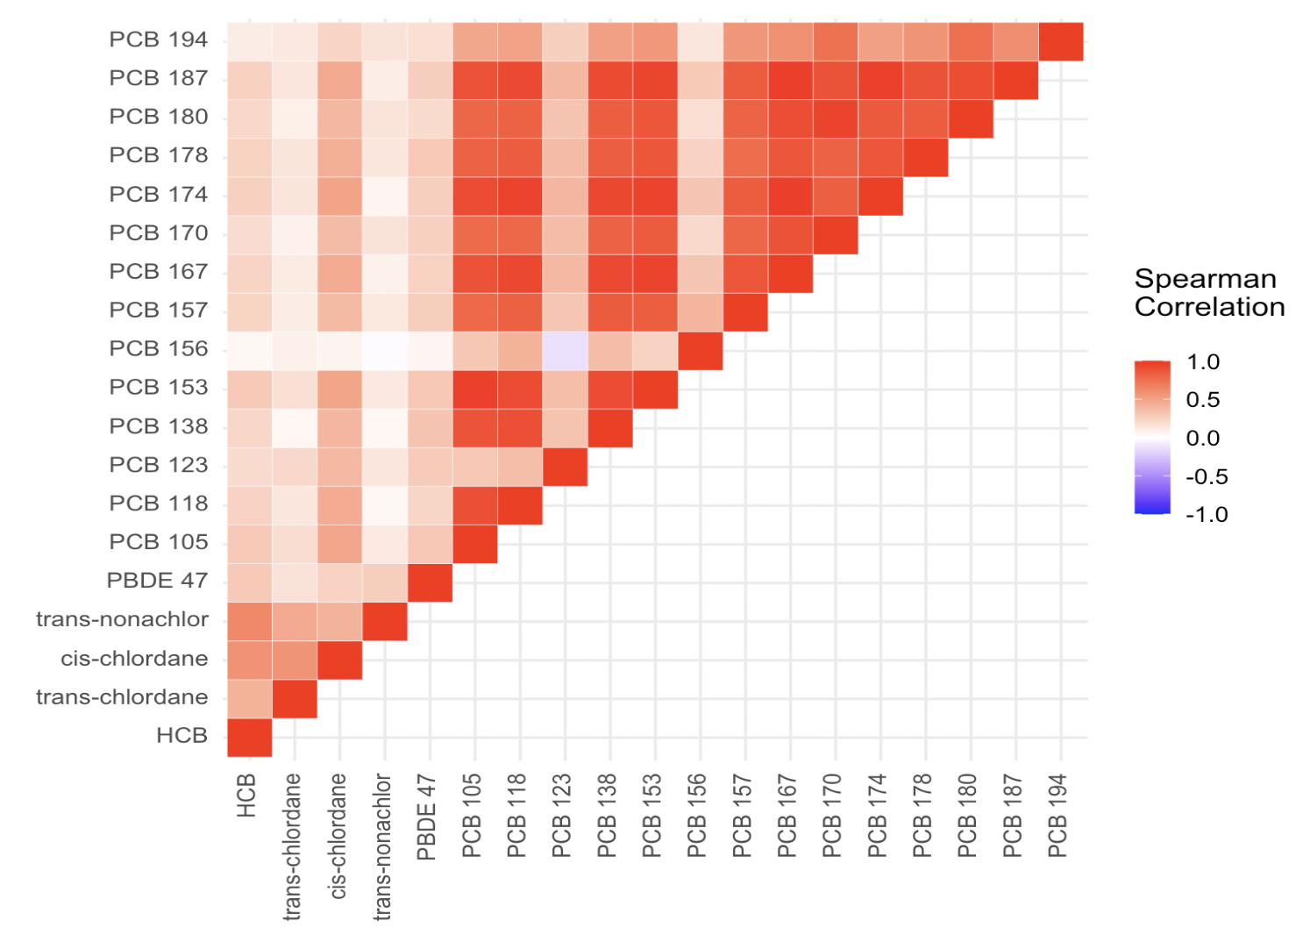

Figure A.3. Individual Contributions of POP Mixture Components to Overall Joint Effect on Diabetes Risk in SWAN MPS (n = 809). Model adjusted for age at baseline, race/ethnicity, site, education, financial strain, alcohol, smoking, parity, physical activity, high fat dairy intake, meat intake, and fish/shellfish intake, serum lipids at baseline, and joint stabilized inverse probability weights.

