Supplementary materials

Study survey

COVID-19 Infection and Vaccination History
We are going to ask you two initial questions. Depending on your answers to these questions we may ask you additional questions to collect more information from you. We will also ask you about your general health today in the last part of the survey.

1. Outside of COVID-19 antibody testing of your blood donation(s), have you ever had a positive COVID-19 result based on a swab test (a sample was collected from your inside your nose or throat), a saliva (spit) sample, or been diagnosed by a physician as having COVID-19?
- Yes
- No

2. Have you received a COVID-19 vaccine? This is also known as a SARS-CoV-2 vaccine.
- Yes
- No

Number of Positive Tests
Since you indicated you have had a positive test or physician diagnosis for COVID-19, we are going to ask you more questions about COVID-19 testing and symptoms you may have had.

How many positive COVID-19 tests or physician diagnoses have you had?
- 1
- 2
- 3
- 4
- 5 or more

Positive Test 1
The questions below are in regard to your FIRST (or only) positive COVID-19 test or physician diagnosis.

When did you have your first positive COVID-19 test or physician diagnosis?
( ) Month ( ) Day ( ) Year

Which type of COVID-19 test did you have?
- Virus Test. If you have a laboratory report it may call this test a Nucleic Acid Amplification Test (NAAT) or a Polymerase Chain Reaction (PCR) Test.
- Antigen Test
- Antibody Test. Please don’t include testing done from your blood donation(s) when answering.
- Diagnosed by physician
- Unsure

Do you know if this was a rapid test where results were available to you within 20 minutes?
- Yes
- No
- Unsure

Did you have any symptoms around the time of this positive COVID-19 test or physician diagnosis?
- Yes
- No
- Unsure

Select the symptoms that you had around the time of your FIRST (or only) positive COVID-19 test. Please do not include possible reactions following vaccination when answering these questions.

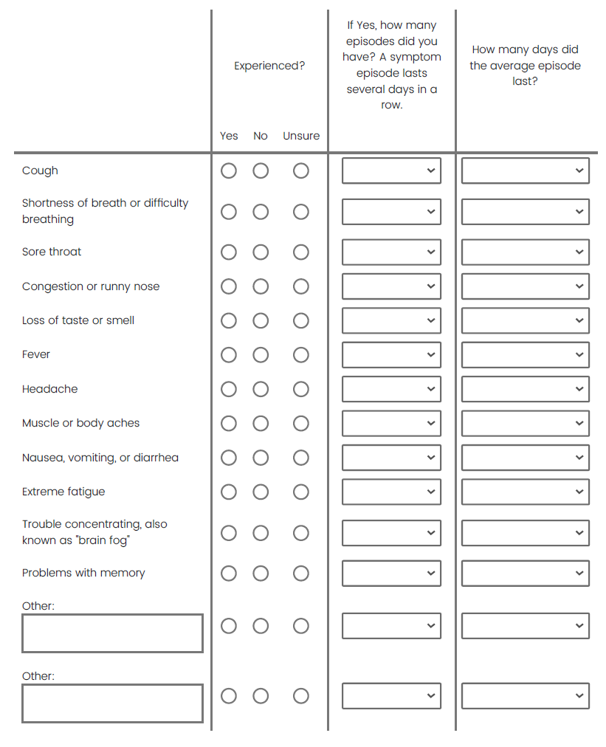

Did you seek healthcare at any of these because of your illness?
- Hospital/ER
- Urgent care
- Physician's office or clinic
- Telehealth
- Other:
- Did not seek healthcare

Were you hospitalized because of this illness?
- Yes
- No

Positive Test 2, 3, 4, and 5
The questions below are in regard to your SECOND/THIRD/FORTH/FIFTH positive COVID-19 test or physician diagnosis.
(sections repeat questions from “Positive Test 1)

Long COVID
The next questions ask about potential long COVID symptoms. Also known as post-acute sequelae of SARS-CoV-2 infection (PASC), long COVID refers to a range of symptoms that can last for months after first being infected with SARS-CoV-2. They can even first appear weeks after the infection has resolved. Long COVID can happen to anyone infected with SARS-CoV-2, even if the illness was mild or entirely asymptomatic.

Did you experience symptoms that lasted for at least four weeks any time after being first infected with SARS-CoV-2 that were not explained by something else?
- Yes
- No

Please mark any symptoms lasting 4 or more weeks that you may have had, indicating how long these symptoms lasted and if they are still ongoing.

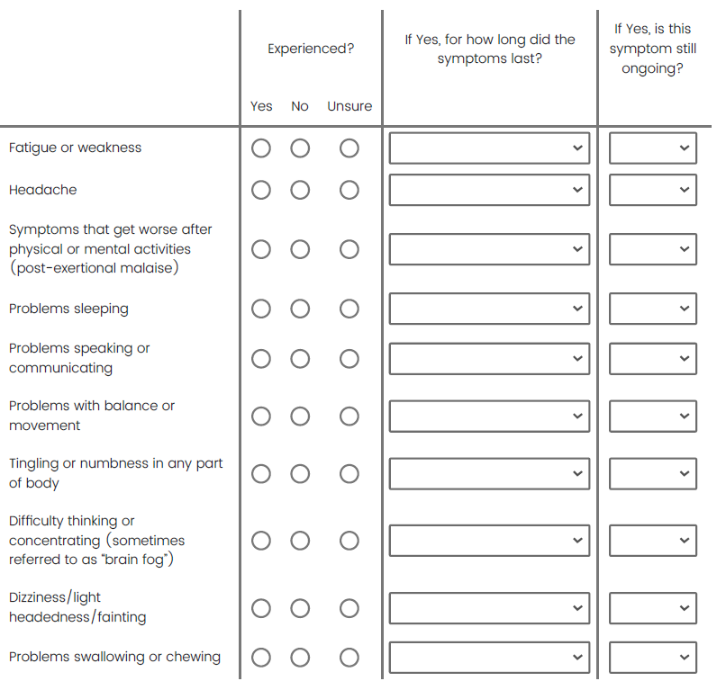
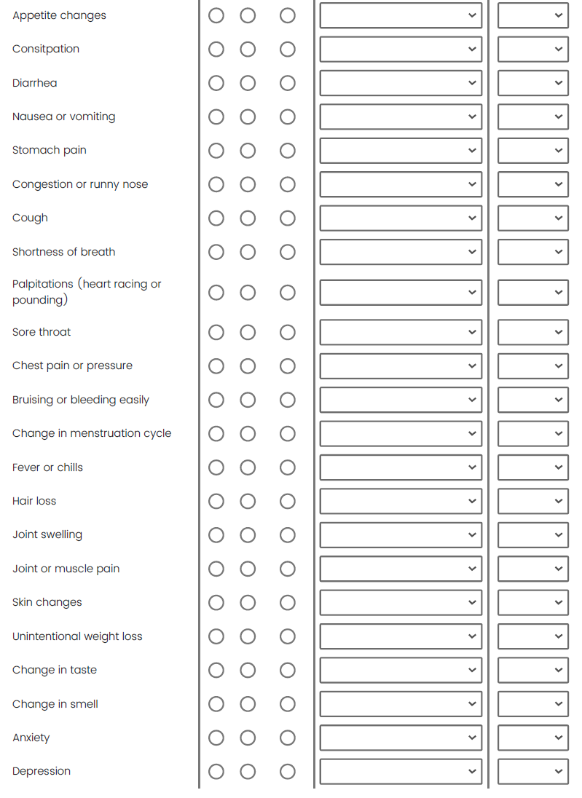
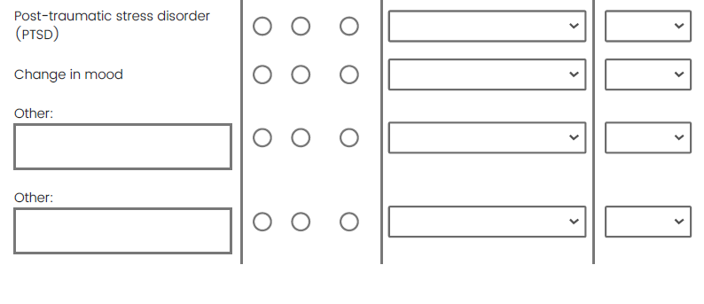
For any of the symptoms lasting more than 4 consecutive weeks, did you ever see a doctor, nurse, or other health professional (including in-person and virtual visits)?
- Yes
- No
- I don't know/Unsure

What kind(s) of doctor(s), nurse(s) or other health professional(s) did you see for the symptoms(s) lasting more than 4 consecutive weeks? Check all that apply.
- Primary care/General/Family Practitioner
- Cardiologist
- Dermatologist
- Mental health practitioner (Counselor, psychologist, psychiatrist, etc.)
- Neurologist
- Physical/Occupational Therapist
- Pulmonologist
- Other health professional (please specify):
- I don't know/Unsure

Would you describe yourself as having "long COVID", that is, do you attribute any of the symptom(s) lasting more than 4 weeks to COVID-19 infection?
- Yes
- No
- Unsure

Are these "long COVID" symptoms still occurring today?
- Yes
- No
- Unsure

Vaccination Details
You indicated you have been vaccinated for COVID-19. To answer the next questions, it will be very helpful if you have your vaccination card in front of you. This is the card that was given to you by the person who gave you the vaccine.

Please refer to your vaccination card to provide the following for any vaccines or boosters received.
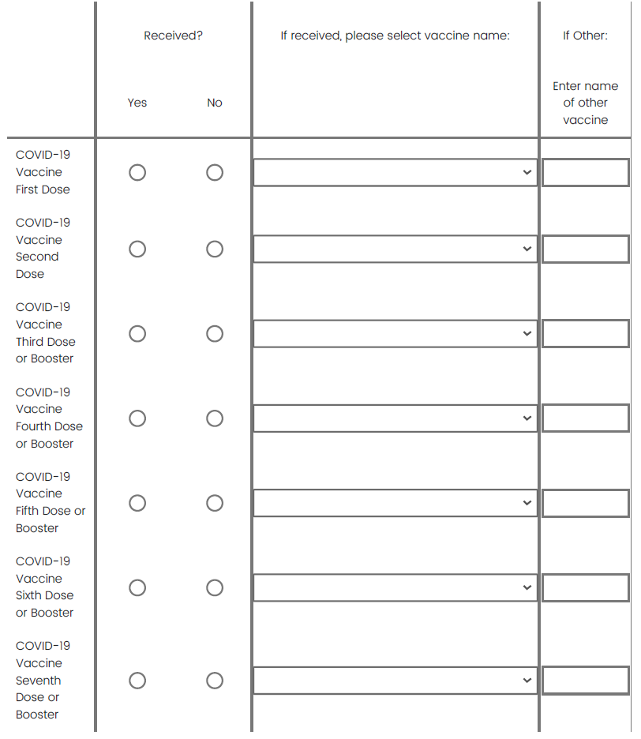
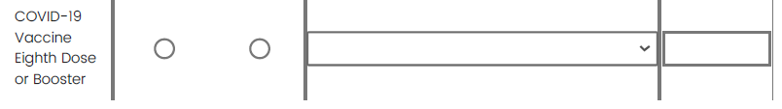

What motivated you to get vaccinated? Select all that apply
- Protect my health
- Protect health of family/friends
- Protect health of co-workers/community
- To get back to work/school
- To resume social activities
- To resume travel
- Because others encouraged me to get vaccinated
- Not sure
- Other:

Vaccine Reaction History

Did you have a reaction following any of your COVID-19 vaccinations?
- Yes
- No
- Unsure

Select the reaction you had after your FIRST COVID-19 vaccination:
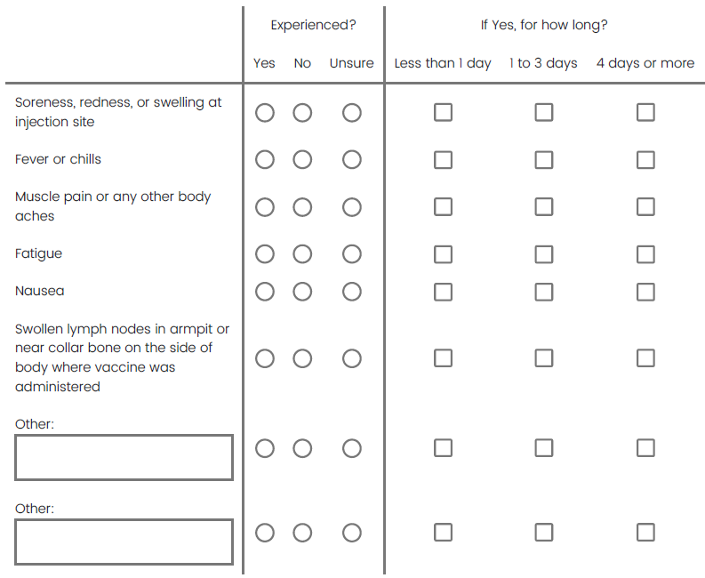

(section is shown again for 2nd-8th vaccination)

Vaccination Opinions
The next questions cover your opinions about vaccination. There are no right answers, please tell us what you think:

How concerned were you about getting a COVID-19 vaccine?
- Not at all concerned
- A little concerned
- Moderately concerned
- Very concerned
- Not sure

How easy was it to get a COVID-19 vaccine for yourself?
- Very easy
- Somewhat easy
- Somewhat difficult
- Very difficult
- Not sure

How concerned are you about getting a COVID-19 vaccine?
- Not at all concerned
- A little concerned
- Moderately concerned
- Very concerned
- Not sure

What makes you not want to get a COVID-19 vaccine? Select all that apply.
- Unsure the vaccines are safe.
- Personal, cultural, or religious beliefs against vaccination.
- I am young and do not need to worry about being vaccinated.
- I am worried about being exposed to SARS-CoV-2 when I am at the vaccination location.
- I can't go on my own (I have a physical or other limitation) or don't have transportation.
- I don't know where to go get vaccinated.
- I'm not eligible to get a COVID-19 vaccine or have a medical reason that makes me ineligible to get vaccinated (e.g., I have had a severe allergy to vaccines in the past).
- The vaccination clinic is too far away or the hours of operation are inconvenient.
- The waiting time is too long. It is difficult to find or make an appointment.
- I am too busy to get vaccinated.
- It is difficult to arrange for childcare.
- I don't have time off work.
- Other:
- Not sure

How easy would it be to get a COVID-19 vaccine for yourself?
- Very easy
- Somewhat easy
- Somewhat difficult
- Very difficult
- Not sure

How likely are you to recommend getting the COVID-19 vaccine to others?
- Not at all likely
- Somewhat likely
- Extremely likely
- Not sure

Medical History Information
The final section of the survey asks about other parts of your medical history. These data will help us to understand whether other health-related topics influence the chance of getting SARS-CoV-2 or COVID- 19.

On the scale below showing 0 to 10, please rate your current health today by dragging or touching the line below. 0 is the worst possible health you can imagine and 10 is the best possible health you can imagine.
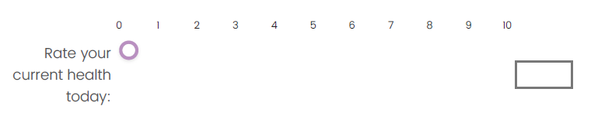
Have you had, or do you currently have any of the following conditions? Check all that apply.
- Asthma
- Other respiratory disease
- Heart or other cardiovascular disease
- High blood pressure
- Diabetes
- Any kind of immune system disorder
- Kidney disease
- Liver disease
- Neurological disease
- Cancer
- None of the above

During the past 30 days, have you smoked part or all of a cigarette?
- Yes
- No

On average, during the past 30 days, how many cigarettes did you smoke per day?
- Zero
- More than zero, but less than one cigarette
- 1 cigarette
- 2 to 5 cigarettes
- 6 to 15 cigarettes
- 16 to 25 cigarettes
- 26 to 35 cigarettes
- More than 35 cigarettes
- Not sure

U.S. States categorized as having less restrictive COVID-19 policies:
- Arizona
- Arkansas
- Connecticut
- Florida
- Georgia
- Idaho
- Iowa
- Kentucky
- Missouri
- Nebraska
- North Dakota
- Oklahoma
- South Carolina
- South Dakota
- Tennessee
- Texas
- Utah
- Wyoming

Supplementary Figure 1: Classification of study participants by vaccination status and reasons for non-vaccination.
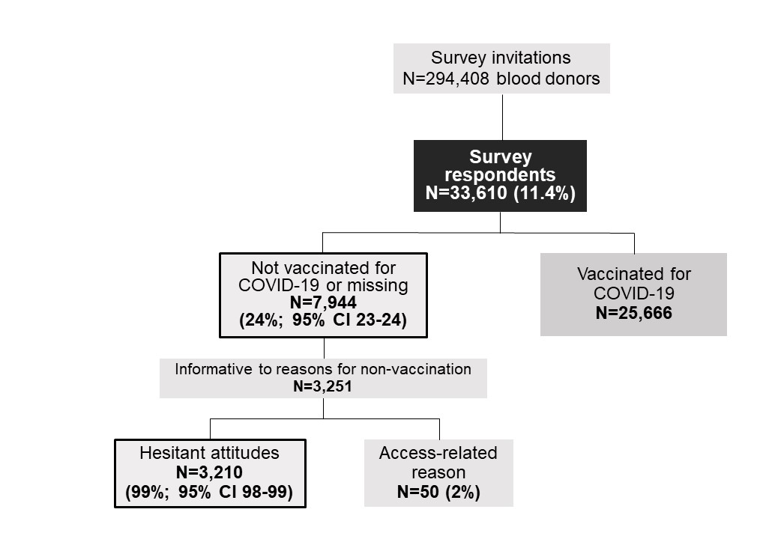

Supplementary Table 1: Frequencies and percentages of study participants by State of residency, overall and by vaccination and hesitancy status.

State | Number of survey respondents | Number of noncompliant participants (%) | Number of hesitant participants among noncompliant donors (%)
Alaska | 3 | 1 (33) | 1 (100)
Alabama | 11 | 5 (45) | 3 (60)
Arkansas | 6 | 1 (17) | 1 (100)
Arizona | 4,811 | 1,274 (26) | 561 (44)
California | 9,481 | 1,700 (18) | 510 (30)
Colorado | 7,067 | 1,394 (20) | 481 (35)
District of Columbia | 2 | 0 (0) | Not applicable
Florida | 7 | 1 (14) | 1 (100)
Georgia | 5 | 2 (40) | 1 (50)
Idaho | 457 | 161 (35) | 94 (58)
Illinois | 10 | 0 (0) | Not applicable
Indiana | 1 | 0 (0) | Not applicable
Kansas | 1 | 1 (100) | 1 (100)
Louisiana | 400 | 144 (36) | 77 (53)
Massachusetts | 3 | 0 (0) | Not applicable
Maryland | 5 | 1 (20) | 0 (0)
Michigan | 1 | 0 (0) | Not applicable
Minnesota | 381 | 108 (28) | 56 (52)
Missouri | 2 | 2 (100) | 0 (0)
Mississippi | 419 | 164 (39) | 87 (53)
Montana | 670 | 211 (31) | 99 (47)
North Carolina | 3 | 1 (33) | 0 (0)
North Dakota | 1,158 | 400 (35) | 208 (52)
Nebraska | 31 | 8 (26) | 5 (63)
New Hampshire | 1 | 0 (0) | Not applicable
New Mexico | 2,106 | 469 (22) | 181 (39)
Nevada | 2,262 | 614 (27) | 252 (41)
New York | 3 | 0 (0) | Not applicable
Oklahoma | 2 | 1 (50) | 1 (100)
Oregon | 9 | 3 (33) | 2 (67)
Pennsylvania | 1 | 0 (0) | Not applicable
South Carolina | 1 | 0 (0) | Not applicable
South Dakota | 795 | 289 (36) | 167 (58)
Tennessee | 388 | 83 (21) | 26 (31)
Texas | 1,149 | 371 (32) | 153 (41)
Utah | 8 | 2 (25) | 1 (50)
Virginia | 4 | 0 (0) | Not applicable
Washington | 1,257 | 301 (24) | 138 (46)
Wisconsin | 5 | 0 (0) | Not applicable
Wyoming | 678 | 231 (34) | 104 (45)
Missing | 6 | 1 (17) | 0 (0)
Total | 33,610 | 7944 (24) | 3,210 (40)

