Supplemental Tables.
Supplemental Table 1. Selected county-level measures by County Health Ranking health outcomes and health factors.
Quality of Life
Age-adjusted average number of poor mental health days reported in the past 30 days | BRFSS¹ | 2020
Health Behaviors
Percentage population who lack adequate access to food | USDA Food Environment Atlas, Map the Meal Gap from Feeding America² | 2020
Methamphetamine overdose death rate per 100K population | OHA Overdose Dashboard³ | 2019
Social and economic factors
Average Violent crime rate per 100K population | Uniform Crime Reporting - FBI | 2014 & 2016
Percentage of population aged 16 and older unemployed but seeking work | Bureau of Labor Statistics⁴ | 2020
Percentage of the population in poverty | ACS 5-Year Estimates⁵ | 2016-2020
Ratio of household income at the 80th percentile to income at the 20th percentile (income inequality ratio) | ACS 5-Year Estimates⁵ | 2016-2020
% population with at least 1 adverse childhood experience | BRFSS¹ | 2017-2021
Physical environment
Houseless rate per 100K population | Oregon Point in Time Count⁶ | 2019

Supplemental Table 2. Correlation matrix of county-level factors.
 | Violent crime rate | Meth overdose death rate | % Poverty | Houseless rate | % with at least 1 ACE | Income Inequality ratio | % Unemployed | % Food Insecure | Average poor mental health days
Violent crime rate | 1.0000
Meth overdose death rate | 0.5968 | 1.0000
% Poverty | 0.3614 | 0.5264 | 1.0000
Houseless rate | 0.4309 | 0.5302 | 0.6090 | 1.0000
% with at least one ACE | 0.8025 | 0.6640 | 0.3330 | 0.5815 | 1.0000
Income inequality ratio | 0.7972 | 0.5053 | 0.5454 | 0.6335 | 0.6856 | 1.0000
% Unemployed | 0.7008 | 0.4879 | 0.3903 | 0.6286 | 0.6899 | 0.7901 | 1.0000
% Food insecure | 0.4728 | 0.4921 | 0.9001 | 0.7738 | 0.5020 | 0.6763 | 0.6777 | 1.0000
Average poor mental health days | 0.6268 | 0.8160 | 0.7209 | 0.7269 | 0.6809 | 0.7172 | 0.6773 | 0.7637 | 1.0000

Supplemental Table 3. Factor loadings, eigenvalues and variance proportions for the first principal components comprising the full and simple scores.
 | Full score: first principal component | Simple score: first principal component
Average poor mental health days | 0.3731
% of the population that is food insecure | 0.3465
Methamphetamine overdose death rate | 0.3098
Violent crime rate | 0.3207 | 0.5111
% unemployment | 0.3364 | 0.4911
% population in poverty | 0.2969
Income inequality ratio | 0.3531 | 0.5067
% of population with at least one ACES | 0.3291 | 0.4908
Houseless rate | 0.3280
Eigenvalue | 6.03 | 3.23
Proportion variance | 0.6698 | 0.8085

References for Tables
1. Centers for Disease Control and Prevention, National Center for Chronic Disease Prevention and Health Promotion D of PH. BRFSS Prevalence & Trends Data [Internet]. 2019 [cited 2023 Jul 23]. Available from: https://www.cdc.gov/brfss/index.html
2. USDA. Map the Meal Gap from Feeding America [Internet]. Food Environment Atlas. 2019 [cited 2024 Dec 2]. Available from: https://www.feedingamerica.org/
3. Oregon Health Authority. Prescribing and Overdose Data for Oregon [Internet]. 2019 [cited 2023 May 10]. Available from: https://www.oregon.gov/oha/ph/preventionwellness/substanceuse/opioids/pages/data.aspx
4. US Bureau of Labor Statistics. Local Area Unemployment Statistics [Internet]. 2020 [cited 2023 May 10]. Available from: https://www.bls.gov/lau/tables.htm
5. US Census Bureau. American Community Survey 5-Year Estimates [Internet]. Available from: https://www.census.gov/programs-surveys/acs/
6. Friends of the Unsheltered. Oregon Point in Time Homeless Count [Internet]. 2019. Available from: https://friendsoftheunsheltered.org/wp-content/uploads/2019-point-in-time-homeless-count-PIT-Oregon-counties.pdf

Supplemental Figures 1a-1d
Plots of the natural log of the predicted risk of congenital syphilis (CS) and the scaled full (bivariable model, a, multivariable model, b) and simple scores (bivariable model, c, multivariable model, d).
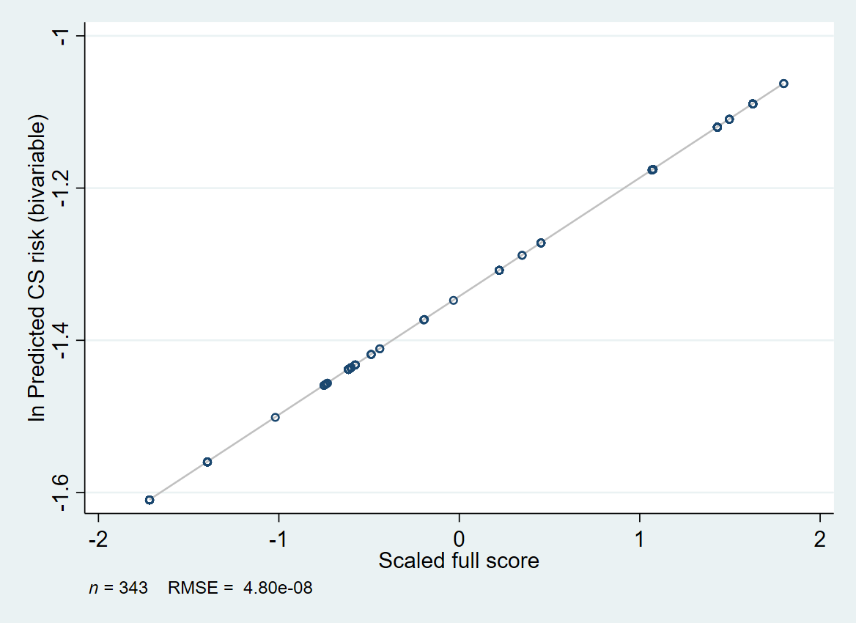
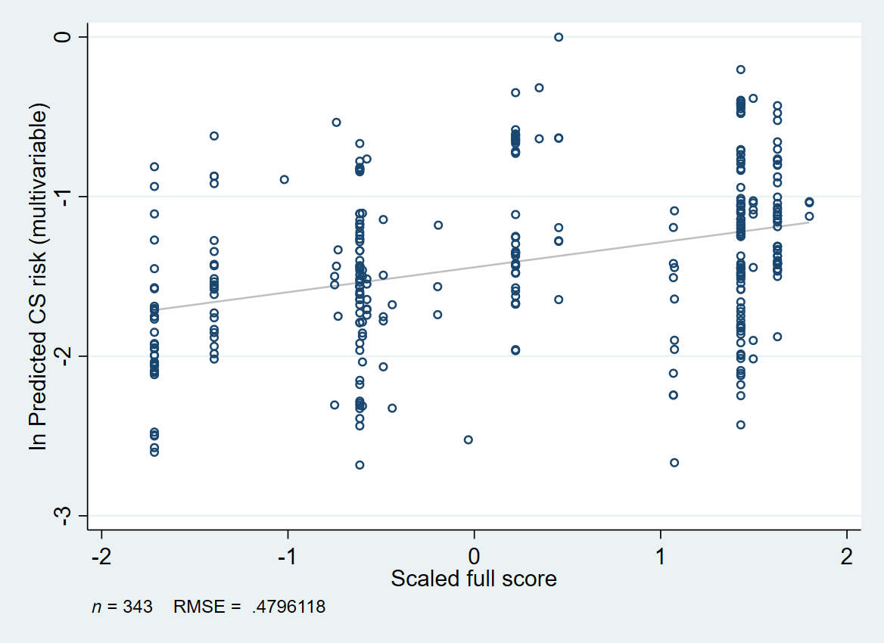

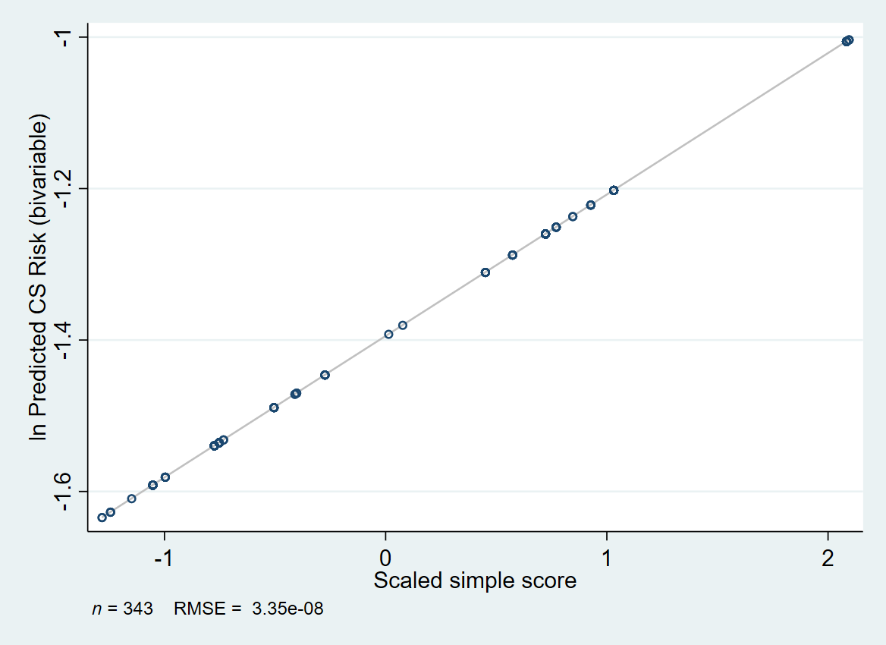

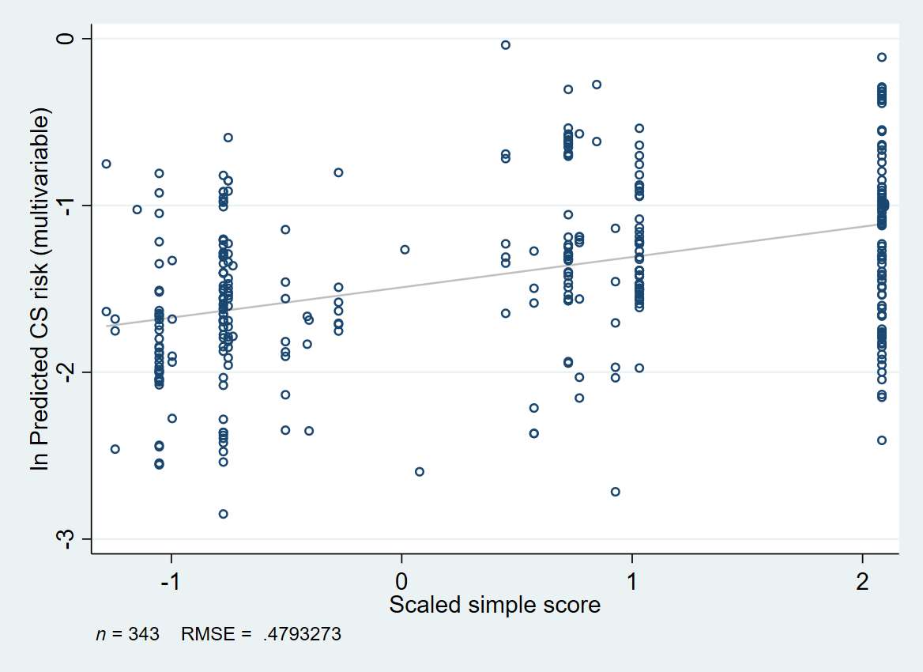

Supplemental Figure 2. Post-hoc evaluation of an interaction between the scaled full score, history of injection drug us and history of corrections involvement. CS, congenital syphilis; IDU, injection drug use; SD, standard deviation.




