Supplementary materials
Epidemiological model can forecast COVID-19 outbreaks from wastewater-based surveillance in rural communities.
Tyler Meadows, Erik R. Coats, Solana Narum, Eva Top, Benjamin J. Ridenhour, Thibault Stalder

Variance analysis
We tested if the variance of the total copies of SARS-CoV-2 collected per day at the wastewater treatment facilities, referred to below as “copies_per_day”, was different between cities referred to below as “location”.
Results from test when testing copies_per_day ~ location
- Brown-Forsythe Test (alpha = 0.05)
-------------------------------------------------------------
data : copies_per_day and location

statistic : 69.33715
num df : 5
denom df : 129.2721
p.value : 6.511297e-35

Result : Difference is statistically significant.
-------------------------------------------------------------
- Levene's Test for Homogeneity of Variance (center = median)
Df F value Pr(>F)
group 5 27.797 < 2.2e-16 ***
503
---
Signif. codes: 0 ‘***’ 0.001 ‘**’ 0.01

- Bartlett test of homogeneity of variances
‘*’ 0.05 ‘.’ 0.1 ‘ ’ 1

data: copies_per_day by location
Bartlett's K-squared = 1560, df = 5, p-value < 2.2e-16

- Fligner-Killeen test of homogeneity of variances
data: copies_per_day by location
Fligner-Killeen:med chi-squared = 307.03, df = 5, p-value < 2.2e-16

Comparisons of the AUC
Simultaneous Tests for General Linear Hypotheses

Multiple Comparisons of Means: Tukey Contrasts

Fit: glmer(formula = AUC ~ Day + (1 | run_ID), data = AUC_Data, family = gaussian(link = make.link("logit")))

Linear Hypotheses:
Estimate Std. Error z value Pr(>|z|)
2 - 1 == 0 -0.104736 0.023831 -4.395 <0.01 **
3 - 1 == 0 -0.119183 0.023777 -5.013 <0.01 ***
4 - 1 == 0 -0.093857 0.023854 -3.935 <0.01 **
5 - 1 == 0 -0.048525 0.024002 -2.022 0.7852
6 - 1 == 0 -0.004944 0.024168 -0.205 1.0000
7 - 1 == 0 0.046541 0.024376 1.909 0.8484
8 - 1 == 0 0.090456 0.024575 3.681 0.0189 *
9 - 1 == 0 0.135982 0.024787 5.486 <0.01 ***
10 - 1 == 0 0.173965 0.024987 6.962 <0.01 ***
11 - 1 == 0 0.206515 0.025172 8.204 <0.01 ***
12 - 1 == 0 0.245328 0.025392 9.662 <0.01 ***
13 - 1 == 0 0.286689 0.025656 11.174 <0.01 ***
14 - 1 == 0 0.314903 0.025840 12.187 <0.01 ***
15 - 1 == 0 0.331965 0.025964 12.785 <0.01 ***
3 - 2 == 0 -0.014447 0.023379 -0.618 1.0000
4 - 2 == 0 0.010879 0.023458 0.464 1.0000
5 - 2 == 0 0.056211 0.023608 2.381 0.5290
6 - 2 == 0 0.099792 0.023776 4.197 <0.01 **
7 - 2 == 0 0.151276 0.023987 6.307 <0.01 ***
8 - 2 == 0 0.195191 0.024190 8.069 <0.01 ***
9 - 2 == 0 0.240718 0.024405 9.863 <0.01 ***
10 - 2 == 0 0.278701 0.024608 11.326 <0.01 ***
11 - 2 == 0 0.311251 0.024796 12.552 <0.01 ***
12 - 2 == 0 0.350064 0.025019 13.992 <0.01 ***
13 - 2 == 0 0.391424 0.025287 15.479 <0.01 ***
14 - 2 == 0 0.419639 0.025474 16.474 <0.01 ***
15 - 2 == 0 0.436701 0.025599 17.059 <0.01 ***
4 - 3 == 0 0.025326 0.023401 1.082 0.9991
5 - 3 == 0 0.070658 0.023552 3.000 0.1523
6 - 3 == 0 0.114239 0.023720 4.816 <0.01 ***
7 - 3 == 0 0.165723 0.023932 6.925 <0.01 ***
8 - 3 == 0 0.209638 0.024134 8.686 <0.01 ***
9 - 3 == 0 0.255165 0.024351 10.479 <0.01 ***
10 - 3 == 0 0.293148 0.024554 11.939 <0.01 ***
11 - 3 == 0 0.325698 0.024742 13.164 <0.01 ***
12 - 3 == 0 0.364511 0.024965 14.601 <0.01 ***
13 - 3 == 0 0.405871 0.025234 16.084 <0.01 ***
14 - 3 == 0 0.434086 0.025421 17.076 <0.01 ***
15 - 3 == 0 0.451148 0.025547 17.659 <0.01 ***
5 - 4 == 0 0.045332 0.023629 1.918 0.8436
6 - 4 == 0 0.088913 0.023797 3.736 0.0158 *
7 - 4 == 0 0.140398 0.024008 5.848 <0.01 ***
8 - 4 == 0 0.184312 0.024210 7.613 <0.01 ***
9 - 4 == 0 0.229839 0.024426 9.410 <0.01 ***
10 - 4 == 0 0.267822 0.024628 10.875 <0.01 ***
11 - 4 == 0 0.300372 0.024816 12.104 <0.01 ***
12 - 4 == 0 0.339185 0.025038 13.547 <0.01 ***
13 - 4 == 0 0.380545 0.025306 15.038 <0.01 ***
14 - 4 == 0 0.408760 0.025493 16.034 <0.01 ***
15 - 4 == 0 0.425822 0.025619 16.622 <0.01 ***
6 - 5 == 0 0.043581 0.023945 1.820 0.8902
7 - 5 == 0 0.095066 0.024154 3.936 <0.01 **
8 - 5 == 0 0.138980 0.024355 5.706 <0.01 ***
9 - 5 == 0 0.184507 0.024569 7.510 <0.01 ***
10 - 5 == 0 0.222490 0.024770 8.982 <0.01 ***
11 - 5 == 0 0.255040 0.024957 10.219 <0.01 ***
12 - 5 == 0 0.293853 0.025178 11.671 <0.01 ***
13 - 5 == 0 0.335213 0.025444 13.174 <0.01 ***
14 - 5 == 0 0.363428 0.025630 14.180 <0.01 ***
15 - 5 == 0 0.380490 0.025755 14.773 <0.01 ***
7 - 6 == 0 0.051485 0.024318 2.117 0.7230
8 - 6 == 0 0.095400 0.024517 3.891 <0.01 **
9 - 6 == 0 0.140926 0.024729 5.699 <0.01 ***
10 - 6 == 0 0.178909 0.024929 7.177 <0.01 ***
11 - 6 == 0 0.211459 0.025115 8.420 <0.01 ***
12 - 6 == 0 0.250272 0.025334 9.879 <0.01 ***
13 - 6 == 0 0.291633 0.025599 11.392 <0.01 ***
14 - 6 == 0 0.319847 0.025783 12.405 <0.01 ***
15 - 6 == 0 0.336909 0.025907 13.004 <0.01 ***
8 - 7 == 0 0.043915 0.024721 1.776 0.9075
9 - 7 == 0 0.089442 0.024932 3.587 0.0261 *
10 - 7 == 0 0.127424 0.025130 5.071 <0.01 ***
11 - 7 == 0 0.159974 0.025314 6.320 <0.01 ***
12 - 7 == 0 0.198787 0.025532 7.786 <0.01 ***
13 - 7 == 0 0.240148 0.025794 9.310 <0.01 ***
14 - 7 == 0 0.268363 0.025977 10.331 <0.01 ***
15 - 7 == 0 0.285425 0.026100 10.936 <0.01 ***
9 - 8 == 0 0.045527 0.025126 1.812 0.8937
10 - 8 == 0 0.083510 0.025322 3.298 0.0659 .
11 - 8 == 0 0.116059 0.025505 4.550 <0.01 ***
12 - 8 == 0 0.154872 0.025721 6.021 <0.01 ***
13 - 8 == 0 0.196233 0.025981 7.553 <0.01 ***
14 - 8 == 0 0.224448 0.026163 8.579 <0.01 ***
15 - 8 == 0 0.241510 0.026285 9.188 <0.01 ***
10 - 9 == 0 0.037983 0.025527 1.488 0.9780
11 - 9 == 0 0.070533 0.025709 2.744 0.2771
12 - 9 == 0 0.109346 0.025923 4.218 <0.01 **
13 - 9 == 0 0.150706 0.026181 5.756 <0.01 ***
14 - 9 == 0 0.178921 0.026361 6.787 <0.01 ***
15 - 9 == 0 0.195983 0.026483 7.400 <0.01 ***
11 - 10 == 0 0.032550 0.025900 1.257 0.9956
12 - 10 == 0 0.071363 0.026113 2.733 0.2832
13 - 10 == 0 0.112723 0.026369 4.275 <0.01 **
14 - 10 == 0 0.140938 0.026548 5.309 <0.01 ***
15 - 10 == 0 0.158000 0.026668 5.925 <0.01 ***
12 - 11 == 0 0.038813 0.026289 1.476 0.9793
13 - 11 == 0 0.080174 0.026544 3.020 0.1438
14 - 11 == 0 0.108388 0.026721 4.056 <0.01 **
15 - 11 == 0 0.125450 0.026840 4.674 <0.01 ***
13 - 12 == 0 0.041361 0.026751 1.546 0.9694
14 - 12 == 0 0.069575 0.026927 2.584 0.3798
15 - 12 == 0 0.086637 0.027046 3.203 0.0866 .
14 - 13 == 0 0.028215 0.027175 1.038 0.9994
15 - 13 == 0 0.045277 0.027293 1.659 0.9448
15 - 14 == 0 0.017062 0.027465 0.621 1.0000
---
Signif. codes: 0 ‘***’ 0.001 ‘**’ 0.01 ‘*’ 0.05 ‘.’ 0.1 ‘ ’ 1
(Adjusted p values reported -- single-step method)

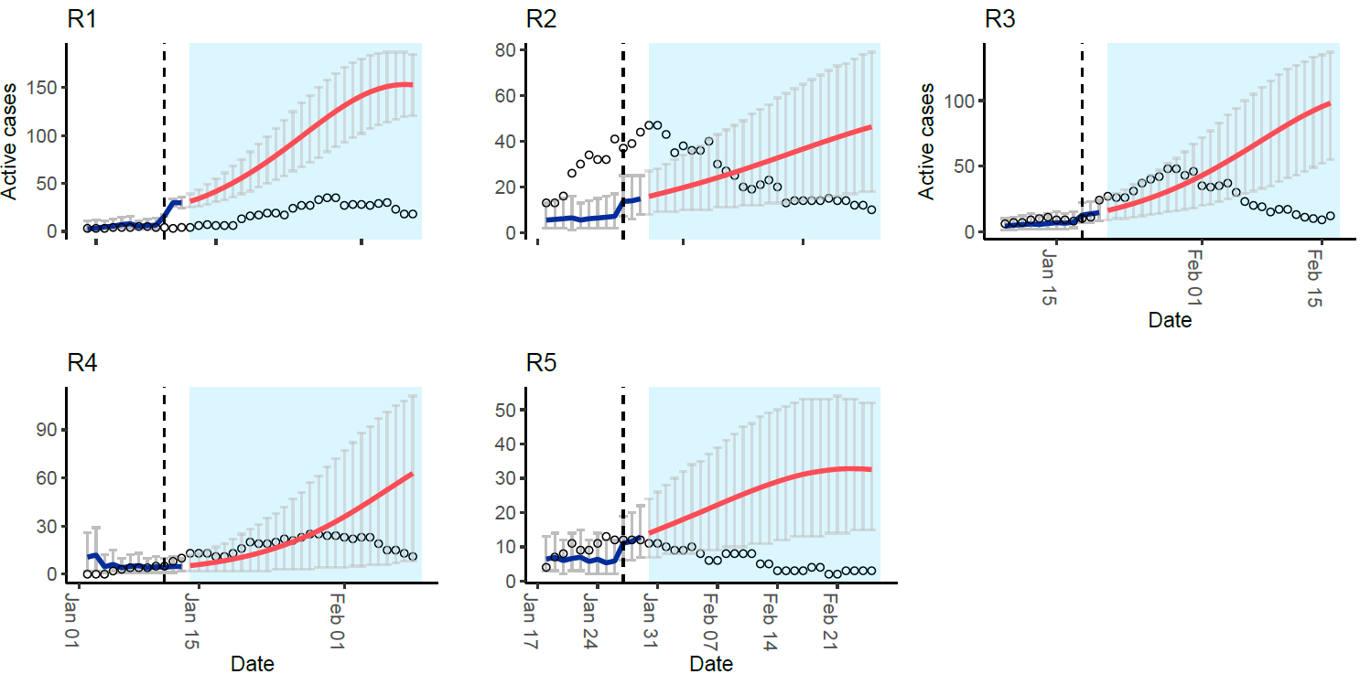
Figure S1: Outbreak peak forecast. The red line in the graph represents the predicted number of active cases of SARS-CoV-2 in wastewater. This prediction was made at the time when the virus levels in wastewater were starting to decrease and corresponded to two days after the peak of SARS-CoV-2 in wastewater, which is indicated by the vertical dashed lines. The blue lines in the graph show the estimated number of active cases based on the wastewater data, and the blue shade represents the data that was not yet observed at the time of the forecast. Based on the wastewater data the model failed to predict the outbreak peak accurately. The gray bars indicate the 95% confidence intervals. The dots in the graph represent the number of active cases, which were determined using a moving sum of the clinically confirmed cases over an 11-day period.

