Supplemental Information for “Household transmission dynamics of seasonal human coronaviruses”
Supplementary Methods

Likelihood of 4-strain household transmission model with missing data

We estimated the weekly probability of acquiring infection, the weekly probability of within-household transmission, the probability of having symptoms upon infection, and the symptoms meeting the definition of ILI, using data on the distribution of symptomatic cases among all detected infections and the distribution of cases among households. Houses that were swabbed in a given week were more likely to have had a HCoV ILI case and more likely to have a symptomatic HCoV infection, and thus represent a biased sample of all households. To correct for the missing data from unswabbed household weeks, we use data on the proportion of swabbed households among all households and the distribution of non-HCoV infections with ILI within swabbed households.

The model parameters θ=(α,β,p_{s},p_{ILI},p_{NC},γ) are described in Table S1 and the observed data in Table S2.

Table S1: Model parameters, meaning, and whether we considered stratification of the parameter

Model Parameter | Meaning | Stratification
α | Probability of acquiring HCoV from outside the household in a calendar week | Strain; study year; age (<19 vs. ≥19)
β | Probability of a susceptible household member being infected by an individual infected with HCoV within a week | Age (<19 vs. ≥19); symptom status (symptomatic vs. asymptomatic)
p_{s} | Probability of displaying symptoms if infected with HCoV | Age (<19 vs. ≥19)
p_{ILI} | Probability of ILI if experiencing symptomatic HCoV infection | Age (<19 vs. ≥19)
p_{NC} | Probability of acquiring non-HCoV infection and having ILI in a calendar week | None
γ | Intra-household correlation coefficient for non-HCoV ILI | N/A
γ_{CoV} | Intra-household correlation coefficient for HCoV community acquisition | N/A

Table S2: Observed data notation and meaning
Data | Meaning
Y_{i} | Number of HCoV infections in household-week i
$Y_{i}^{s}$ | Number of symptomatic HCoV infections in household-week i
$Y_{i}^{ILI}$ | Number of HCoV-associated ILI cases in household-week i
$Y_{i}^{NC}$ | Number of non-HCoV associated ILI cases in household-week i
H_{i} | Number of household members in household-week i
C_{i} | Number of household members <19 years old in household-week i

The likelihood contribution for household-week i is given by

$$P\left[Y_{i}, Y_{i}^{s}, Y_{i}^{ILI}, Y_{i}^{NC}\right|H_{i},C_{i}, θ] =\left\{\begin{aligned}P\left[Y_{i}, Y_{i}^{s}, Y_{i}^{ILI}, Y_{i}^{NC}, household swabbed \right|H_{i},θ], hh week swabbed \\ 1-P\left[household swabbed \right|H_{i},θ], hh week not swabbed.\end{aligned}\right.$$

The likelihood for swabbed households is derived as follows. For swabbed households, the probability can be written as a product of conditional probabilities:

$$P\left[Y_{i}, Y_{i}^{s}, Y_{i}^{ILI}, Y_{i}^{NC}, household swabbed \right|H_{i},θ]=P\left[household swabbed \right|Y_{i}, Y_{i}^{s}, Y_{i}^{ILI}, Y_{i}^{NC},H_{i},θ]P\left[Y_{i}^{NC}\right|Y_{i}, Y_{i}^{s},H_{i},θ]P\left[Y_{i}^{ILI}\right|Y_{i}^{s},θ]P\left[Y_{i}^{s}\right|Y_{i},θ]P\left[Y_{i}\right|H_{i},θ]$$

Non-HCoV ILI cases

Non-HCoV ILI cases are clustered within households. Therefore, we model the probability of observing $Y_{i}^{NC}$ non-HCoV ILIs as a beta-binomial from H_{i}-Y_{i} individuals (i.e., uninfected with HCoV) with probability p_{NC} and intracluster correlation parameter 0<γ<1 [29]:

$$P\left[Y_{i}^{NC}\right|Y_{i},H_{i},θ]= \left({H_{i}-Y_{i} \atop Y_{i}^{NC}}\right)\frac{B(H_{i}-Y_{i}+p_{NC}\left(\frac{1}{γ}-1\right),H_{i}-Y_{i}-Y_{i}^{NC}+(1-p_{NC})\left(\frac{1}{γ}-1\right))}{B(p_{NC}\left(\frac{1}{γ}-1\right),(1-p_{NC})\left(\frac{1}{γ}-1\right))}$$

HCoV-associated ILI cases and symptomatic HCoV infections

Symptomatic HCoV infections and ILI-associated HCoV infections are binomially distributed, given the number of HCoV infections and the number of symptomatic HCoV infections, respectively.

$$P\left[Y_{i}^{s}\right|Y_{i},θ]= \left({Y_{i} \atop Y_{i}^{s}}\right)p_{S}^{ Y_{i}^{s}}(1-p_{S})^{Y_{i}- Y_{i}^{s}}$$
$$P\left[Y_{i}^{ILI}\right|Y_{i}^{s},θ]= \left({Y_{i}^{s} \atop Y_{i}^{ILI}}\right)p_{ILI}^{ Y_{i}^{ILI}}(1-p_{ILI})^{Y_{i}^{s}- Y_{i}^{ILI}}$$

HCoV infections

The probability distribution of HCoV infections, allowing for just a single generation of within-household transmission, is derived by summing over the distribution of community- and household-acquired infections,

$$P[Y_{i}| H_{i},θ] = \sum_{c=0}^{Y_{i}}{\left({H_{i}-c \atop Y_{i}-c}\right)(1-(1-β)^{c})^{Y_{i}-c}{\left(1-β\right)}^{Y_{i}\left(H_{i}-Y_{i}\right)}\left({H_{i} \atop c}\right)α^{c}(1-α)^{H_{i}-c}}$$

Household swabbing

A household is swabbed if at least one ILI is reported in a HH week, regardless of etiology. Let p_{r} be the probability that an ILI is reported, given that it occurs. Then

$$P\left[household swabbed \right|Y_{i}, Y_{i}^{s}, Y_{i}^{ILI}, Y_{i}^{NC},H_{i},θ]=1-(1-p_{r})^{Y_{i}^{ILI}+Y_{i}^{NC}}$$

Finally, the probability that a household is swabbed given it had H_{i} household members is the sum over all possible distributions of HCoV cases, symptomatic HCoV cases, HCoV-associated ILIs, and non-HCoV ILIs:

P[household swabbed | H_{i}=h , θ] = $\sum_{y=0}^{h}{\sum_{s=0}^{y}{\sum_{nc=0}^{h-y}{\sum_{ili=0}^{s}{P_{swab}P_{NC}P_{symp}P_{ILI}P_{Y}}}}}$, where:
$$\begin{aligned}P_{swab}=P\left[swab \right|Y_{i}=y, Y_{i}^{s}=s,Y_{i}^{NC}=nc,H_{i}=h,θ] \\ P_{NC}=P\left[Y_{i}^{NC}=nc\right|Y_{i}=y,H_{i}=h,θ] \\ P_{symp}=P\left[Y_{i}^{s}=s\right|Y_{i}=y,θ] \\ P_{ILI}=P\left[Y_{i}^{ILI}=ili\right|Y_{i}^{s}=s,θ] \\ P_{Y}=P\left[Y_{i}=y | H_{i}=h,θ\right]. \\ \end{aligned}$$
We assume a very strong prior for p_{r}, namely a beta distribution with mean 0.8 and variance 4x10⁻⁴, and use simulation to explore the robustness of the estimated parameters to the value of p_{r}. We perform sensitivity analyses in which we assume different values of p_{r}.

We extend the above model to account for the four HCoV strains separately. We assume that individuals infected with one strain can only transmit that same strain to susceptible individuals within the household. We maximize the sum of the four strain-specific likelihoods.

Stratification of parameters

The transmission parameters, probability of symptoms, and probability of ILI can be stratified by age. As this was a household cohort recruited from a study on school children, we defined two age classes (<19 years and ≥19 years). The likelihood is easily extended to account for the two age categories.

The within-household transmission parameter can be stratified by whether the infected individual displays symptoms or not. Here we drop the i subscript for simplicity. The probability of observing $Y^{s}$ symptomatic individuals (and $Y^{a}$asymptomatic individuals) out of Y infected individuals in household-week i with h household members is calculated by summing over “community-acquired” infections (Y_{c}) and household-acquired infections (Y_{HH}), as below:

$$P\left[ Y^{a}, Y^{s}\right|H=h,θ] = \sum_{c^{a}=0}^{ Y^{a}}{\sum_{c^{s}=0}^{Y^{s}}{\begin{aligned}P\left[Y_{HH}^{a}= Y^{a}-c^{a},Y_{HH}^{s}=Y^{s}-c^{s} | Y_{c}^{a}=c^{a},Y_{c}^{s}=c^{s},H=h,θ\right]x \\ P[Y_{c}^{a}=c^{a},Y_{c}^{s}=c^{s}|H=h,θ]\end{aligned}}}$$

$$P\left[Y_{c}^{a}=c^{a},Y_{c}^{s}=c^{s} | H=h,θ\right]=\left({c^{a}+c^{s} \atop c^{s}}\right)p_{s}^{c^{s}}(1-p_{s})^{c^{a}}\left({n \atop c^{a}+c^{s}}\right)α^{c^{a}+c^{s}}(1-α)^{n-c^{a}-c^{s}}$$

$$P\left[Y_{HH}^{a}=Y^{a}-c^{a},Y_{HH}^{s}=Y^{s}-c^{s} | Y_{c}^{a}=c^{a},Y_{c}^{s}=c^{s},H=h,θ\right]=$$
$$\left({y^{a}+y^{s}-c^{a}-c^{s} \atop y^{s}-c^{s}}\right)p_{s}^{y^{s}-c^{s}}(1-p_{s})^{y^{a}-c^{a}}x$$
$$\left({h-c^{a}-c^{s} \atop y^{a}+y^{s}-c^{a}-c^{s}}\right)[1-(1-β_{a})^{c^{a}}(1-β_{s})^{c^{s}}]^{y^{a}+y^{s}-c^{a}-c^{s}}[(1-β_{a})^{c^{a}}(1-β_{s})^{c^{s}}]^{h-y^{a}-y^{s}}$$

Simulations

We simulated data according to the above probability distributions. Community-acquired infections in each household were generated using a binomial distribution, and household-acquired infections were generated using a binomial distribution with probability of infection dependent on the number of community-acquired infections. Symptomatic infections, ILI cases, and ILI symptoms reported were generated from independent binomial distributions. We fit models to the simulated data sets, with any households without a reported ILI treated as unswabbed households in the model framework.

To understand the power of this study to detect differences in transmission by symptom status, we simulated studies under two parameter values: β_{symp}=0.1 and β_{asymp}=0.05, and β_{symp}=0.1 and β_{asymp}=0.01. For each simulated data set we fit a model with β stratified and unstratified by symptom status. We compared four measures of study power based on the posterior distributions of β_{asymp} and β_{symp}, and the deviance of the model: the proportion of simulated studies that estimated $β_{asymp}^{50}<β_{symp}^{50}$; the proportion of simulated studies that estimated $β_{asymp}^{97.5}<β_{symp}^{50}$; the proportion of simulated studies that estimated $β_{asymp}^{50}<β_{symp}^{2.5}$; and the proportion of simulated studies for which DIC_{stratified}-DIC_{unstratified}≤-2.

Supplementary Results

Supplemental characteristics of HCoV infections and co-infections

Influenza-like illness characteristics

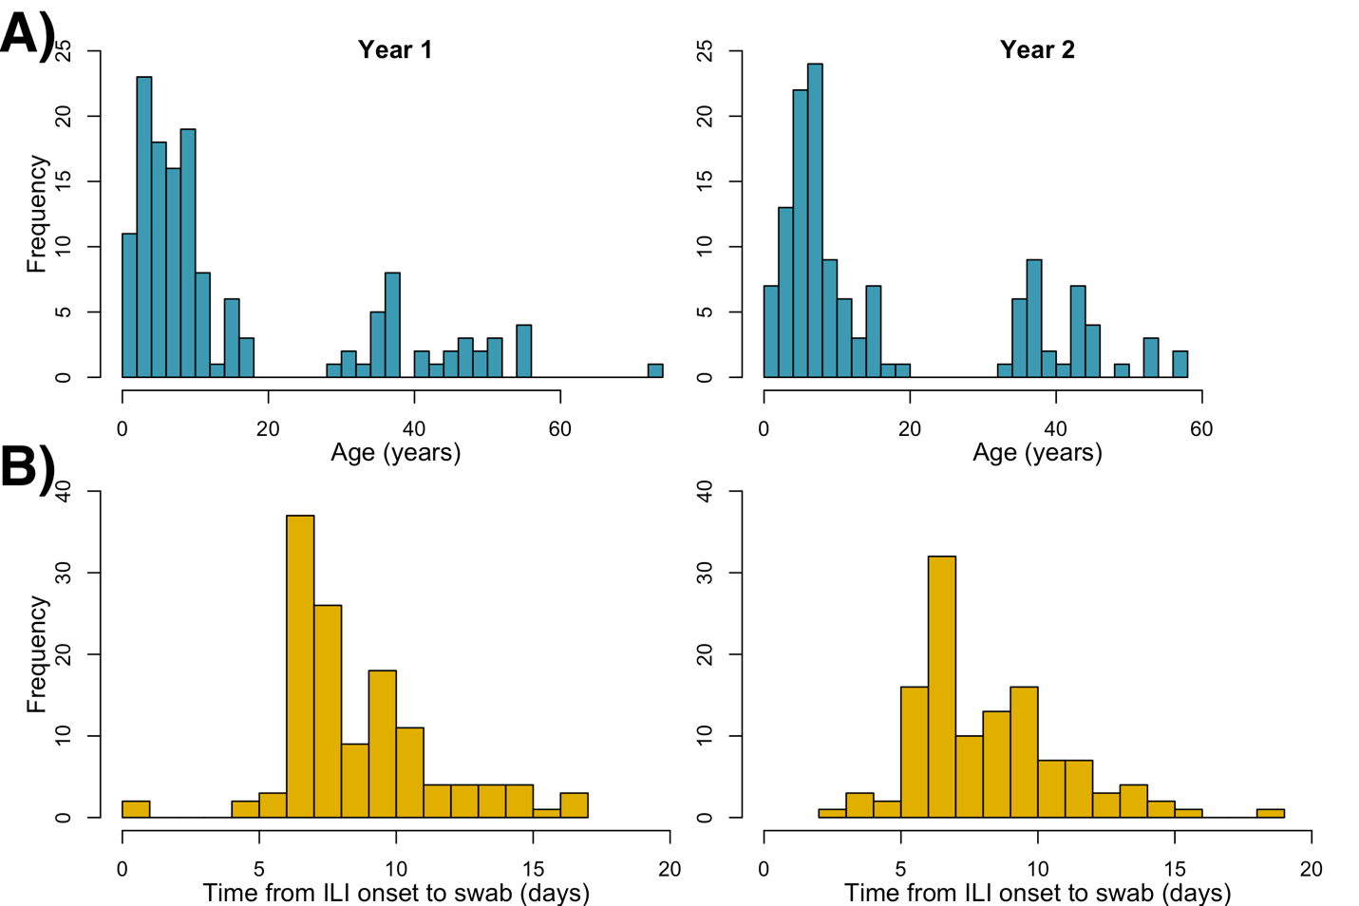

Figure S1. Characteristics of participants reporting influenza-like illness (ILI) during the two years of the SMART2 study. A) The age distribution (in years) of SMART2 participants reporting ILI in year 1 (left column) and year 2 (right column) and B) the time (in days) from ILI symptom onset to nasal swab

Pre-symptomatic infections
We assessed individuals ' symptom diaries to identify asymptomatic infections as individuals with no reported symptoms in the week before or after their sample collection. Any participant with reported symptoms the week before or the week after sample collection was classified as having a symptomatic infection. In year 1, we identified 9 infections where participants experienced symptoms either the week before or after their nasal swab was collected, and six (66%) of those were pre-symptomatic infections. In year 2, 11 participants reported symptoms before or after their nasal swab was collected, and of those 11, 5 (45%) were presymptomatic.

Participants with co-infections
We evaluated the types of co-infections with other respiratory viruses (influenza, respiratory syncytial virus (RSV), adenovirus (AdV), human metapneumovirus (HMPV), human rhinovirus (HRV), and parainfluenza virus (PIV)) that occurred over the course of the study. Of the 121 HCoV infections, we identified 27 co-infections with other respiratory pathogens (Table S3). In 2015-2016, we observed six co-infections and two HCoV co-infections with two other pathogens (one participant had an infection with HCoV, influenza, and HMPV, and another participant had an infection with HCoV, HMPV, and HRV). From 2016 to 2017, there were 16 co-infections and five HCoV infections with two other pathogens (one participant was infected with HCoV 229E, Influenza B, and PIV-3, another participant was infected with HCoV OC43, PIV-1, and AdV, and one participant was infected with HCoV 229E, RSV and HRV). Influenza was the most common HCoV co-infection in both years, followed by co-infection with AdV, PIV, and HRV.

Table S3. Participants co-infected with human coronavirus virus and other respiratory viruses during the SMART² study from December 2015 to May 2017
 |  | Overall | 2015-2016 | 2016-2017
 |  | n= 27 | N = 8 | N = 19
Type of HCoV co-infection |  | n | n | n
Co-Infection and two pathogens | Total | 5 | 2 | 3
Co-Infection and two pathogens | Influenza and HMPV | 1 | 1 | 0
Co-Infection and two pathogens | HMPV and HRV | 1 | 1 | 0
Co-Infection and two pathogens | Influenza and PIV | 1 | 0 | 1
Co-Infection and two pathogens | RSV and HRV | 1 | 0 | 1
Co-Infection and two pathogens | PIV and AdV | 1 | 0 | 1
Co-infections | Total | 22 | 6 | 16
Co-infections | Influenza | 14 | 4 | 10
Co-infections | RSV | 1 | 0 | 1
Co-infections | PIV | 2 | 1 | 1
Co-infections | AdV | 3 | 1 | 2
Co-infections | HMPV | 0 | 0 | 0
Co-infections | HRV | 2 | 0 | 2
Abbreviations: AdV, Adenovirus; HMPV, human metapneumovirus; HRV, human rhinovirus; PIV, parainfluenza virus; RSV, respiratory syncytial virus

We examined the characteristics of participants experiencing co-infections with HCoV and other pathogens (Table S4). Participants with co-infections have similar demographic characteristics and clinical symptoms as other participants. Participants with co-infections did report fever (44%), cough (56%) and runny nose and congestion (56%), and ILI (41%) at a slightly higher frequency.

Table S4. Demographic and clinical characteristics of participants co-infected with human coronavirus and other respiratory viruses during the SMART² study from December 2015 to May 2017
 | Overall | 2015-2016 | 2016-2017
Demographics | n = 27 (%) | n = 8 (%) | n = 19 (%)
Age group
<5 | 8 (30%) | 2 (25%) | 6 (32%)
5 – 9 | 6 (22%) | 1 (12.5%) | 5 (26%)
10-19 | 4 (14%) | 1(12.5%) | 3 (16)
20 – 49 | 8 (30%) | 3 (38%) | 5 (26%)
≥50 | 1 (4%) | 1 (12 %) | 0 (0%)
Gender
Male sex – no. (%) | 13 (48%) | 4 (50%) | 9 (47%)
Symptoms
No symptoms | 8 (30%) | 2 (25%) | 6 (32%)
Fever (>37.8ºC) | 12 (44%) | 6 (75%) | 6 (32%)
Sore throat | 4 (15%) | 1 (12%) | 3 (16%)
Cough | 15 (56%) | 5 (62%) | 10 (53%)
Headache | 7 (26%) | 3 (38%) | 4 (21%)
Runny nose and congestion | 15 (56%) | 5 (62%) | 10 (53%)
Muscle and joint pain | 3 (11%) | 2 (25%) | 1 (5%)
Nausea, diarrhea, and vomiting | 2 (7%) | 2 (25%) | 0 (0%)
Influenza-like illness* | 11 (41%) | 6 (75%) | 5 (26%)

Characteristics of Human coronavirus subtype infections
The characteristics of participants with different HCoV subtypes infections were similar across age groups, gender, and symptoms reported (Table S5). There was some variation in symptom reporting, with participants with HCoV-HKU1 and HCoV-229E infections reporting lower frequencies of nearly all symptoms among HCoV-HKU1 infections and lower frequencies of fever (20%) and cough (24%) for HCoV-229E, though some symptom reporting varied across all subtypes across the two study years.

Table S5. Characteristics of 121 HCoV OC43, HKU1, 229E, and NL63 subtype infections among 109 participants from 60 households in the SMART2 sub-cohort study in Pittsburgh, Pennsylvania, from December 2015 to May 2017

 | 2015-2016 |  |  |  | 2016-2017
 | HCoV OC43 | HCoV HKU1 | HCoV 229E | HCoV NL63 | HCoV OC43 | HCoV HKU1 | HCoV 229E | HCoV NL63
Characteristics | N = 33 | N = 15 | N = 2 | N = 7 | N = 39 | N = 0 | N = 25 | N = 0
Age-group (years) | n (%) | n (%) | n (%) | n (%) | n (%) | n (%) | n (%) | n (%)
<5 | 5 (15%) | 5 (33%) | 0 (0%) | 4 (57%) | 9 (23%) | - | 4 (16%) | -
5-18 | 12 (36%) | 5 (33%) | 2 (100%) | 0 (0%) | 15 (38%) | - | 12 (48%) | -
19-49 | 10 (30%) | 5 (33%) | 0 (0%) | 2 (29%) | 14 (36%) | - | 9 (36%) | -
≥50 | 6 (18%) | 0 (0%) | 0 (0%) | 1 (14%) | 1 (3%) | - | 0 (0%) | -
Sex
Female | 16 (48%) | 8 (53%) | 2 (100%) | 3 (43%) | 21 (54%) | - | 9 (36%) | -
Male | 17 (52%) | 7 (47%) | 0 (0%) | 4 (57%) | 18 (46%) | - | 16 (64%) | -
Symptoms
No symptoms | 9 (27%) | 2 (13%) | 0 (0%) | 2 (29%) | 13 (33%) | - | 6 (24%) | -
Fever (>37C) | 15 (45%) | 3 (20%) | 0 (0%) | 3 (43%) | 12 (31%) | - | 5 (20%) | -
Sore throat | 9 (27%) | 1 (7%) | 0 (0%) | 2 (29%) | 8 (21%) | - | 5 (20%) | -
Cough | 13 (39%) | 4 (27%) | 0 (0%) | 2 (29%) | 15 (38%) | - | 6 (24%) | -
Headache | 10 (30%) | 0 (0%) | 0 (0%) | 2 (29%) | 6 (15%) | - | 5 (20%) | -
Runny nose and congestion | 16 (53%) | 5 (33%) | 1 (50%) | 3 (43%) | 17 (44%) | - | 13 (52%) | -
Muscle and joint pain | 6 (18%) | 0 (0%) | 0 (0%) | 1 (14%) | 3 (8%) | - | 2 (8%) | -
Nausea, diarrhea and vomiting | 4 (12%) | 1 (7%) | 0 (0%) | 1 (14%) | 3 (8%) | - | 2 (8%) | -
Influenza-like illness* | 16 (48%) | 5 (33%) | 0 (0%) | 3 (43%) | 11 (28%) | - | 4 (16%) | -

HCoV Quantitative threshold trends

We assessed the quantitative threshold (Qt) values of the participants with confirmed infections (Qt value of 2 or higher) to identify patterns associated with symptoms and age and HCoV subtype-specific infections.

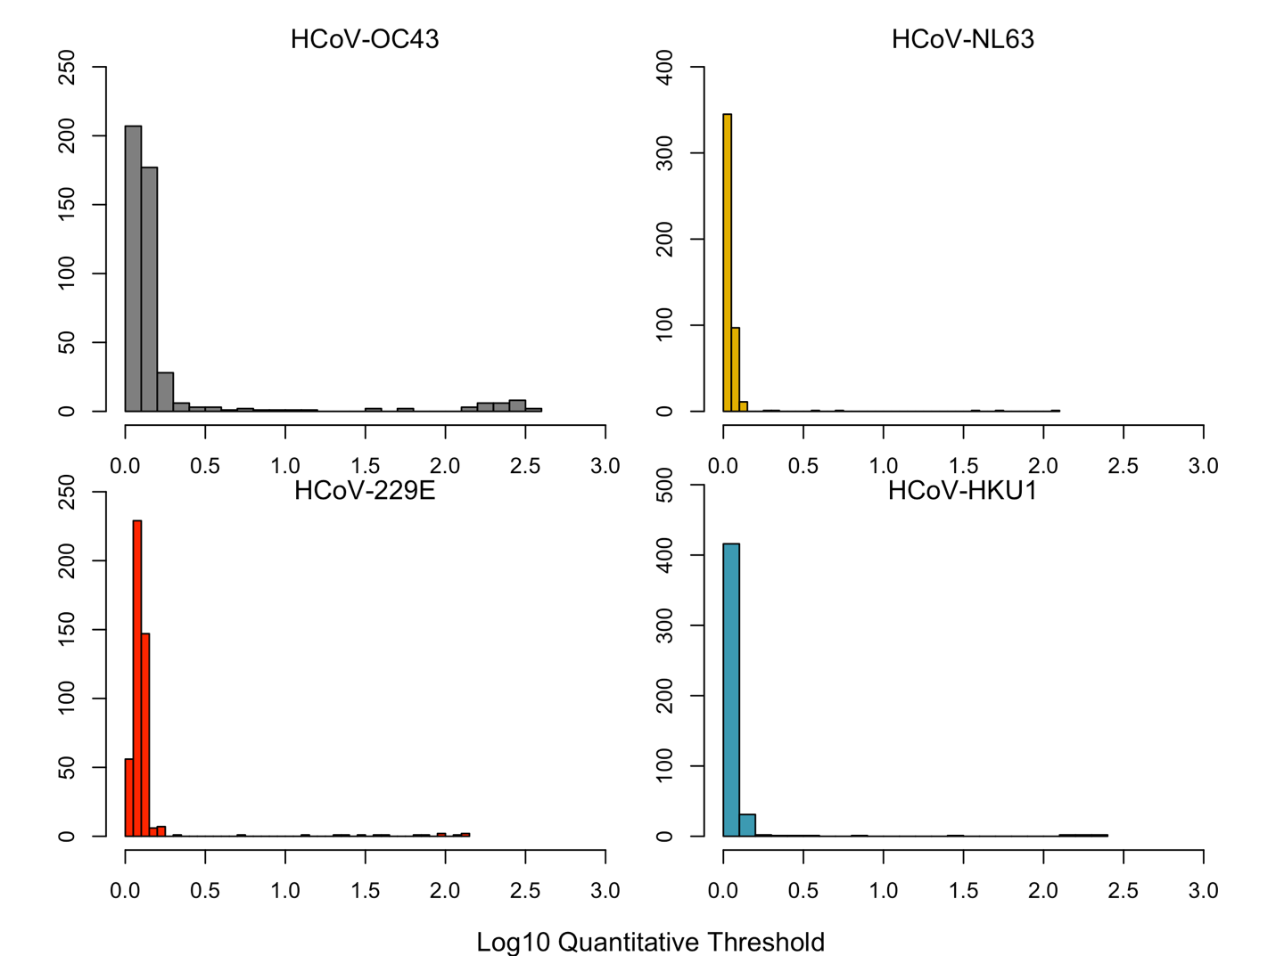

Figure S2. Distributions of Log₁₀ Quantitative Threshold values of Human Coronavirus subtypes

When evaluating all infections, there was no clear difference in the mean Qt values between asymptomatic and symptomatic infections, infections among children compared to adults, and infections assessed by symptoms and age (Fig S3). The average Qt values by subtypes, such as HCoV-OC43, appeared to vary more by symptom and age-specific infections, but not in any consistent patterns.
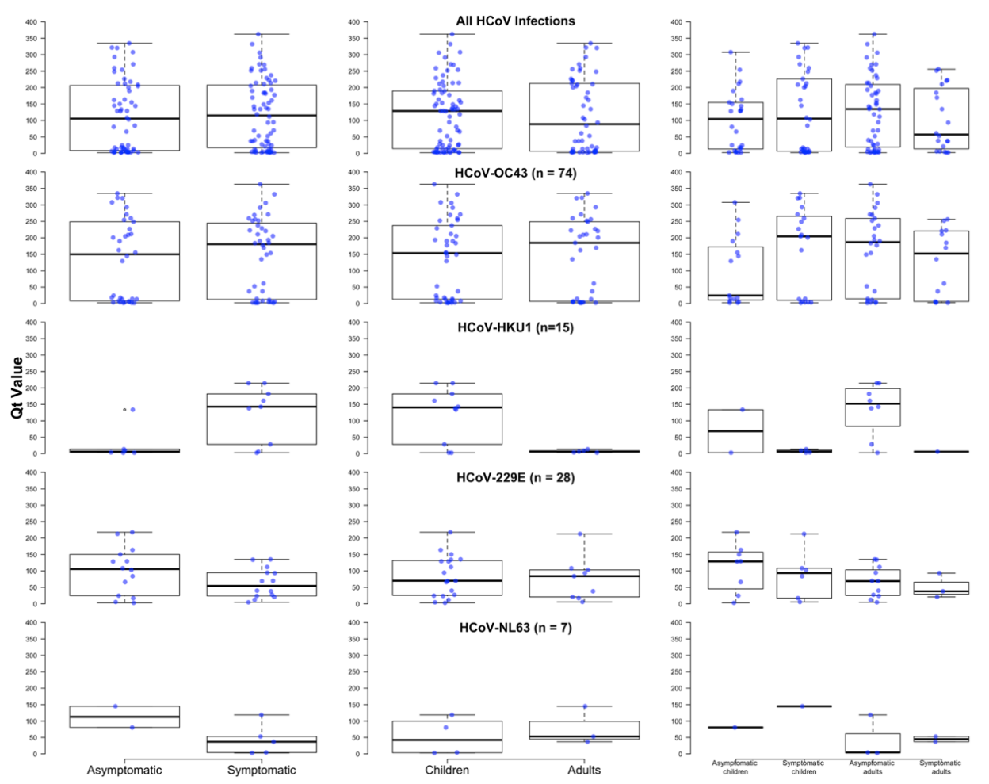

Figure S3: Mean quantitative threshold (QT) values among HCoV cases with symptomatic and asymptomatic infections, children and adults, and asymptomatic and symptomatic infections among children and adults. Points (blue) reflect individual Qt values.

We also evaluated the Qt values among symptomatic infections to assess a relationship between the time from symptom onset to nasal swab collection and the Qt value as a proxy for the relationship between viral load and time from symptom onset. The Qt values observed between 0-15 days showed high variability and no clear pattern in relation to the time between onset and sample collection (Figure S4).
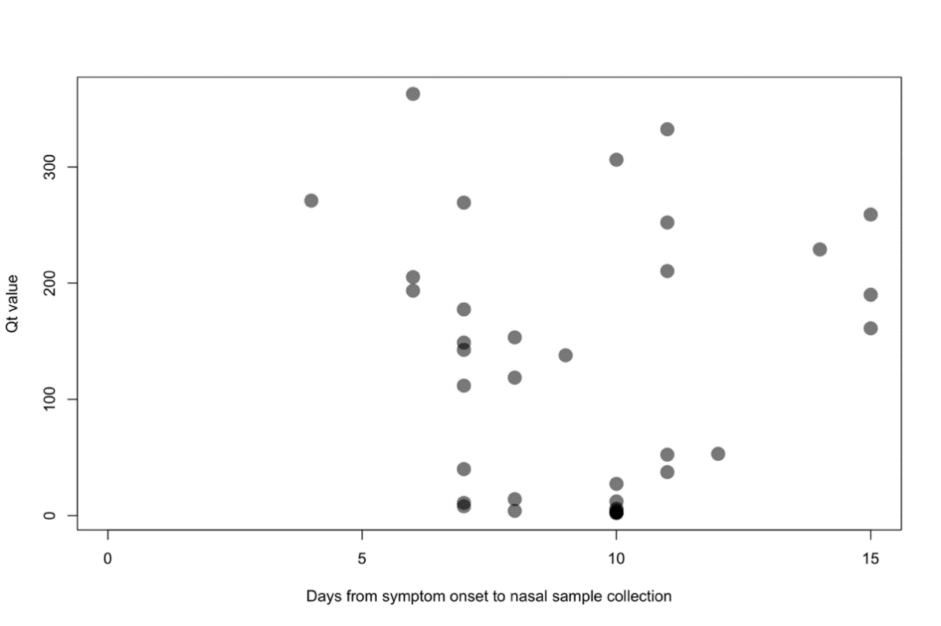
Figure S4: Quantitative threshold (QT) values of symptomatic HCoV cases by the number of days from symptom onset to nasal sample collection
Differences by strain

Supplemental model results
Table S6: Weekly community acquisition probability by strain and year for final model (no variation by age group)

Year | Strain | Estimate (95% CI)
2015-2016 | OC43 | 0.04 (0.02,0.06)
2015-2016 | 229E | 2.6x10⁻³ (3.3x10⁻⁴, 9.2x10⁻³)
2015-2016 | NL63 | 0.01 (0.004,0.02)
2015-2016 | HKU1 | 0.02 (0.01,0.03)
2016-2017 | OC43 | 0.05 (0.03,0.07)
2016-2017 | 229E | 0.03 (0.01,0.04)
2016-2017 | NL63 | 1.2x10⁻³ (4.1x10⁻⁵,6.2x10⁻³)
2016-2017 | HKU1 | 1.2x10⁻³ (3.7x10⁻⁵,6.3x10⁻³)

Although the overall community acquisition probability was not different between years, the distribution of strains was different. As a result, the model supported stratifying community acquisition probability by strain and year (Table S6). OC43 was the dominant strain in both years, whereas 229E appeared primarily in 2016-2017 and NL63 and HKU1 appeared only in 2015-2016.

Model results uncorrected for missing data
Table S7 shows the parameter estimates for the model with symptom-stratified transmission and age-stratified probability of symptoms without the correction for the swabbing process.

Table S7: Parameter estimates from the symptom-stratified model that did not correct for the swabbing process
Parameter | Estimate (95% CrI)
α₁ | 0.003 (0.002,0.004)
α₂ | 0.004 (0.003,0.005)
β_{asymp,k} | 0.09 (0.02,0.19)
β_{asymp,a} | 0.09 (0.02,0.19)
β_{symp,k} | 0.15 (0.09,0.21)
β_{symp,a} | 0.15 (0.09,0.21)
p_{sk} | 0.78 (0.68,0.86)
p_{sa} | 0.64 (0.50,0.76)
p_{ILIk} | 0.53 (0.40,0.65)
p_{ILIa} | 0.28 (0.14,0.44)

Posterior distributions of parameters in the model Symp in Table 3 are shown in Figure S5. The model Null in Table 3 shows a better fit to the observed probability of swabbing and household attack rate among swabbed households than the unstratified model (Figure 3 and Figure S6). However, this best fit model overestimates the probability of being swabbed and underestimates the household attack rate among swabbed households. Both observations could be explained by more within-household clustering of HCoV cases than we have accounted for with household transmission only; for example, between-household variation in community acquisition rate, probability of reporting symptoms, or accuracy of reporting symptoms. To account for this, we modeled the distribution of community-acquired infections as a beta-binomial to allow community-acquired infections to cluster by household. However, this did not improve the model fit or change the estimated parameters (data not shown).

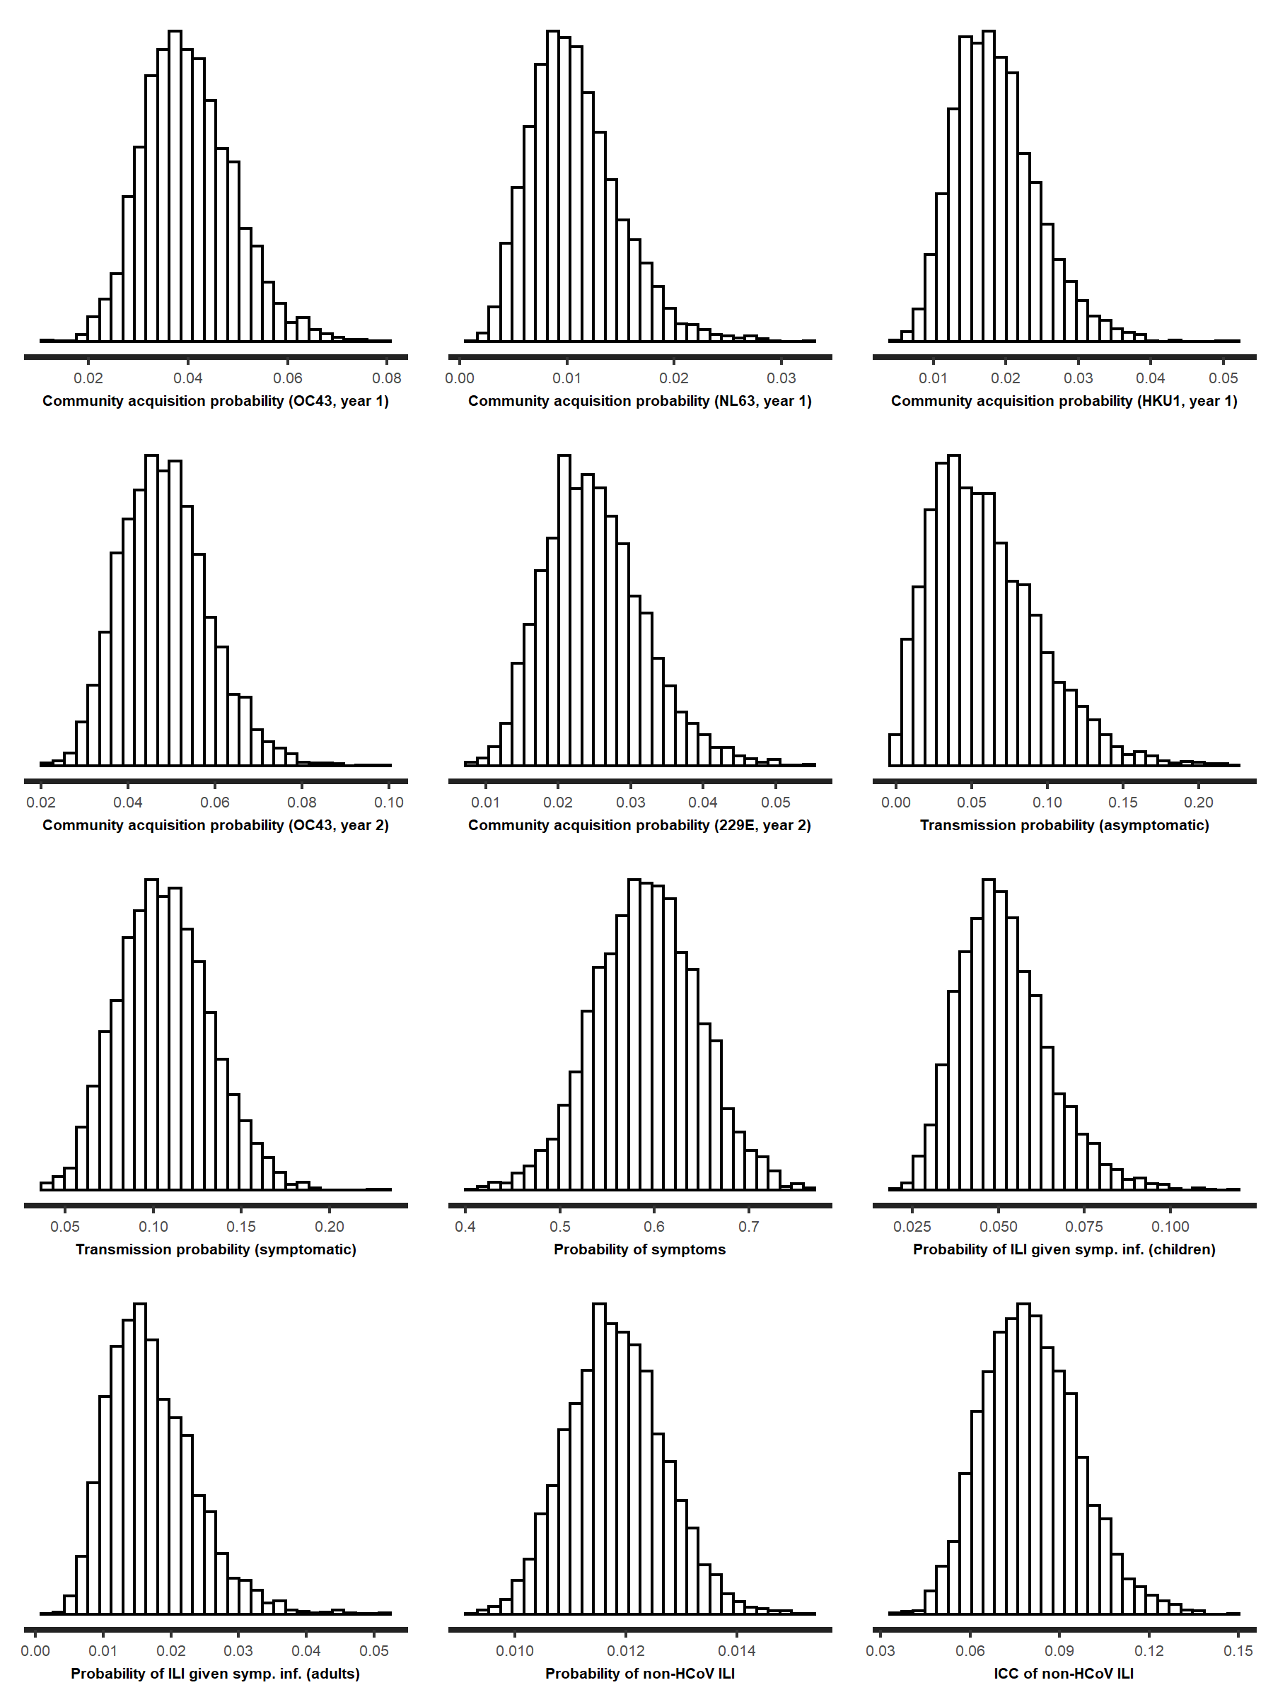
Figure S5: Posterior distributions of parameters in for best-fit model

Figure S6: Summary statistics for the basic, unstratified model. The left column shows the probability of being swabbed overall and by household size from the model posterior (boxplots) and observed (red triangles and 95% binomial confidence interval, red line). The right column shows the household attack rate among swabbed households overall and by household size, from the model posterior (boxplots) and observed (red triangles and 95% binomial confidence interval, red line).

In simulations, we found that the mismatch between the assumed probability of reporting ILI symptoms and the true probability did not affect coverage of the estimated within-household transmission probabilities. We ran the model with different priors for $p_{r}$, and we summarized the results in Table S8. The posterior estimate of $p_{r}$ when an uninformative prior was assumed was 0.18 (95% CrI 0.12,0.30). As seen in the model validation section, the best fit models underestimate the proportion of swabbed households, and reducing the reporting probability allows the model to fit the data better. We note that even in this case, estimates of household transmission parameters are unchanged.

Table S8: Parameter estimates assuming different prior distributions for probability of reporting ILI symptoms, in null model
Parameter | Estimate, p_{r}=0.9 (95% CrI) | Estimate, p_{r}=0.7 (95% CrI) | Estimate, no prior on p_{r} (95% CrI)
α₁ | 0.07 (0.05,0.10) | 0.07 (0.05,0.10) | 0.08 (0.06,0.11)
α₂ | 0.08 (0.05,0.10) | 0.08 (0.05,0.11) | 0.08 (0.06,0.11)
β | 0.09 (0.06,0.13) | 0.09 (0.06,0.13) | 0.09 (0.06,0.13)
p_{s} | 0.60 (0.49,0.70) | 0.60 (0.49,0.70) | 0.62 (0.51,0.72)
p_{ILIk} | 0.04 (0.03,0.07) | 0.06 (0.03,0.09) | 0.16 (0.09,0.26)
p_{ILIa} | 0.01 (0.006,0.03) | 0.02 (0.01,0.04) | 0.05 (0.02,0.11)
p_{NC} | 0.011 (0.010,0.012) | 0.013 (0.012,0.016) | 0.05 (0.03,0.07)

Simulation results

In simulated data sets, the model that failed to account for missing data among unswabbed households underestimated community infection probability, overestimated within-household transmission probability, and the probability of symptoms (Figure S7). The corrected model accurately estimated model parameters stratified by age with coverage close to 95% for a sample size of around 250 swabbed households (Figure S7 and Table S9).
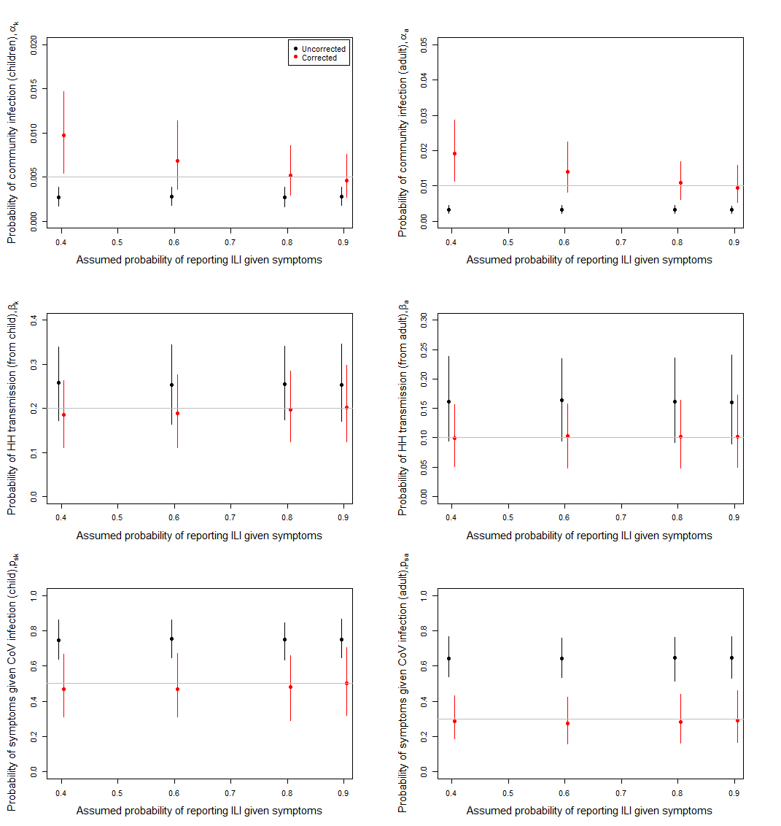
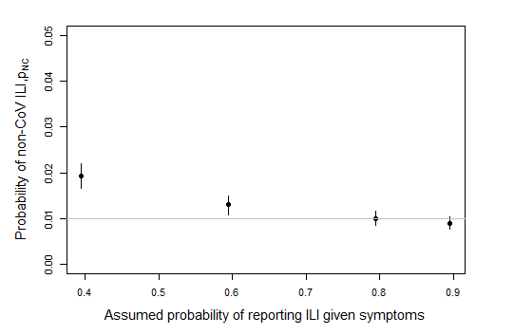
Figure S7: Estimated parameter values for 500 simulated data sets using an uncorrected likelihood for missing data (black) and corrected (red). True parameter values are horizontal lines. The value of reporting probability used to generate the data was 0.8.
Table S9: Proportion of simulations for which 95% CrI contains the true parameter across 500 simulated data sets, by the assumed probability of reporting ILI symptoms given that a person has them. The value of reporting probability used to generate the data was 0.8.
Assumed p_{r} | α_{k} | α_{a} | β_{k} | β_{a} | p_{sk} | p_{sa} | p_{NC}
Uncorrected | 5.0% | 0% | 78.9% | 60.0% | 1.6% | 0.1% | -
0.4 | 32.0% | 28.8% | 93.0% | 96.0% | 93.0% | 96.2% | 0.8%
0.6 | 76.4% | 73.6% | 95.2% | 96.4% | 93.2% | 94.0% | 7.6%
0.8 | 94.1% | 95.9% | 95.9% | 94.9% | 92.9% | 93.9% | 92.7%
0.9 | 93.6% | 94.0% | 94.2% | 94.0% | 94.0% | 94.4% | 64.2%

When the value of p_{r} assumed in the model fitting did not match the value of p_{r} used to generate the data, estimates of α and p_{NC} were biased (Figure S7). In particular, assuming that p_{r} was lower than its true value led to upward bias in both parameters as the model assumed more unreported infections than there truly were. Estimates of within-household transmission and probability of symptoms remained accurate, with coverage close to 95% (Table S9).
For the symptom-stratified model, we found that when the number of cases among swabbed households was around the number of cases in the SMART² data set, the corrected model accurately estimated model parameters even in the presence of missing data (Figure S8). Figure S8 shows estimated model parameters with an increasing proportion of households swabbed (through increasing the probability of non-HCoV ILI symptoms). As the probability of non-HCoV ILI symptoms decreases, the total number of households followed increases, so the average number of observed HCoV infections in swabbed households is 130 across studies. Estimated parameters for the corrected model (red) were accurate (lying on the gray lines), while the uncorrected model (black) underestimated community transmission and overestimated within-household transmission, probability of symptoms, and probability of ILI. For the corrected method, coverage for all parameters was close to 95%, whereas, for the uncorrected method, the coverage decreased as the proportion of unswabbed households increased (Table S10).

Figure S7
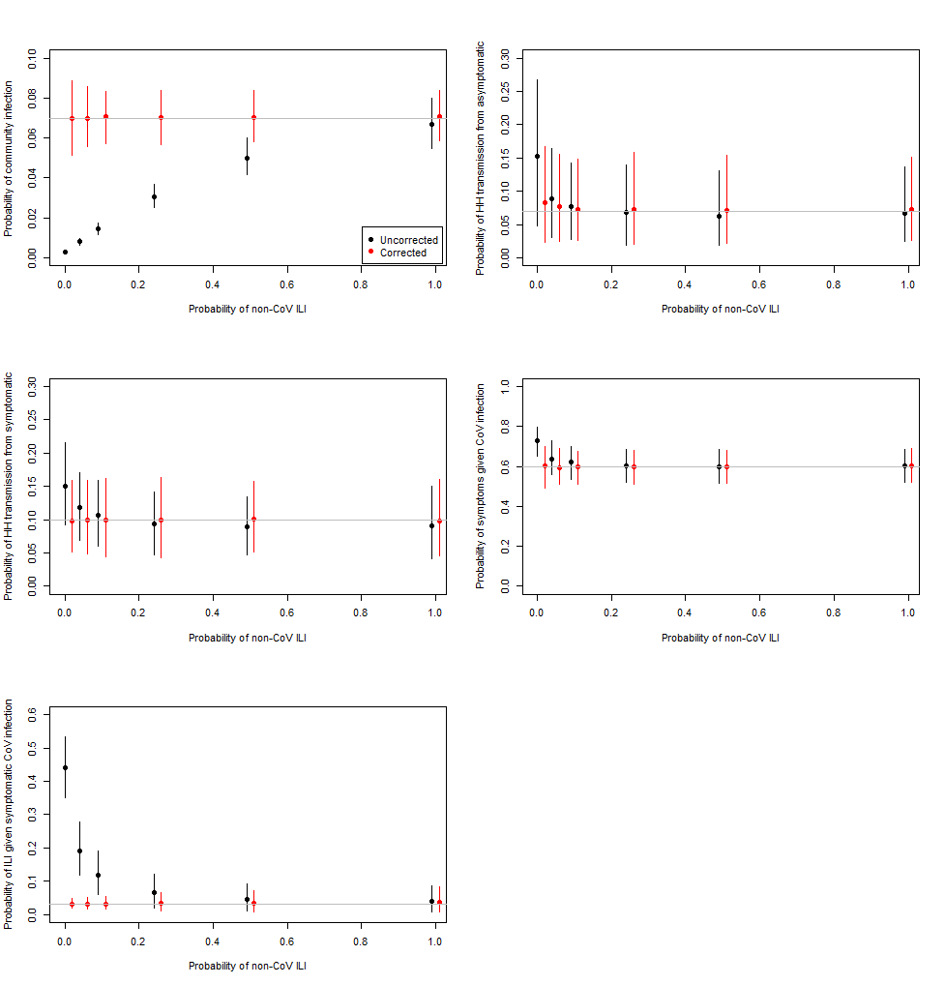
Figure S8: Estimated median parameter values for 500 simulated data sets with approximately 130 HCoV infections using a likelihood uncorrected for missing data (black) and corrected (red) by the probability of having a non-HCoV ILI (related to the degree of missing data). True parameter values are horizontal lines. Lines represent 2.5% and 97.5% quantiles, representing variation across simulations.

Table S9: Proportion of simulations for which 95% CrI contains the true parameter across 500 simulated data sets by the assumed probability of having a non-HCoV ILI.

 | Uncorrected |  |  |  |  | Corrected
p_{NC} | α | β_{asymp} | β_{symp} | p_{S} | p_{ILI} | α | β_{asymp} | β_{symp} | p_{S} | p_{ILI}
0.01 | 0.0% | 58.0% | 48.8% | 13.0% | 0.0% | 93.8% | 97.8% | 94.8% | 94.4% | 93.4%
0.05 | 0.0% | 92.4% | 86.2% | 84.6% | 0.0% | 94.0% | 95.8% | 95.8% | 94.8% | 94.8%
0.1 | 0.0% | 95.8% | 93.6% | 93.0% | 7.2% | 95.4% | 97.4% | 94.4% | 95.0% | 96.4%
0.25 | 0.0% | 95.0% | 94.4% | 94.6% | 61.2% | 93.8% | 95.0% | 95.0% | 94.6% | 94.2%
0.5 | 4.0% | 95.8% | 95.2% | 94.8% | 88.8% | 95.2% | 95.4% | 97.0% | 95.4% | 96.6%
1 | 93.0% | 98.0% | 94.8% | 94.6% | 94.0% | 96.6% | 97.2% | 94.8% | 94.6% | 94.8%

The power of simulated studies of a similar size to the SMART² database was low (Table S10). When the household transmission risk used to generate simulated data was lower among asymptomatic individuals, most models returned point estimates that were lower (Table S10, second column). However, these estimates were not separated (overlapping credible intervals). The DIC of the stratified model was smaller than the DIC of the unstratified model in a small proportion of the simulated studies. The power increased by each metric with increasing study size, but the power as determined by DIC was consistently lower.

Table S10: Estimated "power" of simulated studies of different sizes by four metrics for two transmission risk ratios

Transmission risk ratio  β_{symp}/β_{asymp} | Study size/ SMART² study size | β_{asymp}⁵⁰< β_{symp}⁵⁰ | β_{asymp}^{97.5}< β_{symp}⁵⁰ | β_{asymp}⁵⁰< β_{symp}^{2.5} | DIC_{strat}-DIC_{unstrat}<-2
2 | 1 | 79% | 15% | 45% | 11%
2 | 1.5 | 83% | 24% | 53% | 18%
2 | 2 | 88% | 33% | 66% | 27%
2 | 2.5 | 90% | 40% | 71% | 32%
2 | 3 | 92% | 41% | 72% | 29%
10 | 1 | 93% | 35% | 67% | 29%
10 | 1.5 | 97% | 55% | 83% | 47%
10 | 2 | 99% | 75% | 90% | 66%
10 | 2.5 | 100% | 83% | 96% | 73%
10 | 3 | 100% | 89% | 98% | 78%

