ATP-based assessments of organic surface contamination as indicators of recent cleaning and disinfection for high-touch surfaces in shared toilets
Supplementary Tables and Information
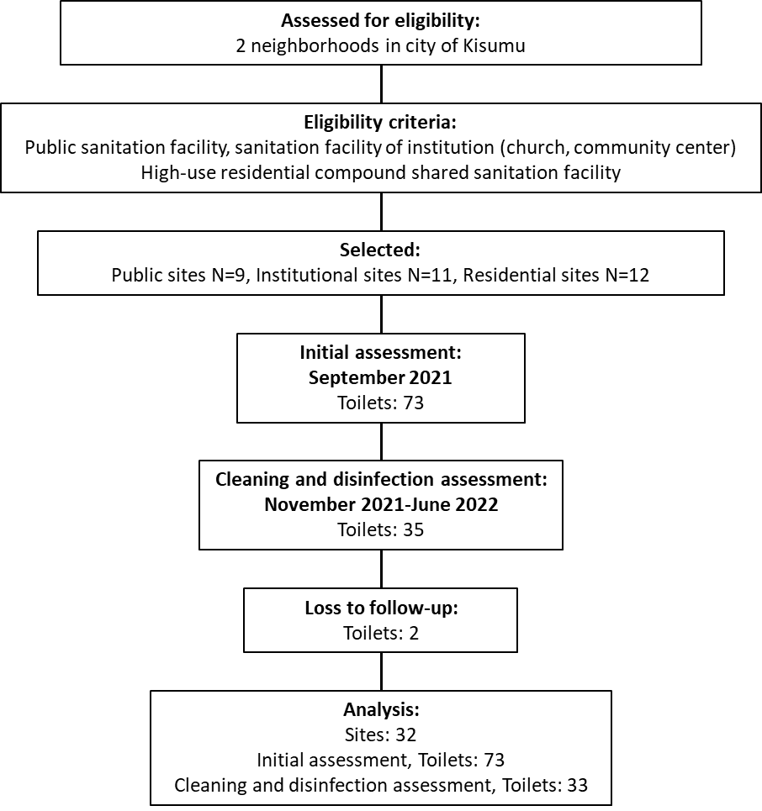
Supplementary Figure 1: Study flow diagram, Kisumu, Kenya
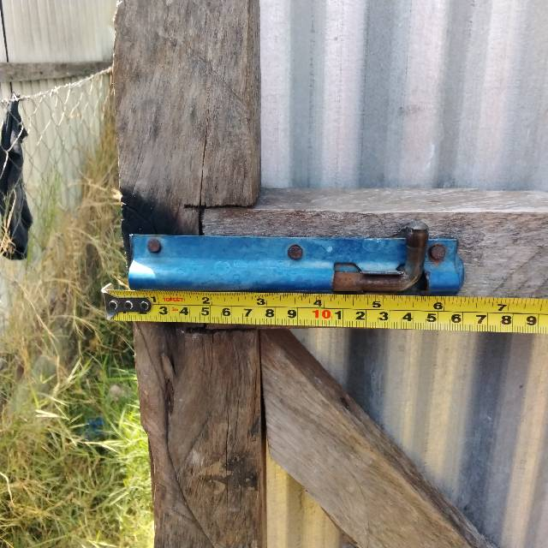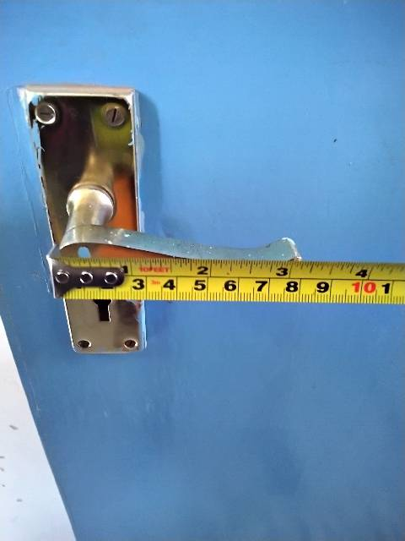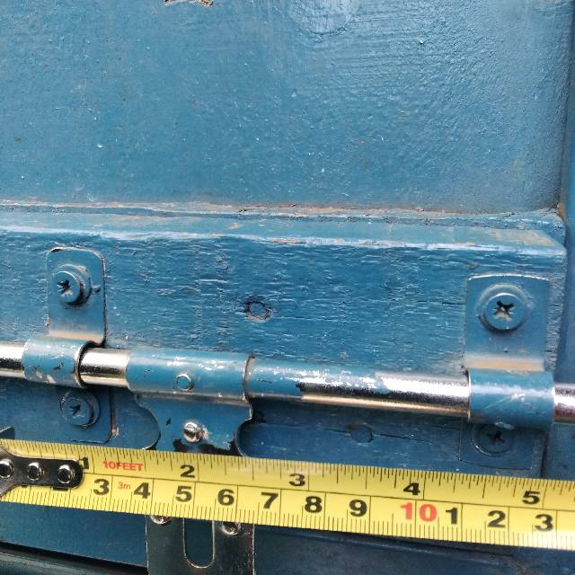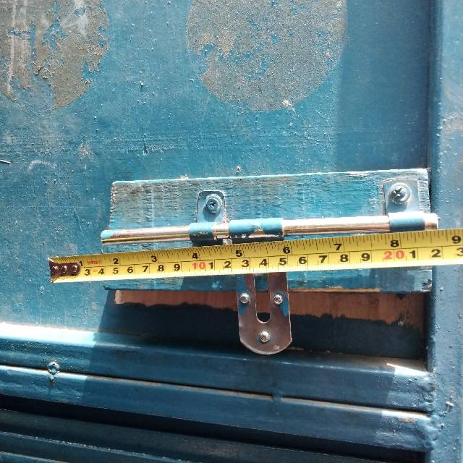
Supplementary Figure 2: Photographs of select high-touch surfaces sampled; inner door handles of shared toilets, Kisumu, Kenya

Supplementary Information: Approximate purchase price of ATP-testing equipment used to assess organic surface contamination in this study
- 3M™ Clean-Trace™ Surface ATP Test Swab: ~$5 / test swab
- 3M Clean-Trace® Surface Positive Controls: ~$7 / vial
- 3M™ Clean-Trace™ Luminometer LX25: ~$6,150 each

Supplementary Table 1: Site and latrine characteristics and toilet conditions through repeated observations in initial assessment, Kisumu, Kenya
 | Residential  N=12  N (%) | Public/  Commercial  N=9  n (%) | Institutional  N=11  n (%) | Overall  N=32  n (%)
Reported cleaning frequency
>= 2 times daily | 1 (8) | 5 (56) | 0 (0) | 6 (19)
Once a day | 8 (67) | 3 (33) | 6 (55) | 17 (53)
A few times a week | 3 (25) | 1 (11) | 4 (36) | 8 (25)
Once a week or less frequently | 0 (0) | 0 (0) | 1 (9) | 1 (3)
Water availability
Available on site | 7 (58) | 9 (100) | 7 (64) | 23 (72)
Available within 15 minutes | 5 (42) | 0 (0) | 4 (36) | 9 (28)
Primary cleaner
Attendant/dedicated cleaner | 2 (17) | 5 (56) | 5 (45) | 12 (38)
Residents | 7 (58) | 1 (11) | 2 (18) | 10 (31)
Toilet operator | 0 (0) | 3 (33) | 0 (0) | 3 (9)
Residential compound landlord | 2 (17) | 0 (0) | 0 (0) | 2 (6)
Volunteers | 1 (8) | 0 (0) | 4 (36) | 5 (16)
Reported daily user volume
>= 100 | 0 (0) | 3 (33) | 1 (9) | 4 (12)
50-99 | 3 (25) | 0 (0) | 0 (0) | 3 (9)
20-49 | 3 (25) | 4 (44) | 7 (64) | 14 (44)
10-19 | 4 (33) | 2 (22) | 2 (18) | 8 (25)
4-9 | 2 (17) | 0 (0) | 1 (9) | 3 (9)
Total Toilets | N=16 | N=31 | N=26 | N=73
Toilet type
Flush/pour-flush | 4 (25) | 26 (84) | 17 (65) | 47 (64)
Pit latrine | 2 (12) | 1 (3) | 4 (15) | 7 (10)
Container-based toilet | 10 (62) | 4 (13) | 5 (19) | 19 (26)
Toilet designation
Neither | 15 (94) | 5 (16) | 12 (46) | 32 (44)
Female | 0 (0) | 13 (42) | 8 (31) | 21 (29)
Male | 1 (6) | 13 (42) | 6 (23) | 20 (27)
Repeat Observations | N=80 | N=155 | N=130 | N=365
Time of Day
Early Morning < 8:29 hrs | 21 (26) | 29 (19) | 23 (18) | 73 (20)
Mid-Morning 8:30 – 11:59 hrs | 22 (28) | 36 (23) | 27 (21) | 85 (23)
Afternoon 12:00 – 15:59 hrs | 20 (25) | 37 (24) | 54 (42) | 111 (30)
Early Evening 16:00 – 17:59 hrs | 9 (11) | 45 (29) | 12 (9) | 66 (18)
Late Evening >18:00 hrs | 8 (10) | 8 (5) | 14 (11) | 30 (8)
Toilet conditions
Intact feces | 22 (28) | 10 (6) | 0 (0) | 32 (9)
Feces traces | 19 (24) | 11 (7) | 5 (4) | 35 (10)
Urine/water puddling | 17 (21) | 40 (26) | 16 (12) | 73 (20)
Rubbish | 15 (19) | 60 (39) | 23 (18) | 98 (27)
Toilet blocked/unusable | 38 (48) | 9 (6) | 1 (1) | 48 (13)

Supplementary Table 2: Comparison of organic surface contamination on high- and low-touch surfaces¹ in shared toilets in initial assessment, Kisumu, Kenya
Adjusted mean difference of log₁₀ RLUs/100 cm²
(95% CI)
Site Category
Residential | 0.83 (0.40, 1.26)
Public/Commercial | 0.66 (0.35, 0.97)
Institutional | 0.72 (0.50, 0.93)
Toilet Type
Flush/pour-flush | 0.80 (0.60, 1.00)
Pit latrine | 0.68 (0.09, 1.27)
Container-based toilet | 0.74 (0.48, 0.99)
Designation
None | 0.59 (0.38, 0.80)
Female | 0.85 (0.45, 1.26)
Male | 0.76 (0.42, 1.11)
Time of Day
Early Morning < 8:29hrs | 0.69 (0.41, 0.97)
Mid-Morning 8:30 – 11:59hrs | 0.74 (0.49, 0.99)
Afternoon 12:00 – 15:59hrs | 0.77 (0.50, 1.04)
Early Evening 16:00 – 17:59hrs | 0.70 (0.44, 0.96)
Late Evening >18:00hrs | 0.79 (0.43, 1.14)
¹Organic surface contamination was assessed for an area ~100cm² on door handles via ATP-based environmental swabbing
Mean difference of log₁₀ RLUs/100 cm² = mean log₁₀ RLU/100cm² on HT surfaces – mean log₁₀ RLU/100cm² on LT surfaces

Supplementary Table 3: Frequency and percentage (%) of surface material types in swab area and time of day for swabbing by toilet site type in cleaning and disinfection assessment, Kisumu, Kenya
 | Residential  N=84 | Public/  Commercial  N=48 | Institutional  N=66 | Overall  N=198
Surface material
Metal | 69 (82) | 37 (77) | 66 (100) | 172 (87)
Painted wood | 69 (82) | 41 (85) | 54 (82) | 164 (83)
Bare wood | 16 (19) | 8 (17) | 11 (17) | 35 (18)
Time of Day
Early Morning < 8:29hrs | 6 (7) | 4 (8) | 9 (14) | 19 (10)
Mid-Morning 8:30 – 11:59hrs | 55 (65) | 23 (48) | 47 (71) | 125 (63)
Afternoon 12:00 – 15:59hrs | 18 (21) | 15 (31) | 9 (14) | 42 (21)
Early Evening 16:00 – 17:59hrs | 5 (6) | 6 (12) | 1 (2) | 12 (6)

Supplementary Table 4: Cleaning products used during standard cleaning, round 1, in cleaning and disinfection assessment, Kisumu, Kenya
 | Frequency
Soap (liquid/bar) | 15
Detergent | 12
None | 3
Soap (liquid/bar) with bleach/disinfectant added to solution | 3

Supplementary Table 5: Frequency and percentage (%) of reported cleanings prior to cleaning and disinfection assessment visits, Kisumu, Kenya
 | Ref. 1  N=33 | Post-Std. 1  N=33 | Post-Disinf. 1  N=33 | Ref. 2  N=33 | Post-Std. 2  N=33 | Post-Disinf. 2  N=33
Toilet cleaned today before assessment visit | 1 (3) | -- | 12 (36) | 7 (21) | 14 (42) | 11 (33)
 | n=1 |  | n=12 | n=7 | n=14 | n=11
Door handles cleaned | 0 (0) | -- | 0 (0) | 0 (0) | 2 (14)* | 0 (0)
* In both instances of cleaner-reported cleaning of door handles prior to assessment visit, cleaners also reported using powdered detergent and liquid soap when cleaning the toilets overall but no disinfectants

Supplementary Table 6: (For subset of toilets selected for cleaning and disinfection assessment) Associations between toilet characteristics and organic surface contamination on high-touch surfaces¹ in shared toilets from initial assessment, Kisumu, Kenya
 | Adjusted log₁₀ difference in RLU/100cm²  (95% CI) | Adjusted mean RLU/100cm²  (95% CI)
Site Category
Residential | Ref. | 1,454 (770-2,745)
Public/Commercial | 0.11 (-0.26, 0.48) | 1,882 (1,026-3,451)
Institutional | 0.20 (-0.17, 0.57) | 2,308 (1,299-4,099)
Toilet Type
Flush/pour-flush | Ref. | 1,469 (840-2,570)
Pit latrine | 0.11 (-0.32, 0.55) | 1,906 (976-3,723)
Container-based toilet | 0.19 (-0.19, 0.57) | 2,254 (1,269-4,003)
Designation
None | Ref. | 2,141 (1,530-2,997)
Female | -0.13 (-0.73, 0.46) | 1,578 (526-4,734)
Male | -0.06 (-0.40, 0.28) | 1,868 (1,149-3,038)
Time of Day
Early Morning < 8:29hrs | Ref. | 1,935 (1,141-3,281)
Mid-Morning 8:30 – 11:59hrs | -0.13 (-0.51, 0.26) | 1,449 (799-2,627)
Afternoon 12:00 – 15:59hrs | -0.09 (-0.41, 0.22) | 1,566 (962-2,549)
Early Evening 16:00 – 17:59hrs | 0.07 (-0.24, 0.39) | 2,293 (1,450-3,627)
Late Evening >18:00hrs | 0.04 (-0.35, 0.44) | 2,142 (1,012-4,531)
¹Organic surface contamination was assessed for an area ~100cm² on door handles via ATP-based environmental swabbing

Supplementary table 7 (as shown in figures 2 & 3): Mean reductions in log₁₀ RLU¹ and adjusted mean RLU¹ on high-touch surfaces in shared toilets within cleaning and disinfection assessment, Kisumu, Kenya
Cleaning and disinfection procedure² | Adjusted difference in mean log₁₀ RLU/100cm²  (95% CI) | Adjusted mean RLU/100cm²  (95% CI)
Residential/Institutional
Reference 1 | Ref. | 4,698 (2,380-9,275)
Post-Standard 1: no disinfection | -0.18 (-0.57, 0.21) | 3,137 (1,614-6,097)
Post-Recommended 1: 0.5% chlorine solution | -0.99 (-1.37, -0.60) | 483 (227-1,030)
Reference 2 | Ref. | 6,968 (3,303-14,698)
Post-Standard 2: 0.02% chlorine solution | -0.50 (-0.96, -0.05) | 2,191 (822-5,837)
Post-Recommended 2: 0.1% chlorine solution | -0.93 (-1.27, -0.59) | 820 (371-1,814)
Public/Commercial
Reference 1 | Ref. | 13,243 (5,420-32,358)
Post-Standard 1: no disinfection | -0.56 (-0.84, -0.28) | 3,628 (1,157-11,381)
Post-Recommended 1: 0.5% chlorine solution | -1.61 (-2.43, -0.79) | 324 (98-1,070)
Reference 2 | Ref. | 10,532 (2,612-42,473)
Post-Standard 2: 0.02% chlorine solution | -0.87 (-1.39, -0.35) | 1,417 (436-4,609)
Post-Recommended 2: 0.1% chlorine solution | -1.16 (-1.77, -0.55) | 728 (212-2,496)
¹Relative light unit
²Cleaning and disinfection procedures described in Table 2

Supplementary table 8: Frequency of high-touch surfaces that meet cleanliness threshold¹ by cleaning procedure² and site category in cleaning and disinfection assessment, Kisumu, Kenya
Cleaning and disinfection procedure | Obs. | Median  log₁₀ RLU  [IQR] | Pass  <1,000  RLU³ | Fail  ≥1,000  RLU³ | Pass  <500  RLU³ | Fail  ≥500  RLU³ | Pass  <250  RLU³ | Fail  ≥250  RLU³
Total
Reference 1 | 33 | 3.68 [3.48-3.88] | 1 (3) | 32 (97) | 0 (0) | 33 (100) | 0 (0) | 33 (100)
Post-Standard 1 | 33 | 3.47 [3.02-3.77] | 7 (21) | 26 (79) | 1 (3) | 32 (97) | 0 (0) | 33 (100)
Post-Rec. 1 | 33 | 2.62 [2.30-3.06] | 24 (73) | 9 (27) | 19 (58) | 14 (42) | 12 (36) | 21 (64)
Reference 2 | 33 | 3.81 [3.46-4.10] | 1 (3) | 32 (97) | 0 (0) | 33 (100) | 0 (0) | 33 (100)
Post-Standard 2 | 33 | 3.33 [2.82-3.76] | 13 (39) | 20 (61) | 7 (21) | 26 (79) | 5 (15) | 28 (85)
Post-Rec. 2 | 33 | 2.71 [2.36-3.36] | 19 (58) | 14 (42) | 16 (48) | 17 (52) | 10 (30) | 23 (70)
Public/Commercial
Reference 1 | 8 | 4.01 [3.68-4.40] | 0 (0) | 8 (100) | 0 (0) | 8 (100) | 0 (0) | 8 (100)
Post-Standard 1 | 8 | 3.55 [3.08-3.71] | 2 (25) | 6 (75) | 0 (0) | 8 (100) | 0 (0) | 8 (100)
Post-Rec. 1 | 8 | 2.46 [2.29-2.58] | 7 (88) | 1 (12) | 7 (88) | 1 (12) | 4 (50) | 4 (50)
Reference 2 | 8 | 4.11 [3.34-4.32] | 0 (0) | 8 (100) | 0 (0) | 8 (100) | 0 (0) | 8 (100)
Post-Standard 2 | 8 | 3.19 [2.67-3.62] | 3 (38) | 5 (62) | 3 (38) | 5 (62) | 1 (12) | 7 (88)
Post-Rec. 2 | 8 | 2.69 [2.56-2.89] | 6 (75) | 2 (25) | 4 (50) | 4 (50) | 2 (25) | 6 (75)
Residential/Institutional
Reference 1 | 25 | 3.65 [3.38-3.82] | 1 (4) | 24 (96) | 0 (0) | 25 (100) | 0 (0) | 25 (100)
Post-Standard 1 | 25 | 3.47 [3.02-3.77] | 5 (20) | 20 (80) | 1 (4) | 24 (96) | 0 (0) | 25 (100)
Post-Rec. 1 | 25 | 2.76 [2.35-3.16] | 17 (68) | 8 (32) | 12 (48) | 13 (52) | 8 (32) | 17 (68)
Reference 2 | 25 | 3.68 [3.53-4.03] | 1 (4) | 24 (96) | 0 (0) | 25 (100) | 0 (0) | 25 (100)
Post-Standard 2 | 25 | 3.33 [2.85-3.76] | 10 (40) | 15 (60) | 4 (16) | 21 (84) | 4 (16) | 21 (84)
Post-Rec. 2 | 25 | 2.90 [2.34-3.38] | 13 (52) | 12 (48) | 12 (48) | 13 (52) | 8 (32) | 17 (68)
¹ATP-based cleanliness thresholds selected from previously published studies that sampled toilets ^{1–3}
²Cleaning and disinfection procedures are described in Table 2
³Relative light unit

Supplementary table 9: Example ATP pass-fail limits for assessing cleanliness of high-touch surfaces in shared toilets in Kenya using 3M™ Clean-Trace™ Luminometer LX25, based on study data, according to previously published methodology⁴, Kisumu, Kenya
 | Pass (RLU/100cm²) | Caution (RLU/100cm²) | Fail (RLU/100cm²)
General
Overall | < 595 | 595 – 1,530 | > 1,530
Sub-Categories
Public toilets | < 520 | 520 – 2,540 | >2,540
Other shared toilets | < 635 | 635 – 1,665 | >1,665
RLU: Relative Light Unit

References
1. Lewis, T., Griffith, C., Gallo, M. & Weinbren, M. A modified ATP benchmark for evaluating the cleaning of some hospital environmental surfaces. Journal of Hospital Infection 69, 156–163 (2008).
2. Cannon, J. L. et al. Hygienic monitoring in long-term care facilities using ATP, crAssphage, and human noroviruses to direct environmental surface cleaning. Am J Infect Control 50, 289–294 (2022).
3. Cunningham, A. E., Rajagopal, R., Lauer, J. & Allwood, P. Assessment of hygienic quality of surfaces in retail food service establishments based on microbial counts and real-time detection of ATP. J Food Prot 74, 686–690 (2011).
4. Bakke, M. A Comprehensive Analysis of ATP Tests: Practical Use and Recent Progress in the Total Adenylate Test for the Effective Monitoring of Hygiene. J Food Prot 85, 1079–1095 (2022).

