Supplementary Figure 1: Day After Conception When Folic Acid Supplementation Began by Treatment Arm

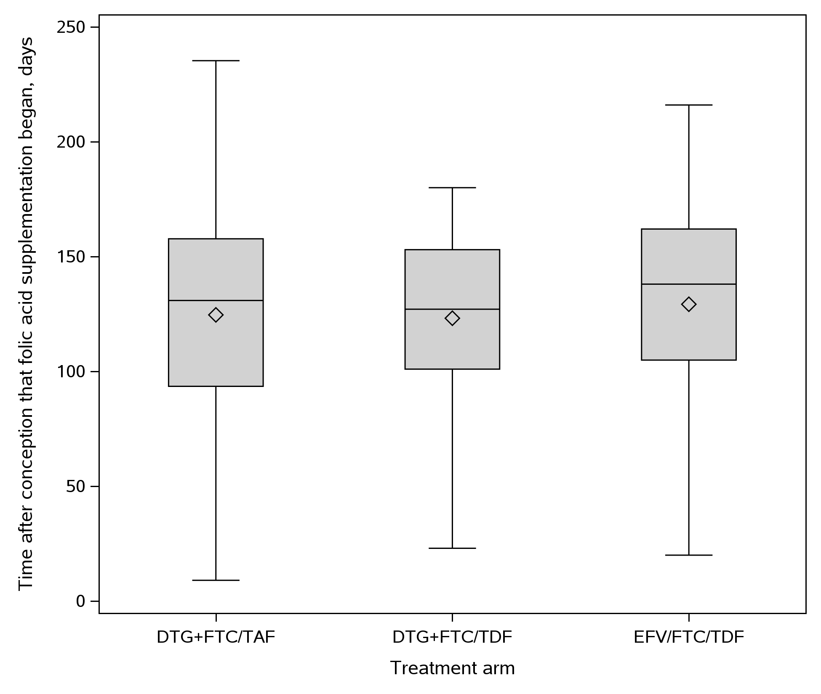

Box plot: Diamond is the mean. The box indicates median and interquartile range. The whiskers indicate the minimum and maximum data values not including outliers. Outliers are those points > 75th percentile + 1.5 * IQR or analogous points below.

