Supplementary Material — A case-cohort study of per- and polyfluoroalkyl substance concentrations and incident prostate cancer in the Cancer Prevention Study-II LifeLink Cohort study; Troeschel, et al.

Supplemental Methods
Gleason’s Score
Gleason’s score was reported in different ways during different years and was primarily based on collaborative staging site-specific factors¹ (CS-SSF) for cases diagnosed in 2004 or later. We used the following hierarchy to infer Gleason’s score. First, we used the highest Gleason’s score reported, based on either the needle core biopsy/transurethral resection of the prostate (CS-SSF 8) or prostatectomy/autopsy (CS-SSF 10) when available (for cases diagnosed in 2010 or later, based on collaborative staging version 2). If CS-SSF 8 and CS-SSF 10 were unavailable, and the case was diagnosed in 2004 or later, we used the historical Gleason’s score based on collaborative staging version 1 (CS-SSF 6), which did not specify the procedure for which Gleason’s score was obtained (e.g., need core biopsy, prostatectomy). Additional details on the CS-SSF for prostate cancer are found elsewhere². If all CS-SSF with information on Gleason’s score were unavailable or the case was diagnosed prior to 2004, then we used a historical Gleason’s score used before collaborative staging was developed. If Gleason’s score could not be obtained based on the previous information (n=166), we inferred Gleason’s score based on the degree of tumor differentiation and year of cancer diagnosis, if available (n=138, Supplemental Table 1). We could not infer Gleason’s score for 28 cases. We then used the inferred Gleason’s score to categorize tumor grade: low-grade (Gleason’s score <7), intermediate-grade (Gleason’s score = 7), and high-grade (Gleason’s score >7).
Other Covariate Considerations
Given that PSA screening is associated with a prostate cancer diagnosis, we thought that it might be important to consider PSA screening as a potential confounder. However, PSA screening at baseline was not associated with PFAS concentrations (Supplemental Table 4) among sub-cohort participants. In addition, exclusion of PSA screening at baseline as a covariate in models led to model estimates within 10% of those obtained from models that included this variable (Supplemental Table 5). Therefore, PSA screening was not included in further analyses.
Similarly, given that the U.S. Department of Defense began using PFAS in fire-fighting foams in the 1970s³, we thought that prior military service, particularly service after 1970, may be associated with PFAS concentrations, and could be a possible confounder. However, prior military service (never, service entirely before 1970, service in 1970 or later) was not associated with the risk of prostate cancer in age-adjusted models (p=0.1079). In addition, exclusion of military service as a covariate in models led to model estimates within 10% of those obtained from models that included this variable (Supplemental Table 5). Therefore, military service was not included in further analyses. Other occupations associated with PFAS exposure were also considered, but there were either too few people within a given occupation (e.g., only 1 sub-cohort participant was a firefighter) or we did not have the level of detail needed to adequately control for occupations associated with PFAS exposure.
We decided not to include body mass index (BMI) as a covariate in our main models because obesity might be on the causal pathway between PFAS concentrations and prostate cancer, and controlling for BMI would likely result in an underestimation of the effect. However, we acknowledge that it is possible that BMI is not on the causal pathway and might instead confound the relationship between PFAS and prostate cancer. Therefore, we conducted a sensitivity analysis in which we controlled for BMI in addition to the other covariates in our main models (age at serum collection, year of serum collection, race and ethnicity, education, smoking status, and alcohol use). The results of this analysis yielded results very similar to our models without BMI as a covariate (Supplemental Table 6). Therefore, we did not consider BMI in further analyses. We did not include batching as a covariate because batching was conducted independently of prostate cancer status. Samples from both case participants and sub-cohort participants were sent to the lab in mixed batches (the lab was blinded to the case status), and all sample testing was completed within a few weeks. Therefore, we would not expect batching to confound the relationship between PFAS and prostate cancer.
Rationale for Selection of Interaction Variables
To investigate whether the association between PFAS and prostate cancer is modified by selected characteristics, we conducted several interaction analyses. Some covariates (family history of prostate cancer, age) were selected as interaction variables primarily because of their potential for a true biological interaction. For example, it is possible that inherited genetic mutations associated with a family history of prostate cancer could interact with PFAS to impact prostate cancer risk. Others (education, smoking, alcohol) were selected primarily because one level of the variable might represent a group that would have a lower potential for bias due to residual or uncontrolled confounding. For example, the potential for residual confounding by carcinogens in cigarette smoke is high among former and current smokers but theoretically, should not be an issue among the never smokers (assuming those who reported never smoking truly never smoked). We did not consider BMI in interaction analyses due to the causal structure described above, and the potential for collider stratification bias.⁴

Supplemental Tables

Supplemental Table 1. Algorithm for Inferring Missing Gleason’s Scores (n=166)

SEER Grade | Terminology | Categorization | Year of Diagnosis
SEER Grade | Terminology | Categorization | <2003 | 2003–2013 | >2013
1 | Well Differentiated | Inferred Gleason’s Score | 2–4 | 2–4 | 2–6
1 | Well Differentiated | Grade categorization | Low-grade | Low-grade | Low-grade
2 | Moderately Differentiated | Inferred Gleason’s Score | 5–7 | 5–6 | 7
2 | Moderately Differentiated | Grade categorization | Low-grade | Low-grade | Intermediate-grade
3 | Poorly Differentiated | Inferred Gleason’s Score | 8–10 | 7–10 | 8–10
3 | Poorly Differentiated | Grade categorization | High-grade | High-grade | High-grade
Inferred Gleason’s scores depend on both the degree of differentiation and year of diagnosis to align with the coding system from the Surveillance, Epidemiology, and End Results (SEER) Program (SEER Program Coding and Staging Manual 2016 (cancer.gov). The table and corresponding text describing SEER’s coding algorithm can be found on page 101.

Supplemental Table 2. Multivariableª Associations of Per- and Polyfluoroalkyl Substance Concentrations with Prostate Cancer According to Age Categories in the Case-Cohort Study of PFAS and Cancer Incidence in the Cancer Prevention Study-II LifeLink Cohort, United States, 1998–2015 (n=2,090)^{b}
 |  | Age at Blood Sample Collection
PFAS | Quartile | <65 years |  | 65-69 years |  | 70-74 years |  | 75+ years
 |  | N Cases/ N Sub-cohort | HR (95% CI) | N Cases/ N Sub-cohort | HR (95% CI) | N Cases/ N Sub-cohort | HR (95% CI) | N Cases/ N Sub-cohort | HR (95% CI)
PFHxS | Q1 | 62/15 | 1.00 (Ref) | 125/30 | 1.00 (Ref) | 95/58 | 1.00 (Ref) | 63/17 | 1.00 (Ref)
 | Q2 | 84/25 | 0.72 (0.35, 1.49) | 159/38 | 1.11 (0.66, 1.86) | 137/27 | 3.48 (2.10, 5.79) | 62/29 | 0.49 (0.24, 0.98)
 | Q3 | 89/19 | 0.95 (0.46, 1.94) | 163/51 | 0.86 (0.53, 1.41) | 120/32 | 2.43 (1.44, 4.09) | 60/24 | 0.52 (0.26, 1.06)
 | Q4 | 79/21 | 0.79 (0.37, 1.66) | 129/37 | 0.95 (0.56, 1.62) | 125/39 | 2.27 (1.40, 3.68) | 47/29 | 0.44 (0.21, 0.94)
 | Continuous |  | 0.97 (0.75, 1.26) |  | 1.01 (0.85, 1.20) |  | 1.30 (1.10, 1.53) |  | 0.83 (0.67, 1.04)
PFNA | Q1 | 70/20 | 1.00 (Ref) | 133/32 | 1.00 (Ref) | 128/43 | 1.00 (Ref) | 58/20 | 1.00 (Ref)
 | Q2 | 66/19 | 0.80 (0.39, 1.62) | 129/39 | 0.68 (0.40, 1.16) | 93/47 | 0.76 (0.46, 1.24) | 49/22 | 0.77 (0.37, 1.59)
 | Q3 | 85/16 | 1.07 (0.52, 2.22) | 175/48 | 0.87 (0.53, 1.42) | 113/36 | 1.17 (0.68, 2.01) | 57/21 | 1.07 (0.51, 2.24)
 | Q4 | 93/25 | 0.79 (0.41, 1.53) | 139/37 | 0.82 (0.49, 1.37) | 143/30 | 2.22 (1.32, 3.73) | 68/36 | 0.65 (0.32, 1.32)
 | Continuous |  | 0.99 (0.74, 1.31) |  | 0.95 (0.76, 1.18) |  | 1.21 (1.00, 1.46) |  | 0.90 (0.69, 1.16)
PFOA | Q1 | 57/11 | 1.00 (Ref) | 126/33 | 1.00 (Ref) | 136/44 | 1.00 (Ref) | 79/24 | 1.00 (Ref)
 | Q2 | 69/21 | 0.37 (0.16, 0.86) | 133/31 | 1.44 (0.83, 2.50) | 105/41 | 0.86 (0.52, 1.43) | 44/28 | 0.56 (0.29, 1.07)
 | Q3 | 93/21 | 0.54 (0.25, 1.19) | 178/50 | 1.08 (0.65, 1.80) | 117/37 | 1.26 (0.76, 2.07) | 66/26 | 0.83 (0.44, 1.57)
 | Q4 | 95/27 | 0.36 (0.17, 0.77) | 139/42 | 1.02 (0.60, 1.72) | 119/34 | 1.44 (0.87, 2.41) | 43/21 | 0.70 (0.35, 1.40)
 | Continuous |  | 0.64 (0.46, 0.89) |  | 0.87 (0.67, 1.13) |  | 1.33 (0.98, 1.80) |  | 1.06 (0.78, 1.44)
PFOS | Q1 | 66/16 | 1.00 (Ref) | 131/37 | 1.00 (Ref) | 131/46 | 1.00 (Ref) | 61/24 | 1.00 (Ref)
 | Q2 | 67/15 | 0.81 (0.37, 1.77) | 120/27 | 1.43 (0.84, 2.43) | 75/33 | 0.98 (0.58, 1.65) | 39/28 | 0.46 (0.22, 0.96)
 | Q3 | 89/27 | 0.56 (0.27, 1.15) | 192/47 | 1.32 (0.81, 2.14) | 151/44 | 1.53 (0.95, 2.45) | 69/23 | 0.93 (0.45, 1.90)
 | Q4 | 92/22 | 0.75 (0.36, 1.56) | 133/45 | 1.01 (0.62, 1.64) | 120/33 | 1.81 (1.09, 2.98) | 63/24 | 1.19 (0.60, 2.35)
 | Continuous |  | 0.82 (0.59, 1.13) |  | 0.88 (0.71, 1.08) |  | 1.26 (1.01, 1.58) |  | 1.21 (0.92, 1.61)
ª Adjusts for age, year of blood sample collection, education, alcohol use, smoking status, race. Age violated the proportional hazards assumption, so interaction models account for this by including dummy variables representing the product terms between the PFAS of interest and the dummy coded age categories as covariates in the model, and including single year of age in the STRATA statement of SAS PROC PHREG. Smoking status (ever smoker, never smoker) also violated the proportional hazards assumption, and was included in the STRATA statement.
^{b} Excludes participants missing information on one or more covariates in the model (n=20).
Supplemental Table 3. Associations of Per- and Polyfluoroalkyl Substance Concentrations with Prostate Cancer According to Age Categories in the Case-Cohort Study of PFAS and Cancer Incidence in the Cancer Prevention Study-II LifeLink Cohort, United States, 1998–2015 (n=2,110)

PFAS | Age Category | Model 1ª  Hazard Ratio per Concentration Doubling  (log₂ continuous measure) | Model 2^{b}  Hazard Ratio per Concentration Doubling  (log₂ continuous measure)
PFHxS | <65 years | 0.97 (0.75, 1.26) | 0.96 (0.76, 1.23)
 | 65-69 years | 1.01 (0.85, 1.20) | 0.95 (0.80, 1.14)
 | 70-74 years | 1.30 (1.10, 1.53) | 1.26 (1.07, 1.50)
 | 75+ years | 0.83 (0.67, 1.04) | 0.85 (0.69, 1.05)
PFNA | <65 years | 0.99 (0.74, 1.31) | 1.03 (0.77, 1.37)
 | 65-69 years | 0.95 (0.76, 1.18) | 0.93 (0.74, 1.18)
 | 70-74 years | 1.21 (1.00, 1.46) | 1.13 (0.94, 1.36)
 | 75+ years | 0.90 (0.69, 1.16) | 0.92 (0.75, 1.14)
PFOA | <65 years | 0.64 (0.46, 0.89) | 0.72 (0.52, 1.01)
 | 65-69 years | 0.87 (0.67, 1.13) | 0.81 (0.63, 1.05)
 | 70-74 years | 1.33 (0.98, 1.80) | 1.18 (0.88, 1.57)
 | 75+ years | 1.06 (0.78, 1.44) | 1.03 (0.74, 1.43)
PFOS | <65 years | 0.82 (0.59, 1.13) | 0.85 (0.58, 1.25)
 | 65-69 years | 0.88 (0.71, 1.08) | 0.85 (0.68, 1.06)
 | 70-74 years | 1.26 (1.01, 1.58) | 1.17 (0.93, 1.46)
 | 75+ years | 1.21 (0.92, 1.61) | 1.18 (0.89, 1.56)

ª Adjusts for age, year of blood sample collection, education, alcohol use, smoking status, race. Age and smoking status violated the proportional hazards assumption, so models adjust for these variables using a stratified Cox procedure, stratifying the baseline hazard on single year of age and smoking status (ever smoker, never smoker) and interactions with age were modeled by including the PFAS of interest and dummy variables representing the product terms between the PFAS of interest and the dummy coded age categories as covariates in the model. These results were originally presented in Supplemental Table 2 but are included here for ease of comparison with the unadjusted models. Participants missing information on one or more covariates in the model were dropped from the model (n=20).
^{b} Unadjusted model. Age violated the proportional hazards assumption, so interactions were modeled by including the PFAS of interest and dummy variables representing the product terms between the PFAS of interest and the dummy coded age categories as covariates in the model, using a stratified Cox procedure, stratifying the baseline hazard on category of age (<65 years, 65-69 years, 70-74 years, and 75+ years).
Supplemental Table 4. PFAS concentrationsª by PSA screening status at baseline among subcohort participants (n=470^{b})
PFAS | No PSA Screening  N = 43 | PSA Screen <2 years  N = 390 | PSA Screen >2 years  N = 37 | P-value^{c}
PFHxS | 4.6 ± 5.81 | 4.8 ± 6.12 | 3.8 ± 2.74 | 0.6160
PFNA | 0.7 ± 0.35 | 1.1 ± 4.18 | 0.8 ± 0.40 | 0.0598
PFOA | 6.6 ± 5.74 | 6.1 ± 3.59 | 6.3 ± 5.93 | 0.6901
PFOS | 20.5 ± 11.59 | 22.0 ± 13.62 | 19.0 ± 9.09 | 0.5303
ª Values above are means ± standard deviations, in ng/mL.
^{b} 30 subcohort participants were missing data on PSA screening and excluded from the table above.
^{c} P-value for the F-test from an ANOVA model, where the outcome was the log₂-transformed PFAS of interest and the exposure was the 3-level PSA screening at baseline variable.

Supplemental Table 5. Multivariable Associations of Per- and Polyfluoroalkyl Substance Concentrations and Incident Prostate Cancer in the Case-Cohort Study of PFAS and Cancer Incidence in the Cancer Prevention Study-II Lifelink Cohort, United States, 1998–2015 (n=2,090)ª
PFAS Type | Category | Cases | Sub-cohort | Model 1^{b} HR (95%CI)  Primary Model | Model 2^{c} HR (95%CI)  Primary Model + Baseline PSA Screening | Model 3^{d} HR (95%CI)  Primary Model + Military Service
PFHxS | Q1: 0.14–2.00 ng/mL | 346 | 124 | 1.00 (-) | 1.00 (-) | 1.00 (-)
 | Q2: 2.10–3.20 ng/mL | 445 | 121 | 1.36 (1.01, 1.83) | 1.46 (1.07, 1.99) | 1.37 (1.01, 1.85)
 | Q3: 3.30–5.20 ng/mL | 437 | 129 | 1.18 (0.88, 1.59) | 1.25 (0.92, 1.70) | 1.24 (0.92, 1.67)
 | Q4: 5.30–95.0 ng/mL | 382 | 126 | 1.18 (0.88, 1.59) | 1.20 (0.89, 1.64) | 1.20 (0.89, 1.62)
 | Continuous^{e} |  |  | 1.06 (0.96, 1.17) | 1.06 (0.96, 1.18) | 1.07 (0.97, 1.18)
PFNA | Q1: 0.06–0.48 ng/mL | 392 | 118 | 1.00 (-) | 1.00 (-) | 1.00 (-)
 | Q2: 0.49–0.66 ng/mL | 337 | 130 | 0.75 (0.56, 1.01) | 0.79 (0.58, 1.08) | 0.77 (0.57, 1.04)
 | Q3: 0.67–0.98 ng/mL | 434 | 124 | 1.03 (0.76, 1.39) | 0.99 (0.72, 1.35) | 1.04 (0.77, 1.40)
 | Q4: 0.99–80.0 ng/mL | 447 | 128 | 1.05 (0.77, 1.41) | 1.02 (0.75, 1.40) | 1.11 (0.82, 1.51)
 | Continuous^{e} |  |  | 1.03 (0.92, 1.16) | 1.01 (0.90, 1.15) | 1.05 (0.93, 1.19)
PFOA | Q1: 0.35–3.90 ng/mL | 401 | 116 | 1.00 (-) | 1.00 (-) | 1.00 (-)
 | Q2: 4.00–5.10 ng/mL | 355 | 124 | 0.89 (0.65, 1.20) | 0.87 (0.64, 1.19) | 0.92 (0.68, 1.26)
 | Q3: 5.20–6.90 ng/mL | 455 | 135 | 1.01 (0.75, 1.35) | 1.02 (0.76, 1.39) | 1.08 (0.80, 1.45)
 | Q4: 7.00–90.0 ng/mL | 399 | 125 | 0.93 (0.69, 1.25) | 0.91 (0.67, 1.24) | 0.96 (0.71, 1.30)
 | Continuous^{e} |  |  | 0.95 (0.82, 1.10) | 0.96 (0.82, 1.12) | 0.96 (0.83, 1.12)
PFOS | Q1: 0.35–13.0 ng/mL | 391 | 125 | 1.00 (-) | 1.00 (-) | 1.00 (-)
 | Q2: 14.0–17.0 ng/mL | 304 | 105 | 1.01 (0.75, 1.37) | 1.00 (0.73, 1.36) | 1.05 (0.77, 1.43)
 | Q3: 18.0–25.0 ng/mL | 504 | 145 | 1.17 (0.88, 1.56) | 1.16 (0.87, 1.56) | 1.21 (0.91, 1.62)
 | Q4: 26.0–160 ng/mL | 411 | 125 | 1.18 (0.89, 1.58) | 1.11 (0.82, 1.50) | 1.22 (0.91, 1.63)
 | Continuous^{e} |  |  | 1.02 (0.90, 1.16) | 1.00 (0.88, 1.14) | 1.03 (0.91, 1.17)
ª Excludes participants missing information on one or more covariates (n=20).
^{b} Adjusts for age, year of blood sample collection, education, alcohol use, smoking status, race. Age and smoking status violated the proportional hazards assumption, so models adjust for these variables using a stratified Cox procedure, stratifying the baseline hazard on single year of age and smoking status (ever smoker, never smoker).
^{c} Includes same covariates as in Model 1 and additionally adjusts for PSA screening at baseline (never, <2 years, >2 years). A total of 110 participants were missing information on PSA screening at baseline and additionally excluded from the model.
^{d} Includes same covariates as in Model 1 and additionally adjusts for prior military service (never, service entirely before 1970, at least some service in 1970 or later). A total of 26 participants were missing information on prior military service and additionally excluded from the model.
^{e} PFAS were log₂-transformed and modeled as a continuous variable.

Supplemental Table 6. Associations of Per- and Polyfluoroalkyl Substance Concentrations and Incident Prostate Cancer in the Case-Cohort Study of PFAS and Cancer Incidence in the Cancer Prevention Study-II Lifelink Cohort, United States, 1998–2015 (n=2,072ª); Sensitivity Analysis Controlling for Body Mass Index.
PFAS Type | Category | Cases | Sub-cohort | HR^{b} (95%CI)
PFHxS | Q1: 0.14–2.00 ng/mL | 344 | 117 | 1.00 (-)
 | Q2: 2.10–3.20 ng/mL | 438 | 118 | 1.33 (0.98, 1.80)
 | Q3: 3.30–5.20 ng/mL | 430 | 124 | 1.16 (0.86, 1.56)
 | Q4: 5.30–95.0 ng/mL | 376 | 125 | 1.14 (0.84, 1.54)
 | Continuous^{c} |  |  | 1.05 (0.95, 1.16)
PFNA | Q1: 0.06–0.48 ng/mL | 385 | 113 | 1.00 (-)
 | Q2: 0.49–0.66 ng/mL | 333 | 126 | 0.74 (0.55, 1.00)
 | Q3: 0.67–0.98 ng/mL | 429 | 119 | 1.07 (0.79, 1.44)
 | Q4: 0.99–80.0 ng/mL | 441 | 126 | 1.05 (0.77, 1.42)
 | Continuous^{c} |  |  | 1.04 (0.92, 1.17)
PFOA | Q1: 0.35–3.90 ng/mL | 394 | 111 | 1.00 (-)
 | Q2: 4.00–5.10 ng/mL | 350 | 120 | 0.90 (0.66, 1.22)
 | Q3: 5.20–6.90 ng/mL | 451 | 132 | 1.04 (0.77, 1.40)
 | Q4: 7.00–90.0 ng/mL | 393 | 121 | 0.97 (0.71, 1.31)
 | Continuous^{c} |  |  | 0.97 (0.83, 1.13)
PFOS | Q1: 0.35–13.0 ng/mL | 385 | 121 | 1.00 (-)
 | Q2: 14.0–17.0 ng/mL | 299 | 102 | 1.01 (0.75, 1.38)
 | Q3: 18.0–25.0 ng/mL | 500 | 140 | 1.17 (0.88, 1.56)
 | Q4: 26.0–160 ng/mL | 404 | 121 | 1.19 (0.89, 1.59)
 | Continuous^{c} |  |  | 1.02 (0.90, 1.16)
ª Excludes 38 participants with missing observations for one or more of the covariates listed below.
^{b} Adjusts for age, year of blood sample collection, education, alcohol use, smoking status, race, and body mass index. Age and smoking status violated the proportional hazards assumption, so models adjust for these variables using a stratified Cox procedure, stratifying the baseline hazard on single year of age and smoking status (ever smoker, never smoker).
^{c} PFAS were log₂-transformed and modeled as a continuous variable.

Supplemental Figure 1. Graphical representation of the association between log₂-transformed PFAS measures and prostate cancer incidence, assessed using restricted cubic splinesª, in the Case-Cohort Study of PFAS and Cancer Incidence in the Cancer Prevention Study-II Lifelink Cohort, United States, 1998–2015
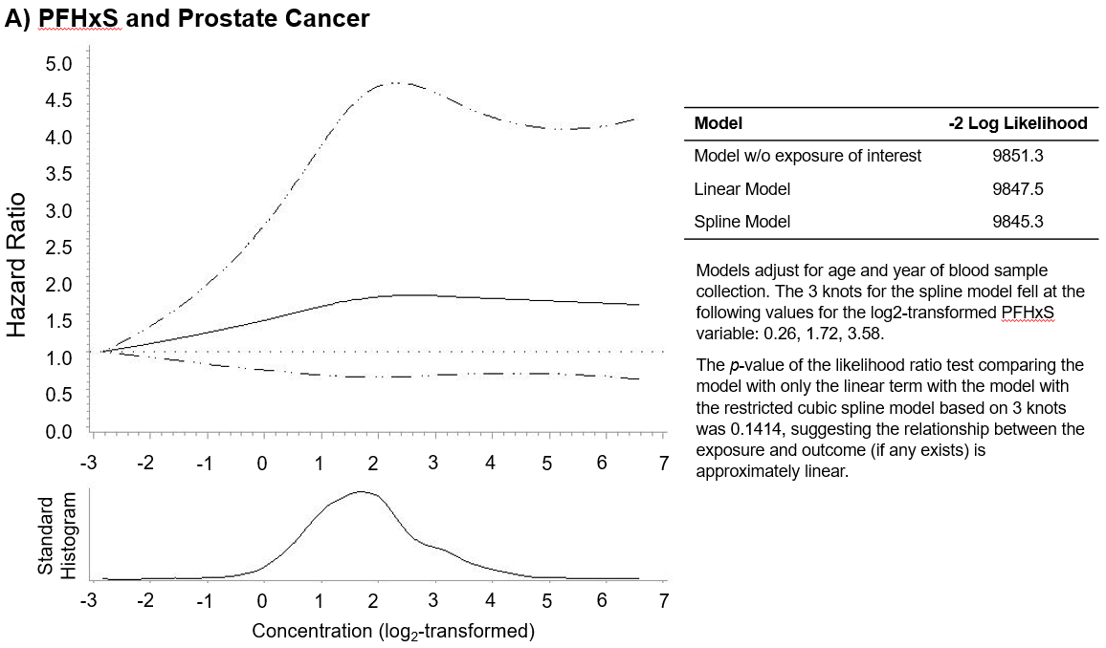
Supplemental Figure 1 (continued). Graphical representation of the association between log₂-transformed PFAS measures and prostate cancer incidence, assessed using restricted cubic splinesª, in the Case-Cohort Study of PFAS and Cancer Incidence in the Cancer Prevention Study-II Lifelink Cohort, United States, 1998–2015
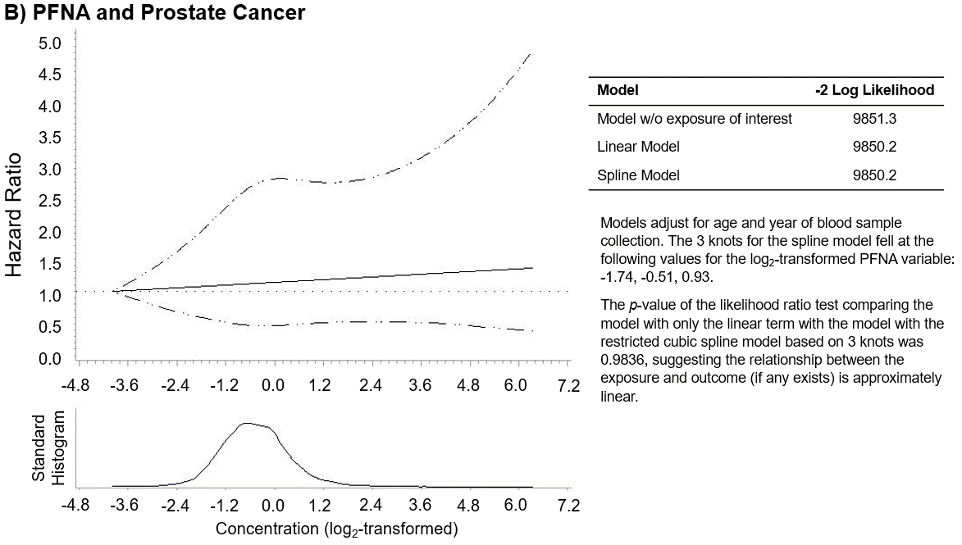

Supplemental Figure 1 (continued). Graphical representation of the association between log₂-transformed PFAS measures and prostate cancer incidence, assessed using restricted cubic splinesª, in the Case-Cohort Study of PFAS and Cancer Incidence in the Cancer Prevention Study-II Lifelink Cohort, United States, 1998–2015
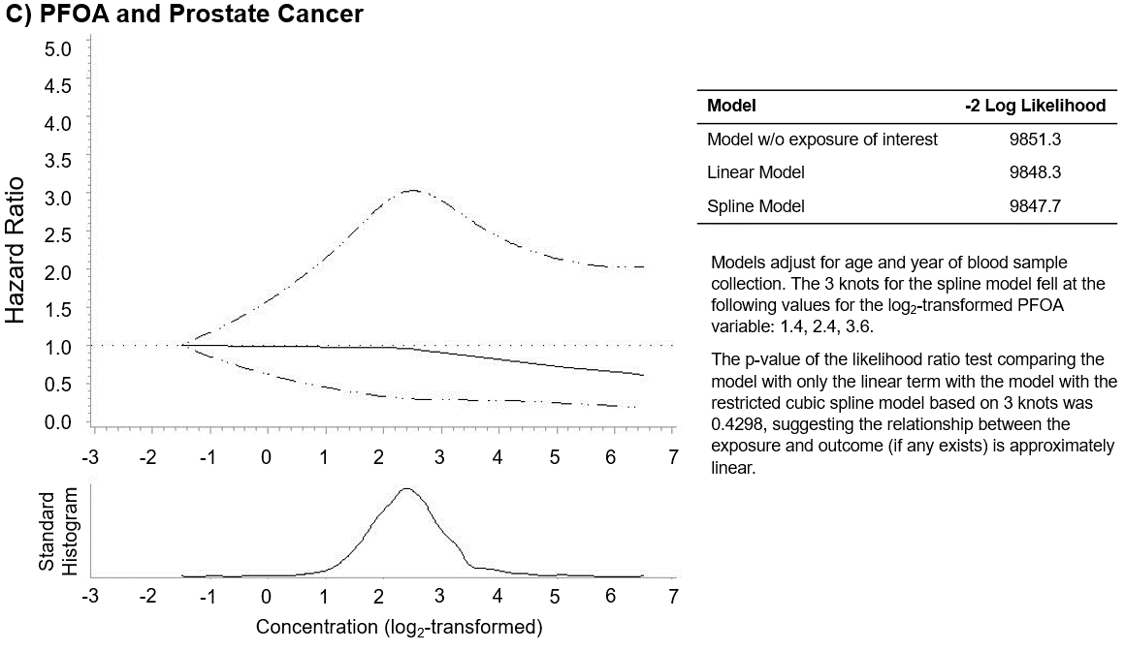

Supplemental Figure 1 (continued). Graphical representation of the association between log₂-transformed PFAS measures and prostate cancer incidence, assessed using restricted cubic splinesª, in the Case-Cohort Study of PFAS and Cancer Incidence in the Cancer Prevention Study-II Lifelink Cohort, United States, 1998–2015
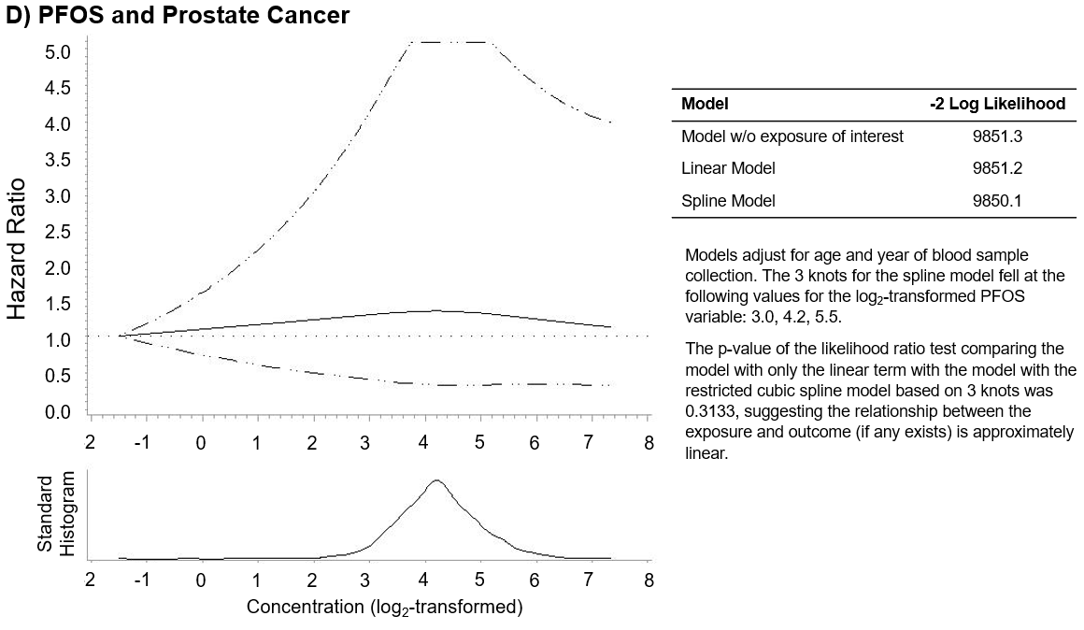

ª The dotted lines represent 95% confidence intervals
1. Collaborative Stage Site-Specific Factors - SEER Documentation. SEER. Accessed July 10, 2023. https://seer.cancer.gov/seerstat/databases/ssf/index.html
2. American College of Surgeons. Collaborative Stage Data Collection System v02.05: Prostate. Accessed June 5, 2023. https://web2.facs.org/cstage0205/prostate/Prostateschema.html?_ga=2.165709050.592640970.1685975209-973966555.1685975209&_gl=1*16wiia5*_ga*OTczOTY2NTU1LjE2ODU5NzUyMDk.*_ga_KBB21NPQBH*MTY4NTk3NTIwOC4xLjEuMTY4NTk3NTIyMC4wLjAuMA..*_ga_6C8S73MC87*MTY4NTk3NTIwOC4xLjAuMTY4NTk3NTIwOC4wLjAuMA..
3. Administration UD of VA Veterans Health. VA.gov | Veterans Affairs. Accessed September 1, 2023. https://www.publichealth.va.gov/exposures/pfas.asp
4. Inoue K, Goto A, Sugiyama T, Ramlau-Hansen CH, Liew Z. The Confounder-Mediator Dilemma: Should We Control for Obesity to Estimate the Effect of Perfluoroalkyl Substances on Health Outcomes? Toxics. 2020;8(4):125. doi:10.3390/toxics8040125

