Supplementary Files
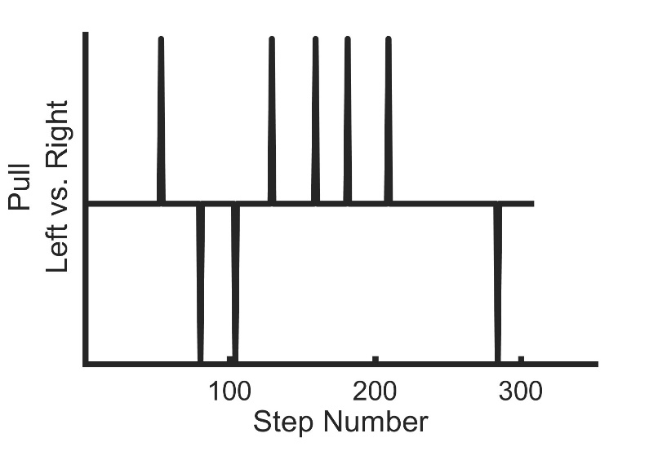
Supplementary Fig 1. Representation of pull timing and direction from a single trial of a PwDCM.
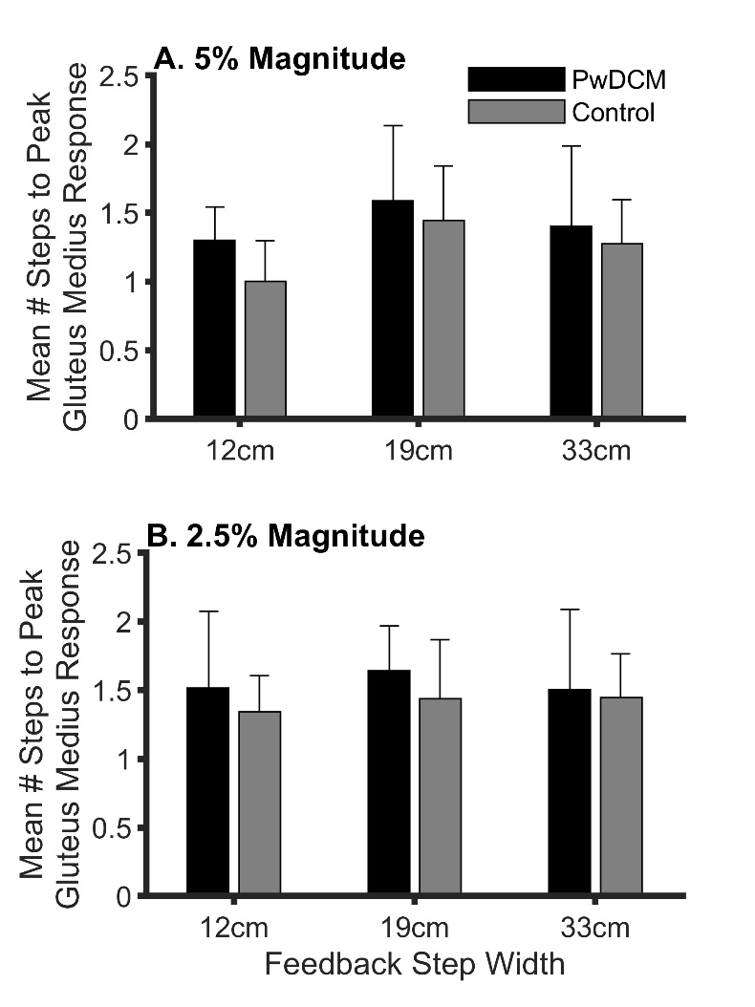
Supplementary Fig 2. Gluteus medius gait cycle timing response following pulls. A) 5% pulls. B) 2.5% pulls. Overall, PwDCM required more steps to reach peak gluteus medius response than healthy controls.
Step Width | Pull Magnitude | PwDCM |  |  | Controls |  |  | Difference | Cohen's d
Change in Center of Mass (cm)
12cm | 5 | 4.49 | ± | 0.92 | 3.60 | ± | 1.17 | 0.90 | 0.80
 | 2.5 | 1.53 | ± | 0.48 | 1.35 | ± | 0.43 | 0.17 | 0.38
19cm | 5 | 3.90 | ± | 1.23 | 3.19 | ± | 1.14 | 0.72 | 0.59
 | 2.5 | 2.02 | ± | 0.64 | 1.32 | ± | 0.48 | 0.70 | 1.07
33cm | 5 | 2.84 | ± | 0.81 | 2.46 | ± | 0.71 | 0.38 | 0.50
 | 2.5 | 1.58 | ± | 0.69 | 1.52 | ± | 0.42 | 0.05 | 0.10
Change in minimum Margin of Stability (cm)
12cm | 5 | -3.50 | ± | 1.68 | -3.27 | ± | 1.70 | -0.24 | -0.14
 | 2.5 | -1.37 | ± | 0.68 | -1.19 | ± | 0.28 | -0.18 | -0.37
19cm | 5 | -3.19 | ± | 1.52 | -2.09 | ± | 1.50 | -1.10 | -0.73
 | 2.5 | -1.97 | ± | 2.20 | -1.11 | ± | 0.20 | -0.86 | -0.72
33cm | 5 | -1.97 | ± | 0.77 | -1.63 | ± | 0.34 | -0.34 | -0.62
 | 2.5 | -1.28 | ± | 0.26 | -1.31 | ± | 0.34 | 0.03 | 0.08
Change in Gluteus Medius EMG (%)
12cm | 5 | 42.79 | ± | 28.71 | 27.90 | ± | 12.01 | 14.89 | 0.67
 | 2.5 | 20.99 | ± | 7.08 | 17.10 | ± | 6.94 | 3.89 | 0.55
19cm | 5 | 31.99 | ± | 15.66 | 20.33 | ± | 9.19 | 11.67 | 0.84
 | 2.5 | 17.72 | ± | 4.83 | 15.00 | ± | 7.43 | 2.72 | 0.44
33cm | 5 | 21.01 | ± | 13.25 | 21.95 | ± | 9.16 | -0.94 | -0.08
 | 2.5 | 17.53 | ± | 4.05 | 19.16 | ± | 10.30 | -1.62 | -0.21
Average number of steps needed to reach peak EMG response (#)
12cm | 5 | 1.30 | ± | 0.24 | 1.00 | ± | 0.30 | 0.30 | 1.10
 | 2.5 | 1.51 | ± | 0.56 | 1.34 | ± | 0.26 | 0.17 | 0.42
19cm | 5 | 1.59 | ± | 0.55 | 1.45 | ± | 0.39 | 0.14 | 0.30
 | 2.5 | 1.64 | ± | 0.33 | 1.44 | ± | 0.43 | 0.20 | 0.54
33cm | 5 | 1.40 | ± | 0.58 | 1.28 | ± | 0.32 | 0.13 | 0.28
 | 2.5 | 1.51 | ± | 0.58 | 1.44 | ± | 0.32 | 0.06 | 0.13
Change in Foot Placement (cm)
12cm | 5 | 6.43 | ± | 3.79 | 6.70 | ± | 4.22 | -0.27 | -0.07
 | 2.5 | 3.22 | ± | 1.27 | 2.55 | ± | 0.93 | 0.67 | 0.58
19cm | 5 | 5.58 | ± | 2.89 | 5.46 | ± | 3.56 | 0.12 | 0.04
 | 2.5 | 3.29 | ± | 1.33 | 3.20 | ± | 0.93 | 0.09 | 0.08
33cm | 5 | 4.24 | ± | 2.18 | 3.83 | ± | 1.90 | 0.40 | 0.20
 | 2.5 | 2.98 | ± | 1.23 | 2.96 | ± | 0.86 | 0.02 | 0.01

Supplementary Table 1. Group by condition values for primary outcome measures. Data are here presented as mean and standard deviation of primary outcome measures. Center of mass and margin of stability have been converted from meters to centimeters to facilitate interpretation. Cohen’s d effect sizes are additionally reported.

