Supplemental Material for
“Attributional Negativity Bias and Acute Stress Disorder Symptoms Mediate the Relationship Between Trauma History and Future PTSD”

To examine specificity of our results, we also examined whether the negativity bias and acute stress disorder symptoms mediated the link between childhood trauma and 6-month PTSD symptoms.
Measures
The childhood trauma questionnaire (CTQ) was also collected in the study (n = 10 did not complete the CTQ). The (CTQ) is a validated measure for self-reported, retrospective childhood trauma history (Bernstein et al., 2003) and consists of 28 items (current sample Cronbach’s alpha = .91) evaluating childhood physical abuse, emotional abuse, sexual abuse, emotional neglect, and physical neglect. A total score was created by summing all items (Bernstein et al., 2003; current sample M = 44.16, SD = 17.10). The PCL-5, CPS-5, negativity bias score, and covariates were derived as detailed in the main text.
Results
The parallel dual mediation model with trauma history defined with CTQ scores (n = 179), revealed the same pattern of results as the primary analyses with LEC-5 scores (i.e., both negativity bias and T1 ASD symptoms mediate the relationship between trauma history and T2 PTSD symptoms; Figure S1).
Higher CTQ scores predicted higher T2 CAPS-5 scores (c path: standardized β = 0.29, unstandardized B = 0.20, standard error (SE) = 0.05, t(177) = 3.89, p = .001), after adjusting for gender, age, and psychiatric history but before accounting for negativity bias and T1 PCL-5 scores (full model: F(4,174) = 5.83, p = .002; R² = 0.12).
After adjusting for covariates (gender, age, and psychiatric history), higher scores on the CTQ were associated with greater negativity bias (a₁ path: β = -0.25, b = -0.02, SE = 0.01, t(177) = -3.28, p = .001; full model: F(4,174) = 3.70, p = .006; R² = 0.08) as well as greater T1 PCL-5 scores (a₂ path: β = 0.25, b = 0.27, SE = 0.08, t(177) = 3.24, p < .001; full model: F(4,174) = 8.13, p < .001; R² = 0.16).
As in the primary analyses, none of the covariates were associated with negativity bias. Age was still associated with T1 PCL-5 scores (age: β = -0.24, b = -0.41, SE = 0.12, t(177) = -3.28, p = .009). However, gender (β = 0.07, b = 2.94, SE = 2.66, t(177) = 1.11, p = .270) and psychiatric history (β = 0.14, b = 6.35, SE = 1.90, t(177) = 1.90, p = .059) were no longer associated with T1 PCL-5 scores.
Greater negativity bias was subsequently related to higher T2 CAPS-5 scores (b₁ path: β = -0.23, B = -2.28, SE = 0.81, t(177) = -2.82, p = .020; full model: F(6,172) = 12.70, p < .001; R² = 0.31), even after controlling for CTQ scores, PCL-5 scores, and covariates. Similarly, T1 PCL-5 scores were subsequently related to greater T2 CAPS-5 scores (b₂ path: β = 0.29, B = 0.18, SE = 0.05, t(177) = 3.39, p = .001), even after controlling for CTQ scores, negativity bias, and covariates. After taking into account negativity bias and T1 PCL-5 scores, CTQ scores were still associated with T2 CAPS-5 scores (c’ path: β = 0.16, B = 0.11, SE = 0.05, t(177) = 2.34, p = .020). Covariates were not associated with T2 CAPS-5 scores after adjusting for CTQ, negativity bias, and T1 PCL-5 scores.
A 95% bias-corrected confidence interval (CI) based on 10,000 bootstrap samples indicated that the indirect effects of negativity bias (ab₁ = 0.04, bootstrapped Standard Error (SE) = 0.02) and T1 PCL-5 scores (ab₂ = 0.05, SE = 0.02) were entirely above zero: 95% CI[0.007, 0.086] and CI[0.010, 0.105], respectively. After taking into account the mediators (negativity bias and T1 PCL-5 scores), the direct effect of CTQ scores on T2 CAPS-5 scores was still significant (i.e., did not include zero, CI[0.205, 0.164]).

References
Bernstein, D. P., Stein, J. A., Newcomb, M. D., Walker, E., Pogge, D., Ahluvalia, T., Stokes, J., Handelsman, L., Medrano, M., Desmond, D., & Zule, W. (2003). Development and validation of a brief screening version of the Childhood Trauma Questionnaire. Child abuse & neglect, 27(2), 169–190. https://doi.org/10.1016/s0145-2134(02)00541-0.
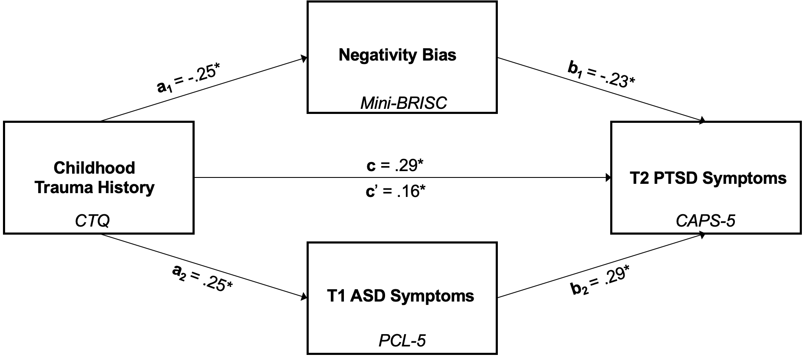
Figure S1. The dual parallel mediating effects of negativity bias (Mini-BRISC negativity bias z-scores) and T1 ASD symptoms (PCL-5 total symptom severity scores) in the relationship between childhood trauma (CTQ total scores) and T2 PTSD symptoms (CAPS-5 total symptom severity scores). Notes: *p < .05; All presented effects are standardized. Model is adjusted for gender, age, and former psychiatric diagnosis and/or treatment. Abbreviations: CTQ: Childhood Trauma Questionnaire; PCL-5: PTSD Checklist for the DSM-5; CAPS-5: Clinician Administered PTSD Scale for the DSM-5.

