Supplemental Figure 1. MDH 17OHP Value (ng/mL) vs. N mutations in molecular test
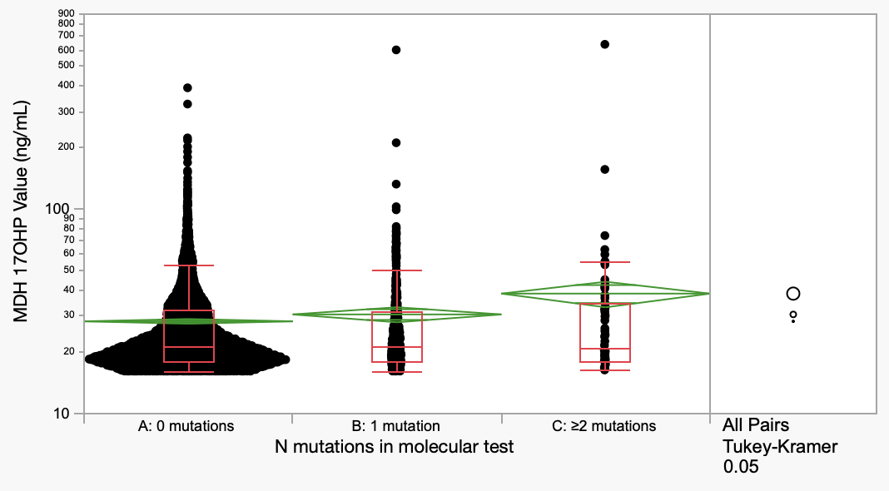
Percentiles
Group | Minimum | 10% | 25% | Median | 75% | 90% | Maximum
A: 0 mutations | 16 | 16.6 | 17.9 | 21.2 | 32.1 | 48.3 | 388.9
B: 1 mutation | 16 | 16.6 | 17.8 | 21 | 31.65 | 58.6 | 596.1
C: ≥2 mutations | 16.2 | 16.79 | 17.8 | 20.85 | 34.15 | 55.54 | 634.6

