Supplementary Materials
Includes:
- Search String
- PRISMA Checklist
- Funnel Plot to assess publication bias
- Coding:
  - Pooled formula for combining two physical activity intervention groups
  - Formula for estimating percent change mean and standard deviations
- Supplementary Results of Hippocampal Volume
  - Left and Right Hippocampus
  - Stratified Analyses
    - Age
    - Patient Status
    - Weeks of Exercise
    - Minutes per Week of Exercise
- Excluded studies: List of 66 studies excluded at the full-text level and reasons for exclusion
- Search string
The PubMed search string was as follows:
((((((exercise[Mesh:noexp] OR gymnastics[mesh] OR muscle stretching exercises[mesh] OR physical conditioning, human[mesh] OR running[mesh] OR swimming[mesh] OR walking[mesh] OR athletic performance[mesh] OR exercise[tiab] OR physical activit*[tiab] OR running[tiab] OR swimming[tiab] OR walking[tiab] OR athletic performance[tiab] OR high-intensity interval training[tiab] OR resistance training[tiab] OR physical fitness[tiab] OR cardiorespiratory fitness[tiab] OR anaerobic threshold[tiab])) AND (hippocampus[Mesh:noexp] OR hippocampal volume[tiab] OR hippocampus[tiab] OR medial temporal lobe[tiab]))) NOT (animals[mesh] OR mice[tiab] OR mouse[tiab] OR rat[tiab] OR rats[tiab] OR gerbils[tiab]))) OR (((((exercise[Mesh:noexp] OR gymnastics[mesh] OR muscle stretching exercises[mesh] OR physical conditioning, human[mesh] OR running[mesh] OR swimming[mesh] OR walking[mesh] OR athletic performance[mesh] OR exercise[tiab] OR physical activit*[tiab] OR running[tiab] OR swimming[tiab] OR walking[tiab] OR athletic performance[tiab] OR high-intensity interval training[tiab] OR resistance training[tiab] OR physical fitness[tiab] OR cardiorespiratory fitness[tiab] OR anaerobic threshold[tiab])) AND (hippocampus[Mesh:noexp] OR hippocampal volume[tiab] OR hippocampus[tiab] OR medial temporal lobe[tiab]))) AND humans[mesh]).

- Prisma Checklist
Section/topic | # | Checklist item | Reported on page #
TITLE
Title | 1 | Identify the report as a systematic review, meta-analysis, or both. | 1
ABSTRACT
Structured summary | 2 | Provide a structured summary including, as applicable: background; objectives; data sources; study eligibility criteria, participants, and interventions; study appraisal and synthesis methods; results; limitations; conclusions and implications of key findings; systematic review registration number. | 2
INTRODUCTION
Rationale | 3 | Describe the rationale for the review in the context of what is already known. | 3-5
Objectives | 4 | Provide an explicit statement of questions being addressed with reference to participants, interventions, comparisons, outcomes, and study design (PICOS). | 4
METHODS
Protocol and registration | 5 | Indicate if a review protocol exists, if and where it can be accessed (e.g., Web address), and, if available, provide registration information including registration number. | 5
Eligibility criteria | 6 | Specify study characteristics (e.g., PICOS, length of follow-up) and report characteristics (e.g., years considered, language, publication status) used as criteria for eligibility, giving rationale. | 5-6
Information sources | 7 | Describe all information sources (e.g., databases with dates of coverage, contact with study authors to identify additional studies) in the search and date last searched. | 5
Search | 8 | Present full electronic search strategy for at least one database, including any limits used, such that it could be repeated. | 5
Study selection | 9 | State the process for selecting studies (i.e., screening, eligibility, included in systematic review, and, if applicable, included in the meta-analysis). | 5-6
Data collection process | 10 | Describe method of data extraction from reports (e.g., piloted forms, independently, in duplicate) and any processes for obtaining and confirming data from investigators. | 7
Data items | 11 | List and define all variables for which data were sought (e.g., PICOS, funding sources) and any assumptions and simplifications made. | 8
Risk of bias in individual studies | 12 | Describe methods used for assessing risk of bias of individual studies (including specification of whether this was done at the study or outcome level), and how this information is to be used in any data synthesis. | 6 -7
Summary measures | 13 | State the principal summary measures (e.g., risk ratio, difference in means). | 7
Synthesis of results | 14 | Describe the methods of handling data and combining results of studies, if done, including measures of consistency (e.g., I²) for each meta-analysis. | 8

Section/topic | # | Checklist item | Reported on page #
Risk of bias across studies | 15 | Specify any assessment of risk of bias that may affect the cumulative evidence (e.g., publication bias, selective reporting within studies). | 7
Additional analyses | 16 | Describe methods of additional analyses (e.g., sensitivity or subgroup analyses, meta-regression), if done, indicating which were pre-specified. | 9
RESULTS
Study selection | 17 | Give numbers of studies screened, assessed for eligibility, and included in the review, with reasons for exclusions at each stage, ideally with a flow diagram. | 10
Study characteristics | 18 | For each study, present characteristics for which data were extracted (e.g., study size, PICOS, follow-up period) and provide the citations. | 10
Risk of bias within studies | 19 | Present data on risk of bias of each study and, if available, any outcome level assessment (see item 12). | 11
Results of individual studies | 20 | For all outcomes considered (benefits or harms), present, for each study: (a) simple summary data for each intervention group (b) effect estimates and confidence intervals, ideally with a forest plot. | 11-12
Synthesis of results | 21 | Present results of each meta-analysis done, including confidence intervals and measures of consistency. | 11-12
Risk of bias across studies | 22 | Present results of any assessment of risk of bias across studies (see Item 15). | 12
Additional analysis | 23 | Give results of additional analyses, if done (e.g., sensitivity or subgroup analyses, meta-regression [see Item 16]). | 13
DISCUSSION
Summary of evidence | 24 | Summarize the main findings including the strength of evidence for each main outcome; consider their relevance to key groups (e.g., healthcare providers, users, and policy makers). | 13-17
Limitations | 25 | Discuss limitations at study and outcome level (e.g., risk of bias), and at review-level (e.g., incomplete retrieval of identified research, reporting bias). | 18-20
Conclusions | 26 | Provide a general interpretation of the results in the context of other evidence, and implications for future research. | 20
FUNDING
Funding | 27 | Describe sources of funding for the systematic review and other support (e.g., supply of data); role of funders for the systematic review. | 1

- Funnel plot to assess risk of publication bias

The funnel plots below plots Hedges’ g as a function of standard error (A) or precision (B) across all studies included in the main analysis of total hippocampal volume. Observed studies and summary Hedges’ g are presented in white. Imputed values and adjusted Hedges’ g from the Trim and Fill analysis are presented in red.

- Coding
  - Pooled formula for combining two physical activity intervention groups:
In instances where a study had two physical activity intervention groups, we combined the mean and standard deviation of the two intervention groups to form one group by calculating the weighted mean and pooled standard deviation using a total variance using the R package psychmeta. Specific code is displayed below.

library(psychmeta)

#Study 1
study1<-list("n"=c( 76, 45),
"mean_pre_tot"= c(8384.27,8296.88),
"sd_pre_tot"= c(781.12,772.42),
"mean_post_tot"=c(8402.22,8248.74),
"sd_post_tot"=c(798.7,784.89))

#pre-test
S1_pre_tot<-mix_dist(mean_vec =study1$mean_pre_tot, var_vec = (study1$sd_pre_tot)^2, n_vec = study1$n)
print(paste0("The pooled standard deviation using a total variance for the pre-test total volume is: ", sqrt(S1_pre_tot[4])) )

#post-test
S1_post_tot<-mix_dist(mean_vec =study1$mean_post_tot, var_vec = (study1$sd_post_tot)^2, n_vec = study1$n)
print(paste0("The pooled standard deviation using a total variance for the post-test total volume is: ", sqrt(S1_post_tot[4])) )

  - Formula for estimating percent change mean and standard deviations

#=============================================================================#
# R code to estimate the mean and standard deviation of the relative change
#==============================================================================#

#-------------------------------------------------------------------------------------------------------#
# We estimate the relative change in percentile scale : R = (V_post - V_pre) / V_pre *100
# RelativeChange.R provides the estimation of the mean and standard deviation of R
# using the following summary statistics.
# The mean and standard deviation forms are derived based on the 2nd order Taylor expansion of R
#
# x_pre : mean of the brain volume measured at pre-intervention
# x_post : mean of the brain volume measured at post-intervention
# sd_pre : standard deviation of the brain volume brain measured at pre-intervention
# sd_post : standard deviation of the brain volume brain measured at post-intervention
# rho_prepost : standard deviation of the brain volume brain measured at post-intervention
# percent_scale = TRUE if we estimate the relative change in the percentile scale
# =FALSE if we estimate the relative change in the raw scale
# < Output >
# mean_change_change = mean of the relative change
# sd_change = sd of the relative change
#-------------------------------------------------------------------------------------------------------#

fnt_RelativeChange_SingleGroup<-function(x_pre, x_post, sd_pre, sd_post, rho_prepost, percent_scale)
{ if(percent_scale)
{a<-100} else
{a<-1}
ch_postpre<-a*(x_post - x_pre) / x_pre

#1. Approximation for E{(Y-X)/X * a}
E_perent_change <- a* ((x_post/x_pre -1)- ((rho*sd_pre*sd_post)/(x_pre^2)) + ((sd_pre^2*x_post)/(x_pre^3)) )

#2. Approximation for sqrt {Var{(Y-X)/X *a}}
v1<- ((sd_post^2)*(x_pre^2)) + ((sd_pre^2)*(x_post^2)) - ( 2 *(rho_prepost* sd_pre*sd_post)*(x_pre*x_post)) # inside of the sqrt : numerator
sd_percent_change <- a * sqrt(v1/ (x_pre^4) )

out<-list("mean_change"=E_perent_change,"sd_change"=sd_percent_change, "v1"=v1)

return(out)
}

#-----------------------Overall brain ----------------------------------------------------------#

rho<-0.6 #Default pre-post correlation coefficient
nn<-18 #Number of individual studies

#individual study mean and sd for the Treatment group
mean_trt_post<-c(7000, 8345.141, 10070, 7430, 7424.86, 6325, 7113, 6187, 6050, 4354, 6991, 4033.76, 10961.2, 7930, 8060, 6451.61, 6920, 9423.09)
mean_trt_pre<-c(6900, 8352.036, 9890, 7462, 7470.25, 6353, 7106, 6313, 6100, 4225, 6238, 3903.83, 10431.5, 8010, 8070, 6366.61, 6900, 9387.41)
sd_trt_post<- c(489.898, 790.38, 934, 827, 585.5548, 700, 793, 817, 1005, 438, 1252, 381.63, 1444.62, 820, 640, 933.26, 684.26, 522.86)
sd_trt_pre<- c(489.898, 774.72, 998, 832, 580.2609, 700, 741, 831, 1300, 399, 1080, 389.58, 1199.83, 800, 660, 991.69, 645.385, 556.2)

#individual study mean and sd for the Control group
mean_cont_post<-c(7100,8195.61, 9690,7668, 7716.51, 6380, 7254, 6230, 6100, 4240, 6704, 3884.93, 9433.06, 8000, 8060, 5951.36, 6970, 9500.77)
mean_cont_pre<-c(7200,8283.09,9820, 7683, 7720.34, 6421, 7259, 6407, 6200, 4170, 6770, 3810.02, 9303.56, 7990, 8130, 6057.27, 6980, 9530.32)
sd_cont_post<- c(479.583, 793.02, 1145, 700, 680.8936, 700, 560, 880, 966, 530, 1011, 504.46, 1614.25, 640, 850, 1117.94,692.02, 846.62)
sd_cont_pre<- c(671.416,769.19,1131, 651, 668.4567, 600, 629, 904, 1300, 480, 955, 466.17, 1043.2, 700, 870, 1089.61, 639.412, 872.81)

#Compute mean and sd of the change in the treatment group
out_trt<-matrix(NA, nrow=nn, ncol=8)
for(i in (1:nn))
{ out_trt[i,c(1:6)]<- c(i, mean_trt_pre[i], mean_trt_post[i], sd_trt_pre[i], sd_trt_post[i], rho)
call_trt<-fnt_RelativeChange_SingleGroup(x_pre=mean_trt_pre[i], x_post=mean_trt_post[i], sd_pre=sd_trt_pre[i], sd_post=sd_trt_post[i], rho_prepost=0.6, percent_scale=TRUE)
out_trt[i, c(7:8)]<-c(call_trt$mean_change, call_trt$sd_change)
}
colnames(out_trt)<-c("StudyID", "mean_trt_pre", "mean_trt_post", "sd_trt_pre", "sd_trt_post", "rho", "mean_change_percent","sd_change_percet")
print(out_trt)

#Compute mean and sd of the change in the control group
out_cont<-matrix(NA, nrow=nn, ncol=8)
for(i in (1:nn))
{ out_cont[i,c(1:6)]<- c(i, mean_cont_pre[i], mean_cont_post[i], sd_cont_pre[i], sd_cont_post[i], rho)
call_cont<-fnt_RelativeChange_SingleGroup(x_pre=mean_cont_pre[i], x_post=mean_cont_post[i], sd_pre=sd_cont_pre[i], sd_post=sd_cont_post[i], rho_prepost=0.6, percent_scale=TRUE)
out_cont[i, c(7:8)]<-c(call_cont$mean_change, call_cont$sd_change)
}

colnames(out_cont)<-c("StudyID", "mean_control_pre", "mean_control_post", "sd_control_pre", "sd_control_post", "rho", "mean_change_percent","sd_change_percet")
print(out_cont)

- Supplementary Results of Hippocampal Volume

- Left and Right Hippocampus
Forest plot showing individual study and pooled effects of exercise on Left (Upper) and Right (Lower) hippocampal volume. CI = confidence interval. Positive values of Hedges’ g reflect increases in hippocampal volume among those in the exercise group relative to the control group. Random effects model statistics are reported in the last row. Hedges’ g and CI include zero indicating non-significance.

Left

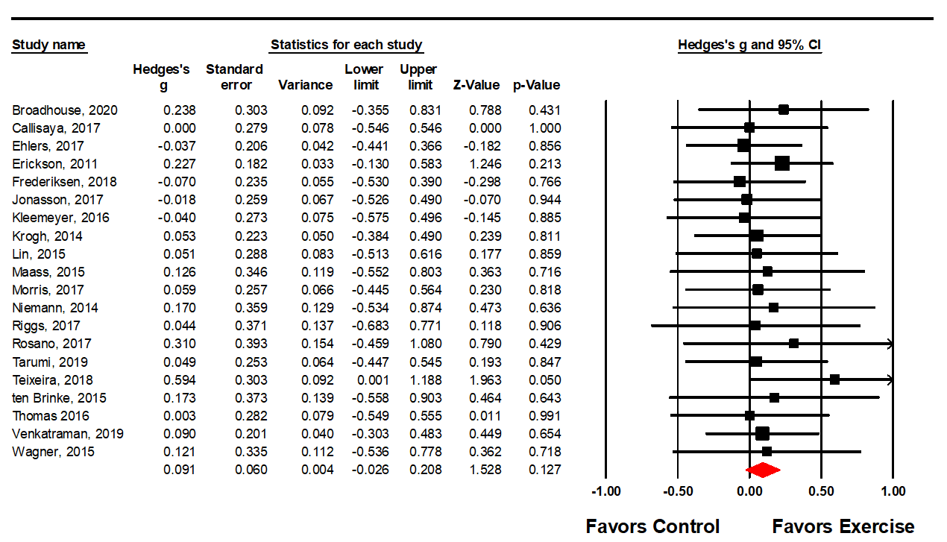
Right

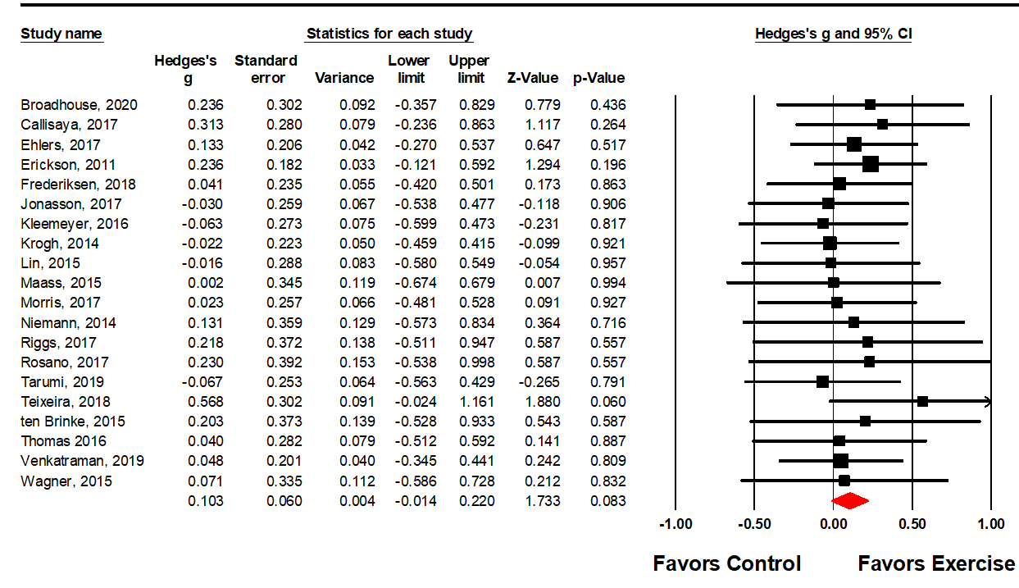

- Stratified Analyses Forest Plots

Forest plots showing stratification analyses by a priori-defined moderators. Stratification by i) age (<65=0 or ≥65 =1), ii) patient status (healthy =1 or patient =0), iii) intervention duration (≤24 weeks=0, > 24 weeks = 1), iv) minutes per week of exercise (<≥ 150 minutes).

- Age Stratified Forest Plot. <65 years of age =0 or ≥65 years of age =1. Last line for each Group is the overall effect.
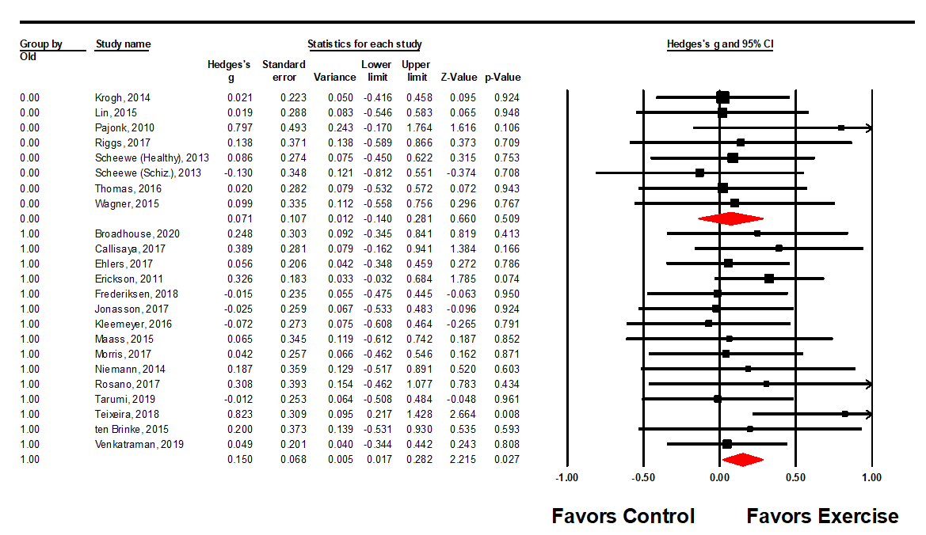

- Healthy or Patient Stratified Forest Plot. Patient = 0, Healthy = 1. Last line for each Group is the overall effect.

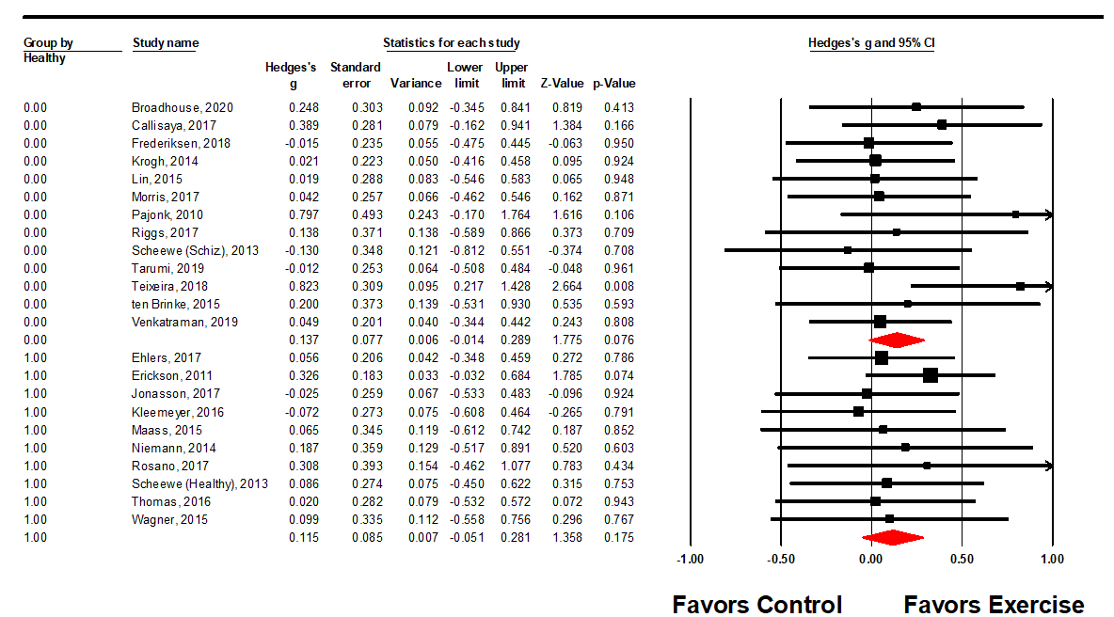

- Weeks of Exercise Stratified Forest Plot. ≤24 weeks = 0, > 24 weeks = 1. Last line for each Group is the overall effect.

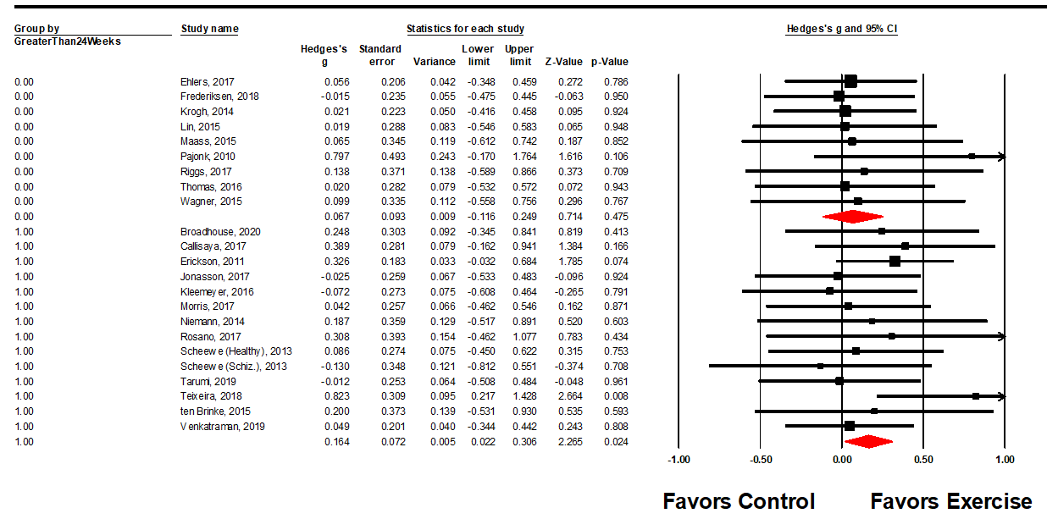

- Minutes per Week of Exercise Stratified Forest Plot. < 150 minutes = 0, ≥ 150 minutes = 1. Last line for each Group is the overall effect.
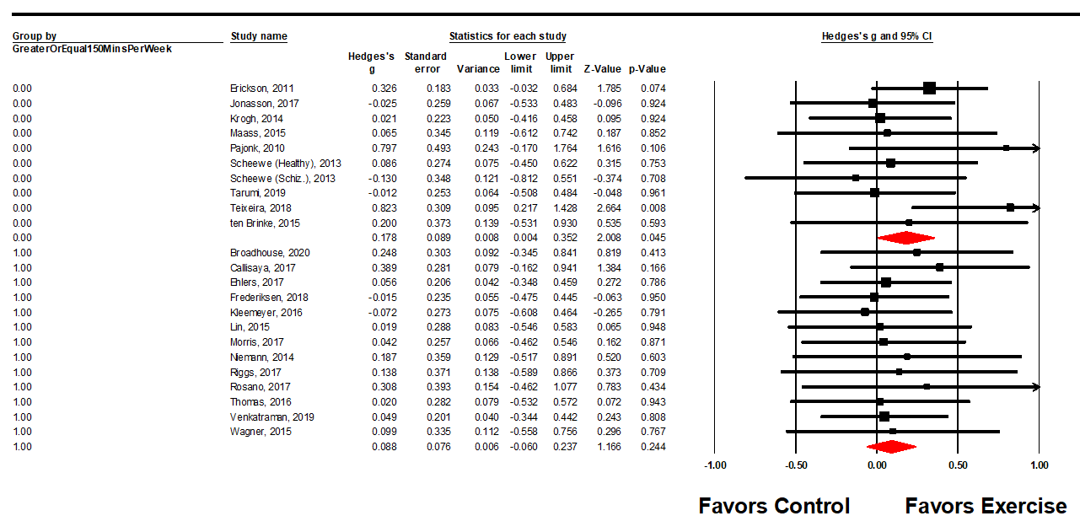

- Excluded Studies with reasons for exclusion.

Study | Reference | Reasons for Exclusion
1 | Fuss, J., Biedermann, S. V., Falfán‐Melgoza, C., Auer, M. K., Zheng, L., Steinle, J., ... & Gass, P. (2014). Exercise boosts hippocampal volume by preventing early age‐related gray matter loss. Hippocampus, 24(2), 131-134. | Animal Study
2 | Shi, Z., Li, C., Yin, Y., Yang, Z., Xue, H., Mu, N., ... & Ma, H. (2018). Aerobic interval training regulated sirt3 attenuates high-fat-diet-associated cognitive dysfunction. BioMed research international, 2018. | Animal study
3 | Walker, T. L., Schallenberg, S., Rund, N., Grönnert, L., Rust, R., Kretschmer, K., & Kempermann, G. (2018). T lymphocytes contribute to the control of baseline neural precursor cell proliferation but not the exercise-induced up-regulation of adult hippocampal neurogenesis. Frontiers in Immunology, 9, 2856. | Animal study
4 | Kim, Y. S., Shin, S. K., Hong, S. B., & Kim, H. J. (2017). The effects of strength exercise on hippocampus volume and functional fitness of older women. Experimental gerontology, 97, 22-28. | Authors unable to be reached
5 | Suo, C., Singh, M. F., Gates, N., Wen, W., Sachdev, P., Brodaty, H., ... & Baune, B. T. (2016). Therapeutically relevant structural and functional mechanisms triggered by physical and cognitive exercise. Molecular psychiatry, 21(11), 1633-1642. | Redundant with Broadhouse
6 | Chen, Eyh,Lin, X,Lam, Mml,Chan, Kw,Chang, Wc,Joe, G,Wong, Ghy,Chiu, Cpy,Khong, Pl,Honer, Wg,Su, W,Chan, Clw,So, Kf,Tse, M (2012). The impacts of yoga and aerobic exercise on neuro-cognition and brain structure in early psychosis-a preliminary analysis of the randomized controlled clinical trial Schizophrenia research., 136(#issue#), S56 | Conference Proceedings
7 | Erickson, K,Weinstein, Am,Verstynen, Td,Voss, Mw,Prakash, Rs,Woods, J,McAuley, E,Kramer, Af (2012). The influence of an aerobic exercise intervention on brain volume in late adulthood Alzheimer's & dementia, 8(4 suppl. 1), P81 | Conference Proceedings
8 | Falkai, Pg,Malchow, B,Huber, J,Fleige, H,Gruber, O,Schulze, Tg,Schmitt, A,Honer, Wg,Keller, K (2012). Effects of indoor cycling on hippocampal structure, metabolism and clinical features of schizophrenia Schizophrenia research., 136, S56 | Conference Proceedings
9 | Frederiksen, Ks,Larsen, Ct,Christensen, An,Hasselbalch, S,Hogh, P,Wermuth, L,Lolk, A,Andersen, Bb,Siebner, Hr,Waldemar, G,Garde, E (2016). Effect of moderate-to-high intensity aerobic exercise on hippocampus and cortical regions in patients with mild Alzheimer's disease European journal of neurology. Conference: 2nd congress of the european academy of neurology. Copenhagen denmark. Conference start: 20160528. Conference end: 20160531. Conference publication: (var.pagings), 23, 252 | Conference Proceedings
10 | Iyalomhe, O,Allard, J,Johnson, S,Obisesan, T (2013). A 6-month aerobic exercise program is associated with increased hippocampal volume in older african-americans Alzheimer's and dementia., 9(4 suppl. 1), P635 | Conference Proceedings
11 | Makizako, H., & Shimada, H. (2014). Exercise and brain health in older adults with mild cognitive impairment. International Journal of Psychophysiology, 2(94), 135-136. | Conference Proceedings
12 | Malchow, B (2017). The impact of endurance training on brain structure and function in schizophrenia patients European archives of psychiatry and clinical neuroscience. Conference: 6th european conference on schizophrenia research: advancing research - promoting recovery. Germany, 267(1 Supplement 1), S35 | Conference Proceedings
13 | Malchow, B,Keller, K,Fleige, H,Doerfler, S,Huber, J,Gruber, O,Schulze, Tg,Schmitt, A,Honer, Wg,Falkai, Pg (2013). Effects of indoor cycling on hippocampal structure, metabolism and clinical features of schizophrenia. Data from a pilot study and a new replication sample Schizophrenia bulletin., 39 S342 | Conference Proceedings
14 | Pajonk, F. G. (2012). THE EFFECTS OF PHYSICAL EXERCISE ON NEURAL PLASTICITY AND CLINICAL SYMPTOMS IN SCHIZOPHRENIA. Schizophrenia Research, (136), S48. | Conference Proceedings
15 | Watkins, A,Rosenbaum, S,Lagopoulos, J,Taylor, L,Barry, B,Trapp, Eg (2013). Working out first-episode schizophrenia: neuroanatomical, cognitive and clinical changes following an aerobic exercise intervention European archives of psychiatry and clinical neuroscience., 263(1 suppl. 1), S64 | Conference Proceedings
16 | Kim, Y. S., Shin, S. K., Hong, S. B., & Kim, H. J. (2017). The effects of strength exercise on hippocampus volume and functional fitness of older women. Experimental gerontology, 97, 22-28. | Further duplicates
17 | Suo, C., Singh, M. F., Gates, N., Wen, W., Sachdev, P., Brodaty, H., ... & Baune, B. T. (2016). Therapeutically relevant structural and functional mechanisms triggered by physical and cognitive exercise. Molecular psychiatry, 21(11), 1633-1642. | Further duplicates
18 | Shimada, H., Makizako, H., Doi, T., Park, H., Tsutsumimoto, K., Verghese, J., & Suzuki, T. (2018). Effects of combined physical and cognitive exercises on cognition and mobility in patients with mild cognitive impairment: a randomized clinical trial. Journal of the American Medical Directors Association, 19(7), 584-591. | Further duplicates
19 | Kim, Y. S., Shin, S. K., Hong, S. B., & Kim, H. J. (2017). The effects of strength exercise on hippocampus volume and functional fitness of older women. Experimental gerontology, 97, 22-28. | Further duplicates
20 | Frederiksen, K. S., Larsen, C. T., Hasselbalch, S. G., Christensen, A. N., Høgh, P., Wermuth, L., ... & Garde, E. (2018). A 16-week aerobic exercise intervention does not affect hippocampal volume and cortical thickness in mild to moderate Alzheimer’s disease. Frontiers in aging neuroscience, 10, 293. | Further duplicates
21 | Shimada, H., Makizako, H., Doi, T., Park, H., Tsutsumimoto, K., Verghese, J., & Suzuki, T. (2018). Effects of combined physical and cognitive exercises on cognition and mobility in patients with mild cognitive impairment: a randomized clinical trial. Journal of the American Medical Directors Association, 19(7), 584-591. | Further duplicates
22 | Malchow, B., Keeser, D., Keller, K., Hasan, A., Rauchmann, B. S., Kimura, H., ... & Honer, W. G. (2016). Effects of endurance training on brain structures in chronic schizophrenia patients and healthy controls. Schizophrenia Research, 173(3), 182-191. | Ineligible intervention
23 | Sehm, B., Taubert, M., Conde, V., Weise, D., Classen, J., Dukart, J., ... & Ragert, P. (2014). Structural brain plasticity in Parkinson's disease induced by balance training. Neurobiology of aging, 35(1), 232-239. | Ineligible intervention
24 | Shimada, H., Makizako, H., Doi, T., Park, H., Tsutsumimoto, K., Verghese, J., & Suzuki, T. (2018). Effects of combined physical and cognitive exercises on cognition and mobility in patients with mild cognitive impairment: a randomized clinical trial. Journal of the American Medical Directors Association, 19(7), 584-591. | Ineligible intervention
25 | Stomby, A., Otten, J., Ryberg, M., Nyberg, L., Olsson, T., & Boraxbekk, C. J. (2017). A paleolithic diet with and without combined aerobic and resistance exercise increases functional brain responses and hippocampal volume in subjects with Type 2 diabetes. Frontiers in Aging Neuroscience, 9, 391. | Ineligible intervention
26 | Tao, J., Liu, J., Liu, W., Huang, J., Xue, X., Chen, X., ... & Sun, S. (2017). Tai Chi Chuan and Baduanjin increase grey matter volume in older adults: a brain imaging study. Journal of Alzheimer's Disease, 60(2), 389-400. | Ineligible intervention
27 | Rogge, A. K., Röder, B., Zech, A., & Hötting, K. (2018). Exercise-induced neuroplasticity: Balance training increases cortical thickness in visual and vestibular cortical regions. Neuroimage, 179, 471-479. | Ineligible Intervention
28 | Espeland, M. A., Erickson, K., Neiberg, R. H., Jakicic, J. M., Wadden, T. A., Wing, R. R., ... & Maschak-Carey, B. J. (2016). Brain and white matter hyperintensity volumes after 10 years of random assignment to lifestyle intervention. Diabetes Care, 39(5), 764-771. | Ineligible Intervention
29 | Papiol, S., Keeser, D., Hasan, A., Schneider-Axmann, T., Raabe, F., Degenhardt, F., ... & Wobrock, T. (2019). Polygenic burden associated to oligodendrocyte precursor cells and radial glia influences the hippocampal volume changes induced by aerobic exercise in schizophrenia patients. Translational psychiatry, 9(1), 1-8. | Ineligible Intervention
30 | Satoh, M., Ogawa, J. I., Tokita, T., Nakaguchi, N., Nakao, K., Kida, H., & Tomimoto, H. (2017). Physical Exercise with Music Maintains Activities of Daily Living in Patients with Dementia: Mihama-Kiho Project Part 2 1. Journal of Alzheimer's Disease, 57(1), 85-96. | Ineligible Intervention
31 | Bär, K. J., Herbsleb, M., Schumann, A., de la Cruz, F., Gabriel, H. W., & Wagner, G. (2016). Hippocampal-brainstem connectivity associated with vagal modulation after an intense exercise intervention in healthy men. Frontiers in neuroscience, 10, 145. | No pre-post volume
32 | Burzynska, A. Z., Jiao, Y., Knecht, A. M., Fanning, J., Awick, E. A., Chen, T., ... & Kramer, A. F. (2017). White matter integrity declined over 6-months, but dance intervention improved integrity of the fornix of older adults. Frontiers in aging neuroscience, 9, 59. | No pre-post volume
33 | Burdette, J. H., Laurienti, P. J., Espeland, M. A., Morgan, A. R., Telesford, Q., Vechlekar, C. D., ... & Rejeski, W. J. (2010). Using network science to evaluate exercise-associated brain changes in older adults. Frontiers in aging neuroscience, 2, 23. | No pre-post volume
34 | Kahn, R. (2012). EFFECTS OF PHYSICAL EXERCISE ON PSYCHOTIC SYMPTOMS, COGNITION AND BRAIN STRUCTURE: RESULTS OF A RANDOMIZED CLINICAL TRIAL IN CHRONIC SCHIZOPHRENIA. Schizophrenia Research, (136), S57. | No pre-post volume
35 | Maass, A., Düzel, S., Goerke, M., Becke, A., Sobieray, U., Neumann, K., ... & Ahrens, D. (2015). Vascular hippocampal plasticity after aerobic exercise in older adults. Molecular psychiatry, 20(5), 585-593. | No pre-post volume
36 | Moore, S., Hallsworth, K., Jakovljevic, D., Blamire, A., He, J., Ford, G., ... & Trenell, M. (2014). Effects of exercise therapy on metabolic risk factors, brain atrophy and cerebral blood flow following stroke: a randomised controlled trial. In UK Stroke Forum 2014. Newcastle University. | No pre-post volume
37 | Yu, F., Bronas, U., & Veith, D. (2014). PRESCRIBING AEROBIC EXERCISE TO OLDER ADULTS WITH ALZHEIMER'S DISEASE. Alzheimer's & Dementia: The Journal of the Alzheimer's Association, 4(10), P607. | No pre-post volume
38 | Bernstein, E. E., & McNally, R. J. (2019). Examining the effects of exercise on pattern separation and the moderating effects of mood symptoms. Behavior therapy, 50(3), 582-593. | No pre-post volume
39 | Daugherty, A. M., Sutton, B. P., Hillman, C. H., Kramer, A. F., Cohen, N. J., & Barbey, A. K. (2020). Individual differences in the neurobiology of fluid intelligence predict responsiveness to training: Evidence from a comprehensive cognitive, mindfulness meditation, and aerobic exercise intervention. Trends in Neuroscience and Education, 18, 100123. | No pre-post volume
40 | Kleinloog, J. P., Mensink, R. P., Ivanov, D., Adam, J. J., Uludag, K., & Joris, P. J. (2019). Aerobic exercise training improves cerebral blood flow and executive function: A randomized, controlled cross-over trial in sedentary older men. Frontiers in Aging Neuroscience, 11, 333. | No pre-post volume
41 | Satoh, M., Ogawa, J. I., Tokita, T., Nakaguchi, N., Nakao, K., Kida, H., & Tomimoto, H. (2014). The effects of physical exercise with music on cognitive function of elderly people: Mihama-Kiho project. PloS one, 9(4), e95230. | No pre-post volume
42 | Voss, M. W., Weng, T. B., Narayana-Kumanan, K., Cole, R. C., Wharff, C., Reist, L., ... & Magnotta, V. A. (2020). Acute Exercise Effects Predict Training Change in Cognition and Connectivity. Medicine and Science in Sports and Exercise, 52(1), 131-140. | No pre-post volume
43 | Woost, L., Bazin, P. L., Taubert, M., Trampel, R., Tardif, C. L., Garthe, A., ... & Rjosk, V. (2018). Physical exercise and spatial training: a longitudinal study of effects on cognition, growth factors, and hippocampal plasticity. Scientific reports, 8(1), 1-13. | No pre-post volume
44 | Rauchmann, B. S., Ghaseminejad, F., Keeser, D., Keller-Varady, K., Schneider-Axmann, T., Takahashi, S., ... & Hasan, A. (2019). The impact of endurance training and table soccer on brain metabolites in schizophrenia. Brain Imaging and Behavior, 1-12. | No pre-post volume
45 | Munive, V., Santi, A., & Torres-Aleman, I. (2016). A concerted action of estradiol and insulin like growth factor I underlies sex differences in mood regulation by exercise. Scientific reports, 6, 25969. | No pre-post volume
46 | Porto, F. H. G., Coutinho, A. M., de Souza Duran, F. L., de Sá Pinto, A. L., Gualano, B., Buchpiguel, C. A., ... & Brucki, S. M. D. (2018). Aerobic training modulates salience network and default mode network metabolism in subjects with mild cognitive impairment. NeuroImage: Clinical, 19, 616-624. | No pre-post volume
47 | Rogge, A. K., Röder, B., Zech, A., Nagel, V., Hollander, K., Braumann, K. M., & Hötting, K. (2017). Balance training improves memory and spatial cognition in healthy adults. Scientific reports, 7(1), 1-10. | No pre-post volume
48 | Saanijoki, T., Nummenmaa, L., Tuulari, J. J., Tuominen, L., Arponen, E., Kalliokoski, K. K., & Hirvonen, J. (2018). Aerobic exercise modulates anticipatory reward processing via the μ‐opioid receptor system. Human brain mapping, 39(10), 3972-3983. | No pre-post volume
49 | Saanijoki, T., Tuominen, L., Tuulari, J. J., Nummenmaa, L., Arponen, E., Kalliokoski, K., & Hirvonen, J. (2018). Opioid release after high-intensity interval training in healthy human subjects. Neuropsychopharmacology, 43(2), 246-254. | No pre-post volume
50 | Sandroff, B. M., Johnson, C. L., & Motl, R. W. (2017). Exercise training effects on memory and hippocampal viscoelasticity in multiple sclerosis: a novel application of magnetic resonance elastography. Neuroradiology, 59(1), 61-67. | No pre-post volume
51 | Xiong, X., Zhu, L. N., Dong, X. X., Wang, W., Yan, J., & Chen, A. G. (2018). Aerobic exercise intervention alters executive function and white matter integrity in deaf children: A randomized controlled study. Neural plasticity, 2018. | No pre-post volume
52 | Parker, B. A., Thompson, P. D., Jordan, K. C., Grimaldi, A. S., Assaf, M., Jagannathan, K., & Pearlson, G. D. (2011). Effect of exercise training on hippocampal volume in humans: a pilot study. Research quarterly for exercise and sport, 82(3), 585-591. | No true control group
53 | Rehfeld, K., Müller, P., Aye, N., Schmicker, M., Dordevic, M., Kaufmann, J., ... & Müller, N. G. (2017). Dancing or fitness sport? The effects of two training programs on hippocampal plasticity and balance abilities in healthy seniors. Frontiers in human neuroscience, 11, 305. | No true control group
54 | Woodward, M. L., Gicas, K. M., Warburton, D. E., White, R. F., Rauscher, A., Leonova, O., ... & Phillips, A. A. (2018). Hippocampal volume and vasculature before and after exercise in treatment-resistant schizophrenia. Schizophrenia Research, 202, 158-165. | No true control group
55 | Nauer, R. K., Dunne, M. F., Stern, C. E., Storer, T. W., & Schon, K. (2020). Improving fitness increases dentate gyrus/CA3 volume in the hippocampal head and enhances memory in young adults. Hippocampus, 30(5), 488-504. | No true control group
56 | Dean, D. J., Bryan, A. D., Newberry, R., Gupta, T., Carol, E., & Mittal, V. A. (2017). A supervised exercise intervention for youth at risk for psychosis: an open-label pilot study. The Journal of clinical psychiatry, 78(9), e1167. | No true control group
57 | Schwartz, B., Teslovich, T., You, X., Cho, J., Schooler, N., Kokkinos, P., & Vaidya, C. (2018). An Exploratory Study of Exercise-related Effects on Memory and Hippocampal Connectivity in Schizophrenia. Clinical schizophrenia & related psychoses. | No true control group
58 | Woodward, M. L., Gicas, K. M., Warburton, D. E., White, R. F., Rauscher, A., Leonova, O., ... & Phillips, A. A. (2018). Hippocampal volume and vasculature before and after exercise in treatment-resistant schizophrenia. Schizophrenia Research, 202, 158-165. | No true control group
59 | Ahlskog, J. E. (2011). Does vigorous exercise have a neuroprotective effect in Parkinson disease?. Neurology, 77(3), 288-294. | Review
60 | Ahlskog, J. E. (2018, March). Aerobic exercise: evidence for a direct brain effect to slow Parkinson disease progression. In Mayo Clinic Proceedings (Vol. 93, No. 3, pp. 360-372). Elsevier. | Review
61 | Ahlskog, J. E., Geda, Y. E., Graff-Radford, N. R., & Petersen, R. C. (2011, September). Physical exercise as a preventive or disease-modifying treatment of dementia and brain aging. In Mayo Clinic Proceedings (Vol. 86, No. 9, pp. 876-884). Elsevier. | Review
62 | Firth, J., Stubbs, B., Vancampfort, D., Schuch, F., Lagopoulos, J., Rosenbaum, S., & Ward, P. B. (2018). Effect of aerobic exercise on hippocampal volume in humans: a systematic review and meta-analysis. Neuroimage, 166, 230-238. | Review
63 | Muller, N,Goerke, M (2013). Running Against Dementia - The Effects of Physical Exercise Training in the Elderly on Cognition, Brain Structure and Function and Neurotrophic Factors Journal of psychophysiology., (75 pages). 27(75 pages), 33-34 | Review
64 | Mueller, K., Möller, H. E., Horstmann, A., Busse, F., Lepsien, J., Blüher, M., ... & Pleger, B. (2015). Physical exercise in overweight to obese individuals induces metabolic-and neurotrophic-related structural brain plasticity. Frontiers in human neuroscience, 9, 372. | VBM
65 | Tao, J., Liu, J., Chen, X., Xia, R., Li, M., Huang, M., ... & Xie, G. (2019). Mind-body exercise improves cognitive function and modulates the function and structure of the hippocampus and anterior cingulate cortex in patients with mild cognitive impairment. NeuroImage: Clinical, 23, 101834. | VBM
66 | Tao, J., Liu, J., Liu, W., Huang, J., Xue, X., Chen, X., ... & Sun, S. (2017). Tai Chi Chuan and Baduanjin increase grey matter volume in older adults: a brain imaging study. Journal of Alzheimer's Disease, 60(2), 389-400. | VBM

