Supplemental Figure 1. Directed Acyclic Graph for Active Tuberculosis Disease (TB) and Chronic Hepatitis B Virus Infection (cHBV) Treatment Outcome Analysis, California 2016–2020.
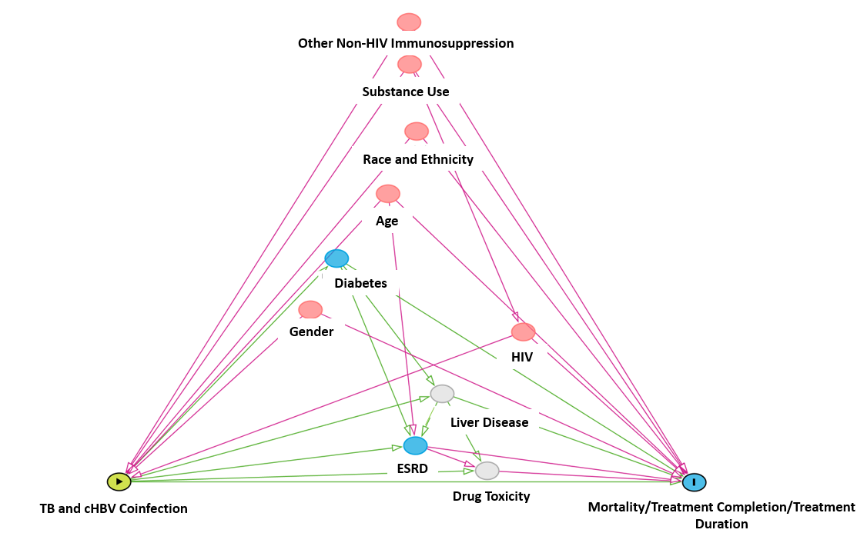
Supplemental Figure 1 Legend: The exposure was TB and cHBV (green circle with triangle) with death during treatment, incomplete treatment, and treatment duration as the outcomes (blue circle with I). Confounders are in red, mediators are in blue, and unmeasured variables are in grey
ESRD = end-stage renal disease. HIV = human Immunodeficiency virus.
*Highly correlated variables (i.e., >0.3 phi-coefficient) and variables which accounted for <5% of persons with coinfection were not included in the model: California Health Places Index (correlated with race and ethnicity), place of birth (correlated with race and ethnicity), homelessness (correlated with substance use), incarceration at time of diagnosis (<5% of persons), and multidrug resistance (<5% of persons)
Supplemental Figure 2. Unadjusted Relative Risk Ratios for Active tuberculosis Disease (TB) Treatment Outcomes for TB and Chronic Hepatitis B Virus Infection (cHBV) Cases vs TB Only Cases, California, 2016–2020.
