Supplemental Table 1. Modified Vesikari Score, based on prior construction of this model for GEMS data as described in Omore 2016 [17].
Child characteristics | Points assigned
 | (N=17)
Duration of diarrhea (days)
1—4 | 1
5 | 2
≥6 | 3
Max no. diarrhea/24 hrs.
3—6 | 2
≥7 | 3
Vomited 3+ times/24 hrs.*
Yes | 3
No | 0
Fever
<=37.0 | 0
37.1—38.4 | 1
38.5—38.9 | 2
≥39 | 3
Dehydration**
Moderate/Severe** | 3
Mild*** | 2
No dehydration | 0
Treatment
Outpatient without IV fluid | 0
Outpatient with IV fluid | 1
Hospitalization with or without IV fluid | 2
* The questionnaire asked a yes/no question about whether the child has ≥3 episodes of vomiting within 24 hours, but it did not ask about any vomiting vs none, thus the original Vesikari score could not be calculated.
** A child was considered mildly dehydrated if 2 or more of the following were present: Restless/irritable on arrival/admission; sunken eyes; thirsty, drank eagerly; skin pinch—goes back slowly (1–2 seconds). A child was considered moderately to severely dehydrated if 2 or more of the following were present: lethargic or unconscious on arrival/admission; sunken eyes; drank poorly or unable to drink; skin pinch—goes back very slowly (>2 seconds)

Supplemental Table 2. Prevalence and modified Vesikari score of viral pathogens using conventional methods, excluding one study site at a time and stratified by age group.
 | Rotavirus | Norovirus GI | Norovirus GII | Sapovirus | Astrovirus | Adenovirus 40/41
 | 1747 (18.5) | 265 (2.8) | 495 (5.2) | 325 (3.4) | 238 (2.5) | 235 (2.5)
Modified Vesikari Score
Conventional test results | 10 (8, 11) | 8 (6, 10) | 8 (6, 10) | 8 (6, 10) | 8 (7, 10) | 9 (7, 11)
Excluding:
The Gambia | 10 (8, 11) | 7.5 (6, 10) | 8 (6, 10) | 8 (6, 10) | 8 (7, 10) | 9 (7, 11)
Mali | 10 (8, 12) | 8 (6, 10) | 8 (6, 10) | 8 (6, 10) | 8 (6, 10) | 9 (7, 11)
Mozambique | 10 (8, 11) | 8 (6, 10) | 8 (6, 10) | 8 (6, 10) | 8 (7, 10) | 9 (7, 11)
Kenya | 10 (8, 11) | 7 (6, 9) | 8 (6, 10) | 8 (6, 10) | 8 (6, 10) | 9 (6, 10)
India | 10 (8, 12) | 7 (6, 10) | 8 (6, 10) | 8 (6, 10) | 8 (7, 10) | 9 (7, 11)
Bangladesh | 10 (8, 11) | 8 (6, 10) | 8 (6, 10) | 8 (6, 10) | 8 (7, 10) | 9 (7, 11)
Pakistan | 10 (8, 11) | 7 (6, 9.5) | 8 (6, 10) | 8 (6, 10) | 8 (6, 10) | 9 (7, 11)
Stratified by age group
0-11 months | 10 (8, 12) | 8 (6, 11) | 8 (6, 10) | 8 (6.5, 10.5) | 8 (6, 10) | 10 (8, 12)
12-59 months | 9 (8, 11) | 7 (6, 8) | 8 (6, 10) | 7 (6, 9) | 8 (6.5, 10) | 8 (6, 10)

Supplemental Table 3. Characteristics of clinical severity by viral etiology among GEMS cases of moderate-to-severe diarrhea (N=9,439) detected using conventional test results.*
Among cases | Rotavirus | Norovirus GI | Norovirus GII | Sapovirus | Astrovirus | Adenovirus 40/41
Modified Vesikari Characteristics
Duration of diarrhea (days)
1—4 | 820 (46.9) | 113 (43) | 229 (46) | 143 (44) | 99 (42) | 115 (49)
5 | 231 (13) | 22 (8) | 55 (11) | 31 (10) | 30 (13) | 26 (11)
≥6 | 696 (40) | 130 (49) | 211 (43) | 151 (46) | 109 (46) | 94 (40)
≥7 no. diarrhea/24 hrs | 809 (46) | 117 (44) | 207 (42) | 130 (40) | 95 (40) | 127 (54)
Vomiting ≥3/24 hrs | 1158 (66) | 81 (31) | 192 (39) | 130 (40) | 97 (41) | 131 (56)
Fever ≥38° C | 371 (21) | 58 (22) | 90 (18) | 44 (14) | 45 (19) | 44 (19)
Dehydration
Mild** | 1090 (62) | 131 (49) | 293 (59) | 202 (62) | 145 (61) | 149 (63)
Moderate/Severe* | 344 (20) | 40 (15) | 78 (16) | 54 (17) | 46 (19) | 40 (17)
Treatment
Outpatient without IV fluid | 1023 (59) | 205 (77) | 387 (78) | 265 (82) | 179 (75) | 166 (71)
Outpatient with IV fluid | 208 (12) | 19 (7) | 20 (4) | 20 (6) | 15 (6) | 21 (9)
Hospitalization with or without IV fluid | 516 (30) | 41 (15) | 88 (18) | 40 (12) | 44 (18) | 48 (20)
*Bolded cells represent characteristics that were statistically significant (p<0.05) in Chi-Square test comparisons between each non-rotavirus viral pathogen and rotavirus (reference).

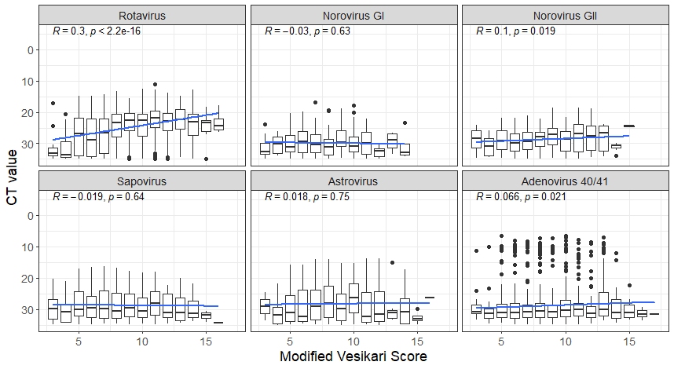
Supplemental Figure 1. Boxplots of TAC diagnostic cycle threshold (CT) by modified Vesikari score for each of the six viral pathogens overlaid with linear regression (blue line) and corresponding Pearson correlation coefficient estimates (R), excluding children with more than one highly-diarrhea associated pathogen.

