Annex or Supplemental Materials
Table 1. Additional sampling assumptions
Assumptions | Assumed Values
Z-score % confidence level | 2.58
p, Sample proportion or standard deviation | 0.0500
1-p | 0.9500
Margin of error - e | 0.02
squared of error - sqE | 0.0004
Population of beneficiaries - N | 2968000
square of Z | 6.6564
X = sqZ*p(1-p)/sqE | 790.4475
y = sqZ*p(1-p)/sqE*N | 0.0003
1+y | 1.0003
n = x/1+y | 790

Table 2. Influenza vaccination coverage in Armenia by target group, 2019-2022.
Risk groups | 2019-20  % | 2020-21  % | 2021-22  %
Children aged from 6 months to 5 years | 10.3 | 23.5 | 16.3
Pregnant women | 5.6 | 7.2 | 0.9
People over 65 years | 13.8 | 28.1 | 17.3
People with underlying chronic medical conditions | 32.7 | 79.8 | 46.7
Health Care providers | 68.6 | 83.5 | 76.7
Special groups of population (children and service providers in orphanages, special educational institutions, residents of nursing homes and service personnel) | 62.3 | 67.3 | 42.5
Military recruits | 86.6 | 100.0 | 100.0
TOTAL | 24.5 | 43.6 | 26.5

Table 3. Influenza vaccination performance in Armenia by target group, 2021-2022.
Risk groups | No. vaccinated | % by target group
Children aged from 6 months to 5 years | 25,431 | 15%
Pregnant women | 127 | 0.1%
People over 65 years | 48,171 | 28.3%
People with underlying chronic medical conditions | 74,235 | 43.7%
Health Care providers | 7,204 | 4.2%
Special groups of population (children and service providers in orphanages, special educational institutions, residents of nursing homes and service personnel) | 4,869 | 2.9%
Military recruits | 9,963 | 5.9%
TOTAL | 170,000 | 100%

Figure 1. WHO Case Definitions for Influenza Sentinel Surveillance
Case | Definition criteria
Influenza-like illness (ILI) | - An acute respiratory infection with measured fever ≥38°C  - AND cough  - With onset within the last 10 days
Severe acute respiratory infection (SARI) | - An acute respiratory infection with measured fever ≥38°C  - AND cough  - With onset within the last 10 days  - AND requires hospitalization

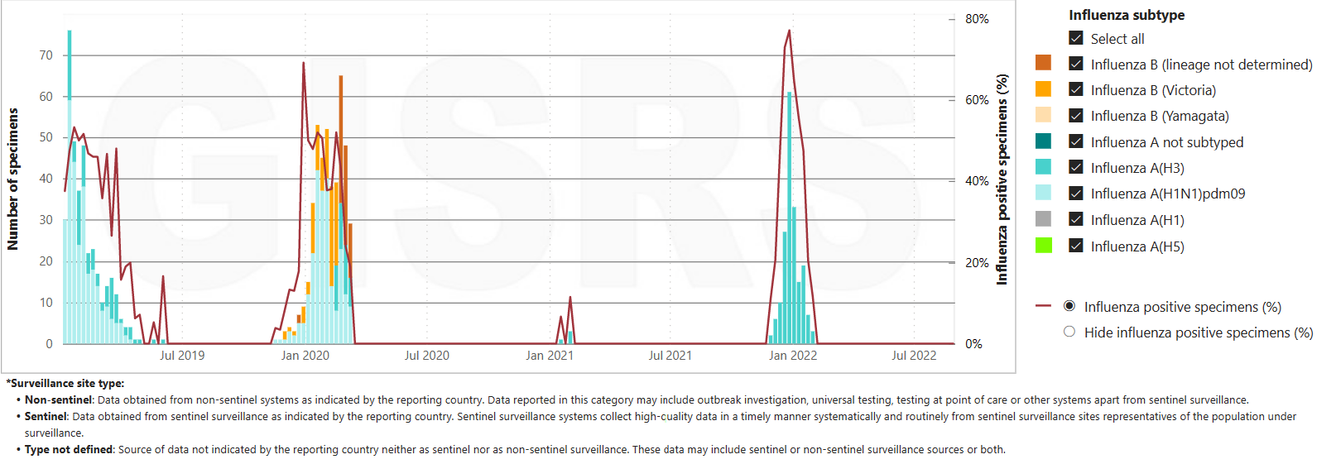
Figure 2. Number of respiratory specimens tested and positive samples by subtype in Armenia by week for three influenza seasons (2019/20 to 2021)

