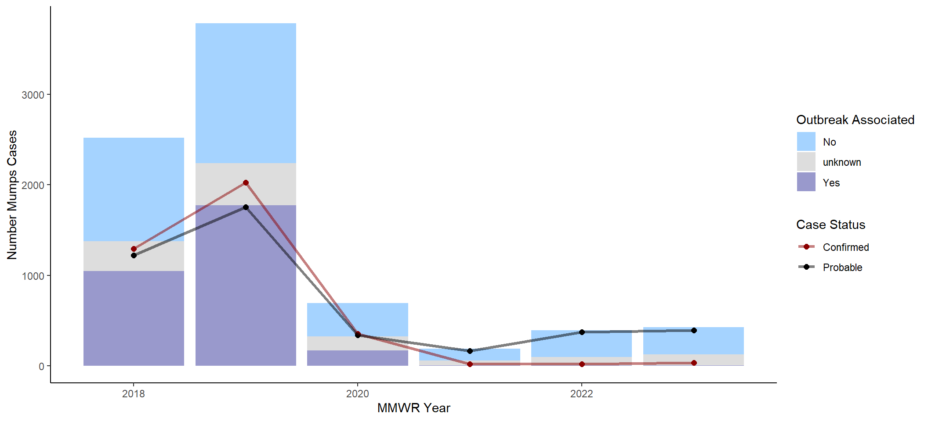
Fig S1. Mumps Cases by Year by Outbreak Association, 2018–2023, National Notifiable Disease Surveillance System

