Appendix 1:
STROBE Statement
 | Item No | Recommendation | Page
Title and abstract | 1 | (a) Indicate the study’s design with a commonly used term in the title or the abstract | 1
Title and abstract | 1 | (b) Provide in the abstract an informative and balanced summary of what was done and what was found | 1
Introduction
Background/rationale | 2 | Explain the scientific background and rationale for the investigation being reported | 2
Objectives | 3 | State specific objectives, including any pre-specified hypotheses | 3
Methods
Study design | 4 | Present key elements of study design early in the paper | 3-4
Setting | 5 | Describe the setting, locations, and relevant dates, including periods of recruitment, exposure, follow-up, and data collection | 3
Participants | 6 | (a) Give the eligibility criteria, and the sources and methods of selection of participants | 3
Variables | 7 | Clearly define all outcomes, exposures, predictors, potential confounders, and effect modifiers. Give diagnostic criteria, if applicable | 4
Data sources/ measurement | 8* | For each variable of interest, give sources of data and details of methods of assessment (measurement). Describe comparability of assessment methods if there is more than one group | 4
Bias | 9 | Describe any efforts to address potential sources of bias | NA
Study size | 10 | Explain how the study size was arrived at | 3
Quantitative variables | 11 | Explain how quantitative variables were handled in the analyses. If applicable, describe which groupings were chosen and why | 4
Statistical methods | 12 | (a) Describe all statistical methods, including those used to control for confounding | 4-5
Statistical methods | 12 | (b) Describe any methods used to examine subgroups and interactions | NA
Statistical methods | 12 | (c) Explain how missing data were addressed | NA
Statistical methods | 12 | (d) If applicable, describe analytical methods taking account of sampling strategy | NA
Statistical methods | 12 | (e) Describe any sensitivity analyses | 5
Results
Participants | 13* | (a) Report numbers of individuals at each stage of study—e.g. numbers potentially eligible, examined for eligibility, confirmed eligible, included in the study, completing follow-up, and analysed | 5
Participants | 13* | (b) Give reasons for non-participation at each stage | NA
Participants | 13* | (c) Consider use of a flow diagram | -
Descriptive data | 14* | (a) Give characteristics of study participants (e.g. demographic, clinical, social) and information on exposures and potential confounders | 5
Descriptive data | 14* | (b) Indicate number of participants with missing data for each variable of interest | NA
Outcome data | 15* | Report numbers of outcome events or summary measures | NA
Main results | 16 | (a) Give unadjusted estimates and, if applicable, confounder-adjusted estimates and their precision (e.g., 95% confidence interval). Make clear which confounders were adjusted for and why they were included | NA
Main results | 16 | (b) Report category boundaries when continuous variables were categorized | 5-6
Main results | 16 | (c) If relevant, consider translating estimates of relative risk into absolute risk for a meaningful time period | NA
Other analyses | 17 | Report other analyses done—e.g. analyses of subgroups and interactions, and sensitivity analyses | 7
Discussion
Key results | 18 | Summarise key results with reference to study objectives | 7-9
Limitations | 19 | Discuss limitations of the study, taking into account sources of potential bias or imprecision. Discuss both direction and magnitude of any potential bias | 10-11
Interpretation | 20 | Give a cautious overall interpretation of results considering objectives, limitations, multiplicity of analyses, results from similar studies, and other relevant evidence | 7-10
Generalisability | 21 | Discuss the generalisability (external validity) of the study results | 10
Other information
Funding | 22 | Give the source of funding and the role of the funders for the present study and, if applicable, for the original study on which the present article is based | NA

Appendix 2: Sensitivity Analysis: unit of analysis: individual level
Appendix 2A. Percentage of reported substances used in the lifetime on assessments completed by adolescents aged 10-18 years who were assessed for substance use treatment, by demographic characteristics, 2017-2021
 | % Substances used during the lifetime
Characteristic | Total  adolescents, %  (N=5,190) | Illegally made fentanyl (n= 118) | Heroin  (n= 145) | Prescription opioid misuse  (n= 700) | Marijuana  (n= 3521) | Alcohol  (n= 2799) | Prescription sedative or tranquilizer misuse  (n= 652) | Prescription stimulant misuse  (n= 494) | Methamphetamine (n= 383) | Cocaine  (n= 508) | No reported substanceª (n=1,206)
Overall |  | 2.27 | 2.79 | 13.49 | 67.84 | 53.93 | 12.56 | 9.52 | 7.38 | 9.79 | 23.24
DEMOGRAPHICS
Sex
Male | 58.82 | 1.83 | 1.93 | 14.05 | 73.08 | 54.44 | 13.33 | 10.06 | 6.06 | 9.11 | 19.03
Female | 41.18 | 2.90 | 4.02 | 12.68 | 60.36 | 53.21 | 11.46 | 8.75 | 9.27 | 10.76 | 29.25
P-value |  | 0.0112 | <.0001 | 0.2693 | <.0001 | 0.6761 | 0.1342 | 0.2796 | <.0001 | 0.0480 | <.0001
Age groups, years
10-12 | 5.53 | 0 | 0.35 | 1.39 | 14.29 | 12.20 | 1.74 | 1.05 | 1.05 | 0.35 | 74.22
13-15 | 44.30 | 1.61 | 1.22 | 10.94 | 60.42 | 46.02 | 10.18 | 7.26 | 5.09 | 5.87 | 29.36
16-18 | 50.17 | 3.11 | 4.45 | 17.24 | 80.30 | 65.51 | 15.86 | 12.44 | 10.10 | 14.29 | 12.21
P-value |  | <.0001 | <.0001 | <.0001 | <.0001 | <.0001 | <.0001 | <.0001 | <.0001 | <.0001 | <.0001
Race/Ethnicity
Non-Hispanic White | 43.08 | 3.00 | 3.94 | 17.84 | 71.87 | 64.67 | 16.68 | 13.73 | 10.73 | 12.92 | 19.23
Hispanic/Latino | 22.77 | 2.20 | 2.45s | 11.00 | 70.14 | 55.67 | 11.34 | 7.28 | 6.68 | 11.59 | 21.49
Non-Hispanic Black | 22.45 | 0.69 | 0.69 | 6.61 | 58.37 | 32.45 | 5.06 | 3.35 | 0.94 | 1.89 | 31.85
Other^{b} | 11.70 | 2.80 | 3.29 | 15.49 | 66.72 | 52.22 | 14.17 | 10.21 | 8.73 | 9.88 | 24.88
P-value |  | 0.0002 | <.0001 | <.0001 | <.0001 | <.0001 | <.0001 | <.0001 | <.0001 | <.0001 | <.0001
Insurance
Medicare/Medicaid ^{c} | 60.19 | 1.50 | 2.34 | 11.88 | 60.44 | 45.71 | 10.82 | 8.03 | 7.20 | 7.33 | 30.15
Other^{d} | 24.74 | 3.97 | 4.13 | 17.13 | 79.83 | 65.19 | 16.28 | 12.46 | 8.41 | 14.56 | 12.54
Self-pay | 10.08 | 2.49 | 2.68 | 13.96 | 82.03 | 71.51 | 12.62 | 10.90 | 8.03 | 12.62 | 9.18
Commercial payer | 2.87 | 2.01 | 0.67 | 14.77 | 78.52 | 63.76 | 16.78 | 10.07 | 2.01 | 9.40 | 17.45
Uninsured/Exhausted benefits | 1.85 | 3.13 | 3.13 | 12.50 | 54.17 | 57.29 | 11.46 | 11.46 | 4.17 | 10.42 | 29.17
Medicare only | 0.27 | 7.14 | 7.14 | 14.29 | 71.43 | 71.43 | 21.43 | 0.00 | 7.14 | 14.29 | 7.14
P-value |  | <.0001 | 0.0137 | 0.0017 | <.0001 | <.0001 | 0.0004 | 0.0005 | 0.0699 | <.0001 | <.0001
US Census Bureau regions (CHAT assessment sites)
South | 59.90 | 1.80 | 1.99 | 10.36 | 56.96 | 42.65 | 10.39 | 7.40 | 4.92 | 7.33 | 32.39
Midwest | 18.15 | 2.65 | 3.72 | 19.75 | 87.69 | 71.66 | 17.52 | 14.76 | 11.78 | 11.78 | 7.75
West | 17.71 | 3.26 | 4.57 | 16.00 | 79.33 | 71.06 | 13.17 | 10.01 | 12.08 | 15.56 | 12.40
Northeast | 4.24 | 3.18 | 2.73 | 20.45 | 88.64 | 65.91 | 19.55 | 15.00 | 3.64 | 11.82 | 5.45
P-value |  | 0.0349 | 0.0001 | <.0001 | <.0001 | <.0001 | <.0001 | <.0001 | <.0001 | <.0001 | <.0001
Urban-rural status (CHAT assessment sites)
Metropolitan | 64.35 | 2.46 | 2.66 | 12.22 | 62.75 | 48.56 | 12.10 | 8.62 | 6.65 | 9.82 | 27.60
Micropolitan^{e} | 26.57 | 2.18 | 3.12 | 16.97 | 75.78 | 61.57 | 14.72 | 11.60 | 9.43 | 9.86 | 16.82
Rural | 9.08 | 1.27 | 2.76 | 12.31 | 80.68 | 69.64 | 9.55 | 9.77 | 6.58 | 9.34 | 11.04
P-value |  | 0.2627 | 0.6902 | 0.0002 | <.0001 | <.0001 | 0.0111 | 0.0062 | 0.0031 | 0.9424 | <.0001
Current living situation (mutually exclusive categories)
One or both biological or adoptive parents | 72.29 | 1.89 | 2.00 | 12.82 | 65.96 | 53.01 | 11.83 | 8.61 | 5.81 | 8.77 | 25.00
Legal guardian | 9.77 | 1.78 | 3.55 | 13.81 | 70.22 | 51.28 | 11.83 | 8.88 | 8.68 | 11.44 | 20.32
Other relatives | 8.34 | 3.93 | 4.16 | 14.09 | 74.60 | 57.27 | 14.32 | 12.01 | 10.39 | 8.55 | 17.32
Other | 5.14 | 3.75 | 5.62 | 13.86 | 71.91 | 56.55 | 14.23 | 12.36 | 10.49 | 12.73 | 22.10
Foster family | 2.93 | 2.63 | 3.55 | 17.11 | 67.76 | 57.24 | 18.42 | 13.82 | 16.45 | 16.45 | 17.76
Friends, a partner/spouse, or alone | 1.52 | 8.86 | 16.46 | 31.65 | 91.14 | 81.01 | 25.32 | 25.32 | 29.11 | 31.65 | 5.06
P-value |  | <.0001 | <.0001 | 0.0012 | <.0001 | 0.0001 | 0.0042 | 0.0001 | <.0001 | <.0001 | <.0001
SCHOOL
Currently enrolled in school (includes technical, vocational, trade, and beauty schools, treatment center schools, and general educational development programs)
Yes | 87.34 | 1.85 | 2.27 | 11.96 | 65.50 | 52.11 | 11.32 | 8.54 | 5.96 | 8.52 | 25.28
No | 12.66 | 5.18 | 6.39 | 24.05 | 84.02 | 66.51 | 21.16 | 16.29 | 17.20 | 18.57 | 9.13
P-value |  | <.0001 | <.0001 | <.0001 | <.0001 | <.0001 | <.0001 | <.0001 | <.0001 | <.0001 | <.0001
During the past year, involved in activities^{f} such as sports team, school clubs
Yes | 64.93 | 1.96 | 2.23 | 11.78 | 64.39 | 51.04 | 10.80 | 8.31 | 5.67 | 7.89 | 25.52
No | 34.76 | 2.83 | 3.88 | 16.74 | 74.61 | 59.59 | 15.91 | 11.81 | 10.59 | 13.41 | 18.85
Unknown/No response | 0.31 | 6.25 | 0.00 | 6.25 | 31.25 | 25.00 | 6.25 | 6.25 | 6.25 | 0.00 | 37.50
P-value |  | 0.0768 | 0.0021 | <.0001 | <.0001 | <.0001 | <.0001 | <.0001 | <.0001 | <.0001 | <.0001
MEDICAL HISTORY
During the past 12 months, admitted to the hospital or the emergency room for medical reason^{g}
Yes | 31.06 | 4.47 | 5.02 | 19.35 | 72.70 | 64.70 | 18.36 | 15.20 | 10.55 | 15.26 | 15.94
No | 68.48 | 1.24 | 1.74 | 10.83 | 65.79 | 49.21 | 9.96 | 6.98 | 5.94 | 7.34 | 26.51
Unknown/No response | 0.46 | 8.33 | 8.33 | 12.50 | 45.83 | 29.17 | 8.33 | 4.17 | 8.33 | 4.17 | 29.17
P-value |  | <.0001 | <.0001 | <.0001 | <.0001 | <.0001 | <.0001 | <.0001 | <.0001 | <.0001 | <.0001
Currently taking medication for any emotional, behavioral, or learning problems
Yes | 33.14 | 3.66 | 4.13 | 17.62 | 67.03 | 58.26 | 18.37 | 14.94 | 9.94 | 13.78 | 22.91
No | 66.67 | 1.56 | 2.14 | 11.47 | 68.41 | 51.88 | 9.71 | 6.85 | 6.13 | 7.83 | 23.35
Unknown/No response | 0.19 | 10.00 | 0.00 | 0.00 | 10.00 | 20.00 | 0.00 | 0.00 | 0.00 | 0.00 | 40.00
P-value |  | <.0001 | 0.0002 | <.0001 | <.0001 | <.0001 | <.0001 | <.0001 | <.0001 | <.0001 | 0.4261
In inpatient controlled environment^{h} during the past 30-day
Yes | 12.50 | 5.86 | 6.47 | 23.88 | 80.28 | 68.41 | 24.65 | 20.80 | 14.33 | 20.03 | 12.33
No | 87.50 | 1.76 | 2.27 | 12.00 | 66.06 | 51.86 | 10.83 | 7.91 | 6.39 | 8.32 | 24.80
P-value |  | <.0001 | <.0001 | <.0001 | <.0001 | <.0001 | <.0001 | <.0001 | <.0001 | <.0001 | <.0001
Abbreviations: CHAT, Comprehensive Health Assessment for Teens
Data Source: The National Addictions Vigilance Intervention and Prevention Program (NAVIPPRO) Comprehensive Health Assessment for Teens (CHAT). The unit of analysis was each adolescent. The result is consistent with the main analysis. Only the P-value for the insurance category among the lifetime methamphetamine users changes from significant (P=0.0412) to nonsignificant (P=0.0699).
a. No reported substance was defined as respondents did not report alcohol use, marijuana use, heroin use, illegally made fentanyl use, prescription opioid misuse, prescription sedative or tranquilizer misuse, prescription stimulant misuse, cocaine use, methamphetamine use, hallucinogens use, inhalants use, ecstasy use, Gamma-Hydroxybutyric acid/Rohypnol use, phencyclidine/ketamine use, cough syrup use, methadone/buprenorphine use, cigarettes use, or other unspecified drugs use in the lifetime.
b. Others include those who selected Asian, American Indian/Alaskan Native, Pacific Islander/Native Hawaiian, Middle Eastern, as well as those who selected multiple races.
c. “Medicare/Medicaid” option is a mix of those who had dual eligibility as well as those who had Medicaid only.
d. “Other" includes New Mexico Behavioral Health Services Division (BHSD), access to recovery, methamphetamine initiative, New Mexico Children’s Code (NMCC), New Mexico Probation and Pre-trial (NMPP), Temporary Assistance for Needy Families Substance Abuse Services (TANF SA Services), Income Support Division/New Mexico Works (ISD/NM Works), New Mexico Total Community Approach (TCA), other and unassigned.
e. Micropolitan statistical areas consist of the county or counties (or equivalent entities) associated with at least one urban cluster of at least 10,000 but less than 50,000 population, plus adjacent counties having a high degree of social and economic integration with the core as measured through commuting ties.
f. Activities include sports team, school clubs or organizations, for example, newspaper, government, yearbook, music, art, acting, or dance, clubs or organizations not connected to school, for example, boy scouts, girl scouts, Young Men's Christian Association, or Young Women's Christian Association, after school programs, lessons for example, music, art, dance, or karate, community volunteering, for example, at a shelter, food kitchen, hospital, or community center, religious or spiritual activities, for example, going to church, mosque, temple, or being part of a youth group, other.
g. Medical reasons for admission to the hospital or the emergency room include drug reaction, overdose, or alcohol poisoning; suicide attempt; harming self on purpose; broken bone; car, bicycle, or another kind of accident; sexual assault or other physical attack; headaches or concussion; pneumonia or other physical illness; and other serious illness.
h. Inpatient controlled environment include inpatient alcohol or drug treatment, inpatient medical hospital, and inpatient psychiatric or mental health treatment.

Appendix 2B. Percentage of reported substances used in the lifetime on assessments completed by adolescents aged 10-18 years who were assessed for substance use treatment, by other demographic characteristics, 2017-2021
 | % Substances used during the lifetime
Characteristic | Total  adolescents, %  (N=5,190) | Illegally made fentanyl (n= 118) | Heroin  (n= 145) | Prescription opioid misuse  (n= 700) | Marijuana  (n= 3521) | Alcohol  (n= 2799) | Prescription sedative or tranquilizer misuse  (n= 652) | Prescription stimulant misuse  (n= 494) | Methamphetamine (n= 383) | Cocaine  (n= 508) | No reported substance (n=1,206)
Overall |  | 2.27 | 2.79 | 13.49 | 67.84 | 53.93 | 12.56 | 9.52 | 7.38 | 9.79 | 23.24
SUBSTANCE USE AND TREATMENT HISTORY
For those who use the corresponding substance, mean age of initiation (Standard Deviation)ª, years |  | 14.28 (2.53) | 14.34 (2.45) | 13.69 (2.69) | 12.92 (2.22) | 13.00  (2.62) | 14.06  (2.14) | 13.51 (3.07) | 14.35 (1.98) | 14.67 (2.01) | NA
Route of administration for any substance used during the lifetime
No injection drug use (swallowed, snorted, smoked or other method^{b} were reported) | 62.99 | 2.48 | 2.54 | 18.87 | 97.34 | 72.35 | 18.26 | 13.18 | 9.24 | 13.52 | 0
Injection drug use (swallowed, snorted, smoked or other method may also be reported) | 1.66 | 40.70 | 68.60 | 72.09 | 96.51 | 89.53 | 61.63 | 52.33 | 83.72 | 66.28 | 0
Missing | 35.36 | 0.11 | 0.16 | 1.14 | 13.95 | 19.46 | 0.11 | 0.98 | 0.49 | 0.49 | 65.72
P-value |  | <.0001 | <.0001 | <.0001 | <.0001 | <.0001 | <.0001 | <.0001 | <.0001 | <.0001 | <.0001
Ever attended Alcoholics Anonymous, Marijuana Anonymous, Cocaine Anonymous, Narcotics Anonymous, or any other kind of group for responders’ alcohol or drug use
Yes | 13.37 | 7.78 | 9.51 | 36.74 | 95.24 | 81.12 | 33.57 | 27.09 | 21.76 | 28.82 | 1.01
No | 86.26 | 1.43 | 1.76 | 9.90 | 63.68 | 49.79 | 9.31 | 6.81 | 5.18 | 6.86 | 26.65
Unknown/No response | 0.37 | 0.00 | 0.00 | 10.53 | 47.37 | 36.84 | 10.53 | 5.26 | 0.00 | 5.26 | 31.58
P-value |  | <.0001 | <.0001 | <.0001 | <.0001 | <.0001 | <.0001 | <.0001 | <.0001 | <.0001 | <.0001
Ever had counseling or treatment^{c} for responders’ alcohol/drug use
Yes | 23.24 | 5.80 | 7.46 | 30.76 | 96.19 | 79.93 | 27.61 | 23.05 | 18.16 | 23.22 | 0.66
No | 76.45 | 1.21 | 1.39 | 8.22 | 59.35 | 46.09 | 7.99 | 5.42 | 4.13 | 5.72 | 30.12
Unknown/No response | 0.31 | 0.00 | 0.00 | 18.75 | 37.50 | 37.50 | 12.50 | 6.25 | 0.00 | 6.25 | 18.75
P-value |  | <.0001 | <.0001 | <.0001 | <.0001 | <.0001 | <.0001 | <.0001 | <.0001 | <.0001 | <.0001
Received treatment as part of an official medications for substance use disorders program in the past 30 days^{d}
Yes | 5.59 | 6.90 | 6.21 | 23.79 | 88.97 | 64.48 | 21.03 | 18.62 | 16.90 | 17.24 | 2.76
No | 92.37 | 2.02 | 2.61 | 12.91 | 67.17 | 53.75 | 12.18 | 9.05 | 6.86 | 9.45 | 24.09
Unknown/No response | 2.04 | 0.94 | 1.89 | 11.32 | 40.57 | 33.02 | 6.60 | 5.66 | 4.72 | 4.72 | 40.57
P-value |  | <.0001 | 0.0012 | <.0001 | <.0001 | <.0001 | <.0001 | <.0001 | <.0001 | <.0001 | <.0001
HISTORY OF INVOLVEMENT WITH THE JUSTICE SYSTEM
History of criminal justice involvement^{e}
Yes | 58.88 | 3.24 | 3.99 | 18.65 | 86.58 | 66.13 | 16.95 | 12.79 | 10.67 | 14.20 | 7.53
No | 41.04 | 0.89 | 1.08 | 6.06 | 41.03 | 36.48 | 6.29 | 4.79 | 2.68 | 3.47 | 45.82
Unknown/No response | 0.08 | 0.00 | 0.00 | 25.00 | 25.00 | 25.00 | 0.00 | 25.00 | 0.00 | 0.00 | 0.00
P-value |  | <.0001 | <.0001 | <.0001 | <.0001 | <.0001 | <.0001 | <.0001 | <.0001 | <.0001 | <.0001
Currently on probation
Yes | 37.76 | 3.06 | 3.32 | 17.86 | 88.57 | 66.28 | 16.43 | 11.48 | 9.85 | 13.78 | 5.87
No | 62.20 | 1.80 | 2.48 | 10.84 | 55.30 | 46.47 | 10.22 | 8.33 | 5.89 | 7.37 | 33.80
Unknown/No response | 0.04 | 0.00 | 0.00 | 0.00 | 0.00 | 0.00 | 0.00 | 0.00 | 0.00 | 0.00 | 0.00
P-value |  | 0.0121 | 0.2008 | <.0001 | <.0001 | <.0001 | <.0001 | <.0001 | <.0001 | <.0001 | <.0001
In the controlled environment (justice-system)^{f} during the past 30-day
Yes | 21.97 | 3.86 | 5.00 | 22.02 | 87.46 | 68.16 | 20.18 | 13.51 | 13.42 | 16.67 | 7.19
No | 78.03 | 1.83 | 2.17 | 11.09 | 62.32 | 49.93 | 10.42 | 8.40 | 5.68 | 7.85 | 27.75
P-value |  | <.0001 | <.0001 | <.0001 | <.0001 | <.0001 | <.0001 | <.0001 | <.0001 | <.0001 | <.0001
MODERATE TO EXTREME SEVERITY IN THE PAST 30-DAY FOR BIOPSYCHOSOCIAL CONTENT AREAS
Emotional/psychological health
Yes | 28.15 | 4.31 | 4.65 | 21.22 | 68.04 | 63.45 | 20.47 | 16.22 | 10.68 | 15.06 | 22.25
No | 70.89 | 1.44 | 2.07 | 10.49 | 68.23 | 50.39 | 9.54 | 6.96 | 6.14 | 7.77 | 23.38
Unknown/No response | 0.96 | 4.00 | 2.00 | 8.00 | 34.00 | 36.00 | 4.00 | 2.00 | 2.00 | 4.00 | 42.00
P-value |  | <.0001 | <.0001 | <.0001 | <.0001 | <.0001 | <.0001 | <.0001 | <.0001 | <.0001 | 0.0047
Family relationships
Yes | 15.05 | 3.71 | 5.51 | 20.10 | 73.37 | 64.66 | 20.23 | 15.62 | 10.37 | 14.85 | 18.57
No | 82.68 | 2.07 | 2.38 | 12.42 | 67.35 | 52.39 | 11.33 | 8.55 | 6.92 | 8.95 | 23.86
Unknown/No response | 2.27 | 0.00 | 0.00 | 8.47 | 49.15 | 38.98 | 6.78 | 4.24 | 4.24 | 6.78 | 31.36
P-value |  | 0.0045 | <.0001 | <.0001 | <.0001 | <.0001 | <.0001 | <.0001 | 0.0013 | <.0001 | 0.0006
Friend/peer relationships
Yes | 18.48 | 6.47 | 7.82 | 28.47 | 82.38 | 73.72 | 25.44 | 22.11 | 17.31 | 22.94 | 10.64
No | 79.36 | 1.36 | 1.70 | 10.10 | 64.99 | 49.75 | 9.66 | 6.63 | 5.12 | 6.82 | 25.90
Unknown/No response | 2.16 | 0.00 | 0.00 | 9.82 | 48.21 | 38.39 | 8.93 | 8.04 | 5.36 | 6.25 | 33.04
P-value |  | <.0001 | <.0001 | <.0001 | <.0001 | <.0001 | <.0001 | <.0001 | <.0001 | <.0001 | <.0001
Alcohol use
Yes | 7.57 | 6.36 | 6.11 | 36.13 | 95.17 | 100.00 | 33.08 | 30.28 | 18.58 | 30.53 | 0.00
No | 91.93 | 1.93 | 2.54 | 11.63 | 65.67 | 50.05 | 10.94 | 7.84 | 6.46 | 8.07 | 25.28
Unknown/No response | 0.50 | 3.85 | 0.00 | 11.54 | 53.85 | 69.23 | 0.00 | 3.85 | 7.69 | 11.54 | 0.00
P-value |  | <.0001 | 0.0001 | <.0001 | <.0001 | <.0001 | <.0001 | <.0001 | <.0001 | <.0001 | <.0001
Tobacco use
Yes | 14.56 | 6.90 | 10.34 | 36.40 | 97.70 | 87.87 | 33.72 | 28.10 | 25.54 | 31.55 | 0.00
No | 84.94 | 1.51 | 1.60 | 9.70 | 63.02 | 48.48 | 9.00 | 6.35 | 4.55 | 6.17 | 27.31
Unknown/No response | 0.50 | 7.41 | 0.00 | 14.81 | 48.15 | 51.85 | 11.11 | 11.11 | 3.70 | 7.41 | 0.00
P-value |  | <.0001 | <.0001 | <.0001 | <.0001 | <.0001 | <.0001 | <.0001 | <.0001 | <.0001 | <.0001
Drug use
Yes | 20.10 | 5.56 | 7.19 | 31.16 | 97.89 | 80.82 | 29.43 | 23.39 | 17.35 | 25.02 | 0.19
No | 76.96 | 1.43 | 1.73 | 8.96 | 60.62 | 47.35 | 8.16 | 6.01 | 4.96 | 6.08 | 28.99
Unknown/No response | 2.95 | 1.96 | 0.65 | 11.11 | 51.63 | 42.48 | 12.42 | 6.54 | 2.61 | 2.61 | 30.07
P-value |  | <.0001 | <.0001 | <.0001 | <.0001 | <.0001 | <.0001 | <.0001 | <.0001 | <.0001 | <.0001
Data Source: The National Addictions Vigilance Intervention and Prevention Program (NAVIPPRO) Comprehensive Health Assessment for Teens (CHAT). The unit of analysis was each adolescent. The result is consistent with the main analysis.
a. For calculating the mean age of initiation of the corresponding substance, we excluded those with 0 and other missing cases (-1, -2), and excluded those who reported that the age of initiation is greater than the respondents’ current age.
b. Swallow doesn’t include legitimate medical use (obtained from a prescription ONLY and used only as directed). Other method includes dissolving the substance in mouth like a cough drop, drinking it after it dissolved in liquid, or other unspecified method.
c. Treatment may include therapy with a counselor, inpatient rehabilitation, or residential treatment.
d. Official medications for SUD program (previously referred to medication-assisted therapy program in the CHAT) included a methadone maintenance program, buprenorphine or Suboxone® treatment, or Vivitrol® or naltrexone treatment for alcohol/ drugs.
e. History of criminal justice involvement is defined as individuals reported that they have ever been in trouble with the law or arrested.
f. Controlled environment (justice-system) include juvenile justice center, detention center, jail, prison, or other residential setting such as a group home or residential program.

Appendix 2C. Within each category of lifetime substance use, percentage of adolescents reporting past-year (and past 30-day) overdoses or hospital visits due to drug/alcohol use among all assessments
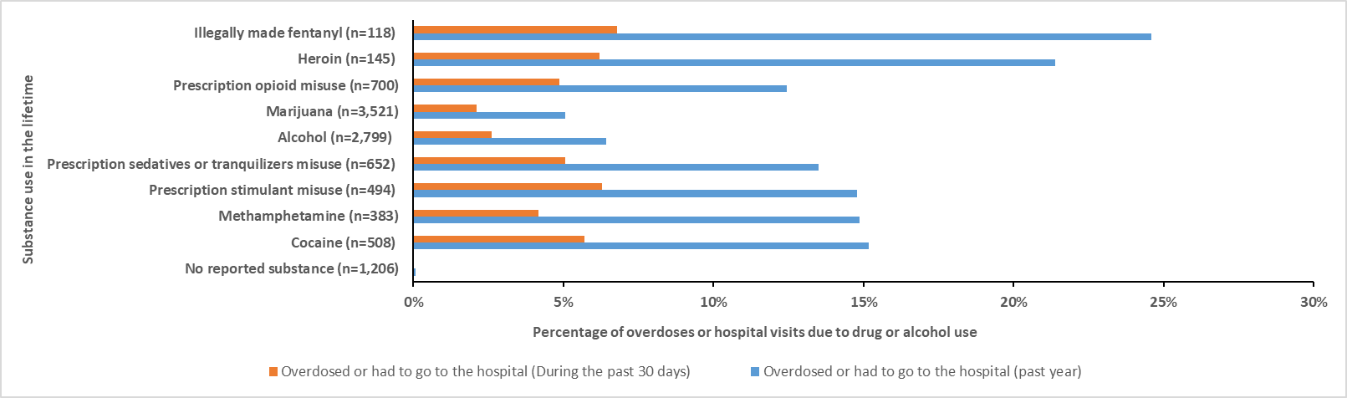Data Source: The National Addictions Vigilance Intervention and Prevention Program (NAVIPPRO) Comprehensive Health Assessment for Teens (CHAT). The unit of analysis was each adolescent. The result is consistent with the main analysis.

Appendix 2D. Most common substance used in the past 30 days among assessments completed by adolescents aged between 10 and 18 years reporting any substance use in the past 30 daysª (N =2,452), 2017-2021^{b}
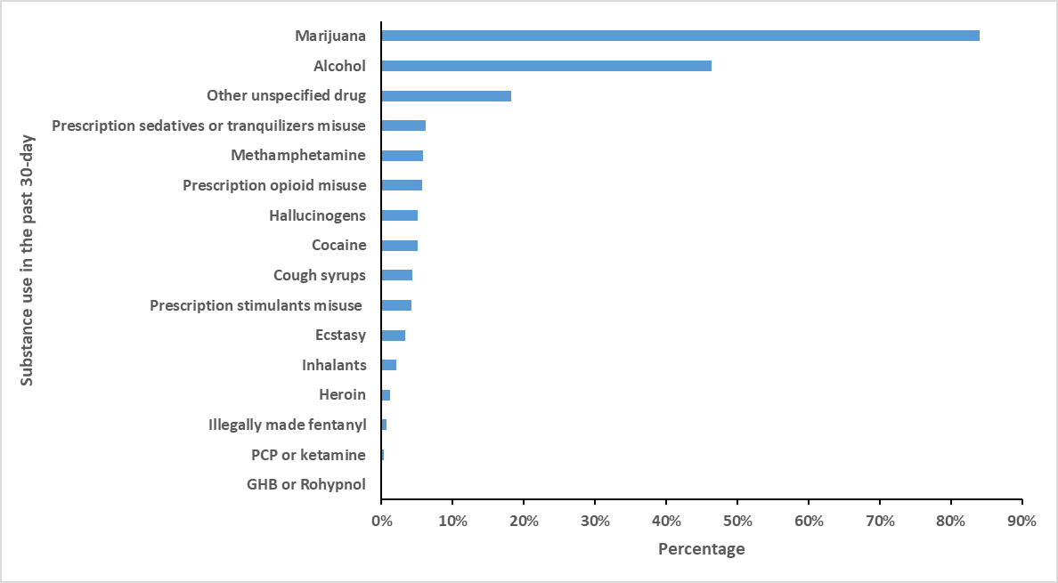 Abbreviations: PCP, phencyclidine; GHB, Gamma-Hydroxybutyric acid.
Data Source: The National Addictions Vigilance Intervention and Prevention Program (NAVIPPRO) Comprehensive Health Assessment for Teens (CHAT). The unit of analysis was each adolescent. The result is consistent with the main analysis.
a. Any substance use in the past 30-day includes past 30-day use (or prescription medication misuse) of the following: alcohol, marijuana, heroin, illegally made fentanyl, prescription opioid misuse, prescription sedative or tranquilizer misuse, prescription stimulant misuse, cocaine, methamphetamine, hallucinogens, inhalants, ecstasy, Gamma-Hydroxybutyric acid/Rohypnol, phencyclidine/ketamine, cough syrup, and other unspecified drugs.
b. Data represents 47.2% of all 9.17.2017-12.31.2021 adolescents who reported using the listed substances during the past 30 days.

Appendix 2E. Most common substance combinations reported among adolescents aged 10-18 years reporting use of more than one substance in the past 30 daysª (N =1,241), 2017-2021^{b}
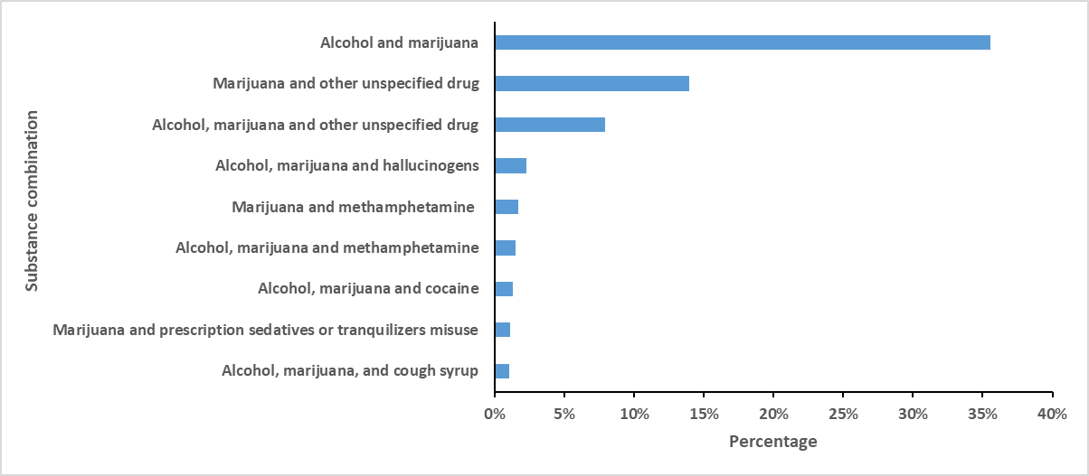Data Source: The National Addictions Vigilance Intervention and Prevention Program (NAVIPPRO) Comprehensive Health Assessment for Teens (CHAT). The unit of analysis was each adolescent. The result is consistent with the main analysis. However, the percentage of marijuana and hallucinogen combinations was <1% (sensitivity analysis: 0.97%; main analysis: 1.09%), so it is no longer listed in the figure.
a. Use of more than one substance in the past 30-day includes past 30-day use (or prescription medication misuse) of at least two of the following: alcohol, marijuana, heroin, illegally made fentanyl, prescription opioid misuse, prescription sedative or tranquilizer misuse, prescription stimulant misuse, cocaine, methamphetamine, hallucinogens, inhalants, ecstasy, Gamma-Hydroxybutyric acid/Rohypnol, phencyclidine/ketamine, cough syrup, and other unspecified drugs. The remaining unique substance combinations each represented <1% of all combinations among assessments reporting use of more than one substance during the past 30 days. Use of more than one substance as displayed in this figure does not necessarily represent use of substances simultaneously.
b. Data represents 23.9% of all 9.17.2017-12.31.2021 adolescents who reported using more than one substance during the past 30 days.

