Supplement Figure 1. Percentage of reported substances that caused the most problems among assessments completed by adolescents aged 10-18 years who were assessed for substance use treatment (N=5,377), 2017-2021^{a,b}
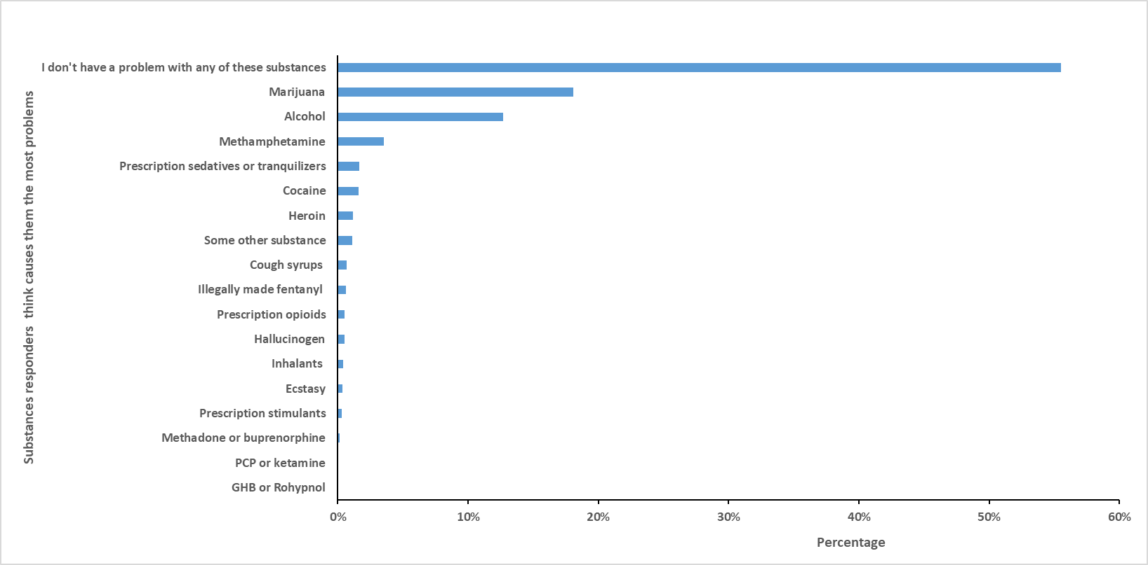Abbreviations: PCP, phencyclidine; GHB, Gamma-Hydroxybutyric acid.
Data Source: The National Addictions Vigilance Intervention and Prevention Program (NAVIPPRO) Comprehensive Health Assessment for Teens (CHAT). The unit of analysis was each assessment.

- For this question, responders did not differentiate whether they misused prescription drugs or not. Prescription sedatives or tranquilizers include but not limited to Valium®, Xanax®, Klonopin®, Diazepam, Seconal®, Nembutal®; Prescription opioids include but not limited to Oxycontin®, Vicodin®, Percocet®, Percodan®, Tylox®, Codeine®; Prescription stimulants include but not limited to Ritalin®, Adderall®, Concerta®, Dexedrine®. “Methadone or buprenorphine”, “PCP or ketamine”, and “GHB or Rohypnol” were listed as three drug groups in the CHAT when presented to adolescents. Each substance reported causing the most problems was mutually exclusive.
- Among 125 assessments of adolescents who reported illegally made fentanyl (IMF) use in the lifetime, 12 (9.6%) thought IMF was causing them the most problems.
Supplement Figure 2. Percentage of substances that adolescents reported as their preferred substances among assessments completed by adolescents aged 10-18 years who were assessed for substance use treatment (N=5,377), 2017-2021^{a,b}
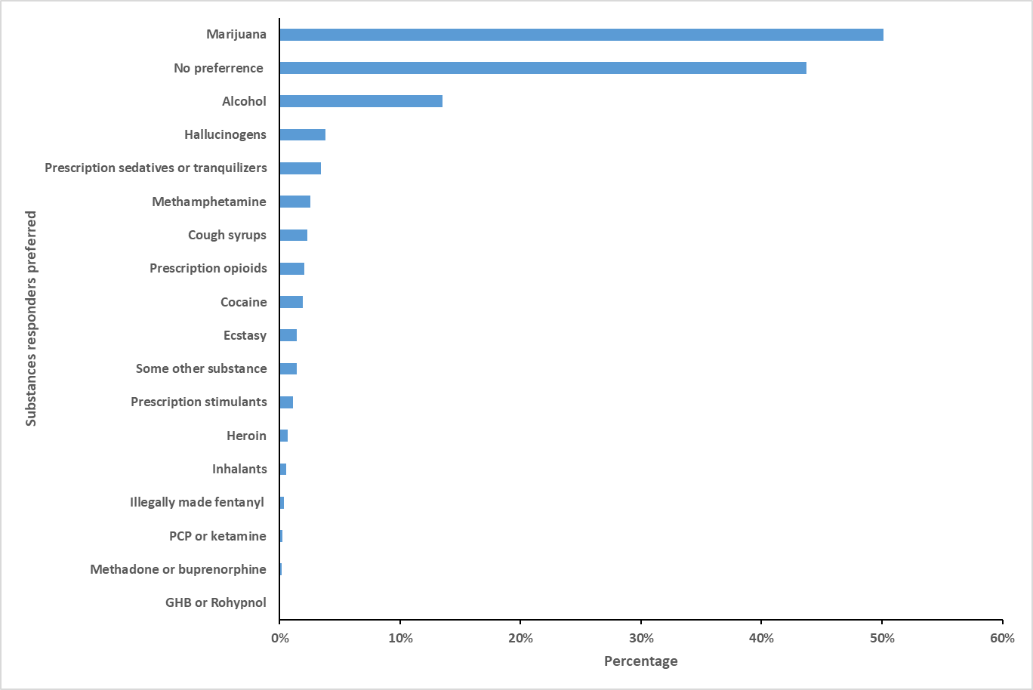Abbreviations: PCP, phencyclidine; GHB, Gamma-Hydroxybutyric acid.
Data Source: The National Addictions Vigilance Intervention and Prevention Program (NAVIPPRO) Comprehensive Health Assessment for Teens (CHAT). The unit of analysis was each assessment.
- Responders can select up to three substances as their preferred substances. There was no rank among the selected preferred substances. “Methadone or buprenorphine”, “PCP or ketamine”, and “GHB or Rohypnol” were listed as three drug groups in the CHAT when presented to adolescents. Each substance reported as the preferred substance was NOT mutually exclusive.
b. Among 125 assessments of adolescents who reported illegally made fentanyl (IMF) use in the lifetime, 15 (12%) reported IMF as the preferred substance.

