SUPPLEMENTAL MATERIALS

Supplementary Methods
Additional details about the Irrigated Agriculture Research and Extension Center (IAREC)
The IAREC was established by legislative mandate to address agricultural research needs in WA [1]. The IAREC conducts collaborative research among Washington State University, United States Department of Agriculture – Agriculture Research Service (USDA-ARS), and the Washington State Department of Agriculture (WSDA) to inform agricultural practice in the area. There are 120 acres of IAREC field research plots at an elevation of approximately 850 feet, per Google Earth.

Additional details about IAREC grape and cherry blocks and selection of crop blocks
Grape and cherry blocks were chosen for this study because there were no plans for pesticide spraying, harvest activities, irrigation, or other activities by IAREC staff within these blocks during the study period. The IAREC wine grape block was planted from 2015-2019 with a range of varieties. The IAREC cherry block was planted in 2019 with primarily seedling cherries, with about 10% cherry rootstocks (Gisela-6) and about 3% grafted cherry cultivars. The crops were planted in North-South rows of about 188 feet in length for grapes and 369 feet in length for cherries. There were approximately 23 grape rows, with a distance of about 9 feet between rows. Grape vines measured approximately 6.8 feet tall. There were approximately 10 cherry rows, with a distance of about 8.5 feet between rows. Cherry trees measured approximately 9.3 feet tall with spacing in accordance with industry standards. Although IAREC does curate hops blocks, we did not choose to conduct monitoring within hops blocks, as hops are typically mechanically harvested rather than manually harvested. Apple blocks were not located in close proximity to grape and cherry blocks, so were not included for logistical reasons and resource constraints.

Field safety plan
The research team conducted heat and wildfire smoke safety and health training and developed a written safety plan to ensure the safety of research staff deploying instruments, collecting data, and making field observations. Research staff worked in pairs to allow for observation of co-workers, were stationed under shade canopies, were provided sufficient quantities of suitably cool drinking water in coolers, and took regular cool-down rest breaks in a nearby air-conditioned building or vehicle. Air temperatures exceeded 90°F on each day but no wildfire smoke events occurred during sampling.

Wind speed assessment
Washington State University’s AgWeatherNet (https://weather.wsu.edu/) consists of a network of over 200 professional weather stations that provides real-time, local information intended for crop decision support [2]. Wind speed was recorded every 15 minutes from the “Prosser NE” station located near the IAREC at a latitude of 46° 15' 0", longitude of 119° 44' 24", and an elevation of 252 meters. Wind speed was measured using a Campbell Scientific Model 014A Met One three cup anemometer 2 meters above the surface (Logan, UT).

Field observations
Research staff filled out a standardized observation sheet at each site approximately every hour recording display output readings from each QUESTemp°, namely DBT, RH, BGT, WBT, and WBGT_{out}. The data collection sheet also included a pictorial assessment of cloud cover (0% no clouds, 10% few clouds, 10-25% isolated clouds, 25-50% scattered clouds, 50-90% broken clouds, >90% overcast) and an assessment of whether each device was in full sun, full shade, or mixed conditions at each observation time and location.

Equation used to calculate outside Wet Bulb Globe Temperature (WBGT_{out}) [3,4]
WBGT_{out} = 0.7 T_{w} + 0.2 T_{g} + 0.1 T_{d,} where:
T_{w} = (natural) wet bulb temperature
T_{g} = globe temperature
T_{d} = dry air temperature

Equations for calculating National Institute for Occupational Safety and Health (NIOSH) heat stress Recommended Exposure Limits (RELs) and Recommended Alert Limits (RALs), which correspond to ACGIH Threshold Limit Values (TLVs) and Action Limits (ALs) [3,4]
RAL (°C) = 59.9 - 14.1 log₁₀TWA-M
REL (°C) = 56.7 - 11.5 log₁₀TWA-M
where
TWA-M = (M₁ * t₁ + … + M_{n}*t_{n})/(t₁+…+ t_{n}),
and t = time interval, n = number of time intervals, and M is the metabolic rate in Watts.

Approach to selecting rest break durations considered:

Chapter 296-307-097 Outdoor Heat Exposure Permanent Language [5]:

“296-307-09747 High heat procedures.
The employer must implement the following high heat procedures when the temperature is at or above 90 degrees Fahrenheit, unless engineering or administrative controls (such as air-conditioning or scheduling work at cooler times of the day) are used to lower employees' exposure below 90 degrees Fahrenheit.
(1) Ensure that employees take at a minimum the mandatory cool-down rest periods in Table 2. The cool-down rest period must be provided in the shade or using other equally or more effective means to reduce body temperature. The mandatory cool-down rest period may be provided concurrently with any meal or rest period required under WAC 296-131-020 and must be paid unless taken during a meal period that is not otherwise required to be compensated. Mandatory cool-down rest periods in Table 2 are not required during emergency response operations where rescue, evacuation, utilities, communications, transportation, law enforcement, and medical operations are directly aiding firefighting, protecting public health and safety, or actively protecting, restoring or maintaining the safe and reliable operation of critical infrastructure at risk.

Table 2
Air Temperature | Mandatory cool-down rest periods
At or above 90°F | 10 minutes/2 hours
At or above 100°F | 15 minutes/1 hour

Notes:

• Employers may also consider implementing more additional protective rest periods per NIOSH or ACGIH methods:

- NIOSH Criteria for a Recommended Standard for Occupational Exposure to Heat and Hot Environments: https://www.cdc.gov/niosh/docs/ 2016-106/pdfs/2016-106.pdf?id=10.26616/NIOSHPUB2016106

- American Conference of Governmental Industrial Hygienists (ACGIH) Threshold Limit Value (TLV) for Heat Stress and Strain: https:// www.acgih.org/heat-stress-and-strain-2/

• The department will review work-rest periods within three years after the outdoor heat exposure rule goes into effect. We will review applicable data including, but not limited to, heat-related illness claims, inspections, other national and state regulations, peer-reviewed publications, and nationally recognized standards.”

WAC 296-131-020: Meal periods—Rest periods [6]:
“(1) Every employee employed more than five hours shall receive a meal period of at least thirty minutes. Employees working eleven or more hours in a day shall be allowed at least one additional thirty-minute meal period.
(2) Every employee shall be allowed a rest period of at least ten minutes, on the employer's time, in each four-hour period of employment. For purposes of computing the minimum wage on a piecework basis, the time allotted an employee for rest periods shall be included in the number of hours for which the minimum wage must be paid.”

Approach for calculating hourly TWA-WBGT_{out} [3,4]
TWA-WBGT_{out} = (WBGT₁ * t₁ + … + WBGT_{n}*t_{n})/(t₁+…+ t_{n}),
where t = time interval and n = number of time intervals

Supplementary Results
Cloud cover and device sun/shade
Research staff reported no clouds on Day 1 and no clouds-few clouds on Day 2. On Day 3, research staff reported variable cloud cover conditions, from few clouds to overcast. A plateau in temperature beginning at about the 11:00 hour was seen on Day 3 in both crops, corresponding to when increased cloud cover was observed. In the cherry block, in the 09:00-13:00 hours on Day 1, field staff reported full sun on all devices in the open area and full shade under the shade (Supplementary Figure 1). However, the device in the middle of the row was reported to be in full sun until about noon and then in mixed sun/shade on Day 1. In the cherry block on Day 2, there was a transition at about the 10:00 hour from mixed sun/shade to full sun in the mid-point of the row. In the cherry block on Day 3, there was a transition at about the 10:00 hour from mixed sun/shade to full sun in the mid-point of the row and from mixed sun/shade to full shade in the shade area. In the grape block on Day 1, field staff reported full sun on all devices in the open area and mid-point of the row on all days and full shade under the shade. In the 08:00 hour in the grape block on Days 2 and 3, field staff reported mixed sun/shade conditions in the shade and rows/open area, respectively (Supplementary Figure 2). Device sun/shade observations per hour were not included as a factor in models because variability in sun and shade was only present within the crop rows (i.e., mid-row) and is driven by crop architecture, sun position, and wind. Sun/shade variation is therefore an inherent element of worker-relevant exposure within a row.

Results of sensitivity analyses
WBGT_{out} and BGT models among cherries and grapes, subset to hours with substantial sun when we did not observe cloud cover (first hour of sampling to 12:00 noon) for Days 1 through 3, resulted in no change in model inferences, suggesting relative differences in WBGT_{out} and BGT among sample locations did not differ due to cloud cover. Introduction of cloud cover by location interactions into the WBGT_{out} and BGT models for cherries and grapes failed to converge, as variability in cloud cover per treatment was minimal. Sensitivity analyses also included minutes nested within day and hour (random factor), yielding no change in model inferences, yet an increase in effect estimate standard errors. Separate models that examined WBGT_{out} and BGT as outcomes yet that also included crop type (cherry or grape), crop by location, crop by hour, and a crop by location by hour interaction as fixed factors and hour nested within day as a random effect were examined. These models showed no appreciable differences in model inferences and standard errors from that of the single crop models; however, the main effect of crop for the WBGT_{out} model was significant, indicating that the grape block was 2.5ºC higher in temperature than the cherry block (95% CI: 0.66, 4.39; P=0.008). No significant differences were found among crops for the BGT model.
Supplementary Table 1. Summary of environmental parameters by crop and day
 | Cherries |  |  | Grapes
 | Day 1 | Day 2 | Day 3 | Day 1 | Day 2 | Day 3
Max dry air temperature, °C (°F) | 36.9 (98.4) | 36.6  (97.8) | 38.2  (100.8) | 36.7 (98.1) | 39.1  (102.3) | 37.5  (99.5)
Max black globe temperature, °C (°F) | 54.2 (129.5) | 55.5  (131.8) | 56.7  (134.0) | 55.1  (131.1) | 54.6  (130.2) | 53.0  (127.3)
Max wet bulb temperature, °C (°F) | 25.6 (78.1) | 27.1  (80.7) | 27.1  (80.7) | 24.2  (75.5) | 27.2  (80.9) | 24.6  (76.2)
Max WBGT_{out}, °C (°F) | 31.8 (89.2) | 33.5  (92.4) | 33.6  (92.5) | 31.5 (88.7) | 33.8 (92.8) | 31.5 (88.7)

Supplementary Figure 1. Dry Bulb Temperature, Black Globe Temperature, Wet Bulb Temperature, and WBGT_{out} over time by day and location in the cherry block
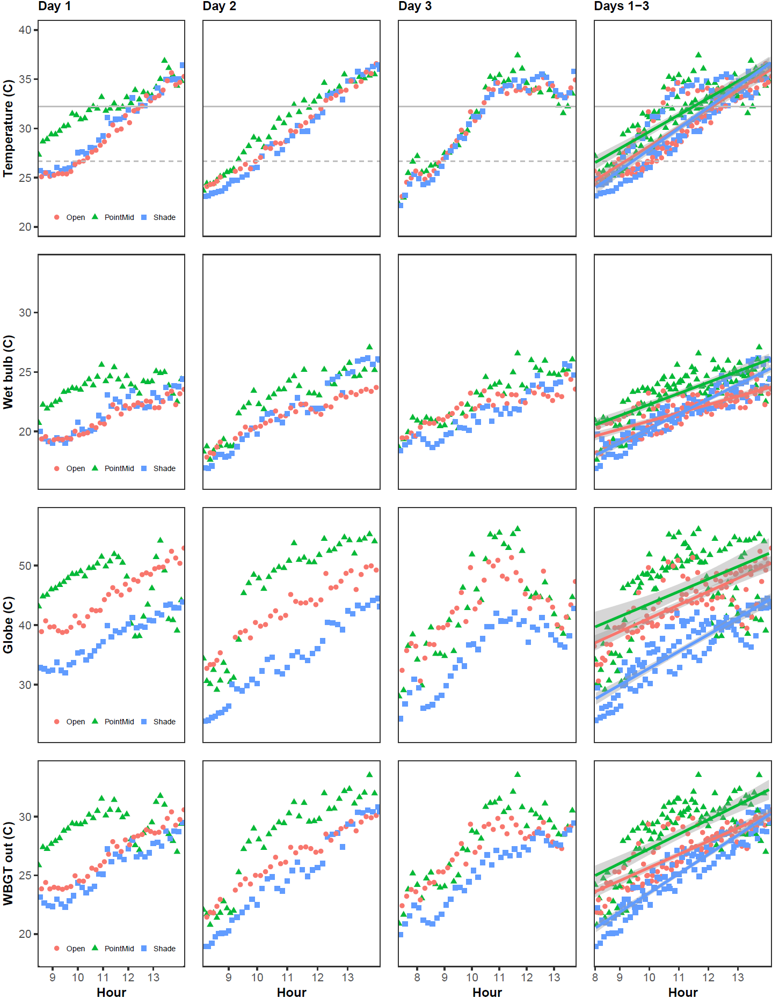
Best fit lines (temperature on hour) and 95% confidence intervals are for Days 1-3
Note: Dashed gray line = 27ºC (80ºF), solid gray line = 32ºC (90ºF)
Supplementary Figure 2. Dry Bulb Temperature, Black Globe Temperature, Wet Bulb Temperature, and WBGT_{out} over time by day and location in the grape block
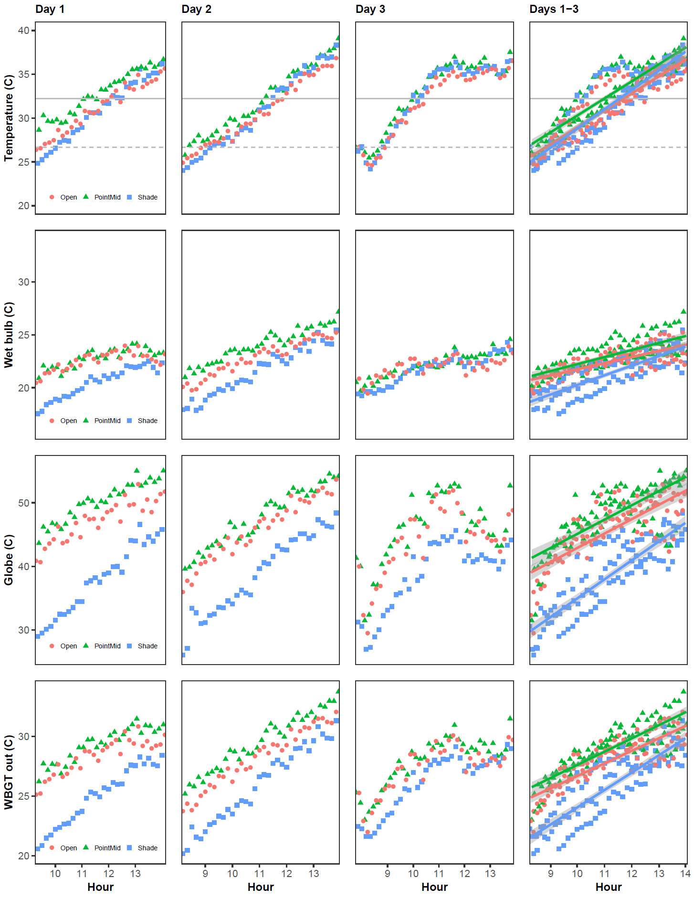
Best fit lines (temperature on hour) and 95% confidence intervals are for Days 1-3
Note: Dashed gray line = 27ºC (80ºF), solid gray line = 32ºC (90ºF)

Supplementary References

[1] Washington State University Extension. Prosser Irrigated Agriculture Research and Extension Center [Internet]. Prosser (WA): WSU [cited 2023 Aug 3]. Available from: https://iarec.wsu.edu/.
[2] Washington State University. The Washington Agricultural Weather Network Version 2.0, WSU Prosser -- AgWeatherNet [Internet]. Prosser (WA): WSU; 2013 [cited 2023 Aug 3]. Available from: http://weather.wsu.edu/awn.php.
[3] ACGIH®. Heat Stress and Strain: TLV® Physical Agents. Cincinnati, OH: American Conference of Governmental Industrial Hygienists; 2022.
[4] Jacklitsch B, Williams W, Musolin K, et al. NIOSH criteria for a recommended standard: occupational exposure to heat and hot environments [Internet]. Cincinnati (OH): NIOSH; 2016 [cited 2023 Aug 3]. Available from: http://www.cdc.gov/niosh/docs/2016-106/pdfs/2016-106.pdf.
[5] Washington State Legislature. WAC 296-307-097 Outdoor Heat Exposure [Internet]. Olympia (WA): WA Legislature;2023 [cited 2024 Apr 2]. Available from: https://app.leg.wa.gov/WAC/default.aspx?dispo=true&cite=296-307&full=true#296-307-097.
[6] Washington State Legislature. WAC 296-131-020: Meals and rest periods [Internet]. Olympia (WA): WA Legislature; 1990[cited 2023 May 4]. Available from: https://app.leg.wa.gov/wac/default.aspx?cite=296-131-020#:~:text=Meals%20and%20rest%20periods.&text=Employees%20working%20eleven%20or%20more,four%2Dhour%20period%20of%20employment.

