Supplementary Figure 1 Legend. Annual numbers of tests among patients aged >18 years who were tested for hepatitis C virus antibody and tested hepatitis C virus antibody-positive, Quest Diagnostics, 2013–2021ª

Data source: 2013–2021 Quest Diagnostics.
Abbreviation: HCV, hepatitis C virus.
ªDuring 2013–2021, the annual number of patients aged >18 years who were tested for HCV antibody from Quest Diagnostics, on average, increased by 373,136 patients per year (P<.001); the annual HCV antibody-positivity proportion declined (P=.002). Data were not deduplicated across years.
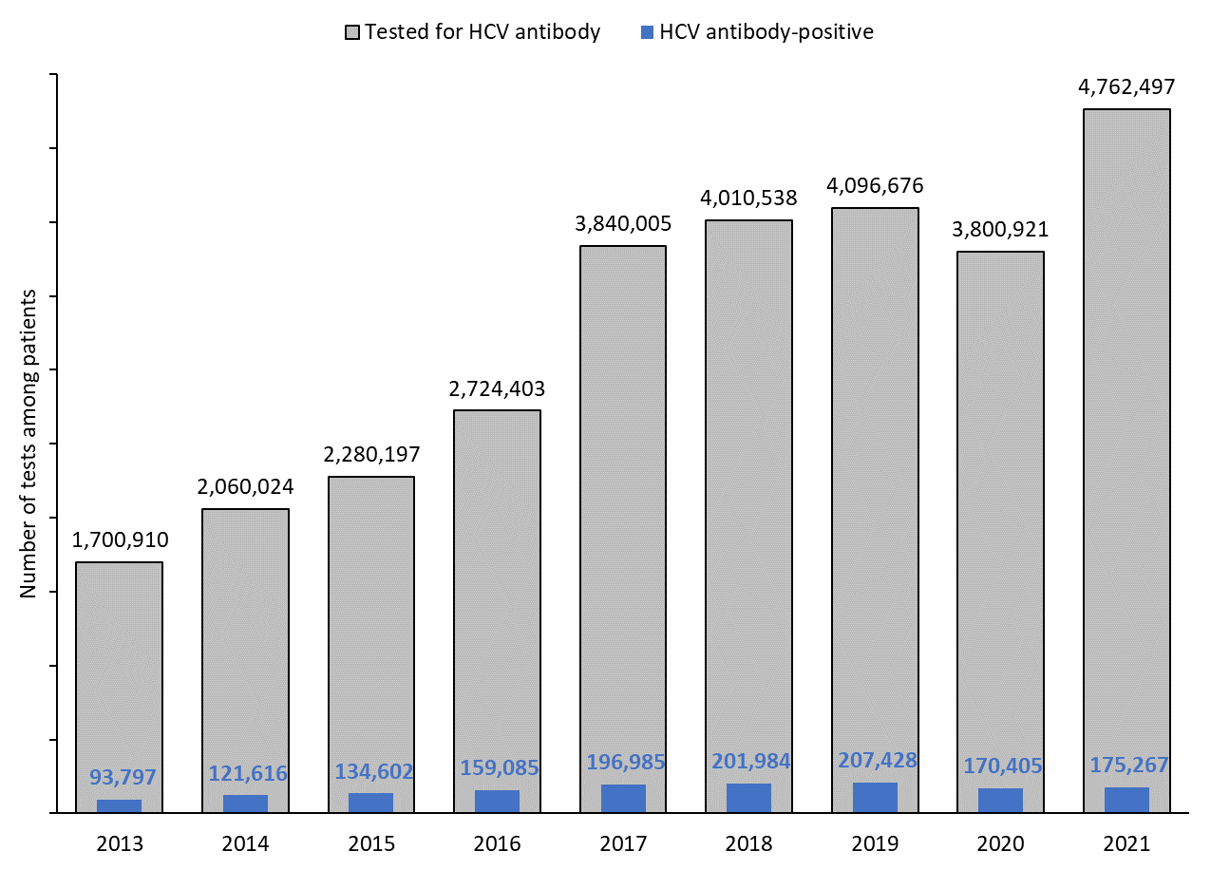
5.8%
5.1%
5.0%
5.1%
4.5%
3.7%
5.9%
5.9%
5.5%
Supplementary Figure 2 Legend. Annual numbers of hepatitis C virus RNA-positive results among hepatitis C virus antibody-positive patients aged >18 years who were tested for hepatitis C virus RNA, Quest Diagnostics, 2013–2021ª

Data source: 2013–2021 Quest Diagnostics.
Abbreviations: HCV, hepatitis C virus; RNA, ribonucleic acid.
ªDuring 2013–2021, the HCV RNA-positivity proportion was approximately 60% during 2013–2015 and declined, on average, by 3.2% per year during 2015–2021 (P=.58 for 2013-2015, P<.001 for 2015-2021). Data were not deduplicated across years.
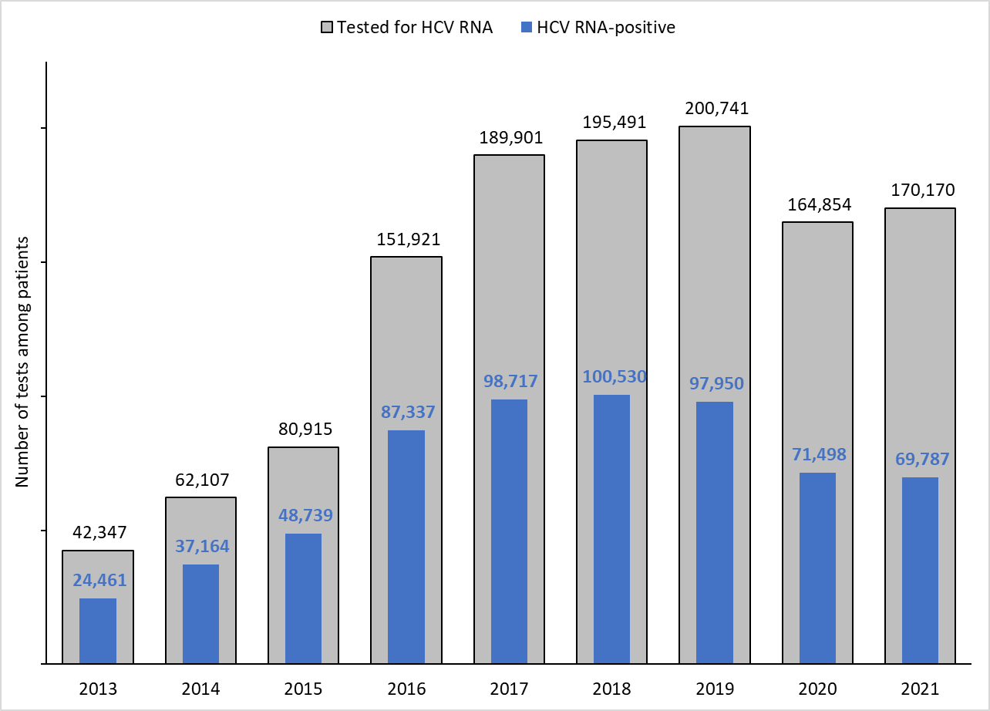
43.4%
41.0%
48.8%
51.4%
52.0%
57.5%
60.2%
59.8%
57.8%
Supplementary Figure 3 Legend. Hepatitis C virus antibody-positivity proportions among patients aged >18 years by patient and ordering provider characteristic, Quest Diagnostics, 2021ª

Data source: 2021 Quest Diagnostics.
Abbreviations: HCV, hepatitis C virus; RNA, ribonucleic acid; SUD, substance use disorder.
ªChi-square test to determine whether differences in the proportions of patient and ordering provider characteristics were statistically significantly different from the overall proportion without that characteristic, where a P-value that was <.05 was considered statistically significant. The proportions for all patient and ordering provider characteristics were statistically significantly different than the overall proportion (all comparisons, P<.001).

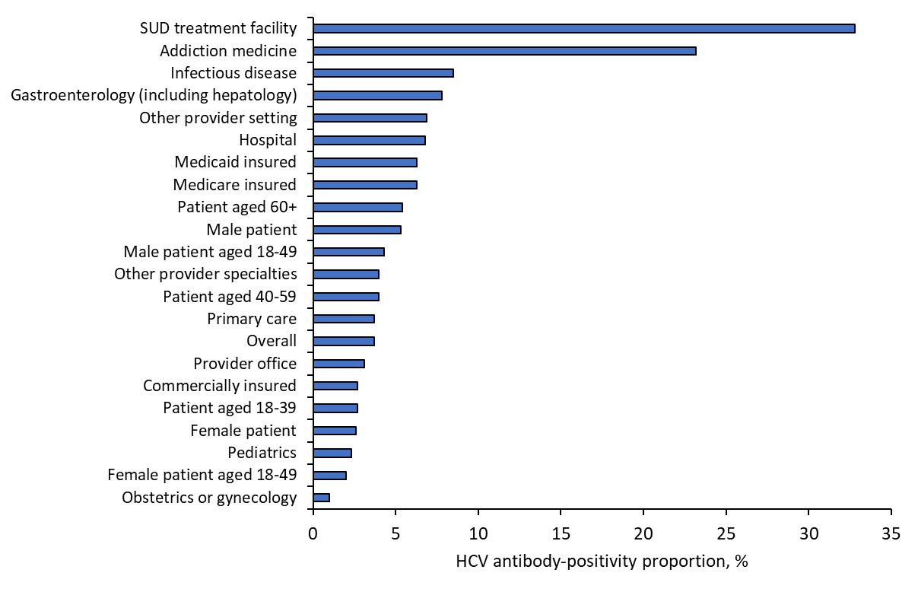

Supplementary Figure 4 Legend. Hepatitis C virus RNA-positivity proportions among hepatitis C virus antibody-positive patients aged >18 years who were tested for hepatitis C virus RNA by patient and ordering provider characteristic, Quest Diagnostics, 2021ª

Data source: 2021 Quest Diagnostics.
Abbreviations: HCV, hepatitis C virus; RNA, ribonucleic acid; SUD, substance use disorder.
ªTest to determine whether differences in the HCV RNA-positivity proportions of patient and ordering provider characteristics were statistically significantly different from the overall proportion without that characteristic, where a Chi-square P-value that was <.05 was considered statistically significant. An asterisk denotes that the proportion was statistically significantly different than the overall proportion.
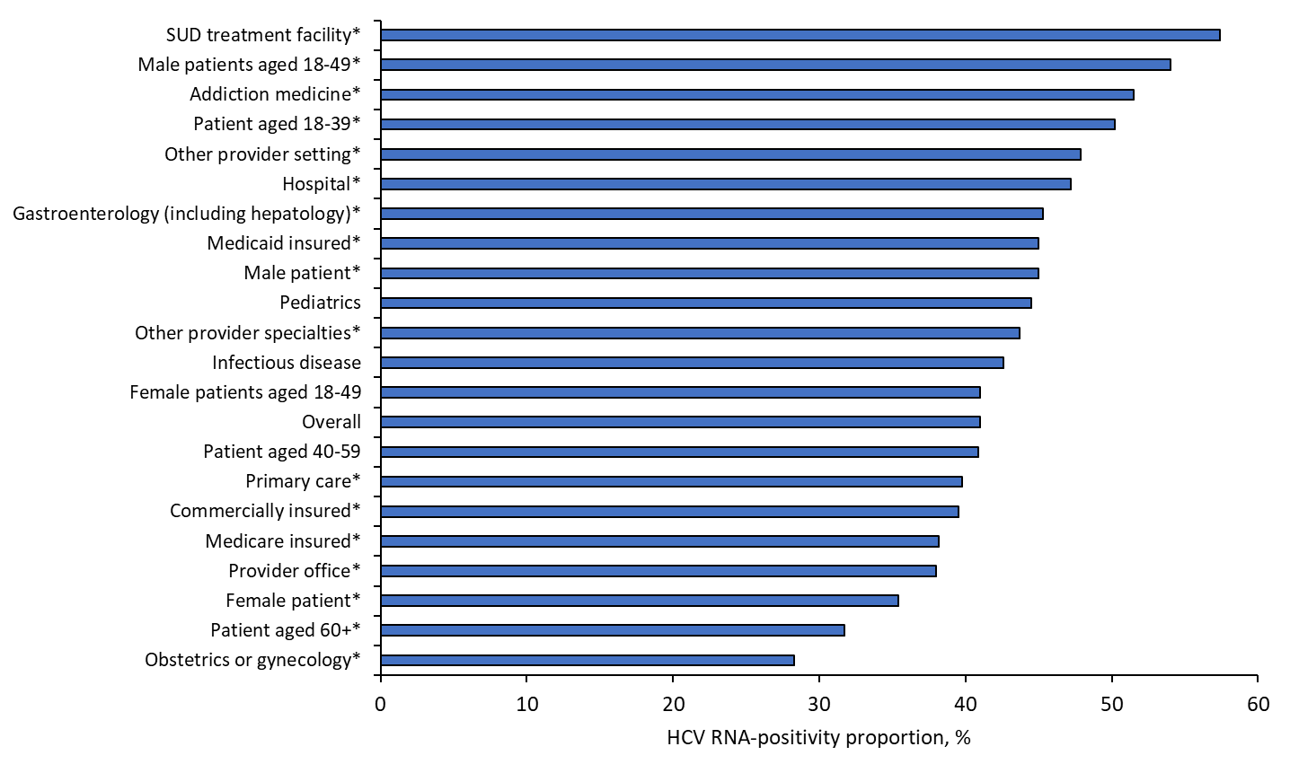
Supplementary Table 1. Chi-square analysis of hepatitis C virus antibody-positive patients aged >18 years by hepatitis C virus RNA testing status pre- and post-discontinuation of the HCV antibody standalone test option and full implementation of hepatitis C virus RNA reflex testing, Quest Diagnostics, 2013–2021
 | Tested for HCV-RNA |  |  | P-valueª
Years | Yes | No | Total | P-valueª
2013-2015 (prior to full HCV RNA reflex testing) |  |  |  | <.001
Number | 185,369 | 164,646 | 350,015
Row Percent | 53.0 | 47.0 | 100
2016-2021 (during full HCV RNA reflex testing)
Number | 1,073,078 | 38,076 | 1,111,154
Row Percent | 96.6 | 3.4 | 100
Total | 1,258,447 | 202,722 | 1,461,169

Data source: 2013–2021 Quest Diagnostics dataset, Quest Diagnostics.
Abbreviations: HCV, hepatitis C virus; RNA, ribonucleic acid.
ªChi-square test to determine statistically significance in the difference in the proportion of HCV antibody-positive patients tested for HCV-RNA prior to (2013–2015) versus post discontinuation of the standalone HCV-antibody test option and full implementation of HCV RNA reflex testing (2016–2021), where a P-value that was <.05 was considered statistically significant.

