Supplemental Material

Antibodies to Malondialdehyde-Acetaldehyde (MAA) Modified Proteins Are Associated with Prevalent and Incident Rheumatoid Arthritis-Associated Interstitial Lung Disease
Aripova N et al.
Supplemental Figure 1. Study flow diagram for prevalent and incident RA-ILD analyses.
Supplemental Table 1. Baseline characteristics of participants stratified by incident RA-ILD
Supplemental Table 2. Associations of protein-specific anti-MAA antibody concentrations with prevalent RA-ILD in sensitivity analyses including individuals who developed RA-ILD in the first year of follow-up.
Supplemental Table 3. Associations of protein-specific anti-MAA antibodies with prevalent RA-ILD when high anti-MAA was defined >75% (main analyses defined high anti-MAA as >50%).
Supplemental Table 4. Sensitivity analyses when stratifying individuals with prevalent RA-ILD by RA-ILD pattern, MUC5B status, and MMP-7 adjustment.
Supplemental Table 5. Pearson correlations of standardized log-transformed protein-specific anti-MAA antibody values.
Supplemental Table 6. Pearson correlations of standardized log-transformed protein-specific anti-MAA antibody values with anti-CCP and RF.
Supplemental Table 7. Associations of protein-specific anti-MAA antibody concentrations with incident RA-ILD in sensitivity analyses excluding individuals who developed RA-ILD in the first year of follow-up.
Supplemental Table 8. Associations of protein-specific anti-MAA antibody with incident RA-ILD when high anti-MAA was defined >75% (main analyses defined high anti-MAA as >50%).
Supplemental Table 9. Sensitivity analyses when incident RA-ILD cases where stratified by MUC5B status, MMP-7 adjustment, and DAS28 adjustment.
Supplemental Figure 2. Anti-MAA-collagen antibody concentrations and cumulative hazard of developing RA-ILD.
Supplemental Figure 3. Anti-MAA-fibrinogen antibody concentrations and cumulative hazard of developing RA-ILD.
Supplemental Figure 4. Anti-MAA-vimentin antibody concentrations and cumulative hazard of developing RA-ILD.

Supplemental Figure 1. Study flow diagram for prevalent and incident RA-ILD analyses.
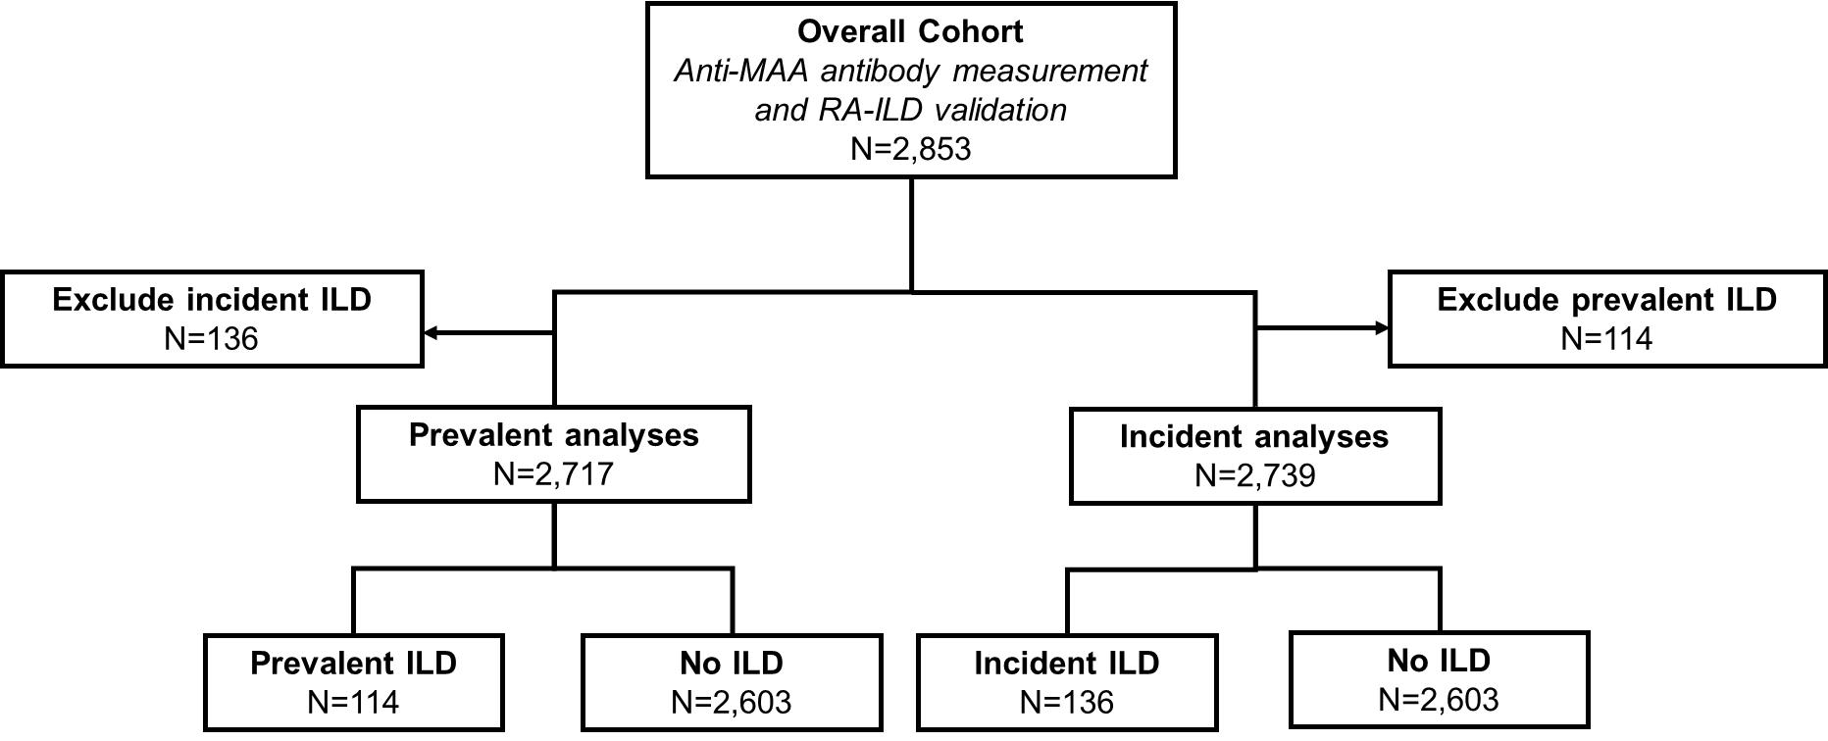

Supplemental Table 1. Baseline characteristics of participants stratified by incident RA-ILD
Variables | RA-no ILD  N=2,603 | RA-ILD  N=136 | p-value
Demographics, Health Behaviors
Age in years: Mean ± SD | 63.9 ± 11.1 | 64.5 ± 9.2 | 0.48
Male sex (n, %) | 2,283 (87.7%) | 129 (94.9%) | 0.01
Race (n, %) |  |  | 0.06
White | 2,003 (76.9%) | 95 (69.9%)
Non-White | 600 (23.1%) | 41 (30.1%)
Body mass index (BMI; kg/m²): Mean ± SD | 28.8 ± 5.9 | 28.0 ± 5.1 | 0.11
Smoking status (n, %) |  |  | 0.03
Never | 535 (21.3%) | 22 (16.2%)
Former | 1,358 (54.0%) | 67 (49.3%)
Current | 624 (24.7%) | 47 (34.5%)
RA-related Factors
RA duration in years: Mean ± SD | 11.3 ± 11.2 | 10.6 ± 10.7 | 0.47
DAS28: Mean ± SD | 3.8 ± 1.6 | 4.1 ± 1.5 | 0.02
Anti-CCP positive (n, %) | 1,981 (76.1%) | 110 (80.9%) | 0.33
Methotrexate use (n, %) | 1,178 (45.3%) | 69 (50.7%) | 0.28
Biologic use (n, %) | 571 (21.9%) | 39 (28.7%) | 0.08
Prednisone use (n, %) | 1,145 (44.0%) | 81 (59.6%) | <0.001

Data are mean ± standard deviation (SD) or number (%) as appropriate.
Missing values: BMI (n=85), smoking status (n=86), RA duration (n=87), DAS28 (n=236)
Abbreviations: Anti-CCP, anti-cyclic citrullinated peptide antibody; DAS28, disease activity score for 28 joints; RA-ILD, rheumatoid arthritis-associated interstitial lung disease.

Supplemental Table 2. Associations of protein-specific anti-MAA antibody concentrations with prevalent RA-ILD in sensitivity analyses including individuals who developed RA-ILD in the first year of follow-up.
Antibody* | aOR (95% CI) | p-value
Anti-MAA-collagen (n=2,548 / n=139 ILD)
IgA | 1.29 (1.05, 1.57) | 0.01
IgM | 1.41 (1.14, 1.74) | 0.002
IgG | 1.05 (0.87, 1.27) | 0.62
Anti-MAA-fibrinogen (n=2,535 / n=139 ILD)
IgA | 1.38 (1.10, 1.72) | 0.01
IgM | 1.17 (0.96, 1.42) | 0.12
IgG | 1.13 (0.93, 1.38) | 0.22
Anti-MAA-vimentin (n=2,535 / n=139 ILD)
IgA | 1.80 (1.39, 2.34) | <0.001
IgM | 1.21 (0.97, 1.50) | 0.10
IgG | 1.43 (1.14, 1.80) | 0.002
Combined protein-specific anti-MAA (n=2,517 / n=112 ILD)
Sum of high anti-MAA** | 1.20 (1.11, 1.30) | <0.001
Total anti-MAA score*** | 1.09 (1.05, 1.14) | <0.001
Values adjusted odds ratios and 95% confidence intervals.
Models adjusted for age, sex, race (white, non-white), smoking status, anti-CCP positivity, and baseline DAS28.
*The results on associations of anti-MAA-albumin antibody concentrations and prevalent RA-ILD were reported previously (15).
**Anti-MAA antibody values were divided into quartiles and the upper two quartiles were classified as high.
***Total anti-MAA score calculated from the summation of log-transformed and standardized values of protein-specific anti-MAA antibodies (collagen, fibrinogen, vimentin).
Abbreviations: aOR, adjusted odds ratio; anti-MAA, anti-malondialdehyde acetaldehyde adduct antibodies; CI, confidence interval; RA-ILD, rheumatoid arthritis patients with interstitial lung disease

Supplemental Table 3. Associations of protein-specific anti-MAA antibodies with prevalent RA-ILD when high anti-MAA was defined >75% (main analyses defined high anti-MAA as >50%).
Antibody | aOR (95% CI) when high anti-MAA >50% | aOR (95% CI) when high anti-MAA >75%
Anti-MAA-collagen
IgA | 1.14 (0.92, 1.40) | 1.29 (0.82, 2.02)
IgM | 1.28 (1.02, 1.61) | 1.51 (0.97, 2.36)
IgG | 0.95 (0.78, 1.16) | 1.13 (0.71, 1.79)
Anti-MAA-fibrinogen
IgA | 1.48 (1.14, 1.92) | 1.58 (1.02, 2.44)
IgM | 1.19 (0.95, 1.47) | 1.37 (0.88, 2.15)
IgG | 1.15 (0.92, 1.44) | 1.44 (0.92, 2.23)
Anti-MAA-vimentin
IgA | 1.78 (1.34, 2.37) | 2.18 (1.43, 3.34)
IgM | 1.11 (0.89, 1.39) | 1.72 (1.12, 2.65)
IgG | 1.48 (1.14, 1.92) | 1.72 (1.12, 2.66)
Combined protein-specific anti-MAA
Sum of high anti-MAA | 1.18 (1.08, 1.28) | 1.14 (1.04, 1.25)
Total anti-MAA score | 1.08 (1.03, 1.12) | 1.08 (1.03, 1.12)
Values adjusted odds ratios and 95% confidence intervals.
Models adjusted for age, sex, race (white, non-white), smoking status, anti-CCP positivity, and baseline DAS28.
Abbreviations: aOR, adjusted odds ratio; anti-MAA, anti-malondialdehyde acetaldehyde adduct antibodies; CI, confidence interval; RA-ILD, rheumatoid arthritis patients with interstitial lung disease

Supplemental Table 4. Sensitivity analyses when stratifying individuals with prevalent RA-ILD by RA-ILD pattern, MUC5B status, and MMP-7 adjustment.
 | Sum of high anti-MAA  aOR (95% CI) | Total anti-MAA score  aOR (95% CI)
RA-ILD pattern
All ILD patterns (n=114 ILD) | 1.18 (1.08, 1.28) | 1.08 (1.03, 1.12)
UIP pattern (n=59 ILD) | 1.19 (1.06, 1.33) | 1.10 (1.04, 1.17)
Non-UIP pattern (n=55 ILD) | 1.16 (1.02, 1.32) | 1.05 (0.98, 1.11)
MUC5B status
All (n=103 ILD) | 1.18 (1.08, 1.28) | 1.08 (1.03, 1.12)
MUC5B positive (n=42 ILD) | 1.26 (1.08, 1.46) | 1.09 (1.02, 1.18)
MUC5B negative (n=61 ILD) | 1.11 (0.99, 1.25) | 1.05 (0.99, 1.12)
MMP-7 adjustment
No adjustment | 1.18 (1.08, 1.28) | 1.08 (1.03, 1.12)
With adjustment | 1.14 (1.04, 1.24) | 1.06 (1.02, 1.11)
Values adjusted odds ratios and 95% confidence intervals.
Models adjusted for age, sex, race (white, non-white), smoking status, anti-CCP positivity, and baseline DAS28.
Abbreviations: aOR, adjusted odds ratio; anti-MAA, anti-malondialdehyde acetaldehyde adduct antibodies; CI, confidence interval; MMP-7, metalloproteinase-7; RA-ILD, rheumatoid arthritis patients with interstitial lung disease; UIP, usual interstitial pneumonia.

Supplemental Table 5. Pearson correlations of standardized log-transformed protein-specific anti-MAA antibody values.
 |  | Anti-MAA-albumin |  |  | Anti-MAA-collagen |  |  | Anti-MAA-fibrinogen |  |  | Anti-MAA-vimentin
 |  | N=2,280 |  |  | N=2,674 |  |  | N=2,661 |  |  | N=2,661
 |  | IgA | IgM | IgG | IgA | IgM | IgG | IgA | IgM | IgG | IgA | IgM | IgG
Anti-MAA-albumin | IgA | 1.00
Anti-MAA-albumin | IgM | 0.61 | 1.00
Anti-MAA-albumin | IgG | 0.61 | 0.56 | 1.00
Anti-MAA-collagen | IgA | 0.17 | 0.09 | 0.01 | 1.00
Anti-MAA-collagen | IgM | 0.05 | 0.15 | 0.03 | 0.36 | 1.00
Anti-MAA-collagen | IgG | 0.06 | 0.06 | 0.15 | 0.34 | 0.2 | 1.00
Anti-MAA-fibrinogen | IgA | 0.19 | 0.1 | 0.07 | 0.14 | 0.16 | 0.28 | 1.00
Anti-MAA-fibrinogen | IgM | 0.01 | 0.08 | -0.01 | 0.15 | 0.36 | 0.14 | 0.37 | 1.00
Anti-MAA-fibrinogen | IgG | 0.11 | -0.02 | 0.14 | 0.11 | 0.04 | 0.3 | 0.25 | 0.21 | 1.00
Anti-MAA-vimentin | IgA | 0.21 | 0.09 | 0.07 | 0.18 | 0.1 | 0.09 | 0.32 | 0.19 | 0.18 | 1.00
Anti-MAA-vimentin | IgM | 0.02 | 0.13 | 0.04 | 0.03 | 0.21 | 0.03 | 0.14 | 0.29 | 0.12 | 0.36 | 1.00
Anti-MAA-vimentin | IgG | -0.04 | -0.04 | 0.06 | 0.04 | 0.03 | 0.25 | 0.16 | 0.15 | 0.32 | 0.29 | 0.22 | 1.00
Blue color represents lower correlation coefficient values while yellow color represents higher correlation coefficient values.
Abbreviations: anti-MAA, anti-malondialdehyde acetaldehyde adduct antibodies.

Supplemental Table 6. Pearson correlations of standardized log-transformed protein-specific anti-MAA antibody values with anti-CCP and RF.
Variables |  | Correlation with anti-CCP | Correlation with RF
Anti-MAA-collagen | IgA | 0.03 | 0.05
Anti-MAA-collagen | IgM | 0.01 | 0.03
Anti-MAA-collagen | IgG | 0.11 | 0.08
Anti-MAA-fibrinogen | IgA | 0.03 | 0.08
Anti-MAA-fibrinogen | IgM | 0.03 | 0.07
Anti-MAA-fibrinogen | IgG | 0.11 | 0.07
Anti-MAA-vimentin | IgA | 0.12 | 0.18
Anti-MAA-vimentin | IgM | 0.14 | 0.19
Anti-MAA-vimentin | IgG | 0.13 | 0.08
Abbreviations: anti-CCP, anti-cyclic citrullinated peptide antibodies; anti-MAA, anti-malondialdehyde acetaldehyde adduct antibodies; RF, rheumatoid factor.

Supplemental Table 7. Associations of protein-specific anti-MAA antibody concentrations with incident RA-ILD in sensitivity analyses excluding individuals who developed RA-ILD in the first year of follow-up.
Antibody | aHR (95% CI) | p-value
Anti-MAA-albumin (n=2,154 / n=102 ILD)
IgA | 1.45 (1.12, 1.89) | 0.01
IgM | 1.29 (1.01, 1.63) | 0.04
IgG | 1.23 (0.96, 1.57) | 0.11
Anti-MAA-collagen (n=2,548 / n=99 ILD)
IgA | 0.91 (0.75, 1.11) | 0.35
IgM | 0.97 (0.96, 1.24) | 0.73
IgG | 0.96 (0.79, 1.17) | 0.70
Anti-MAA-fibrinogen (n=2,535 / n=99 ILD)
IgA | 1.01 (0.82, 1.24) | 0.95
IgM | 1.04 (0.84, 1.28) | 0.71
IgG | 0.93 (0.77, 1.13) | 0.47
Anti-MAA-vimentin (n=2,535 / n=99 ILD)
IgA | 1.01 (0.81, 1.26) | 0.92
IgM | 1.02 (0.82, 1.27) | 0.85
IgG | 1.01 (0.82, 1.26) | 0.90
Combined albumin and protein-specific anti-MAA (n=2,517 / n=112 ILD)
Sum of high anti-MAA* | 1.05 (0.97, 1.14) | 0.25
Total anti-MAA score** | 1.02 (0.97, 1.06) | 0.46
Values adjusted hazard ratios and 95% confidence intervals.
Models adjusted for age, sex, race (white, non-white), smoking status, anti-CCP positivity, and baseline DAS28.
*Anti-MAA antibody values were divided into quartiles and the upper two quartiles were classified as high.
**Total anti-MAA score calculated from the summation of log-transformed and standardized values anti-MAA antibodies (albumin, collagen, fibrinogen, vimentin).
Abbreviations: aHR, adjusted hazard ratio; anti-MAA, anti-malondialdehyde acetaldehyde adduct antibodies; CI, confidence interval; RA-ILD, rheumatoid arthritis patients with interstitial lung disease

Supplemental Table 8. Associations of protein-specific anti-MAA antibody with incident RA-ILD when high anti-MAA was defined >75% (main analyses defined high anti-MAA as >50%).
Antibody | aHR (95% CI) when high anti-MAA >50% | aHR (95% CI) when high anti-MAA >75%
Anti-MAA-albumin
IgA | 1.40 (1.11, 1.76) | 1.66 (1.14, 2.40)
IgM | 1.29 (1.04, 1.60) | 1.43 (0.98, 2.08)
IgG | 1.24 (0.99, 1.54) | 1.21 (0.83, 1.78)
Anti-MAA-collagen
IgA | 1.06 (0.88, 1.28) | 1.40 (0.95, 2.07)
IgM | 1.09 (0.91, 1.31) | 1.48 (1.00, 2.20)
IgG | 1.06 (0.88, 1.28) | 1.50 (1.02, 2.22)
Anti-MAA-fibrinogen
IgA | 1.02 (0.87, 1.23) | 0.92 (0.60, 1.41)
IgM | 1.06 (0.87, 1.27) | 1.16 (0.77, 1.75)
IgG | 0.95 (0.80, 1.14) | 1.03 (0.68, 1.56)
Anti-MAA-vimentin
IgA | 1.12 (0.90, 1.39) | 1.16 (0.77, 1.75)
IgM | 1.13 (0.91, 1.40) | 0.89 (0.58, 1.36)
IgG | 1.06 (0.88, 1.29) | 0.74 (0.46, 1.19)
Combined protein-specific anti-MAA
Sum of high anti-MAA | 1.09 (1.02, 1.18) | 1.08 (1.00, 1.17)
Total anti-MAA score | 1.04 (1.01, 1.08) | 1.04 (1.01, 1.08)
Values adjusted hazard ratios and 95% confidence intervals.
Models adjusted for age, sex, race (white, non-white), smoking status, anti-CCP positivity, and baseline DAS28.
Abbreviations: aHR, adjusted hazard ratio; anti-MAA, anti-malondialdehyde acetaldehyde adduct antibodies; CI, confidence interval; RA-ILD, rheumatoid arthritis patients with interstitial lung disease

Supplemental Table 9. Sensitivity analyses when incident RA-ILD cases where stratified by MUC5B status, MMP-7 adjustment, and DAS28 adjustment.
 | Sum of high anti-MAA  aHR (95% CI) | Total anti-MAA score  aHR (95% CI)
MUC5B status
All | 1.09 (1.02, 1.18) | 1.04 (1.01, 1.08)
MUC5B positive | 1.16 (1.00, 1.34) | 1.05 (0.98, 1.13)
MUC5B negative | 1.09 (0.99, 1.19) | 1.04 (0.99, 1.09)
MMP-7 adjustment
No adjustment | 1.09 (1.02, 1.18) | 1.04 (1.01, 1.08)
With adjustment | 1.09 (1.01, 1.17) | 1.04 (0.99, 1.08)
DAS28 adjustment
Baseline DAS28 adjustment | 1.09 (1.02, 1.18) | 1.04 (1.01, 1.08)
Mean DAS28 adjustment | 1.08 (1.00, 1.16) | 1.03 (0.99, 1.07)
Values adjusted hazard ratios and 95% confidence intervals.
Models adjusted for age, sex, race (white, non-white), smoking status, anti-CCP positivity, and baseline DAS28.
Abbreviations: aHR, adjusted hazard ratio; anti-MAA, anti-malondialdehyde acetaldehyde adduct antibodies; CI, confidence interval; DAS28, disease activity score in 28 joints; MMP-7, metalloproteinase-7; RA-ILD, rheumatoid arthritis patients with interstitial lung disease

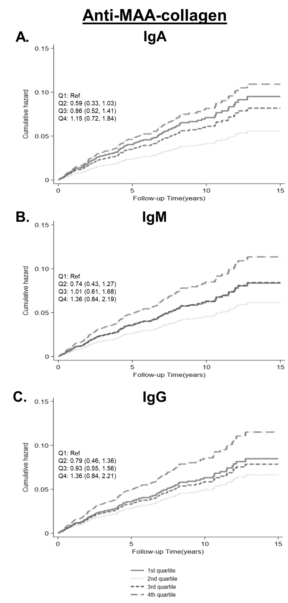
Supplemental Figure 2. Anti-MAA-collagen antibody concentrations and cumulative hazard of developing RA-ILD.
Supplemental Figure 2 legend. Incidence of developing RA-ILD by quartiles of (A) IgA, (B) IgM, and (C) IgG anti-MAA-collagen antibodies. Values are adjusted hazards ratios (95% confidence intervals) from Cox regression models adjusted for age, sex, race, smoking status, anti-CCP antibody positivity, and DAS28. Line patterns: —— 1st quartile, ……2nd quartile, - - - 3rd quartile, —·— 4th quartile. Abbreviations: Anti-MAA, antibody to malondialdehyde acetaldehyde; Q1, 1st quartile; Q2, 2nd quartile; Q3, 3rd quartile; Q4, 4th quartile; RA-ILD, rheumatoid arthritis patients with interstitial lung disease; Ref, referent.

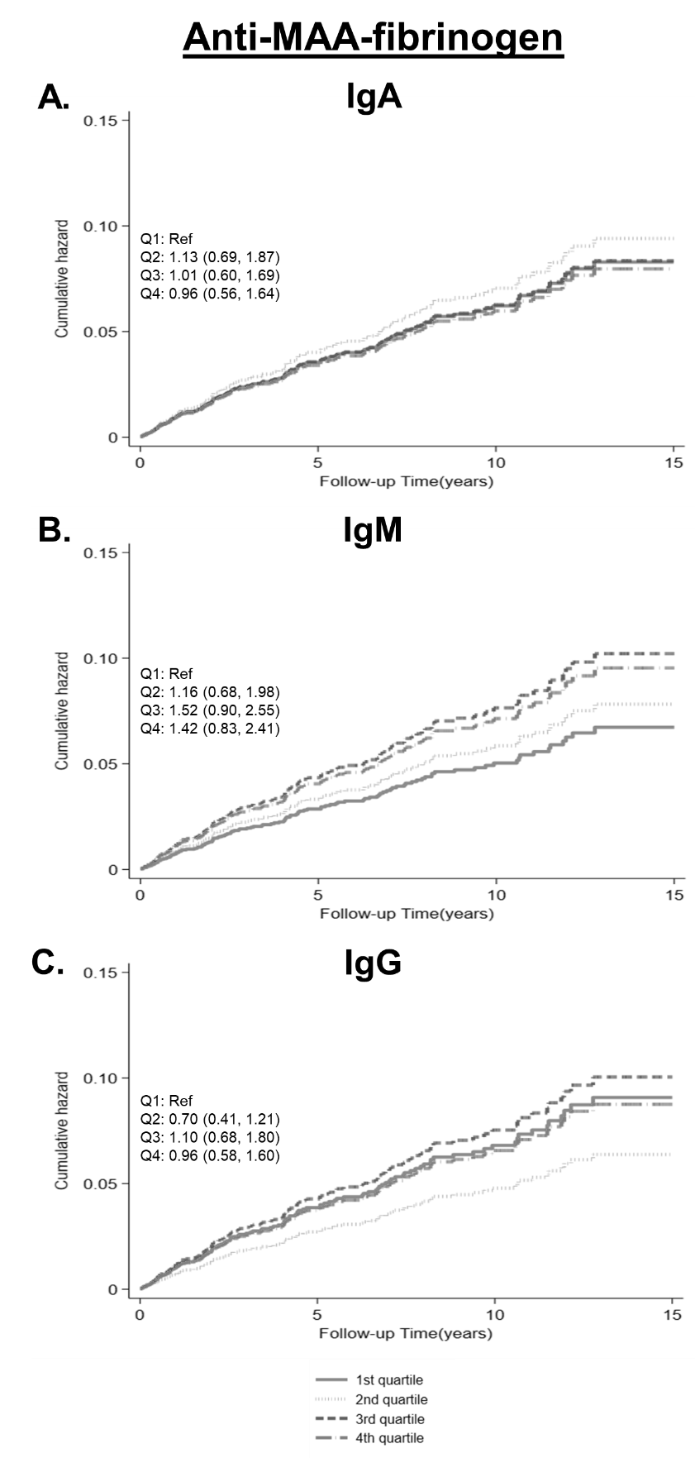
Supplemental Figure 3. Anti-MAA-fibrinogen antibody concentrations and cumulative hazard of developing RA-ILD.

Supplemental Figure 3 legend. Incidence of developing RA-ILD by quartiles of (A) IgA, (B) IgM, and (C) IgG anti-MAA-fibrinogen antibodies. Values are adjusted hazards ratios (95% confidence intervals) from Cox regression models adjusted for age, sex, race, smoking status, anti-CCP antibody positivity, and DAS28. Line patterns: —— 1st quartile, ……2nd quartile, - - - 3rd quartile, —·— 4th quartile. Abbreviations: Anti-MAA, antibody to malondialdehyde acetaldehyde; Q1, 1st quartile; Q2, 2nd quartile; Q3, 3rd quartile; Q4, 4th quartile; RA-ILD, rheumatoid arthritis patients with interstitial lung disease; Ref, referent.

Supplemental Figure 4. Anti-MAA-vimentin antibody concentrations and cumulative hazard of developing RA-ILD.
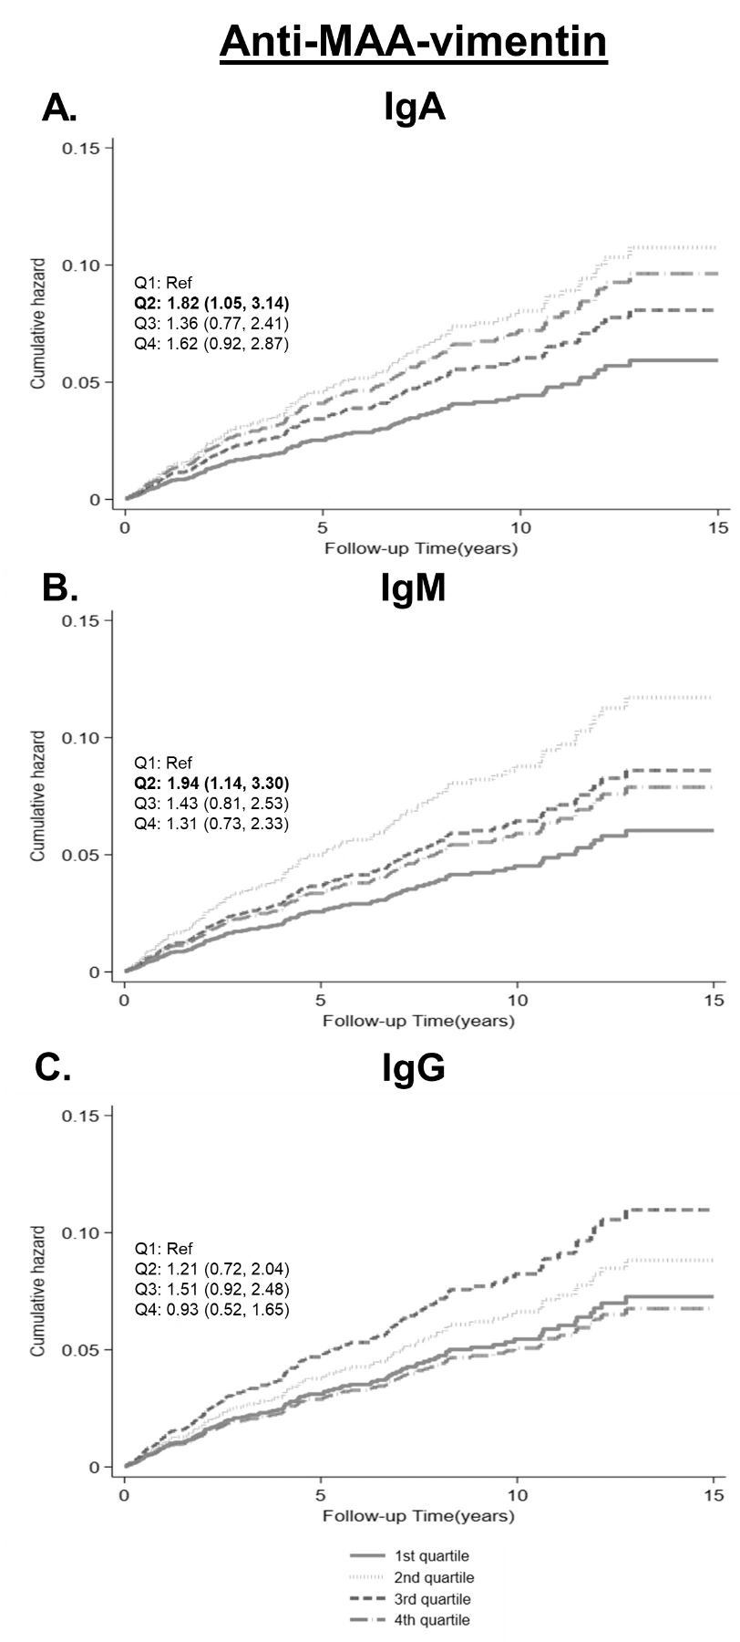
Supplemental Figure 4 legend. Incidence of developing RA-ILD by quartiles of (A) IgA, (B) IgM, and (C) IgG anti-MAA-vimentin antibodies. Values are adjusted hazards ratios (95% confidence intervals) from Cox regression models adjusted for age, sex, race, smoking status, anti-CCP antibody positivity, and DAS28. Line patterns: —— 1st quartile, ……2nd quartile, - - - 3rd quartile, —·— 4th quartile. Abbreviations: Anti-MAA, antibody to malondialdehyde acetaldehyde; Q1, 1st quartile; Q2, 2nd quartile; Q3, 3rd quartile; Q4, 4th quartile; RA-ILD, rheumatoid arthritis patients with interstitial lung disease; Ref, referent.

