Potential impact of curative and preventive interventions toward hepatitis C elimination in people who inject drugs – a network modeling study

Supplement

Table S1 Impact of curative and preventive intervention effect parameters on reductions in person-years of HCV infection and incidence rates over two years among the PWID population with different coverage levels and allocation approaches*
Parameter | Variation | Coverage | Allocation | %reduction PY infection | %reduction incidence
Relative risk of infection after DAA | 50% decrease | 12.5% | random | 10.56 | 13.39
Relative risk of infection after DAA | 50% decrease | 12.5% | degree | 10.98 | 17.71
Relative risk of infection after DAA | 50% decrease | 25% | random | 21.19 | 26.32
Relative risk of infection after DAA | 50% decrease | 25% | degree | 22.35 | 37.06
Relative risk of infection after DAA | 50% decrease | 37.5% | random | 31.98 | 38.80
Relative risk of infection after DAA | 50% decrease | 37.5% | degree | 33.91 | 55.27
Relative risk of infection after DAA | 50% increase | 12.5% | random | 9.76 | 3.83
Relative risk of infection after DAA | 50% increase | 12.5% | degree | 9.68 | 2.61
Relative risk of infection after DAA | 50% increase | 25% | random | 19.83 | 11.17
Relative risk of infection after DAA | 50% increase | 25% | degree | 20.28 | 16.22
Relative risk of infection after DAA | 50% increase | 37.5% | random | 30.12 | 20.78
Relative risk of infection after DAA | 50% increase | 37.5% | degree | 31.48 | 36.20
Relative risk of infection with preventive interventions | 50% decrease | 12.5% | random | 1.35 | 13.39
Relative risk of infection with preventive interventions | 50% decrease | 12.5% | degree | 2.70 | 25.33
Relative risk of infection with preventive interventions | 50% decrease | 25% | random | 2.60 | 25.11
Relative risk of infection with preventive interventions | 50% decrease | 25% | degree | 4.94 | 45.04
Relative risk of infection with preventive interventions | 50% decrease | 37.5% | random | 3.85 | 36.51
Relative risk of infection with preventive interventions | 50% decrease | 37.5% | degree | 6.82 | 59.93
Relative risk of infection with preventive interventions | 50% increase | 12.5% | random | 0.40 | 4.24
Relative risk of infection with preventive interventions | 50% increase | 12.5% | degree | 0.84 | 8.39
Relative risk of infection with preventive interventions | 50% increase | 25% | random | 0.84 | 8.20
Relative risk of infection with preventive interventions | 50% increase | 25% | degree | 1.66 | 15.64
Relative risk of infection with preventive interventions | 50% increase | 37.5% | random | 1.30 | 12.56
Relative risk of infection with preventive interventions | 50% increase | 37.5% | degree | 2.42 | 22.59
Engagement duration of preventive interventions | 50% decrease | 12.5% | random | 0.58 | 4.88
Engagement duration of preventive interventions | 50% decrease | 12.5% | degree | 1.14 | 10.29
Engagement duration of preventive interventions | 50% decrease | 25% | random | 1.13 | 9.76
Engagement duration of preventive interventions | 50% decrease | 25% | degree | 2.28 | 19.64
Engagement duration of preventive interventions | 50% decrease | 37.5% | random | 1.72 | 14.96
Engagement duration of preventive interventions | 50% decrease | 37.5% | degree | 3.35 | 28.18
Engagement duration of preventive interventions | 50% increase | 12.5% | random | 0.96 | 10.86
Engagement duration of preventive interventions | 50% increase | 12.5% | degree | 2.00 | 20.93
Engagement duration of preventive interventions | 50% increase | 25% | random | 1.99 | 21.12
Engagement duration of preventive interventions | 50% increase | 25% | degree | 3.73 | 37.05
Engagement duration of preventive interventions | 50% increase | 37.5% | random | 2.90 | 30.22
Engagement duration of preventive interventions | 50% increase | 37.5% | degree | 5.14 | 49.45

* This table supplements Figure 3a to provide results of all coverage levels and allocation approaches. DAA is direct-acting antiviral treatment for HCV infection representing curative interventions. For parameters related to DAA’s effect, the relative reductions are calculated from comparing the curative alone strategy to status quo (no intervention); for parameters related to preventive intervention’s effect, the relative reductions are calculated from comparing the preventive alone strategy to status quo, in order to present the impact of the intervention effect parameters on outcomes of coresponding interventions.

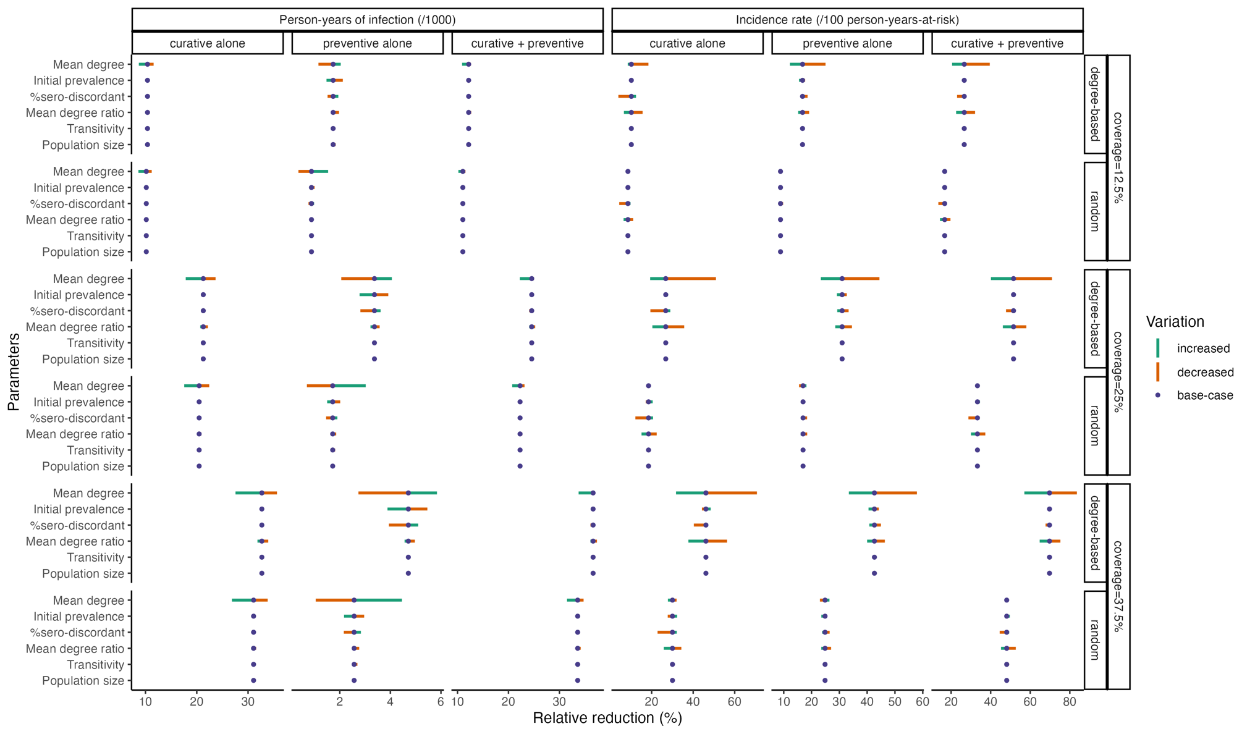
Figure S1 Impact of network parameters on person-years of HCV infection and incidence rate with different interventions, coverage levels, and allocation approaches
This figure supplements figure 3c to provide results (main column titles) of all interventions (sub row titles), coverage levels (main row titles), and allocation approaches (sub column titles). In each panel, the parameters varied in the sensitivity analysis are shown as row labels, and the value axis shows relative reductions in the corresponding outcomes under different intervention scenarios and parameter values. For each parameter, the point in the middle represents the relative reduction after intervention in the main analysis (base-case), and the endpoints of lines represent relative reductions when the parameter value was varied from the base-case level (variation noted by line colors).

