Appendix
Appendix Table 1. Prevalence (%) of five types of perceived job discrimination and overall job discrimination in the last five years, by participant characteristics, analytical sample from Sister Study
Type of Job Discrimination in Last 5 Years
(% of group who experienced this type)
 | n (%) | Any | Sex | Age | Race | Sexual Orientation | Medical
Full sample | 16,770 (100%) | 10.5 | 4.7 | 5.7 | 1.8 | 0.6 | 1.6
Cumulative incidence of hypertension during follow-up
No | 13,544 (80.8%) | 10.0 | 4.6 | 5.4 | 1.8 | 0.6 | 1.4
Yes | 3,226 (19.2%) | 12.6 | 5.1 | 7.0 | 1.9 | 0.9 | 2.4
Race/Ethnicity
Non-Hispanic white | 14,802 (88.3%) | 9.5 | 4.4 | 5.4 | 0.6 | 0.6 | 1.5
Black | 951 (5.7%) | 25.2 | 8.6 | 9.4 | 19.6 | 1.6 | 2.9
Non-Black Hispanic/Latina | 622 (3.7%) | 11.3 | 4.2 | 5.5 | 4.0 | 0.6 | 1.3
Asian, American Indian/Alaskan Native, Native Hawaiian/Pacific Islander | 395 (2.4%) | 14.2 | 7.1 | 8.6 | 2.5 | 0.5 | 2.3
Age (years) at baseline
54.6 years (median) or younger | 8,638 (51.5%) | 10.2 | 5.5 | 3.7 | 2.3 | 0.7 | 1.8
Older than 54.6 years (median) | 8,132 (48.5%) | 10.9 | 3.9 | 7.9 | 1.3 | 0.6 | 1.4
Sexual orientation, %
Heterosexual | 16,255 (96.9%) | 10.3 | 4.7 | 5.6 | 1.8 | 0.5 | 1.5
Homosexual | 314 (1.9%) | 15.3 | 6.7 | 7.0 | 1.9 | 8.0 | 3.8
Bisexual | 190 (1.1%) | 18.4 | 7.4 | 9.5 | 1.6 | 2.6 | 5.8
Asexual | 11 (0.1%) | 18.2 | 0.0 | 18.2 | 9.1 | 0.0 | 0.0
Self-rated health
Excellent | 7,971 (47.5%) | 8.2 | 3.8 | 4.6 | 1.3 | 0.5 | 0.6
Very good | 6,139 (36.6%) | 11.1 | 5.0 | 6.2 | 1.9 | 0.6 | 1.6
Good | 2,195 (13.1%) | 15.4 | 6.5 | 7.5 | 3.2 | 1.2 | 4.0
Fair or Poor | 465 (2.8%) | 19.8 | 8.2 | 10.3 | 2.6 | 1.1 | 8.8
Educational attainment
Some College or Less | 4,631 (27.6%) | 9.8 | 3.9 | 5.6 | 1.4 | 0.8 | 1.8
Associate, Technical, or Bachelor's Degree | 7,338 (43.8%) | 10.0 | 4.3 | 5.3 | 1.9 | 0.6 | 1.7
Graduate Degree | 4,801 (28.6%) | 12.1 | 6.2 | 6.4 | 2.1 | 0.6 | 1.4
Childhood socioeconomic status (self-rated)
Well off | 1,193 (7.1%) | 10.9 | 5.9 | 6.1 | 1.4 | 1.0 | 1.8
Middle income | 10,867 (64.8%) | 9.8 | 4.5 | 5.2 | 1.2 | 0.6 | 1.5
Low income | 3,803 (22.7%) | 11.2 | 4.5 | 6.4 | 2.4 | 0.6 | 1.6
Poor | 907 (5.4%) | 15.9 | 6.7 | 8.3 | 6.7 | 1.3 | 2.9
Marital status
Married/living as married | 12,928 (77.1%) | 9.1 | 4.1 | 4.9 | 1.3 | 0.5 | 1.3
Widowed/divorced/separated | 2,835 (16.9%) | 15.3 | 6.0 | 9.0 | 3.4 | 1.1 | 2.6
Never married | 1,007 (6.0%) | 16.0 | 8.4 | 7.5 | 3.8 | 1.3 | 2.2
Current job count
1 | 15,597 (93.0%) | 10.2 | 4.6 | 5.4 | 1.7 | 0.6 | 1.6
2+ | 1,173 (7.0%) | 14.9 | 6.4 | 9.4 | 3.2 | 1.3 | 2.3
Annual household income, last year (USD)
Less than $20,000 | 312 (1.9%) | 16.3 | 3.2 | 9.9 | 3.5 | 1.0 | 6.1
$20,000 to $49,999 | 2,481 (14.8%) | 14.1 | 5.4 | 9.0 | 2.5 | 0.8 | 2.9
$50,000 to $99,999 | 7,118 (42.4%) | 10.7 | 4.4 | 6.0 | 1.8 | 0.6 | 1.5
$100,000 to $200,000 | 5,528 (33.0%) | 8.9 | 4.8 | 4.2 | 1.7 | 0.6 | 1.2
More than $200,000 | 1,331 (7.9%) | 8.4 | 5.0 | 3.5 | 1.0 | 0.3 | 0.8
Hours worked per week
0-30 | 4,105 (24.5%) | 6.7 | 2.1 | 4.6 | 0.8 | 0.1 | 1.3
>30-35 | 1,242 (7.4%) | 7.6 | 2.7 | 4.8 | 1.1 | 0.3 | 1.0
>35-45 | 8,096 (48.3%) | 11.5 | 5.3 | 6.0 | 2.2 | 0.7 | 1.7
>45 | 3,327 (19.8%) | 14.1 | 7.4 | 6.7 | 2.4 | 1.3 | 1.9
Longest job worked (occupational category)
Professional and related occupations | 6,648 (39.6%) | 8.9 | 3.9 | 4.8 | 1.5 | 0.5 | 1.5
Sales and office occupations | 4,374 (26.1%) | 10.8 | 4.4 | 6.6 | 1.8 | 0.8 | 1.6
Management, business, and financial occupations | 4,058 (24.2%) | 12.8 | 6.5 | 6.4 | 2.2 | 0.7 | 1.4
Service occupations | 1,130 (6.7%) | 9.0 | 2.9 | 5.3 | 2.0 | 0.2 | 1.9
Production, transportation, and material moving occupations | 332 (2.0%) | 13.3 | 7.2 | 5.7 | 1.5 | 2.1 | 3.9
Other (military, unemployed, volunteer, student, retired, homemaker, construction, maintenance, farming, fishing, forestry, or not reported) | 228 (1.4%) | 13.6 | 9.2 | 5.7 | 2.6 | 0.9 | 3.1
Pack-years smoked
0 | 9,996 (59.6%) | 10.0 | 4.7 | 5.2 | 2.0 | 0.6 | 1.4
>0-4 | 2,489 (14.8%) | 10.2 | 4.7 | 5.4 | 1.8 | 0.5 | 1.5
>4-15 | 2,310 (13.8%) | 10.8 | 4.3 | 5.8 | 1.6 | 0.6 | 2.1
>15 | 1,975 (11.8%) | 13.1 | 5.5 | 9.0 | 1.0 | 1.1 | 2.1
Alcohol, drinks per week
0 | 2,242 (13.4%) | 12.9 | 4.2 | 7.3 | 2.9 | 1.0 | 2.9
>0-1 | 6,665 (39.7%) | 11.1 | 5.1 | 5.8 | 2.2 | 0.6 | 1.7
>1-10 | 6,845 (40.8%) | 9.5 | 4.6 | 5.3 | 1.3 | 0.6 | 1.2
>10 | 1,018 (6.1%) | 8.7 | 4.0 | 4.2 | 0.7 | 0.8 | 1.6
Physical activity, sports/exercise (MET-hours per week)
0-3 | 4,267 (25.4%) | 12.3 | 5.2 | 6.1 | 2.6 | 0.8 | 2.5
>3-10 | 4,178 (24.9%) | 10.5 | 4.3 | 5.9 | 1.6 | 0.8 | 2.0
>10-20 | 3,759 (22.4%) | 9.0 | 4.3 | 5.2 | 1.4 | 0.5 | 0.9
>20 | 4,566 (27.2%) | 10.2 | 5.1 | 5.6 | 1.6 | 0.5 | 1.0
Body-Mass Index (kg/m^2)
13-20 | 1,059 (6.3%) | 8.1 | 4.3 | 4.1 | 1.2 | 0.3 | 2.0
>20-25 | 7,352 (43.8%) | 8.7 | 4.0 | 4.7 | 1.2 | 0.5 | 1.1
>25-30 | 5,152 (30.7%) | 11.2 | 5.1 | 6.1 | 2.1 | 0.7 | 1.5
>30 | 3,207 (19.1%) | 14.5 | 5.9 | 8.0 | 3.0 | 1.0 | 2.9
Systolic blood pressure (mm Hg)
62-100 | 3,937 (23.5%) | 9.9 | 5.1 | 5.0 | 1.7 | 0.4 | 1.3
>100-115 | 7,874 (47.0%) | 10.5 | 4.5 | 5.6 | 1.9 | 0.7 | 1.8
>115-130 | 4,547 (27.1%) | 11.2 | 4.7 | 6.6 | 1.7 | 0.7 | 1.7
>130 | 412 (2.5%) | 10.0 | 4.9 | 4.9 | 2.4 | 0.7 | 1.0
Diastolic blood pressure (mm Hg) (SD)
40-63 | 4,290 (25.6%) | 9.7 | 4.6 | 5.0 | 1.7 | 0.6 | 1.5
>63-70 | 4,897 (29.2%) | 10.1 | 4.6 | 5.5 | 1.8 | 0.5 | 1.6
>70-76 | 3,648 (21.8%) | 10.5 | 4.8 | 5.9 | 1.5 | 0.8 | 1.6
>76-105 | 3,935 (23.5%) | 12.0 | 4.9 | 6.6 | 2.2 | 0.7 | 1.8
Waist-hip ratio
0.45-0.74 | 4,271 (25.5%) | 9.6 | 4.5 | 5.0 | 1.2 | 0.5 | 1.1
>0.74-0.78 | 3,875 (23.1%) | 9.9 | 4.8 | 5.0 | 1.7 | 0.6 | 1.4
>0.78-0.83 | 4,366 (26.0%) | 10.7 | 4.6 | 6.0 | 2.0 | 0.6 | 1.7
>0.83-2.86 | 4,258 (25.4%) | 11.9 | 5.0 | 6.8 | 2.3 | 0.8 | 2.3
Perceived stress score
0 | 3,740 (22.3%) | 6.9 | 3.4 | 3.5 | 1.4 | 0.5 | 0.7
1 | 3,211 (19.1%) | 7.9 | 3.6 | 4.5 | 1.1 | 0.4 | 1.1
2 | 2,693 (16.1%) | 9.4 | 3.8 | 5.1 | 1.8 | 0.7 | 0.9
3-4 | 3,453 (20.6%) | 11.9 | 5.4 | 6.6 | 1.9 | 0.7 | 1.6
5+ | 3,673 (21.9%) | 16.0 | 7.1 | 8.7 | 2.8 | 0.9 | 3.5
High cholesterol
No | 13,076 (78.0%) | 10.2 | 4.8 | 5.3 | 1.8 | 0.7 | 1.5
Yes | 3,694 (22.0%) | 11.7 | 4.6 | 7.2 | 1.7 | 0.4 | 2.2
Diabetes
No | 16,528 (98.6%) | 10.4 | 4.7 | 5.7 | 1.8 | 0.6 | 1.6
Yes | 242 (1.4%) | 17.8 | 8.7 | 9.5 | 3.7 | 0.4 | 3.7
Entered menopause
No | 8,283 (49.4%) | 10.4 | 5.5 | 4.0 | 2.2 | 0.7 | 1.6
Yes | 8,487 (50.6%) | 10.7 | 3.9 | 7.4 | 1.4 | 0.6 | 1.6
Parity
0 | 3,693 (22.0%) | 12.4 | 6.3 | 6.0 | 2.1 | 0.9 | 2.1
1-2 | 9,177 (54.7%) | 10.3 | 4.6 | 5.7 | 1.9 | 0.6 | 1.5
3+ | 3,900 (23.3%) | 9.3 | 3.6 | 5.6 | 1.4 | 0.5 | 1.3
Other racial discrimination
No | 15,065 (89.8%) | 8.6 | 4.0 | 4.8 | 0.4 | 0.5 | 1.3
Yes | 1,705 (10.2%) | 27.5 | 11.5 | 13.8 | 14.0 | 2.1 | 4.6
Other sexual orientation discrimination (ever)
No | 15,571 (92.9%) | 9.4 | 4.0 | 5.2 | 1.5 | 0.1 | 1.3
Yes | 1,199 (7.1%) | 25.5 | 14.3 | 13.2 | 5.6 | 7.9 | 5.3
Appendix Table 2. Cumulative incidence (%) of hypertension, by participant characteristics, analytical sample from Sister Study
 | Incident Hypertension during Follow-up (%), Full Analytical Sample  (N = 16,770) |  |  | Incident Hypertension during Follow-up (%), Sample Reporting no Job Discrimination Ever (N=12,881)
 | n (%) | Yes | No | n (%) | Yes | No
Full sample | 16,770 (100%) | 19.2 | 80.8 | 12,881 (100%) | 18.8 | 81.2
Race/Ethnicity
Non-Hispanic white | 14,802 (88.3%) | 19.0 | 81.0 | 11,554 (89.7%) | 18.7 | 81.3
Black | 951 (5.7%) | 24.3 | 75.7 | 537 (4.2%) | 23.6 | 76.4
Non-Black Hispanic/Latina | 622 (3.7%) | 17.0 | 83.0 | 500 (3.9%) | 17.2 | 82.8
Asian, American Indian/Alaskan Native, Native Hawaiian/Pacific Islander | 395 (2.4%) | 20.8 | 79.2 | 290 (2.3%) | 19.3 | 80.7
Age (years) at baseline
54.6 years (median) or younger | 8,638 (51.5%) | 17.2 | 82.8 | 6,823 (53.0%) | 16.8 | 83.2
Older than 54.6 years (median) | 8,132 (48.5%) | 21.4 | 78.6 | 6,058 (47.0%) | 21.1 | 78.9
Sexual orientation, %
Heterosexual | 16,255 (96.9%) | 19.3 | 80.7 | 12,563 (97.5%) | 18.9 | 81.1
Homosexual | 314 (1.9%) | 16.9 | 83.1 | 193 (1.5%) | 18.7 | 81.3
Bisexual | 190 (1.1%) | 16.3 | 83.7 | 118 (0.9%) | 13.6 | 86.4
Asexual | 11 (0.1%) | 18.2 | 81.8 | 7 (0.1%) | 14.3 | 85.7
Self-rated health
Excellent | 7,971 (47.5%) | 16.6 | 83.4 | 6,408 (49.7%) | 16.2 | 83.8
Very good | 6,139 (36.6%) | 21.1 | 78.9 | 4,642 (36.0%) | 21.0 | 79.0
Good | 2,195 (13.1%) | 22.6 | 77.4 | 1,526 (11.8%) | 22.5 | 77.5
Fair or Poor | 465 (2.8%) | 24.3 | 75.7 | 305 (2.4%) | 22.0 | 78.0
Educational attainment
Some College or Less | 4,631 (27.6%) | 22.0 | 78.0 | 3,707 (28.8%) | 21.7 | 78.3
Associate, Technical, or Bachelor's Degree | 7,338 (43.8%) | 19.0 | 81.0 | 5,752 (44.7%) | 18.5 | 81.5
Graduate Degree | 4,801 (28.6%) | 17.0 | 83.0 | 3,422 (26.6%) | 16.2 | 83.8
Childhood socioeconomic status (self-rated)
Well off | 1,193 (7.1%) | 15.7 | 84.3 | 921 (7.2%) | 15.9 | 84.1
Middle income | 10,867 (64.8%) | 18.8 | 81.2 | 8,491 (65.9%) | 18.5 | 81.5
Low income | 3,803 (22.7%) | 20.8 | 79.2 | 2,845 (22.1%) | 20.7 | 79.3
Poor | 907 (5.4%) | 22.1 | 77.9 | 624 (4.8%) | 19.1 | 80.9
Marital status
Married/living as married | 12,928 (77.1%) | 18.4 | 81.6 | 10,186 (79.1%) | 18.1 | 81.9
Widowed/divorced/separated | 2,835 (16.9%) | 22.3 | 77.7 | 1,995 (15.5%) | 21.8 | 78.2
Never married | 1,007 (6.0%) | 21.3 | 78.7 | 700 (5.4%) | 21.0 | 79.0
Current job count
1 | 15,597 (93.0%) | 19.1 | 80.9 | 12,042 (93.5%) | 18.8 | 81.2
2+ | 1,173 (7.0%) | 20.5 | 79.5 | 839 (6.5%) | 19.5 | 80.5
Annual household income, last year (USD)
Less than $20,000 | 312 (1.9%) | 23.4 | 76.6 | 206 (1.6%) | 25.2 | 74.8
$20,000 to $49,999 | 2,481 (14.8%) | 23.0 | 77.0 | 1,829 (14.2%) | 22.2 | 77.8
$50,000 to $99,999 | 7,118 (42.4%) | 20.7 | 79.3 | 5,520 (42.9%) | 20.4 | 79.6
$100,000 to $200,000 | 5,528 (33.0%) | 16.9 | 83.1 | 4,306 (33.4%) | 16.5 | 83.5
More than $200,000 | 1,331 (7.9%) | 13.3 | 86.7 | 1,020 (7.9%) | 13.1 | 86.9
Hours worked per week
0-30 | 4,105 (24.5%) | 18.6 | 81.4 | 3,289 (25.5%) | 18.2 | 81.8
>30-35 | 1,242 (7.4%) | 18.4 | 81.6 | 1,011 (7.8%) | 17.0 | 83.0
>35-45 | 8,096 (48.3%) | 19.6 | 80.4 | 6,212 (48.2%) | 19.5 | 80.5
>45 | 3,327 (19.8%) | 19.4 | 80.6 | 2,369 (18.4%) | 18.7 | 81.3
Longest job worked (occupational category)
Professional and related occupations | 6,648 (39.6%) | 18.6 | 81.4 | 5,242 (40.7%) | 18.0 | 82.0
Sales and office occupations | 4,374 (26.1%) | 21.2 | 78.8 | 3,401 (26.4%) | 20.8 | 79.2
Management, business, and financial occupations | 4,058 (24.2%) | 18.1 | 81.9 | 2,894 (22.5%) | 17.5 | 82.5
Service occupations | 1,130 (6.7%) | 19.2 | 80.8 | 927 (7.2%) | 19.6 | 80.4
Production, transportation, and material moving occupations | 332 (2.0%) | 22.0 | 78.0 | 254 (2.0%) | 23.6 | 76.4
Other (military, unemployed, volunteer, student, retired, homemaker, construction, maintenance, farming, fishing, forestry, or not reported) | 228 (1.4%) | 17.1 | 82.9 | 163 (1.3%) | 16.6 | 83.4
Pack-years smoked
0 | 9,996 (59.6%) | 17.9 | 82.1 | 7,837 (60.8%) | 17.6 | 82.4
>0-4 | 2,489 (14.8%) | 19.1 | 80.9 | 1,938 (15.0%) | 18.7 | 81.3
>4-15 | 2,310 (13.8%) | 20.3 | 79.7 | 1,714 (13.3%) | 20.2 | 79.8
>15 | 1,975 (11.8%) | 24.7 | 75.3 | 1,392 (10.8%) | 24.3 | 75.7
Alcohol, drinks per week
0 | 2,242 (13.4%) | 20.9 | 79.1 | 1,696 (13.2%) | 20.1 | 79.9
>0-1 | 6,665 (39.7%) | 19.4 | 80.6 | 5,102 (39.6%) | 18.9 | 81.1
>1-10 | 6,845 (40.8%) | 17.6 | 82.4 | 5,294 (41.1%) | 17.4 | 82.6
>10 | 1,018 (6.1%) | 25.0 | 75.0 | 789 (6.1%) | 25.6 | 74.4
Physical activity, sports/exercise (MET-hours per week)
0-3 | 4,267 (25.4%) | 23.1 | 76.9 | 3,201 (24.9%) | 22.9 | 77.1
>3-10 | 4,178 (24.9%) | 20.5 | 79.5 | 3,231 (25.1%) | 20.1 | 79.9
>10-20 | 3,759 (22.4%) | 18.4 | 81.6 | 2,986 (23.2%) | 18.2 | 81.8
>20 | 4,566 (27.2%) | 15.1 | 84.9 | 3,463 (26.9%) | 14.5 | 85.5
Body-Mass Index (kg/m^2)
13-20 | 1,059 (6.3%) | 9.7 | 90.3 | 860 (6.7%) | 9.9 | 90.1
>20-25 | 7,352 (43.8%) | 14.5 | 85.5 | 5,827 (45.2%) | 14.3 | 85.7
>25-30 | 5,152 (30.7%) | 21.7 | 78.3 | 3,896 (30.2%) | 21.5 | 78.5
>30 | 3,207 (19.1%) | 29.2 | 70.8 | 2,298 (17.8%) | 29.1 | 70.9
Systolic blood pressure (mm Hg)
62-100 | 3,937 (23.5%) | 7.2 | 92.8 | 3,072 (23.8%) | 6.8 | 93.2
>100-115 | 7,874 (47.0%) | 17.3 | 82.7 | 6,058 (47.0%) | 17.2 | 82.8
>115-130 | 4,547 (27.1%) | 30.6 | 69.4 | 3,443 (26.7%) | 30.1 | 69.9
>130 | 412 (2.5%) | 46.1 | 53.9 | 308 (2.4%) | 44.5 | 55.5
Diastolic blood pressure (mm Hg) (SD)
40-63 | 4,290 (25.6%) | 8.7 | 91.3 | 3,330 (25.9%) | 8.3 | 91.7
>63-70 | 4,897 (29.2%) | 15.4 | 84.6 | 3,778 (29.3%) | 15.1 | 84.9
>70-76 | 3,648 (21.8%) | 22.1 | 77.9 | 2,821 (21.9%) | 22.0 | 78.0
>76-105 | 3,935 (23.5%) | 32.8 | 67.2 | 2,952 (22.9%) | 32.5 | 67.5
Waist-hip ratio
0.45-0.74 | 4,271 (25.5%) | 13.0 | 87.0 | 3,327 (25.8%) | 12.6 | 87.4
>0.74-0.78 | 3,875 (23.1%) | 15.9 | 84.1 | 3,012 (23.4%) | 15.5 | 84.5
>0.78-0.83 | 4,366 (26.0%) | 22.4 | 77.6 | 3,347 (26.0%) | 22.0 | 78.0
>0.83-2.86 | 4,258 (25.4%) | 25.2 | 74.8 | 3,195 (24.8%) | 25.1 | 74.9
Perceived stress score
0 | 3,740 (22.3%) | 18.3 | 81.7 | 3,080 (23.9%) | 18.0 | 82.0
1 | 3,211 (19.1%) | 18.2 | 81.8 | 2,559 (19.9%) | 17.9 | 82.1
2 | 2,693 (16.1%) | 19.5 | 80.5 | 2,086 (16.2%) | 18.9 | 81.1
3-4 | 3,453 (20.6%) | 19.8 | 80.2 | 2,589 (20.1%) | 19.6 | 80.4
5+ | 3,673 (21.9%) | 20.4 | 79.6 | 2,567 (19.9%) | 20.0 | 80.0
High cholesterol
No | 13,076 (78.0%) | 18.1 | 81.9 | 10,151 (78.8%) | 17.6 | 82.4
Yes | 3,694 (22.0%) | 23.3 | 76.7 | 2,730 (21.2%) | 23.4 | 76.6
Diabetes
No | 16,528 (98.6%) | 19.0 | 81.0 | 12,721 (98.8%) | 18.7 | 81.3
Yes | 242 (1.4%) | 33.1 | 66.9 | 160 (1.2%) | 30.6 | 69.4
Entered menopause
No | 8,283 (49.4%) | 16.7 | 83.3 | 6,498 (50.4%) | 16.3 | 83.7
Yes | 8,487 (50.6%) | 21.7 | 78.3 | 6,383 (49.6%) | 21.4 | 78.6
Parity
0 | 3,693 (22.0%) | 17.9 | 82.1 | 2,597 (20.2%) | 18.2 | 81.8
1-2 | 9,177 (54.7%) | 19.1 | 80.9 | 7,115 (55.2%) | 18.5 | 81.5
3+ | 3,900 (23.3%) | 20.9 | 79.1 | 3,169 (24.6%) | 20.2 | 79.8
Other racial discrimination (ever)
No | 15,065 (89.8%) | 18.9 | 81.1 | 11,997 (93.1%) | 18.7 | 81.3
Yes | 1,705 (10.2%) | 22.0 | 78.0 | 884 (6.9%) | 20.9 | 79.1
Other sexual orientation discrimination (ever)
No | 15,571 (92.9%) | 19.0 | 81.0 | 12,286 (95.4%) | 18.7 | 81.3
Yes | 1,199 (7.1%) | 21.9 | 78.1 | 595 (4.6%) | 22.0 | 78.0

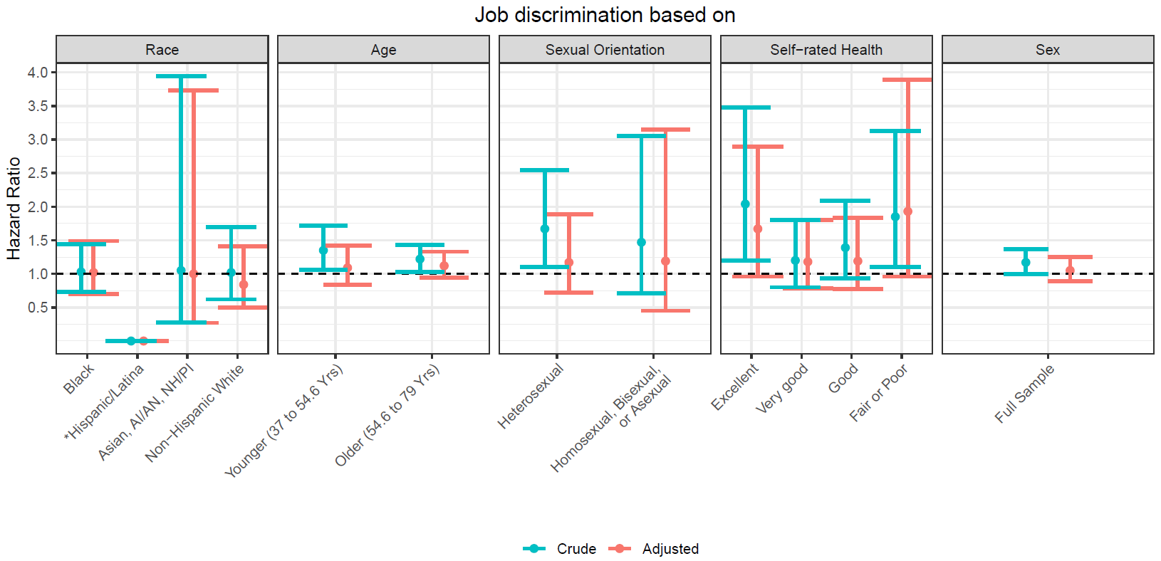
*There were cases of incident hypertension among 25 non-Black Hispanic/Latina individuals who reported job discrimination based on race. Hazard ratios estimated from models fit on data stratified by the categories on the x-axis using exposures based on the corresponding type of discrimination (e.g. age-based job discrimination in the past 5 years for Younger participants). Adjusted model adjusted for sociodemographic characteristics and characteristics upon which discrimination was based including race/ethnicity, age, educational attainment, household income, marital status, sexual orientation, and baseline health status, as well as time between baseline and first follow-up; behavioral and work-related factors including smoking, alcohol consumption, sports/exercise physical activity, hours worked per week, number of jobs, and occupation category for the longest held current job; biological factors including BMI, baseline systolic and diastolic blood pressure, stress score, waist-to-hip ratio, prior diagnosis of diabetes and/or high cholesterol, menopause status, and parity; and having experienced other forms of discrimination (non-job-related discrimiknation) based on race or sexual orientation.
Appendix Figure 1. Estimated hazard ratios for incident hypertension comparing those who reported specific types of job discrimination in the past five years to those who did not, estimates from models stratified by groups

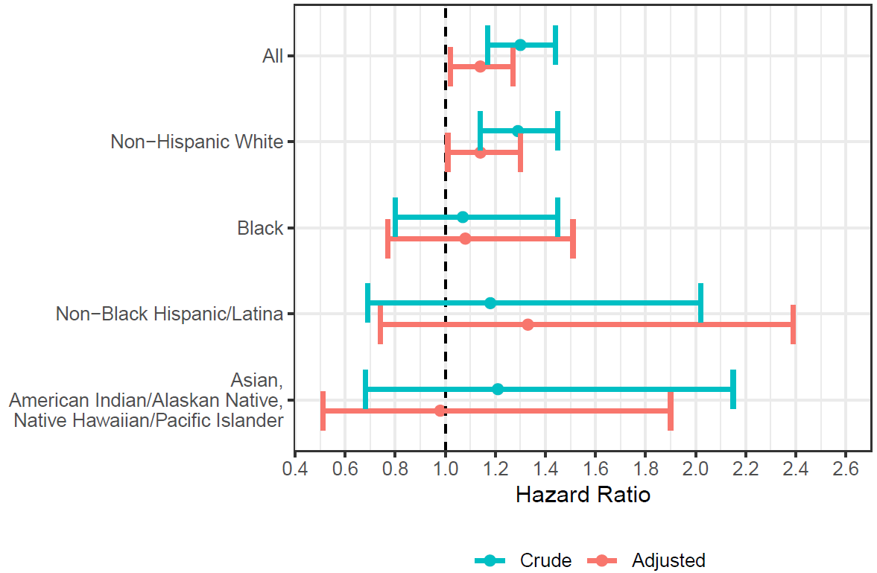
Crude estimate uses age as time scale in Cox proportional hazards regression without covariates. Adjusted model adjusted for sociodemographic characteristics and characteristics upon which discrimination was based including race/ethnicity, age, educational attainment, household income, marital status, sexual orientation, and baseline health status, as well as time between baseline and first follow-up; behavioral and work-related factors including smoking, alcohol consumption, sports/exercise physical activity, hours worked per week, number of jobs, and occupation category for the longest held current job; biological factors including BMI, baseline systolic and diastolic blood pressure, stress score, waist-to-hip ratio, prior diagnosis of diabetes and/or high cholesterol, menopause status, and parity; and having experienced other forms of discrimination (non-job-related discrimination) based on race or sexual orientation.
Appendix Figure 2. Estimated hazard ratios for future incident hypertension, comparing participants reporting at least one types of job discrimination in the last five years to those reporting none, stratified by race/ethnicity

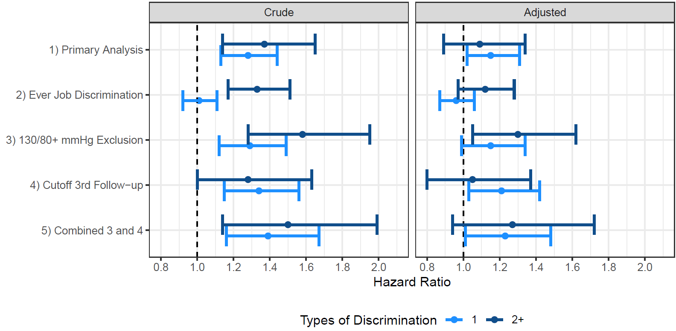
Model adjusted for sociodemographic characteristics and characteristics upon which discrimination was based including race/ethnicity, age, educational attainment, household income, marital status, sexual orientation, and baseline health status, as well as time between baseline and first follow-up; behavioral and work-related factors including smoking, alcohol consumption, sports/exercise physical activity, hours worked per week, number of jobs, and occupation category for the longest held current job; biological factors including BMI, baseline systolic and diastolic blood pressure, stress score, waist-to-hip ratio, prior diagnosis of diabetes and/or high cholesterol, menopause status, and parity; and having experienced other forms of discrimination (non-job-related discrimination) based on race or sexual orientation.
Appendix Figure 3. Estimated hazard ratios for future incident hypertension, comparing participants reporting 1 or 2+ types of job discrimination in the last five years to those reporting none, comparison of sensitivity analyses

Appendix Table 3. Characteristics of working women according to their experience of job discrimination (ever), Sister Study
 | Total Sample  N = 16,770 | Perceived At Least One Type of Job Discrimination¹ Ever  N = 3,889 | Did Not Perceive Any Type of Job Discrimination¹ Ever  N = 12,881
Cumulative incidence of hypertension during follow-up, % | 19.2% | 20.5% | 18.8%
Race/Ethnicity, %
Non-Hispanic White | 88.3% | 83.5% | 89.7%
Black | 5.7% | 10.6% | 4.2%
Non-Black Hispanic/Latina | 3.7% | 3.1% | 3.9%
Asian, American Indian/Alaskan Native, Native Hawaiian/Pacific Islander | 2.4% | 2.7% | 2.3%
Age (years) at baseline, Mean (SD) | 51.5 (7.4) | 52.2 (7.0) | 51.3 (7.5)
Age at first follow-up, %
54.6 years (median) or younger | 51.5% | 46.7% | 53.0%
Older than 54.6 years (median) | 48.5% | 53.3% | 47.0%
Sexual orientation, %
Heterosexual | 96.9% | 94.9% | 97.5%
Homosexual | 1.9% | 3.1% | 1.5%
Bisexual | 1.1% | 1.9% | 0.9%
Asexual | 0.1% | 0.1% | 0.1%
Self-rated health, %
Excellent | 47.5% | 40.2% | 49.7%
Very good | 36.6% | 38.5% | 36.0%
Good | 13.1% | 17.2% | 11.8%
Fair or Poor | 2.8% | 4.1% | 2.4%
Educational attainment, %
Some College or Less | 27.6% | 23.8% | 28.8%
Associate, Technical, or Bachelor's Degree | 43.8% | 40.8% | 44.7%
Graduate Degree | 28.6% | 35.5% | 26.6%
Childhood socioeconomic status (self-rated), %
Well off | 7.1% | 7.0% | 7.2%
Middle income | 64.8% | 61.1% | 65.9%
Low income | 22.7% | 24.6% | 22.1%
Poor | 5.4% | 7.3% | 4.8%
Marital status, %
Married/living as married | 77.1% | 70.5% | 79.1%
Widowed/divorced/separated | 16.9% | 21.6% | 15.5%
Never married | 6.0% | 7.9% | 5.4%
Current job count, %
1 | 93.0% | 91.4% | 93.5%
2+ | 7.0% | 8.6% | 6.5%
Household income, last year (USD), %
Less than $20,000 | 1.9% | 2.7% | 1.6%
$20,000 to $49,999 | 14.8% | 16.8% | 14.2%
$50,000 to $99,999 | 42.4% | 41.1% | 42.9%
$100,000 to $200,000 | 33.0% | 31.4% | 33.4%
More than $200,000 | 7.9% | 8.0% | 7.9%
Hours worked per week, Mean (SD) | 38.2 (12.6) | 40.0 (13.0) | 37.7 (12.4)
Longest job worked (occupational category), %
Professional and related occupations | 39.6% | 36.2% | 40.7%
Sales and office occupations | 26.1% | 25.0% | 26.4%
Management, business, and financial occupations | 24.2% | 29.9% | 22.5%
Service occupations | 6.7% | 5.2% | 7.2%
Production, transportation, and material moving occupations | 2.0% | 2.0% | 2.0%
Other (military, unemployed, volunteer, student, retired, homemaker, construction, maintenance, farming, fishing, forestry, or not reported) | 1.4% | 1.7% | 1.3%
Pack-years smoked, Mean (SD) | 4.7 (9.8) | 5.9 (11.3) | 4.3 (9.2)
Alcohol, drinks per week, Mean (SD) | 2.9 (4.5) | 2.9 (4.6) | 3.0 (4.5)
Physical activity, sports/exercise (MET-hours per week), Mean (SD) | 15.7 (18.8) | 15.9 (19.6) | 15.6 (18.6)
Body-Mass Index (kg/m²), Mean (SD) | 26.1 (5.2) | 26.8 (5.5) | 25.8 (5.1)
Systolic blood pressure (mm Hg), Mean (SD) | 109.1 (10.8) | 109.6 (10.7) | 108.9 (10.8)
Diastolic blood pressure (mm Hg), Mean (SD) | 69.8 (7.7) | 70.2 (7.8) | 69.7 (7.7)
Waist-hip ratio, Mean (SD) | 0.8 (0.1) | 0.8 (0.1) | 0.8 (0.1)
Perceived stress score, Mean (SD) | 2.7 (2.6) | 3.2 (2.8) | 2.6 (2.5)
High cholesterol, % | 22.0% | 24.8% | 21.2%
Diabetes, % | 1.4% | 2.1% | 1.2%
Entered menopause, % | 50.6% | 54.1% | 49.6%
Parity, %
0 | 22.0% | 28.2% | 20.2%
1-2 | 54.7% | 53.0% | 55.2%
3+ | 23.3% | 18.8% | 24.6%
Other racial/ethnic discrimination (ever), % | 10.2% | 21.1% | 6.9%
Other sexual orientation discrimination (ever), % | 7.1% | 15.5% | 4.6%
¹Types of job discrimination were discrimination based on race, gender, age, sexual orientation, and health status.

