Supplementary Online Content

Supplementary Online Content to: Margo A Sidell, Darios Getahun, Sara Y Tartof, Anny H Xiang, Andrea J Sharma, Sagori Mukhopadhyay, Karen M Puopolo, Stephanie J Schrag, Poornima Kunani, Corinna Koebnick; Higher Body Mass Index after Intrapartum Antibiotic Exposure in Children Persists over 10-year

Table S1. Demographic, maternal, birth-related, and childhood characteristics by delivery mode and intrapartum antibiotic exposure*

Table S2. Model estimate, standard error, p-value, and e-value for CS and vaginal models for main exposure and other variables.

Figure S1. Study flow chart

Figure S2. Adjusted body mass index (BMI), delta BMI, and their 95% CIs for children unexposed to intrapartum antibiotics (None), children exposed to intrapartum antibiotic prophylaxis as recommended for the prevention of perinatal group B streptococcal disease (GBS-IAP) and any other type or duration of intrapartum antibiotic administration (Other) after vaginal (S2-A) and Cesarean (S2-B) delivery

**Table S1.** Demographic, maternal, birth-related, and childhood characteristics by delivery mode and intrapartum antibiotic exposure*

|  |  |  |  |  |  |  |  |
| --- | --- | --- | --- | --- | --- | --- | --- |
| Vaginal delivery | | | |  | Cesarean delivery | |  |
| Antibiotic exposure: | None | GBS IAP | Other IAP | P  value | GBS IAP | Other IAP | P  value |
| N | 95 244 | 22 528 | 8 774 |  | 5 279 | 42 070 |  |
| Children within delivery  mode (%) | 75.3 | 17.8 | 6.9 |  | 11.1 | 88.9 |  |
| Total follow-up, years |  |  |  | <0.001 |  |  | <0.001 |
| Mean | 7.2 (2.6) | 6.8 (2.5) | 7.0 (2.5) |  | 6.8 (2.5) | 7.2 (2.6) |  |
| Median (IQR) | 7.6 (5.3, 9.9) | 6.8 (5.2, 9.3) | 7.1 (5.3, 9.5) |  | 6.8 (5.1, 9.4) | 7.6 (5.3, 9.9) |  |
| **Demographics** |  |  |  |  |  |  |  |
| Sex, |  |  |  | 0.1640 |  |  | <0.001 |
| Male | 48155 (50.56) | 11283 (50.08) | 4360 (49.69) |  | 2353 (44.57) | 20310 (48.28) |  |
| Female | 47089 (49.44) | 11245 (49.92) | 4414 (50.31) |  | 2926 (55.43) | 21760 (51.72) |  |
| Race/Ethnicity |  |  |  | <0.001 |  |  | <0.001 |
| White | 24693 (25.93) | 5574 (24.74) | 1969 (22.44) |  | 1154 (21.86) | 10866 (25.83) |  |
| Hispanic | 6058 (6.36) | 2124 (9.43) | 665 (7.58) |  | 599 (11.35) | 3390 (8.06) |  |
| Black | 49244 (51.7) | 10771 (47.81) | 4461 (50.84) |  | 2475 (46.88) | 20400 (48.49) |  |
| Asian/Pacific Islander | 12636 (13.27) | 3349 (14.87) | 1396 (15.91) |  | 870 (16.48) | 6299 (14.97) |  |
| Other, unknown | 2613 (2.65) | 710 (3.15) | 283 (3.23) |  | 181 (3.43) | 1105 (2.65) |  |
| State-subsidized health plan | 8493 (8.92) | 2349 (10.43) | 823 (9.38) | <0.001 | 410 (7.77) | 3297 (7.84) | 0.858 |
| **Maternal and pregnancy-related factors** | | | | | | | |
| Maternal education |  |  |  | <0.001 |  |  | <0.001 |
| <High school | 22507 (23.68) | 5541 (24.61) | 2190 (24.99) |  | 1442 (27.34) | 10725 (25.52) |  |
| High School | 24584 (25.87) | 5586 (24.81) | 2175 (24.82) |  | 1157 (21.94) | 9647 (22.95) |  |

|  |  |  |  |  |  |  |  |
| --- | --- | --- | --- | --- | --- | --- | --- |
| Some college | 5213 (5.49) | 874 (3.88) | 405 (4.62) |  | 152 (2.88) | 1804 (4.29) |  |
| College degree | 13308 (14) | 3190 (14.17) | 1272 (14.52) |  | 814 (15.43) | 6634 (15.78) |  |
| Unknown | 28382 (29.87) | 7038 (31.26) | 2608 (29.76) |  | 1630 (30.91) | 12696 (30.21) |  |
| Parity |  |  |  | <0.001 |  |  | <0.001 |
| 1 | 30075 (34.55) | 8175 (41.17) | 2912 (36.85) |  | 1290 (29.05) | 13060 (33.64) |  |
| 2+ | 56971 (65.45) | 11684 (58.83) | 4991 (63.15) |  | 3150 (70.95) | 25766 (66.36) |  |
| Missing | 8198 | 2669 | 871 |  | 839 | 3244 |  |
| Diabetes# | 3981 (4.18) | 1374 (6.1) | 490 (5.58) | <0.001 | 433 (8.20) | 3091 (7.35) | 0.026 |
| Pre-pregnancy BMI class |  |  |  | <0.001 |  |  | <0.001 |
| Underweight | 2793 (2.93) | 568 (2.52) | 248 (2.83) |  | 80 (1.52) | 678 (1.61) |  |
| Normal | 45017 (47.26) | 10120 (44.92) | 4162 (47.44) |  | 1928 (36.52) | 15738 (37.41) |  |
| Overweight | 27967 (29.36) | 6220 (27.61) | 2487 (28.35) |  | 1450 (27.47) | 12492 (29.69) |  |
| Obesity class I | 12432 (13.05) | 3336 (14.81) | 1169 (13.32) |  | 933 (17.67) | 7250 (17.23) |  |
| Obesity class II or higher | 7035 (7.39) | 2284 (10.14) | 708 (8.07) |  | 888 (16.82) | 5912 (14.05) |  |
| Pregnancy weight gain  (pounds) |  |  |  |  |  |  |  |
| Mean (SD) | 27.80 (13.50) | 28.00 (14.16) | 27.90 (13.35) | <0.001 | 29.60 (15.07) | 28.10 (14.47) | <0.001 |
| Smoking during pregnancy | 9617 (10.1) | 2565 (11.39) | 869 (9.9) | 0.051 | 679 (12.86) | 4746 (11.28) | <0.001 |
| Antibiotic exposure |  |  |  |  |  |  |  |
| Antepartum, trimester 1/2 | 24368 (25.58) | 7730 (34.31) | 2638 (30.07) | <0.001 | 1742 (33) | 11872 (28.22) | <0.001 |
| Antepartum, trimester 3 | 10456 (10.98) | 3241 (14.39) | 1097 (12.5) | <0.001 | 770 (14.59) | 5267 (12.52) | <0.001 |
| **Birth** |  |  |  |  |  |  |  |
| Birth weight (g) |  |  |  |  |  |  |  |
| Mean (SD) | 3372 (371) | 3372 (374) | 3357 (371) | 0.001 | 3449 (387) | 3417 (384) | <0.001 |
| Gestational age (weeks) |  |  |  |  |  |  |  |
| Mean (SD) | 39.1 (1.07) | 39.1 (1.11) | 39.1 (1.06) | <0.001 | 39.4 (1.16) | 39.0 (1.02) | <0.001 |
| **Childhood** |  |  |  |  |  |  |  |

|  |  |  |  |  |  |  |  |
| --- | --- | --- | --- | --- | --- | --- | --- |
| Any Breastfeeding | 63740 (66.92) | 15578 (69.15) | 6091 (69.42) |  | 3522 (66.72) | 27172 (64.59) | 0.002 |
| Antibiotic exposure |  |  |  |  |  |  |  |
| Neonatal (72 hrs) | 880 (0.92) | 549 (2.44) | 546 (6.22) | <0.001 | 319 (6.04) | 920 (2.19) | <0.001 |
| Indirect during lactation |  |  |  |  |  |  |  |
| 0-3 months | 11 105 (11.7) | 3 142 (14.0) | 1 325 (15.1) | <0.001 | 1 097 (20.8) | 6 358 (15.1) | <0.001 |
| 3-6 months | 5 330 (5.6) | 1 511 (6.7) | 542 (6.2) | <0.001 | 340 (6.4) | 2 667 (6.3) | 0.776 |
| Cumulative childhood episodes (count) | | | | | | | |
| Mean (SD) | 3.3 (3.66) | 3.0 (3.45) | 3.1 (3.52) | <0.001 | 3.2 (3.50) | 3.5 (3.81) | <0.001 |

Note: We compared intrapartum antibiotic exposure groups using descriptive statistical methods including the Pearson chi-square test for categorical variables and analysis of variance (ANOVA), the Kruskal-Wallis, student's T, or the Wilcoxon rank-sum tests.

* Antibiotic exposure: none, no intrapartum exposure to antibiotics; GBS, GBS intrapartum antibiotic prophylaxis as recommended for the prevention of perinatal group B streptococcal disease; other, any other type or duration of intrapartum antibiotic administration (IAP)

# Any maternal diagnosis of diabetes at birth, including gestational diabetes

**Table S2.** Model estimates, standard error, p-value, and e-value for CS and vaginal models for main exposure and other variables.

|  |  |  |  |  |  |  |  |  |
| --- | --- | --- | --- | --- | --- | --- | --- | --- |
|  |  | **CS** |  |  |  | **Vaginal** | |  |
| **Variable** | **Estimate** | **SE** | **p-value** | **e-value** | **Estimate** | **SE** | **p-value** | **e-value** |
| GBS IAP | -0.1327 | 0.0334 | 0.0001 | 1.2774 | -0.0863 | 0.0156 | 0.0000 | 1.2134 |
| Cesarean section Skin prophylaxis | N/A |  |  |  | -0.0441 | 0.0231 | 0.0557 | 1.1445 |
| Infant Sex (Female) | -0.1907 | 0.0148 | 0.0000 | 1.3495 | -0.1853 | 0.0086 | 0.0000 | 1.3431 |
| Race/Ethnicity NH Black | 0.0839 | 0.0310 | 0.0067 | 1.2099 | 0.1081 | 0.0193 | 0.0000 | 1.2445 |
| Race/Ethnicity Hispanic | 0.3108 | 0.0194 | 0.0000 | 1.4862 | 0.3175 | 0.0113 | 0.0000 | 1.4935 |
| Race/Ethnicity Asian/PI | 0.0592 | 0.0247 | 0.0167 | 1.1710 | 0.0477 | 0.0148 | 0.0012 | 1.1511 |
| Race/Ethnicity Other | 0.0658 | 0.0474 | 0.1647 | 1.1819 | 0.0065 | 0.0269 | 0.8088 | 1.0512 |
| Race/Ethnicity Unknown | 0.0527 | 0.2053 | 0.7974 | 1.1600 | 0.1712 | 0.1353 | 0.2057 | 1.3260 |
| Birth Year | -0.0028 | 0.0032 | 0.3771 | 1.0331 | -0.0043 | 0.0018 | 0.0190 | 1.0412 |
| Birth Weight | 0.0009 | 0.0000 | 0.0000 | 1.0183 | 0.0009 | 0.0000 | 0.0000 | 1.0183 |
| Age (years) | 0.6241 | 0.0021 | 0.0000 | 1.8211 | 0.5947 | 0.0014 | 0.0000 | 1.7898 |
| Gestational Age (Weeks) | -0.1073 | 0.0077 | 0.0000 | 1.2435 | -0.1068 | 0.0043 | 0.0000 | 1.2427 |
| Maternal Education- Some College | -0.0664 | 0.2455 | 0.7867 | 1.1829 | 0.2489 | 0.0975 | 0.0107 | 1.4172 |
| Maternal Education- Bachelor | -0.0769 | 0.0202 | 0.0001 | 1.1993 | -0.0683 | 0.0120 | 0.0000 | 1.1859 |
| Maternal Education- High School | 0.0649 | 0.0207 | 0.0017 | 1.1804 | 0.0505 | 0.0117 | 0.0000 | 1.1560 |
| Maternal Education- Less than HS | 0.3124 | 0.0406 | 0.0000 | 1.4879 | 0.2751 | 0.0217 | 0.0000 | 1.4466 |
| Maternal Education- Post-graduate | -0.1655 | 0.0232 | 0.0000 | 1.3190 | -0.1062 | 0.0140 | 0.0000 | 1.2418 |
| Maternal Education- Withheld | -0.0224 | 0.0693 | 0.7465 | 1.0991 | 0.0361 | 0.0422 | 0.3920 | 1.1290 |
| Medicaid | 0.0755 | 0.0294 | 0.0102 | 1.1972 | 0.0808 | 0.0159 | 0.0000 | 1.2053 |
| Parity | -0.0452 | 0.0174 | 0.0095 | 1.1466 | -0.1012 | 0.0094 | 0.0000 | 1.2349 |
| Maternal Diabetes during Pregnancy | 0.0941 | 0.0276 | 0.0007 | 1.2247 | 0.0416 | 0.0196 | 0.0336 | 1.1398 |
| Maternal Antibiotics during Pregnancy, T1-T2 | -0.0104 | 0.0161 | 0.5170 | 1.0656 | 0.0213 | 0.0095 | 0.0251 | 1.0963 |
| Maternal Antibiotics during Pregnancy, T3 | -0.0103 | 0.0220 | 0.6409 | 1.0651 | 0.0149 | 0.0132 | 0.2582 | 1.0795 |
| Pre-Pregnancy BMI < 18.5 | -0.3463 | 0.0602 | 0.0000 | 1.5249 | -0.3802 | 0.0265 | 0.00000 | 1.5615 |
| Pre-Pregnancy BMI 25.0-29.9 | 0.3080 | 0.0185 | 0.0000 | 1.4831 | 0.317 | 0.0104 | 0.00000 | 1.4930 |
| Pre-Pregnancy BMI 30.0-34.9 | 0.5836 | 0.0226 | 0.0000 | 1.7780 | 0.6234 | 0.0139 | 0.00000 | 1.8204 |
| Pre-Pregnancy BMI 35+ | 1.0394 | 0.0254 | 0.0000 | 2.2798 | 0.9891 | 0.0175 | 0.00000 | 2.2220 |

|  |  |  |  |  |  |  |  |  |
| --- | --- | --- | --- | --- | --- | --- | --- | --- |
| Pregnancy Weight Gain (lbs) | 0.0061 | 0.0006 | 0.0000 | 1.0496 | 0.0051 | 0.0004 | 0.00000 | 1.0451 |
| Smoking During Pregnancy | 0.0924 | 0.0234 | 0.0001 | 1.2224 | 0.0984 | 0.0142 | 0.00000 | 1.2310 |
| Neonatal Antibiotic Exposure | 0.0453 | 0.0453 | 0.3172 | 1.1467 | -0.029 | 0.0342 | 0.39530 | 1.1143 |
| Childhood Recent ABX Exposure (prior 6 mo) | -0.0544 | 0.0091 | 0.0000 | 1.1628 | -0.0343 | 0.0057 | 0.00000 | 1.1254 |
| Cumulative Childhood ABX Exposure | 0.0569 | 0.0058 | 0.0000 | 1.1672 | 0.0535 | 0.0037 | 0.00000 | 1.1614 |
| Lagged Cumulative Child ABX Exposure | -0.0056 | 0.0058 | 0.3347 | 1.0471 | -0.0094 | 0.0036 | 0.00980 | 1.0622 |
| Lactation ABX Exposure 0 - 3 mo (indirect) | 0.1087 | 0.0133 | 0.0000 | 1.2454 | 0.1126 | 0.0088 | 0.00000 | 1.2508 |
| Lactation ABX Exposure 3 - 6 mo (indirect) | -0.0341 | 0.028 | 0.2234 | 1.1250 | -0.0614 | 0.0173 | 0.00040 | 1.1747 |
| Breastfeeding | -0.1586 | 0.016 | 0.00000 | 1.3104 | -0.1805 | 0.0096 | 0.00000 | 1.3373 |
| Exposure None Spline 1 | N/A |  |  |  | 4.1235 | 0.0090 | 0.0000 | 8.4469 |
| Exposure None Spline 2 | N/A |  |  |  | 3.2828 | 0.0075 | 0.0000 | 6.0657 |
| Exposure None Spline 3 | N/A |  |  |  | 1.2756 | 0.0095 | 0.0000 | 2.5613 |
| Exposure None Spline 4 | N/A |  |  |  | -1.2659 | 0.0109 | 0.0000 | 2.5494 |
| Exposure None Spline 5 | N/A |  |  |  | -1.1768 | 0.0213 | 0.0000 | 2.4413 |
| Exposure None Spline 6 | N/A |  |  |  | N/A |  |  |  |
| GBS IAP Spline 1 | 0.0354 | 0.0417 | 0.3963 | 1.1276 | 0.0600 | 0.0202 | 0.0029 | 1.1724 |
| GBS IAP Spline 2 | 0.1457 | 0.0338 | 0.0000 | 1.2942 | 0.0957 | 0.0166 | 0.0000 | 1.2270 |
| GBS IAP Spline 3 | 0.1866 | 0.0411 | 0.0000 | 1.3447 | 0.0709 | 0.0202 | 0.0005 | 1.1900 |
| GBS IAP Spline 4 | 0.3082 | 0.0553 | 0.0000 | 1.4833 | 0.2098 | 0.0275 | 0.0000 | 1.3722 |
| GBS IAP Spline 5 | 0.2840 | 0.0692 | 0.0000 | 1.4566 | 0.2552 | 0.0346 | 0.0000 | 1.4243 |
| GBS IAP Spline 6 | 0.5375 | 0.0627 | 0.0000 | 1.7290 | 0.2291 | 0.0318 | 0.0000 | 1.3945 |
| Other ABX Spline 1 | 4.1886 | 0.0139 | 0.0000 | 8.6634 | 0.1016 | 0.0300 | 0.0007 | 1.2355 |
| Other ABX Spline 2 | 3.3589 | 0.0115 | 0.0000 | 6.2529 | 0.0497 | 0.0248 | 0.0449 | 1.1546 |
| Other ABX Spline 3 | 1.2900 | 0.0145 | 0.0000 | 2.5790 | 0.0899 | 0.0301 | 0.0029 | 1.2187 |
| Other ABX Spline 4 | -1.2789 | 0.0165 | 0.0000 | 2.5654 | 0.0939 | 0.0409 | 0.0215 | 1.2246 |
| Other ABX Spline 5 | -1.0377 | 0.0323 | 0.0000 | 2.2779 | 0.1599 | 0.0510 | 0.0017 | 1.3120 |
| Other ABX Spline 6 | N/A |  |  |  | -0.0804 | 0.0470 | 0.0873 | 1.2046 |

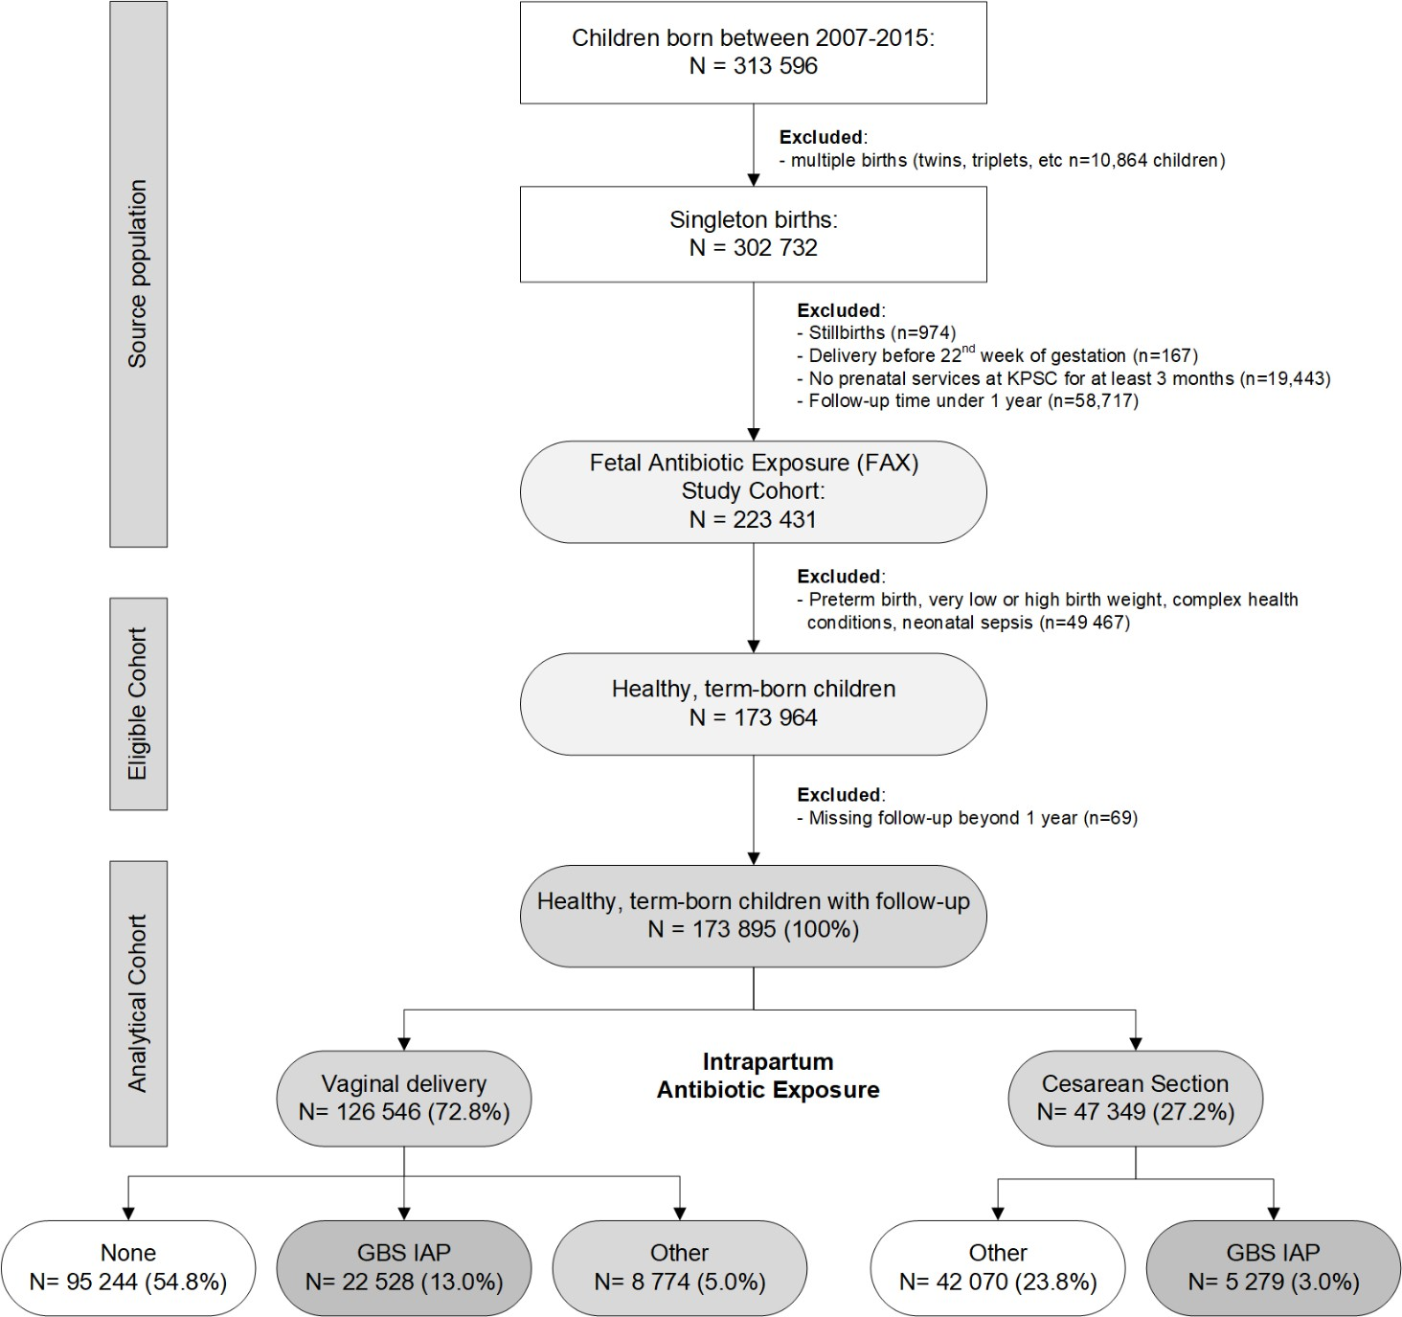

**Figure S1:** Study flow chart

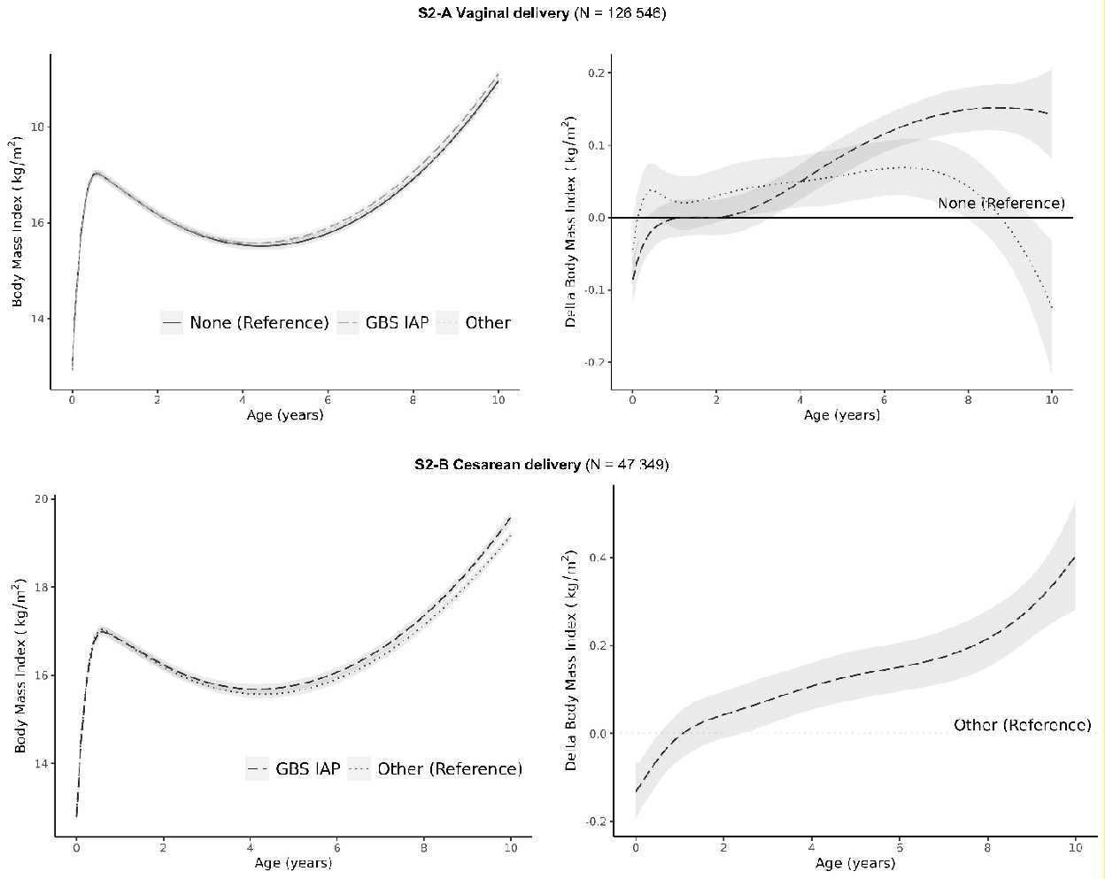

**Figure S2**: Adjusted body mass index (BMI), delta BMI, and their 95% CIs for children unexposed to intrapartum antibiotics (None), children exposed to intrapartum antibiotic prophylaxis as recommended for the prevention of perinatal group B streptococcal disease (GBS-IAP) and any other type or duration of intrapartum antibiotic administration (Other) after vaginal (**S2-A**) and Cesarean (**S2-B**) delivery.

Covariate adjustments included demographics, maternal and birth-related factors included infant sex, gestational age at birth, birth weight, infant’s race/ethnicity (White, Black, Hispanic, Asian or Pacific Islander, other or unknown), year of birth, medical center of birth, maternal education, parity, maternal diabetes, maternal pre-pregnancy BMI, maternal gestational weight gain, maternal smoking during pregnancy, antepartum antibiotic exposure, neonatal antibiotic exposure, any breastfeeding, indirect antibiotic exposure during breastfeeding, and childhood antibiotic exposure.