Public Health Applications of Historical Smoke Forecasts: An Evaluation of Archived BlueSky data for the Coterminous United States, 2015- 2018
Ryan Michael, PhD; Maria C. Mirabelli, PhD; and Ambarish Vaidyanathan, PhD;
Climate and Health Program, National Center for Environmental Health, Centers for Disease Control and Prevention, 4770 Buford Highway NE, Mailstop S106-6, Atlanta, GA 30341 US

Manuscript Reference Number: CAGEO_CAGEO-D-20-00455

Supplementary Data
Table S1. Correlation between county-level model-derived and AQS-, IMPROVE-, WRCC-, and AIRSIS-derived estimates
Spatial Aggregation | Temporal  Aggregation |  | Model vs AQS¹  ρ (p-value) | Model vs IMPROVE²  ρ (p-value) | Model vs WRCC^{3,5}  ρ (p-value) | Model vs AIRSIS^{4,5}  ρ (p-value)
Coterminous United States | Year | 2015 | 0.09 (<0.001) | 0.15 (<0.001) | - | -
Coterminous United States | Year | 2016 | 0.14 (<0.001) | 0.18 (<0.001) | - | -
Coterminous United States | Year | 2017 | 0.14 (<0.001) | 0.21 (<0.001) | - | -
Coterminous United States | Year | 2018 | 0.17 (<0.001) | 0.21 (<0.001) | - | -
Coterminous United States | Month | January | 0.04 (<0.001) | 0.17 (<0.001) | - | -
Coterminous United States | Month | February | 0.10 (<0.001) | 0.21 (<0.001) | - | -
Coterminous United States | Month | March | 0.24 (<0.001) | 0.28 (<0.001) | - | -
Coterminous United States | Month | April | 0.22 (<0.001) | 0.23 (<0.001) | - | -
Coterminous United States | Month | May | 0.12 (<0.001) | 0.16 (<0.001) | - | -
Coterminous United States | Month | June | 0.11 (<0.001) | 0.15 (<0.001) | - | -
Coterminous United States | Month | July | 0.09 (<0.001) | 0.13 (<0.001) | - | -
Coterminous United States | Month | August | 0.21 (<0.001) | 0.34 (<0.001) | - | -
Coterminous United States | Month | September | 0.16 (<0.001) | 0.20 (<0.001) | - | -
Coterminous United States | Month | October | 0.20 (<0.001) | 0.19 (<0.001) | - | -
Coterminous United States | Month | November | 0.16 (<0.001) | 0.12 (<0.001) | - | -
Coterminous United States | Month | December | 0.09 (<0.001) | 0.06 (<0.001) | - | -
High Wildfire Impact States: AZ, CA, CO, ID, MT, NM, NV, OR, UT, WA, WY | Year | 2015 | 0.14 (<0.001) | 0.20 (<0.001) | 0.42 (<0.001) | 0.38 (<0.001)
 | Year | 2016 | 0.16 (<0.001) | 0.20 (<0.001) | 0.29 (<0.001) | 0.21 (<0.001)
 | Year | 2017 | 0.18 (<0.001) | 0.27 (<0.001) | 0.50 (<0.001) | 0.49 (<0.001)
 | Year | 2018 | 0.24 (<0.001) | 0.29 (<0.001) | 0.45 (<0.001) | 0.53 (<0.001)
 | Month | January | 0.02 (<0.001) | 0.07 (<0.001) | NS | NS
 | Month | February | 0.10 (<0.001) | 0.12 (<0.001) | NS | NS
 | Month | March | 0.13 (<0.001) | 0.13 (<0.001) | NS | 0.20 (<0.001)
 | Month | April | 0.10 (<0.001) | 0.17 (<0.001) | 0.22 (<0.001) | 0.17 (<0.001)
 | Month | May | 0.09 (<0.001) | 0.19 (<0.001) | 0.17 (<0.001) | 0.10 (<0.001)
 | Month | June | 0.18 (<0.001) | 0.25 (<0.001) | 0.39 (<0.001) | 0.22 (<0.001)
 | Month | July | 0.23 (<0.001) | 0.28 (<0.001) | 0.43 (<0.001) | 0.50 (<0.001)
 | Month | August | 0.33 (<0.001) | 0.47 (<0.001) | 0.49 (<0.001) | 0.50 (<0.001)
 | Month | September | 0.24 (<0.001) | 0.34 (<0.001) | 0.49 (<0.001) | 0.47 (<0.001)
 | Month | October | 0.21 (<0.001) | 0.26 (<0.001) | 0.18 (<0.001) | 0.33 (<0.001)
 | Month | November | 0.21 (<0.001) | 0.21 (<0.001) | 0.10 (<0.001) | 0.44 (<0.001)
 | Month | December | 0.09 (<0.001) | 0.07 (<0.001) | NS | NS
¹EPA Air Quality System (AQS)
² Inter-agency Monitoring of Protected Visual Environments (IMPROVE). ). Elemental carbon fraction of total PM_{2.5} mass used to evaluate model data
³Western Region Climate Centers
⁴Inter-agency Real Time Smoke Monitoring Network
⁵No comparisons for the coterminous United States using the WRCC and AIRSIS networks because these monitors are only located in the western United States
AZ = Arizona, CA = California, CO = Colorado, ID = Idaho, MT = Montana, NM = New Mexico, NV = Nevada, OR = Oregon, UT = Utah, WA = Washington, WY = Wyoming
NS = not significant
No comparisons for the coterminous United States using the WRCC and AIRSIS networks because these monitors are only located in the western United States

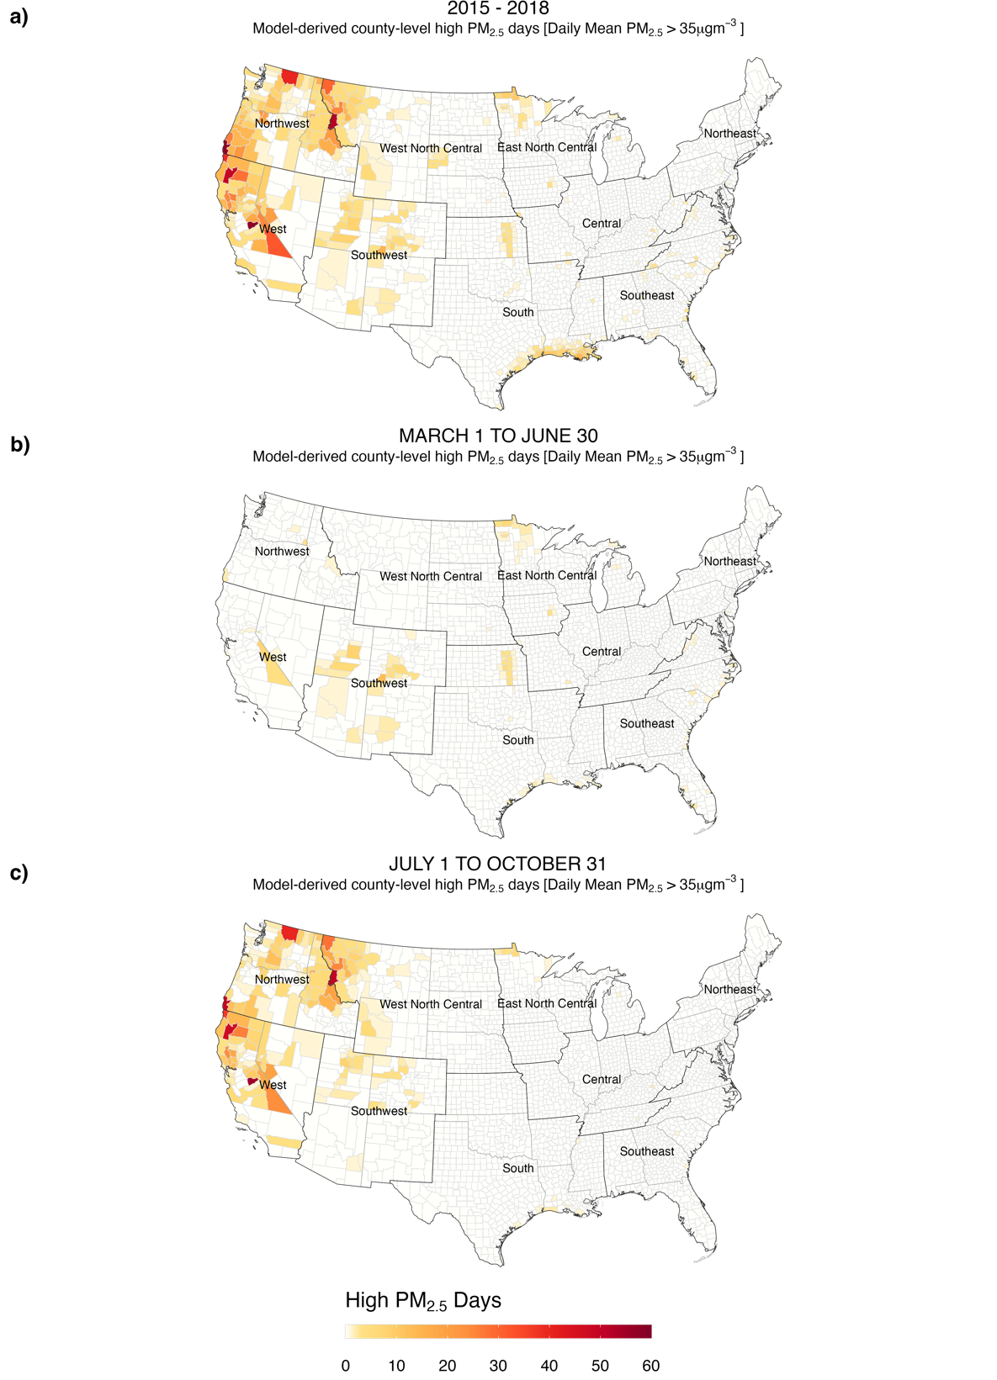
Figure S1. Spatio-temporal distribution of county-level estimates of model-derived PM_{2.5} concentrations. Data display model-derived estimates of county-level high PM_{2.5} days. High PM_{2.5} days were defined as days when the daily mean PM_{2.5} concentration is greater than 35 µg/m³. Panel a show data for all months over the study period (2015–2018), panel b shows data for period March 1 to June 30, and panel c shows data for period July 1 to October 31.

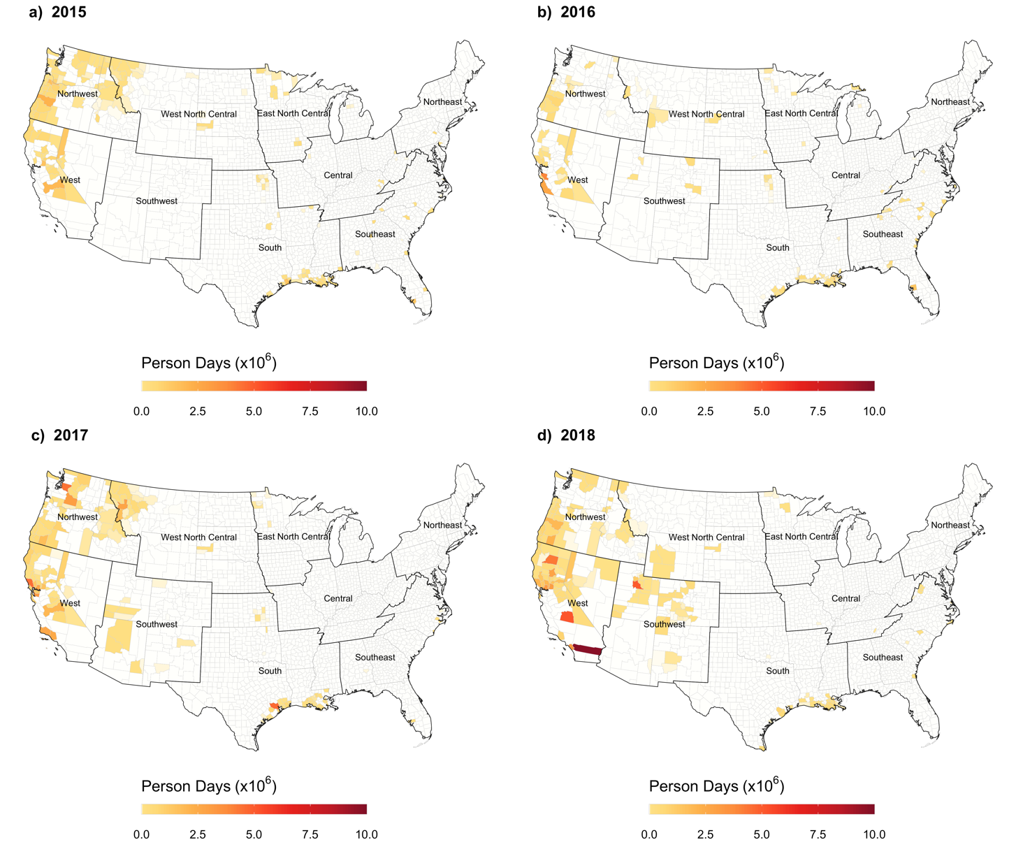
Figure S2. County-level person-days of exposure for model-derived estimates of PM_{2.5} concentrations for all counties for 2015 (panel a), 2016 (panel b), 2017 (panel c), and 2018 (panel d). Smoke days are defined as days when the daily mean PM_{2.5} concentration is greater than 35 µg/m³.

