SUPPLEMENTAL TABLE 1. Chi-square goodness-of-fit tests for representativeness of child and maternal characteristics
and maternal exposures for participants included in the analytical sample, National Birth Defects Prevention Study,
2000-2005
Characteristics | All control children |  | Control children in the analytical sample |  | Case children, all NTDs combined |  | Case children in the analytical sample, all NTDs combined |  | Control children | Case children, all NTDs combined
 | Nª | % | Nª | % | Nª | % | Nª | % | p | p
Totals | 3974 |  | 649 |  | 667 |  | 111
Child characteristics
Pregnancy outcome
Livebirth | 3973 | 100.0 | 649 | 100.0 | 453 | 68.0 | 69 | 62.2 | NC | <.01
Fetal death (≥20 weeks gestation) | 0 | 0.0 | 0 | 0.0 | 56 | 8.4 | 3 | 2.7
Induced abortion | 0 | 0.0 | 0 | 0.0 | 157 | 23.6 | 39 | 35.1
Missing | 1 |  | 0 |  | 1 |  | 0
Sex
Male | 2030 | 51.1 | 339 | 52.2 | 304 | 48.3 | 52 | 52.5 | .57 | .40
Female | 1940 | 48.9 | 310 | 47.8 | 325 | 51.7 | 47 | 47.5
Missing | 4 |  | 0 |  | 38 |  | 12
Gestational age (weeks)
Preterm (<37) | 391 | 9.8 | 70 | 10.8 | 322 | 48.3 | 57 | 51.4 | .42 | .52
Term (≥37) | 3582 | 90.2 | 579 | 89.2 | 345 | 51.7 | 54 | 48.6
Missing | 1 |  | 0 |  | 0 |  | 0
Family history of NTDs
First-degree relative | 6 | 0.2 | 1 | 0.2 | 6 | 0.9 | 1 | 0.9 | 1.00^{b} | 1.00^{b}
None | 3968 | 99.8 | 648 | 99.8 | 661 | 99.1 | 110 | 99.1
Missing | 0 |  | 0 |  | 0 |  | 0
Plurality
Single birth | 3854 | 97.0 | 622 | 95.8 | 637 | 95.5 | 104 | 93.7 | .09 | .35^{b}
Multiple birth | 120 | 3.0 | 27 | 4.2 | 30 | 4.5 | 7 | 6.3
Missing | 0 |  | 0 |  | 0 |  | 0
Maternal characteristics
Age at delivery (years)
<20 | 366 | 9.2 | 37 | 5.7 | 70 | 10.5 | 3 | 2.7 | .01 | .01
20-34 | 3043 | 76.6 | 508 | 78.3 | 500 | 75.0 | 85 | 76.6
≥35 | 565 | 14.2 | 104 | 16.0 | 97 | 14.5 | 23 | 20.7
Missing | 0 |  | 0 |  | 0 |  | 0
Educational attainment at delivery (years)
<12 | 613 | 15.5 | 43 | 6.6 | 122 | 18.3 | 10 | 9.0 | <.01 | <.01
12 | 943 | 23.8 | 131 | 20.2 | 180 | 27.1 | 18 | 16.2
>12 | 2405 | 60.7 | 475 | 73.2 | 363 | 54.6 | 83 | 74.8
Missing | 13 |  | 0 |  | 2 |  | 0
Race/Ethnicity
Non-Hispanic white | 2523 | 63.5 | 451 | 69.5 | 378 | 56.7 | 77 | 69.4 | <.01 | <.01
Non-Hispanic black | 487 | 12.3 | 95 | 14.6 | 74 | 11.1 | 15 | 13.5
Hispanic | 723 | 18.2 | 70 | 10.8 | 171 | 25.6 | 12 | 10.8
Other | 241 | 6.1 | 33 | 5.1 | 44 | 6.6 | 7 | 6.3
Missing | 0 |  | 0 |  | 0 |  | 0
Gravidity
First pregnancy | 1162 | 29.2 | 188 | 29.0 | 179 | 26.8 | 38 | 34.2 | .01 | .15
Second pregnancy | 1186 | 29.9 | 226 | 34.8 | 191 | 28.6 | 25 | 22.5
Third or later pregnancy | 1625 | 40.9 | 235 | 36.2 | 297 | 44.5 | 48 | 43.2
Missing | 1 |  | 0 |  | 0 |  | 0
Pre-pregnancy BMI (kg/m²)
Underweight (<18.5) | 205 | 5.4 | 17 | 2.7 | 24 | 3.8 | 6 | 5.7 | .02 | .27^{b}
Normal (18.5-<25.0) | 2094 | 54.7 | 370 | 58.2 | 316 | 50.2 | 60 | 56.6
Overweight (25.0-<30.0) | 886 | 23.2 | 149 | 23.4 | 148 | 23.5 | 23 | 21.7
Obese (≥30.0) | 642 | 16.8 | 100 | 15.7 | 142 | 22.5 | 17 | 16.0
Missing | 147 |  | 13 |  | 37 |  | 5
Study site
Arkansas | 641 | 16.1 | 124 | 19.1 | 105 | 15.7 | 20 | 18.0 | <.01 | <.01
Georgia | 529 | 13.3 | 109 | 16.8 | 107 | 16.0 | 15 | 13.5
Iowa | 534 | 13.4 | 143 | 22.0 | 104 | 15.6 | 25 | 22.5
Massachusetts | 565 | 14.2 | 77 | 11.9 | 43 | 6.4 | 4 | 3.6
New York | 401 | 10.1 | 13 | 2.0 | 49 | 7.3 | 3 | 2.7
North Carolina^{c} | 383 | 9.6 | 95 | 14.6 | 65 | 9.7 | 22 | 19.8
Texas | 560 | 14.1 | 49 | 7.6 | 117 | 17.5 | 8 | 7.2
Utah^{c} | 361 | 9.1 | 39 | 6.0 | 77 | 11.5 | 14 | 12.6
Missing | 0 |  | 0 |  | 0 |  | 0
Maternal exposures
Periconceptional cigarette smoking^{d}
No active or passive smoking | 2731 | 69.0 | 477 | 73.6 | 422 | 63.7 | 73 | 65.8 | <.01 | .64
Active smoking only | 299 | 7.6 | 44 | 6.8 | 46 | 6.9 | 5 | 4.5
Passive smoking only | 481 | 12.2 | 83 | 12.8 | 129 | 19.5 | 24 | 21.6
Active and passive smoking | 447 | 11.3 | 44 | 6.8 | 66 | 10.0 | 9 | 8.1
Missing | 16 |  | 1 |  | 4 |  | 0
Periconceptional alcohol consumption^{d}
No drinking | 2639 | 67.0 | 401 | 62.3 | 463 | 70.2 | 70 | 64.8 | .03 | .38
Binge drinking (≥4 drinks/occasion) | 417 | 10.6 | 82 | 12.7 | 77 | 11.7 | 13 | 12.0
Drinking but no binge drinking | 884 | 22.4 | 161 | 25.0 | 120 | 18.2 | 25 | 23.1
Missing | 34 |  | 5 |  | 7 |  | 3
Prepregnancy dietary folate intake (μg/day)
<600 | 2852 | 71.8 | 489 | 75.3 | 499 | 74.8 | 86 | 77.5 | .04 | .52
≥600 | 1121 | 28.2 | 160 | 24.7 | 168 | 25.2 | 25 | 22.5
Missing | 1 |  | 0 |  | 0 |  | 0
Periconceptional folic acid containing supplement use
Yes | 2153 | 54.7 | 408 | 63.2 | 364 | 55.7 | 76 | 71.0 | <.01 | <.01
No | 1783 | 45.3 | 238 | 36.8 | 289 | 44.3 | 31 | 29.0
Missing | 38 |  | 3 |  | 14 |  | 4
Periconceptional fever^{d}
Yes | 179 | 4.9 | 28 | 4.8 | 46 | 7.8 | 9 | 9.8 | .85 | .49
No | 3455 | 95.1 | 560 | 95.2 | 541 | 92.2 | 83 | 90.2
Missing | 340 |  | 61 |  | 80 |  | 19
Average shower duration^{e}
<15 minutes | 2004 | 52.3 | 366 | 57.5 | 291 | 45.5 | 53 | 51.0 | .01 | .26
≥15 minutes | 1827 | 47.7 | 270 | 42.5 | 349 | 54.5 | 51 | 49.0
Missing | 143 |  | 13 |  | 27 |  | 7
Note: Because of rounding, percentages might not total 100.
Abbreviations: BMI, body mass index; NC, not calculated; NTD, neural tube defect.
ª Missing values not included in chi-square tests.
^{b} Exact p-value.
^{c} Includes estimated dates of delivery during 2003-2005.
^{d} Periconceptional period defined as 1 month before conception and 1 month after conception.
^{e} Assessed around the time the participant became pregnant.

SUPPLEMENTAL TABLE 2. Correlations of residential trihalomethane (THM) and haloacetic acid (HAA) concentrations in public tap water among participants
included in the analytical sample, National Birth Defects Prevention Study, 2000-2005
Exposure (μg/L, B1-P1)ª | TTHM | Bromo-form | Chloro-form | Bromo-dichloro-methane | Dibromo-chloro-methane | HAA5 | Chloro-acetic acid | Dichloro-acetic acid | Trichloro-acetic acid | Bromo-acetic acid | Dibromo-acetic acid
TTHM | 1.00 | 0.21 | 0.89 | 0.77 | 0.44 | 0.63 | 0.54 | 0.65 | 0.51 | 0.31 | 0.36
Bromoform | 0.21 | 1.00 | -0.11 | 0.10 | 0.60 | 0.07 | 0.18 | 0.00 | -0.06 | 0.19 | 0.65
Chloroform | 0.89 | -0.11 | 1.00 | 0.54 | 0.03 | 0.69 | 0.45 | 0.70 | 0.63 | 0.27 | 0.04
Bromodichloromethane | 0.77 | 0.10 | 0.54 | 1.00 | 0.67 | 0.49 | 0.53 | 0.47 | 0.25 | 0.25 | 0.51
Dibromochloromethane | 0.44 | 0.60 | 0.03 | 0.67 | 1.00 | 0.15 | 0.33 | 0.11 | -0.10 | 0.23 | 0.71
HAA5 | 0.63 | 0.07 | 0.69 | 0.49 | 0.15 | 1.00 | 0.68 | 0.95 | 0.87 | 0.31 | 0.28
Chloroacetic acid | 0.54 | 0.18 | 0.45 | 0.53 | 0.33 | 0.68 | 1.00 | 0.55 | 0.45 | 0.32 | 0.44
Dichloroacetic acid | 0.65 | 0.00 | 0.70 | 0.47 | 0.11 | 0.95 | 0.55 | 1.00 | 0.78 | 0.28 | 0.18
Trichloroacetic acid | 0.51 | -0.06 | 0.63 | 0.25 | -0.10 | 0.87 | 0.45 | 0.78 | 1.00 | 0.17 | -0.02
Bromoacetic acid | 0.31 | 0.19 | 0.27 | 0.25 | 0.23 | 0.31 | 0.32 | 0.28 | 0.17 | 1.00 | 0.20
Dibromoacetic acid | 0.36 | 0.65 | 0.04 | 0.51 | 0.71 | 0.28 | 0.44 | 0.18 | -0.02 | 0.20 | 1.00
Abbreviations: B1, one month before conception; HAA5, group of five most common haloacetic acids; P1, one month after conception; TTHM, total trihalomethanes.
ª Massachusetts and Utah did not report individual THM and HAA concentrations and were not included in the analysis of individual disinfection by-products.

SUPPLEMENTAL TABLE 3. Correlations of average daily maternal ingestion of trihalomethanes (THMs) and haloacetic acids (HAAs) among participants included
in the analytical sample, National Birth Defects Prevention Study, 2000-2005
Exposure (μg/L, B1-P1)ª | TTHM | Bromo-form | Chloro-form | Bromo-dichloro-methane | Dibromo-chloro-methane | HAA5 | Chloro-acetic acid | Dichloro-acetic acid | Trichloro-acetic acid | Bromo-acetic acid | Dibromo-acetic acid
TTHM | 1.00 | 0.46 | 0.84 | 0.90 | 0.64 | 0.78 | 0.58 | 0.72 | 0.68 | 0.54 | 0.58
Bromoform | 0.46 | 1.00 | 0.03 | 0.42 | 0.76 | 0.20 | 0.24 | 0.13 | 0.05 | 0.41 | 0.83
Chloroform | 0.84 | 0.03 | 1.00 | 0.64 | 0.15 | 0.86 | 0.61 | 0.83 | 0.87 | 0.43 | 0.14
Bromodichloromethane | 0.90 | 0.42 | 0.64 | 1.00 | 0.77 | 0.59 | 0.44 | 0.53 | 0.45 | 0.54 | 0.68
Dibromochloromethane | 0.64 | 0.76 | 0.15 | 0.77 | 1.00 | 0.25 | 0.25 | 0.18 | 0.06 | 0.46 | 0.87
HAA5 | 0.78 | 0.20 | 0.86 | 0.59 | 0.25 | 1.00 | 0.71 | 0.96 | 0.93 | 0.45 | 0.30
Chloroacetic acid | 0.58 | 0.24 | 0.61 | 0.44 | 0.25 | 0.71 | 1.00 | 0.63 | 0.60 | 0.45 | 0.28
Dichloroacetic acid | 0.72 | 0.13 | 0.83 | 0.53 | 0.18 | 0.96 | 0.63 | 1.00 | 0.86 | 0.37 | 0.23
Trichloroacetic acid | 0.68 | 0.05 | 0.87 | 0.45 | 0.06 | 0.93 | 0.60 | 0.86 | 1.00 | 0.36 | 0.09
Bromoacetic acid | 0.54 | 0.41 | 0.43 | 0.54 | 0.46 | 0.45 | 0.45 | 0.37 | 0.36 | 1.00 | 0.42
Dibromoacetic acid | 0.58 | 0.83 | 0.14 | 0.68 | 0.87 | 0.30 | 0.28 | 0.23 | 0.09 | 0.42 | 1.00
Abbreviations: B1, one month before conception; HAA5, group of five most common haloacetic acids; P1, one month after conception; TTHM, total trihalomethanes.
ª Massachusetts and Utah did not report individual THM and HAA concentrations and were not included in the analysis of individual disinfection by-products.

SUPPLEMENTAL FIGURE 1. Directed Acyclic Graph for adjustment variable selection
between drinking water disinfection by-products and neural tube defects (NTDs)
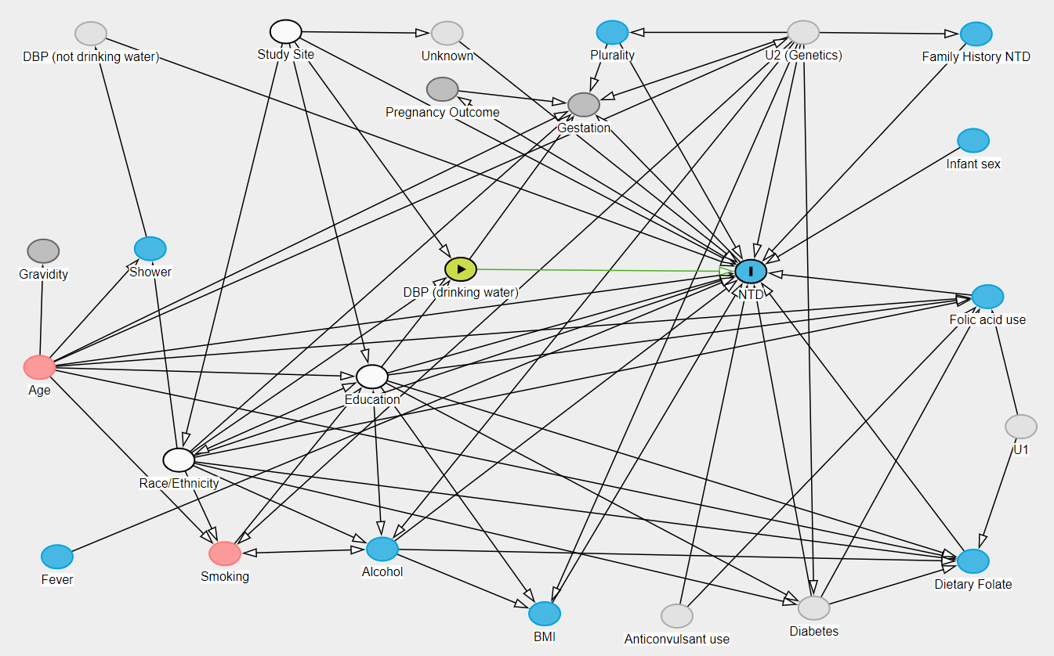
BMI=Body Mass Index; DBP=Disinfection by-product; U=Unknown
Minimal sufficient adjustment set for estimating the total effect of drinking water disinfection
by-products and neural tube defects: Maternal educational attainment at delivery, maternal
race/ethnicity, and study site.
The Directed Acyclic Graph was generated using the R package “DAGitty” (Textor et al., 2016).
DAGgitty color legend:
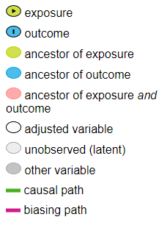

DAGitty MODEL CODE:

dag {
bb="-6.767,-12.319,7.753,7.543"
"Anticonvulsant use" [latent,pos="2.800,6.434"]
"DBP (drinking water)" [exposure,pos="-0.030,-3.180"]
"DBP (not drinking water)" [latent,pos="-4.870,-9.716"]
"Dietary Folate" [pos="6.676,4.919"]
"Family History NTD" [pos="6.716,-9.704"]
"Folic acid use" [pos="6.866,-2.422"]
"Infant sex" [pos="6.678,-6.750"]
"Pregnancy Outcome" [pos="-0.269,-8.171"]
"Race/Ethnicity" [adjusted,pos="-3.718,2.110"]
"Study Site" [adjusted,pos="-2.319,-9.771"]
"U2 (Genetics)" [latent,pos="4.454,-9.749"]
Age [pos="-5.542,-0.460"]
Alcohol [pos="-1.055,4.578"]
BMI [pos="1.068,6.371"]
Diabetes [latent,pos="4.592,6.213"]
Education [adjusted,pos="-1.189,-0.201"]
Fever [pos="-5.311,4.791"]
Gestation [pos="1.580,-7.742"]
Gravidity [pos="-5.492,-3.684"]
NTD [outcome,pos="3.767,-3.121"]
Plurality [pos="1.955,-9.749"]
Shower [pos="-4.093,-3.752"]
Smoking [pos="-3.116,4.706"]
U1 [latent,pos="7.303,1.185"]
Unknown [latent,pos="-0.207,-9.726"]
"Anticonvulsant use" -> "Folic acid use"
"Anticonvulsant use" -> NTD
"DBP (drinking water)" -> Gestation
"DBP (drinking water)" -> NTD
"DBP (not drinking water)" -> NTD
"Dietary Folate" -> NTD
"Family History NTD" -> NTD
"Folic acid use" -> NTD
"Infant sex" -> NTD
"Pregnancy Outcome" -> Gestation
"Pregnancy Outcome" <-> NTD
"Race/Ethnicity" -> "DBP (drinking water)"
"Race/Ethnicity" -> "Dietary Folate"
"Race/Ethnicity" -> "Folic acid use"
"Race/Ethnicity" -> Alcohol
"Race/Ethnicity" -> Diabetes
"Race/Ethnicity" -> Gestation
"Race/Ethnicity" -> NTD
"Race/Ethnicity" -> Shower
"Race/Ethnicity" -> Smoking
"Race/Ethnicity" <-> Education
"Study Site" -> "DBP (drinking water)"
"Study Site" -> "Race/Ethnicity"
"Study Site" -> Education
"Study Site" -> NTD
"Study Site" -> Unknown
"U2 (Genetics)" -> "Family History NTD"
"U2 (Genetics)" -> Alcohol
"U2 (Genetics)" -> BMI
"U2 (Genetics)" -> Diabetes
"U2 (Genetics)" -> Gestation
"U2 (Genetics)" -> NTD
"U2 (Genetics)" -> Plurality
"U2 (Genetics)" -> Smoking
Age -> "Dietary Folate"
Age -> "Folic acid use"
Age -> "U2 (Genetics)"
Age -> Education
Age -> Gestation
Age -> Gravidity
Age -> NTD
Age -> Shower
Age -> Smoking
Alcohol -> "Dietary Folate"
Alcohol -> BMI
Alcohol -> NTD
Alcohol <-> Education
Alcohol <-> Smoking
BMI -> NTD
Diabetes -> "Dietary Folate"
Diabetes -> "Folic acid use"
Diabetes -> NTD
Education -> "DBP (drinking water)"
Education -> "Dietary Folate"
Education -> "Folic acid use"
Education -> BMI
Education -> Diabetes
Education -> NTD
Fever -> NTD
NTD -> Gestation
Plurality -> Gestation
Plurality -> NTD
Shower -> "DBP (not drinking water)"
Smoking -> Education
U1 -> "Dietary Folate"
U1 -> "Folic acid use"
Unknown -> NTD
}

