**Supplementary Data**

**Additional Details of the Data and Methods Used for Analyses**

In the United States, measles cases are classified according to standard case definitions published by the Council of State and Territorial Epidemiologists (CSTE).[1] All confirmed cases are reported to the Centers for Disease Control and Prevention (CDC) electronically through the National Notifiable Diseases Surveillance System (NNDSS) and to the National Center for Immunization and Respiratory Diseases (NCIRD) by telephone or e-mail. The study is a review of public health surveillance data for which the CDC did not require ethical review and approval.

If the duration of transmission was ≤6 days, cases were considered to have 0 generations of spread; 7–14 days was considered 1 generation of spread; 15–24 days was considered 2 generations of spread; and subsequent generations were added every 10 days, as previously described.[2]

*R* of 1 represents the epidemic threshold, below which each infectious individual, on average, infects less than one other individual, and transmission cannot be sustained; measles elimination requires maintenance of *R*<1.

**Supplementary Figure 1**. Distribution of distinct sequence identification numbers (DSID) of measles by epidemiological week in the United States, week 40, 2018 through week 52, 2019. DSIDs are a four-digit distinct number, which is assigned to all submissions with identical sequences in the global Measles Nucleotide Surveillance database (MeaNS); i.e., the same DSID is assigned to all submissions with identical N-450 sequences. DSIDs that are detected in multiple countries over at least two years are designated named strains (<https://www.who.int/wer/2015/wer9030.pdf?ua=1>). Panel A shows DSIDs within genotype D8. Thirty-four D8 DSIDs were detected, differing by at least one nucleotide in the N-450 sequence based on standard nomenclature for sequence variants procedures recommended by WHO. The majority of cases in genotype D8 were associated with the named strain, Gir Somnath (pale blue, DSID 4683). Panel B shows thirteen DSIDs detected within genotype B3. The majority of cases were associated with the named strain Marikina City (salmon color, DSID 5306).

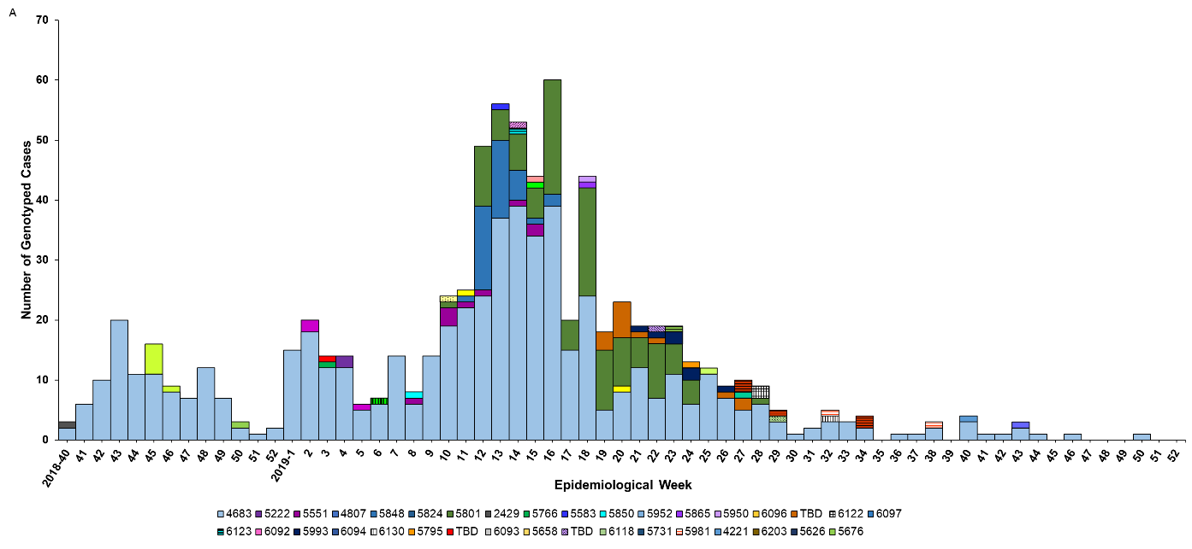

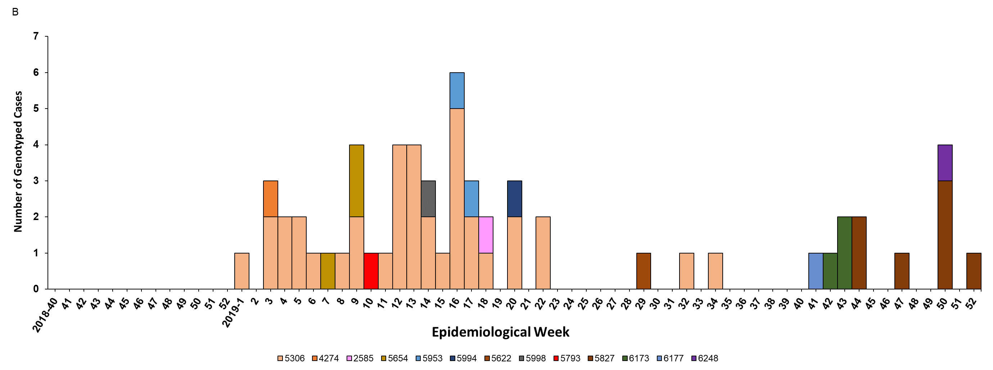

**Number of days between cases in each 2-case cluster and outbreak**

Obtaining accurate data on the length of transmission is challenging due to the possibility of unobserved cases and missed links. To assess surveillance sensitivity, we ascertained the potential for missed cases within 2-case clusters and outbreaks by measuring the number of days between the rash onset of cases in each cluster. Excluding index cases (i.e., cases with the earliest rash onset in each cluster), we calculated the number of days between rash onset of each case (or cohort of cases if more than one case was reported in a day) and the closest preceding case or cohort in the cluster. When the number of days between cases exceeds 21 days, or one maximum incubation period, it indicates the possibility of a missing case in a chain of transmission.

Among 270 measles infection clusters with 2 or more cases, the median number of days between cases in each cluster was 7.5 days (range, 1 to 27 days). The number of days between cases exceeded 21 days in 6 or 2% of clusters, including two 2-case clusters, one 3-5 case outbreak, two 6-24 case outbreaks, and one ≥50 case outbreak.

**Unknown Source Cases**

Because unknown source cases have no known epidemiological link to an international importation, careful evaluation of these events is essential to exclude the possibility of an unrecognized endemic chain of transmission. Unknown source cases could represent secondary cases from un-identified importations or other unreported cases, cases in which the connection to a known case could not be established (e.g., a fleeting exposure), as well as false-positive cases. We analyzed unknown source cases using three separate approaches. First, we evaluated whether single unknown source cases could be linked in time and space to each other, to potentially form an endemic transmission chain. Second, we evaluated whether single unknown source cases could constitute additional cases of an unknown source 2-case cluster or outbreak, or be an unrecognized link between unknown source 2-case clusters or outbreaks, to potentially form an endemic transmission chain. Third, we evaluated whether unknown source 2-case clusters and outbreaks could be linked in time and space to each other, to potentially form an endemic transmission chain. We used state or county and a time between rash onsets of 21or 28 days (i.e., one maximum incubation period and the maximum number of days between cases in infection clusters, respectively) as parameters to link cases. Potential links between unknown source cases, 2-case clusters, and outbreaks were ruled out if distinct genotypes were identified amongst the possible pairs.

A total of 826 unknown source cases (21% of all cases) were reported from 2001 through 2019; annual median number of 19 cases (range, 2–157 cases). Unknown source cases, 2-case clusters, and outbreaks were reported in 43 states and Washington DC, and in 164 or 5% of 3,142 U.S. counties; only 89 counties (<3% of U.S. counties) reported more than 1 unknown source case, 2-case cluster, or outbreak. The geographic distribution and the time span of unknown source cases, 2-case clusters, and outbreaks was inconsistent with endemic measles virus transmission (among potential chains, the maximum size and duration was 148 cases and 3.3 months, respectively) (Supplementary Table 1).

**Supplementary Table 1.** Analyses of unknown source single cases, 2-case clusters, and outbreaks of measles based on time and space,a United States, 2001–2019

|  |  |  |  |  |
| --- | --- | --- | --- | --- |
|  | No. (%) of single unknown source cases that could be linked (N=172) | No. of new potential chains | No. of cases per chain, median (range) | No. of days per chain, median (range) |
| Linking single unknown source cases into chains |  |  |  |  |
| By state and 28 days | 57 (33) | 19 | 2 (2–13) | 14 (0–85) |
| By state and 21 days | 47 (27) | 17 | 2 (2–10) | 9 (0–49) |
| By county and 28 days | 36 (21) | 15 | 2 (2–6) | 14 (5–50) |
| By county and 21 days | 28 (16) | 12 | 2 (2–6) | 9.5 (1–26) |
| Adding single unknown source cases to unknown source 2-case clusters or outbreaks, or linking unknown source 2-case clusters or outbreaks using single unknown source cases |  |  |  |  |
| By state and 28 days | 53 (31) | 14 | 9 (3–148) | 54.5 (15–101) |
| By state and 21 days | 36 (21) | 13 | 10 (3–148) | 47 (15–85) |
| By county and 28 days | 16 (9) | 7 | 8 (5–148) | 58 (23–71) |
| By county and 21 days | 14 (8) | 7 | 7 (5–148) | 46 (23–71) |
| Linking unknown source 2-case clusters or outbreaks |  |  |  |  |
| By state and 28 days | – | 7 | 8 (4–26) | 45 (5–69) |
| By state and 21 days | – | 7 | 8 (4–26) | 45 (5–69) |
| By county and 28 days | – | 1 | 19 (19–19) | 52 (52–52) |
| By county and 21 days | – | 1 | 19 (19–19) | 52 (52–52) |

aUnknown source cases, 2-case clusters, and outbreaks were artificially linked in time and space if there were ≤21 or ≤28 days between the rash onsets of cases, and cases were reported in the same state or county; except for those with genotyping results that were different.

**References**

1. Gastanaduy P, Redd S, Clemmons N, et al. Manual for the Surveillance of Vaccine-Preventable Diseases. Chapter 7: Measles. Available at: https://www.cdc.gov/vaccines/pubs/surv-manual/chpt07-measles.html. Accessed May 6.

2. Gay NJ, De Serres G, Farrington CP, Redd SB, Papania MJ. Assessment of the status of measles elimination from reported outbreaks: United States, 1997-1999. J Infect Dis **2004**; 189 Suppl 1: S36-42.