**SUPPLEMENTARY MATERIAL**

**Effectiveness of 13-valent pneumococcal conjugate vaccine for prevention of invasive pneumococcal disease among children in the United States between 2010 and 2019: an indirect cohort study**

Table of Contents

|  |  |  |
| --- | --- | --- |
| **Figure S1** | Flow diagram of children included in the Late PCV13 Implementation study period ((June 1 2014 – Dec 31 2019) from the Active Bacterial Core Surveillance (ABCs)………………………………… | 2 |
| **Figure S2** | Distribution of VT and NVT cases by PCV13 receipt for the full study period…………………………… | 3 |
| **Table S1** | Inclusion/exclusion of PCV7 recipients in coding of vaccine exposure variable for each analysis | 4 |
| **Table S2** | Serotype distribution among vaccinated and unvaccinated VT-cases by study period ……..……... | 5 |
| **Table S3** | Serotype distribution among vaccinated and unvaccinated NVT-cases by study period ..………… | 6 |
| **Table S4** | Proportion of study participants with no PCV doses by year of study inclusion …….………………… | 7 |

**Figure S1.** Flow diagram of children included in the Late PCV13 Implementation study period (June 1 2014 – Dec 31 2019) from Active Bacterial Core surveillance (ABCs).

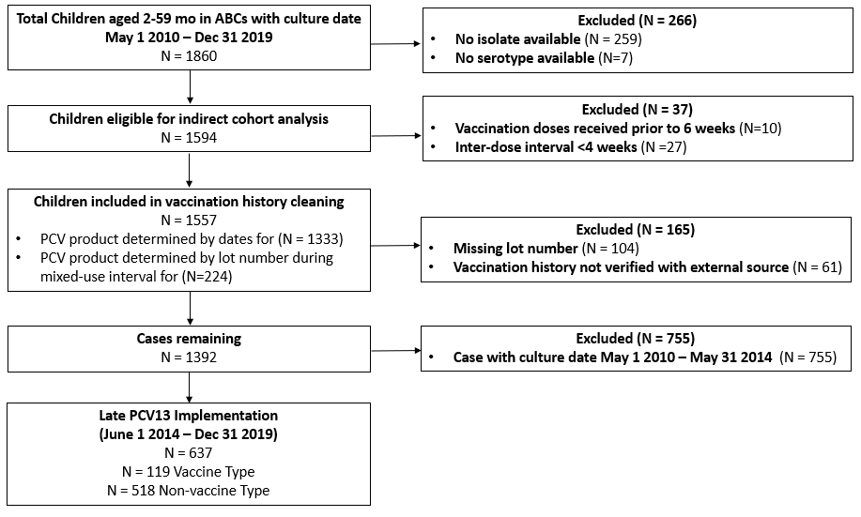

**Figure S2.** Distribution of VT and NVT cases by PCV13 receipt for the full study period. This plots PCV13 status regardless of prior history of PCV7.

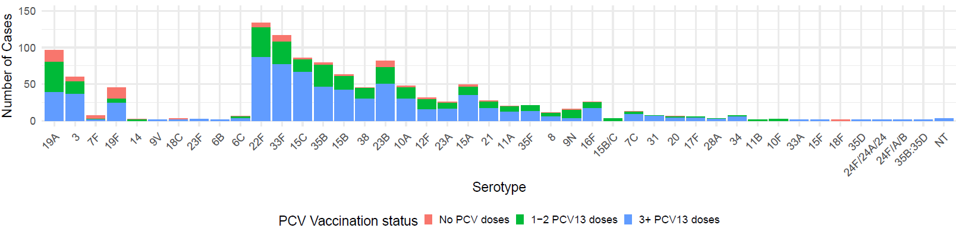

**Table S1.** Inclusion/exclusion of PCV7 recipients in coding of vaccine exposure variable for each analysis

|  |  |  |
| --- | --- | --- |
|  | **Exposed (Vaccinated)** | **Unexposed (Unvaccinated)** |
| Primary analysis | >3 PCV13 doses, regardless of prior PCV7 dose(s) | No doses of any PCV product; excluded participants who received PCV7; all age-eligible to have received 3 doses (12 months or older) |
| Serotype specific analysis | >3 PCV13 doses, regardless of prior PCV7 dose(s) | for VE of serotypes unique to PCV13: no doses of PCV13 (allowed PCV7 recipients in the “unexposed”); all age-eligible to have received 3 doses (12 months or older)  for VE of serotypes included in PCV7: no doses of any PCV products (excluded participants who had received PCV7); all age-eligible to have received 3 doses (12 months or older) |
| Schedule analysis | Number of PCV13 doses ONLY in a given schedule, excludes participants who received any doses of PCV7 | No doses of any PCV product; excluded participants who received PCV7; all age-eligible to have received a given schedule |

**Table S2**. Serotype distribution among vaccinated and unvaccinated VT-cases by study period

|  |  |  |  |  |  |  |
| --- | --- | --- | --- | --- | --- | --- |
| **Serotype** | **>1 dose PCV13** | | | **No doses of PCV** | | |
|  | Early PCV13 implementation | Late PCV13 implementation |  | Early PCV13 implementation | Late PCV13 implementation |  |
|  | N (%) | N (%) | *p* value2 | N (%) | N (%) | *p* value |
|  | N = 861 | N = 90 |  | N = 18 | N = 29 |  |
| 19A | 49 (57.0) | 31 (34.4) | 0.004 | 8 (44.4) | 8 (27.6) | 0.38 |
| 3 | 26 (30.2) | 27 (30.0) | 1 | 2 (11.1) | 5 (17.2) | 0.88 |
| 7F | 2 (2.3) | 0 (0.0) | 0.46 | 5 (27.8) | 0 (0.0) | 0.01 |
| 19F | 3 (3.5) | 27 (30.0) | <0.001 | 1 (5.6) | 14 (48.3) | 0.006 |
| 14 | 1 (1.2) | 0 (0.0) | 0.98 | 1 (5.6) | 0 (0.0) | 0.81 |
| 9V | 1 (1.2) | 0 (0.0) | 0.98 | 0 (0.0) | 0 (0.0) | -- |
| 18C | 0 (0.0) | 1 (1.1) | 0.98 | 0 (0.0) | 2 (6.9) | 0.69 |
| 23F | 1 (1.2) | 1 (1.1) | 1 | 0 (0.0) | 0 (0.0) | -- |
| 4 | 0 (0.0) | 0 (0.0) | -- | 0 (0.0) | 0 (0.0) | -- |
| 6B | 0 (0.0) | 1 (1.1) | 0.98 | 0 (0.0) | 0 (0.0) | -- |
| 6C | 3 (3.5) | 2 (2.2) | 0.96 | 1 (5.6) | 0 (0.0) | 0.81 |

1N = 86 for case-control study because this excludes N = 126 who received only PCV7 during this period   
2*P* values obtained via two-sample z test for equality of proportions (prop.test in R). By default, the Yates continuity correction is applied. Hypothesis tested conducted at a type one error rate of 0.05; statistically significant when *p* < 0.05.

**Table S3**. Serotype distribution among vaccinated and unvaccinated NVT-cases by study period

|  |  |  |  |  |
| --- | --- | --- | --- | --- |
| **Serotype** | **>1 dose PCV13** | | **No doses PCV** | |
|  | Early PCV13 implementation | Late PCV13 implementation | Early PCV13 implementation | Late PCV13 implementation |
|  | N (%) | N (%) | N (%) | N (%) |
|  | N = 399 | N = 486 | N = 21 | N = 32 |
| 22F | 68 (17.0) | 59 (12.1) | 3 (14.3) | 4 (12.5) |
| 33F | 53 (13.3) | 55 (11.3) | 6 (28.6) | 3 (9.4) |
| 15C | 37 (9.3) | 46 (9.5) | 0 (0.0) | 3 (9.4) |
| 15B | 32 (8.0) | 29 (6.0) | 1 (4.8) | 1 (3.1) |
| 35B | 36 (9.0) | 40 (8.2) | 1 (4.8) | 2 (6.2) |
| 38 | 26 (6.5) | 18 (3.7) | 1 (4.8) | 0 (0.0) |
| 23B | 21 (5.3) | 52 (10.7) | 3 (14.3) | 6 (18.8) |
| 10A | 20 (5.0) | 25 (5.1) | 2 (9.5) | 1 (3.1) |
| 12F | 16 (4.0) | 13 (2.7) | 2 (9.5) | 0 (0.0) |
| 15A | 13 (3.3) | 33 (6.8) | 0 (0.0) | 3 (9.4) |
| 23A | 12 (3.0) | 12 (2.5) | 1 (4.8) | 1 (3.1) |
| 21 | 11 (2.8) | 15 (3.1) | 0 (0.0) | 1 (3.1) |
| 11A | 9 (2.3) | 10 (2.1) | 0 (0.0) | 1 (3.1) |
| 35F | 8 (2.0) | 13 (2.7) | 0 (0.0) | 0 (0.0) |
| 8 | 7 (1.8) | 3 (0.6) | 1 (4.8) | 0 (0.0) |
| 9N | 8 (2.0) | 6 (1.2) | 0 (0.0) | 2 (6.2) |
| 15B/C | 3 (0.8) | 0 (0.0) | 0 (0.0) | 0 (0.0) |
| 16F | 5 (1.3) | 20 (4.1) | 0 (0.0) | 1 (3.1) |
| 7C | 3 (0.8) | 9 (1.9) | 0 (0.0) | 1 (3.1) |
| 20 | 2 (0.5) | 3 (0.6) | 0 (0.0) | 1 (3.1) |
| 31 | 3 (0.8) | 4 (0.8) | 0 (0.0) | 0 (0.0) |
| 17F | 1 (0.3) | 4 (0.8) | 0 (0.0) | 0 (0.0) |
| 28A | 2 (0.5) | 1 (0.2) | 0 (0.0) | 0 (0.0) |
| 34 | 1 (0.3) | 6 (1.2) | 0 (0.0) | 0 (0.0) |
| 11B | 1 (0.3) | 0 (0.0) | 0 (0.0) | 0 (0.0) |
| 10F | 0 (0.0) | 2 (0.4) | 0 (0.0) | 0 (0.0) |
| 33A | 0 (0.0) | 1 (0.2) | 0 (0.0) | 0 (0.0) |
| 15F | 0 (0.0) | 1 (0.2) | 0 (0.0) | 0 (0.0) |
| 18F | 0 (0.0) | 0 (0.0) | 0 (0.0) | 1 (3.1) |
| 35D | 0 (0.0) | 1 (0.2) | 0 (0.0) | 0 (0.0) |
| 24F/24A/24 | 0 (0.0) | 1 (0.2) | 0 (0.0) | 0 (0.0) |
| 24F/A/B | 0 (0.0) | 1 (0.2) | 0 (0.0) | 0 (0.0) |
| 35B:35D | 0 (0.0) | 1 (0.2) | 0 (0.0) | 0 (0.0) |
| NT | 1 (0.3) | 2 (0.4) | 0 (0.0) | 0 (0.0) |

**Table S4.** Proportion of participants with no PCV doses by year of study inclusion

|  |  |  |  |  |  |  |  |  |  |  |
| --- | --- | --- | --- | --- | --- | --- | --- | --- | --- | --- |
|  | **2010** | **2011** | **2012** | **2013** | **2014** | **2015** | **2016** | **2017** | **2018** | **2019** |
| Proportion with no PCV doses | 6.4 | 6.3 | 5.6 | 3.1 | 6.3 | 8.7 | 12.7 | 10.8 | 8.1 | 8.9 |
| Proportion with >1 dose of PCV7 or PCV13 | 93.6 | 93.7 | 94.4 | 96.9 | 93.6 | 91.3 | 87.3 | 89.2 | 91.8 | 91.1 |