The Medications for Opioid Use Disorder Study: Methods and Initial Outcomes from an 18-Month Study of Patients in Treatment for Opioid Use Disorder

eFigure1. Geographic Distribution of 62 MOUD Study Facilities
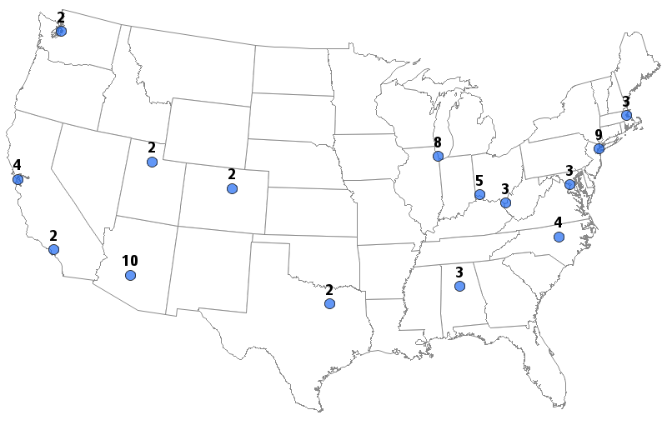 | Location | Enrolled Facilities
 | Birmingham, AL | 3
 | Phoenix, AZ | 10
 | San Francisco / Los Angeles, CA | 6
 | Denver, CO | 2
 | District of Columbia (region) | 3
 | Chicago, IL | 8
 | Boston, MA | 3
 | New York, NY | 9
 | Raleigh / Durham, NC | 4
 | Cincinnati, OH | 5
 | Dallas, TX | 2
 | Salt Lake City, UT | 2
 | Seattle, WA | 2
 | Huntington, WV | 3

eTable 1. Timeline for the MOUD Study Activities, August 2017 through May 2021
 | 2017 |  | 2018 |  |  |  | 2019 |  |  |  | 2020 |  |  |  | 2021
Project Activity | Q3 | Q4 | Q1 | Q2 | Q3 | Q4 | Q1 | Q2 | Q3 | Q4 | Q1 | Q2 | Q3 | Q4 | Q1 | Q2
Recruit study treatment facilities ª | ● | ● | ● | ● | ● | ● | ● | ● | ●
Treatment facility baseline questionnaire |  |  | ● | ● | ● | ● | ● | ● | ●
Treatment facility 18-mo questionnaire |  |  |  |  |  |  |  |  | ● | ● | ● | ● | ● | ● | ● | ●
Patient screening, baseline questionnaire ^{b} |  |  | ● | ● | ● | ● | ● | ● | ● | ●
Patient health forms |  |  | ● | ● | ● | ● | ● | ● | ● | ● | ● | ● | ● | ●
Patient 3-month questionnaire |  |  |  | ● | ● | ● | ● | ● | ● | ● | ●
Patient 6-month questionnaire |  |  |  |  | ● | ● | ● | ● | ● | ● | ● | ●
Patient 12-month questionnaire |  |  |  |  |  |  | ● | ● | ● | ● | ● | ● | ● | ●
Patient 18-month questionnaire |  |  |  |  |  |  |  |  | ● | ● | ● | ● | ● | ● | ● | ●
Patient electronic health records |  |  |  |  |  |  |  |  |  |  |  |  | ● | ● | ● | ●
Patient focus groups ^{c} |  |  |  |  |  | ● | ● | ● | ● | ● | ● | ● | ● | ● | ●
Provider focus groups / interviews ^{d} |  |  |  |  |  | ● | ● | ● | ● | ● | ● | ● | ● | ● | ● | ●
MOUD = Medications for OUD; Q = quarter within calendar year
ª Facility recruitment occurred on a rolling basis from August 2017 to June 2019.
^{b} Patient recruitment, eligibility screening, and study enrollment from the participating treatment facilities occurred on a rolling basis from March 2018 to December 2019.
^{c} One-hour focus groups were held by telephone with selected study patients between October 2018 and January 2021.
^{1d} Provider focus groups and one-on-one interviews were conducted periodically from December 2018 through May 2021.

eFigure 2. MOUD Study Recruitment and Data Collection Protocol
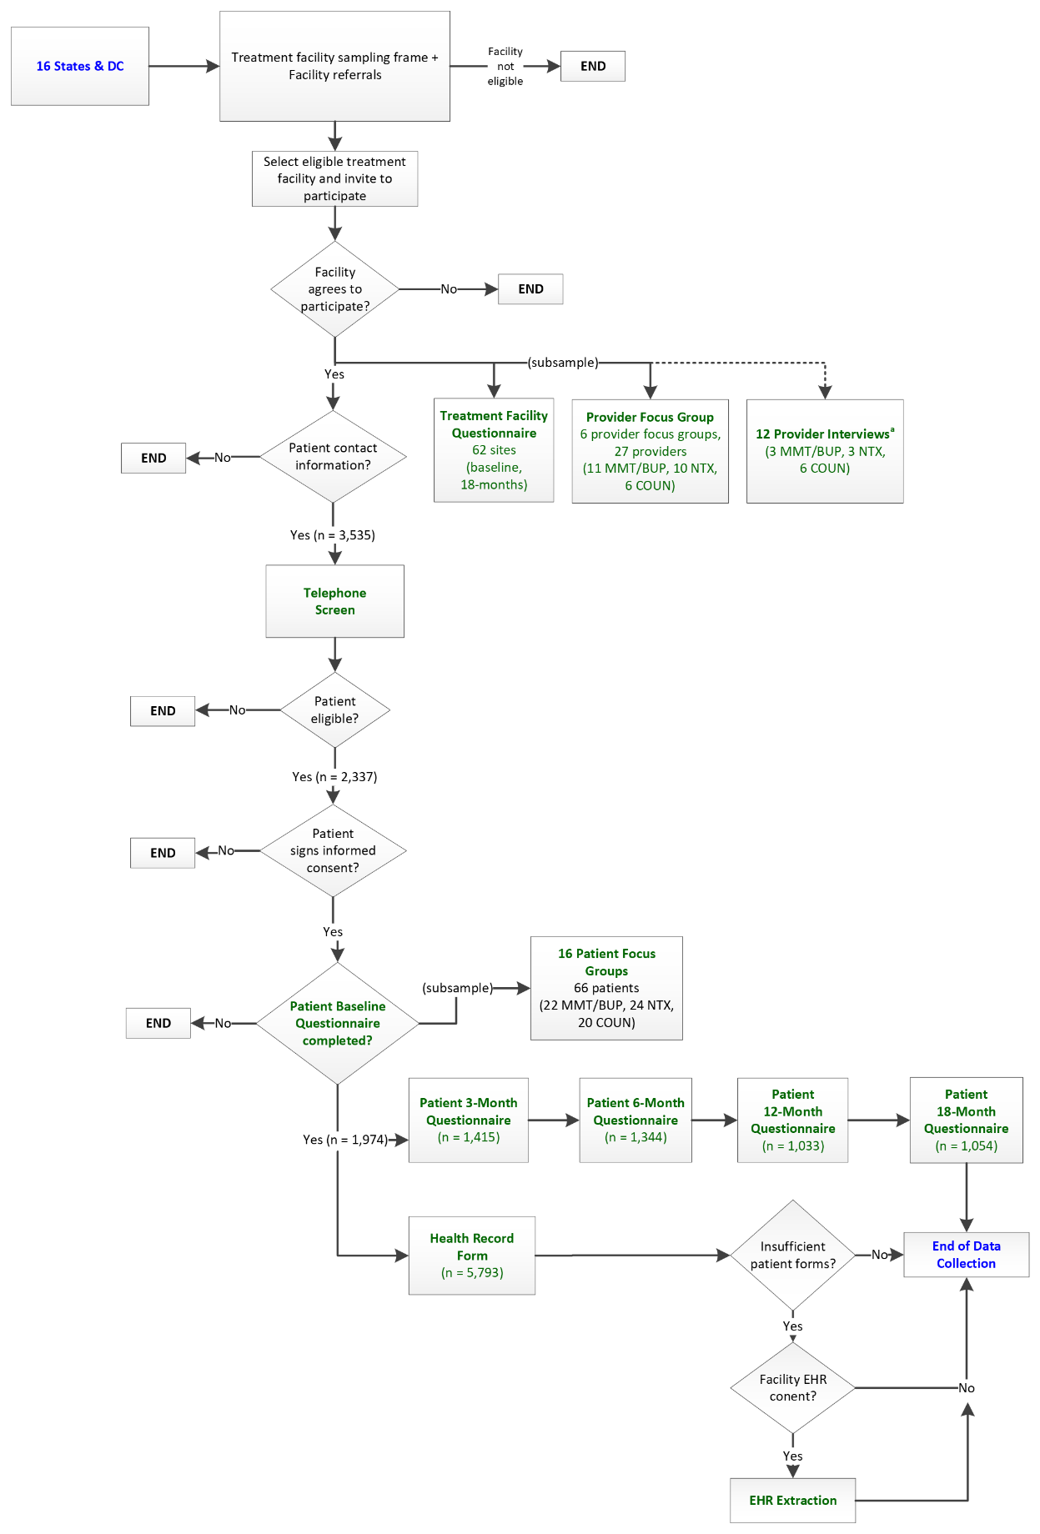
MMT = methadone maintenance; BUP = buprenorphine; NTX = naltrexone; COUN = counseling without medication for opioid use disorder treatment; EHR = electronic health record
eTable2. Summary of the MOUD Study Data Collection Protocol Conducted over 18 Months, March 2018 through May 2021
Person Providing Study Data | Type of Data Collection Activity | Time point | Incentiveª | Construct  Category | Construct Descriptions
Treatment Facility Director^{b} | Self-administered Questionnaire | Baseline (study enrollment) | $150 | Facility | Primary focus, for-profit status, accreditation, accepted insurance, revenue sources
 |  |  |  | Staff | Count by type, experience, training
 |  |  |  | Evaluations | Urine drug screen, trauma, chronic pain
 |  |  |  | Treatment | OUD treatment, inpatient and outpatient treatment options, restrictions by type of treatment, on-site counseling (e.g., cognitive behavioral therapy), tapering procedures, trauma-focused interventions
 |  |  |  | Patients | Number treated in past 12 months, average distance patients travel to facility, readmission count
Treatment Facility Director^{b} | Self-administered Questionnaire | 18-months post-baseline | $150 | Facility | Staff turnover
 |  |  |  | Patients | Protocols for patients who relapse  (see facility baseline questionnaire for additional items)
Patient receiving OUD treatment^{c,d} | Eligibility Phone Screener | After patient contact information provided | - |  | Language (English / Spanish), age, current (index) treatment at study facility, sex, ethnicity, racial group, ZIP code of current residence,
Patient receiving OUD treatment^{c,d} | Self-administered Questionnaire | Baseline (study enrollment) | $30 | Treatment | Status of treatment at study facility, treatment type and start/end dates, reasons for initiating / ending treatment, treatment services (e.g., counseling, medical exam / tests, peer navigator, medically supervised withdrawal), history of OUD treatments, frequency of visits, (take-home) dosage, adverse side effects, cost, assistance in choosing treatment options, self-help group / alternative treatment
 |  |  |  | Opioid Usage | Type of opioids (prescription opioids, heroin, fentanyl) used, History before / after treatment, quit attempts
 |  |  |  | Health /  Healthcare | Hospital / emergency room visits, primary care, co-morbidities, pregnancy status / history, mental health, nonfatal overdose, opinion of health
 |  |  |  | Socio-demographics | Employment, health insurance, living situation, marital status, military service, mode of transportation, Arrest / incarceration history
 |  |  |  | Mental / Emotional | diagnoses / treatment, trauma, adverse childhood experiences, quality of life, social support, stigma
Patient receiving OUD treatment^{c,d} | Self-administered Questionnaire | 3-months post-baseline | $20 | Treatment | Status of treatment at study facility, treatment type and start/end dates, reasons for initiating (new) / ending treatment, treatment services (counseling, medical exam / tests, peer navigator, medically supervised withdrawal), history of OUD treatments, self-help group, alternative treatments to MOUD (e.g., acupuncture, hypnosis)
 |  |  |  | Opioid Usage | Type of opioids (prescription opioid, heroin, fentanyl) used, history after treatment end
 |  |  |  | Health / Healthcare | Hospital / emergency room visits, primary care, pregnancy status, nonfatal overdose, opinion of health
Patient receiving OUD treatment^{c,d} | Self-administered Questionnaire | 6-months post-baseline | $20 |  | (see patient 3-month questionnaire for additional items)
Patient receiving OUD treatment^{c,d} | Self-administered Questionnaire | 12-months post-baseline | $30 |  | (see patient baseline questionnaire for additional items)
Patient receiving OUD treatment^{c,d} | Self-administered Questionnaire | 18-months post-baseline | $30 |  | (see patient baseline questionnaire for additional items)
Patient receiving OUD treatment^{c,d} | Patient focus group^{e} | 3 groups conducted annually | $40 |  | Reasons to enter treatment for opioid addiction, access to and options for treatment, reasons for choosing index treatment, barriers and facilitators to OUD treatment, experience with treatment providers / facility
Treatment Provider | Patient Health Form | Months 1, 2, 3, 6, 9, and 12 post-baseline, while receiving their index treatment | $20 |  | Treatment type, history of MOUD dosage, frequency of counseling sessions, opinion of treatment adherence, dates / results for urine drug screens, known health diagnoses, other prescribed medications
Treatment Provider | Patient Electronic Health Record | End of 12-month index treatment period for all study patients within the facility | $2000 (max) |  | Treatment type, history of MOUD dosage, dates / results for urine drug screens
Treatment Provider | Provider focus group^{e} | 3 groups (MMT/BUP, NTX, COUN) conducted mid-study | $75 |  | Current environment / organizational structure where OUD treatment is administered, background / training in OUD treatment specialty, barriers and facilitators to treating patients with OUD, opinions of treatment effectiveness for OUD
Treatment Provider | Provider one-on-one interview | Final data collection year | $75 |  | (see treatment provider focus group session for additional items)
OUD = Opioid Use Disorder; MOUD = Medications for OUD
ª Incentives for the treatment facility director questionnaires, patient health forms, and patient electronic health records were distributed to the treatment facility upon completion. Incentives for patient questionnaires and focus group / one-on-one interviews were sent to the individual participants.
^{b} 62 treatment facilities participated in the study. 61 facility directors (98.4%) responded to the baseline questionnaire; 37 facility directors (59.7%) responded to the 18-month questionnaire. Many questions were selected from the National Survey of Substance Abuse Treatment Services¹ and the National Treatment Center Study,² additional questions were devised to gather information specific to the MOUD Study.
^{c} 1,974 patients completed the baseline questionnaire and enrolled in the study. 1415 (71.7%) study patients completed the 3-month questionnaire, 1344 (68.1%) completed the 6-month questionnaire, 1033 (52.3%) completed the 12-month questionnaire, and 1054 (53.4%) completed the 18-month questionnaire. Across the patient questionnaires. Patient completion rates by treatment are shown in Table S2. Questions were chosen from existing sources such as the 2015 National Survey on Drug Use and Health,³ CDC’s Healthy Days measures found in the Behavioral Risk Factor Surveillance System,⁴ EQ-5D (https://euroqol.org/eq-5d-instruments/), the Multi-Dimensional Scale of Perceived Social Support,⁵ and the Substance Abuse Self-Stigma Scale item pool.⁶
^{d} OUD (opioid use disorder) treatments under study included methadone (MMT); buprenorphine (BUP), oral or injectable/implant; naltrexone (NTX), oral or injectable; and counseling without MOUD (COUN). Index treatment refers to the OUD treatment administered when study eligibility screening occurred.
^{e} Focus group participants were grouped into 3 sessions based on index treatment (patient) or administration (provider): methadone or buprenorphine (combined), naltrexone, and counseling without MOUD.

References
1. Substance Abuse and Mental Health Services Administration (SAMHSA), Center for Behavioral Health Statistics and Quality. Behavioral health services information series: National directory of drug and alcohol abuse treatment facilities 2015, HHS Publication No. (SMA) 16-4940. https://www.samhsa.gov/data/sites/default/files/2015_National_%20Directory_of_Drug_and_Alcohol_Abuse_Treatment_Centers_v1.pdf. Published 2015.
2. Roman PM, Johnson JA. Adoption and implementation of new technologies in substance abuse treatment. J Subst Abuse Treat. 2002;22:211-218. http://dx.doi.org/10.1016/s0740-5472(02)00241-6
3. Center for Behavioral Health Statistics and Quality. 2016 National Survey on Drug Use and Health (NSDUH): CAI Specifications for Programming (English Version). https://www.samhsa.gov/data/sites/default/files/NSDUHmrbCAIquex2016v2.pdf. Published 2015.
4. Centers for Disease Control and Prevention. Behavioral risk factor surveillance survey questionnaire. https://www.cdc.gov/brfss/questionnaires/index.htm. Published 2015.
5. Zimet G, Dahlem N, Zimet F. Multidimensional scale of perceived social support. http://www.yorku.ca/rokada/psyctest/socsupp.pdf. Published 1988.
6. Luoma JB, Nobles RH, Drake CE, Hayes SC, O'Hair A, Fletcher L, Kohlenberg BS. Self-stigma in substance abuse: Development of a new measure. J Psychopathol Behav Assess. 2013;35:223-234. http://dx.doi.org/10.1007/s10862-012-9323-4

