**Supplemental Table 1. Move-in and move-out rates among the general population and persons with diagnosed HIV, by area, 2019 -- United States**

|  |  |  |  |  |  |  |  |  |  |  |
| --- | --- | --- | --- | --- | --- | --- | --- | --- | --- | --- |
|  | **Move-in** | | | | | **Move-out** | | | | |
|  | **General Population** | | **Persons with diagnosed HIVa** | | | **General Population** | | | **Persons with diagnosed HIVa** | |
| **Jurisdiction** | **Percentage (%)** | **95% C.I.** | **Percentage (%)** | **Rate Ratio** | **Percentage (%)** | | **95% C.I.** | **Percentage (%)** | | **Rate Ratio** |
| Alabama | 2.17 | 1.96-2.37 | 3.64 | 1.68 | 2.04 | | 1.83-2.26 | 3.53 | | 1.73 |
| Alaska | 4.74 | 4.01-5.48 | 7.55 | 1.59 | 6.83 | | 5.68-7.98 | 7.02 | | 1.03 |
| Arizona | 3.54 | 3.33-3.75 | 4.86 | 1.37 | 2.45 | | 2.28-2.63 | 3.45 | | 1.41 |
| Arkansas | 2.00 | 1.74-2.26 | 3.84 | 1.91 | 2.16 | | 1.85-2.47 | 3.33 | | 1.54 |
| California | 1.24 | 1.18-1.30 | 1.81 | 1.46 | 1.68 | | 1.60-1.75 | 1.98 | | 1.18 |
| Colorado | 4.24 | 3.94-4.54 | 4.18 | 0.98 | 3.52 | | 3.23-3.82 | 3.95 | | 1.12 |
| Connecticut | 2.57 | 2.30-2.84 | 3.53 | 1.37 | 2.99 | | 2.72-3.26 | 2.59 | | 0.86 |
| Delaware | 3.96 | 3.26-4.65 | 5.89 | 1.49 | 2.98 | | 2.36-3.6 | 4.21 | | 1.41 |
| District of Columbia | 8.56 | 7.59-9.53 | 4.53 | 0.53 | 7.65 | | 6.75-8.55 | 5.28 | | 0.69 |
| Florida | 2.86 | 2.71-3.00 | 2.59 | 0.91 | 2.19 | | 2.08-2.29 | 2.65 | | 1.21 |
| Georgia | 2.72 | 2.52-2.93 | 3.71 | 1.36 | 2.43 | | 2.26-2.61 | 3.53 | | 1.45 |
| Hawaii | 3.60 | 3.13-4.06 | 6.66 | 1.85 | 4.88 | | 4.18-5.58 | 7.02 | | 1.44 |
| Idaho | 4.48 | 3.89-5.07 | 7.19 | 1.61 | 3.16 | | 2.73-3.59 | 4.51 | | 1.43 |
| Illinois | 1.53 | 1.44-1.62 | 2.63 | 1.72 | 2.45 | | 2.29-2.60 | 4.66 | | 1.91 |
| Indiana | 2.28 | 2.09-2.47 | 4.58 | 2.00 | 2.15 | | 1.95-2.35 | 5.71 | | 2.65 |
| Iowa | 2.34 | 2.09-2.59 | 7.31 | 3.13 | 2.4 | | 2.13-2.67 | 5.32 | | 2.21 |
| Kansas | 3.30 | 2.97-3.63 | 6.58 | 1.99 | 3.11 | | 2.81-3.41 | 7.01 | | 2.25 |
| Kentucky | 2.27 | 1.99-2.55 | 5.23 | 2.30 | 2.29 | | 2.10-2.48 | 4.43 | | 1.93 |
| Louisiana | 1.48 | 1.28-1.67 | 3.08 | 2.08 | 2.08 | | 1.84-2.33 | 3.15 | | 1.51 |
| Maine | 2.72 | 2.42-3.03 | 6.57 | 2.41 | 2.88 | | 2.43-3.33 | 4.40 | | 1.53 |
| Maryland | 2.39 | 2.21-2.57 | 3.04 | 1.27 | 3.07 | | 2.81-3.32 | 3.48 | | 1.14 |
| Massachusetts | 2.13 | 1.99-2.27 | 2.46 | 1.15 | 2.62 | | 2.44-2.80 | 2.42 | | 0.92 |
| Michigan | 1.34 | 1.24-1.44 | 3.94 | 2.94 | 1.54 | | 1.44-1.65 | 2.88 | | 1.86 |
| Minnesota | 1.93 | 1.77-2.08 | 3.96 | 2.06 | 2.06 | | 1.89-2.23 | 3.20 | | 1.55 |
| Mississippi | 2.10 | 1.85-2.35 | 3.65 | 1.74 | 2.05 | | 1.74-2.36 | 4.01 | | 1.96 |
| Missouri | 2.52 | 2.37-2.67 | 4.01 | 1.59 | 2.25 | | 2.02-2.48 | 4.22 | | 1.87 |
| Montana | 3.88 | 3.37-4.39 | 7.50 | 1.93 | 3.73 | | 3.18-4.29 | 6.62 | | 1.77 |
| Nebraska | 2.42 | 2.07-2.77 | 5.37 | 2.22 | 2.75 | | 2.27-3.23 | 4.62 | | 1.68 |
| Nevada | 4.39 | 4.01-4.77 | 7.12 | 1.62 | 3.51 | | 3.13-3.89 | 5.81 | | 1.66 |
| New Hampshire | 3.74 | 3.28-4.21 | 7.34 | 1.96 | 3.16 | | 2.73-3.58 | 4.59 | | 1.45 |
| New Jersey | 1.71 | 1.58-1.84 | 2.47 | 1.45 | 2.61 | | 2.44-2.77 | 2.69 | | 1.03 |
| New Mexico | 2.69 | 2.24-3.15 | 5.23 | 1.94 | 3.43 | | 2.88-3.98 | 4.06 | | 1.18 |
| New York | 1.33 | 1.26-1.41 | 2.08 | 1.56 | 2.28 | | 2.18-2.38 | 2.56 | | 1.12 |
| North Carolina | 3.05 | 2.86-3.25 | 4.31 | 1.41 | 2.49 | | 2.34-2.64 | 3.24 | | 1.3 |
| North Dakota | 4.91 | 3.96-5.86 | 8.89 | 1.81 | 4.04 | | 3.29-4.79 | 7.49 | | 1.85 |
| Ohio | 1.79 | 1.67-1.90 | 3.49 | 1.96 | 1.67 | | 1.55-1.80 | 2.82 | | 1.68 |
| Oklahoma | 2.62 | 2.36-2.87 | 3.68 | 1.41 | 2.21 | | 1.95-2.46 | 3.73 | | 1.69 |
| Oregon | 3.12 | 2.88-3.36 | 6.31 | 2.02 | 2.79 | | 2.53-3.06 | 4.44 | | 1.59 |
| Pennsylvania | 2.12 | 1.99-2.25 | 3.10 | 1.46 | 2.04 | | 1.92-2.16 | 2.81 | | 1.38 |
| Rhode Island | 3.34 | 2.86-3.83 | 4.59 | 1.37 | 2.99 | | 2.43-3.55 | 3.59 | | 1.2 |
| South Carolina | 3.47 | 3.17-3.78 | 4.21 | 1.21 | 2.57 | | 2.33-2.81 | 3.53 | | 1.37 |
| South Dakota | 3.10 | 2.59-3.61 | 9.11 | 2.93 | 3.17 | | 2.64-3.70 | 7.48 | | 2.36 |
| Tennessee | 2.92 | 2.69-3.15 | 2.64 | 0.90 | 2.34 | | 2.13-2.55 | 2.51 | | 1.07 |
| Texas | 1.97 | 1.87-2.07 | 2.59 | 1.31 | 1.6 | | 1.52-1.68 | 2.04 | | 1.28 |
| Utah | 3.04 | 2.69-3.39 | 6.31 | 2.08 | 2.82 | | 2.53-3.11 | 4.67 | | 1.66 |
| Vermont | 3.44 | 2.95-3.94 | 6.14 | 1.78 | 3.68 | | 2.92-4.44 | 5.08 | | 1.38 |
| Virginia | 3.16 | 2.99-3.34 | 4.73 | 1.50 | 3.3 | | 3.09-3.51 | 3.85 | | 1.17 |
| Washington | 3.11 | 2.86-3.35 | 4.71 | 1.52 | 2.69 | | 2.50-2.88 | 3.69 | | 1.37 |
| West Virginia | 2.24 | 1.91-2.56 | 5.68 | 2.54 | 2.29 | | 1.93-2.65 | 5.73 | | 2.5 |
| Wisconsin | 1.88 | 1.73-2.03 | 4.84 | 2.57 | 1.77 | | 1.61-1.93 | 3.71 | | 2.09 |
| Wyoming | 5.29 | 4.33-6.25 | 6.85 | 1.29 | 4.12 | | 3.14-5.11 | 9.80 | | 2.38 |
| **Region** |  |  |  |  |  | |  |  | |  |
| Northeast | 1.90 | 1.85-1.96 | 2.50 | 1.31 | 2.43 | | 2.37-2.49 | 2.65 | | 1.09 |
| Midwest | 1.97 | 1.92-2.02 | 3.81 | 1.94 | 2.11 | | 2.05-2.17 | 4.09 | | 1.94 |
| South | 2.57 | 2.52-2.62 | 3.28 | 1.28 | 2.27 | | 2.22-2.31 | 3.05 | | 1.34 |
| West | 2.41 | 2.35-2.47 | 3.10 | 1.29 | 2.39 | | 2.33-2.45 | 2.82 | | 1.18 |
| **United States** | **2.29** | **2.27-2.32** | **3.13** | **1.37** | **2.29** | | **2.27-2.32** | **3.04** | | **1.32** |

Abbreviations: CI, confidence interval.

Note. The overall rates for the general population are calculated for persons residing in the United States the entire year resulting in equal move-in and move-out rates. The overall rates for persons with diagnosed HIV include some persons that resided outside the U.S. during the year resulting in move-in and move-out rates that are not equal.

aData are based on residence at year-end 2018 using NHSS data.

**Supplemental Table 2. Move-in and move-out rates among persons with diagnosed HIV by selected characteristics, 2011-2019 -- United Statesa**

|  |  |  |  |  |  |  |  |  |  |
| --- | --- | --- | --- | --- | --- | --- | --- | --- | --- |
|  | **2011** | **2012** | **2013** | **2014** | **2015** | **2016** | **2017** | **2018** | **2019** |
|  | **Move-in Rates (%)** | | | | | | | | |
| **Total** | **3.10** | **3.43** | **3.51** | **3.92** | **3.65** | **3.98** | **3.47** | **3.42** | **3.13** |
| **Sex assigned at birth** |  |  |  |  |  |  |  |  |  |
| Male | 3.36 | 3.73 | 3.80 | 4.25 | 3.97 | 4.32 | 3.77 | 3.73 | 3.40 |
| Female | 2.32 | 2.55 | 2.60 | 2.88 | 2.65 | 2.91 | 2.50 | 2.41 | 2.24 |
| **Race/ethnicity** |  |  |  |  |  |  |  |  |  |
| Black/African American | 2.64 | 2.90 | 3.14 | 3.47 | 3.19 | 3.52 | 3.09 | 3.16 | 2.93 |
| Hispanic/Latinob | 2.77 | 3.12 | 3.11 | 3.49 | 3.24 | 3.57 | 3.25 | 3.17 | 2.89 |
| White | 3.35 | 3.80 | 3.66 | 4.14 | 3.93 | 4.31 | 3.60 | 3.49 | 3.12 |
| Otherc | 5.72 | 6.00 | 6.28 | 7.00 | 6.45 | 6.72 | 5.91 | 5.51 | 5.25 |
| **Age at year-end 2018 (yr)** |  |  |  |  |  |  |  |  |  |
| ≤24 | 4.55 | 4.88 | 5.41 | 5.80 | 5.66 | 6.26 | 5.92 | 5.99 | 5.58 |
| 25-44 | 3.91 | 4.34 | 4.56 | 5.13 | 4.92 | 5.45 | 4.95 | 4.97 | 4.67 |
| ≥45 | 2.36 | 2.68 | 2.66 | 3.02 | 2.74 | 2.99 | 2.49 | 2.41 | 2.15 |
| **Transmission categoryd** |  |  |  |  |  |  |  |  |  |
| Male-to-male sexual contact  and male-to-male sexual contact and injection drug usee | 3.76 | 4.16 | 4.27 | 4.74 | 4.41 | 4.78 | 4.19 | 4.12 | 3.74 |
| Injection drug usef | 2.37 | 2.60 | 2.45 | 2.88 | 2.58 | 2.87 | 2.34 | 2.24 | 2.18 |
| Heterosexual contactg | 2.10 | 2.31 | 2.38 | 2.62 | 2.43 | 2.65 | 2.29 | 2.27 | 2.09 |
| Otherh | 2.66 | 3.17 | 3.30 | 3.59 | 3.57 | 4.20 | 3.59 | 3.59 | 3.25 |
|  | **Move-out Rates (%)** | | | | | | | | |
| **Total** | **3.05** | **3.38** | **3.47** | **3.87** | **3.59** | **3.90** | **3.35** | **3.31** | **3.04** |
| **Sex assigned at birth** |  |  |  |  |  |  |  |  |  |
| Male | 3.32 | 3.69 | 3.78 | 4.22 | 3.92 | 4.26 | 3.68 | 3.64 | 3.32 |
| Female | 2.25 | 2.47 | 2.54 | 2.78 | 2.55 | 2.77 | 2.31 | 2.25 | 2.10 |
| **Race/ethnicity** |  |  |  |  |  |  |  |  |  |
| Black/African American | 2.62 | 2.87 | 3.12 | 3.43 | 3.14 | 3.44 | 3.00 | 3.08 | 2.85 |
| Hispanic/Latinob | 2.63 | 2.96 | 3.03 | 3.37 | 3.11 | 3.39 | 2.98 | 2.93 | 2.69 |
| White | 3.34 | 3.79 | 3.65 | 4.13 | 3.93 | 4.29 | 3.57 | 3.46 | 3.09 |
| Otherc | 5.67 | 5.94 | 6.21 | 6.94 | 6.35 | 6.61 | 5.76 | 5.40 | 5.11 |
| **Age at year-end 2018 (yr)** |  |  |  |  |  |  |  |  |  |
| ≤24 | 4.43 | 4.75 | 5.28 | 5.57 | 5.43 | 5.96 | 5.59 | 5.64 | 5.23 |
| 25-44 | 3.85 | 4.27 | 4.49 | 5.04 | 4.82 | 5.31 | 4.75 | 4.79 | 4.48 |
| ≥45 | 2.33 | 2.65 | 2.66 | 3.01 | 2.73 | 2.96 | 2.43 | 2.36 | 2.12 |
| **Transmission categoryd** |  |  |  |  |  |  |  |  |  |
| Male-to-male sexual contact  and male-to-male sexual contact and injection drug usee | 3.74 | 4.13 | 4.26 | 4.71 | 4.37 | 4.73 | 4.11 | 4.05 | 3.66 |
| Injection drug usef | 2.29 | 2.53 | 2.40 | 2.82 | 2.55 | 2.79 | 2.22 | 2.14 | 2.11 |
| Heterosexual contactg | 2.04 | 2.24 | 2.32 | 2.54 | 2.35 | 2.52 | 2.13 | 2.12 | 1.96 |
| Otherh | 2.44 | 2.96 | 3.07 | 3.27 | 3.27 | 3.83 | 3.12 | 3.11 | 2.91 |

aHispanic/Latino persons can be of any race. Other includes American Indian/Alaska Native, Asian, Native Hawaiian or other Pacific Islander, or multiracial persons.

bTransmission category is classified based on a hierarchy of the risk factors most likely responsible for HIV transmission; classification is determined based on the person’s sex assigned at birth. Data have been statistically adjusted to account for missing transmission category.

cIncludes persons with diagnosed HIV attributed to male-to-male sexual contact and injection drug use.

dSexual contact with a person known to have, or with a risk factor for, HIV infection.

eOther risk factors, including perinatal, hemophilia, and blood transfusion.

a Data source: National HIV Surveillance System.

b Hispanic or Latino can be of any race.

c “Other” includes American Indian or Alaska Native, Asian, Native Hawaiian or other Pacific Islander, or multiracial persons.

d Transmission category is classified based on a hierarchy of the risk factors most likely responsible for HIV transmission; classification is determined based on the person’s assigned sex at birth. Data have been statistically adjusted to account for missing transmission category.

e Categories were combined because of small cell sizes for the male-to-male sexual contact and injection drug use transmission category.

f Includes persons who injected nonprescription drugs or who injected prescription drugs for nonmedical purposes. Also includes injection of drugs prescribed to persons if there is evidence that injection equipment was shared (e.g., syringes, needles, cookers).

g Heterosexual contact with a person known to have, or with a risk factor for, HIV infection.

h Other risk factors, including hemophilia, blood transfusion, and risk factor not reported or not identified.

**Supplemental Figure 1. Correlation of HIV incidence rate and HIV prevalence rate, by state, 2019.**

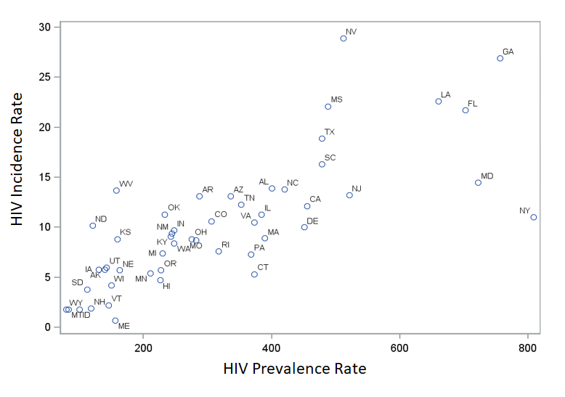

**Supplemental Figure 2. Correlation of HIV incidence rate and move-in rate of persons with diagnosed HIV, by state, 2019.**

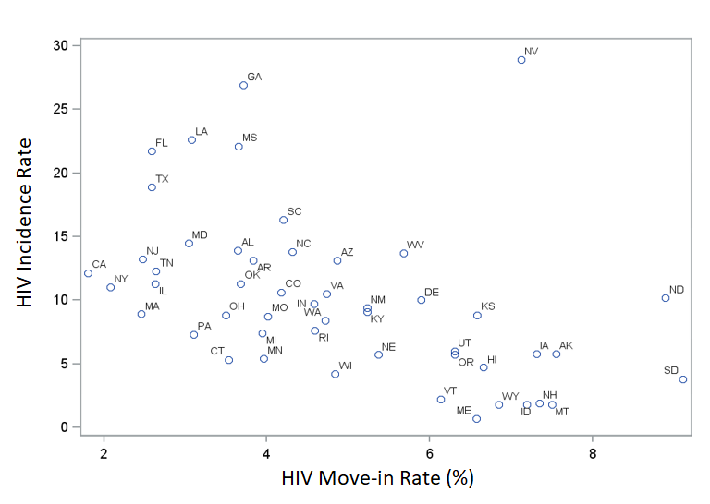

**Supplemental Figure 3. Correlation of HIV prevalence rate and move-in rate of persons with diagnosed HIV, by state, 2019.**

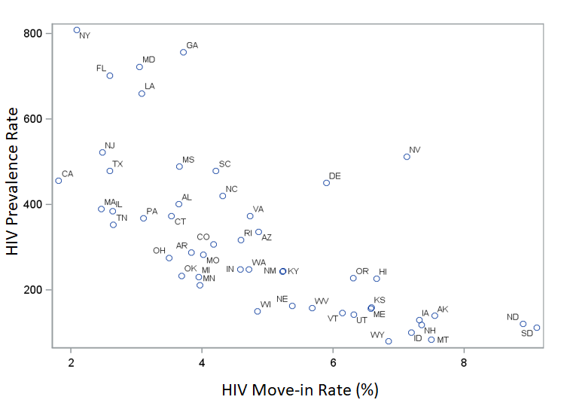

**Supplemental Figure 4. Correlation of move-in rate among persons with diagnosed HIV and population density, by state, 2019.**

