Supplementary Materials
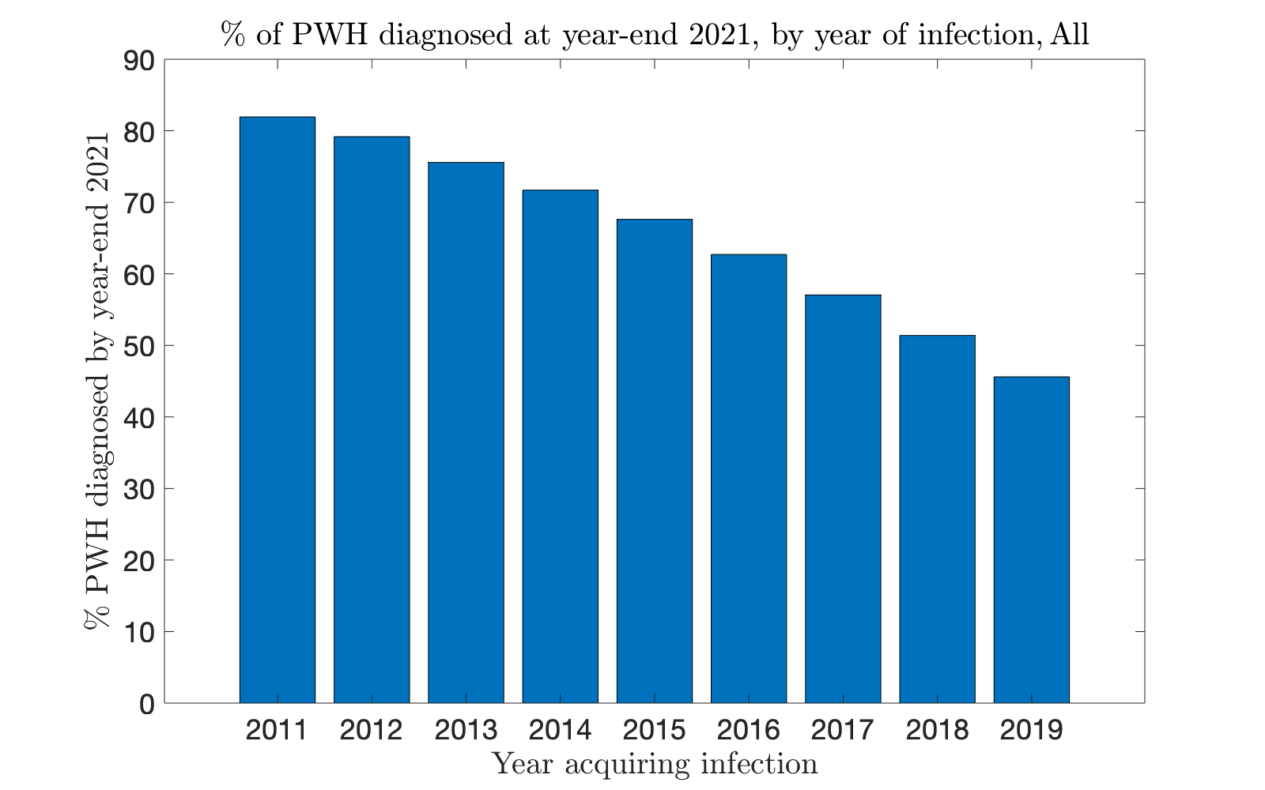
Figure A1: Estimated % of population aware of status at year-end 2021, based on year acquiring infection.

Validation analyses: 2019

We report two metrics, % error (total) and % error (year-by-year). Denoting as $D_{i}^{proj}, D_{i}^{obs}$ the number of projected and observed diagnoses in year $i$ , respectively, these are defined as:

$$\%Error \left(total\right)=\frac{|\sum_{i=2011}^{2017}{\left(D_{i}^{proj}-D_{i}^{obs}\right)|}}{\sum_{i=2011}^{2017}{D_{i}^{obs}}}, \\ \%Error \left(year-by-year\right)=\frac{\sqrt{\sum_{i=2011}^{2017}{{\left(D_{i}^{proj}-D_{i}^{obs}\right)}^{2}}}}{\sqrt{\sum_{i=2011}^{2017}{{\left(D_{i}^{obs}\right)}^{2}}}}.$$

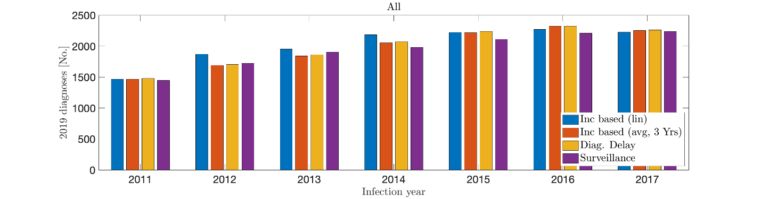
Method | Total diagnoses | % error (total) | % error (year by year)
Surveillance | 13605 | NA | NA
Diag. Delay | 13950 | 2.4% | 3.8%
Inc. (3 yr. avg) | 13850 | 1.8% | 3.5%
Inc. (regression) | 14000 | 2.9% | 4.8%
Table/Figure A2: Validation analyses, total population. The projected diagnoses in 2019 using data up through 2017 are in good agreement with observation, establishing the validity of the extending the developed methods to 2021.

Group | Observed Diagnoses | Projected diagnoses | % error (total) | % error (year by year)
Male | 11320 | 11750 | 3.7% | 4.9%
Female | 2283 | 2200 | 3.7% | 6.0%
Black/African American | 5967 | 5950 | 0.4% | 3.8%
Hisp/Latino | 3813 | 3900 | 2.3% | 7.2%
White | 3018 | 3100 | 2.7% | 4.2%
Northeast | 1995 | 2000 | 0.2% | 6.0%
Midwest | 1779 | 1850 | 3.8% | 9.0%
West | 2788 | 2850 | 2.2% | 8.2%
South | 7043 | 7150 | 1.7% | 4.2%
MSM | 9517 | 9850 | 3.5% | 5.2%
HET | 2551 | 2550 | 0.003% | 6.3%
PWID | 1001 | 950 | 5.1% | 9.3%
MWID | 505 | 500 | 0.9% | 6.8%
Table A3: Validation analyses, population subgroups, Incidence-based method with averaging. Errors are slightly higher than for the 1-year projection (as may be expected). The total diagnosis error is consistently under 5%, and the year-by-year error under 10%.

