Supplemental Table 1

Supplemental Table 1. Percent of children with autism spectrum disorder and any ADOS test who have recorded ADOS-2 by site and selected characteristics — ADDM Network, 11 sites, United States, 2018
 | Children with ASD
 | With Any ADOS | With ADOS-2
Site/Characteristic | No. | No. (%)
Site
Arizona | 154 | 139 (90.3)
Arkansas | 199 | 188 (90.3)
California | 294 | 257 (87.4)
Georgia | 167 | 133 (79.6)
Maryland | 186 | 157 (84.4)
Minnesota | 219 | 188 (85.8)
Missouri | 198 | 189 (95.5)
New Jersey | 69 | 42 (60.9)
Tennessee | 281 | 161 (57.3)
Utah | 165 | 146 (88.5)
Wisconsin | 193 | 172 (89.1)
Total | 2125 | 1772 (83.4)
Sex ª
Male | 1737 | 1449 (83.4)
Female | 387 | 322 (83.2)
Race/Ethnicity
White | 1111 | 925 (83.3)
Black | 370 | 310 (83.8)
Hispanic | 396 | 325 (82.1)
Asian/Pacific Islander | 127 | 106 (83.5)
Multiracial | 94 | 84 (89.4)
American Indian/Alaskan Native | 16 | 13 (81.2)
Unknown | 11 | 9 (81.8)
Median Household Income Tertile
Low | 674 | 560 (83.1)
Medium | 807 | 687 (85.1)
High | 634 | 516 (81.4)
Co-Occurring Intellectual Disability
No Intellectual Disability | 1117 | 965 (86.4)
Intellectual Disability | 553 | 421 (76.1)
Unknown | 455 | 386 (84.8)

Supplemental Table 1 Legend

Abbreviations: ASD – autism spectrum disorder; ADOS - Autism Diagnostic Observation Schedule; ADI-R - Autism Diagnostic Interview-Revised
ª Excludes 2 children of unknown sex.

Supplemental Table 2

Supplemental Table 2. Percent of children with autism spectrum disorder who have recorded autism spectrum disorder tests by site and race/ethnicity — Autism and Developmental Disabilities Monitoring Network, 11 sites, United States, 2018
 | With Any ASD Test |  |  |  | With ADOS or ADI-R
Race/  Ethnicity | White | Black | Hispanic | A/PI | White | Black | Hispanic | A/PI
Site
Arizona | 90.8% | 76.0% | 94.1% | — ª | 54.9% | 32.0% | 45.4% | — ª
Arkansas | 73.5% | 71.6% | 68.2% | — ª | 59.8% | 47.3% | 50.0% | — ª
California | 85.8% | 91.3% | 90.2% | 88.0% | 53.0% | 37.0% | 50.0% | 54.2%
Georgia | 65.5% | 64.2% | 81.8% | 82.9% | 36.6% | 26.6% | 47.0% | 34.3%
Maryland | 47.8% | 46.2% | 40.0% | 71.8% | 44.9% | 41.7% | 40.0% | 53.8%
Minnesota | 89.9% | 82.9% | 80.8% | 72.2% | 82.9% | 74.4% | 73.1% | 55.6%
Missouri | 73.7% | 71.6% | — ª | 75.0% | 47.4% | 52.3% | — ª | 43.8%
New Jersey | 25.0% | 24.5% | 23.9% | 10.3% | 22.4% | 10.5% | 13.1% | 3.4%
Tennessee | 68.4% | 62.2% | 74.7% | 68.4% | 50.6% | 46.2% | 48.4% | 63.2%
Utah | 50.9% | — ª | 41.7% | 61.1% | 31.3% | — ª | 28.1% | 27.8%
Wisconsin | 60.6% | 32.6% | 51.8% | 65.2% | 42.3% | 14.7% | 33.6% | 34.8%
Total | 65.3% | 54.7% | 66.0% | 71.8% | 46.4% | 35.6% | 39.2% | 43.2%

Supplemental Table 2 Legend

Abbreviations: ASD – autism spectrum disorder; ADOS - Autism Diagnostic Observation Schedule; ADI-R - Autism Diagnostic Interview-Revised
ª Estimate was suppressed because standard error for prevalence was ≥30% of estimate¹².

Supplemental Table 3

Supplemental Table 3. Percent of children with autism spectrum disorder who have recorded autism spectrum disorder tests by site and median household income — Autism and Developmental Disabilities Monitoring Network, 11 sites, United States, 2018
 | With Any ASD Test |  |  | With ADOS or ADI-R
Median Household Income (MHI) | Low | Medium | High | Low | Medium | High
Site
Arizona | 90.7% | 92.0% | 86.2% | 43.5% | 50.0% | 55.2%
Arkansas | 71.9% | 74.0% | 65.0% | 53.3% | 61.8% | 55.0%
California | 86.2% | 86.4% | 90.8% | 46.8% | 50.8% | 52.7%
Georgia | 69.2% | 79.4% | 78.6% | 38.3% | 38.7% | 31.3%
Maryland | 56.5% | 79.4% | 76.8% | 52.2% | 74.2% | 68.9%
Minnesota | 85.4% | 85.0% | 90.7% | 76.4% | 77.9% | 84.0%
Missouri | 75.0% | 76.2% | 70.4% | 52.4% | 51.0% | 43.7%
New Jersey | 26.2% | 22.7% | 20.4% | 12.0% | 14.3% | 17.7%
Tennessee | 67.3% | 66.4% | 76.9% | 45.8% | 50.4% | 57.4%
Utah | 44.0% | 53.2% | 54.1% | 33.0% | 30.6% | 32.2%
Wisconsin | 37.7% | 64.7% | 73.1% | 21.5% | 43.9% | 52.1%
Total | 62.5% | 70.2% | 69.6% | 39.3% | 47.5% | 46.8%

Supplemental Table 3 Legend

Abbreviations: ASD – autism spectrum disorder; ADOS - Autism Diagnostic Observation Schedule; ADI-R - Autism Diagnostic Interview-Revised

Supplemental Table 4

Supplemental Table 4. Categorization of Autism Spectrum Disorder Tests
Test Name |  | Category
ADOS |  | Diagnostic
ADI-R |  | Diagnostic
ASDS |  | Screening
ASRS |  | Screening
CARS |  | Diagnostic
GARS |  | Screening
GADS |  | Screening
KADI |  | Screening
SRS |  | Screening

Supplemental Table 4 Legend

Abbreviations: ADOS - Autism Diagnostic Observation Schedule, ADI-R - Autism Diagnostic Interview-Revised, ASRS - Autism Spectrum Rating Scales, CARS - Childhood Autism Rating Scale, GARS - Gilliam Autism Rating Scale, SRS - Social Responsiveness Scale, ASDS - Asperger Syndrome Diagnostic Scale, GADS -Gilliam Asperger's Disorder Scale, KADI - Krug Asperger's Disorder Index

Supplemental Figure 1 Title
Supplemental Figure 1. Percent of children with autism spectrum disorder who have recorded autism spectrum disorder test by their intellectual ability level — Autism and Developmental Disabilities Monitoring Network, 11 sites, United States, 2018
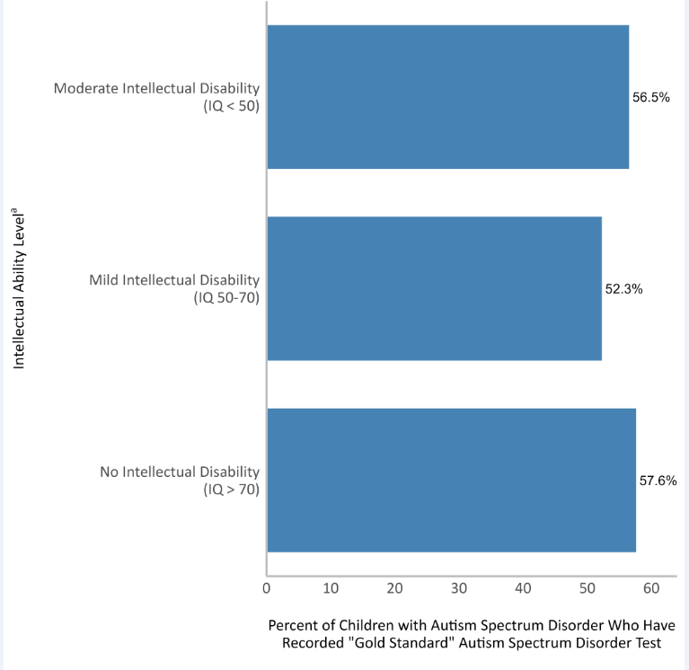

Supplemental Figure 1 Footnote
ª Intellectual ability status was determined intelligence quotient scores on the child’s most recent IQ test or a qualified professional’s statement of ID. Approximately 8% of children who had intellectual disability could not be further classified into an intellectual ability level and were excluded from this analysis.

Supplemental Figure 2 Title
Supplemental Figure 2. Percent of children with autism spectrum disorder who have recorded autism spectrum disorder test by their diagnosis location — Autism and Developmental Disabilities Monitoring Network, 11 sites, United States, 2018
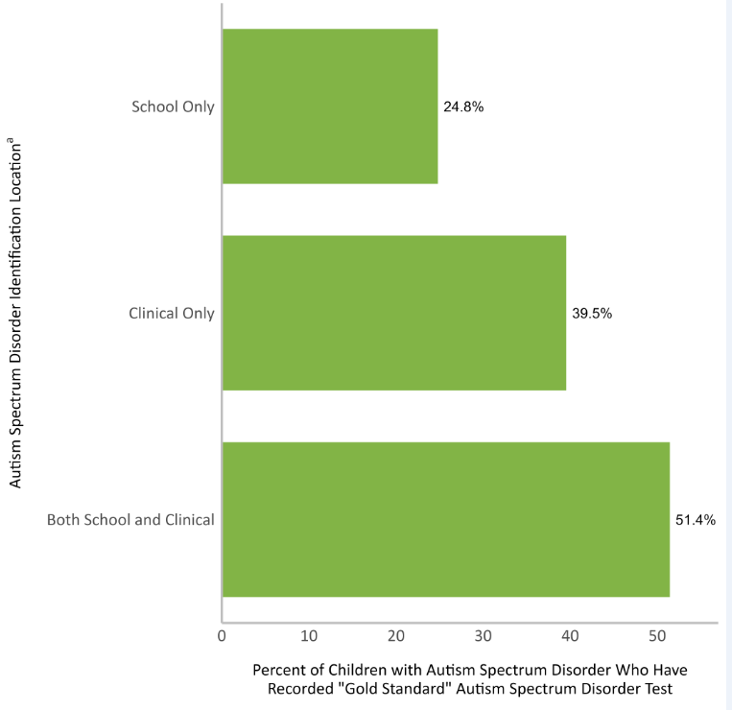

Supplemental Figure 2 Footnote
ª Clinical identification was determined by the presence of an autism spectrum disorder International Classification of Diseases code or written diagnostic statement from a qualified professional in a child’s health records while school identification was determined by the presence of an autism special education classification in education records¹².

