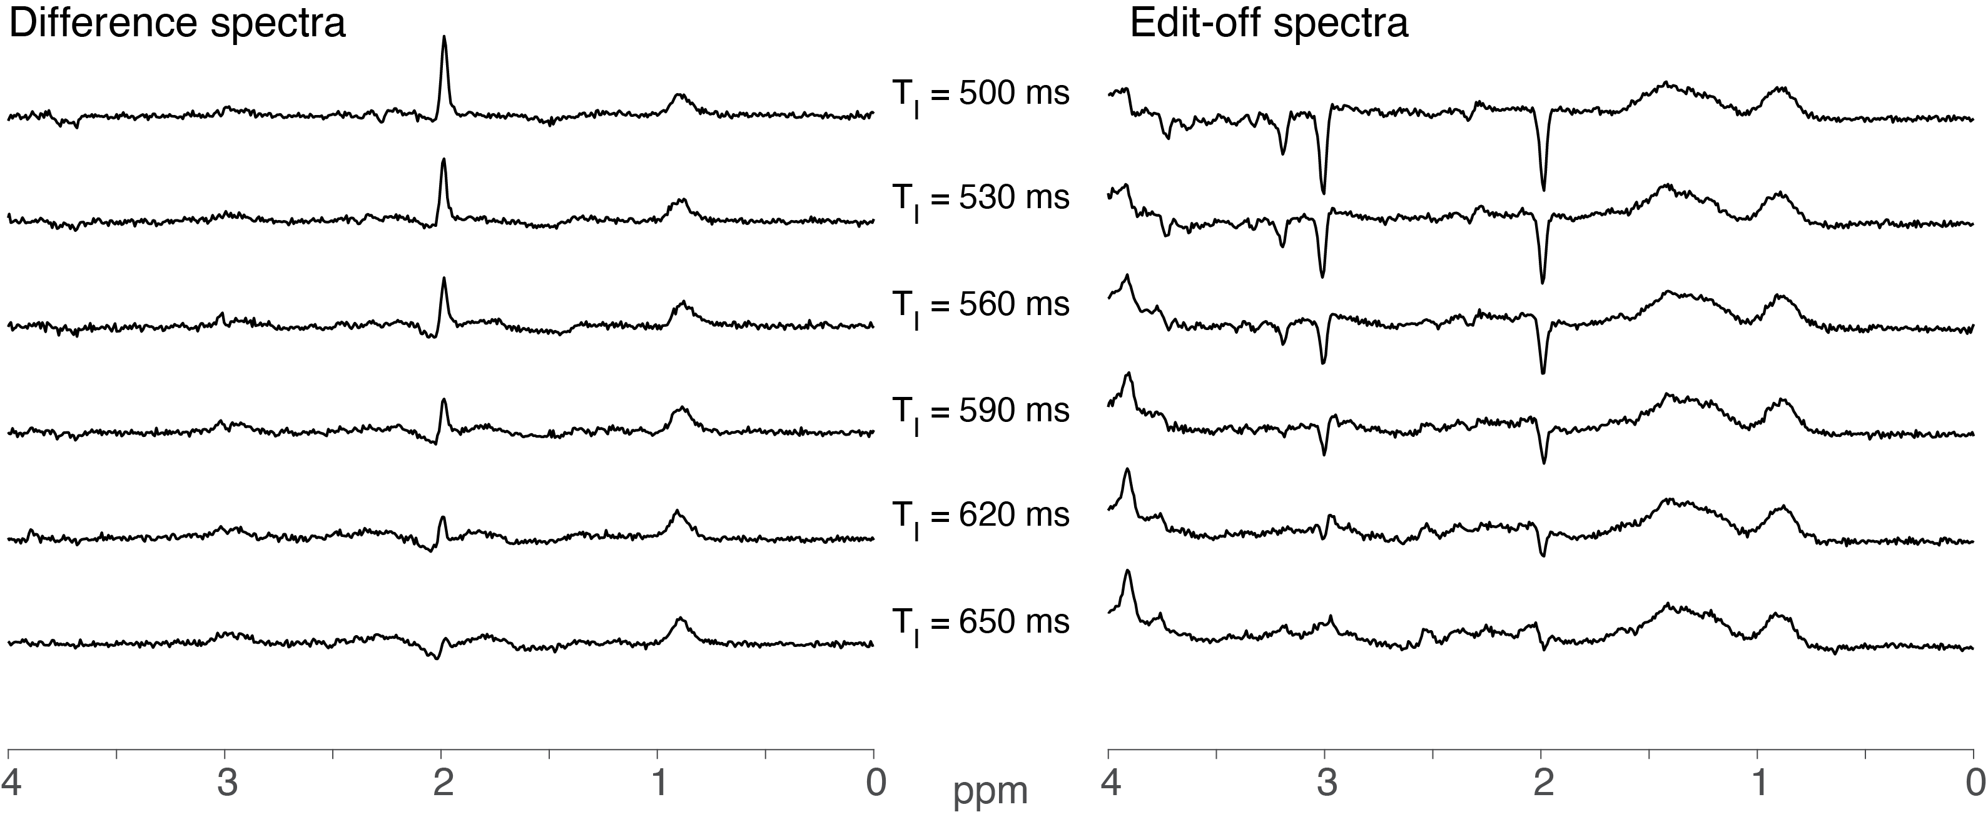

Supplementary Figure S1. The full TI series from the 2nd pilot subject. The left panel shows the difference spectrum, and the right panel shows the edit-off spectrum.

Table S1. Minimum reporting standards in MRS table.

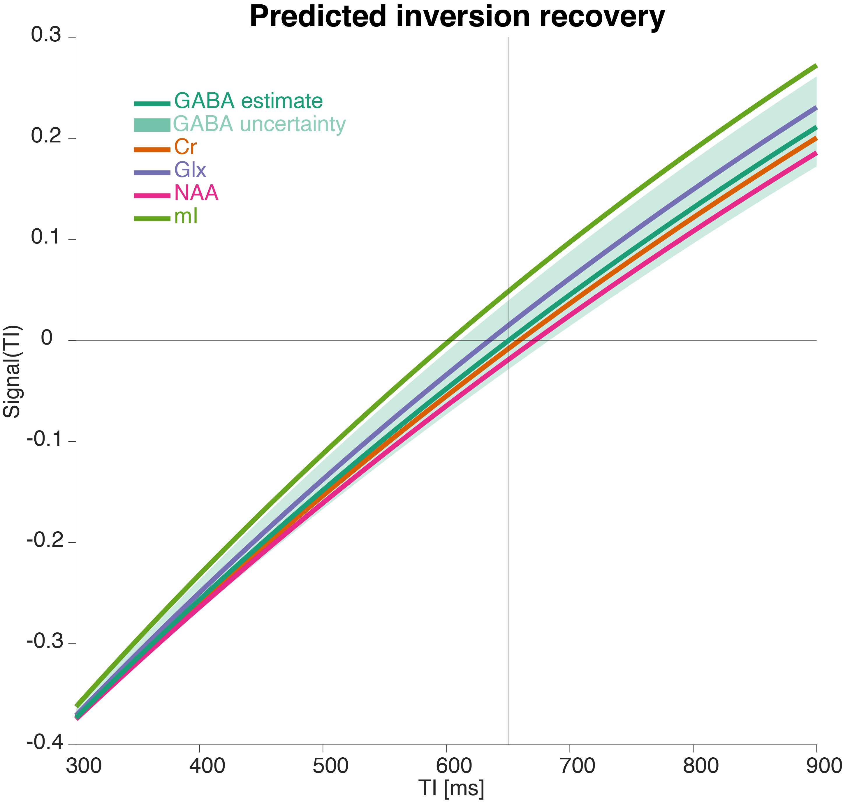

Supplementary Figure S2. A plot of the predicted inversion recovery curves for several metabolites using literature T₁ values: mI (light green), NAA (pink), Glx (purple), Cr (orange), and GABA (dark green). The green shaded area illustrates the reported uncertainty in the GABA T₁. Note that the TI used in this study, 650 ms, lies directly at the null point of GABA.

 |  |  | Single Gaussian | Experimental MM |  | Multiple Gaussian
 | GABA | mean | 0.19 |  | 0.15 |  | 0.15
 | GABA | sd | 0.051 |  | 0.049 |  | 0.043
 | GABA | median | 0.19 |  | 0.16 |  | 0.15
 | GABA | CV | 0.27 |  | 0.33 |  | 0.29
 | GABA | IQR | 0.062 |  | 0.076 |  | 0.049
 | MM | mean | 0.19 |  | 0.21 |  | 0.21
 | MM | sd | 0.033 |  | 0.039 |  | 0.038
 | MM | median | 0.19 |  | 0.21 |  | 0.21
 | MM | CV | 0.17 |  | 0.18 |  | 0.18
 | MM | IQR | 0.049 |  | 0.044 |  | 0.056
 | GABA+ | mean | 0.38 |  | 0.36 |  | 0.36
 | GABA+ | sd | 0.069 |  | 0.067 |  | 0.065
 | GABA+ | median | 0.39 |  | 0.36 |  | 0.36
 | GABA+ | CV | 0.18 |  | 0.19 |  | 0.18
 | GABA+ | IQR | 0.095 |  | 0.089 |  | 0.087
Residual | Amp | mean | 0.092 |  | 0.081 |  | 0.081
Residual | Amp | sd | 0.028 |  | 0.026 |  | 0.026
Residual | Amp | median | 0.083 |  | 0.079 |  | 0.077
Residual | Amp | CV | 0.3 |  | 0.32 |  | 0.32
Residual | Amp | IQR | 0.034 |  | 0.029 |  | 0.031
Residual | S.D. | mean | 0.011 |  | 0.01 |  | 0.01
Residual | S.D. | sd | 0.0027 |  | 0.0025 |  | 0.0025
Residual | S.D. | median | 0.011 |  | 0.01 |  | 0.0097
Residual | S.D. | CV | 0.24 |  | 0.24 |  | 0.25
Residual | S.D. | IQR | 0.0035 |  | 0.0027 |  | 0.0034
Residual | Amp (GABA) | mean | 0.026 |  | 0.025 |  | 0.025
Residual | Amp (GABA) | sd | 0.0066 |  | 0.0071 |  | 0.0075
Residual | Amp (GABA) | median | 0.026 |  | 0.025 |  | 0.024
Residual | Amp (GABA) | CV | 0.25 |  | 0.28 |  | 0.3
Residual | Amp (GABA) | IQR | 0.0066 |  | 0.0084 |  | 0.0088
Residual | S.D. (GABA) | mean | 0.01 |  | 0.0097 |  | 0.0098
Residual | S.D. (GABA) | sd | 0.0025 |  | 0.0025 |  | 0.0024
Residual | S.D. (GABA) | median | 0.01 |  | 0.009 |  | 0.0093
Residual | S.D. (GABA) | CV | 0.24 |  | 0.26 |  | 0.25
Residual | S.D. (GABA) | IQR | 0.0037 |  | 0.0038 |  | 0.0034

Table S2. For the three MM methods: Mean, standard deviation (S.D.), median, coefficient of variation (C.V.), and inter-quartile range (I.Q.R.) are reported for the distributions of GABA/tCr, MM/tCr, GABA+/tCr, overall residual amplitude, overall residual standard deviation, residual amplitude about GABA (2.93–3.12 ppm), and standard deviation of the residual in the same frequency range. Residuals are normalized to the tNAA amplitude.

 |  | SG–Exp | SG–MG | Exp–MG
 | GABA | > 0.001 | > 0.001 | 0.97
 | MM | 0.007 | 0.009 | 0.92
 | GABA+ | 0.10 | 0.079 | 0.93
Overall | Residual Amp. | 0.034 | 0.031 | 0.96
Overall | Residual S.D | 0.047 | 0.008 | 0.46
GABA | Residual Amp. | 0.34 | 0.19 | 0.71
GABA | Residual S.D | 0.16 | 0.26 | 0.78

Table S3. Paired t-test p-values for single Gaussian versus experimental MMs (SG–Exp), single Gaussian versus multiple Gaussian (SG–MG), and experimental MMs versus multiple Gaussian (Exp–MG). The rows correspond to GABA/tCr, MM/tCr, GABA+/tCr, overall residual amplitude, overall residual standard deviation, residual amplitude about GABA (2.93–3.12 ppm), and standard deviation of the residual in the same frequency range. Residuals are normalized to the tNAA amplitude.

Supplementary analysis 1: Iteration of the multi-Gaussian MM model

We investigated the effect of fitting the BigGABA dataset using different combinations of the multi-Gaussian MMs: MM_{3.0} only, MM_{3.0} + MM_{2.05}, MM_{3.0} + MM_{0.93}, and MM_{3.0} + MM_{2.05}+ MM_{0.93}. Like the main study, we examined statistical differences between the amplitude estimates reported by each approach, as well as the residuals around the 3 ppm GABA signal.

Supplementary Figure S3 shows the fitted profiles resulting from this analysis. We noted larger residuals when MM_{0.93} was excluded and a larger variation in the MM fit, and when MM_{2.05}
Was excluded, we noted an increased baseline undulation, compensating for the resonance’s absence.
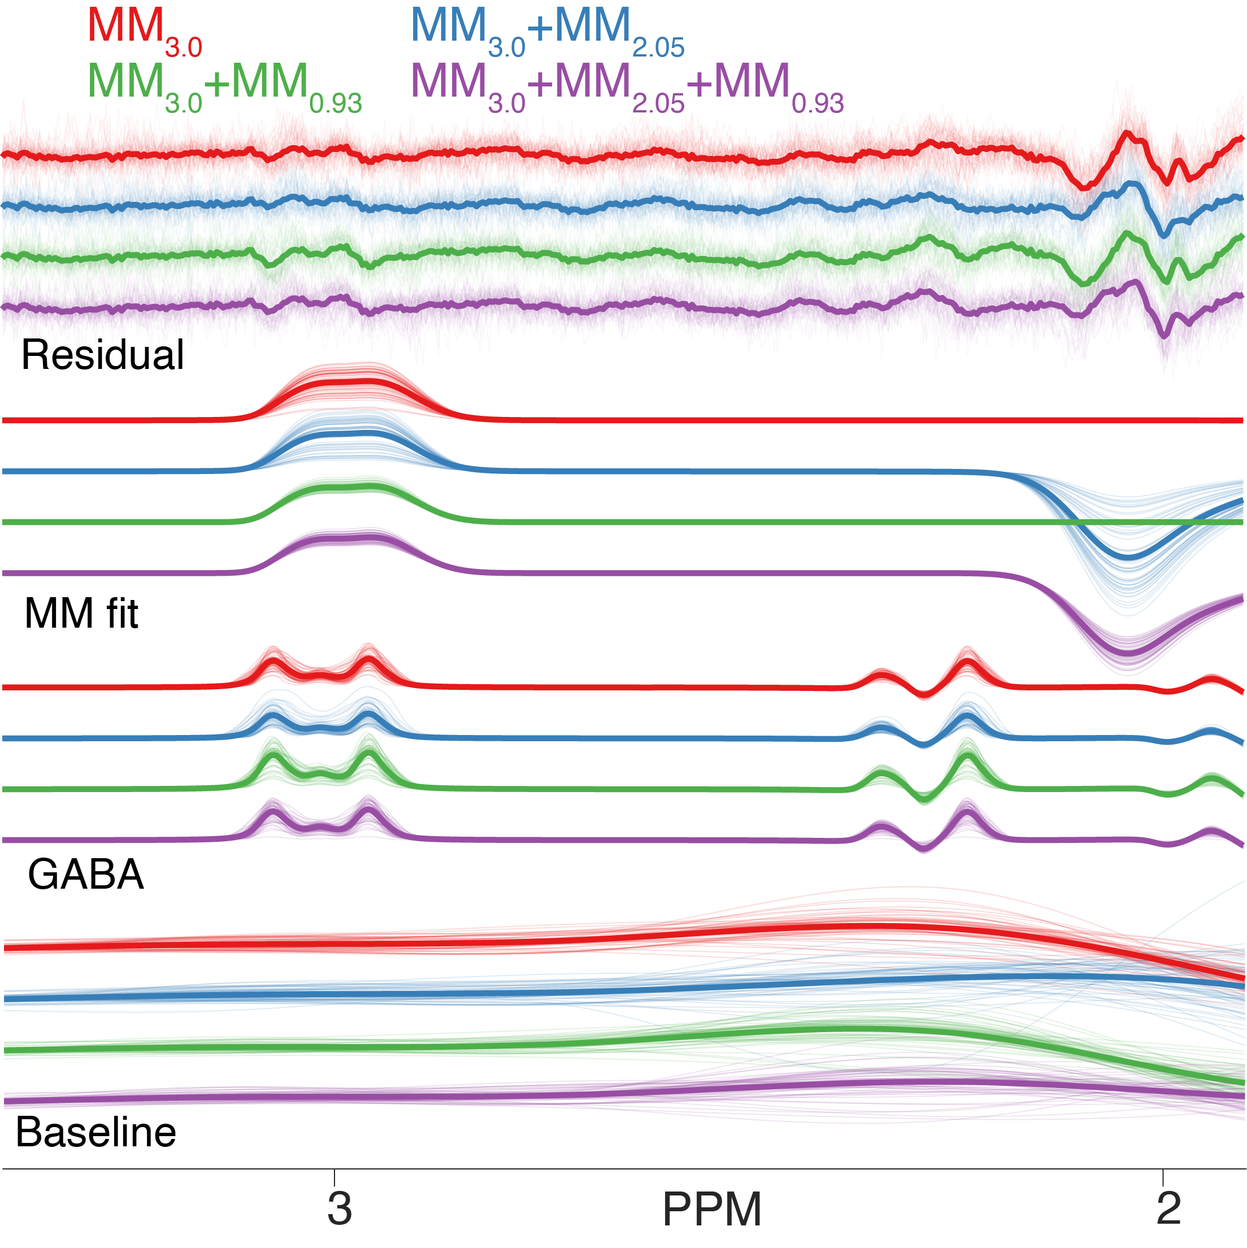

Supplementary Figure S3. Resulting fits of the BigGABA dataset when only a subset of the parameterized MM peaks are included: just MM_{3.0} (red), MM_{3.0}and MM_{2.05} (blue), MM_{3.0} and MM_{0.93} (green), and all three MM resonances (purple).

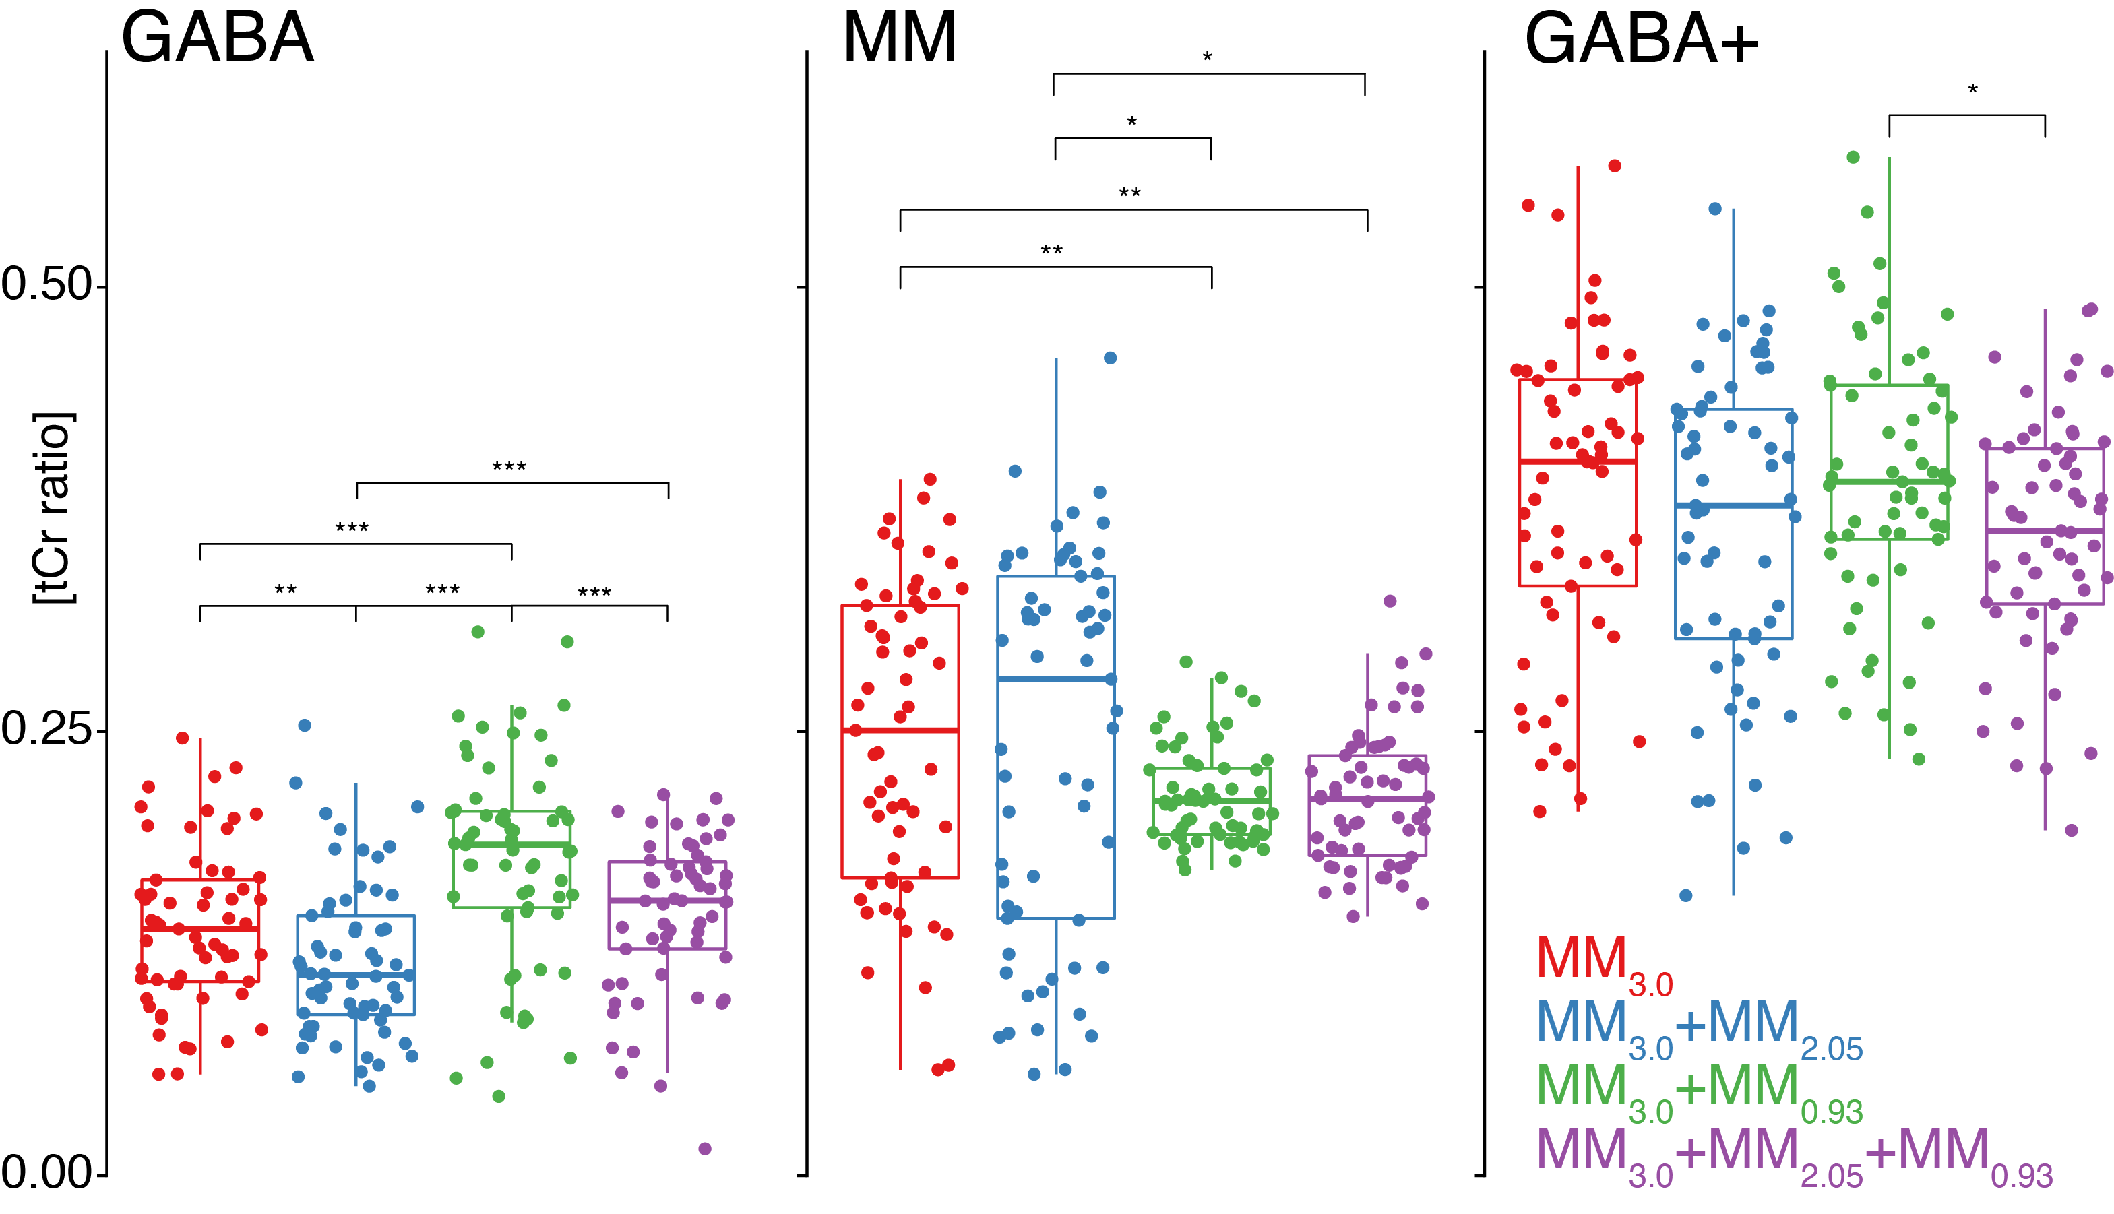

Supplementary Figure S4. Box plots of GABA, MM, and GABA+ tCr ratio estimates when using subsets of parameterized MM peaks: MM_{3.0} (red), MM_{3.0} and MM_{2.05} (blue), MM_{3.0} and MM_{0.93} (green), and all three MM resonances (purple). Significant differences between the analyses are identified using paired t-tests and marked with an increasing number of asterisks for p-values < 0.05, 0.01, and 0.001, respectively.

While differences in GABA+ tCr ratios are mostly statistically insignificant, the GABA-MM ratio is heavily influenced by the choice of MM basis function. Without the MM_{0.93} anchor, the standard deviation of the GABA residuals decreases—as the model has more freedom—but there is a substantially larger variation in the fitted MM amplitude. This may be most evidently seen in the CVs of MM/tCr ratios (supplementary table S3) and this variation propagates into the GABA+ estimates. These findings suggest the stabilizing benefit of including MM_{0.93} in the basis function. Additionally, including MM_{2.05} improved baseline stability around 2 ppm without substantially impacting GABA+ CVs, suggesting the full basis function, including all three peaks, provided the greatest measurement stability.

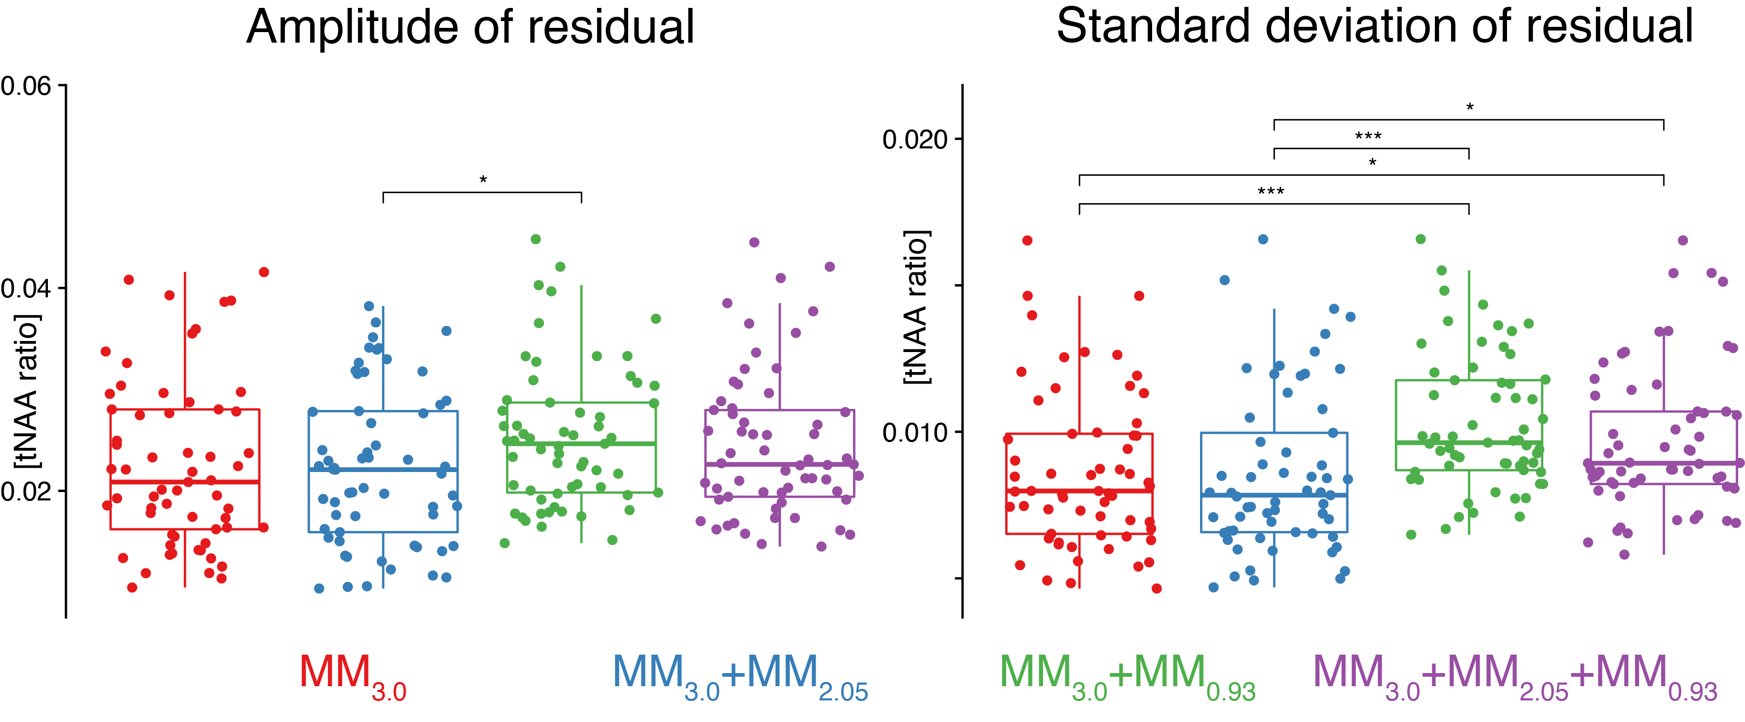

Supplementary Figure S5. Box plots of the amplitude and standard deviation of the residual around GABA for subsets of parameterized MMs: MM_{3.0} (red), MM_{3.0} and MM_{2.05} (blue), MM_{3.0} and MM_{0.93} (green), and all three MM resonances (purple). Significant differences between the analyses are identified using paired t-tests and marked with an increasing number of asterisks for p-values < 0.05, 0.01, and 0.001, respectively.

 |  |  | MM_{3.0} | MM_{3.0}+ MM_{2.05} | MM_{3.0}+ MM_{0.93} | MM_{3.0}+ MM_{2.05}+ MM_{0.93}
 | GABA | mean | 0.14 | 0.12 | 0.18 | 0.15
 | GABA | sd | 0.045 | 0.044 | 0.058 | 0.043
 | GABA | median | 0.14 | 0.11 | 0.19 | 0.15
 | GABA | CV | 0.32 | 0.37 | 0.33 | 0.29
 | GABA | IQR | 0.057 | 0.056 | 0.054 | 0.049
 | MM | mean | 0.25 | 0.24 | 0.21 | 0.21
 | MM | sd | 0.086 | 0.11 | 0.027 | 0.038
 | MM | median | 0.25 | 0.28 | 0.21 | 0.21
 | MM | CV | 0.35 | 0.44 | 0.13 | 0.18
 | MM | IQR | 0.15 | 0.19 | 0.037 | 0.056
 | GABA+ | mean | 0.39 | 0.36 | 0.39 | 0.36
 | GABA+ | sd | 0.087 | 0.09 | 0.075 | 0.065
 | GABA+ | median | 0.4 | 0.38 | 0.39 | 0.36
 | GABA+ | CV | 0.23 | 0.25 | 0.19 | 0.18
 | GABA+ | IQR | 0.12 | 0.13 | 0.087 | 0.087
Residual | Amp (GABA) | mean | 0.023 | 0.022 | 0.025 | 0.024
Residual | Amp (GABA) | sd | 0.0082 | 0.0077 | 0.0069 | 0.0072
Residual | Amp (GABA) | median | 0.021 | 0.022 | 0.025 | 0.023
Residual | Amp (GABA) | CV | 0.37 | 0.35 | 0.27 | 0.29
Residual | Amp (GABA) | IQR | 0.012 | 0.012 | 0.0089 | 0.0085
Residual | S.D. (GABA) | mean | 0.0086 | 0.0086 | 0.01 | 0.0096
Residual | S.D. (GABA) | sd | 0.0027 | 0.0028 | 0.0023 | 0.0025
Residual | S.D. (GABA) | median | 0.008 | 0.0078 | 0.0096 | 0.0089
Residual | S.D. (GABA) | CV | 0.31 | 0.32 | 0.23 | 0.26
Residual | S.D. (GABA) | IQR | 0.0034 | 0.0034 | 0.0031 | 0.0025

Table S4. For the four configurations of multi-Gaussian MMs (MM_{3.0}, MM_{3.0}+ MM_{2.05}, MM_{3.0}+ MM_{0.93}, MM_{3.0}+ MM_{2.05}+ MM_{0.93}) we report the following: Mean, standard deviation (S.D.), median, coefficient of variation (C.V.), and inter-quartile range (I.Q.R.) for the distributions of GABA/tCr, MM/tCr, GABA+/tCr, overall residual amplitude, overall residual standard deviation, residual amplitude about GABA (2.93–3.12 ppm), and standard deviation of the residual in the same frequency range. Residuals are normalized to the tNAA amplitude.

Supplementary analysis 2: The impact of MM representations in the presence of lipid signals.

To determine if (and to what extent) lipid signals could interfere with the modeling, we conducted two related supplementary analyses.

First, we introduced several categories of synthetic lipid artifacts (with varying amplitude and center frequency) into the 61 Big GABA datasets examined in the main study and modeled these with each of our new MM approaches (the experimental and fully parametrized multi-Gaussian basis functions), as well as subsets of the parameterized profiles (i.e. a multi-Gaussian parametrization with only MM30+MM20, and a multi-Gaussian parameterization that only contained MM30). We then compared the resulting GABA+ estimates to the “ground truth”, i.e., the GABA+ estimates from the ‘lipid-free’ spectra, (the ones before the addition of the lipid artifact).

Secondly, we looked through the larger Big GABA dataset to find real in-vivo MEGA-PRESS spectra with lipid contamination to examine the impact of realistically occurring in-vivo lipids. This allowed us to compile two datasets (with/without lipids, 16 spectra each), and like the synthetic-lipid analysis, modeled each spectrum with the abovementioned MM profiles and, again, compared GABA+ estimates between lipid-contaminated and lipid-free spectra for each method.

Full details of the methods, results, and interpretation may be found in a publicly available OSF repository (DOI: 10.17605/OSF.IO/QD37B; docs/SupplementaryAnalyses.docx)
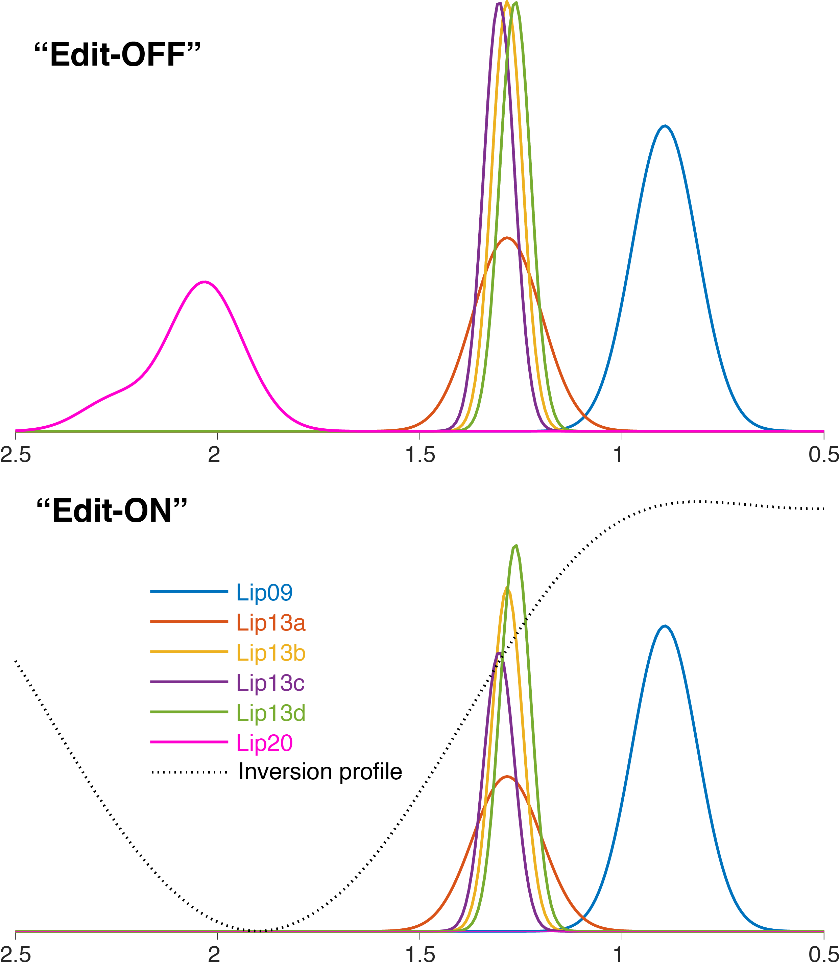
Supplementary Figure S6. Illustration of synthetic Gaussian lipid basis derived from LCModel’s definitions (top panel), and an implementation of their attenuation resulting from the approximated impact of the MEGA-PRESS inversion pulse (dashed black line).

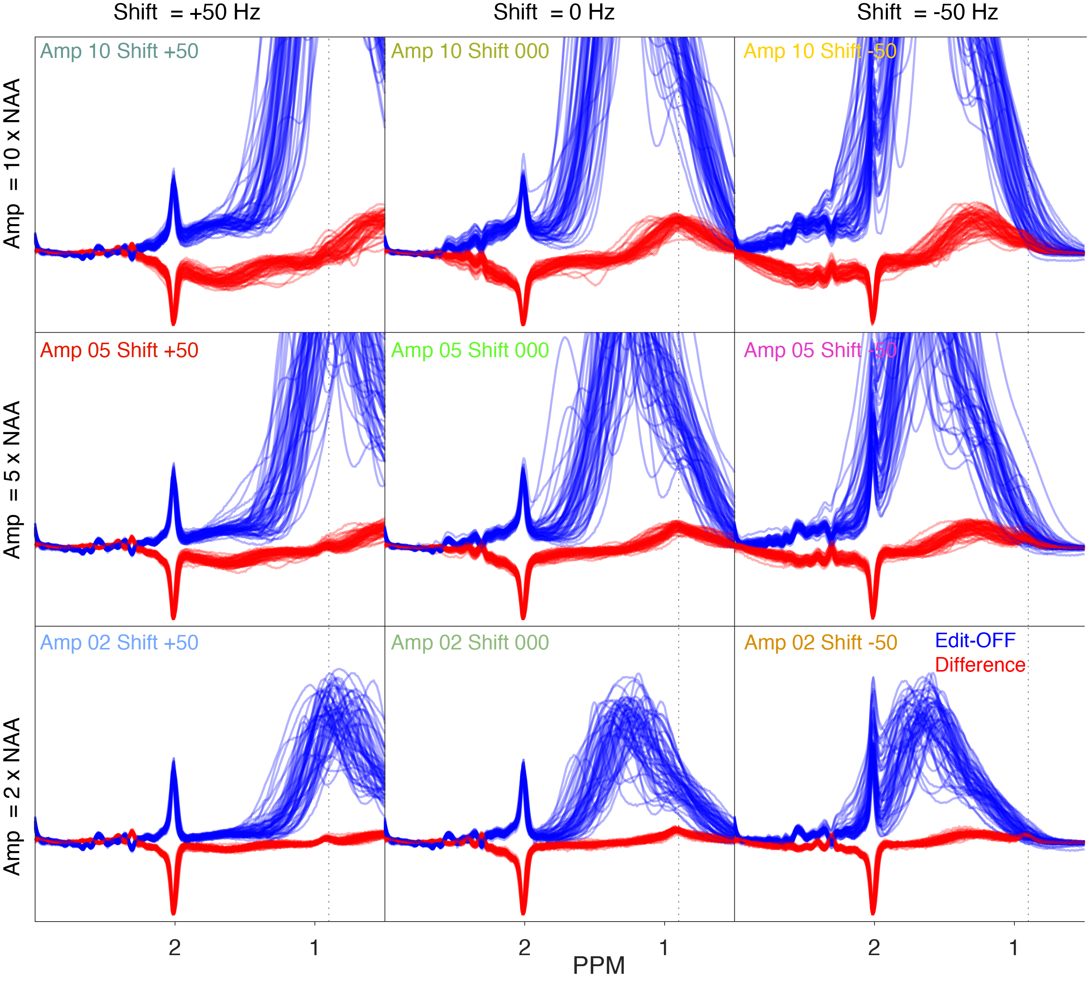
Supplementary Figure S7. In-vivo spectra with synthetic lipid artifacts introduced. Edit-off spectra (blue) are plotted alongside the difference spectra (red). Columns represent different relative shifts for the lipid signals (50, 0, and -50 Hz from their default frequency, respectively), and rows represent different relative amplitudes of the lipid artifacts (2, 5, and 10 times the NAA).

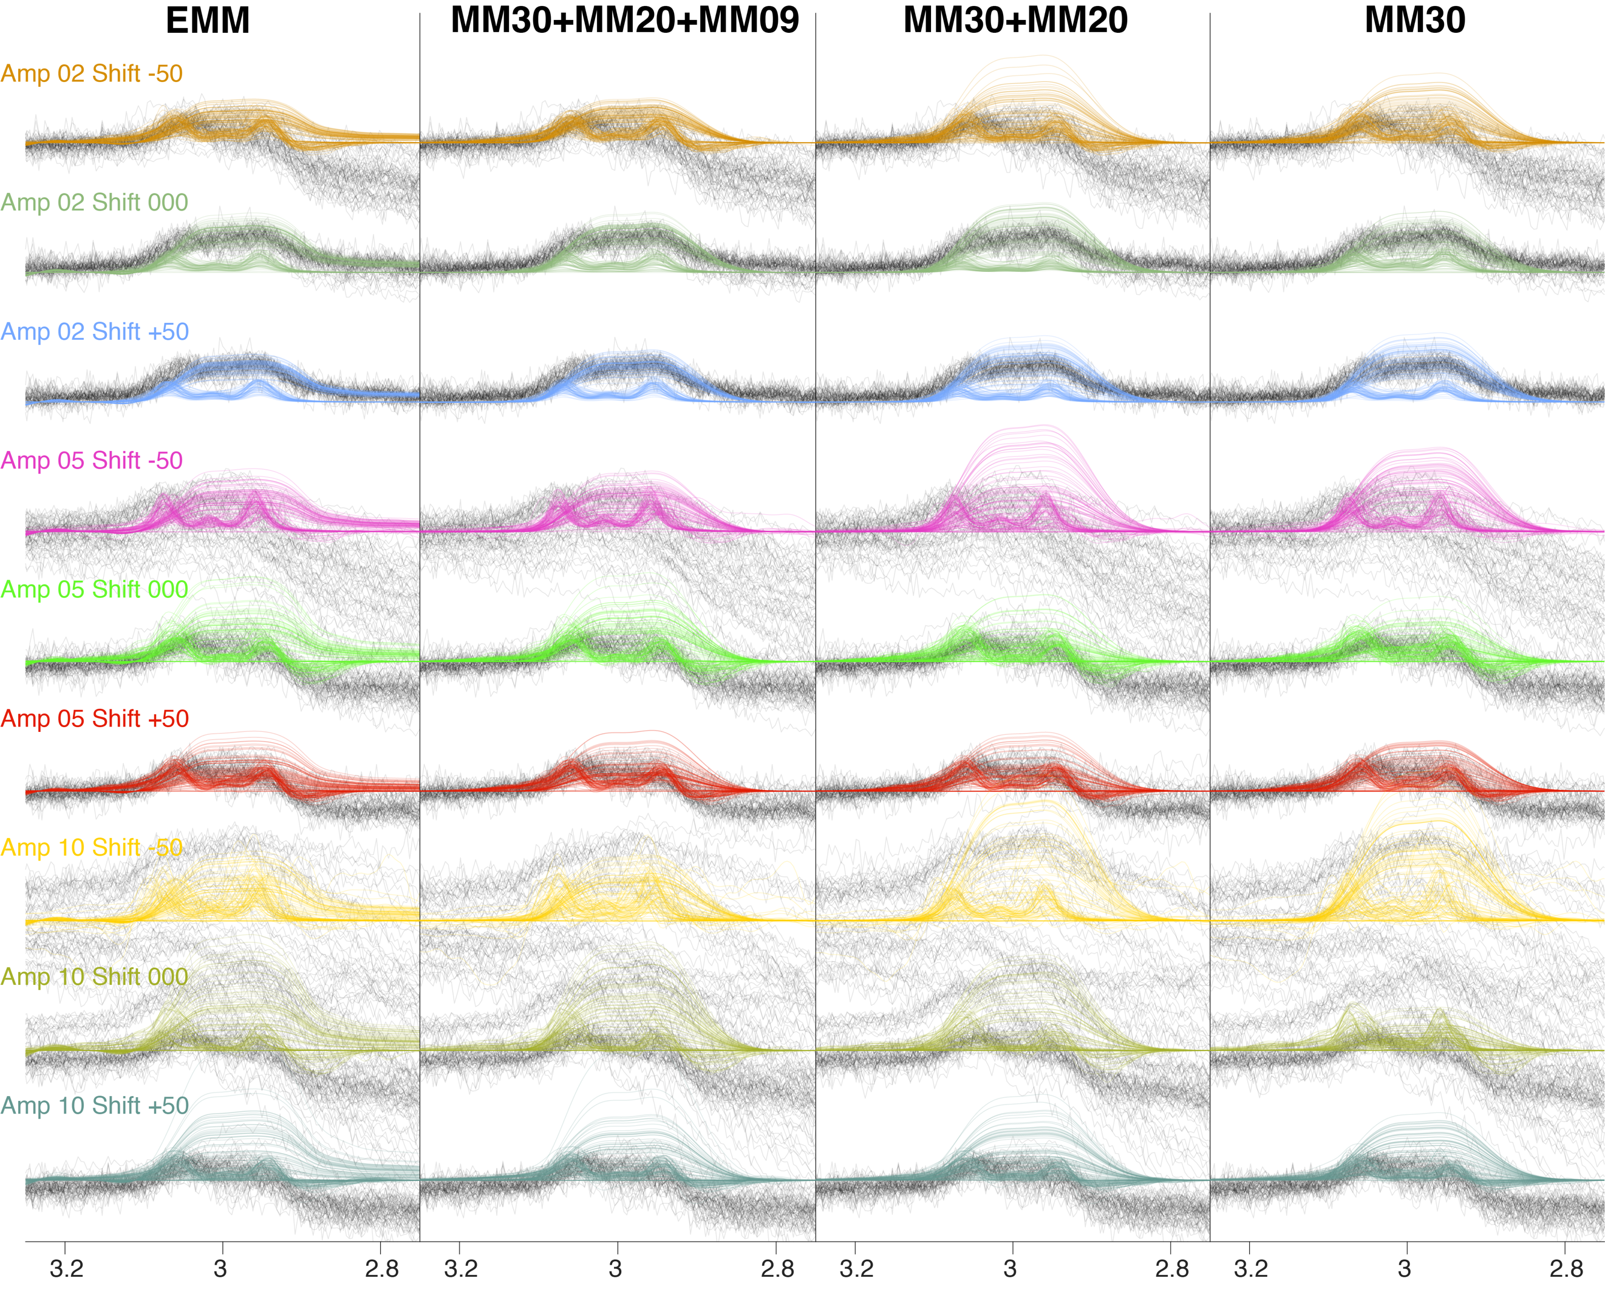
Supplementary Figure S8. Visualization of modeling results of the difference spectra (around GABA). Rows represent different classes of lipid artifacts, and columns represent different MM modeling approaches. The data are plotted in grey, and the MM and GABA fits are overlaid in the colored lines. Models are plotted without baseline contributions to appreciate the effects on GABA+ estimation more clearly.

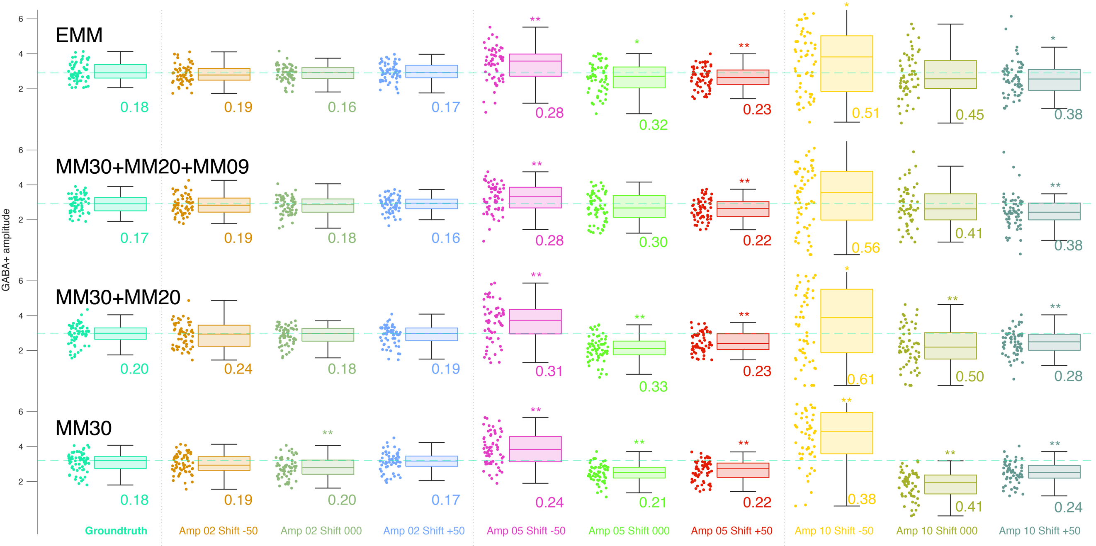
Supplementary Figure S9. Boxplots of GABA+ estimates for each MM representation and class of lipid contamination. Each row represents a different underlying MM basis function, and columns/colors represent lipid data scenarios, with the “ground truth” uncontaminated spectra in the left-most column (cyan). Coefficients of variation are noted next to each boxplot, and asterisks are used to mark significant deviations from the ground truth (“*”, p<0.05; “**”, p<0.005).

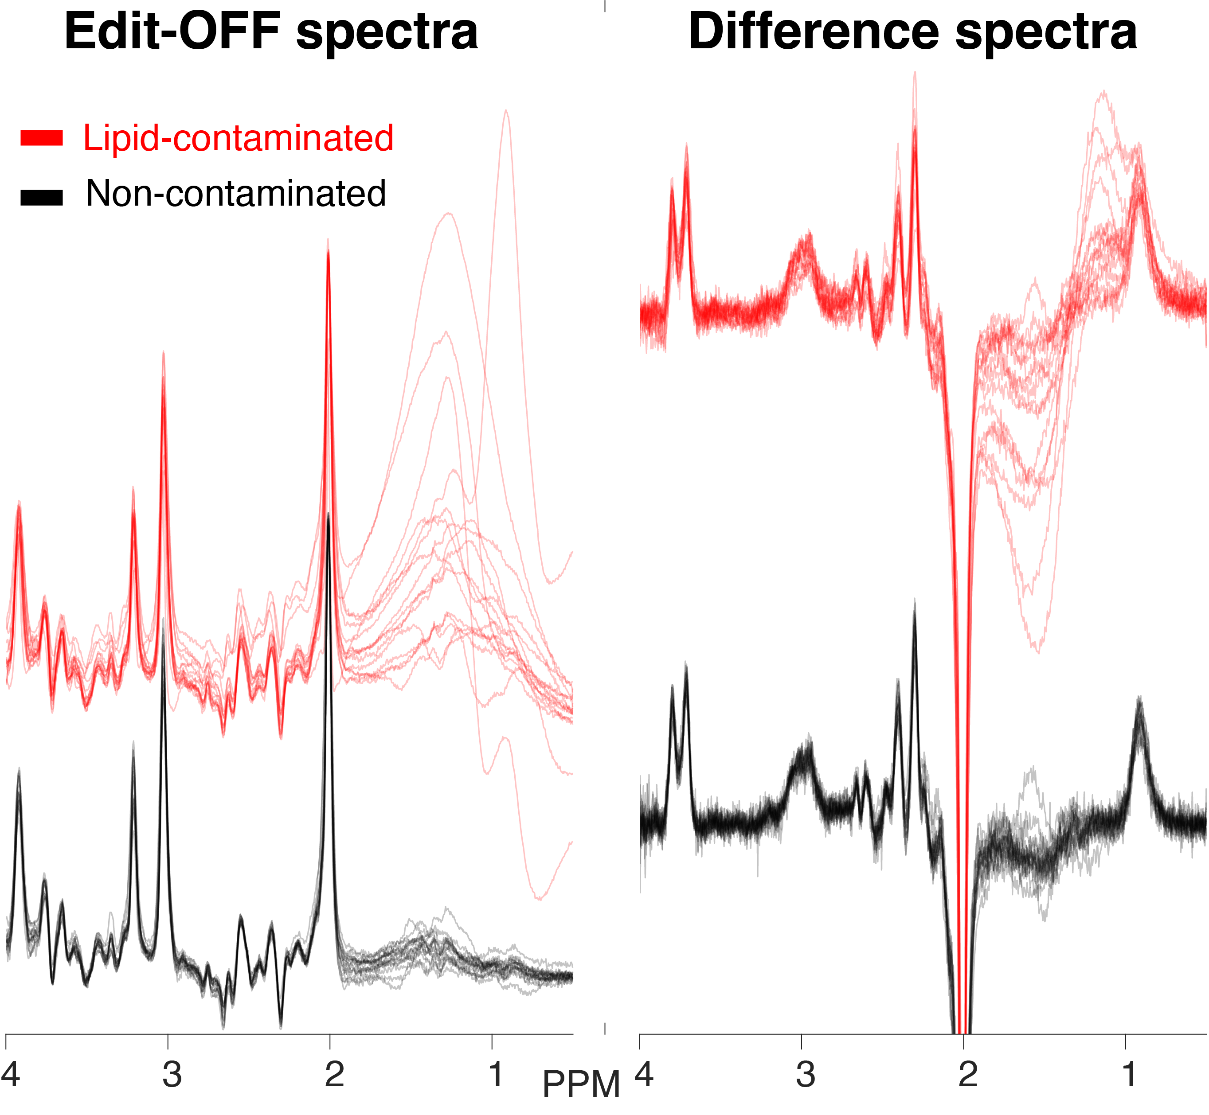
Supplementary Figure S10. Real in-vivo spectra derived from the full BigGABA dataset. Edit-off (left) and difference spectra (right) are plotted. We identified 16 lipid-contaminated spectra (red) and 16 corresponding non-lipid-contaminated spectra (black) for analysis.

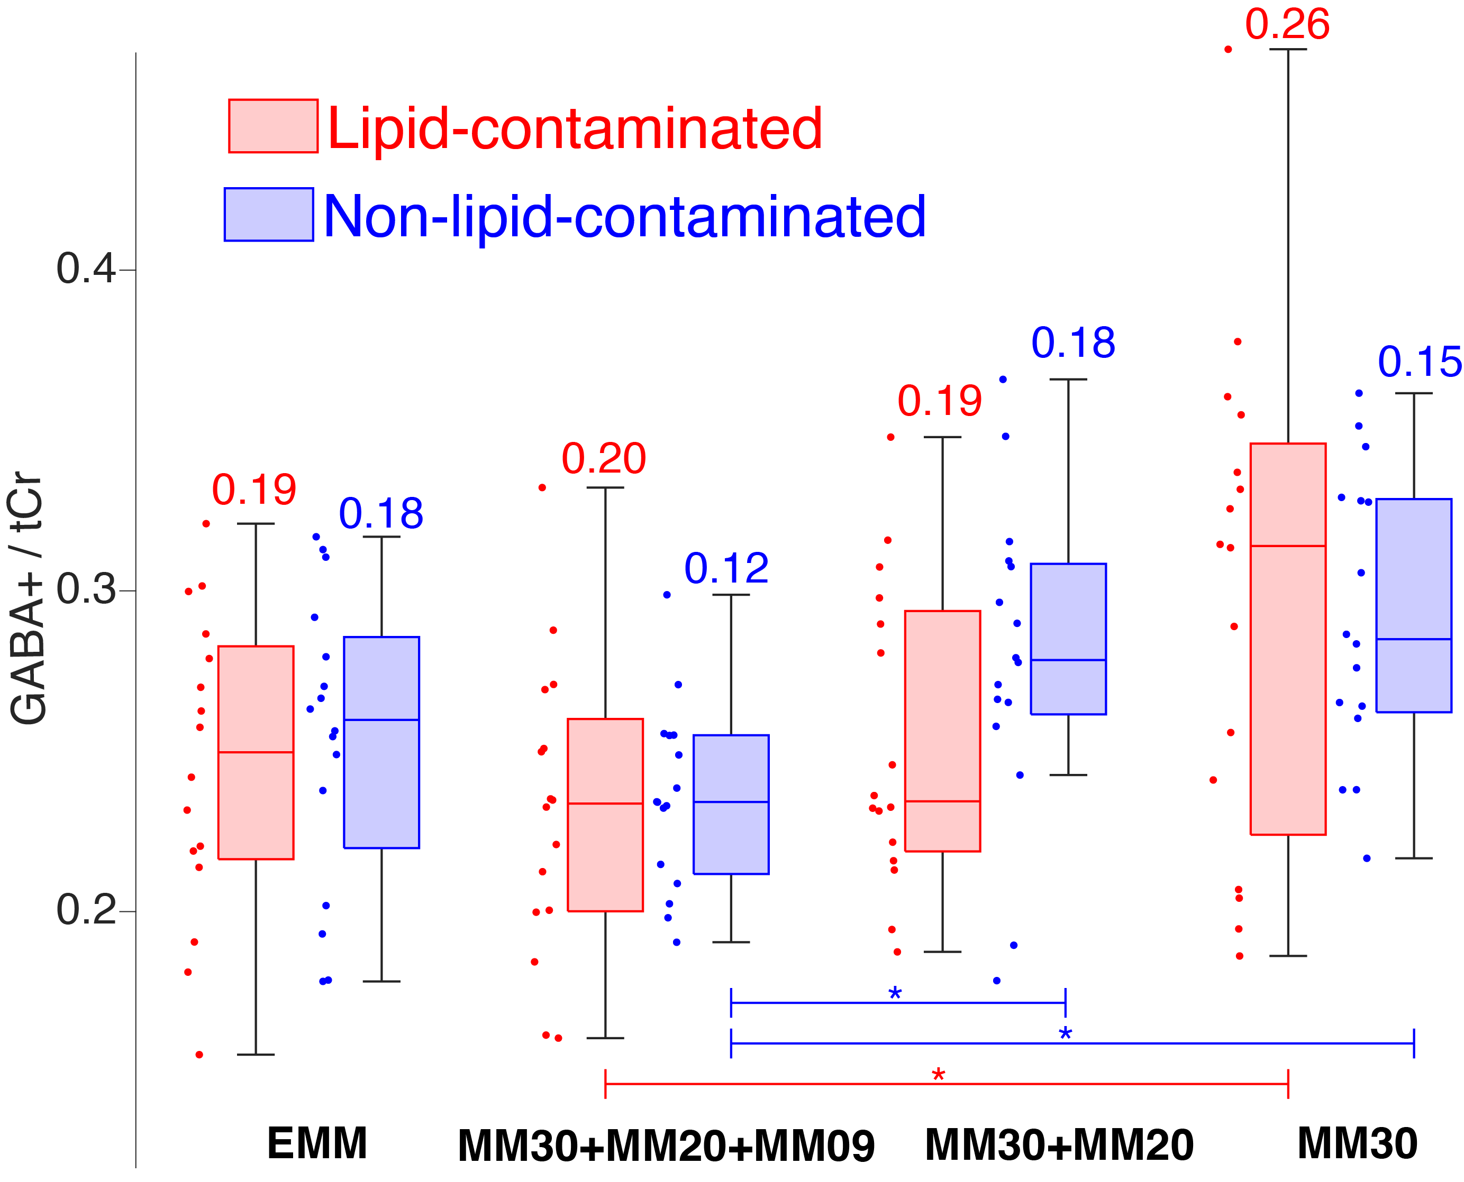
Supplementary Figure S12. Boxplots of GABA+/tCr ratios for the lipid-contaminated spectra (red), non-contaminated spectra (blue), with the CVs across the GABA+ estimates shown above. Pairs of boxplots are generated for each basis function. From left-to-right we show: the experimental MM profile (EMM), full multiple-Gaussian parameterization (MM30+MM20+MM09), multiple-Gaussian parameterization without MM09 (MM30+MM20), and multiple-Gaussian parameterization with only MM30 (MM30). Statistically significant differences between methods are marked with an asterisk and color coded according to the data source (lipid-contaminated or non-lipid-contaminated spectra).

Supplementary analysis 3: Test-retest of Siemens MEGA-PRESS

We performed an analysis in a test-retest dataset acquired on a Siemens 3T scanner, which formed the core of a recent investigation into the impact of modeling parameters on test-retest reproducibility for GABA+ and included a MEGA-PRESS sequence acquired with the same sequence parameters as the Philips MEGA-PRESS data presented in this manuscript (TE = 68 ms; 14-ms editing pulses; edit-on at 1.9 ppm)⁶⁶. We performed a comparative analysis using the three MM methods described in the main manuscript. We calculated within-subject CVs and 90% confidence intervals using the root-mean method (Bland, 2006: https://www-users.york.ac.uk/~mb55/meas/cv.htm), aligning with the reported outcome measures from the original study⁶⁶.

Supplementary Figure S13 shows the resulting CVs and 90% confidence intervals for the three methods. While there was an overlap in the confidence intervals, we found that the experimental MMs and multiple-Gaussian MMs lowered the within-subject CVs of GABA+ estimates, compared to the single-Gaussian parameterization (6.45% and 6.42%, respectively, versus 9.28% for the single-Gaussian parameterization). This suggests that the new MM methods improve the reproducibility of GABA+ estimation, despite these MM profiles being derived from data acquired using a different scanner vendor.

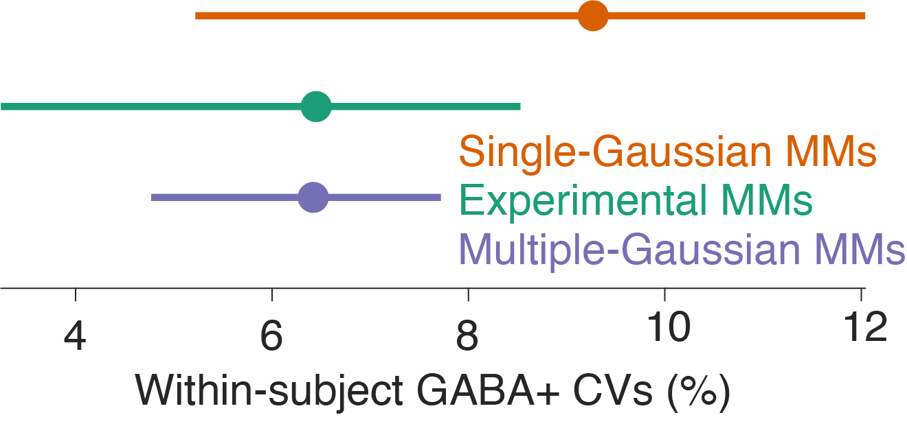

Supplementary Figure S13. Dot-whisker plots showing the within-subject CVs of GABA+ estimates and 90% confidence intervals. Three different methods of MM modeling are represented: single-Gaussian MMs (orange), experimental MMs (green), and multiple-gaussian MMs (purple).

