Supplementary Figure 1. Relationship among six death outcomes

excluding COVID-19 related deaths

cardiac-related deaths

without pre-existing

cancer and heart disease

cardiac-related deaths

non-COVID-19 cardiac-related deaths

non-COVID-19 cardiac-related deaths without

pre-existing cancer and heart disease

excluding deaths with pre-existing

cancer and heart disease

selecting deaths with cause-of-death being cardiac

all-cause deaths

non-COVID-19 deaths

Supplementary Figure 2. Overall and weekly relative incidences of primary and secondary outcomes 10 weeks after BNT162b2 vaccination§

Dose 1 Dose 2

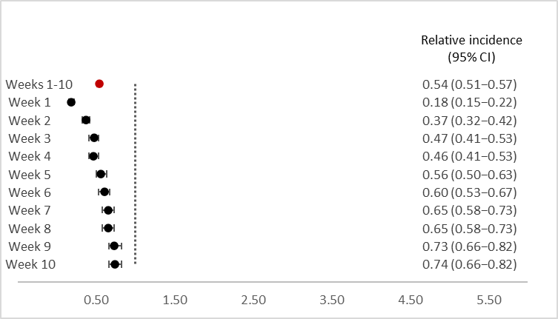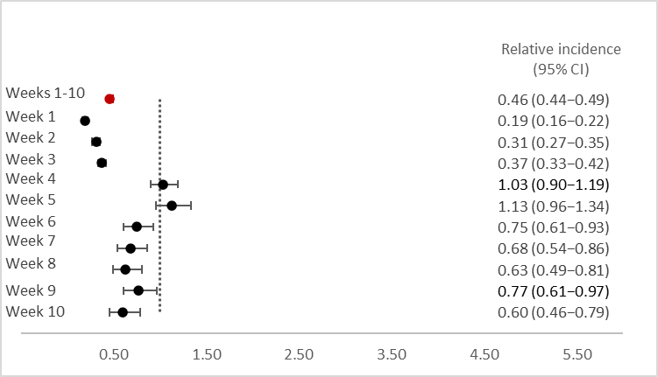

Non-COVID-19 mortality

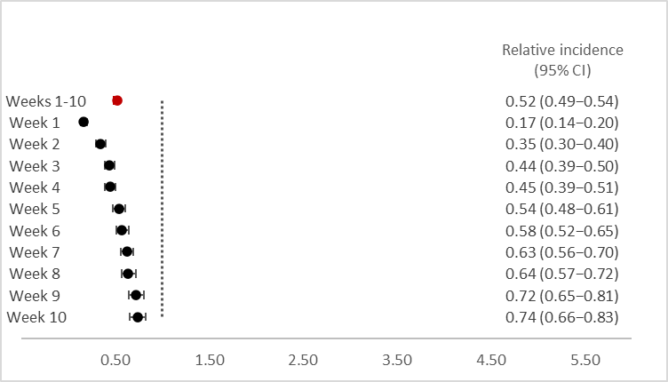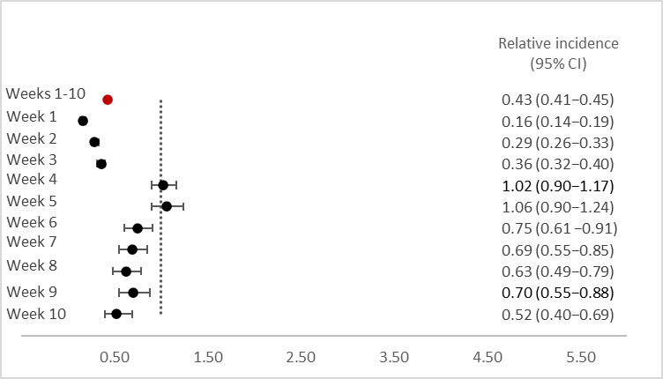

All-cause mortality

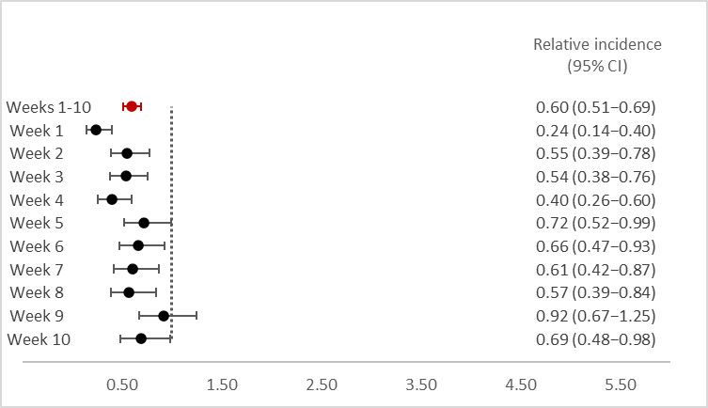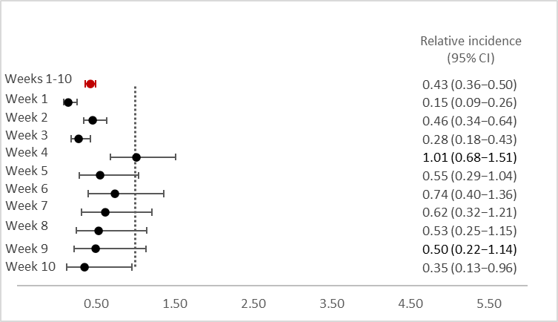

Cardiac-related mortality

Supplementary Figure 2 (continued).

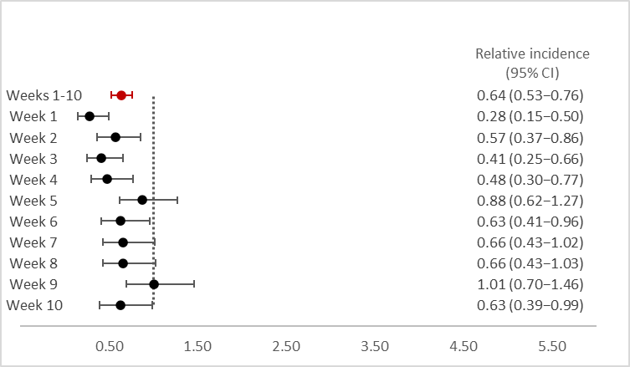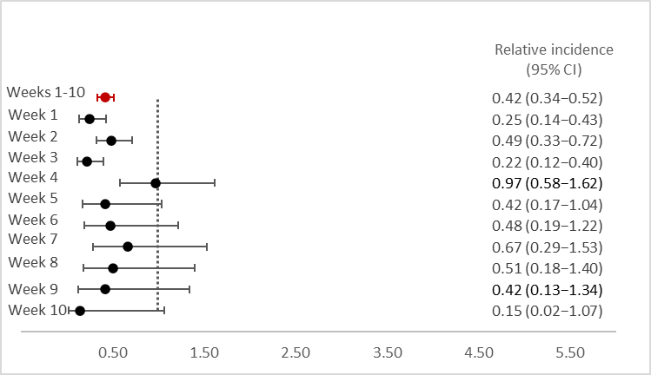

Cardiac-related mortality

excluding pre-existing cancer and heart disease

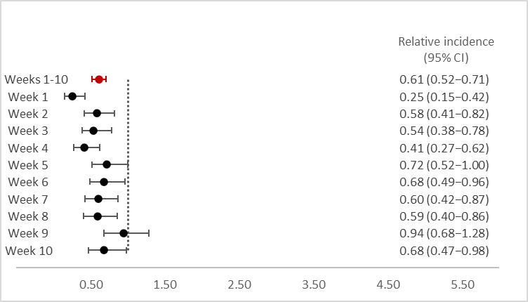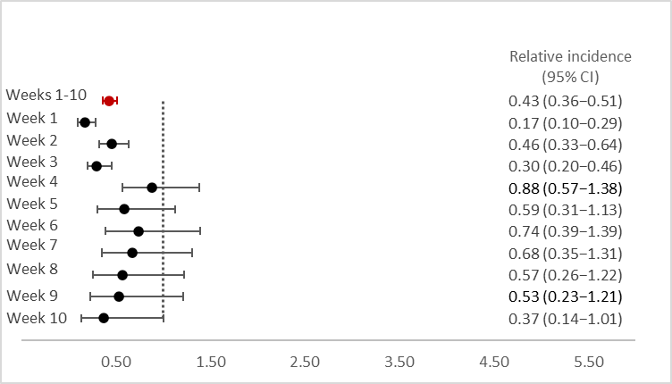

Non-COVID-19 cardiac-related mortality

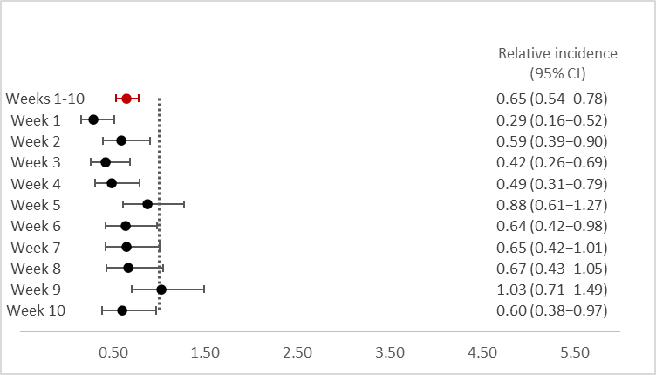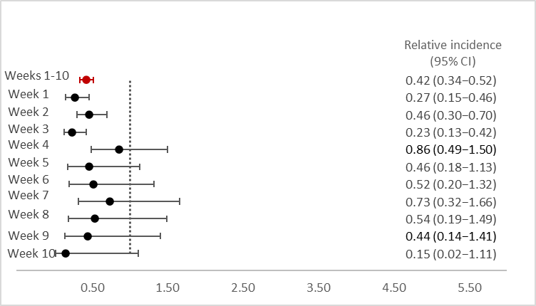

Non-COVID-19 cardiac-related mortality excluding pre-existing cancer and heart disease

§Data from six of the eight VSD sites were included in the analysis of cardiac-related deaths, as the remaining two did not have cause-of-death data for the study period. CI, confidence interval.

Supplementary Figure 3. Overall and weekly relative incidences of primary and secondary outcomes 10 weeks after mRNA-1273 vaccination§

Dose 1 Dose 2

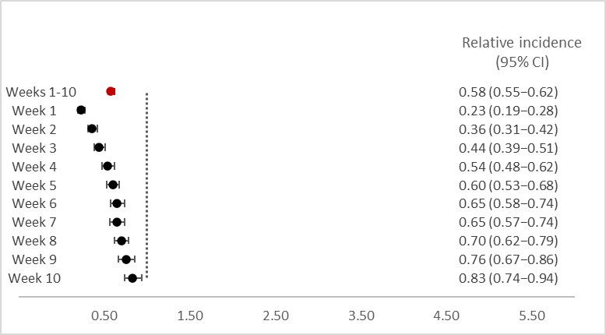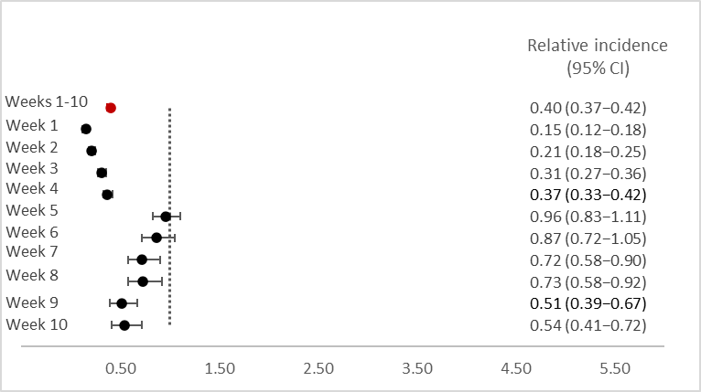

Non-COVID-19 mortality

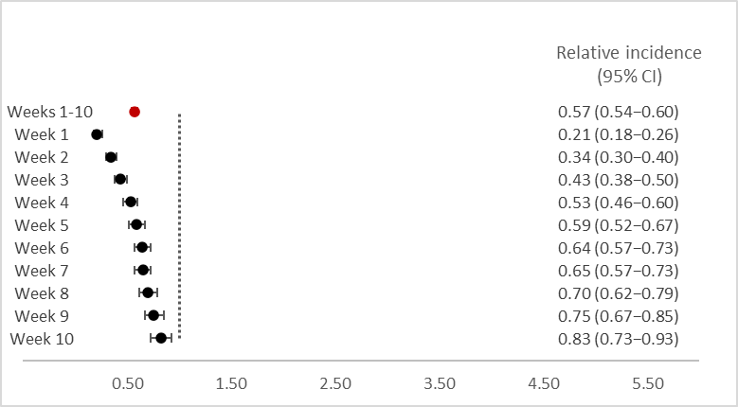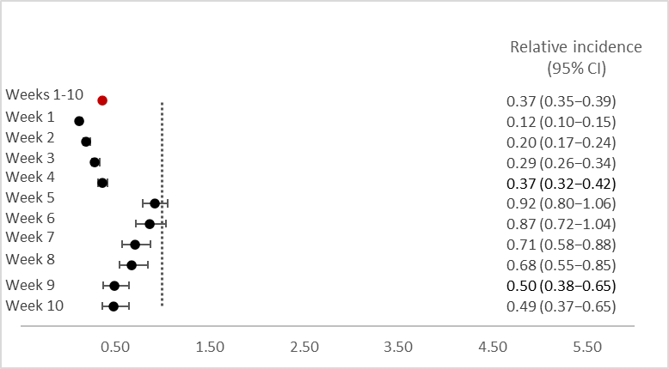

All-cause mortality

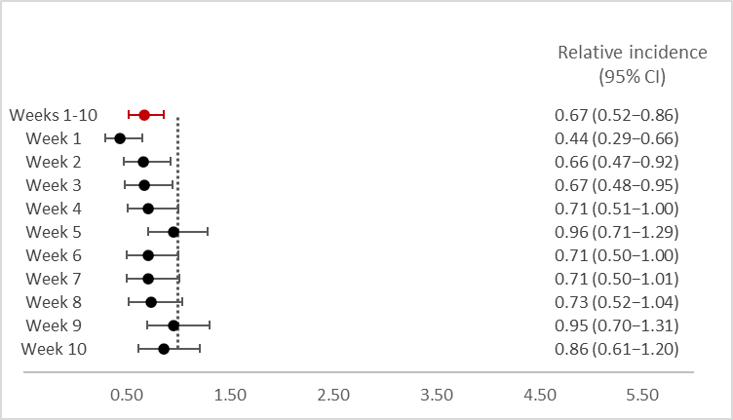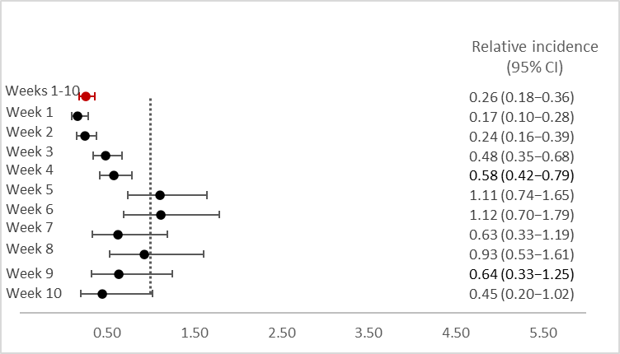

Cardiac-related mortality

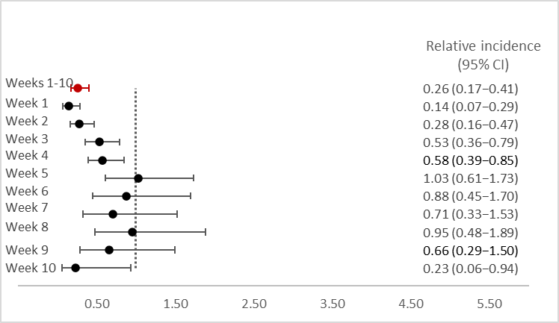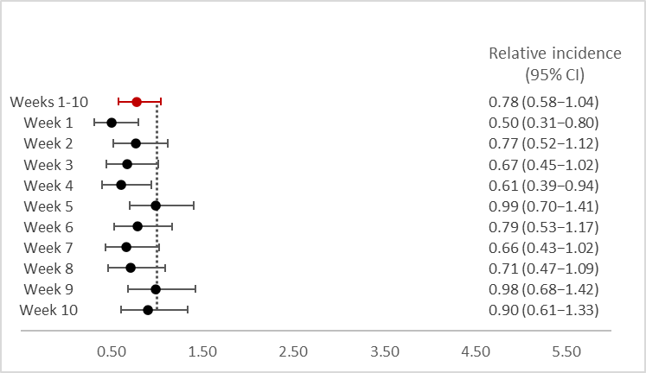Supplementary Figure 3 (continued).

Cardiac-related mortality

excluding pre-existing cancer and heart disease

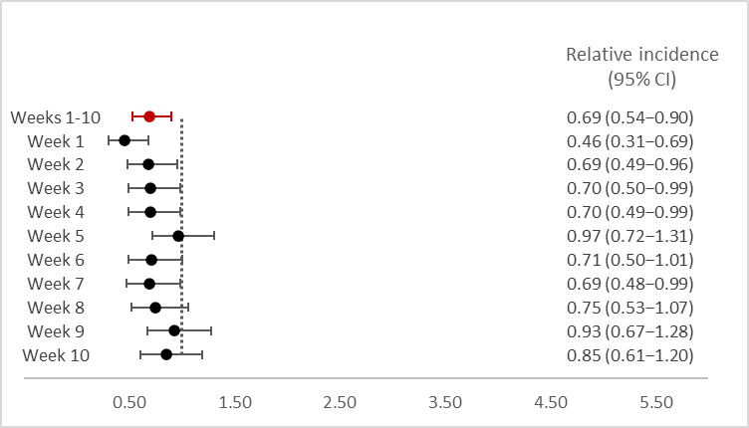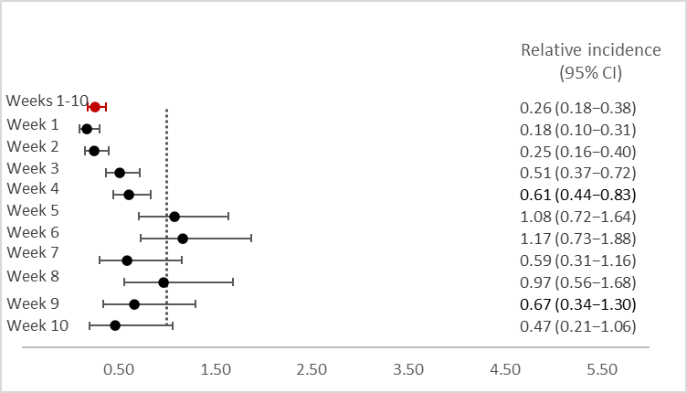

Non-COVID-19 cardiac-related mortality

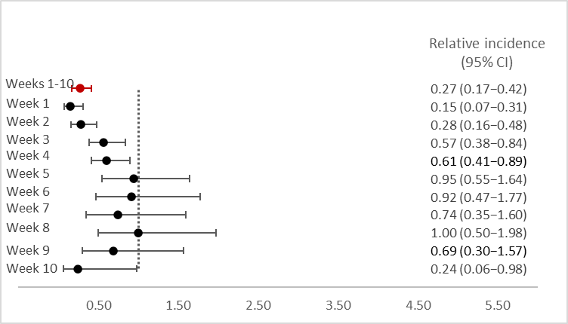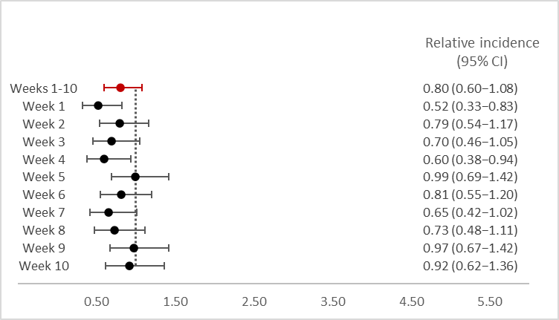

Non-COVID-19 cardiac-related mortality excluding pre-existing cancer and heart disease

§Data from six of the eight VSD sites were included in the analysis of cardiac-related deaths, as the remaining two did not have cause-of-death data for the study period. CI, confidence interval.

Supplementary Figure 4. Overall and weekly relative incidences of primary and secondary outcomes 10 weeks after Ad26.COV2.S vaccination§

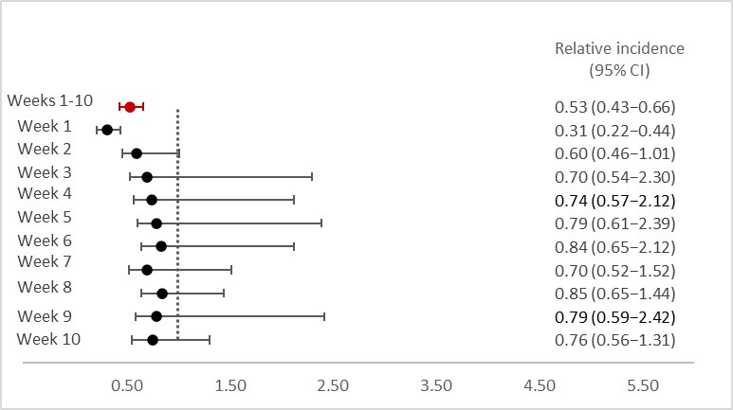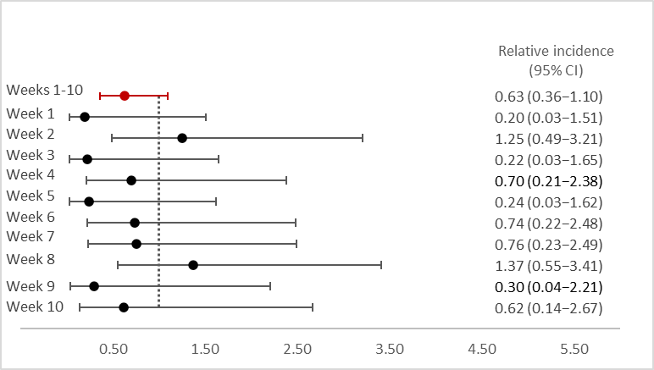

Non-COVID-19 mortality

Cardiac-related mortality

excluding pre-existing cancer and heart disease

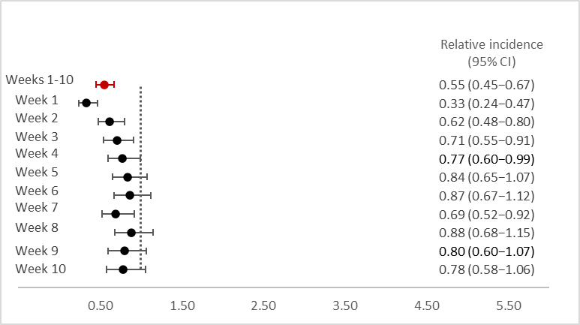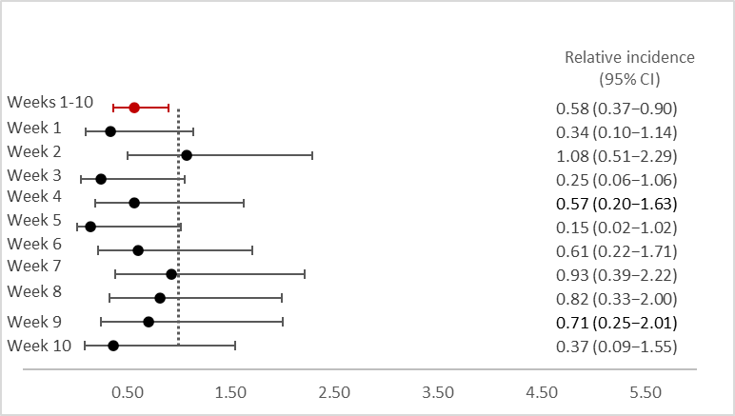

All-cause mortality

Non-COVID-19 cardiac-related mortality

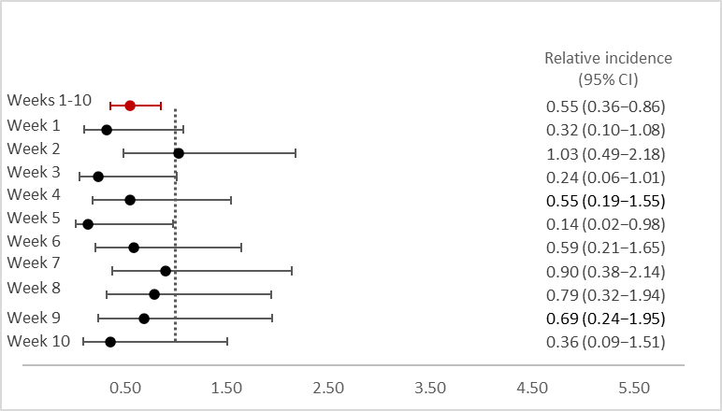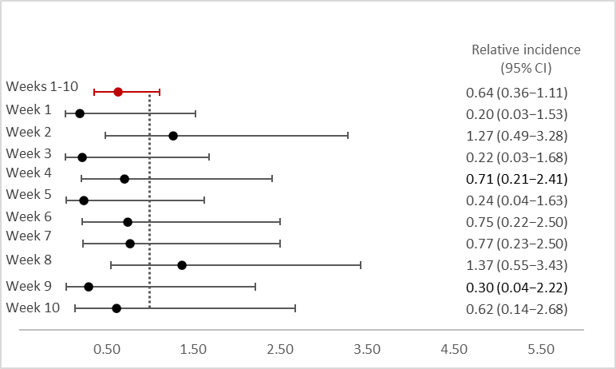

Cardiac-related mortality

Non-COVID-19 cardiac-related mortality excluding pre-existing cancer and heart disease

§Data from six of the eight VSD sites were included in the analysis of cardiac-related deaths, as the remaining two did not have cause-of-death data for the study period. CI, confidence interval.