Supplementary Material

Fundamentals of low-cost aerosol sensor design and operation
James Ouimetteª, W. Patrick Arnott^{b}, Philip Laven^{c}, Richard Whitwell^{d}, Nagarajan Radhakrishnan^{e}, Suresh Dhaniyala^{e}, Michael Sandink^{b}, Jessica Tryner^{f}, & John Volckens^{f}
ªSanta Rosa, CA 95409, USA; ^{b}Department of Physics, University of Nevada, Reno, NV 89557, USA; ^{c}Horley RH6 7DJ, UK; ^{d}Vallejo, CA 94952, USA; ^{e}Department of Mechanical and Aeronautical Engineering, Clarkson University, Potsdam, NY 13699, USA; ^{f}Department of Mechanical Engineering, Colorado State University, Fort Collins, CO, 80523, USA
Contents
S1 Introduction 2
S2 Materials and Methods 2
S2.1 PMS5003 laser profile measurements 2
S2.2 PMS5003 photodiode and signal processing measurements 5
S2.3 Measuring the effect of inlet flow impedance on PMS5003 number concentration and flow rate 7
S2.4 Estimating PMS5003 particle size detection limit with polystyrene latex (PSL) spheres 10
S2.5 Physical-optical particle light scattering model and computer program 13
S2.5.1 Physical-optical particle light scattering model 13
S2.5.2 Particle light scattering computer program PA-PMS 14
S3 Results and Discussion 25
S3.1 PMS5003 laser profile measurements 25
S3.2 Photodiode and signal processing 28
S3.2.1 Detecting and sizing individual smoke particles 28
S3.2.2 Allocating measured pulse amplitude voltages to PMS5003 number concentration channels 32
S3.3 Effect of inlet flow impedance on PMS5003 flow rate and reported number concentration 37
S3.3.1 PMS5003 number concentration CH1 vs differential pressure 37
S3.3.2 Estimating the lower and upper bound PMS5003 flow rate from measurements of the laser beam width and the particle traverse time 40
S3.4 Estimating PMS5003 detection limit with polystyrene latex (PSL) spheres 41
S3.5 Particle light scattering model predictions and comparisons with laboratory data 43
S3.5.1 Model predictions of PMS5003 particle counting efficiency and size attribution 43
S3.5.2 Comparing model predictions with laboratory PMS5003 number distributions 45
S3.5.3 Comparing model scattering coefficient predictions with laboratory data 47
S3.5.4 PMS5003 mass scattering efficiency 48
S3.5.5 Comparing the model-predicted PMS5003 response to relative humidity with laboratory data 48
S3.5.6 Effect of particle refractive index on PMS5003 detection and counting efficiency 53
S3.6 Modeling PurpleAir sampling efficiency with computational fluid dynamics 61
S3.7 Coarse particle transmission losses in the PMS5003 65

S1 Introduction
This supplemental provides a detailed examination of the internal geometry, operating characteristics, and embedded systems within the Plantower PMS5003 sensor (i.e., a device “teardown”). We also provide a description of the light-scattering model used to predict sensor response to aerosols of varying properties. An executable version of the program used to implement this model is also provided in a .zip file as additional supplementary material.

S2 Materials and Methods

S2.1 PMS5003 laser profile measurements
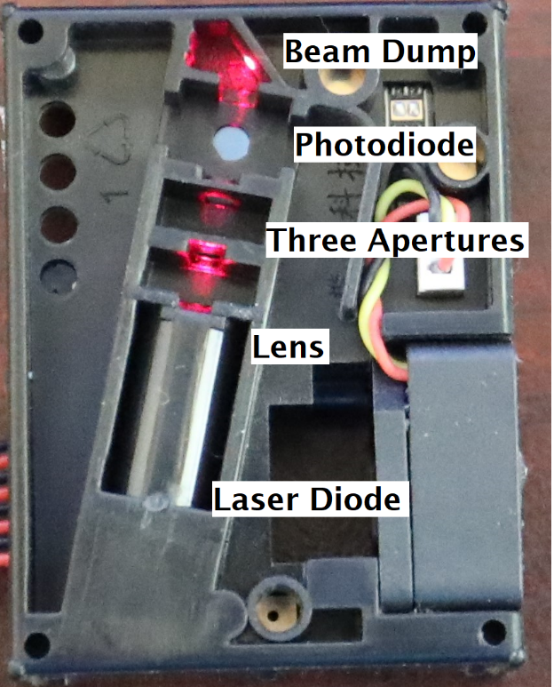
Figure S1 is an annotated image of the laser beam reflections by optical elements in an assembled PMS5003. Ideally the laser beam profile measurements would be performed in an assembled instrument. However, the neutral density filter and Thorlabs WM100 sensor head could not be placed in the region above the photodiode due to space constraints, even after the plastic frame was removed in the area past the photodiode. The apertures reduce stray light flux to the photodiode, though it may also affect the laser beam profile after the last aperture (Zheng et al. 2007). Therefore, we consider the laser beam profile measurements to be our best current values, subject to later revision obtained with an improved optical arrangement. An unsuccessful attempt was made to translate the laser focal region away from the photodiode using a convex lens where measurements of the refocused beam were made; however, these results were highly uncertain and not fruitful. Insights may also be obtained through modeling the beam propagation from the laser diode to the beam dump using the theory presented in (Zheng et al. 2007).
Figure S1. View of the laser beam in an assembled PMS5003. Light from the laser diode is focused by the lens, passes through three apertures, comes to focus above the photodiode, and is deposited in the beam dump.
The Thorlabs WM100 is a beam profiler that uses the knife-edge scanning technique, an established method of beam profiling detailed in ISO 11146-3:2004. With knife-edge scanning, a “knife”—in this case the edge of a scanning drum with an input aperture of diameter 12.7 millimeters (0.5 inches) —allows laser light to pass through as the drum edge begins to scan over the beam spot. This light is then increasingly incident on a photodiode as the drum scans, creating the leading edge of a square wave with a corresponding rise time, until the beam has been scanned completely and intensity reaches a maximum. The process is then reversed and repeated. This signal, known as the monitor, is then passed through a differentiation circuit, then filtered and amplified, which gives a “profile out” signal that can be seen on an oscilloscope. Both the “monitor out” and “profile out” signals were passed into an AKTAKOM ADS-2061M Digital Oscilloscope and recorded for analysis. Then, the rise time, measured from 16% to 84% of maximum intensity using the monitor out signal, combined with the frequency of the rotating drum, nominally 10 Hz, provides all the information needed to obtain a value of the $1/e$ beam diameter using the following equation:
$$D=16002×2π×f×Tr,$$
where D is the “monitor out” voltage, $f$is the frequency provided by the oscilloscope, and $Tr$ as the 16-84% rise time (https://www.thorlabs.com/_sd.cfm?fileName=0224-d05.pdf&partNumber=WM100). The rise time is used by the WM100 to calculate beam diameters without any further user input required. An example of the rise time being manually determined is included in Figure S2.
Figure S2: Example calculation of 16-84% rise time. Since in this example the maximum monitor out is 10000mV, then only the times corresponding to 1600mV and 8400mV signals need to be found for determining the laser beam diameter.
Leads were soldered to the PMS5003 circuit board to provide 3.3 volts for the laser diode operation. The laser focus was identified as the point at which the waist diameter of the beam (measured by the WM100) reaches a minimum when using a fine alignment block with the WM100 optical head bolted onto it. The alignment block is also used to measure changes in beam diameter as a function of distance z away from the laser diode (the beam diverges with increasing z, and the focal region of the beam is miniscule). The dial gauge was then put into place by securing it to the optical table and fitting the gauge onto a flat tightening screw. Images of this configuration are included as Figure S3. Then, after reaching focus, the WM100 optical head was translated away from the diode in the direction of beam propagation, with diameters recorded every ${10}^{-3}$ inch. For the first PMS5003, the parallel-to-photodiode surface was measured up to $70×{10}^{-3} inch =1.778$mm and the perpendicular-to-photodiode surface up to $56×{10}^{-3} inch =1.422 mm$. The second PMS5003 parallel-to-photodiode surface was measured up to $z=30×{10}^{-3} inch=0.762 mm$ at every ${10}^{-3} in$ch and past that point for every ${10}^{-2} inch$ until $z=60×{10}^{-3} inch=1.524 mm$.
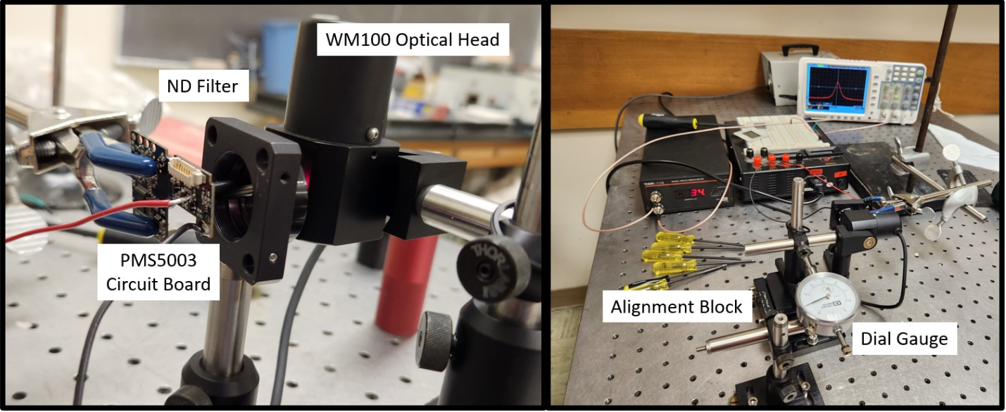
Figure S3: Laser diode set-up. A “ND = 0.1” neutral density filter is placed between the laser and the optical head to prevent overloading the WM100. The laser diode was bent at 90 degrees to the plane of the PMS5003 circuit board for measurements. As pictured on the left, the knife edge of the WM100 is moving perpendicular to beam polarization. The right photo shows the WM100 being connected to the ADS-2061M oscilloscope as it measures the direction parallel to the photodiode, as well as the dial gauge used to measure distance z from the focused beam diameter.

S2.2 PMS5003 photodiode and signal processing measurements
To examine the PMS5003 signal processing in detail, the microprocessor family was confirmed to be a Cypress Programmable System-On-Chip (PsoC) 4200. The operational amplifier output directly related to the photodiode response was found to be Pin 45. The output of the photodiode is conditioned by an active filter comprising passive surface-mount components on the circuit board and an operational amplifier included within the microprocessor.
Direct current (DC) signals, such as stray light on the photodiode, are suppressed by the high pass filter. Any nearly constant Rayleigh scattering from air and nephelometer calibration molecules CO₂ and Suva® (DuPont™ Suva® 134a refrigerant) would be seen as DC and, therefore, would be suppressed by the high pass filter. This was confirmed in laboratory experiments in which a PMS5003 sensor sampled filtered CO₂ and Suva® for one hour each and reported the CH1 (total number concentration) at the same low value as HEPA-filtered air.
We monitored the analog output at the closest passive component connected to pin 45 of the Cyprus microprocessor, as shown on Figures S4 and S5. Connections to the amplifier output and the laser diode power connection were made, referenced to the 0v power supply at pin 2 of the edge connector. A PicoScope logging application (PicoScope 6 – PC Oscilloscope software version 6.14.61.6219) was used to record and decode the analog photodiode signals as well as the serial data transmitted from the PMS5003 for each laser pulse.
Figure S6 shows a partially disassembled PMS5003, modified for testing. The laser diode housing is shown in the middle; note also the miniature fan and its connector, and 3 compression springs in place. Figure S7 shows the output connections, temporarily connected to one of the passive components on the circuit board, adjacent to the Cyprus microprocessor and to the supply power connection of the laser diode.
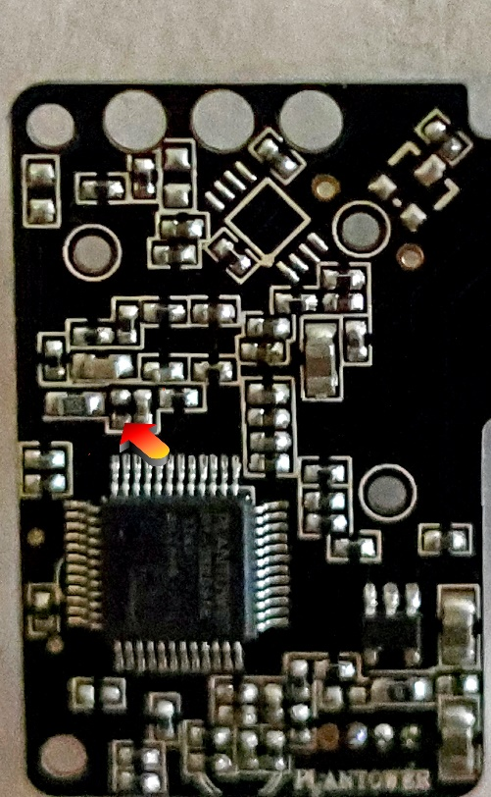
Figure S4: The pin used to probe amplified photodiode output
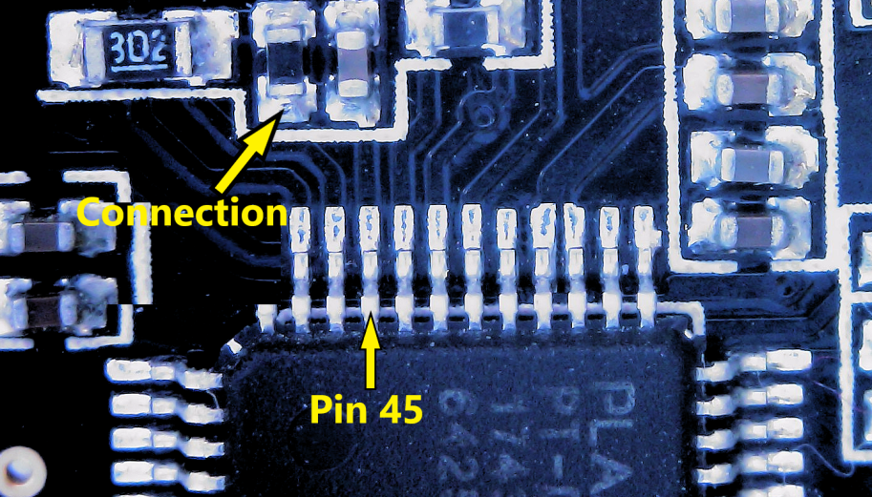

Figure S5: Zoomed in view of the amplified photodiode signal output pins

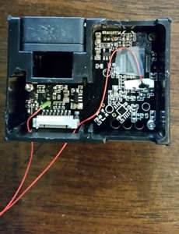

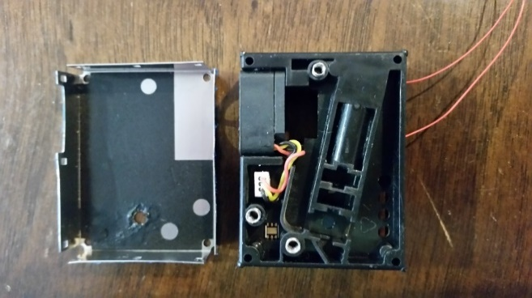

Figure S7: Connections used to provide power to the laser
Figure S6: Disassembled PMS5003 unit used for testing

In operation, the laser diode does not run continuously but is pulsed at a rate and duration depending on the previous particle counts. A typical pulse duration is approximately 600 milliseconds. The measured interval between pulses / measurement varied between 0.9 and 2.6 seconds.
Following the termination of the laser pulse, and less than 150 milliseconds later, the microprocessor’s digital outputs provide three groups of data, using a quasi-RS232 9600 baud serial transmission, the principal output being 6 channels representing particle size, plus PM₁, PM_{2.5}, and PM₁₀. Data transmissions from the PMS5003 occur at regular intervals, typically 0.78 seconds.

S2.3 Measuring the effect of inlet flow impedance on PMS5003 number concentration and flow rate

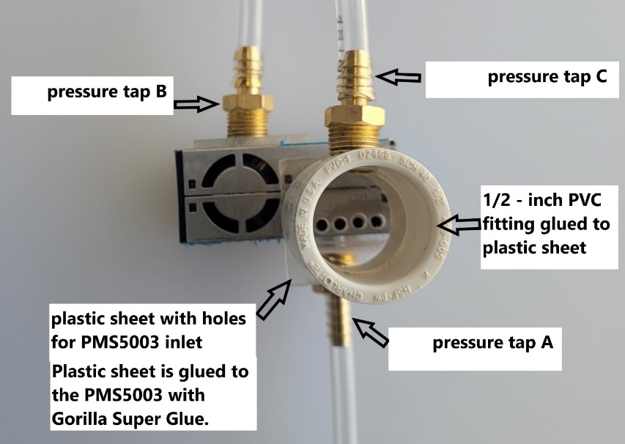
The PMS5003 uses a miniature fan to pull air through the sensor. If there is an impediment to the inlet flow, the fan will pull a slight vacuum at the inlet and the flow rate may drop. If the PMS5003 is an optical particle counter, the reported PMS5003 number concentration should drop proportionally to the drop in flow rate. To measure the PMS5003 flow rate and inlet differential pressure while varying the upstream pressure, the inlet of the PMS5003 was modified to allow a direct connection with a ½ inch PVC Schedule 40 tube. A plastic sheet (LEXAN™ 0.093-inch-thick polycarbonate) with holes drilled out for the PMS5003 inlet holes was glued (Gorilla Super Glue) to the PMS5003, and the PVC tube was glued to the polycarbonate. Two 1/8-inch diameter holes were carefully drilled into the PMS5003, directly downstream of the inlet holes (Pressure tap A) and directly upstream of the fan exhaust (Pressure tap B).
Figure S8. Modifications to PMS5003 for pressure and flow rate measurements.
Two barbed connector fittings (3/16” Barb to 1/8” Male NPT Adapter Brass Hose) were screwed into pieces of polycarbonate sheet and then glued to the PMS5003 over the pressure tap holes A and B, as shown on Figure S8. The connections were leak tested, and then connected to the differential pressure gauge (MAGRFHELIC TE-2000, 0-30 Pascals) with 3/16” ID vinyl tubing. Pressure tap C was installed in the PVC fitting to provide inlet differential pressure.
To measure how the PMS5003 number concentration, inlet differential pressure, and flow rate were affected by upstream flow impedance, ambient air was drawn through orifices of varying diameters into the PMS5003. The orifices were drilled in 27-millimeter diameter, 2.0-millimeter-thick acrylic discs. The hole diameters ranged from 0.50 mm to 5.95 mm. The disc was placed in a ½-inch PVC compression repair coupling, leak tested, and connected to the PMS5003 with a ½-inch PVC tube, as shown in Figure S9.
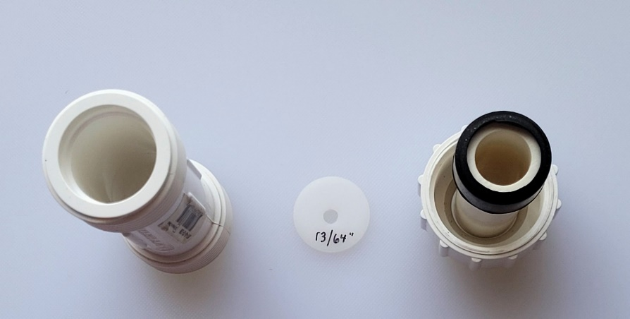
Figure S9. Acrylic disc with orifice and PVC compression repair coupling to form a leak-free seal.
The setup is shown in Figure S10. Each run consisted of collecting 10 minutes of ambient flow without the orifice, followed by 10 minutes of flow through the orifice, then followed by 10 minutes of flow without the orifice. This procedure was repeated for 20 different orifice diameters. PMS5003 2-minute average number and mass concentrations were stored on a microSD card connected to a PurpleAir printed circuit board. The differential pressure gauge was zeroed during each no-orifice run, and then manually read and logged during each orifice run. The measurement precision is estimated to be +/- 0.1 Pascal following this procedure.

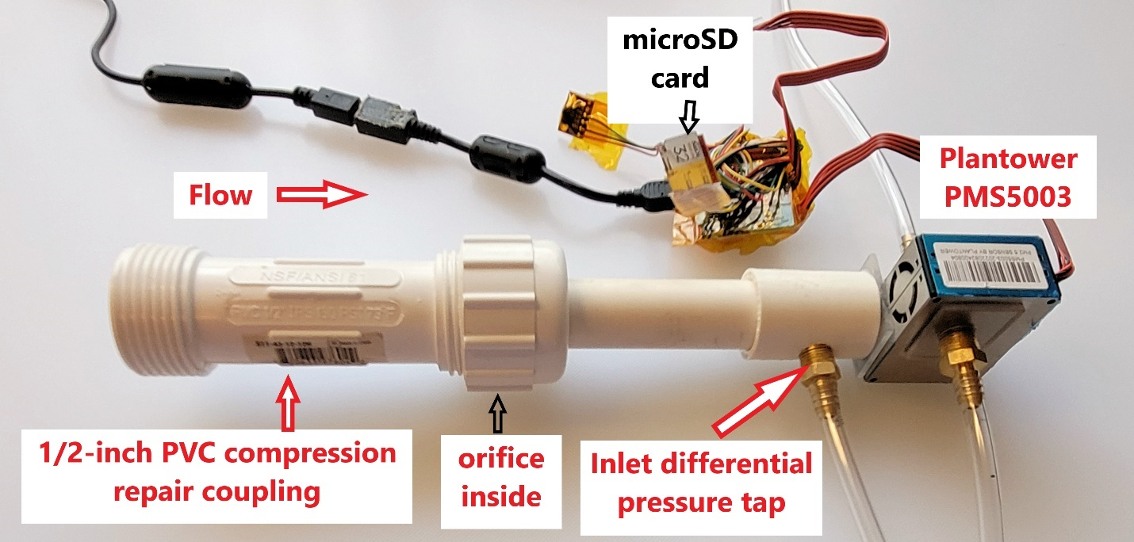
Figure S10. Setup for measuring the impact of differential pressure on PMS5003 number and mass concentration.

We used a similar setup to measure the flow rate with a mass flow meter (Model 4143, TSI, Shoreview, MN, USA), shown in Figure S11. The PMS5003 drew ambient air through the flow meter. The PMS5003 number and mass concentration, the differential pressure at the PMS5003 inlet, and the TSI 4143 flow rate were measured for two PMS5003 sensors.
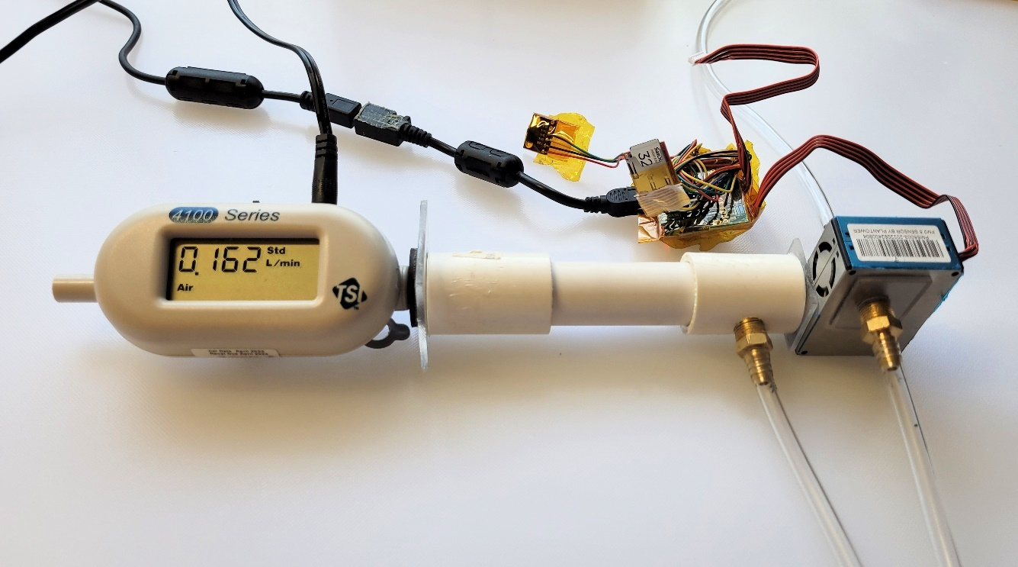
Figure S11. Flow meter connection to the PMS5003.

S2.4 Estimating PMS5003 particle size detection limit with polystyrene latex (PSL) spheres

This laboratory experiment was repeated twice: once using 0.1 μm PSL (G100, Thermo Scientific, Fremont, CA, USA) and once using 0.2 μm PSL (NT07N, Bangs Laboratories, Fishers, IN, USA).

Four drops of 1% solids (w/v) PSL suspension (were added to 40 mL of LCMS-grade water (WX0001, MilliporeSigma, Burlington, MA, USA). This mixture was sonicated for a few minutes and then placed in a six-jet Collison nebulizer (CH Technologies, Westwood, NJ, USA). A continuous supply of HEPA-filtered (HC21-4N-PTF, Eta Filters, Aerocolloid, Minneapolis, MN, USA) compressed air, at 151.7 kPa (22 psig), was supplied to the nebulizer inlet. The aerosol leaving the nebulizer was mixed with another ~1.5 L min⁻¹ of HEPA-filtered (HC10-4N-PTF, Eta Filters) compressed air to help dry the aerosol. The aerosol then passed through a Po-210 neutralizer before entering an electrostatic classifier (Model 3082, TSI, Shoreview, MN, USA). The electrostatic classifier was operated with a sheath air flow rate of 13 L min⁻¹. Differential mobility analyzer (DMA) voltages of 1880.0 V and 6062.6 V were used to select 0.100 µm and 0.200 µm particles, respectively.
The monodisperse aerosol leaving the DMA and another ~6 L min⁻¹ of HEPA-filtered (HC10-4N-PTF, Eta Filters) compressed air were fed into a 520 × 445 × 395-mm (interior dimensions) acrylic-walled enclosure that contained eight PMS5003 sensors (Figure S12). All eight sensors were purchased in 2019 but had not been used previously. Data from the PMS5003 sensors—including PM₁, PM_{2.5}, and PM₁₀ mass concentrations (µg m⁻³) with correction factors of 1 (“CF=1”); PM₁, PM_{2.5}, and PM₁₀ mass concentrations (µg m⁻³) with “atmospheric” correction factors; as well as number concentrations of particles beyond 0.3, 0.5, 1.0, 2.5, 5.0, and 10 µm (# dL⁻¹)—were logged to a text file at 3-s intervals using two NUCLEO-F767ZI development boards (STMicroelectronics, Geneva, Switzerland), custom firmware written in Mbed (Arm Mbed, Cambridge, UK), and a custom MegunoLink interface (Number Eight Innovation Limited, Hamilton, New Zealand).
The size distribution of the aerosol inside the enclosure with the PMS5003 sensors was monitored using a scanning mobility particle sizer (SMPS; Model 3082 Electrostatic Classifier and Model 3787 Condensation Particle Counter, TSI, Shoreview, MN, USA). The aerosol passed through a Kr-85 neutralizer (3012A, TSI) before entering the SMPS. The SMPS was operated with sample (i.e., aerosol) and sheath air flow rates of 0.6 L min⁻¹ and 4.0 L min⁻¹ along with scan, retrace, and purge times of 120 s, 3 s, and 15 s, respectively. Using these settings, the SMPS was able to size and count particles with electrical mobility diameters between 13.3 and 582.9 nm.
Aerosol supply and sampling lines were constructed using a combination of conductive (i.e., stainless steel or brass) metal tubing and static-dissipative rubber tubing. For each PSL size, the flow rates of aerosol and air described above were maintained for at least 60 minutes to allow the aerosol concentration inside the acrylic enclosure to reach a steady-state condition. Data from the PMS5003 sensors and the SMPS were logged for the entire >60-minute duration but, for each PSL size, only data from a 15-minute long steady-state period were used for analysis.
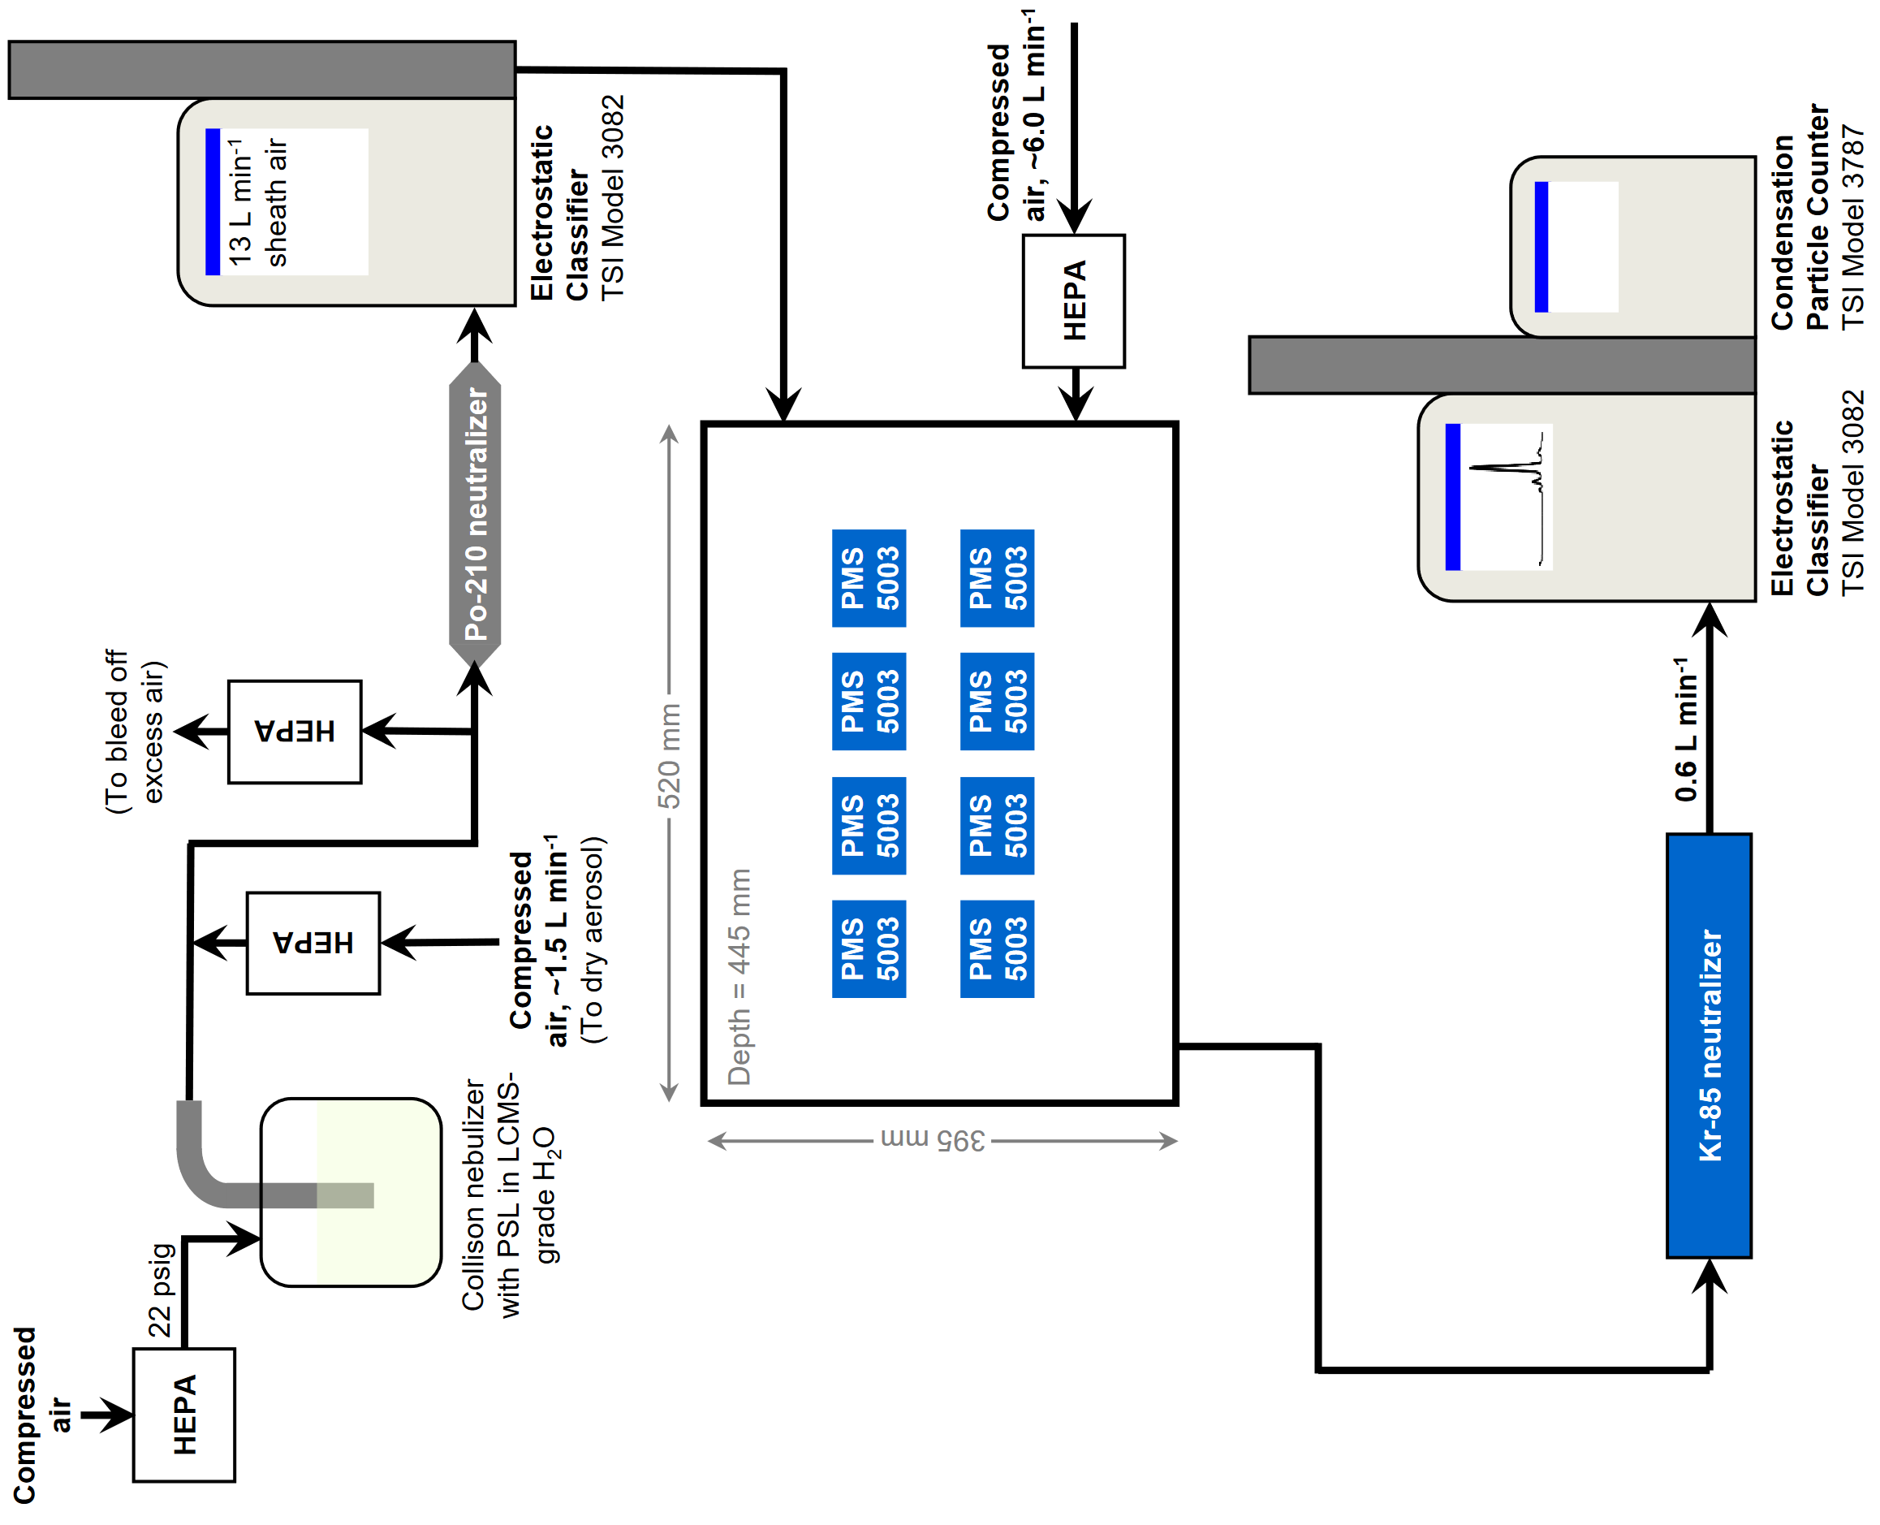
Figure S12. A diagram of the experimental setup used to test the ability of PMS5003 sensors to measure 0.100 µm and 0.200 µm particles. Differential mobility analyzer voltages of 1880.0 V and 6062.6 V were used to select 0.100 µm and 0.200 µm particles, respectively.

S2.5 Physical-optical particle light scattering model and computer program

S2.5.1 Physical-optical particle light scattering model

Gaussian vs plane wave calculations
This section shows that the plane wave Mie calculations can be used within the Gaussian beam for particles less than 10 µm diameter. MiePlot uses a slightly extended version of J. A. Lock’s algorithm for scattering by a Gaussian beam. The details of the changes are provided in Scattering of Gaussian beams by spherical particles (www.philiplaven.com/p3d.html):
Numerical evaluation (www.philiplaven.com/p3d1.html)
Selecting the calculation parameters (www.philiplaven.com/p3d2.html)
Overflow problems (www.philiplaven.com/p3d3.html)
Plane wave Mie calculations give almost identical results to “Gaussian beam” Mie calculations when the particle radius is much smaller than the beam spot radius (w₀) (e.g., when r = 5 µm and w₀ = 17.5 µm). This can be seen in Figure S13.
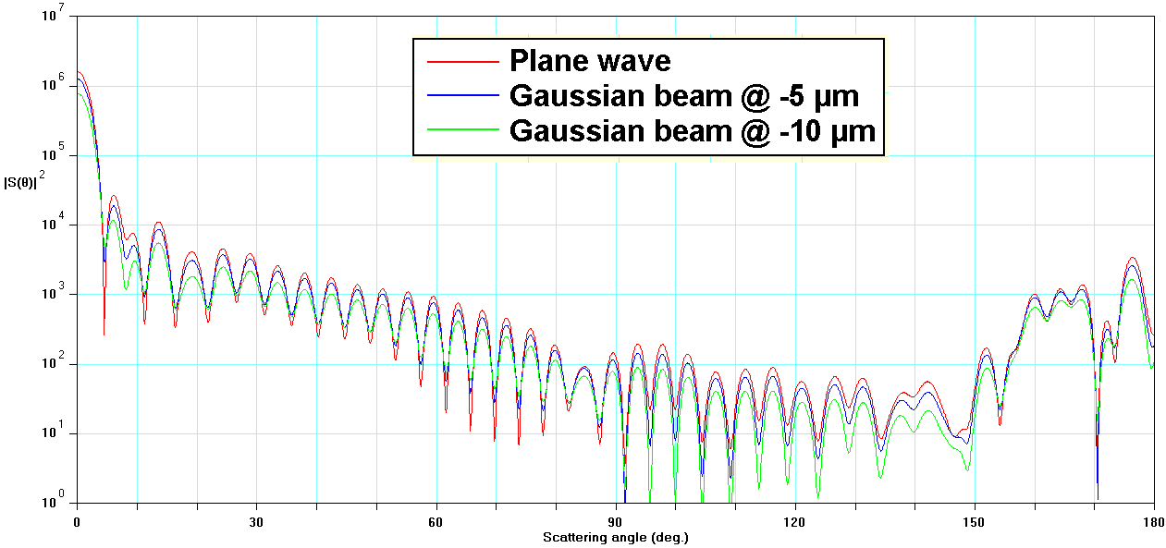
Figure S13. Comparing Gaussian beam (w₀ = 17.5 μm) and plane wave calculations of |S₁(θ)|² for a sphere of diameter D_{p} = 10 μm and refractive index 1.52 + i0.002.

The red curve in Figure S13 shows scattering of a plane wave by a particle of diameter D_{p} = 10 μm, whereas the blue and green curves show the effect of offsetting a Gaussian beam (w₀ = 17.5 μm) by 5 μm and 10 μm respectively from the center of the particle. The differences are relatively small for particles as large as D_{p} = 10 μm. However, plane wave calculations would not be appropriate for larger particles where w₀ < D_{p}.

Figure S13 shows that the result for a Gaussian beam aligned with the center of the particle is almost identical to the plane wave result. Bearing in mind that PMS5003 sensor is triggered by the scattered signal reaching its maximum intensity; it does not make any significant difference if we choose the plane wave Mie calculation or the more sophisticated Gaussian beam calculation. Also bearing in mind that the light incident on the PMS5003 photodiode is further smoothed by the combination of scattering over a range of scattering angles, we are confident that Gaussian beam calculations are not necessary.

S2.5.2 Particle light scattering computer program PA-PMS
This section describes the computer program designed to simulate the light scattering processes in the PMS5003 sensor – as outlined in references 1 and 2 below. The user interface is shown in Figure S14.
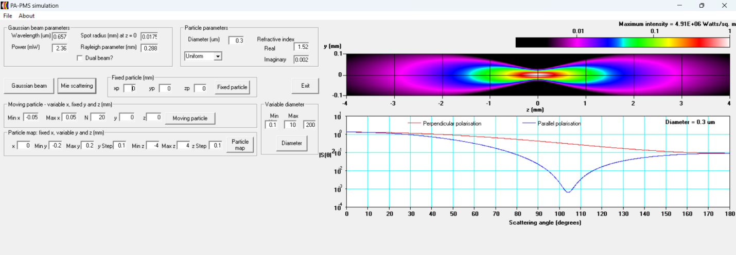
Figure S14. User interface for the PA-PMS computer program.
The program assumes the following characteristics of the laser beam:
- Wavelength: λ = 657 nm;
- Nominal power: P = 2.36 mW;
- Beam spot radius at focal point (x = 0, y = 0, z = 0): w₀ = 17.5 μm;
- Rayleigh length; z₀ = 0.288 mm.
Although these are the program’s default values, users can easily define other values of these parameters.
When the program starts, the user can accept the default beam parameters (or enter different values) and then click on the Gaussian beam command button (see Figure S15) which uses the following equations (Moosmüller and She, 1991) to calculate the intensity I_{p} of the beam at an arbitrary point (x, y, z).

r = (x² + y²)^{0.5}
t = [1 + (z / z₀)²]^{-0.5} exp[-(r / w₀)² / (1 + (z / z₀)²)]
I_{max} = P / (0.5 π w₀²)
I_{p} = t² I_{max}

as shown in Figure S15 below.
Figure S15. Gaussian beam parameters and the Gaussian beam command button
The Gaussian beam profile is shown in Figure S16.
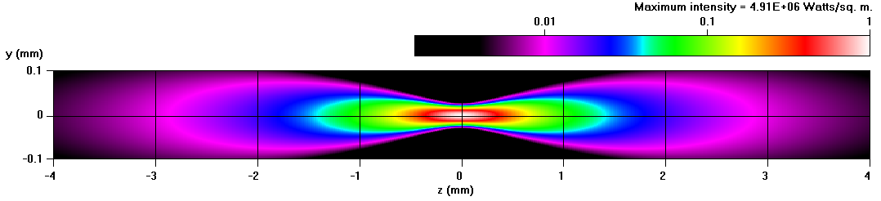
Figure S16. Gaussian beam profile in the–y - z plane for the default parameters.
Note that the vertical y scale in Figure S16 has been greatly exaggerated to show the beam profile more clearly. The maximum intensity I_{max} = 4.91 × 10⁶ W m⁻² occurs at the focal point of the laser beam (x = 0, y = 0 and z = 0). The bright purple colors in Figure S16 (e.g., at y = 0 and z ≈ ±2.8 mm) correspond to areas where the incident intensity is about 1% of the maximum intensity. As we have assumed that the Gaussian beam is symmetrical about the z-axis, the beam profile in the x – z plane would be identical to the profile in the y – z plane shown in Figure S16.

Intensity of light scattered by a particle
The program first uses Equation 3 to calculate the laser beam intensity as a function of position, then it uses Equations 2 with Mie theory to calculate the scattering pattern of a single spherical particle. After specifying the basic parameters of the particle in the user interface, (see Figure S17) clicking on the Mie scattering command button generates a graph of the scattering pattern (see Figure S18).
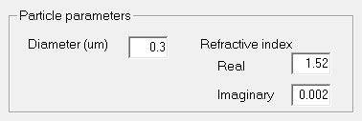
Figure S17. Specifying the parameters of the particle.
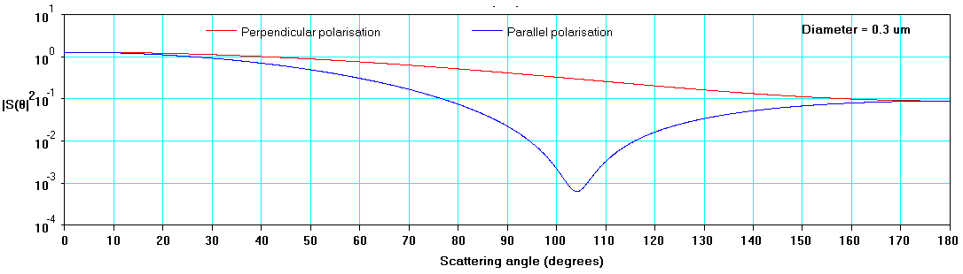
Figure S18. Mie theory results showing |S₁(θ)|² and |S₂(θ)|² for the particle specified in Figure S17.
The response of the photodiode depends on the light’s angle of arrival. The maximum response occurs when the light is orthogonal to the surface of the photodiode as in the numerical example (i.e., α = 0°). At other angles, the response is modeled by the cos(α) term in Equation (2) in the Main article:
$I=I_{p}\frac{\left({\left|S_{1}\left(θ\right)\right|}^{2}\cos^{2}\left(ϕ\right)+{\left|S_{2}\left(θ\right)\right|}^{2}\sin^{2}\left(ϕ\right)\right)\cos\left(α\right)}{k^{2}d^{2}}$ (2)
Taking a numerical example, we can calculate the intensity I of the light arriving at the center of the photodiode (x_{d} = 0, y_{d}= -1.8 mm, z_{d} = 0) after having been scattered by a particle of 0.3 μm diameter with refractive index m = 1.52 + i 0.002 located at (x_{p} = 0 y_{p} = 0, z_{p} = 0) where the laser beam intensity I_{p} = 4.91 × 10⁶ Wm⁻². In this case, as θ = 90°, φ = 0° and α = 0°, Mie theory calculations for d = 1.8 mm, give |S₁(θ)|² = 0.4176 (as shown in Figure S18). Applying these values in Eq. (2), we find that I ≈ 6.92 × 10⁻³ Wm⁻².
We will see later that the value of I varies across the face of the photodiode. Consequently, it is useful to divide the photodiode into a grid of 100 x 100 small squares (i.e., 10,000 squares) and then calculate I for each square. As the active area of the photodiode is 2.73 mm × 2.73 mm [4], each small square has an area A = 7.45 × 10⁻¹⁰ m². The power of the light incident on a given small square is I × A watts: for example, at the center of the photodiode, the power incident on the small square at (x_{d} = 0, y_{d}= -1.8 mm, z_{d} = 0) is ≈ 6.92 × 10⁻³ Wm⁻² × 7.45 × 10⁻¹⁰ m² ≈ 5.15 × 10⁻¹² W.

Fixed Particle

Figure S19. Performing calculations for a fixed particle.
Using the dialog box shown in Figure S19, the program can perform calculations for a fixed particle at (x_{p}, y_{p}, z_{p}) and then display the results in the form of diagrams showing the variation of received power across the photodiode in the x – z plane – as illustrated by Figure S20 for a 0.3-μm diameter particle:

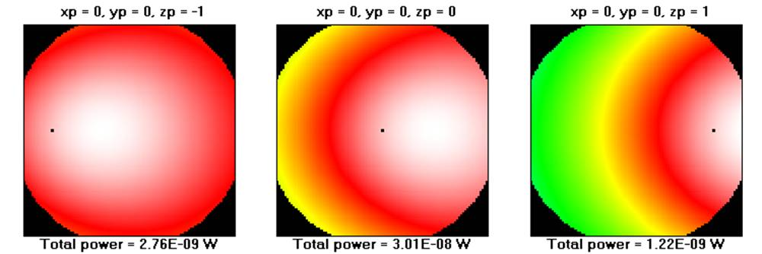

Figure S20. Diagrams representing the power distribution of the scattered light across the surface of the photodiode for a 0.3-μm diameter particle at the specified values of (x_{p}, y_{p}, z_{p}).
The black dots show the location of the particle in the x – z plane.

Although the photo-sensitive area of the photodiode is 2.73 mm x 2.73 mm square, its active area is restricted by a 3-mm diameter hole which is centered above the photodiode. This prevents some parts of the photodiode receiving any light – as indicated by the black areas in Figure S20.

For particles with larger diameters, the Mie theory curves exhibit multiple maxima and minima, as shown in Figure S21 for a 2-μm diameter particle.
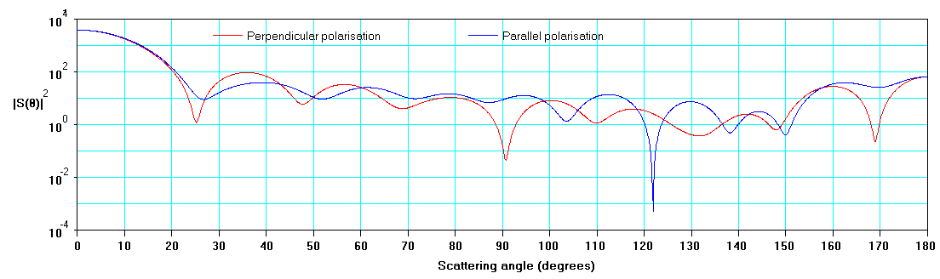
Figure S21 Mie theory calculations for a spherical particle of 2-μm diameter with refractive index m = 1.52 + i 0.002.
The diagrams showing the power distribution across the photodiode also become much more complicated when the particle diameter is increased, as illustrated in Figure S22 for a 2-μm diameter particle. In this example, the particle is located at x_{p} = 0 and y_{p} = 0 with values of z_{p} between z_{p} = -3 mm and z_{p} = +3 mm.

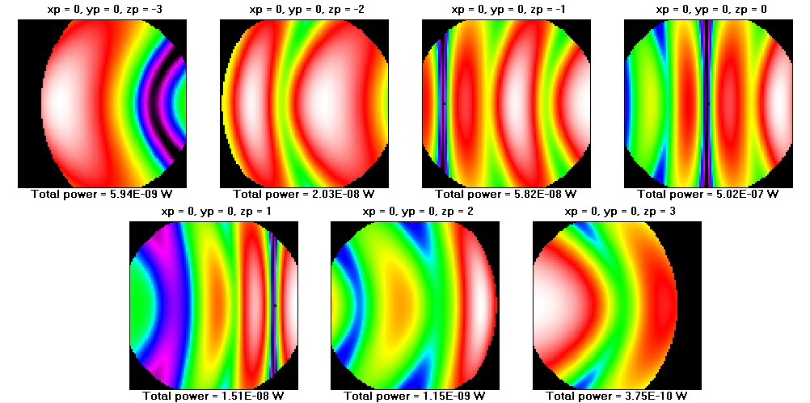

Figure S22. Diagrams representing the power distribution across the surface of the photodiode
for scattering by a particle of 2-μm diameter at the specified location (x_{p}, y_{p}, z_{p}).
As in Figure S20, the black areas in Figure S22 show the blocking effects of the cylindrical hole above the photodiode. An additional effect occurs when the particle’s (x_{p}, y_{p}) coordinates are more than 1.5 mm from the center of the photodiode (x_{d} = 0, y_{d} = 0). For example, when z_{p} = -3 mm, the particle is not visible from some parts of the left side of the photodiode due to shadowing by the 0.46 mm high wall of the cylindrical hole. Similarly, when z_{p} = + 3 mm, the shadow affects the right side of the photodiode.

Particle Map
To understand the effects of a single particle at different positions relative to the laser beam, the program includes the Particle Map option (see Figure S23 below) in which the scattered power (as measured by the photodiode) can be computed for a particle at a fixed value of x_{p} across a range of values of y_{p} and z_{p}. The Particle Map option is used in Section 3.5.1 to estimate the PMS5003 particle counting efficiency and size attribution for particles ranging from 0.30 μm to 10 μm.
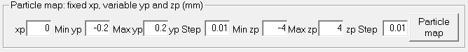
Figure S23. The Particle map option
Figure S24 shows results obtained using the Particle Map option for selected particle diameters D between 0.3 μm and 10 μm for x_{p} = 0. The maximum scattered power occurs when the particles are close to the focal point (y = 0 and z = 0) of the Gaussian beam. However, unlike the Gaussian beam, the particle maps are not symmetrical: in all cases, the scattered power is higher when z_{p} = -2 mm than when z_{p} = 2 mm. This disparity becomes larger as the particle diameter D is increased because forward-scattering (θ < 90°) becomes much stronger than backward-scattering (θ > 90°) as D is increased.
Note that the Particle Map option can be computationally intensive because it involves many calculations, especially if the values of y_{p} step and z_{p} step are small.


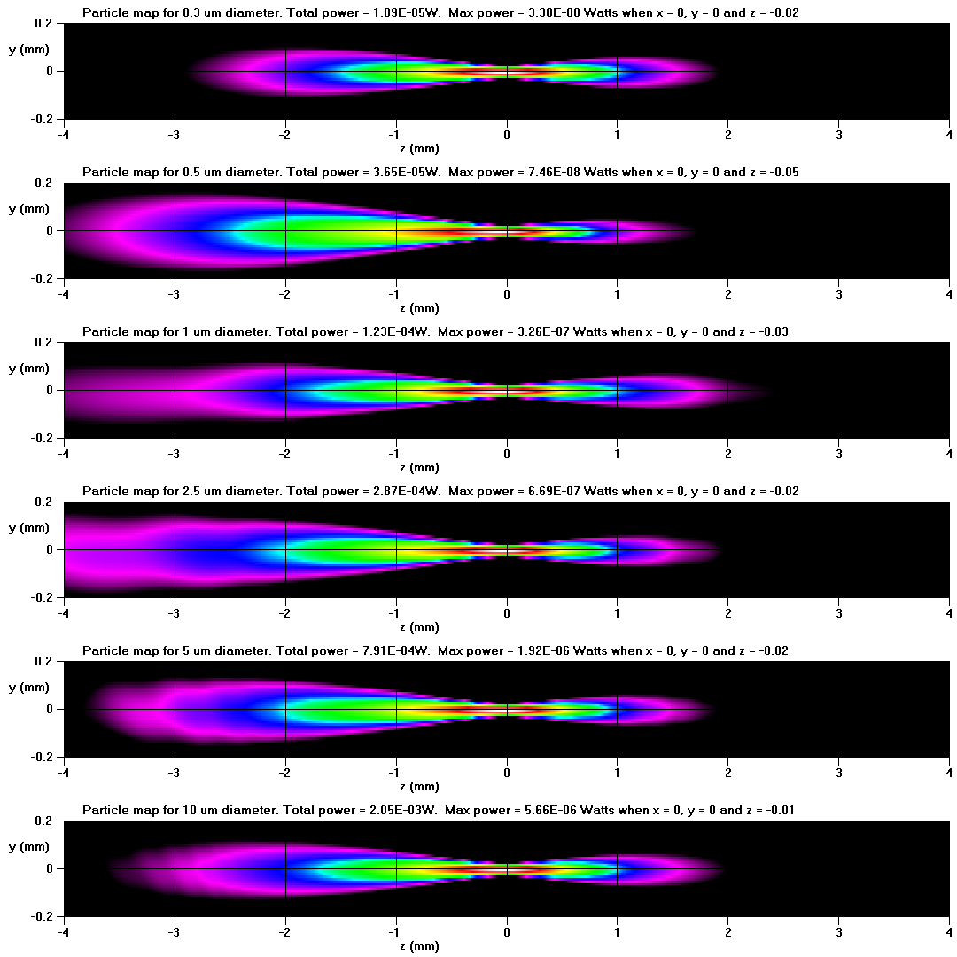
Figure S24. False-color maps showing the variation of scattered power for x_{p} = 0 as a function of y_{p} and z_{p} for particles with the specified value of diameter D.
After a Particle Map has been completed, the File menu includes the option Save Particle Map results as a text file which saves the detailed numerical results corresponding to each (y_{p}, z_{p}) value in the Particle Map. Having saved the results in a .txt file, it is helpful to copy the results into a spreadsheet (e.g., Excel) for further analysis.
These Particle Map text files also include an analysis of the cumulative probability of the power measured by the photodiode for all the particle locations, as shown in Figure S25 below.
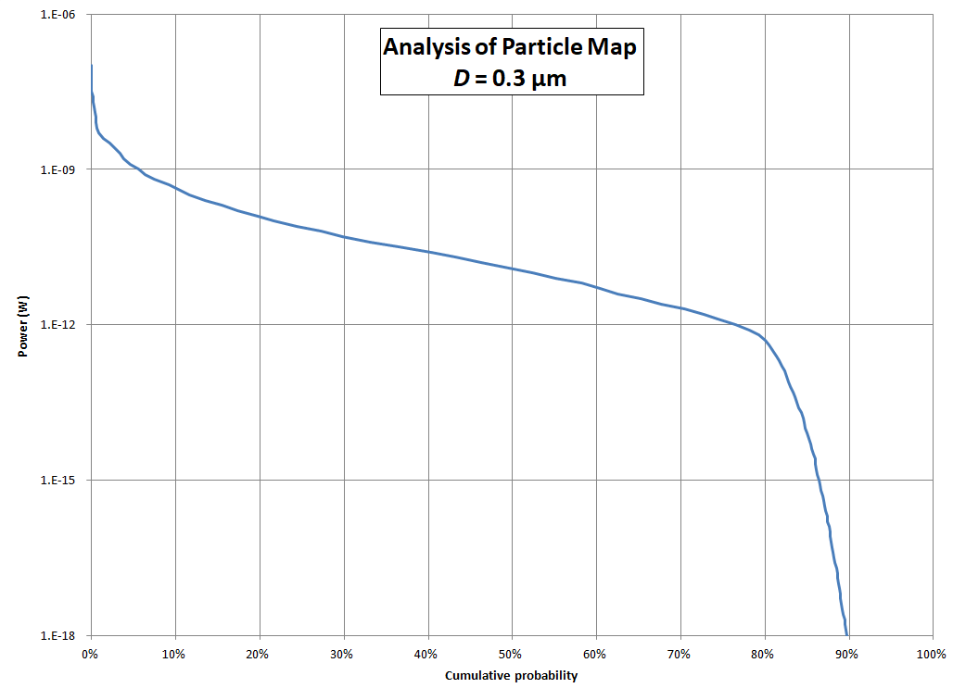
Figure S25. Cumulative probability of power measured by the photodiode for a given particle map.
The graph in Figure S25 indicates that:
- about 5% of particle locations result in measured powers greater than 10⁻⁹ Watts;
- about 10% of particle locations result in measured powers greater than 4.5 × 10⁻¹⁰ Watts;
- about 50% of particle locations result in measured powers greater than 1.25 × 10¹¹ Watts.

Effects of polarization
Although it is assumed that the photodiode is insensitive to polarization, it is important to take account of (a) the polarization of the laser beam and (b) the polarization of the light scattered by a particle towards the photodiode. Equation (2) indicates that the power scattered towards the photodiode is proportional to the sum of |S₁(θ)|² cos²(φ) and |S₂(θ)|² sin²(φ). The first term represents the contribution from perpendicular polarization, whereas the second term represents the contribution from parallel polarization.
As indicated by Particle Map, particles very close to the focus of the laser beam scatter much more power than those away from the focus. Recalling that φ is the tilt of the scattering plane relative to the vertical, the terms cos²(φ) and sin²(φ) indicate that the scattered light is entirely perpendicularly polarized when φ = 0 (i.e., x_{p} = x_{d}). However, when x_{p} ≠ x_{d}, then φ ≠ 0, which implies that parallel polarized scattered light cannot be ignored. The diagrams in Figure S26 below show that parallel polarization makes no contribution along the horizontal center line (because x_{p}- x_{d} = 0 and, hence, φ = 0), but it becomes more important towards the edges of the photodiode.

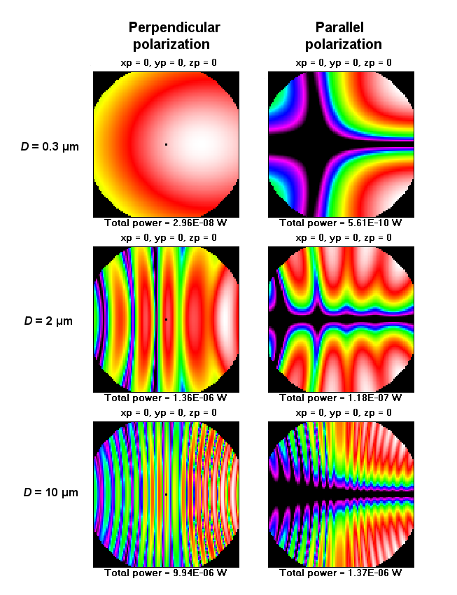
Figure S26. Diagrams representing the power distribution of the scattered light across the x_{d} - z_{d} surface of the photodiode for perpendicular and parallel polarizations as a function of diameter D for a particle at (x_{p} = 0, y_{p} = 0, z_{p}= 0).
Looking at the total powers shown underneath the diagrams for each value of diameter D in Figure S26 suggests that perpendicular polarization is dominant. Exactly how dominant is illustrated in Figure S27 where the contributions from perpendicular polarization are greater than those from parallel polarization by a factor of almost 100 when D = 0.1 µm and about 10 when D ≥ 0.4 µm.
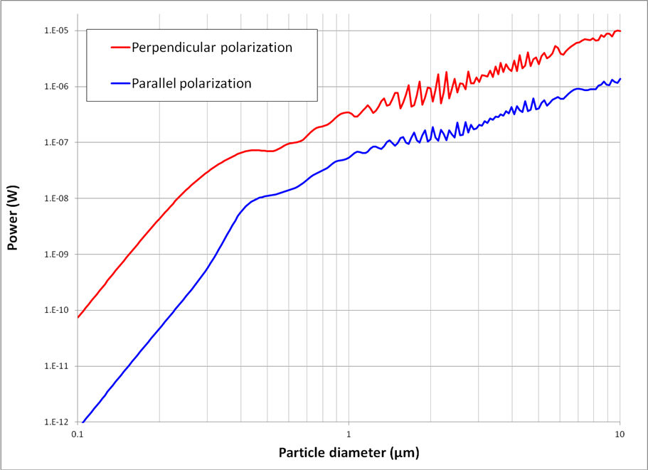
Figure S27. Contribution of parallel and perpendicular polarization to scattered light power to the PMS5003 photodiode. The particles have refractive index m = 1.52 + i 0.002 and they are located at x_{p} = 0, y_{p} = 0, z_{p} =0.
References for S2.5
- J. R. Ouimette, W. C. Malm, B. A. Schichtel, P. J. Sheridan, E. Andrews, J. A. Ogren and W. P. Arnott, “Evaluating the PurpleAir monitor as an aerosol light scattering instrument”, Atmos. Meas. Tech., 15, 655–676 (2022).
- J. R. Ouimette et al, Supplement of “Evaluating the PurpleAir monitor as an aerosol light scattering instrument”, Supplement of Atmos. Meas. Tech., 15, 655–676 (2022).
- H. Moosmüller and C-Y. She, “Equal intensity and phase contours on focused laser beams”, IEEE J. Quantum Electronics, 22, 869-874 (1991).
- Osram Technical specification: BPW-34 v. 1.7 (2019) (https://www.vishay.com/docs/81521/bpw34.pdf)
- C. F. Bohren and D. R. Huffman, Absorption and Scattering of Light by Small Particles, Wiley-VCH, Weinheim (2004).

S3 Results and Discussion

S3.1 PMS5003 laser profile measurements
To obtain the Rayleigh length $z_{0}$, the laser profile data were plotted in Excel and the summed squared error between the model given in Moosmuller and She (1991) for beam diameter as a function of z and experimental values was found. This error was then minimized using the Solver tool in Excel, which provides $z_{0}$. The results from this fitting are shown below in Figure S28 for the parallel-to-photodiode axis, and in Figure S29 for the PMS5003 perpendicular-to-photodiode axis.
Figure S28: Laser beam diameters for the perpendicular-to-photodiode axes of two separate PMS5003s, compared to the model values for beam radius given in Equation 1 and shown on the figure. While not exact, both diodes correspond closely, suggesting a waist diameter of $0.035-0.040 mm$ for the PMS5003 laser in this direction. PMS1 exhibited a Rayleigh length $z_{0}=$ $0.288 mm$, whereas PMS2 showed $z_{0}=0.305 mm$.
Figure S29: The perpendicular-to-photodiode axis compared to the model Equation (1) in the Main article. This axis does not fit the form of the model well; this is very likely due to excess laser light hitting the WM100 in the absence of the apertures that are built into the PMS5003 plastic housing. A waist diameter of 0.064 mm and a Rayleigh length of 0.235 mm were found for this axis.

Figure S30 shows the focused Gaussian laser beam intensity within the PMS5003 aerosol transport channel. The transport channel is 6 mm high and 8 mm wide. These results show that the transport channel is dark for the great majority of the particles that flow past the laser beam. Only a small fraction of the particles would intercept the laser. Small particles would need to intercept the beam very near the focal point to generate enough scattered light power to be detected by the photodiode. Large particles, say 5-10 μm, could intercept the beam away from the focal point and scatter enough light power (in the forward scattering direction) to be detected.
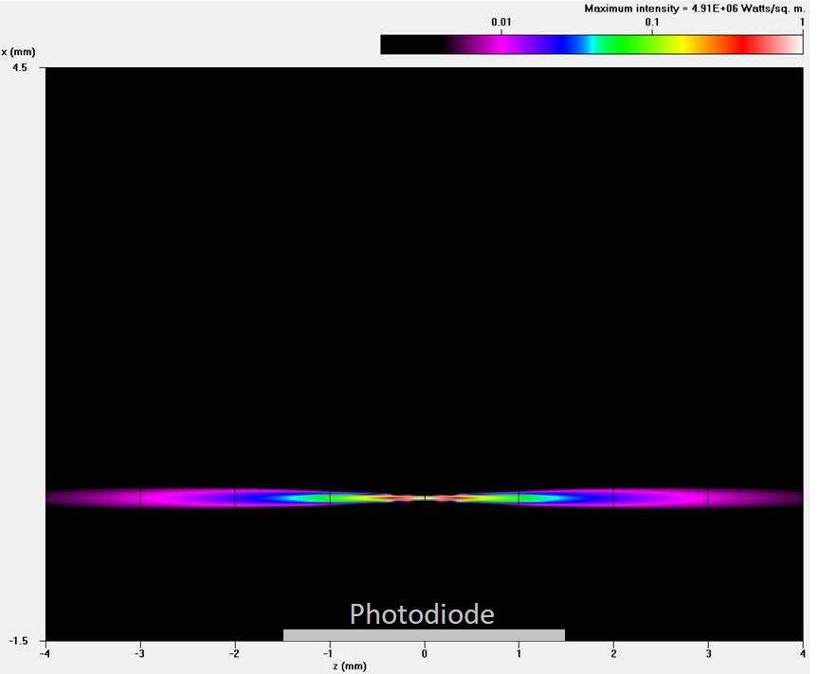
Figure S30. PMS5003 focused Gaussian laser intensity distribution in the 6 mm by 8 mm aerosol transport channel using the measured beam spot radius at focal point w₀ of 17.5 μm and measured Rayleigh length z₀ of 0.288 mm.

References for S3.1
ISO 11146-3:2004, “Lasers and laser-related equipment —Test methods for laser beam widths, divergence angles and beam propagation ratios — Part 3: Intrinsic and geometrical laser beam classification, propagation and details of test methods,” International Organization for Standardization, 2004, https://www.iso.org/standard/33627.html.
Moosmuller, H., and C. Y. She, 1991: Equal intensity and phase contours in focused gaussian laser-beams. Ieee Journal of Quantum Electronics, 27, 869-874.
Zheng, C. W., Y. J. Zhang, and L. Wang, 2007: Propagation of vectorial Gaussian beams behind a circular aperture. Optics and Laser Technology, 39, 598-604.

S3.2 Photodiode and signal processing

S3.2.1 Detecting and sizing individual smoke particles

To test the output from the photodiode on Pin 45 and RS-232, smoke from a match was introduced to the PMS5003 for approximately one minute. Figure S31 illustrates the data output transmitted during the smoke test, with time sequence from front to back. During the specific test discussed here, there were 76 data transmissions but only 57 measurement cycles. The logging system used takes time to store data and so some cycles only logged partial waveform information (the representations of photo-diode activity). As a result, there were 47 “complete” samples. Each sample consisted of 600 milliseconds of Pin 45 and RS-232 data. Channel 1 reached its 16-bit maximum of 65,535 dL⁻¹ for several of these 600-millisecond samples. The total volume of air flowing past the laser in each of these 600 millisecond samples is 8.9 cm³ if the PMS5003 flow rate is 0.89 L min⁻¹.
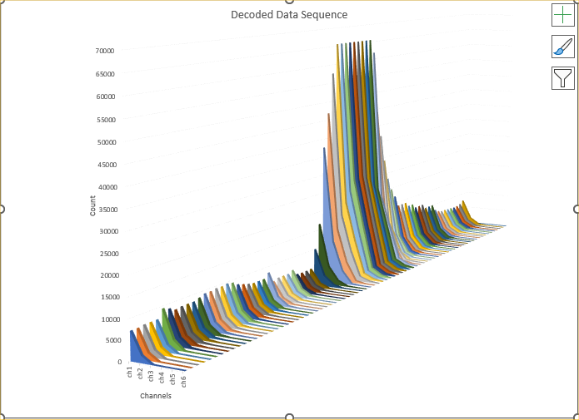
Figure S31. RS-232 data for each second of the 1-minute smoke test. Particle number concentrations in Channels 1-6 for each second
To determine how successfully the PMS5003 was able to detect and size individual particles in the smoke, detailed analyses were performed on two of the samples:
- Sample 7 had a Channel 1 value of 9545 dL⁻¹. This corresponds to a fine particle scattering coefficient of approximately 142 Mm⁻¹, and PM_{2.5} of approximately 40 µg m⁻³, based on ambient smoke data from NOAA Table Mountain Sept 6, 2020, UTC 19:00 – 20:00
- Sample 31 had a high smoke concentration, with a Channel 1 value of 61737 dL⁻¹. This corresponds to a fine particle scattering coefficient of approximately 1000 Mm⁻¹, and PM_{2.5} of approximately 250 μg m⁻³, based on ambient smoke data from NOAA Table Mountain (October 17, 2020, UTC 00:00-01:00).
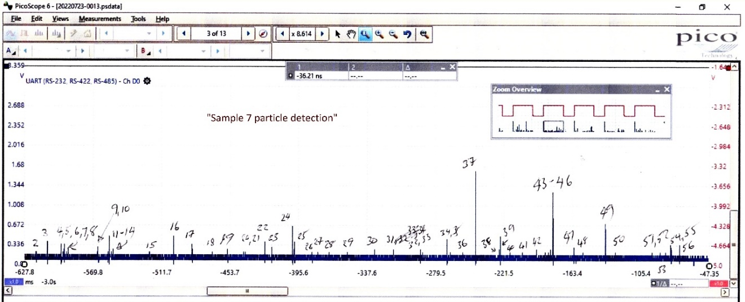
The PicoScope logging application recorded and decoded the photodiode voltage from the individual particles for Samples 7 and 31. The results are shown in Figures S32 and S33. Sample 7 had 56 pulses exceed the noise threshold of 0.1754 volts, and Sample 31 had 134 pulses exceed the noise threshold. Figure S34 shows two examples of individual pulses detected by the photodiode.

Figure S32. Sample 7 annotated
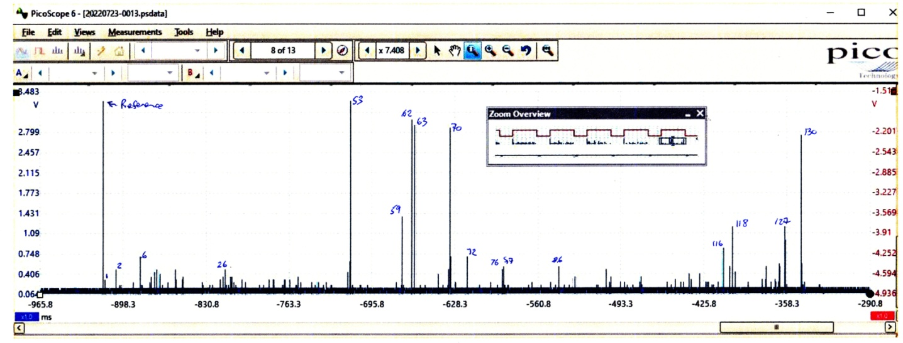

Figure S33. Sample 31 annotated

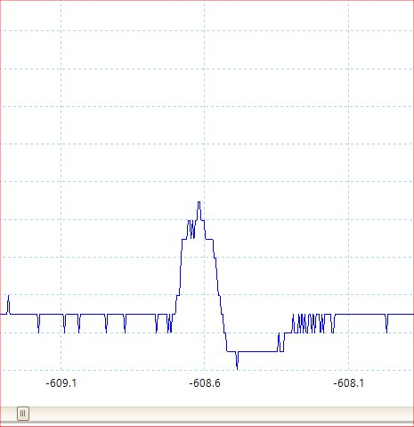
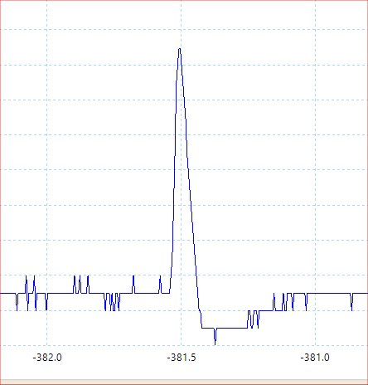
Figures S34ab. Two examples of individual pulses detected by the photodiode. Amplitude of S30a is 618.6 mV and S30b is 265.1 mV. The x-axis is in units of milliseconds.

Figure S35 shows the measured distribution of the digitized photodiode pulse amplitudes from Samples 7 and 31.
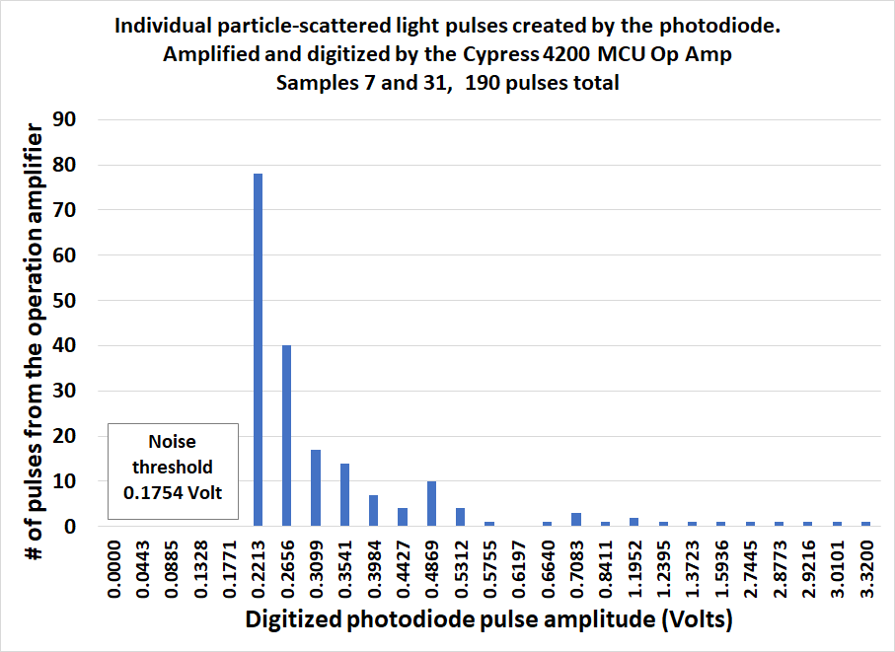
Figure S35. Distribution of digitized photodiode pulse amplitudes from Samples 7 and 31.
It was found that the PMS5003 electronics followed the increased amplitude from the photodiode as each particle entered the laser beam, and then passed through the beam’s center. Once the amplitude started to drop as the particle passed through the middle of the beam, the pulse was clipped at the maximum amplitude. This tended to produce shorter pulse widths than the actual time it took for each particle to traverse the entire width of the beam, by approximately a factor of 2. This pulse clipping apparently improves the ability of the PMS5003 to count individual particles. Figure S36 shows the measured distribution of particle traverse times through the laser beam.
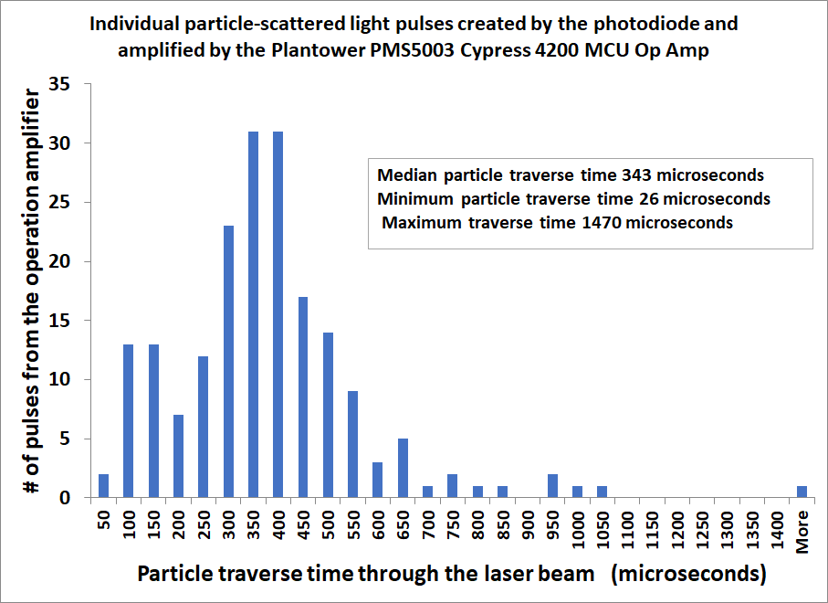
Figure S36. The distribution of particle traverse time through the laser beam.

S3.2.2 Allocating measured pulse amplitude voltages to PMS5003 number concentration channels
An attempt was made to determine if the measured pulse amplitude voltages could be allocated to the six size Channels in the RS-232 output. The results are only estimates, and not rigorous. The actual algorithm that the PMS5003 uses is unknown. First, the physical-optical model for the PA-PMS program was used to calculate the scattered light power from smoke particles to the photodiode as a function of optical diameter. The result is in Figure S37. It shows that the relationship between optical diameter and scattered light power to the photodiode can be linearized and approximated by a power function with an R² = 0.983. Then a power function was fit to the pulse voltage between two points on a pulse voltage vs optical diameter curve. It was assumed that the 0.222 volts corresponds to the minimum detection limit of 0.30 μm, and that the upper bound of 3.0 volts corresponds to 10 μm. This choice is somewhat arbitrary and not proven.
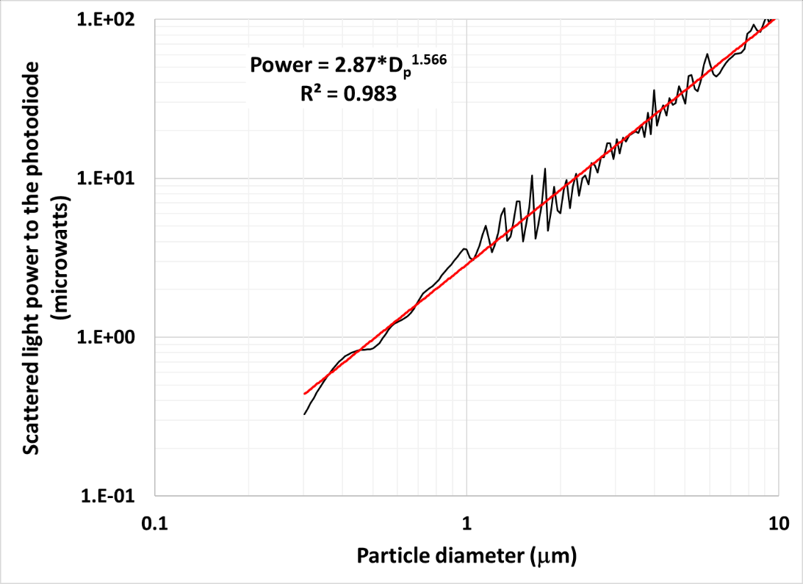
Figure S37. The PA-PMS computer program predicted total power from smoke, refractive index m = 1.57 + i 0.002; laser w₀ = 0.0175 mm, z₀ = 0.288 mm. The scattered light power is used to estimate the cut point voltages for 0.5 μm, 1.0 μm, 2.5 μm, and 5 μm.

Figure S37 is used to estimate the cut point voltages for 0.5 μm, 1.0 μm, 2.5 μm, and 5 μm on that power function. The result is shown in Figure S38.
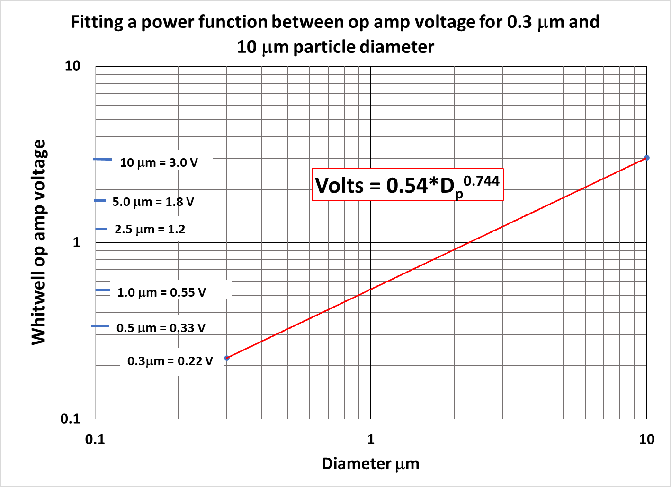
Figure S38. Fitting a power function between 0.3 μm and 10 μm particle diameter to the op amp voltage.
Figure S38 was then used to create a lookup table which related PMS5003 size cut interval to a pulse voltage interval. The results are in Figure S39. For example, the 0.3 μm to 0.5 μm diameter interval corresponds to the 0.221 V to 0.330 V interval. Pulses with voltages in this voltage interval would be assigned to the diameter interval 0.3 μm to 0.5 μm.
Figures S39 and S40 present the results in tabular form of applying this approach to the pulse voltage data in Samples 7 and 31. The figures also compare the results with the PMS5003 RS-232 Channel 1-6 data. The results are summarized in graphical form in Figures S41 and S42. It is surprising how few particles of diameter larger than 1 μm were counted.

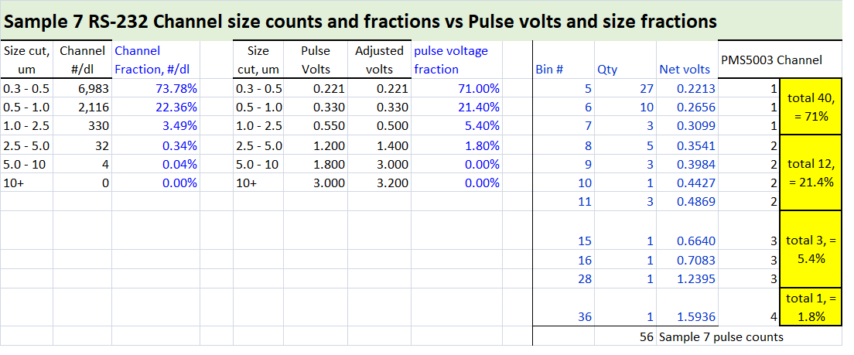
Figure S39. Sample 7 RS-232 channel size counts and pulse amplitude in volts
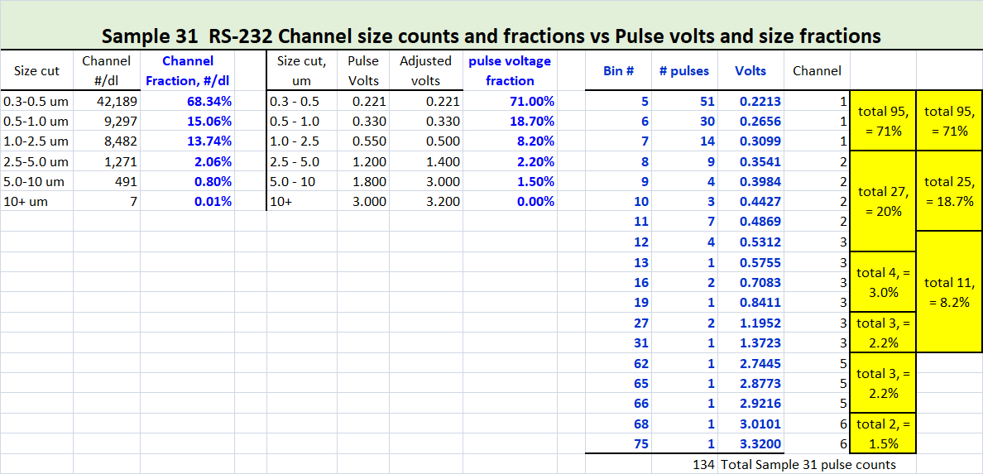
Figure S40. Sample 31 RS-232 channel size counts and pulse amplitude in volts
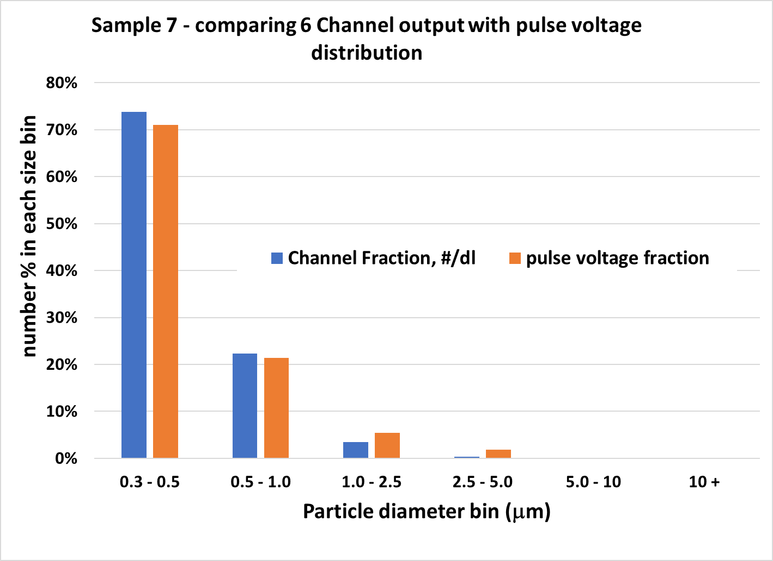
Figure S41. Sample 7 size cut fractions – comparing PMS5003 pulse voltage fraction to number concentration channel fraction
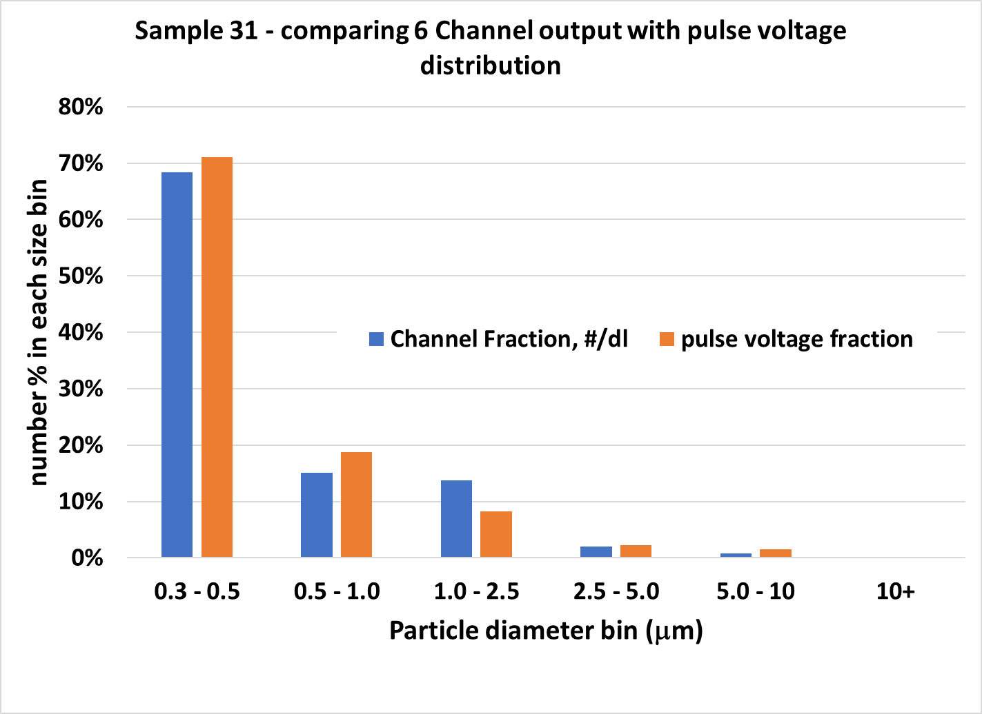
Figure S42. Sample 31 size cut fractions -- comparing PMS5003 pulse voltage fraction to number concentration channel fraction
We find there is good agreement between the normalized submicron size distribution estimated from measuring the photodiode pulse voltages and the PMS5003 channel output for the two smoke Samples 7 and 31. Given the many assumptions embedded in this analysis, this agreement may be serendipitous. It may not necessarily extend to a very different aerosol such as wind-blown dust.

S3.3 Effect of inlet flow impedance on PMS5003 flow rate and reported number concentration

S3.3.1 PMS5003 number concentration CH1 vs differential pressure

To measure how the PMS5003 reported particle concentration was affected by upstream pressure changes, the flow to the PMS5003 inlet was impeded by orifices of varying diameters, from 0.50 to 5.95 mm. Figure S43 shows that decreasing the orifice diameter to below 1.0 mm results in the PMS5003 fan reaching a limit of 2.7 +/- 0.1 Pa (0.011 inch H₂O) differential vacuum at the inlet (Pressure tap C on Figure S8.) We found that an impedance of 1.0 Pa results from flow through an orifice diameter of 3.57 mm.

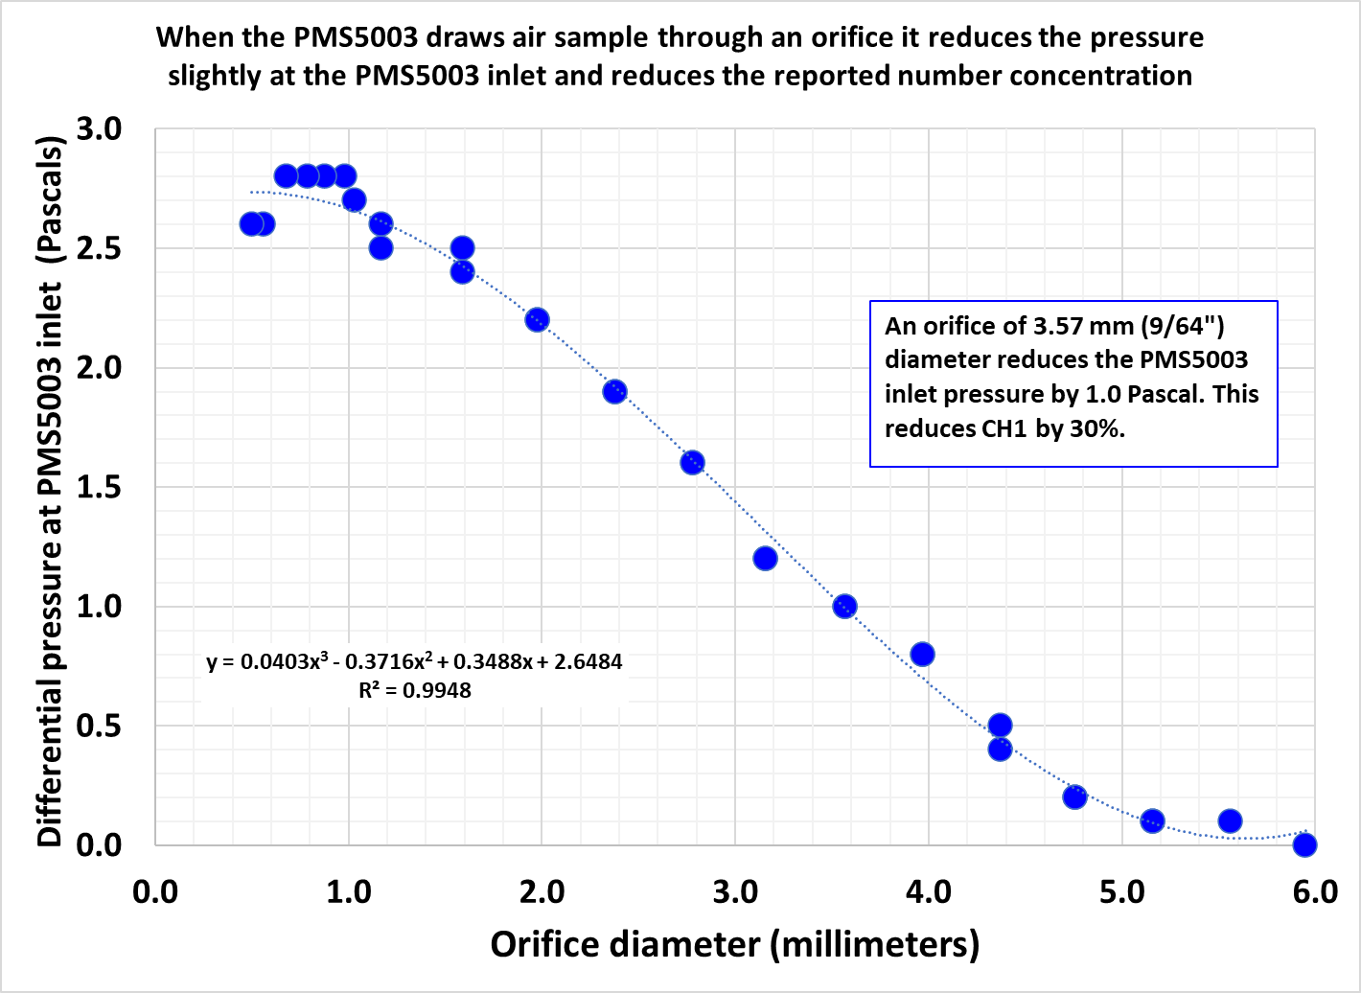

Figure S43. Pressure reduction between PMS5003 inlet and outlet as a function of orifice diameter.

Figure S44 shows that the PMS5003 number concentration CH1 is very sensitive to differential pressure between the inlet and the outlet. We measured a CH1 decrease of 30% resulting from a 1.0 Pa (0.004 inch H₂O) pressure differential between the PMS5003 inlet and outlet. This is a very small pressure drop. The flow reduction only occurs if there is an imbalance between the inlet and outlet pressures. Pressure changes in the atmosphere will usually have no impact on the differential pressure and CH1 unless wind turbulence causes an imbalance.

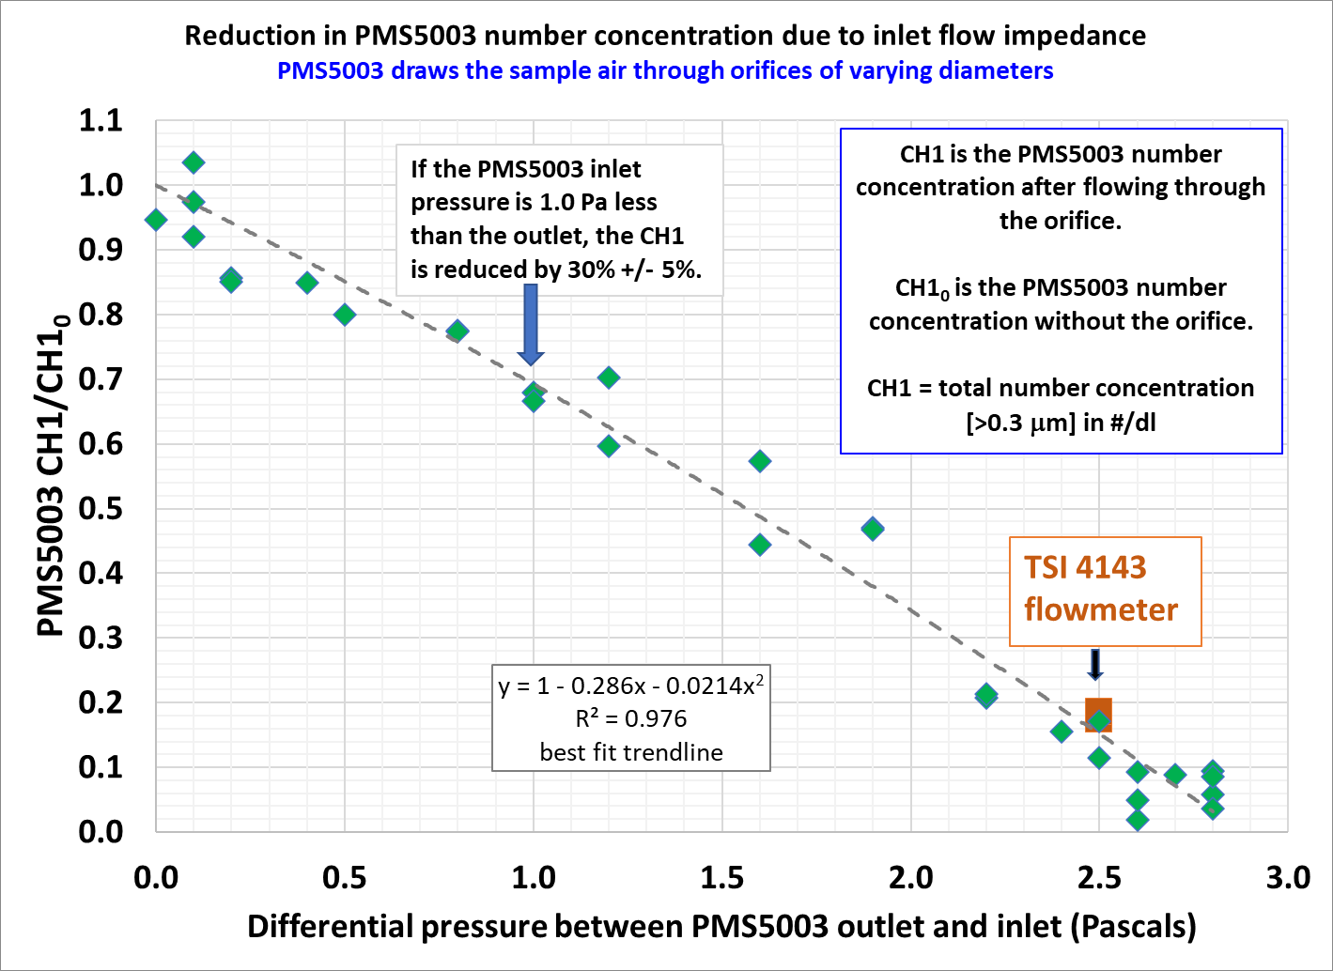
Figure S44. Reduction in PMS5003 number concentration because of flow rate reduction due to inlet flow impedance. The PMS5003 CH1 is the number concentration of particles greater than 0.3 μm diameter. The differential pressure was measured with a 0-30 Pa differential pressure gauge (MAGRFHELIC TE-2000, 0-30 Pascals).

When the TSI 4143 flow meter was connected to the PMS5003 inlet, it caused a back pressure of 2.5 Pa, resulting in significant flow impediment to the PMS5003. The PMS5003 CH1 number concentration dropped to 18% of its value with no flow meter connected. The results for the two PMS5003 sensors are in Table S1 and in Figure S44. The reported CH1 number concentration decrease is a result of a proportional decrease in the actual flow rate through the PMS5003 because the PMS is an OPC. The flow meter measured 0.16 L min⁻¹ under this flow impediment condition. This implies that the estimated flow rate through the PMS5003 with no impediment would be = (0.16 L min⁻¹)/0.18 = 0.89 L min⁻¹. This estimate needs to be tested with alternative methods that do not cause flow impedance.

Table S1. PMS5003 CH1 reduction and flow impediment due to TSI 4143 flowmeter

S3.3.2 Estimating the lower and upper bound PMS5003 flow rate from measurements of the laser beam width and the particle traverse time

Measurements of the laser beam width and the particle traverse time through the beam can be used to estimate the particle velocity through the beam, and hence the PMS5003 flow rate. The beam width, particle traverse time, and particle velocity all vary. The laser beam width has a minimum of 35 μm at the focal point. Figure S47 shows that if the laser beam width exceeds about 100 μm then submicron particles would not scatter light of sufficient intensity to be detected. Figure S36 shows that the particle traverse time varies from 100 to 500 μsec about 95% of the time. Due to the geometry of the PMS5003, the particle velocity in the vicinity of the laser beam may vary in time and location.
The PMS5003 flow rate was calculated as a function of particle traverse time for laser beam diameters of 35, 70 and 105 μm. The results are in Figure S45. There is a broad range of calculated flow rates, from 0.2 to 2.0 L min⁻¹. The distribution of particle traverse times in Figure S36 suggests that an approximate lower and upper bound estimated flow rate is roughly 0.3 to 1.0 L min⁻¹. The measured flow rate of 0.89 L min⁻¹ is near the upper bound of the calculated flow rate. These calculations indicate reasonable internal consistency among the three different measurements of the laser beam, the scattered light pulses, and the flow rate.

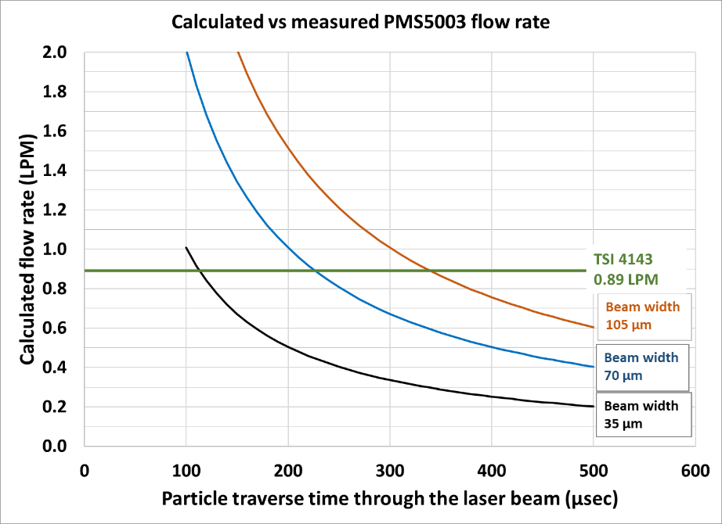
Figure S45. PMS5003 flow rate calculated from laser beam diameter and particle traverse times. It is compared with the measured flow rate by TSI 4143.

S3.4 Estimating PMS5003 detection limit with polystyrene latex (PSL) spheres

The 0.10 µm and 0.20 μm-diameter PSL number distributions are shown in Figure S46. For the 0.10 µm PSL, the geometric mean diameter was 0.096 μm and the geometric standard deviation was 1.13 as measured by the SMPS. For the 0.20 µm PSL, the geometric mean diameter is 0.199 μm and a geometric standard deviation of 1.46. The PMS5003 and SMPS number distributions are compared in Table S2. It is apparent that the PMS5003 detects PSL particles over 0.25 μm but not smaller than that. This is consistent with Figure S57, which shows that if the PMS5003 detection limit is 0.26 μm for PSL with a refractive index of m = 1.59, then it would be 0.30 μm, as is advertised by the Plantower manufacturer, for particles of refractive index 1.48 + i0.011.

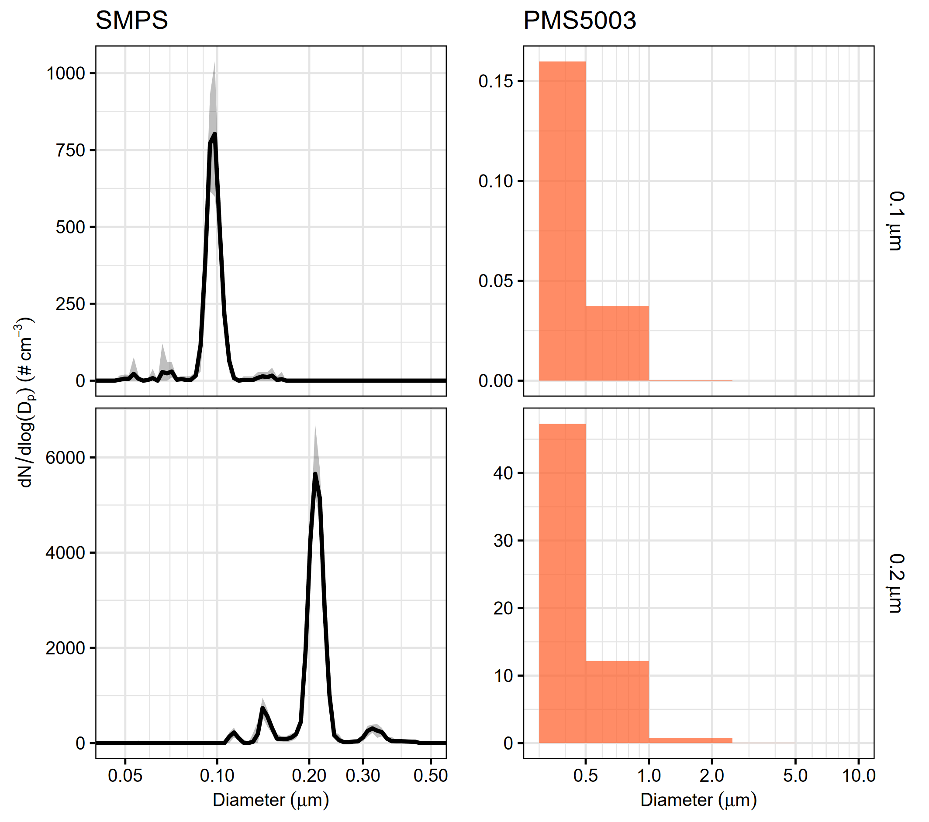
Figure S46. PSL number concentration distributions measured by SMPS are shown on the left. The black line represents the mean and shaded gray area represents the total range of number concentrations measured for each particle size during the 15-minute steady-state period. The PSL number concentration distributions measured by the PMS5003 are shown on the right. The height of each orange bar represents the number concentration averaged across the 15-minute steady-state period and across all replicate PMS5003 sensors.

Table S2. Comparison of particle number concentrations measured by the SMPS and PMS5003 sensors for HEPA-filtered air, 0.1 µm PSL, and 0.2 µm PSL. The measurements of HEPA-filtered air were collected after the measurements of 0.1 µm PSL. For SMPS data, the average number concentration measured during the 15-minute steady-state period is shown. For PMS5003 data, the average number concentration measured during the 15-minute steady-state period, averaged across all replicate sensors, is shown.
Parameter | Filtered air | 0.1 um PSL | 0.2 um PSL
SMPS number concentration for D_{p} > 0.05 (# cm⁻³) | 0.705 | 48.3 | 406
SMPS number concentration for D_{p} > 0.15 (# cm⁻³) | 0.0383 | 0.365 | 374
SMPS number concentration for D_{p} > 0.25 (# cm⁻³) | 0 | 0 | 26.0
PMS5003 number concentration for D_{p} > 0.3 (# cm⁻³) | 0.0280 | 0.0468 | 14.5
PMS5003/SMPS number concentration ratio (D_{p} > 0.05 µm) | 0.040 | 9.7 × 10⁻⁴ | 0.036
PMS5003/SMPS number concentration ratio (D_{p} > 0.15 µm) | 0.73 | 0.13 | 0.039
PMS5003/SMPS number concentration ratio (D_{p} > 0.25 µm) | - | - | 0.56

S3.5 Particle light scattering model predictions and comparisons with laboratory data

S3.5.1 Model predictions of PMS5003 particle counting efficiency and size attribution

Figure S47 shows the contours of detection as a function of particle diameter. Particles smaller than 0.5 μm need to intersect the focal point or very close to it in order to generate enough power at the photodiode to be detected. The effective sensing volume for 0.5 μm particles is a tiny cylinder with a length of 0.6 mm and a diameter of 0.04 mm. The sensing volume is larger for larger diameter particles.

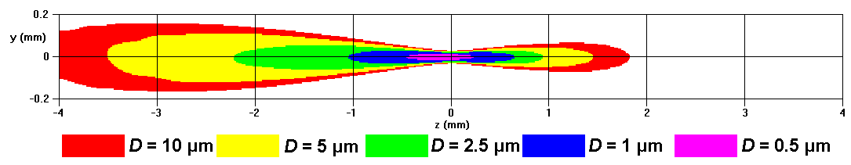
Figure S47. Contours of detection for different particle sizes. (Refractive index m =1.52 +i0.002)

Figure S48 quantifies the fraction of particles detected as a function of diameter. Only about three 0.4-μm particles out of 10,000 are detected as they flow past the laser. The fraction increases with particle size.

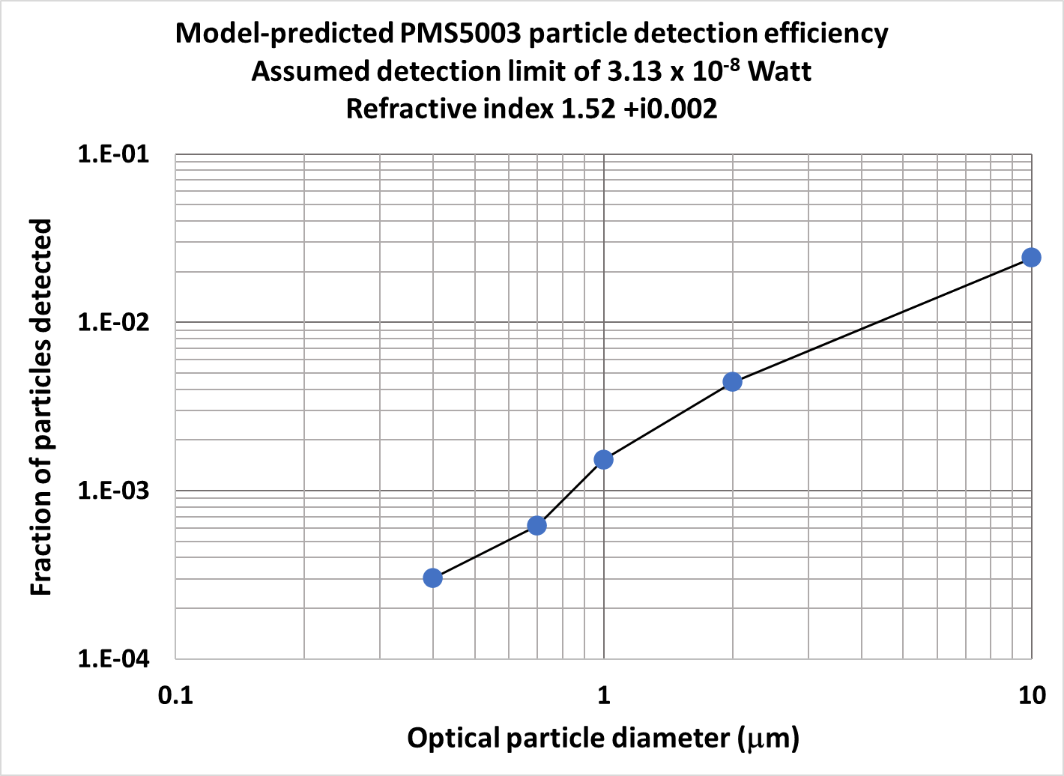
Figure S48. Model-predicted particle detection efficiency at detection limit of 3.13 x 10⁻⁸ W.

S3.5.2 Comparing model predictions with laboratory PMS5003 number distributions

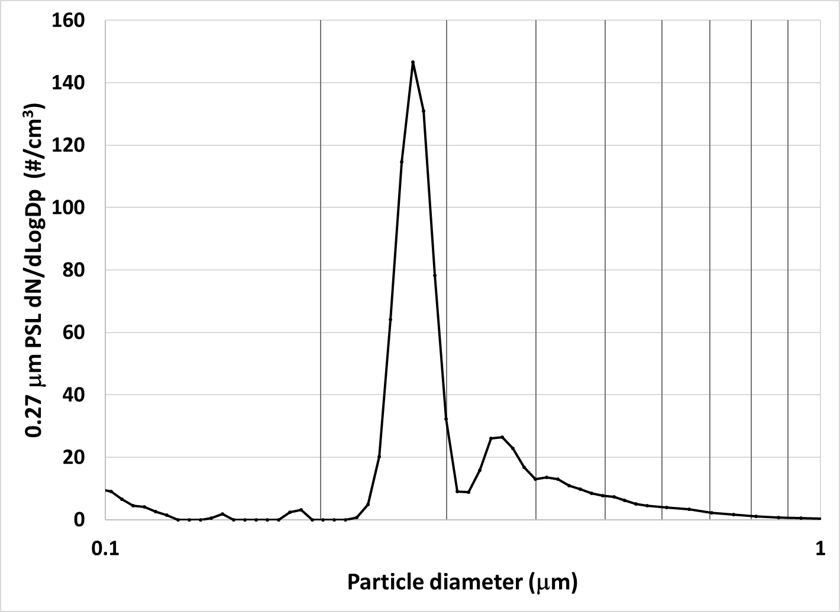
Figure S49. 0.27-μm PSL number concentration by SMPS and APS for Dp >0.3 μm = 272/cm³. PMS5003 number concentration for Dp > 0.3 μm = 116/cm³.

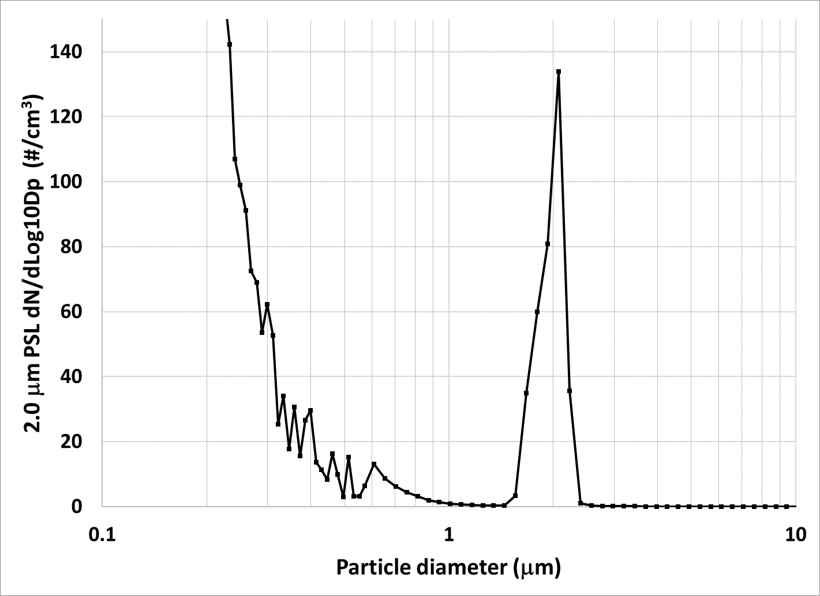
Figure S50. 2.0-μm PSL number concentration by SMPS and APS for Dp >0.3 μm = 18.2 cm⁻³ PMS5003 number concentration for Dp > 0.3 μm = 4.10 cm⁻³

S3.5.3 Comparing model scattering coefficient predictions with laboratory data

Table S3. Tryner et al. (2020) laboratory data sets used for scattering coefficient analysis
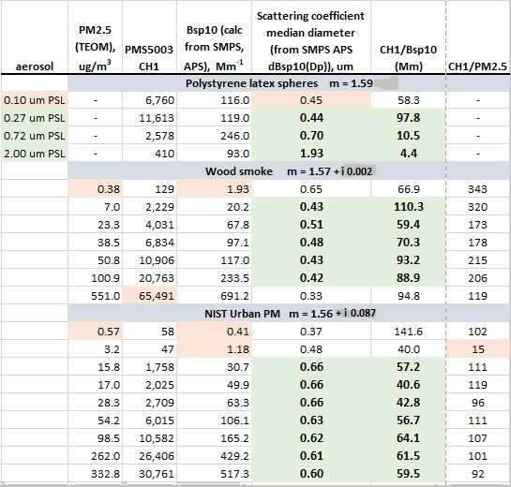

Table S4. Tryner et al. (2020) laboratory data sets used for scattering coefficient analysis.
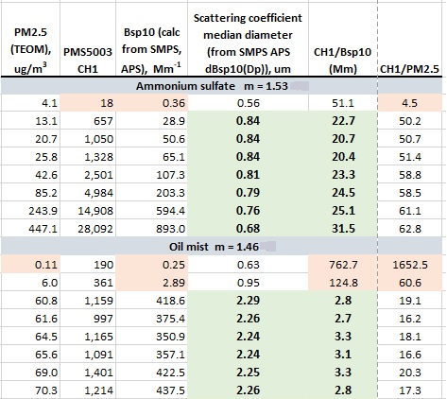

S3.5.4 PMS5003 mass scattering efficiency
No supplemental material.

S3.5.5 Comparing the model-predicted PMS5003 response to relative humidity with laboratory data

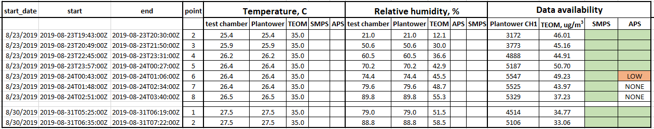
Table S5. Tryner et al. (2020) laboratory data sets used for the RH analysis.

Approach:
Use the Tryner et al. (2020) laboratory SMPS and APS data to:
- Calculate the aerosol size distribution from 21% to 89% RH
- Calculate the wet aerosol mass concentration and MMD from 21% to 89% RH
- Calculate the wet aerosol scattering coefficient and SCMD from 21% to 89% RH
Calculate the correct aerosol density ρ for the Aerodynamic Particle Sizer (APS) data as RH increases – by iteration as follows:
- The dry ammonium sulfate (AS) aerosol has a density ρ_{AS} = 1.77 g cm⁻³. As the RH increases, water is absorbed into the particle and its density decreases significantly, down to 1.2 g cm⁻³ at RH = 90%. The APS data need the correct aerosol density to provide the correct particle size cuts
- This model assumes that the absorbed water forms a saturated AS solution in the particle in equilibrium with the undissolved AS. From RH = 21% to about 80%, the aerosol consists of undissolved AS plus dissolved AS in a saturated solution with water. For RH over 80%, all the AS is dissolved.
- Calculating the correct particle density ρ for each RH uses an iterative process with the SMPS and APS data as follows:
- An initial guess at the particle density ρ₁ is made. The first estimated total aerosol volume concentration VT₁ is calculated from the SMPS and APS data using density ρ₁
- It can be shown that the new aerosol density is calculated from
ρ_{i+1} = ρ_{AS} (V₀/VT_{i}) + (1/Q)(1 - V₀/VT_{i})
where V₀ = 20.0 μm ³ cm⁻³ from the RH=21% Point 2 run,
and Q = (a+1)/b – (a/ρ_{AS}),
where ρ_{AS} = 1.77 g cm⁻³ ; a = 0.744 (solubility of AS in water, gram AS per gram H₂O); and b = 1.23 g cm⁻³ (density of saturated solution of AS in water) (reference: www.EngineeringToolBox.com)

- Repeat 1 and 2 until ρ_{i+1} and VT_{i+1} converge, usually 3-4 steps. Do this for every RH.
- Use the final converged particle density ρ_{i+1} for a given RH to calculate the wet size distribution with the SMPS and APS data. Do this for every RH. The results for RH 21% and RH 89% are shown in Figure S51.

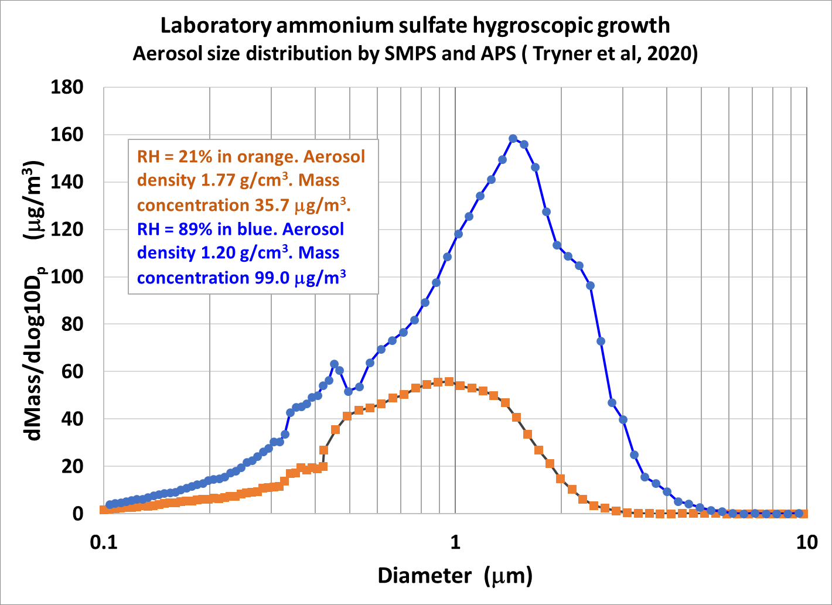
Figure S51. Ammonium sulfate size distribution growth. The aerosol number distribution was measured at actual RH with a differential mobility particle sizer (SMPS) and an aerodynamic particle analyzer (APS).

Figure S52 shows the exponential increase of ammonium sulfate PM_{2.5} with RH. However, the PMS5003 reported PM_{2.5} did not increase exponentially. This is because the ammonium sulfate grew into diameters for which the PMS5003 was not as efficient in light scattering.
Figures S53 and S54 shows that while the theoretical ammonium sulfate mass scattering efficiency stays approximately constant with RH increase, the PMS5003 mass scattering efficiency drops significantly with RH.
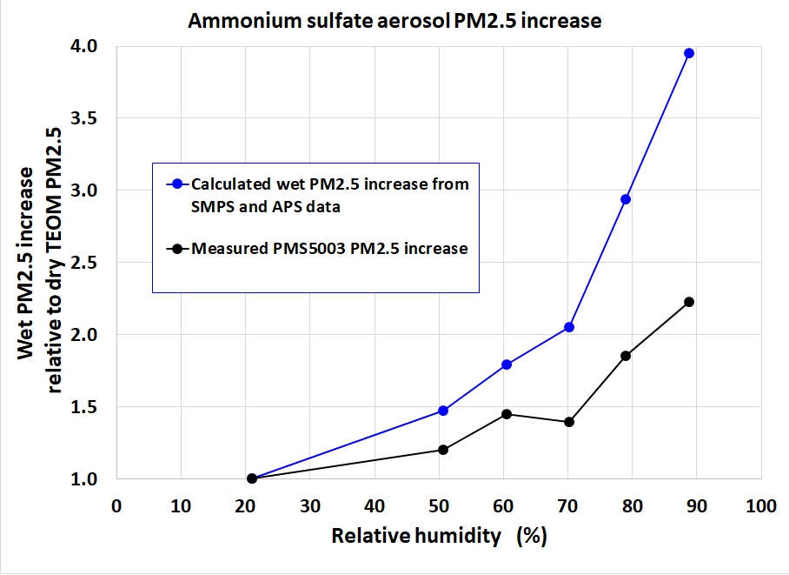
Figure S52. Calculated “wet” PM_{2.5} and PMS5003 PM_{2.5} vs relative humidity, normalized to the measured dry PM_{2.5}. The real-time PM_{2.5} “dry” mass concentration at 35% RH was measured by the tapered element oscillating microbalance (TEOM) with a Mesa Labs GK2.05 (KTL) cyclone. The SMPS and APS data were used to calculate the aerosol number distribution, scattering coefficient distribution, total scattering coefficient, aerosol mass distribution, and mass concentration as the RH increased. The aerosol number distribution was measured at actual RH with a differential mobility particle sizer (SMPS) and an aerodynamic particle analyzer (APS). The number and “wet” mass concentrations at actual RH were measured by the PMS5003.

Table S6. Calculated ammonium sulfate refractive index vs RH.
RH, % | g(RH)  (κ = 0.53) | Refractive index m
21.0 | 1.04 | 1.51
50.6 | 1.15 | 1.46
60.5 | 1.22 | 1.44
70.2 | 1.31 | 1.42
74.4 | 1.28 | 1.41
79.0 | 1.45 | 1.39
88.8 | 1.75 | 1.36
g(RH) from Petters and Kreidenweis (2007) and m from Zieger et al. (2013).

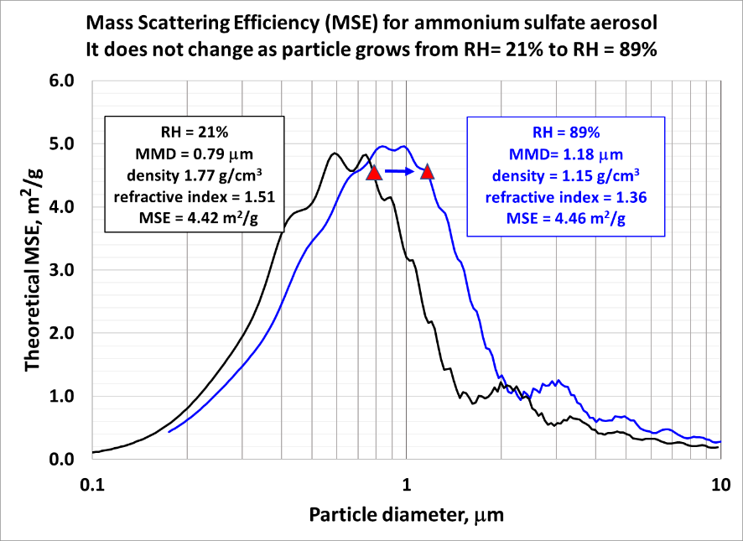
Figure S53. Theoretical mass scattering efficiencies as a function of particle diameter for ammonium sulfate aerosol for RH = 21% and RH = 89%. Calculated from Equation (4). As the ammonium sulfate mass median diameter in the laboratory experiment grew from 0.79 μm to 1.18 μm, its density dropped from 1.77 to 1.15 g cm⁻³ and its refractive index dropped from 1.51 to 1.36. Its mass scattering efficiency remained approximately constant at 4.42 to 4.46 m²g⁻¹.
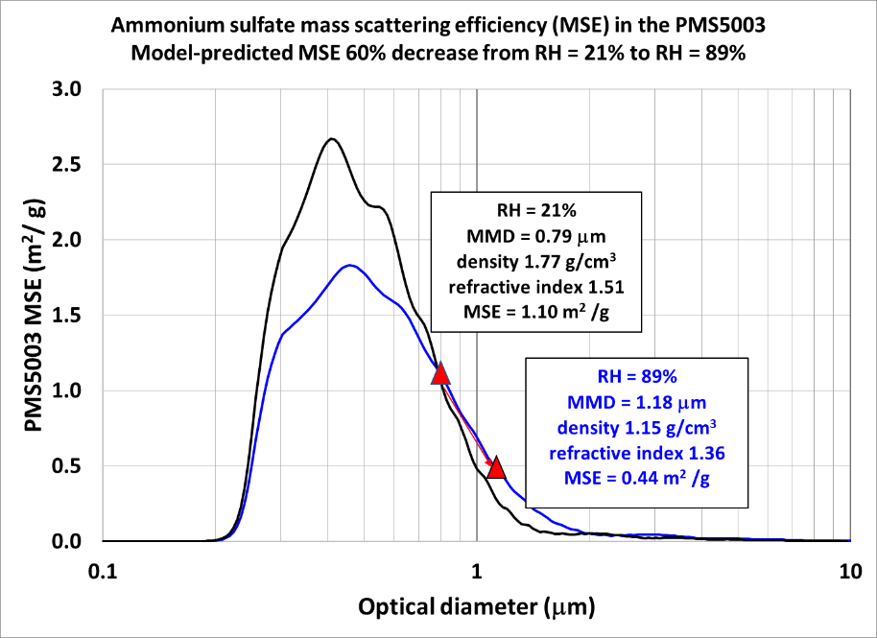
Figure S54. Ammonium sulfate mass scattering efficiencies in the PMS5003 for RH = 21% and RH = 89% calculated from Equation 5. As the ammonium sulfate mass median diameter in the laboratory experiment grew from 0.79 μm to 1.18 μm, its density dropped from 1.77 to 1.15 g cm⁻³ and its refractive index dropped from 1.51 to 1.36. The PMS5003 mass scattering efficiency decreased from 1.10 m² g⁻¹ to 0.44 m² g⁻¹.
References for S3.5.5
Petters, M. D. and Kreidenweis, S. M.: A single parameter representation of hygroscopic growth and cloud condensation nucleus activity, Atmos. Chem. Phys., 7, 1961–1971, https://doi.org/10.5194/acp-7-1961-2007, 2007.
Zieger, P., Fierz-Schmidhauser, R., Weingartner, E., and Baltensperger, U.: Effects of relative humidity on aerosol light scattering: results from different European sites, Atmos. Chem. Phys., 13, 10609–10631, https://doi.org/10.5194/acp-13-10609-2013, 2013.

S3.5.6 Effect of particle refractive index on PMS5003 detection and counting efficiency
Atmospheric aerosols vary widely in particle size, morphology, refractive index, and other properties. Atmospheric particles of the same geometric diameter may have different refractive indices (McMurry, 2000). Commercial optical particle counters are typically calibrated with monodisperse polystyrene latex (PSL) spheres. The PSL complex refractive index of 1.59 is usually different from ambient aerosols. Hagan and Kroll (2020) reviewed the existing literature on ambient aerosol refractive index and provided suggested refractive indices for urban, background, marine, dust, and wildfire aerosol types. They predicted the impact that uncertainty in refractive index can have on OPC-type and nephelometer-type low-cost sensors. Several studies have used a variety of techniques to estimate the variability in the aerosol refractive index for wildfire smoke, background, and urban sources (Bian et al, 2020; Espinosa et al 2019; Aldhaif, et al, 2018; Hand et al, 2002a and 2002b). Bian et al (2020) showed that aerosol in the humid southeast US has a lower average refractive index than the western US, presumably due to higher relative humidity. They found that the refractive index was not sensitive to wavelengths between 440 nm and 1020 nm. Recently, several studies have evaluated and modeled soil dust refractive indices for nonspherical shapes (Huang et al, 2021; Di Biagio et al, 2017; Kok et al, 2017). In some cases coarse particles can contain nitrates and organics, which often coat dust particles (Lee et al, 2008; Cheng et al, 2015), and may affect the refractive index. Baumgardner et al. (1996), found that stratospheric and free troposphere aerosol refractive indices varied from 1.40 to 1.42 over a latitude range from 70°S to 50°N and from 1.34 to 1.46 over a vertical range from 4–20 km.
Many low-cost sensors are not calibrated with monodisperse spheres of known diameter and refractive index, such as PSL. For example, the Amphenol SM-UART-04L is calibrated using cigarette smoke against a TSI DustTrak™ II Aerosol Monitor 8530 (https://docs.rs-online.com/b25f/A700000007241544.pdf). The refractive index of cigarette smoke averages 1.51 to 1.52 (McRae, 1982), and the mass distribution is bimodal with median diameters of about 0.25 and 5 μm (Chang et al, 1985). The Sensirion SPS30 is calibrated with ambient aerosol against a TSI DustTrak™ II Aerosol Monitor 8533, Ambient Mode https://sensirion.com/media/documents/8600FF88/616542B5/Sensirion_PM_Sensors_Datasheet_SPS30.pdf The ambient aerosol may have been at Sensirion’s headquarters near Zurich, Switzerland. Moschos et al. (2021) measured an annual average submicron mass median diameter of 0.30 μm in Zurich.
We hypothesize that the PMS5003 was probably manufactured and calibrated at Plantower’s headquarters in Beijing, China, using ambient aerosol to match the PMS5003 PM_{2.5} with a regulatory PM_{2.5} at the time of calibration. Wu and Boor (2021) found that China’s aerosol mass distributions average larger than Europe and North America, in the range of 0.4 – 0.6 μm. Chen et al. (2019) inferred fine-mode and coarse-mode aerosol complex refractive indices from AERONET inversion products over China. They estimated a 21-site AERONET average aerosol refractive index of 1.45 + i 0.011. Che et al (2008) compared aerosol optical properties by a PREDE sky radiometer with a CIMEL sun photometer over Beijing, China. They estimated an aerosol refractive index of 1.50 + i 0.011 at a wavelength of 670 nm. Li et al. (2013) estimated an aerosol refractive index of 1.48 + i 0.008 during heavy haze days in Beijing winter. Based on these results, for this study we assume that the PMS5003 was calibrated in Beijing with an ambient aerosol having a refractive index of 1.48 + i 0.011. Table S7 summarizes the calibration aerosol properties for various low-cost sensors.
Table S7. Calibration aerosol properties for various low-cost sensors

To evaluate the effect of particle refractive index on PMS5003 response, we used the PA-PMS program to calculate the peak power of light scattered on the photodiode as a function of diameter for a variety of refractive indices. Figure S55 is a screenshot of the user interface as it is calculating the peak power at the photodiode for the PMS5003 sensor. Figures S56 and S57 show the effect of refractive index on peak light-scattered power to the photodiode. It shows that 0.30 μm smoke particles scatter approximately 40% more light intensity than 0.30 μm Beijing particles. If the 50% detection particle size is 0.30 μm for the Beijing aerosol, then it is 0.27 μm for smoke. In both cases the PMS5003 would report a higher total number concentration and PM_{2.5} for smoke than for the Beijing aerosol.

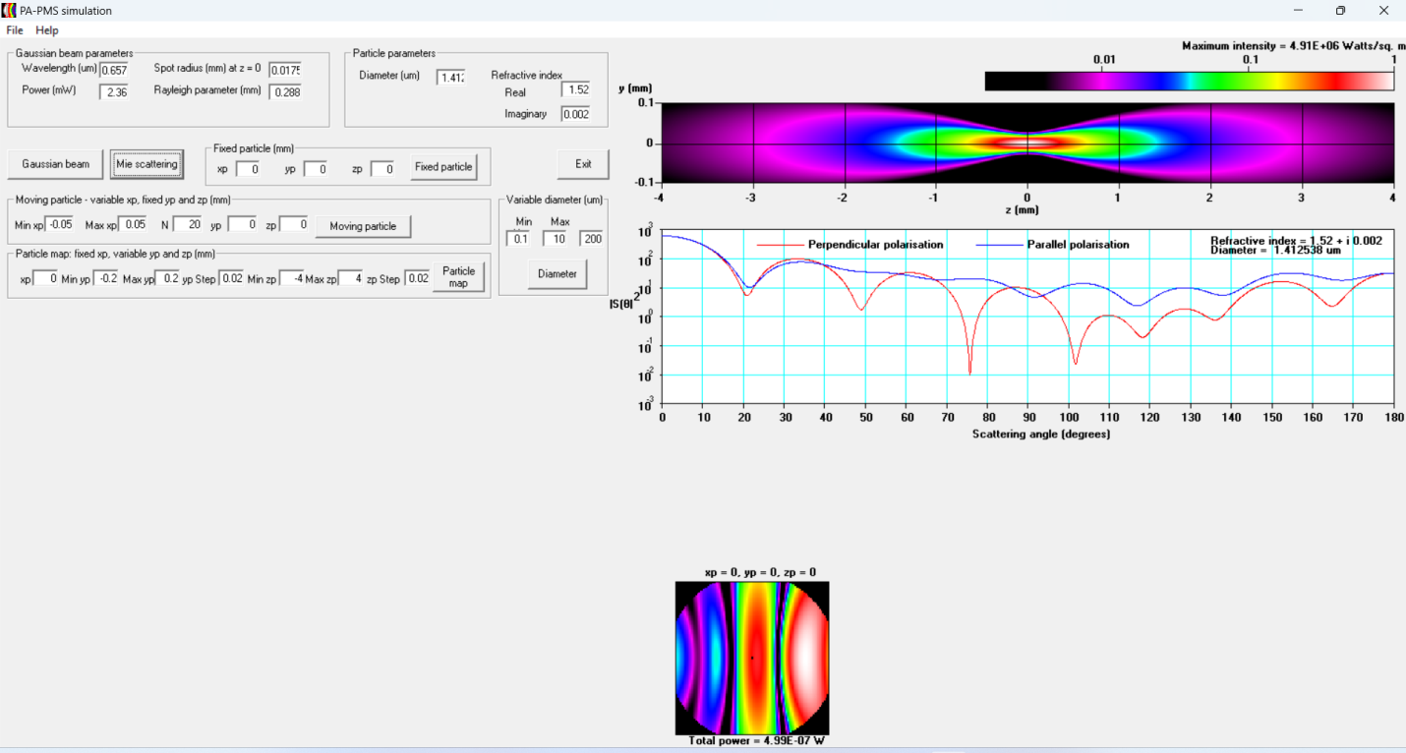
Figure S55. Screenshot of PA-PMS program user interface while calculating peak power at (x,y,z) = (0,0,0) for 0.10 μm < D_{p} < 10 μm.

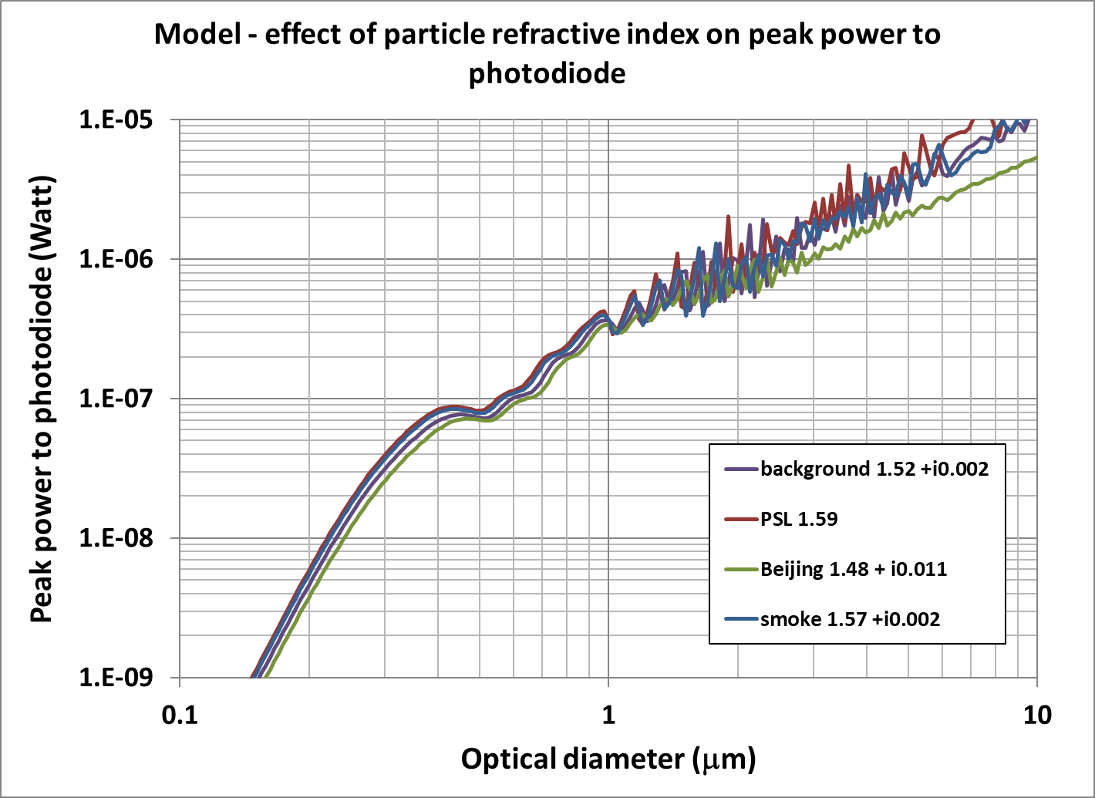
Figure S56. Model-predicted peak scattered light power as a function of particle diameter for homogeneous spheres of various refractive indices. Focused Gaussian laser 2.36 mW and wavelength 657 nm.

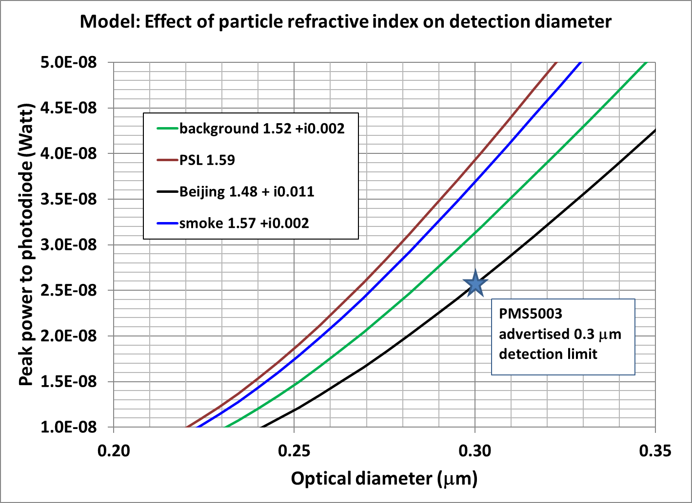
Figure S57. Plantower advertises the PMS5003 50% detection limit to be 0.30 μm. The peak power at 0.30 μm is approximately 2.6 × 10 ⁻⁸ W for particles with m = 1.48 + i 0.011. It is 3.7 × 10⁻⁸ W for smoke and 3.1 × 10⁻⁸ W for background aerosol. For 2.6 × 10 ⁻⁸ W, the particle diameter detection limit for smoke is 0.27μm.
References for S3.5.6
Aldhaif, A. M., Stahl, C., Braun, R. A., Moghaddam, M. A., Shingler, T., Crosbie, E., et al. (2018). Characterization of the real part of dry aerosol refractive index over North America from the surface to 12 km. Journal of Geophysical Research: Atmospheres, 123, 8283– 8300. https://doi.org/10.1029/2018JD028504
Bian, Q., Ford, B., Pierce, J. R., & Kreidenweis, S. M. (2020). A decadal climatology of chemical, physical, and optical properties of ambient smoke in the western and southeastern United States. Journal of Geophysical Research: Atmospheres, 125, e2019JD031372. https://doi.org/10.1029/2019JD031372
Baumgardner, Darrel, Dye, James E. ; Gandrud, Bruce; Barr, Keith; Kelly, Ken; Chan, K. Roland. Refractive indices of aerosols in the upper troposphere and lower stratosphere. Geophysical Research Letters 23(7):749-752. doi.org/10.1029/96GL00707
Chang, Pao-T; Leonard K. Peters & Yasuo Ueno (1985) Particle Size Distribution of Mainstream Cigarette Smoke Undergoing Dilution, Aerosol Science and Technology, 4:2, 191-207, DOI: 10.1080/02786828508959048
Che, H., Shi, G., Uchiyama, A., Yamazaki, A., Chen, H., Goloub, P., and Zhang, X.: Intercomparison between aerosol optical properties by a PREDE skyradiometer and CIMEL sun photometer over Beijing, China, Atmos. Chem. Phys., 8, 3199–3214, https://doi.org/10.5194/acp-8-3199-2008, 2008. (Beijing refractive index at 670 nm was 1.50 – 0.011i)
Chen, Q.-X.; Shen, W.-X.; Yuan, Y.; Xie, M.; Tan, H.-P. Inferring Fine-Mode and Coarse-Mode Aerosol Complex Refractive Indices from AERONET Inversion Products over China. Atmosphere 2019, 10, 158. https://doi.org/10.3390/atmos10030158 (21-site AERONET average m = 1.45 – 0.011i)
Cheng, Cheng; Gehui Wang, Jingjing Meng, Qiyuan Wang, Junji Cao, Jianjun Li, Jiayuan Wang, Size-resolved airborne particulate oxalic and related secondary organic aerosol species in the urban atmosphere of Chengdu, China, Atmospheric Research, Volumes 161–162, 2015, Pages 134-142, https://doi.org/10.1016/j.atmosres.2015.04.010.
Di Biagio, C., Formenti, P., Balkanski, Y., Caponi, L., Cazaunau, M., Pangui, E., Journet, E., Nowak, S., Caquineau, S., Andreae, M. O., Kandler, K., Saeed, T., Piketh, S., Seibert, D., Williams, E., and Doussin, J.-F.: Global scale variability of the mineral dust long-wave refractive index: a new dataset of in situ measurements for climate modeling and remote sensing, Atmos. Chem. Phys., 17, 1901–1929, https://doi.org/10.5194/acp-17-1901-2017, 2017.
Espinosa, W. R., Vanderlei Martins, J., Remer, L. A., Dubovik, O., Lapyonok, T., Fuertes, D., Anin Puthukkudy, Daniel Orozco, Luke Ziemba, K. Lee Thornhill, Robert Levy (2019). Retrievals of aerosol size distribution, spherical fraction, and complex refractive index from airborne in situ angular light scattering and absorption measurements. Journal of Geophysical Research: Atmospheres, 124, 7997– 8024. https://doi.org/10.1029/2018JD030009
Hagan, D. H. and Kroll, J. H.: Assessing the accuracy of low-cost optical particle sensors using a physics-based approach, Atmos. Meas. Tech., 13, 6343–6355, https://doi.org/10.5194/amt-13-6343-2020, 2020.
Hand Jenny; & Sonia M. Kreidenweis (2002) A New Method for Retrieving Particle Refractive Index and Effective Density from Aerosol Size Distribution Data, Aerosol Science and Technology, 36:10, 1012-1026, DOI: 10.1080/02786820290092276
Huang, Y.; A.A. Adebiyi, P. Formenti, J.F. Kok. Linking the different diameter types of aspherical desert dust indicates that models underestimate coarse dust emission. Geophysical Research Letters, 48 (6) (2021), https://doi.org/10.1029/2020gl092054.
Kok, J., Ridley, D., Zhou, Q. et al. Smaller desert dust cooling effect estimated from analysis of dust size and abundance. Nature Geosci 10, 274–278 (2017). https://doi.org/10.1038/ngeo2912
Li, Z., Gu, X., Wang, L., Li, D., Xie, Y., Li, K., Dubovik, O., Schuster, G., Goloub, P., Zhang, Y., Li, L., Ma, Y., and Xu, H.: Aerosol physical and chemical properties retrieved from ground-based remote sensing measurements during heavy haze days in Beijing winter, Atmos. Chem. Phys., 13, 10171–10183, https://doi.org/10.5194/acp-13-10171-2013, 2013. (Beijing heavy haze refractive index at 670 nm was 1.48 – 0.008i)
McMurry, Peter. A review of atmospheric aerosol measurements, Atmospheric Environment, Volume 34, Issues 12–14, 2000, Pages 1959-1999, https://doi.org/10.1016/S1352-2310(99)00455-0.
McRae, D. D. The refractive index of individual cigarette smoke droplets, Journal of Colloid and Interface Science, 87(1):117-123, 1982. https://doi.org/10.1016/0021-9797(82)90376-9.
Meng, J., Huang, Y., Leung, D. M., Li, L., Adebiyi, A. A., Ryder, C. L., Natalie M. Mahowald; Jasper F. Kok (2022). Improved parameterization for the size distribution of emitted dust aerosols reduces model underestimation of super coarse dust. Geophysical Research Letters, 49, e2021GL097287. https://doi.org/10.1029/2021GL097287
Moschos, V., Gysel-Beer, M., Modini, R. L., Corbin, J. C., Massabò, D., Costa, C., Danelli, S. G., Vlachou, A., Daellenbach, K. R., Szidat, S., Prati, P., Prévôt, A. S. H., Baltensperger, U., and El Haddad, I.: 2021 Source-specific light absorption by carbonaceous components in the complex aerosol matrix from yearly filter-based measurements, Atmos. Chem. Phys., 21, 12809–12833, https://doi.org/10.5194/acp-21-12809-2021-supplement (Zurich size distributions)
Wang, G. H., Li, J. J., Cheng, C. L., Zhou, B. H., Xie, M. J., Hu, S. Y., Meng, J. J., Sun, T., Ren, Y. Q., Cao, J. J., Liu, S. X., Zhang, T., and Zhao, Z. Z.: Observation of atmospheric aerosols at Mt. Hua and Mt. Tai in central and east China during spring 2009 – Part 2: Impact of dust storm on organic aerosol composition and size distribution, Atmos. Chem. Phys., 12, 4065–4080, https://doi.org/10.5194/acp-12-4065-2012, 2012.
Wu, T. and Boor, B. E.: Urban aerosol size distributions: a global perspective, Atmos. Chem. Phys., 21, 8883–8914, https://doi.org/10.5194/acp-21-8883-2021, 2021.

S3.6 Modeling PurpleAir sampling efficiency with computational fluid dynamics

Figure S58 shows the 3D model of the PurpleAir PA-II air quality monitor housing. For modeling simplicity, the final design accurately locates the two PMS5003 sensors in the housing but eliminates other details such as the small gaps around the sensors that could permit a small amount of air deeper into the enclosure.
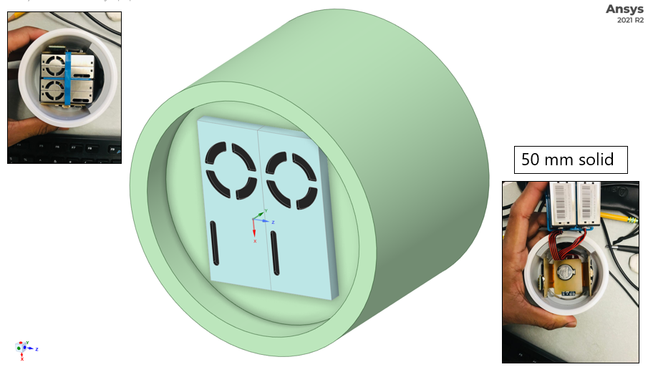
Figure S58. 3D model of the PurpleAir (PA) enclosure with PMS5003 units used for CFD simulations.
The flow around the PA unit was calculated using the computational fluid dynamics software ANSYS FLUENT (version 21). The modeling conditions are listed in Table S8. The flow field was modeled using the k-ε turbulence model. The geometry was meshed repeatedly, until the flow field results were independent of mesh size, and this resulted in a modeling domain with ~ 2 million cells.

Table S8. Boundary conditions used in the simulations of the PurpleAir enclosure.
Boundary conditions | Settings
Model | 3-D
Solver | k-epsilon
Operating pressure | 101325 Pa
Domain Inlet | Velocity 0.4 to 20 m s⁻¹
Domain outlet | Pressure outlet
Sensor Inlet | 0.1 L min⁻¹and 1.0 L min⁻¹
Sensor Outlet | 0.1 L min⁻¹and 1.0 L min⁻¹
Gravity | 9.81 m s⁻²
Fluid | Air
Air Density (constant) | 1.225 kg m⁻³
Viscosity (constant) | 1.7894 × 10 ⁻⁵kg m⁻¹ s⁻¹
Enclosure wall | Trap boundary condition

A sample flow field from the CFD calculations for ambient wind speed of 3 m s⁻¹ is shown in Figure S59a. At the bottom of the PA enclosure, flow accelerates past the open face and creates a recirculation region that extends into the PA enclosure. The PMS5003 sensors housed in the enclosure sample from this recirculation region. The deceleration in velocities creates a turbulent flow field as shown in Figure S59b. The turbulence is maximum in the region below the enclosure and hence plays a critical part in the transport of ambient particles into the PMS5003 sampling region.

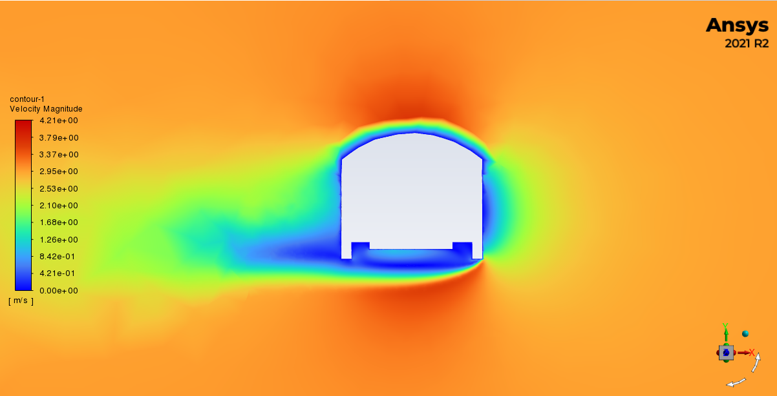

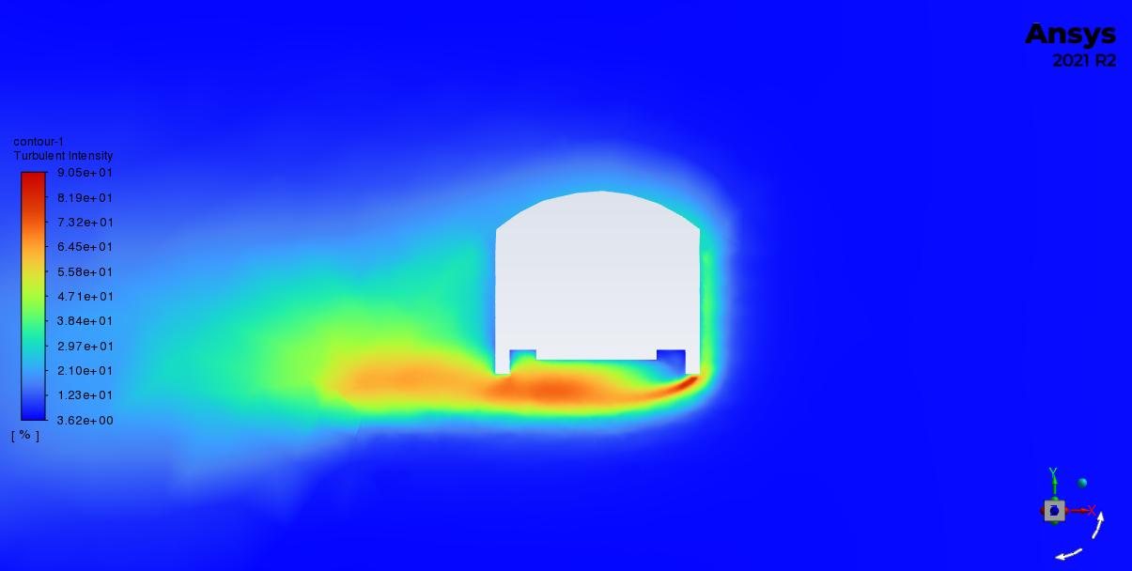
Figure S59 (a) Velocity contours for flow around the PA enclosure for 3 m s⁻¹ freestream velocity; (b) Turbulent intensities in the vicinity of the PA enclosure for freestream velocity of 3 m s⁻¹.
To track the fate of particles in the vicinity of the enclosure, we injected 2,500 particles upstream of the PA over a rectangular region. Repeated particle trajectory calculations were performed to determine the boundaries of injection locations. The boundaries were established such that particles injected from locations outside this boundary passed through the PA enclosure without entering it. Particle trajectories were calculated considering the effect of non-continuum drag, gravity, ultra-Stokesian drag coefficient (Rader & Marple 1985), and turbulent stochastic motion. Particle diffusion was ignored for these calculations. Particle simulations were conducted for five different wind velocities ranging from 0.4 to 20 m s⁻¹.
Particles ranging in diameters from 1 nm to 10 µm, and density of 1 g cm⁻³ were injected and tracked around the PA unit. Ignoring diffusion, it is expected that the trajectories of 1 nm particles should perfectly track the flow streamlines, and hence these particles should act as a surrogate for sample flow in different regions of interest. To understand the sampling efficiency of particles into the PA enclosure, we determined the number of particles crossing the bottom plane of the PA enclosure for all selected particle sizes. Then the sampling efficiency of particles entering the PA bottom plane was calculated as the ratio of number of particles of a selected diameter entering the plane to the number of 1nm particles entering the unit. Sample particle trajectories in and around the PA enclosure are shown in Figure S60. Determination of appropriate particle injection locations is critical to accurately calculating enclosure sampling efficiency. For this, we ran repeated trials to establish a rectangular region that enclosed injection locations from which particles entered the PA enclosure and reached the sampling port of the PMS5003 sensors in the enclosure.
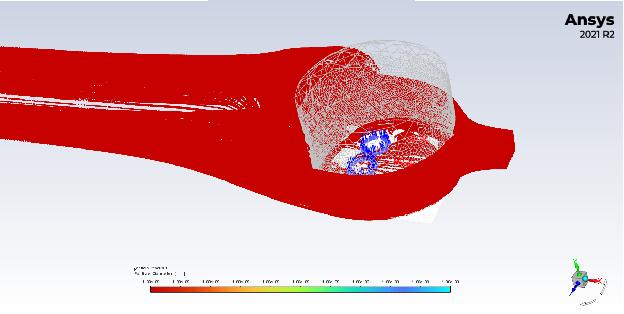
Figure S60. Sample particle trajectories showing the injection plane and particle paths in and around the PA enclosure.
The resulting sampling efficiency of particles entering the PA enclosure obtained from the CFD simulations is shown in Figure 8 in the Main article.
The CFD calculations were carried out for assumed PMS5003 flow rates of 0.1 L min⁻¹ and 1.0 L min⁻¹. Figure S61 shows that flow rate had no appreciable effect on the predicted coarse particle aspiration efficiency.
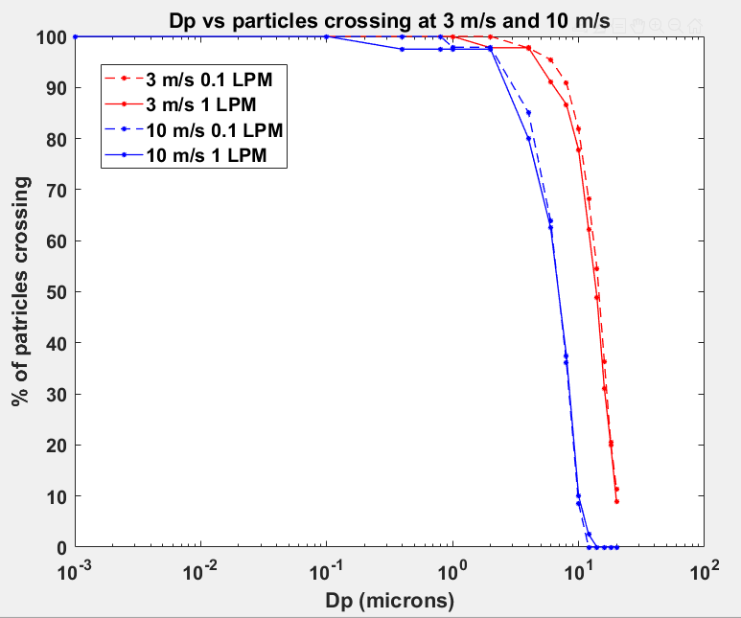
Figure S61. The PMS5003 assumed flowrate had no impact on aspiration efficiency both wind-speeds studied.
References for S3.6:
Agarwal J.K and Liu B.Y.H. (1980). A criterion for accurate aerosol sampling in calm air. American Industrial Hygiene Association Journal, 41(3), 191-197.
Belyaev, S. P., & Levin, L. M. (1974). Techniques for collection of representative aerosol samples. Journal of Aerosol Science, 5(4), 325-338.
Davies, C. N. (1968). The entry of aerosols into sampling tubes and heads. Journal of Physics D: Applied Physics, 1(7), 921.
Hangal, S., & Willeke, K. (1990). Aspiration efficiency: unified model for all forward sampling angles. Environmental Science & Technology, 24(5), 688-691.
Rader, D.J. and V.A. Marple. 1985. Effect of Ultra-Stokesian Drag and Particle Interception on Impaction Characteristics. Aerosol Science and Technology. 4 (2):141-156. DOI: 10.1080/02786828508959044

S3.7 Coarse particle transmission losses in the PMS5003

The PurpleAir monitor operated at the Remote Automated Weather Station adjacent to the Austin, Nevada, U.S. Forest Service Station from July 2, 2019, to August 27, 2021. The air quality was generally very good but would experience occasional windblown dust episodes and smoke from distant wildfires. The PurpleAir sampled approximately 1,000 m³ of ambient air while operating at 0.89 L min⁻¹ during the two-year period. There was no regulatory PM₁₀ monitor in Austin. Similar remote desert sites in California and Nevada have an annual average PM₁₀ of 10-30 μg m⁻³. We assumed this value for making estimates in this section.
Figures S62 and S63 show that coarse aerosol was able to enter the PurpleAir PMS5003 sensors at Austin, Nevada, consistent with the CFD aspiration model predictions. Because of the orientation of the PMS5003 sensors in the PurpleAir with respect to gravity, coarse aerosol was lost to impaction and sedimentation before entering the laser detection zone.
Figures S63 and S64 show that coarse aerosol was lost to sedimentation and then to impaction on the fan blades after flowing past the laser detection zone.
A very rough calculation was performed to estimate what fraction of the coarse aerosol was lost to impaction and sedimentation before detection. We measured the internal PMS5003 surface area available to impaction and sedimentation before detection to be 2 +/- 0.6 cm². If all the sampled 10-30 mg of PM₁₀ were lost to this surface area, it would create a white coating of 50-150 μm thick. This was not observed. However, it is clear from the three white impaction circles and the lightly coated sedimentation section in Figure S59 that some internal transmission losses of coarse particles did occur before detection. We estimate that the surface area that was coated in Figure S62 is approximately 0.8 cm². It is unknown how thick the impaction and sedimentation coatings are. Lai et al. (2008) cited references that indicate that uncoated impaction surfaces may start to experience aerosol bounce after loadings of a few particles thick. This suggests that the circular impaction coatings on Figures S62 and S63 may be approximately 5 to 20 μm thick. If this is the case, then the transmission losses before detection for the two-year sampling period may be roughly 1-4 mg. This would be roughly 3-40% of the PM₁₀ sampled.
The high uncertainty in these rough calculations suggest the need for future measurements of the transmission losses. It is not known if our results are representative of other PurpleAir monitors sampling significant windblown dust. These observations of coarse particles entering the PMS5003 with some internal losses before detection lead us to conclude that the PMS5003’s low reported coarse particle mass concentration (PM₁₀ – PM_{2.5}) is primarily due to its counting inefficiency, not poor aspiration efficiency. Transmission losses before detection may play a minor role.
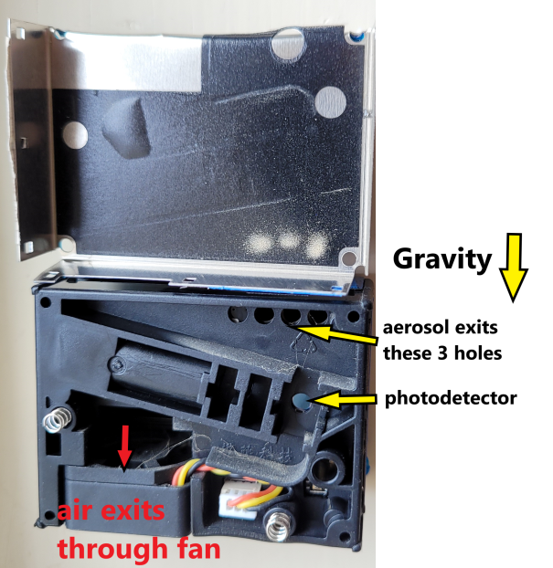

Figure S62. PMS5003 with cover off. It operated in a PurpleAir monitor at a Remote Automated Weather Station in Austin, Nevada, from 2020 to 2022.

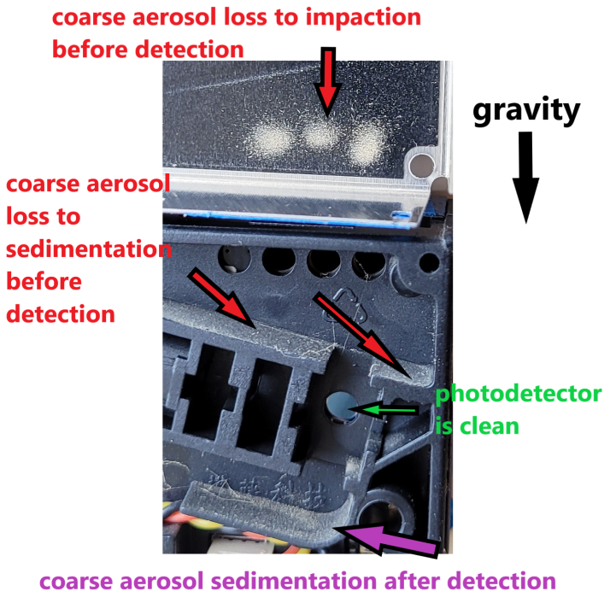
Figure S63. Close-up of PMS5003 showing aerosol deposition by impaction and sedimentation in the vicinity of the photodiode. It operated in a PurpleAir monitor at a Remote Automated Weather Station in Austin, Nevada, from 2020 to 2022.

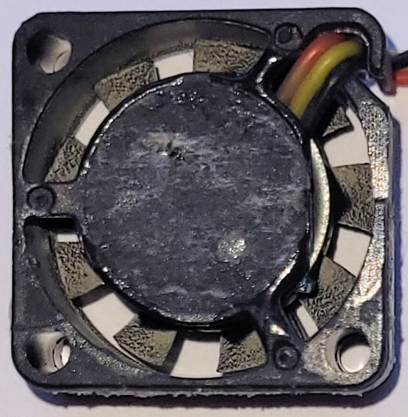
Figure S64. Coarse aerosol impaction on the Austin, Nevada, PMS5003 fan blades after detection

Reference for S3.7
Chane-Yu Lai, Sheng-Hsiu Huang, Cheng-Ping Chang & Jia-Yun Lin (2008). Reducing Particle Bounce and Loading Effect for a Multi-Hole Impactor, Aerosol Science and Technology, 42:2, 114-122, DOI: 10.1080/02786820701809045

