Supplement

Supplement to: DeLara D, Pollack L, Wall H, et al. “County-Level Cardiac Rehabilitation and Broadband Availability: Opportunities for Hybrid Care in the United States”

APPENDIX METHODS
THE EMPIRICAL MONTE-CARLO CUZICK TEST FOR TREND BY LEVELS OF CR AVAILABILITY
Motivation
We compared trends in county-level population characteristics (race/ethnicity, sex, age, insurance, education, income) between the differing levels of CR availability (highest tier, medium tier, and lowest tier) using an empirical Cuzick test for trend, a generalization of the Wilcoxon test for trend designed for 3 or more groups of ordinal data.²⁷ However, our characteristic data is weighted by county population, and neither the Wilcoxon test nor the Cuzick test can account for weighted data. Using the guidelines laid out by North et al,²⁶ we simulate the results of the Cuzick test in equivalent nonweighted replicates generated from our data.

Derivation
We calculated means $μ_{i}$ and variances $σ_{i}^{2}$ weighted by county population for each characteristic at each level of CR availability. For race/ethnicity, sex, age, insurance, education, poverty, and Affordable Connectivity Program eligible status, we generated beta distributed replicates based on the weighted means and variances. Using the definitions for mean and variance of a beta distribution:
$$μ=\frac{α}{α+β}; σ^{2}=\frac{αβ}{{\left(α+β\right)}^{2}(α+β+1)}$$
we calculated rate and shape parameters for our beta distributed replicates:
$$x_{i}\sim Beta\left(α_{i},β_{i}\right); α_{i}=\frac{μ_{i}^{2}\left(1-μ_{i}\right)-μ_{i}σ_{i}^{2}}{σ_{i}^{2}}; β_{i}=α_{i}\frac{1-μ_{i}}{μ_{i}}$$
Where $i=\{lowest tier, medium tier, highest tier\}$. For median income, the weighted mean and variance was directly used to generate normally distributed replicates:
$$x_{i}\sim N\left(μ_{i},σ_{i}^{2}\right) .$$
We generated 3 size $n_{i}$ samples (where $n_{i}$ is the number of counties inside of each CR availability category) and calculated the Cuzick test z-score. The number of counties inside each CR availability category is used to emulate the strength of the original dataset, as using higher sample sizes leads to artificially high z-scores. This was repeated $N=1,000$ times to ensure asymptotic approximation of the z-score. Trends were tested in both the negative and positive direction. Our empirical p value was given as
$${\hat{p}}_{positive}=\frac{r_{positive}+1}{N+1};{\hat{p}}_{negative}=\frac{r_{negative}+1}{N+1}$$
where $r_{positive}$ is the number of replicates whose Cuzick test statistics detected a positive trend ($z>1.96$) and $r_{negative}$ is the number of replicates whose Cuzick test statistics detected a negative trend ($z<-1.96$). $\hat{p}$ is considered statistically significant if $1-\hat{p}<0.05$.

SPATIALLY ADAPTIVE FLOATING CATCHMENTS
Calculating a Single Spatially Adaptive Floating Catchment
Appendix Figure 1. Spatially adaptive floating catchment for a single facility in a single county.
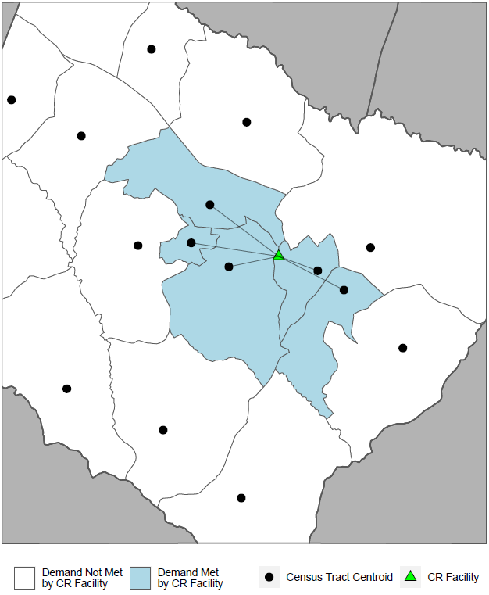
Facility meets demand of closest census tracts until demand (approximately) equals supply.
Total facility supply = 45.
Total demand met = 50.
CR indicates cardiac rehabilitation.

Calculation of spatially adaptive floating catchment (SAFC) for a single facility. The origin of the CR facility is marked as a green triangle, which is associated with a certain amount of supply. Each black dot represents the population weighted centroid of the local census tracts and is associated with a certain amount of demand. Each census tract is organized by Euclidean (as the crow flies) distance from the CR facility. Distances were measured by Euclidean distance as preliminary analyses found no statistically significant differences in our results using Euclidean distance versus drive times. The triangle “extends” its area to each census tract until the cumulative demand of all the closest census tracts is either equal to or slightly exceeds the supply associated with the CR facility. Therefore, the total facility supply is 45 and the total demand met is 50. The SAFC for this facility is highlighted in blue, along with lines showing the distance between the facility and each census tract centroid. Census tracts shown in white do not have their demand met by the CR facility. Cumulative demand is calculated for the entire census tract at one time.

Calculating Demand Met for a Single County
Appendix Figure 2. Demand met by local cardiac rehabilitation facilities in county X.
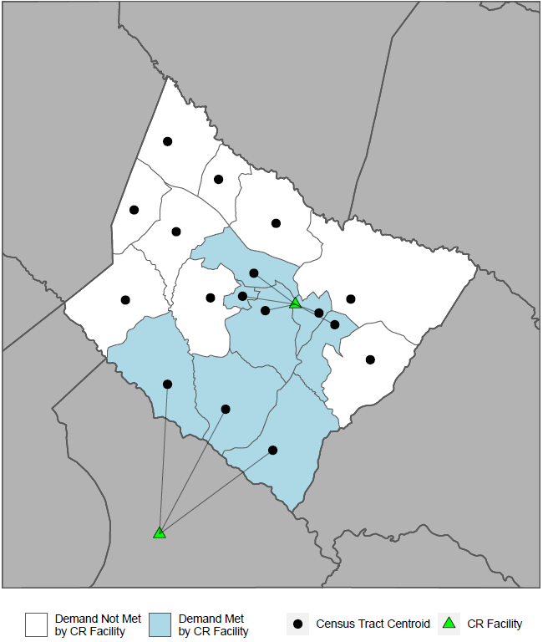
Footnotes: Demand for CR in this county is met by facilities both inside and outside the county.
Demand met = 69 (sum of blue census tracts).
County demand = 125 (sum of blue and white census tracts).
County-level % CR availability = 55.2% (69/125).
CR indicates cardiac rehabilitation.

There are 2 spatially adaptive floating catchments (SAFCs) that extend into County X: one from inside the county and one from outside the county. The outside-the-county SAFC includes outside-the-county census tracts, but these are not counted in the demand met calculation for County X, nor are they shown here for simplicity. The census tracts whose demands are met by these 2 CR facilities are highlighted in blue, and the percent demand met is calculated by dividing the sum of the demand in the blue census tracts by the sum of the demand in the blue and the white census tracts. The demand calculation for each census tract is not an exact measurement but is randomly allocated to each census tract using a multinomial distribution. The total demand in County X is 125, and each census tract receives a randomly allocated amount of that 125, weighted by the total population aged ≥65 years in that census tract. Final county estimates are calculated by randomly distributing demand estimates and calculating the demand met for each county 1,000 times, then taking the median of each county estimate. This process makes explicit our uncertainty about the number of beneficiaries with a CR qualifying event in each census tract and allows us to report a range of estimates if necessary.

