Home indoor air quality and cognitive function over one year for people working remotely during COVID-19

Supplementary Material

Anna Young*^{1,2}, Shivani Parikh^{1,3}, Sandra Dedesko^{1,3}, Maya Bliss^{1,2}, Jiaxuan Xu¹, Antonella Zanobetti¹, Shelly Miller⁴, Joseph Allen¹

Supplemental Tables & Figures

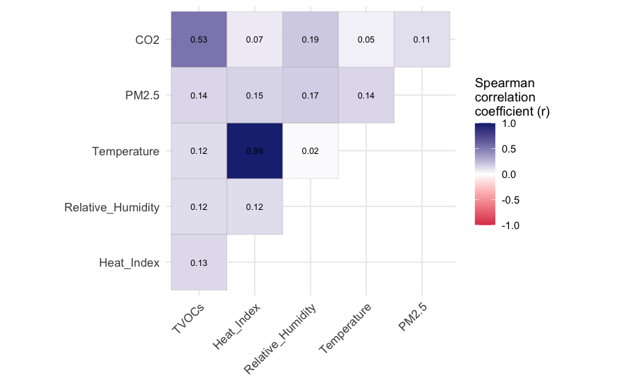

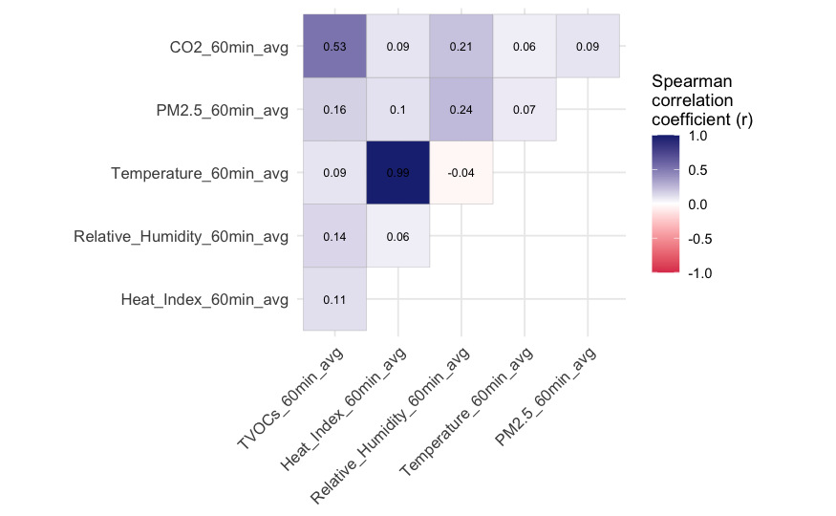
Figure S1. Spearman correlation matrices with p-values for the correlations between concentrations of different indoor air quality parameters, either for all time points (top panel) or for the one-hour period before cognitive test responses by participants (bottom panel).
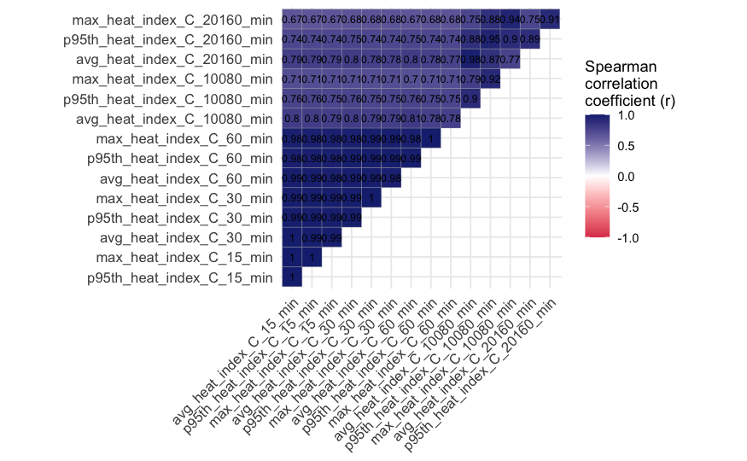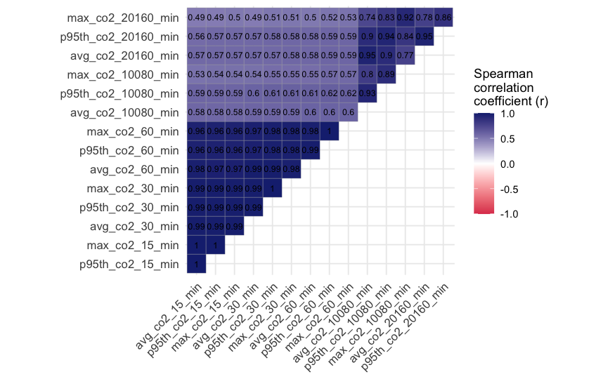
Figure S2. Spearman correlation matrices with p-values for the correlations between different summary statistics of heat index (top panel) or carbon dioxide (bottom panel) concentrations at the time of cognitive test responses (max, average, or 95th percentile of concentrations during the 15-min, 30-min, 60-min, one-week, or two-week period before the test response).

Figure S3. Boxplots summarizing all 5-minute indoor air quality concentrations from 314 Awair Omni real-time sensors during the entire study period between May 2021 and December 2022. For PM_{2.5}, only the lower 95% of values are shown to improve visualization of the boxplot. Spring = March, April, May; Summer = June, July, August; Autumn = September, October, November; Winter = December, January, February.

Figure S4. Three dimensional graphs of the bivariate thin plate spline between carbon dioxide and heat index in association with a suite of five different cognitive function metrics in fully adjusted mixed models. Note: cRAT outcome was log-transformed.

Figure S5. Spline curves from fully adjusted generalized additive mixed models for the association between average indoor air quality parameters and a suite of cognitive function outcomes among 125 participants during a one-year longitudinal period.
Note: edf=effective degrees of freedom. Dotted lines represented 95% confidence intervals. Black vertical bars at the bottom of each graph show where the actual data points lie.

Figure S6. Three-dimensional bivariate thin plate spline surfaces of interaction between temperature and relative humidity in associations with a suite of cognitive function outcomes in fully adjusted GAMMs.

Table S1. Population characteristics for the participants included in the final analysis of the paper and for all participants with available survey data.
Table S2. Financial and work characteristics for the participants included in the final analysis of the paper and for all participants with available survey data.

Table S3. Housing characteristics for the participants included in the final analysis of the paper and for all participants with available survey data.

