Table S1. Descriptive information on participation levels and summary test metrics by cognitive test type

Figure S1a and S1b. Screenshots of the mobile app user interface of the Stroop and ADD tests
b)
a)
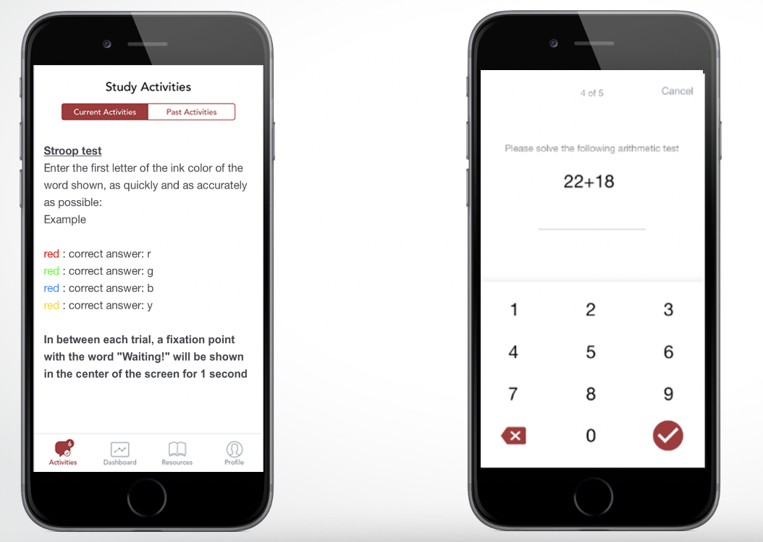
Fig S1a. Stroop test interface; fig S1b ADD test interface

