Table 1. **Adjusted hazard ratios of opioid related events**

|  |  |  |  |  |
| --- | --- | --- | --- | --- |
|  | **Risk of any event** | **Risk of suicide** | **Risk of overdose** | **Risk of adverse event** |
|  | aHR (95% CI) | aHR (95% CI) | aHR (95% CI) | aHR (95% CI) |
| Stable or increasing dose | (Ref) | (Ref) | (Ref) | (Ref) |
| Abrupt Discontinuation | 1.22 (0.94-1.58) | 3.63 (1.42-9.25) | 0.62 (0.4-0.94) | 1.61 (1.15-2.26) |
| Dose reduction and discontinuation | 1.13 (0.84-1.53) | 4.47 (1.68-11.89) | 0.36 (0.2-0.66) | 1.54 (1.05-2.25) |
| Dose reduction without discontinuation | 0.94 (0.73-1.21) | 1.29 (0.48-3.45) | 0.41 (0.27-0.62) | 1.45 (1.04-2.02) |
| Male | (Ref) | (Ref) | (Ref) | (Ref) |
| Female | 1.07 (0.9-1.25) | 1.0 (0.65-1.55) | 1.119 (0.804-1.56) | 1.08 (0.9-1.31) |
| Urban | (Ref) | (Ref) | (Ref) | (Ref) |
| Rural | 0.69 (0.59-0.82) | 0.8 (0.53-1.22) | 0.911 (0.66-1.26) | 0.65 (0.54-0.79) |
| Age 0-29 | (Ref) | (Ref) | (Ref) | (Ref) |
| Age 30-39 | 0.49 (0.35-0.68) | 0.64 (0.2-2.0) | 0.43 (0.2-0.89) | 0.47 (0.32-0.68) |
| Age 40-49 | 0.52 (0.37-0.71) | 1.26 (0.44-3.6) | 0.44 (0.22-0.89) | 0.48 (0.33-0.68) |
| Age 50-59 | 0.46 (0.34-0.63) | 0.86 (0.3-2.47) | 0.54 (0.28-1.04) | 0.4 (0.28-0.57) |
| Age 60+ | 0.42 (0.3-0.597) | 0.44 (0.14-1.42) | 0.46 (0.23-0.95) | 0.42 (0.29-0.62) |
| Race: White | (Ref) | (Ref) | (Ref) | (Ref) |
| Black | 1.03 (0.67-1.591) |  | 0.88 (0.36-2.19) | 1.28 (0.81-2.03) |
| Unknown | 0.85 (0.68-1.049) | 0.66 (0.35-1.23) | 0.74 (0.47-1.16) | 0.86 (0.68-1.11) |
| Other | 0.65 (0.42-1) | 0.81 (0.29-2.22) | 0.12 (0.02-0.82) | 0.76 (0.48-1.21) |
| Comorbidities (ref=none) |  |  |  |  |
| Depression | 1.33 (1.07-1.64) | 1.66 (0.93-2.96) | 1.21 (0.78-1.89) | 1.3 (1.02-1.66) |
| Drug Abuse | 2.15 (1.75-2.65) | 1.04 (0.53-2.06) | 2.23 (1.46-3.41) | 2.31 (1.83-2.91) |
| Alcohol abuse | 1.17 (0.77-1.78) | 1.19 (0.36-3.88) | 1.79 (0.85-3.77) | 1.1 (0.68-1.79) |
| Chronic pain (ref=none) |  |  |  |  |
| Chronic pain | 5.85 (4.67-7.33) | 2.53 (1.54-4.14) | 5.1 (3.33-7.79) | 8.15 (6.09-10.9) |
| MME dose: 50-119 | (Ref) | (Ref) | (Ref) | (Ref) |
| MME dose: 120-149 | 1.29 (1.01-1.66) | 1.18 (0.59-2.34) | 0.98 (0.57-1.69) | 1.48 (1.13-1.96) |
| MME dose: 150-199 | 1.33 (1.02-1.73) | 1.6 (0.84-3.03) | 0.77 (0.4-1.48) | 1.47 (1.09-1.99) |
| MME dose: 200+ | 1.98 (1.61-2.43) | 1.96 (1.16-3.34) | 2.01 (1.35-2.99) | 2.0 (1.57-2.54) |
| Benzodiazepine filled | 1.44 (1.22-1.69) | 2.13 (1.35-3.35) | 1.38 (1-1.91) | 1.37 (1.13-1.65) |

aHR: adjusted hazard ratio; CI: confidence interval; Ref: reference; MME: morphine milligram equivalent

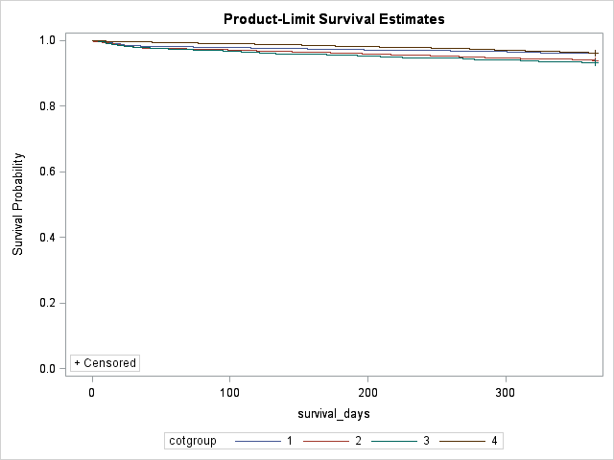

**Figure 1:** Survival curves differences in any opioid related event between dose reduction groups

Group 1= Stable or increasing dose

Group2 = Abrupt discontinuation

Group 3 = Dose reduction and discontinuation

Group 4 = Dose reduction without discontinuation

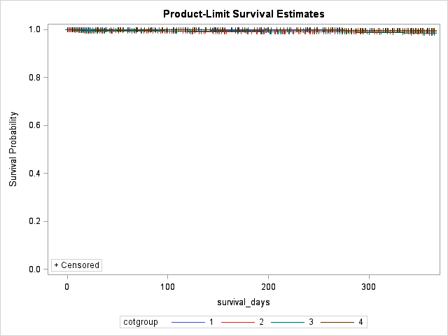

**Figure 2:** Survival curves differences in suicide events between dose reduction groups

Group 1= Stable or increasing dose

Group2 = Abrupt discontinuation

Group 3 = Dose reduction and discontinuation

Group 4 = Dose reduction without discontinuation

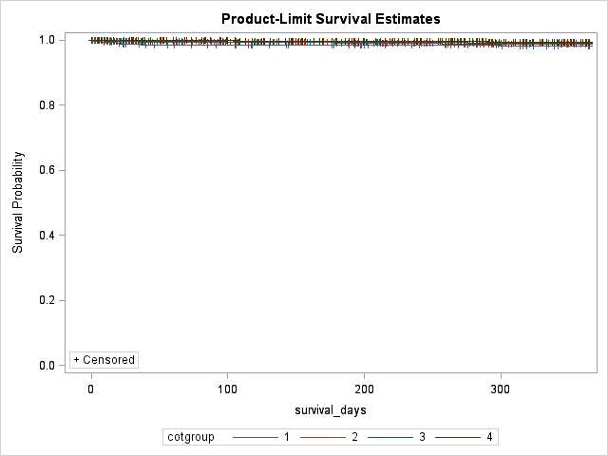

**Figure 3:** Survival curves differences in opioid overdose events between dose reduction groups

Group 1= Stable or increasing dose

Group2 = Abrupt discontinuation

Group 3 = Dose reduction and discontinuation

Group 4 = Dose reduction without discontinuation

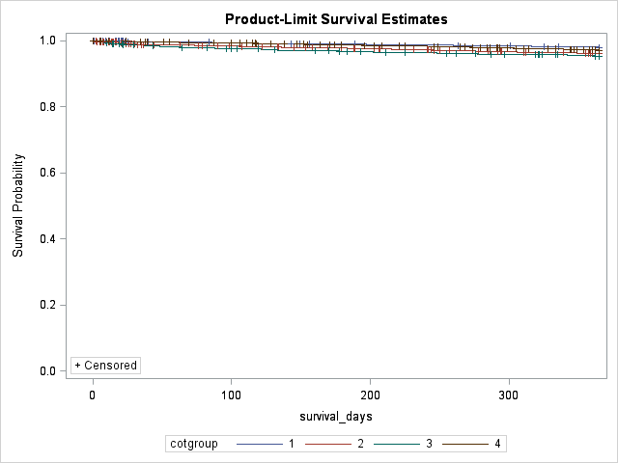

**Figure 4:** Survival curves differences in opioid adverse events between dose reduction groups

Group 1= Stable or increasing dose

Group2 = Abrupt discontinuation

Group 3 = Dose reduction and discontinuation

Group 4 = Dose reduction without discontinuation