Supplemental Digital Content

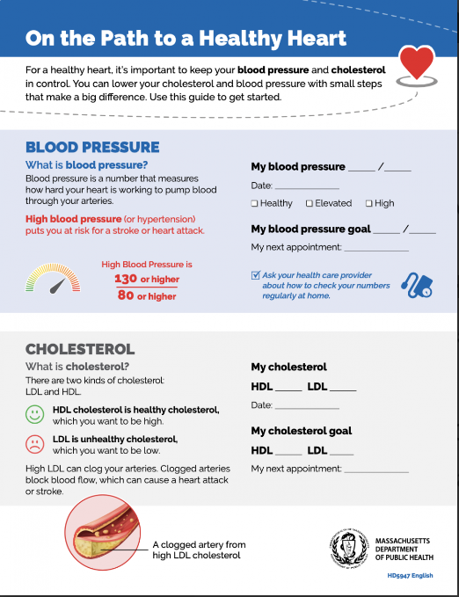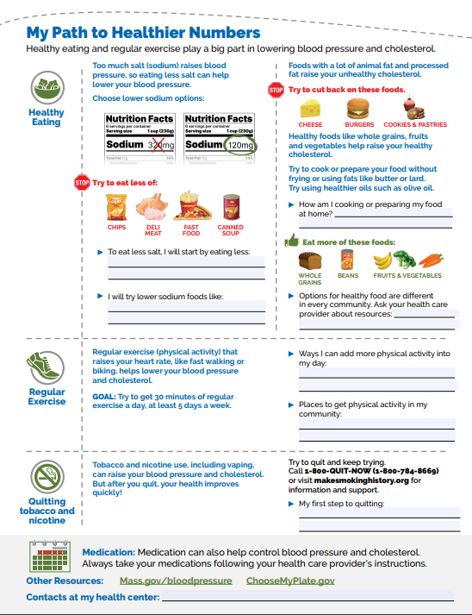
Figure S1. “On the Path to a Healthy Heart” Worksheet

Figure S2. Changes in Blood Pressure Among SMBP Participants by the Length of Their Enrollment.
Abbreviations: SMBP = self-monitoring of blood pressure; SBP: = systolic blood pressure; DBP = diastolic blood pressure
Figure S1 depicts boxplots of the initial and final systolic and diastolic blood pressure of participants by the length of their SMBP enrollment. The box represents the interquartile range (quartile 1 and quartile 3). The horizontal line indicates the mean, the ‘X’ indicates the median, the length of the bars represents the range of values between the upper and lower extremes, and the outliers are the data points that lie in both extremes of the data.

